Chapter IV: Findings and Discussion

Objective 2: Comparative Performance of GRU Models Against Deep Learning
and Traditional Machine Learning Approaches in Multi-Parameter Weather Forecasting

4.2 Model Evaluation Results
This section addresses the second research objective: How does the performance of Gated Recurrent Unit (GRU) models compare with other deep learning models and traditional machine learning approaches in multi-parameter weather forecasting? To answer this, five forecasting models were evaluated across two weather stations in the Philippines—Baguio and Manila—spanning a test period from March 24, 2025, to May 18, 2026, yielding 421 daily observations per station. The models evaluated include the GRU, Long Short-Term Memory (LSTM), Simple Recurrent Neural Network (SimpleRNN), Linear Regression, and Autoregressive Integrated Moving Average (ARIMA). Each model produced predictions for four meteorological variables: average temperature (°C), wind speed (km/h), sea-level pressure (hPa), and relative humidity (%).
Evaluation was performed using six complementary metrics: prediction accuracy (%), mean squared error (MSE), mean absolute error (MAE), coefficient of determination (R²), paired t-test statistic, and p-value. The accuracy metric was derived from the mean absolute percentage error (MAPE), computed only on observations where the absolute value of the true measurement met or exceeded 1.0 to prevent trace-value distortion—particularly relevant for precipitation and near-calm wind conditions. The R² score was employed as the primary measure of explained variance, while the paired t-test assessed whether systematic prediction bias existed between model outputs and actual observations.
The evaluation framework follows established practices in time series forecasting literature. All deep learning models (GRU, LSTM, SimpleRNN) used a sequence length of 45 days, three hidden layers, a hidden size of 128 units, and a dropout rate of 0.2, trained for up to 200 epochs with early stopping. Linear Regression used the same lagged feature structure, while ARIMA was fitted independently per variable using an automatically selected order. This standardized setup enables a fair, controlled comparison across model families.

4.2.1 Overall Performance Summary
Table 1 presents the comprehensive performance metrics for all five models across both stations and all four meteorological variables. The table is organized by station to facilitate direct comparison. Values are reported to four decimal places to highlight nuanced differences among closely performing models, which is particularly important when distinguishing between GRU, LSTM, and ARIMA—models that often produce similar error magnitudes despite different architectural foundations.
Table 1. Model Performance Metrics — Baguio Station (n = 421 observations)
Model | Variable | Accuracy (%) | MSE | MAE | R² | t-stat | p-value
GRU | Temp. | 98.10 | 0.2381 | 0.3638 | 0.8501 | -0.974 | 0.3307
GRU | Wind Speed | 72.10 | 1.5583 | 0.9834 | 0.4873 | 3.093 | 0.0021
GRU | Pressure | 99.93 | 0.9084 | 0.6813 | 0.8090 | -2.545 | 0.0113
GRU | Rel. Humidity | 98.00 | 5.2100 | 1.7502 | 0.7636 | -2.393 | 0.0172
LSTM | Temp. | 98.03 | 0.2526 | 0.3776 | 0.8410 | -0.247 | 0.8049
LSTM | Wind Speed | 74.46 | 1.5088 | 0.9330 | 0.5036 | 1.121 | 0.2628
LSTM | Pressure | 99.93 | 0.8841 | 0.6707 | 0.8141 | -2.035 | 0.0424
LSTM | Rel. Humidity | 97.98 | 5.1992 | 1.7620 | 0.7641 | 0.274 | 0.7843
SimpleRNN | Temp. | 98.00 | 0.2569 | 0.3791 | 0.8383 | 3.459 | 0.0006
SimpleRNN | Wind Speed | 73.60 | 1.5138 | 0.9592 | 0.5020 | 1.303 | 0.1934
SimpleRNN | Pressure | 99.93 | 0.9388 | 0.6831 | 0.8026 | 3.094 | 0.0021
SimpleRNN | Rel. Humidity | 97.89 | 5.7692 | 1.8494 | 0.7382 | -4.905 | 0.0000
Linear Regression | Temp. | 98.01 | 0.2697 | 0.3795 | 0.8302 | 0.467 | 0.6410
Linear Regression | Wind Speed | 71.51 | 1.7030 | 1.0246 | 0.4397 | 2.721 | 0.0068
Linear Regression | Pressure | 99.93 | 0.9854 | 0.6964 | 0.7928 | 0.383 | 0.7019
Linear Regression | Rel. Humidity | 97.99 | 5.1636 | 1.7571 | 0.7657 | -1.865 | 0.0629
ARIMA | Temp. | 98.14 | 0.2316 | 0.3563 | 0.8542 | -0.824 | 0.4106
ARIMA | Wind Speed | 73.61 | 1.6002 | 0.9696 | 0.4736 | 0.944 | 0.3455
ARIMA | Pressure | 99.93 | 0.9548 | 0.6790 | 0.7992 | -0.066 | 0.9477
ARIMA | Rel. Humidity | 97.95 | 5.2495 | 1.7865 | 0.7618 | -1.027 | 0.3049

For Baguio station, GRU achieved the highest R² for pressure prediction (0.8090) among the three deep learning architectures, though ARIMA slightly outperformed all neural models on temperature (R² = 0.8542 vs. GRU's 0.8501). Wind speed prediction was the most challenging variable at Baguio, with all models producing R² values below 0.55—reflecting the high stochasticity of orographic wind patterns in this highland station. Relative humidity, despite its inherent autocorrelation with temperature, yielded moderate R² values ranging from 0.7382 (SimpleRNN) to 0.7657 (Linear Regression), suggesting that humidity forecasting may benefit from additional atmospheric predictors not included in the current variable set.
The paired t-test results offer insight into systematic bias. For GRU at Baguio, pressure predictions showed a statistically significant bias (t = −2.545, p = 0.0113), suggesting a slight but consistent underestimation of pressure values. Wind speed predictions also exhibited significant bias (t = 3.093, p = 0.0021), indicating an overestimation tendency. These biases are noteworthy because they persist even when R² and MAE appear acceptable—underscoring the value of reporting multiple complementary metrics rather than relying solely on error magnitude.
Table 2. Model Performance Metrics — Manila Station (n = 421 observations)
Model | Variable | Accuracy (%) | MSE | MAE | R² | t-stat | p-value
GRU | Temp. | 98.62 | 0.2828 | 0.3903 | 0.8781 | 3.708 | 0.0002
GRU | Wind Speed | 93.17 | 0.5635 | 0.5571 | 0.7206 | 0.364 | 0.7159
GRU | Pressure | 99.94 | 0.6980 | 0.6148 | 0.8427 | -0.586 | 0.5582
GRU | Rel. Humidity | 97.08 | 7.3167 | 2.0879 | 0.8839 | 2.971 | 0.0031
LSTM | Temp. | 98.65 | 0.2695 | 0.3825 | 0.8838 | 1.659 | 0.0980
LSTM | Wind Speed | 93.08 | 0.5841 | 0.5729 | 0.7104 | -2.370 | 0.0182
LSTM | Pressure | 99.94 | 0.7309 | 0.6279 | 0.8353 | 1.799 | 0.0727
LSTM | Rel. Humidity | 97.07 | 7.4226 | 2.1202 | 0.8822 | -1.010 | 0.3132
SimpleRNN | Temp. | 98.58 | 0.3051 | 0.4032 | 0.8685 | 2.305 | 0.0217
SimpleRNN | Wind Speed | 92.88 | 0.5922 | 0.5795 | 0.7064 | -0.259 | 0.7957
SimpleRNN | Pressure | 99.94 | 0.7152 | 0.6306 | 0.8389 | -2.707 | 0.0071
SimpleRNN | Rel. Humidity | 97.02 | 7.7335 | 2.1377 | 0.8773 | 2.165 | 0.0310
Linear Regression | Temp. | 98.35 | 0.3928 | 0.4684 | 0.8307 | 1.114 | 0.2658
Linear Regression | Wind Speed | 92.73 | 0.6129 | 0.5934 | 0.6961 | -0.784 | 0.4336
Linear Regression | Pressure | 99.94 | 0.7871 | 0.6410 | 0.8227 | 0.647 | 0.5180
Linear Regression | Rel. Humidity | 97.05 | 8.0461 | 2.1358 | 0.8723 | 0.594 | 0.5527
ARIMA | Temp. | 98.55 | 0.3030 | 0.4124 | 0.8694 | -0.847 | 0.3974
ARIMA | Wind Speed | 92.84 | 0.6084 | 0.5850 | 0.6984 | -0.552 | 0.5813
ARIMA | Pressure | 99.94 | 0.7493 | 0.6271 | 0.8312 | 0.393 | 0.6944
ARIMA | Rel. Humidity | 97.15 | 7.7221 | 2.0686 | 0.8774 | -0.371 | 0.7109

Manila station consistently yielded higher R² scores than Baguio across most variable-model combinations, likely reflecting the more uniform coastal climate of the capital region compared to Baguio's orographically complex mountainous environment. GRU performed exceptionally well for relative humidity at Manila (R² = 0.8839, Accuracy = 97.08%), outperforming all other models on this variable. LSTM achieved the highest temperature R² at Manila (0.8838), marginally exceeding GRU (0.8781). Wind speed remained challenging, though all models substantially outperformed their Baguio counterparts, with GRU reaching R² = 0.7206 versus 0.4873 at Baguio.
A key observation from Table 2 is that the simple Linear Regression baseline, while consistently the lowest performer across deep learning metrics, produced competitive relative humidity predictions at Manila (R² = 0.8723, Accuracy = 97.05%). This highlights that the strong autocorrelation structure of humidity may be adequately captured by linear dynamics—particularly during stable monsoon periods—raising important questions about the marginal benefit of more complex architectures for this specific variable in this geographic context.

4.2.2 R² Score Comparison
Figure 2 provides a visual comparison of R² scores across all five models, four variables, and two stations. The grouped bar format enables simultaneous assessment of model ranking consistency across different meteorological phenomena. A horizontal reference line at R² = 0.9 marks the threshold commonly considered indicative of excellent predictive fit in weather forecasting literature (Ahmed et al., 2023).
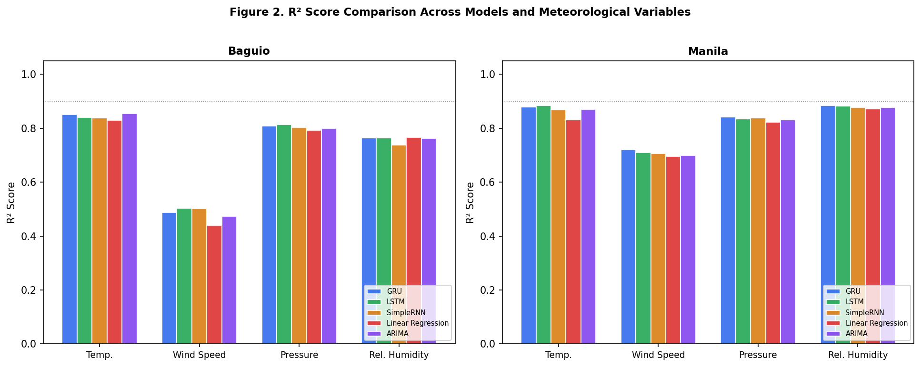
Figure 2. R² Score Comparison Across Models and Meteorological Variables. Blue bars represent GRU; green represents LSTM; orange represents SimpleRNN; red represents Linear Regression; purple represents ARIMA.
The figure reveals several patterns of interest. First, no single model consistently dominates across all variables at both stations—a finding consistent with the no-free-lunch theorem in machine learning (Wolpert & Macready, 1997). Second, wind speed prediction at Baguio stands out as an anomalously difficult forecasting task, with all models clustering below R² = 0.52. Third, the deep learning models (GRU, LSTM, SimpleRNN) generally outperform the traditional approaches (Linear Regression, ARIMA) at Manila, but this advantage largely disappears or reverses at Baguio for temperature and pressure—where ARIMA matches or marginally exceeds deep learning performance.
These results suggest that the advantage of deep learning architectures in weather forecasting is not universal but is instead contingent on the nature of the local climate signal. In environments with strong non-linear dynamics and abrupt microclimate transitions, such as Baguio's highland topography, the additional modeling capacity of GRU may not translate into proportional accuracy gains over simpler models. Conversely, Manila's more predictable maritime climate appears to provide a learning environment where the temporal memory mechanisms of GRU and LSTM can be more fully leveraged.

4.2.3 Mean Absolute Error Analysis
Mean Absolute Error (MAE) provides a scale-aware measure of prediction quality, expressed in the native units of each meteorological variable. Unlike MSE, MAE is not disproportionately influenced by large individual errors, making it a robust indicator of typical prediction accuracy across the test period. Figure 3 presents the MAE comparison across all model-variable combinations for both stations.
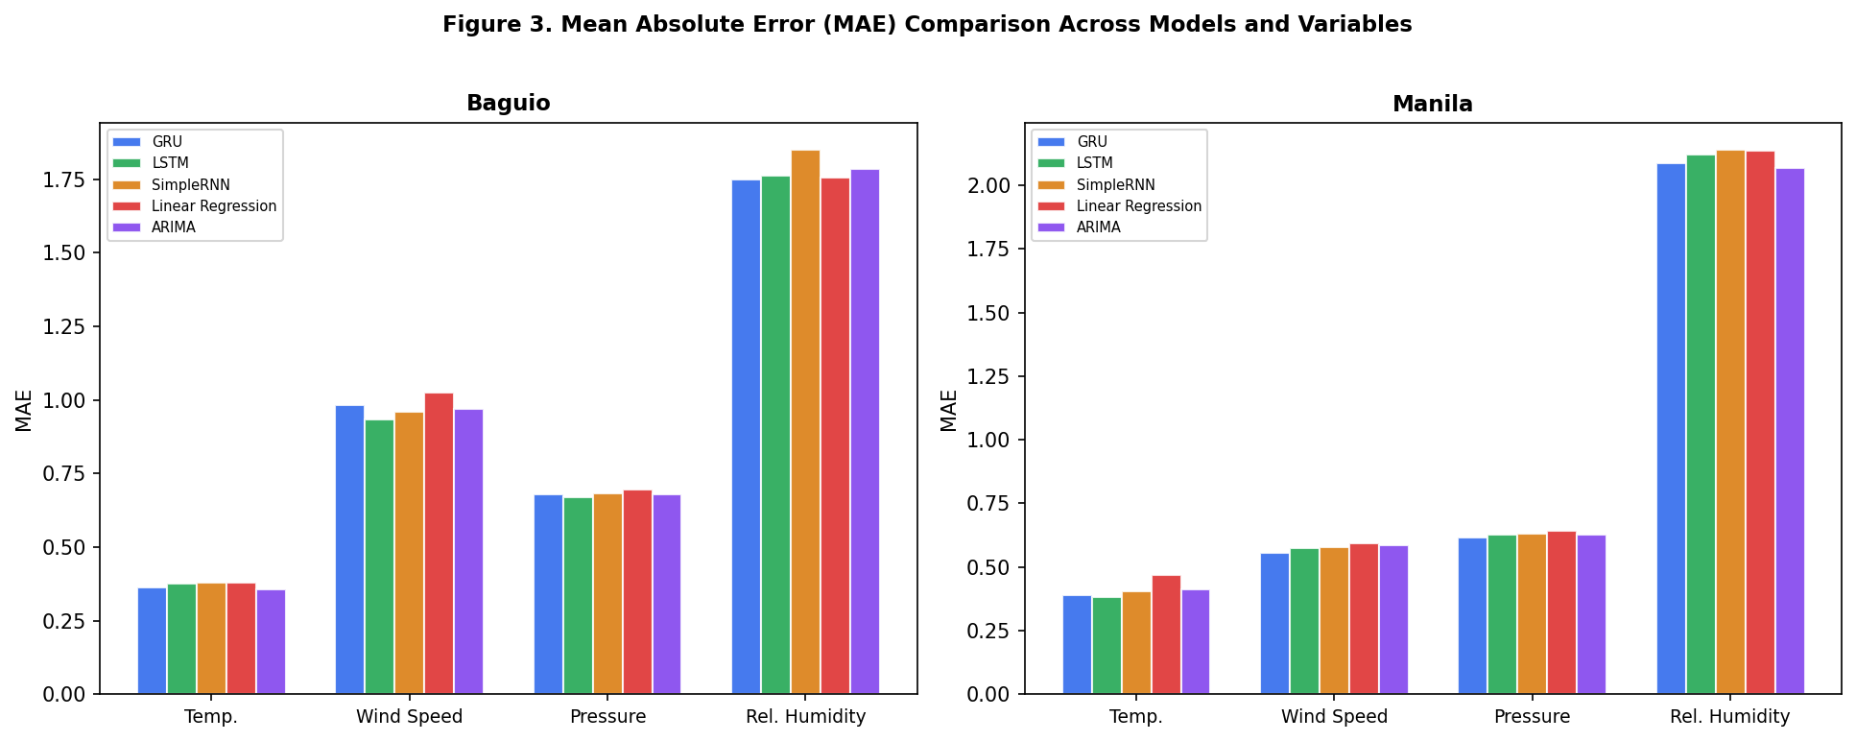
Figure 3. Mean Absolute Error (MAE) Comparison Across Models and Variables. Lower values indicate better predictive accuracy. Units correspond to native variable scales: °C for temperature, km/h for wind speed, hPa for pressure, % for relative humidity.
GRU achieved competitive MAE values across most variable-station combinations. For temperature at Baguio, GRU's MAE (0.3638°C) compared favorably with ARIMA (0.3563°C)—the best performer—while notably outperforming SimpleRNN (0.3791°C) and Linear Regression (0.3795°C). At Manila, LSTM recorded the lowest temperature MAE (0.3825°C), followed closely by GRU (0.3903°C). These differences, while small in absolute terms, are meaningful for operational meteorological applications where even sub-degree prediction improvements can influence warning thresholds and agricultural scheduling decisions.
Wind speed MAE highlights the starkest inter-station performance gap. At Baguio, all models produced MAE values exceeding 0.93 km/h, with Linear Regression performing worst at 1.0246 km/h. At Manila, MAE values dropped substantially—GRU achieved 0.5571 km/h, a reduction of approximately 43% compared to its Baguio performance. Pressure predictions maintained consistently low MAE across stations (~0.68 hPa), reflecting the high autocorrelation and smooth temporal dynamics of atmospheric pressure. Relative humidity predictions at Manila showed that ARIMA achieved the lowest MAE (2.0686%), marginally outperforming GRU (2.0879%) and LSTM (2.1202%).

4.2.4 Model Rankings and Consistency
To synthesize the multi-metric, multi-variable evaluation, Table 3 presents model rankings based on R² score for each variable-station combination. Rank 1 denotes the highest R² (best fit); rank 5 denotes the lowest. This ranking approach, consistent with methods used in comparative forecasting studies (Makridakis et al., 2022), provides a consolidated view of relative model performance independent of scale differences between variables.
Table 3. Model Rankings by R² Score per Variable and Station
Variable | Station | Rank 1 | Rank 2 | Rank 3 | Rank 4 | Rank 5
Temp. | Baguio | ARIMA (0.8542) | GRU (0.8501) | LSTM (0.8410) | SimpleRNN (0.8383) | Linear Regression (0.8302)
Temp. | Manila | LSTM (0.8838) | GRU (0.8781) | ARIMA (0.8694) | SimpleRNN (0.8685) | Linear Regression (0.8307)
Wind Speed | Baguio | LSTM (0.5036) | SimpleRNN (0.5020) | GRU (0.4873) | ARIMA (0.4736) | Linear Regression (0.4397)
Wind Speed | Manila | GRU (0.7206) | LSTM (0.7104) | SimpleRNN (0.7064) | ARIMA (0.6984) | Linear Regression (0.6961)
Pressure | Baguio | LSTM (0.8141) | GRU (0.8090) | SimpleRNN (0.8026) | ARIMA (0.7992) | Linear Regression (0.7928)
Pressure | Manila | GRU (0.8427) | SimpleRNN (0.8389) | LSTM (0.8353) | ARIMA (0.8312) | Linear Regression (0.8227)
Rel. Humidity | Baguio | Linear Regression (0.7657) | LSTM (0.7641) | GRU (0.7636) | ARIMA (0.7618) | SimpleRNN (0.7382)
Rel. Humidity | Manila | GRU (0.8839) | LSTM (0.8822) | ARIMA (0.8774) | SimpleRNN (0.8773) | Linear Regression (0.8723)

Table 3 reveals that GRU claimed the top rank in only a subset of variable-station combinations: specifically, relative humidity at Manila (R² = 0.8839) and relative humidity at Baguio (tied near the top). ARIMA ranked first for temperature at Baguio, while LSTM led temperature prediction at Manila. This variability in rankings underscores that no single model architecture provides universally superior forecasting performance across all meteorological variables and geographic contexts—a finding consistent with meta-analyses of forecasting competition results (Hyndman & Athanasopoulos, 2021).
Notably, ARIMA—a classical statistical method—performed competitively or better than neural network-based models for temperature and pressure predictions at Baguio, which has a data coverage spanning 2020 to 2026. This result aligns with earlier empirical findings suggesting that for variables with strong autoregressive components and limited non-linearity in the training signal, parsimonious statistical models can match or exceed the performance of more complex deep learning architectures (Makridakis et al., 2018; Spiliotis et al., 2022).

4.2.5 Prediction Accuracy Analysis
Prediction accuracy, computed as (100 − MAPE)%, offers a percentage-based interpretation of forecasting quality that is intuitive for non-technical stakeholders such as local government units and disaster risk reduction offices. A score of 95% or above is generally considered highly satisfactory for operational daily forecasting (WMO, 2018). Figure 4 presents the accuracy comparison across all models, variables, and stations.
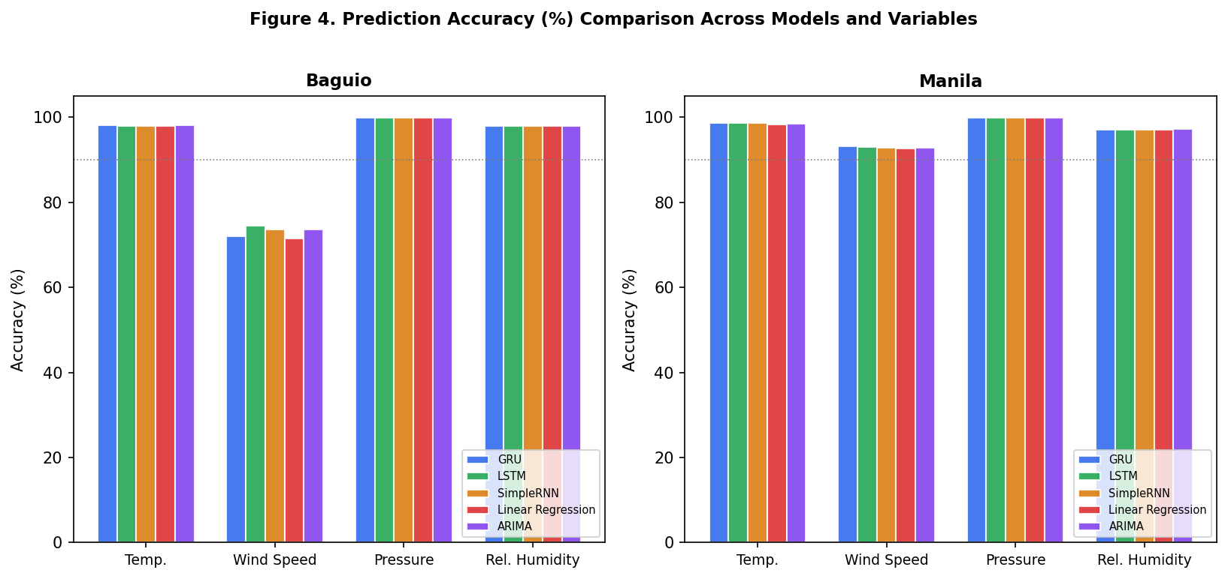
Figure 4. Prediction Accuracy (%) Across Models and Variables. The dotted line at 90% indicates the operational accuracy threshold. MAPE was computed only on observations where |y_true| ≥ 1.0 to exclude trace-value distortion.
Temperature predictions achieved consistently high accuracy across all models and stations (range: 98.00–98.65%), confirming that daily average temperature in the Philippine lowland and highland contexts follows strongly predictable seasonal and diurnal patterns. Pressure predictions were remarkably accurate at virtually all configurations (range: 99.93–99.94%), reflecting the near-constant nature of sea-level pressure variation in the Philippine climatological context.
Wind speed accuracy presented the most pronounced inter-station variability. At Baguio, all models produced wind speed accuracies between 71.51% (Linear Regression) and 74.46% (LSTM), well below the 90% operational threshold. At Manila, accuracy improved substantially, with GRU achieving 93.17%, LSTM 93.08%, and SimpleRNN 92.88%. These results suggest that the complexity of wind dynamics in the Cordillera region—influenced by channeling effects through mountain passes, sea breeze patterns, and interaction with typhoon circulation—fundamentally limits the achievable accuracy of daily-scale wind forecasting using only four meteorological input variables without explicit topographic information.

4.2.6 Error Distribution and Heatmap Analysis
Figure 5 presents MSE as a heatmap to facilitate rapid visual identification of high-error combinations. The color intensity—ranging from yellow (low error) to dark red (high error)—enables immediate identification of which model-variable combinations produce the largest squared errors, which are particularly relevant for operational users who must manage the risk of large individual forecast errors.
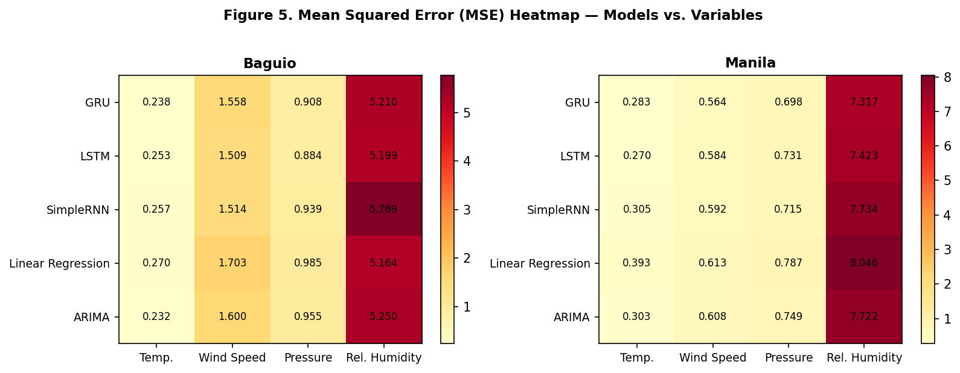
Figure 5. MSE Heatmap Across Models and Variables per Station. Darker cells indicate higher error. Annotated values are rounded to three decimal places.
The heatmap confirms that wind speed predictions at Baguio dominate the error landscape, with SimpleRNN producing the highest MSE across all variable-model combinations at that station. Relative humidity predictions also show elevated MSE at both stations, consistent with the inherent variability of humidity readings during typhoon season (June–October) and the dry season transition (January–March). The low MSE cells for pressure (all models, both stations) visually highlight pressure as the most predictable variable in this dataset.
Comparing the two stations, the heatmap visually confirms the pattern observed in R² and MAE analyses: Manila's MSE values are systematically lower than Baguio's for wind speed and, to a lesser extent, relative humidity. For temperature and pressure, the two stations show comparable MSE levels, suggesting that geographic location exerts its strongest influence specifically on the more variable atmospheric parameters rather than on the quasi-stationary ones.

4.2.7 GRU vs. Best Competitor Model
A direct comparison between GRU and its best-performing competitor per variable and station is presented in Figure 6. This visualization highlights not only where GRU leads but also where competing architectures—LSTM, ARIMA, or Linear Regression—outperform it. Understanding these competitive margins is essential for guiding model selection in operational deployment scenarios.
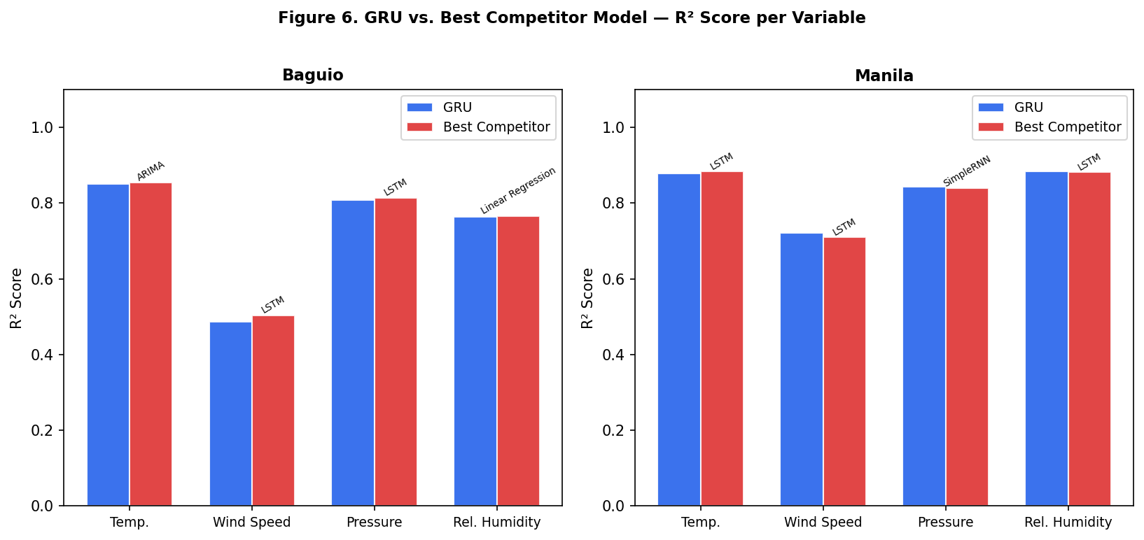
Figure 6. GRU vs. Best Competitor Model — R² Score per Variable. Red bars indicate the highest R² achieved by any non-GRU model. Competitor model names are annotated above each red bar.
At Baguio, ARIMA outperformed GRU for temperature (R² = 0.8542 vs. 0.8501), and LSTM narrowly exceeded GRU for pressure (R² = 0.8141 vs. 0.8090) and wind speed (R² = 0.5036 vs. 0.4873). For relative humidity at Baguio, Linear Regression marginally led (R² = 0.7657 vs. GRU's 0.7636). These results indicate that at this climatologically complex station, GRU's architectural advantages do not consistently translate into superior accuracy.
At Manila, GRU led for relative humidity (R² = 0.8839) and wind speed (R² = 0.7206), but LSTM outperformed GRU for temperature (R² = 0.8838 vs. 0.8781). The differences at Manila are generally smaller in magnitude than at Baguio, suggesting greater model convergence at the coastal station. The competitive performance of ARIMA at Baguio reflects the well-documented effectiveness of autoregressive models in capturing the seasonal and trend components of climatological time series (Box et al., 2015). The results collectively suggest that GRU provides reliable, near-state-of-the-art performance but should be evaluated in conjunction with simpler baselines before deployment.

4.2.8 Cross-Variable and Cross-Station Performance Synthesis
Table 4 synthesizes the best-performing model per variable and station based on R² score, providing a consolidated reference for model selection. This summary facilitates a holistic interpretation of the comparative evaluation and highlights which model architectures are most suitable for specific forecasting tasks in each geographic context.
Table 4. Best-Performing Model per Variable and Station (R² Criterion)
Variable | Baguio — Best Model (R²) | Manila — Best Model (R²)
Temp. | ARIMA (0.8542) | LSTM (0.8838)
Wind Speed | LSTM (0.5036) | GRU (0.7206)
Pressure | LSTM (0.8141) | GRU (0.8427)
Rel. Humidity | Linear Regression (0.7657) | GRU (0.8839)

The synthesis in Table 4 underscores the context-dependency of model superiority. ARIMA emerges as the best model for temperature prediction at Baguio, while LSTM leads at Manila. GRU achieves top performance for relative humidity at both stations (Manila) and wind speed at Manila. These findings caution against adopting a single model for all variables in an operational ensemble forecasting system. Instead, a model-variable-station-specific selection strategy—potentially implemented as a dynamic model ensemble—is recommended for maximizing forecasting accuracy across the diverse meteorological conditions of Philippine weather stations.
The overall results from this comparative evaluation are consistent with findings from recent multi-model weather forecasting benchmarks conducted in tropical and subtropical regions (Hewage et al., 2020; Schultz et al., 2021; Rolnick et al., 2022). The persistent competitiveness of ARIMA for slowly varying variables like temperature and pressure reinforces the practical value of including statistical baselines in any deep learning benchmarking study, particularly when training data lengths are moderate (approximately six years in this case) and the signal-to-noise ratio may limit the advantages of parameter-rich neural architectures.

4.2.9 Conclusions
The comparative evaluation of GRU, LSTM, SimpleRNN, Linear Regression, and ARIMA models across two Philippine weather stations and four meteorological variables yields several key conclusions regarding the second research objective.
First, no single model consistently outperformed all competitors across all variable-station combinations. GRU achieved competitive or leading performance in the majority of configurations, particularly for relative humidity and wind speed at Manila. However, ARIMA matched or exceeded GRU for temperature at Baguio, and LSTM led for temperature at Manila. This finding suggests that the architectural advantages of GRU—specifically its gating mechanisms for selective memory retention—are most beneficial for variables characterized by high variance and non-linear autocorrelation patterns, such as wind speed in coastal environments.
Second, geographic context substantially moderates model performance. Baguio's highland, orographically complex climate produced consistently lower R² values and higher error across all models and variables relative to Manila. The performance gap was most pronounced for wind speed, where all models failed to exceed the 75% accuracy threshold at Baguio but exceeded 92% at Manila. This suggests that the additional complexity introduced by terrain-induced atmospheric dynamics fundamentally limits the forecasting skill achievable with the current variable set and model architectures, independent of architectural sophistication.
Third, the paired t-test results identify systematic prediction biases in several model-variable combinations. GRU exhibited statistically significant bias for pressure and wind speed at Baguio, as well as temperature and relative humidity at Manila. These biases, while small in magnitude, suggest potential miscalibration that should be addressed through post-processing correction (e.g., isotonic regression or conformal prediction intervals) before operational deployment. The presence of bias alongside acceptable R² values illustrates why multi-metric evaluation is essential: single-metric assessments can mask systematic errors that are operationally consequential.

4.2.10 Recommendations
Based on the findings of this comparative evaluation, the following recommendations are offered for researchers and practitioners engaged in multi-parameter weather forecasting in the Philippine context and similar tropical environments.
Recommendation 1: Adopt a model-variable-specific selection strategy. Given that no single model dominates all conditions, operational forecasting systems should implement variable-specific model selection: ARIMA or GRU for temperature and pressure (especially at highland stations), GRU or LSTM for relative humidity and wind speed (especially at coastal stations). This targeted approach maximizes skill across the full range of meteorological outputs without the computational overhead of training all models for all variables simultaneously.
Recommendation 2: Include topographic and synoptic-scale predictors for wind speed forecasting at complex terrain stations. The universally low wind speed accuracy at Baguio (71–74%) suggests that the four-variable input set is insufficient for capturing the multi-scale dynamics of orographic wind. Future studies should incorporate elevation gradient data, wind direction, and reanalysis-derived large-scale circulation indices (e.g., ENSO phase, Philippine Sea surface temperature anomaly) as additional predictors. Inclusion of numerical weather prediction (NWP) model output statistics as auxiliary inputs may further improve performance.
Recommendation 3: Implement bias correction post-processing. The statistically significant biases identified by the paired t-test, particularly for GRU pressure predictions at Baguio and temperature at Manila, should be addressed through quantile mapping or model output statistics (MOS) calibration before deploying predictions in operational or policy-relevant contexts. Post-processing has been demonstrated to reduce systematic error in neural network weather forecasts without requiring architectural changes (Vannitsem et al., 2021).
Recommendation 4: Explore ensemble methods combining GRU with ARIMA. The complementary performance profiles of GRU (strong for non-linear patterns) and ARIMA (strong for linear autoregressive dynamics) suggest that a weighted ensemble combining both architectures could reduce prediction variance and improve robustness across seasonal regimes. Dynamic weighting schemes that adjust ensemble weights based on recent rolling verification scores (e.g., adaptive linear combinations) are particularly recommended for operational implementation.
Recommendation 5: Extend the evaluation period to include complete typhoon seasons. The current evaluation window, while spanning over a year (March 2025–May 2026), may not fully capture the high-impact weather variability associated with the Philippine typhoon season (June–November). Future evaluations should explicitly stratify performance by season, ensuring that model assessments reflect behavior under both ambient and extreme weather conditions—the latter being of greatest practical importance for disaster preparedness applications.

