The History of the Dental Profession
From Ancient Origins to Modern Day

 Introduction
- Dentistry is a profession which prides itself on being on the cutting edge of both scientific research and technology. We are taught always to look forward towards the next advancement. In fact, we are legally required to continue to take courses long after we graduate, so that we may refine our craft and deliver the best possible treatment to our patients. In The Prince, Machiavelli wrote that “Whoever wishes to foresee the future must consult the past; for human events ever resemble those of preceding times. This arises from the fact that they are produced by men who ever have been, and ever shall be, animated by the same passions, and thus they necessarily have the same results.”
- Students of the dental profession are gifted with the most up to date knowledge and advanced skills a member of this group has ever possessed. This gift is given to us by the countless lives who came before us who have suffered and toiled, and by the passion of those who chose to advance this craft. In order to see the future of where dentistry is going, we believe we must take time to learn about the past.
- Holding on to the past is often looked down upon in this profession. For example, modern dentists tend only to choose the more advanced material of composite resins over amalgam, which is often regarded as obsolete. An older dentist would be ridiculed for only using amalgam in his restorations and never learning how to place composites. However, there is a reason why we learn to work with amalgam in the sim lab before we work with composite. Even though it is a material of the past, it still has its applications and adds value to our compendium of techniques.
- We believe that not enough of our education is spent studying and honoring the past, and that is the purpose of this literature-based research paper. As a dental student, my aim is to provide my colleagues with an opportunity to enjoy the history of those who came before us so that we can know who to thank for giving us this gift.
- A profession is defined by Merriam Webster as “a calling requiring specialized knowledge and often long and intensive academic preparation.” Dentistry is one of the oldest professions to be developed. Some people may believe that the origins of this profession began with the barber surgeons of the middle ages. However, this is a misconception; the reality is that our history began much earlier than that. Ever since there have been humans, there have been problems with our teeth, and we have been figuring out ways to alleviate them. The idea that there were people specializing in the healing of the teeth and oral diseases has roots to ancient prehistory and a long and fascinating saga.
? this history is divided into five stages:
- -Ancient pre-history - Origins
- -Middle ages to Renaissance – Early Beginnings
- -Colonial Period in America – The Development of the Profession
- -19th Century - Advancements in Organization and Education
- -Late 19th Century to Modern Day – Innovations in Techniques and Technology
- In this research paper we will explore some of the earliest known evidence of dental treatment and travel through time discussing important figures who made vital contributions toward the development of this profession.
- While other sources and research articles were also referenced, much of the information from this paper comes from a great book given to me by my mentor Dr. Jack Saroyan. The book Dentistry: a Historical Perspective: Being a Historical Account of the History of Dentistry from
- Ancient Times, with Emphasis upon the United States from the Colonial to the Present Period, by Milton Asbell, goes into much more detail than we were able to and is recommended reading for anyone who wants to learn more Any information not otherwise directly cited comes from this text.
Ancient Pre-history – Origins
- Our knowledge of dentistry having been performed in ancient societies comes mainly from archeological findings and historic records. Studying the dentition of human remains from archaeological excavations gives researchers important insights into their diet as well as a variety of social and cultural factors.
- Prior to the development of agricultural societies, tooth decay was not a common issue for ancient humans, though dental caries did exist and is not a condition exclusive to humans. The arrival of farming introduced a more varied diet and increase in carbohydrate intake, such as refined sugar and white flour. This directly correlated with an increase in the incidence of dental caries and tooth decay.
- Humans came up with sophisticated solutions to these problems shortly after. Archaeologists have made discoveries in sites around the world that show evidence of pre-historic teeth being scraped, cleaned, and even drilled and filled to remove decayed tissue. There were also findings of paleolithic era jaw bones showing evidence of tooth and bone removal. It is theorized that this was accomplished with a sharp wooden stake and a rock for the mallet. One of the earliest known examples of the attempted treatment of tooth disease is seen in an infected tooth discovered in Italy, which showed carved grooves, evidence of being caries scraped away with flint tools around 14,000 years ago.
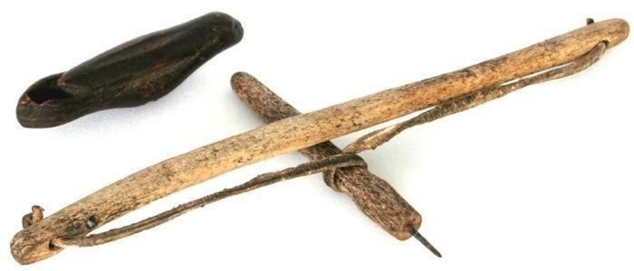
- The ability to treat these conditions improved with a technological advancement – the dental drill. It is believed to have been first developed around 9,000 years ago. An interesting way to look at this is that the dental drill predates civilization, writing, and even the invention of the wheel by thousands of years. Some skilled individual must have wielded that drill, making them one of the first dentists.
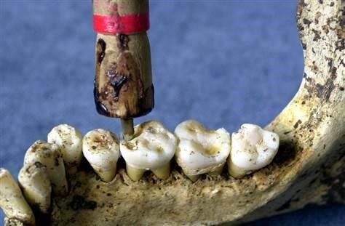
- Researchers in Pakistan discovered a Neolithic period graveyard where at least 9 early humans showed evidence of having dental procedures performed on their teeth using a flint tipped wooden bow drill. All of them had molars with very precise holes, 1 to 3 mm in diameter, drilled into their biting surfaces. Those 9 sufferers of dental pain would have been among the first dental patients.
- The first known dental filling was made from beeswax, and evidence of this dates back to 6500 years ago from a site located in Slovenia. Beeswax made an excellent ancient filling material because it had antibacterial and anti-inflammatory properties. It also could be softened at warm temperatures but solidified at body temperature.
- Throughout the millennia we have seen evidence that the practice of dentistry played an important role in society. Sumerian civilization in Mesopotamia around 3000 BCE had ornately decorated gold toothpicks, which reflected how high a value was placed on oral hygiene. The Code of Hammurabi, dated to around 1754 BCE, showed that the Babylonian civilization also placed an important value on oral hygiene, with the popular phrase “An eye for an eye, a tooth for a tooth.”
- ?Around that time, the Babylonians developed a theory on what caused toothaches – the tooth worm. Records show the first mention of the tooth worm dates to 1800 BCE. A cuneiform tablet from the seventh century BCE titled “The Legend of the Worm” tells the tale of the tooth worm, a demon which drinks the blood and eats the roots of the teeth, causing toothaches and periodontitis. The belief that worms lived inside of the teeth eating them away was echoed by many civilizations from the Mayans to the Chinese and persisted until the 18th century, showing the superstitious roots of dentistry and medicine. There were various methods people used to eradicate these tooth worms ranging from fumigation, concoctions, magical charms, and chants.
- The first dentist whose name we know was HesyRe, an ancient Egyptian from the third dynasty. He was known as Wer-ibeh-senjw, meaning either "Great one of the ivory cutters" or "Great one of the dentists."
- In ancient Egypt medicine was divided by specialized practitioners who dealt with specific areas and conditions, rather than the body as a whole.
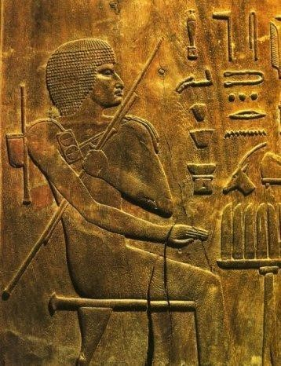
- This civilization was the first to have specialized members of society dedicated to the treatment of oral health.
- They called these people the “Toothers,” the treaters of teeth. These were specialists who engaged in surgical procedures as opposed to physicians who were concerned with the creation of medicines. This marks the separation of dentistry from medicine as a surgical based practice.
- The extent of their knowledge is described in the Edwin Smith Surgical Papyrus, dated 1700 BCE, and the Ebers papyrus dated 1550 BCE.
- The former describes surgical case histories and techniques, one example is the treatment of the dislocation of a mandible.
- The latter artifact details several dental and gingival disorders and offers treatments and remedies for them.
- These ancient dentists developed scaling instruments that closely resemble scalers today in shape and function, and they invented the first toothpaste incorporating rock salt, black pepper, flowers, and mint.
- They also developed sophisticated techniques, as seen in the discovery of a mandible, dated around 2500 BCE, with two holes drilled into it near the roots of the first molar. They bored these holes to relieve an abscess, one of the first dental surgical procedures ever.
- The ancient Egyptians also exhibited some of earliest bridgework, securing teeth with gold and silver wire.
- These techniques were also exhibited by the neighboring Phoenicians, who were wealthy tradesmen.
- Archaeologic specimens from around 2000 years ago show advanced bridge work where triple-threaded gold wire was used to intertwine and bind anterior teeth, which had their roots removed, to neighboring abutments.
- The Hebrews intertwined their practice of medicine with their religious beliefs. They regarded health and disease as coming from the divine source of God.
- At this time, dentistry was under the umbrella of general medicine and did not have a separate system.
- Their understandings were also influenced by surrounding civilizations, as the ancient Israelites believed in the tooth worm theory of Babylonian origins.
- The Talmud was the central religious text as well as an encyclopedic account of their history.
- It discusses tooth conditions and oral pathologies extensively and their remedies. The extraction of teeth was considered a last resort and heavily discouraged
- The ancient Greeks had priest/physicans who performed medical duties and combined their knowledge of healing with their religious beliefs.
- Often times their approach to dental care involved simply praying to the gods and hoping for the best.
- One of the pioneers of medicine was Hippocrates who lived from 460 to 377 BCE. He was the first to separate medicine from religion and gathered a comprehensive collection of medical observation and techniques known as the Corpus Hippocraticum.
- The Hippocratic oath, one of the earliest examples of medical ethics that is still used today, is attributed to him and dedicated to his contributions. His texts contained several references to teeth gums and jaws including the eruption pattern of teeth, treating decayed teeth and gum disease, extracting teeth with forceps, and using wires to stabilize loose teeth and fractured jaws.
- Aristotle, who lived from 384 to 322 BCE also had significant contribution towards the medical field, including his study of teeth in his comparative anatomy. He had an advanced understanding of dental diseases, correctly attributing dental caries to sweet foods like figs. This was an important step in developing prevention.
- The physicians of classical Greece possessed a wide body of knowledge and preferred to treat conditions with drugs and medicines rather than surgery.
- Surgical skills were far more developed amongst the barbers, who played an important and prominent role in society and often removed teeth as part of their services.
- They had the tools and hand skills to perform more complex procedures.
- While highly esteemed physicians practiced dentistry in classical Greece, their cities were also plagued with quacks and charlatans who took advantage of the common peoples’ superstitions by selling charms, amulets, and incantations.
- They traveled from place to place and pretended to heal, a problem that would follow dentistry throughout the centuries.
- ? The neighboring Etruscans from the Italian peninsula had a long history of developing advanced dental techniques. There is evidence of practices such as tooth removal and replacement using fixtures made from gold bands with real teeth bound in them. These people also figured out how to seal exposed nerves to protect the teeth.
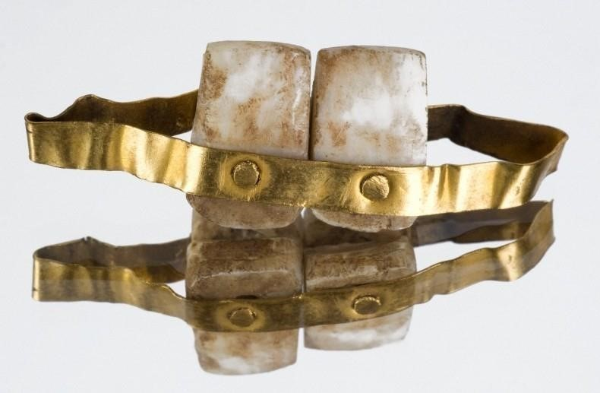
- The Romans replaced the Etruscans, but they continued their developments in dentistry and turned it into a profession. Manuscripts from this period describe many dental advancements. Claudius Galen who lived in the second century CE, discovered that teeth were comprised of bone with nerves inside rather than worms. There is evidence in the Roman Forum that highly skilled dental practices which also had pain relief medicines existed amongst the shops and market stalls.
- Dentistry did not only occur in the Western world; it has its own roots in ancient Chinese civilization as well.
- They had been practicing dentistry since 7000 BC, using wires to stabilize teeth and performing routine extractions.
- The first three emperors of China also practiced the arts of healing. Likely the first Chinese to study oral diseases was Huang Ti, emperor during 2698 BCE.
- He developed the methods of diagnosis and divided oral diseases into three categories: fong ya or inflammatory conditions, ya kan or diseases of soft tissue, and chong ya or dental decay. He is believed to have introduced the popularization of the toothpick. Some of the therapies that the ancient Chinese used for dental issues included crushed garlic pills, animal bones and excrement, herbs, and acupuncture.
- They also developed the first amalgam fillings during the Tang Dynasty. They combined tin and silver, according to medical texts written by Su Kung in 659 AD. The Chinese were experts in dentistry by the time Li Yuan became Emperor, though. They also developed acupuncture as a form of therapy.
- As previously mentioned, evidence shows dentistry had also been practiced in the Indus Valley for thousands of years.
- In ancient India, the practice of dentistry can be traced back to the sixth century BCE when a famous ancient surgeon Susruta compiled a work known as the Susruta Samhita which discussed dental techniques.
- The most ancient Hindu scriptures, known as the Vedas, contain the history of the ancient Indian Civilization, and also their medical system. The Ayurveda discussed at length the subject of teeth and oral diseases.
- In the Americas, the native people of the Americas had a rich history of dental tradition as well. These societies, much like other ancient societies had their medical practice governed by superstition and religious beliefs.
- They believed that illness was a result of evil sorcery, not natural causes, and thus the means of curing illnesses was counter magic. They also used herbs and remedies, for example the Aztecs chewed on chili pepper to relieve toothaches. The Incas in Peru chewed on coca leaves to numb a painful area, the predecessor to modern anesthetics.
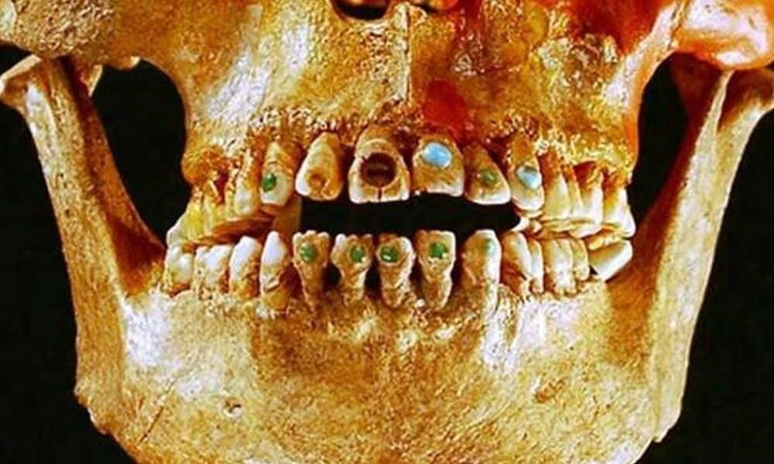
- The Mayans employed sophisticated techniques to file their teeth and inlay jewels into the surfaces. Interestingly, they did this purely for esthetic reasons, rather than to eliminate dental diseases. They also had dental implants made from seashells and advanced gold inlays.
Middle Ages to Renaissance – Early Beginnings
- The Roman civilization contributed greatly to the progress of dentistry, however following the breakup of the Roman Empire in 476 AD there was a great change in European society. During the middle ages, dentistry much like all of medicine was an amalgam of science, sorcery, superstition, and dogma. Life in general was dominated by the authority of the Church and people turned towards a more spiritual concept of life. Tooth extraction became the dominant treatment as other methods were ineffective.
Life itself was hazardous and little attention was payed to oral health. After the fall of the Roman Empire, barbarian tribes took over and Northern Europe experienced an era of magic and mysticism, where miracles and spells dominated, not experiments and observation.
- This was not the case in all areas of the world, as scientific medicine and dentistry were carried forward by Arabic society. They derived their understanding from the continuation of Greek tradition and contributed vast developments to the field in terms of understanding of anatomy and physiology. This Islamic golden age of science was instrumental for the later renaissance that would occur in Europe where science started to take over and the wisdom of the Greek and Arabic physicians was more appreciated.
- From the 1300s to the 1600s, a revolution of scientific thought and a movement away from church dogma began in Venice, Florence, Rome and spread throughout Europe. This period was known as the Renaissance and involved a revitalization and progression of the dental profession. Previously the Church forbade any sort of dissection. As this ban was lifted, or subverted, so began our understanding of musculature, blood supply, oral and dental anatomy, and nerves. Just as Michelangelo and Da Vinci used this knowledge to create more beautiful paintings, dentists used this knowledge to better treat dental diseases.
- While there were specialized groups of people who conducted dental procedures, dentistry itself was not a profession during the middle ages. It was often performed under the umbrella of general medicine by physicians, continuing the tradition of classical Greece. However, dentistry was also performed by barbers in China and France; they had the dexterity and tools, and their patients were already in the chair. Barbers were mainly limited in performing extractions to alleviate pain and clear up tooth infections, but their skills and training improved over time.
- In 1210 a Guild of Barbers was established in France, where barbers eventually evolved into two groups: trained surgeons who performed complex medical operations, and lay barbers who performed routine hygiene and extractions.
- Guy de Chauliac was the most famous French surgeon of the fourteenth century. He detailed his techniques and invented the dental pelican, an instrument used to perform extractions that was the predecessor to modern forceps. However, he also was still a proponent of the ancient tooth worm theory.
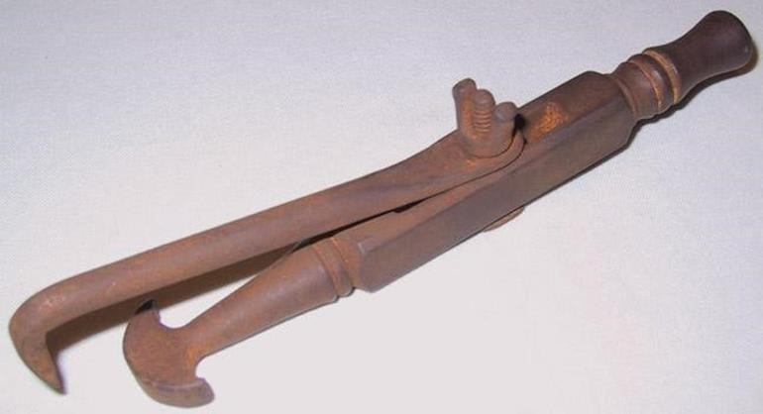
- The invention of the printing press put an end to the Church’s monopoly on learning, and information was able to spread among the people giving them a power they never had before. The progress made in the fields of biology, anatomy, physiology, pathology, and surgery was brought to the forefront and directly exhibited the spirit of this era.
- Several medical texts were produced during this period which included sections on dentistry. The first book dedicated entirely to the practice of dentistry was published in 1530 in Germany, titled Artzney Buchlein or “The Little Medicinal Book for All Kinds of Diseases and Infirmities of the Teeth”. This text was instrumental for uneducated barber-surgeons to treat the mouth. Topics covered included oral hygiene, tooth extraction, drilling teeth, and placement of gold fillings.
- The type of dentistry being practiced at this time was derived solely from scientific and professional achievement, not from superstitions or quackery. There were a variety of types of practitioners, but they had a specialized training and a body of knowledge which required intensive academic preparation.
- The profession as we now know it really owes itself to the work of Pierre Fauchard, who lived from 1678 to 1761. Fauchard is known as the father of modern dentistry because his work turned dentistry from a craft into a profession. He wrote the first complete scientific description of dentistry in 1723 called Le Chirurgien Dentiste or "The Surgeon Dentist". This text described oral anatomy, function, oral pathology, operative methods for decay removal, restorative techniques, periodontal disease, orthodontics, endodontics, and replacement of missing teeth. He compiled all the dental knowledge and techniques that from up until that time and determined what worked and didn’t work. He also disproved the tooth worm theory with his microscopic observations and proposed that the cause of dental caries was sugar, suggesting that its consumption should be limited. Fauchard debunked and openly disapproved charlatans and strived to move dentistry away from this towards scientific reasoning to present a trustworthy front to the public.
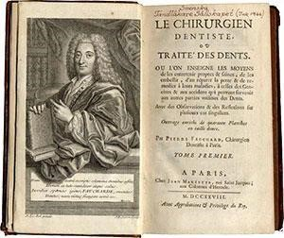
- Fauchard’s philosophy was that dental knowledge should be open to those qualified to practice and he rejected the practice of selfishness and secrecy. He outlined the way which the profession would evolve, through education, organization, research, and literature. His philosophy inspired many others to publish their knowledge and experience, and many books by other qualified surgeon dentists followed. This advanced dentistry greatly and set the framework for growth of the profession.
Colonial Period – The Development of the Profession
- Dentistry continued to grow in Europe, with an explosion of literature and innovations. Dentistry was starting to take its modern form. The development of dentistry in America took place in stages. First with the migration of the dental craft, then with the migration of specialized trained practitioners. The development of dental education followed, and finally the regulation of the practice and ultimately, the development of the profession as we know it today.
- As colonists began to migrate from Europe to America, they brought their trades, skills, and traditions with them. In terms of dentistry many brought their home remedies and superstitions with them, but some brought their skills and knowledge of the practice of dentistry. Barber surgeons and tooth pullers came with the early settlers and began to establish their trade to suit the needs of the growing settlements and colonies.
- Next came the migration of surgeon dentists and trained dental operators, who gained their skills from apprenticeships and learning institutions in Europe. In 1760 John Baker immigrated to America from England, becoming the earliest medically trained dentist to practice in America. These practitioners also served as teachers to the next generation. As America grew, its native sons began to take over the profession. Isaac Greenwood was an example, as he was the first nativeborn American dentist. He also had several children who went on to establish their own dental practices.
- John Greenwood, one son of Isaac Greenwood, created some of the most famous and interesting examples of early American dentistry as the dentist to our nation’s first president, George Washington. Washington was plagued all his life with dental issues, and had several dentists attempt to alleviate his problems.
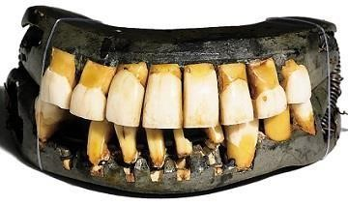
- The legend says that Washington had wooden teeth, but the reality is that he had complex dentures fabricated from metal, bone, ivory. Greenwood created 4 sets of dentures for Washington. He had two styles created, a set of aesthetic and speaking teeth, and a set of functional eating teeth with a heavy metal framework which incorporated springs.
- Another notable figure was Paul Revere, a well-known patriot and part-time dentist. Before Paul Revere became famous as a messenger, he studied dentistry with Baker. He learned how to create ivory dentures and eventually opened his own dentistry practice. In fact, Revere is known as the first to practice dental forensics, as he was able to identify the remains of an individual based on recognition of the dental appliance which he constructed for the man.
- As this nation developed itself and sought to establish its independence, so did the profession of dentistry. Dentistry began to emerge as an autonomous health care profession, rather than just a branch of medicine. Unlike medicine at the time, which relied on European influence for leadership, American dentistry adapted European principles and developed its own direction.
19th century - Advancements in Organization and Education
- The next chapter for the dental profession involved the development of dental education, including dental societies and dental literature. One of the most important achievements was the discrediting of untrained charlatans and quacks and the emergence of modern evidence-based dentistry.
- This time also saw a rapid increase in the prevalence of dental caries due to the availability and overuse of cane sugar. There was a strong movement towards public education and informing the public of the importance of their oral health, and dentists were needed more than ever. This reinforced in the public, and within the profession, that dentistry was practiced by those who possessed skill, scientific knowledge, and altruistic concern. During this time regulation was also established and licensure was created. In 1841 Alabama enacted the first dental practice act, regulating who could and could not practice dentistry in the United States.
- Organization was a central pillar towards the advancement and legitimization of the profession. Horace H. Hayden proposed the idea of a dental society as early as 1817 and gained enough influence to achieve that dream in 1834. He was the founder and first president of the Society of Surgeon Dentists of the City and State of New York. It was comprised of medically trained practitioners who considered themselves surgeon dentists. The first national dental society was founded in 1840 and was called the American Society of Dental Surgeons. This society founded the first dental journal, The American Journal of Dental Science. Satellite societies began to pop up in various cities and perform as regional branches.
- Ultimately a dental convention was held in 1859 where 26 dentists met in Niagara Falls, New York and created the American Dental Association. This national organization was established to represent dentists, create a set of standards of practice, declare research as an important part of practice, encourage regional organizations, and develop a guideline of ethical principles to deal with the commercial aspects of dentistry.
- Hayden would make another huge contribution to the dental profession: the establishment of an independent school. During this time, practicing dentists had received their qualifications from medical schools, where dentistry was part of the curriculum, but gained their skills through apprenticeship. Hayden and Chapin Harris believed that this education was insufficient for the specialty of medicine. They founded the world’s first independent dental school, the Baltimore College of Dental Surgery in
1840 and established the DDS degree. They based their curriculum on Fauchard’s teachings. This school later merged with the University of Maryland in 1923 and is still active.
- Several schools followed suit, establishing dental programs, and offering the DDS and Doctor of Medicine in Dentistry, or DMD, degree. One amazing program, which I would like to discuss, has its roots in 1896 as the
College of Physicians and Surgeons. This school was founded in San Francisco at 818 Howard Street, and offered programs in dentistry, medicine, and pharmacy. In 1918, P&S reorganized and chose to focus solely on dentistry, eliminating its medical and pharmacy programs. In 1942, in response the high demand for dentists to serve in World War II, the school chose to reorganize into a four quarter, year-round, three-year program. It continues to be the only American dental school which offers such an accelerated program.
- Outgrowing its facility, the school looked to expand at a new location. 6 graduates purchased the proprietary school and created a not for profit institution with the future intent of becoming a graduate school of an existing university. In 1962, the program was adopted by the University of the Pacific and became the UOP School of Dentistry. Shortly after, it moved to the 2155 Webster Street location in 1967. In 2004, the school was renamed to the Arthur A. Dugoni School of Dentistry in honor of its longstanding dean, who served for 28 years. He also graduated from the school in 1948. In 2015, the school changed locations to its current home, a beautiful and modern facility on 155 5th street, right next to its original location.
- Other notable pioneers are important to discuss. The first woman to practice dentistry in the United States was named Emeline Roberts Jones, who assisted her dentist husband in 1855 and later had her own career as a dentist. Lucy Hobbs Taylor was the first woman to graduate from a dental school in 1866.
- Robert Tanner Freeman was the first African-American to earn a dental degree, graduating from Harvard University Dental School in 1869. His classmate George Franklin Grant graduated shortly after and went on to become the first African-American dental educator, joining the faculty at Harvard University. These men paved the way for the end of segregation and discrimination in dentistry as well as the increase in the delivery of dental care to African-American communities.
- For a long time, the field of dentistry was totally dominated by men, but in 1885 dentist C. Edmond Kells, started the trend of hiring a full time female dental assistant, Malvina Cueria. Her duties include chair-side assisting, instrument sterilization, and front office work like scheduling and bookkeeping. This development resulted in an influx of women to the practice who were now able to seek safe dental treatment in the presence of women. This enhanced the delivery of dental care to women in communities and offered women more opportunity to have careers.
- The expansion of dental auxiliary personnel was another crucial step in the ability to provide better dental care to the public. The dentist, the dental assistant, the dental hygienist, and the laboratory technician all worked together to provide a team approach towards dental practice.
- Since Kells’ introduction of the female dental assistant, the role expanded and began to incorporate training and regulation. In 1907 the first College of Dental Assistants formed in Kansas City, and in 1911 the Ohio College of Dental Surgery began offering courses for dental assistants. The first dental assistant association was founded by Juliette Southard in 1923.
- As oral hygiene and prophylaxis become more apparent towards prevention of dental diseases, a dedicated position known as the dental hygienist was introduced. In 1907, Irene Newman was the first hygienist, responsible for the polishing of teeth and preventative care of the mouth. This sparked the first schools of dental hygiene which were established in 1913. States began legalizing dental hygienists and modifying the dental practice act to regulate the role. The American Dental Hygienist association also formed in 1923 and by the 1940’s, over 5,000 dental hygienists were registered. The establishment of a respectable female-led occupation was invaluable to the expansion of women’s rights and the advancement of the women’s movement in general.
Late 19th century to modern day – Innovations in Techniques and Technology
- The past 150 years have seen a large growth in public demand for dental care. Post industrial revolution advancements in technology helped the profession grow to meet that demand. Dentists began to concentrate on getting rid of pain and on prevention rather than reparation, while technological innovations and research continued to develop the dentist’s arsenal.
- There were several prominent figures during this period who made countless amazing innovations that are still used today. We are thankful for these amazing contributors to the field, who broke down barriers and introduced innovations that were indispensable.
- One individual who we know well is Greene Vardiman Black, who lived from 1836 to 1915. He is known as the father of operative dentistry and performed monumental work on amalgam alloy, cavity standardization, and preparation design. He developed the first classification system for caries lesions, which we still use today. His Manual of Operative Dentistry was published in 1896 and included vast amounts of innovative knowledge, it is considered a standard even today. He dreamed of a day when dentistry is practiced for prevention rather than restoration.
- Black’s techniques would never have been possible without a major technological advancement. The dental drill was a major breakthrough in the role of preventative dentistry, allowing for the early intervention of caries and prevention of total loss of the tooth. As mentioned previously, the dental drill has roots to prehistoric times, but the industrial revolution allowed for complex machinery to take over. George F. Green created the foot pedal powered pneumatic drill in 1868, which increased the speed and precision which infected tissue could be removed. He continued to innovate and developed and patented the electric powered drill in 1875.
- Another interesting development in dentistry was the introduction of anesthesia. This innovation ushered in the era of painless dentistry and made the practice much more acceptable to the general public. Humpfry Davey was the first to discover the fascinating effects of Nitrous Oxide, coin it as “laughing gas” in 1799. He theorized on its potential medical use, but it was mainly used as a recreationally by the British upper class at parties. In a public demonstration, which was more like an entertainment show, by Gardner Quincy Colton in 1844, an audience volunteer accidentally bumped his leg and did not feel any pain.
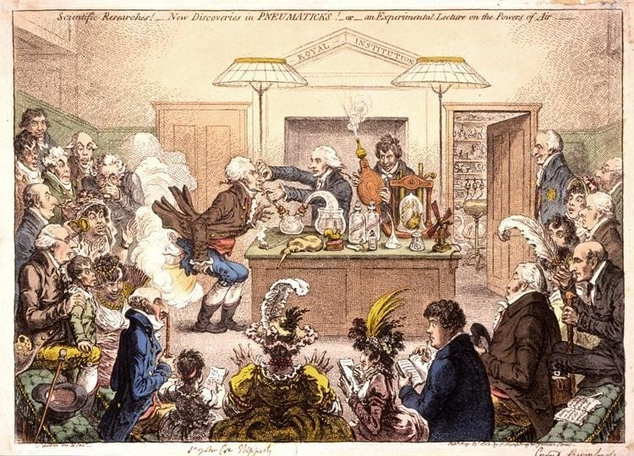
- Horace Wells, a dentist in attendance, recognized the potential for the use in dental surgery and began to advocate on its behalf, transforming the field of dentistry. Wells even volunteered himself to be the first patient to have his tooth extracted while under the gas. Unfortunately, his early demonstrations were unsuccessful, and it took a while for NO to catch on (16). Willian Morton, an associate of Wells, did the same by demonstrating the effectiveness of Ether as an inhaled anesthetic in 1846. His demonstrations were successful and widely publicized. The two men would clash over who really introduced anesthesia to the medical world, but both are considered innovators in their own right.
- Later William Halstead, MD would discover the effectiveness of cocaine solutions, or hydrocaine, as a local anesthetic in medical surgery. This would set the framework for the nonpsychoactive derivatives which would be developed such as novocaine in 1904 and later lidocaine in 1943, which is still used. Subsequent patients were incredibly grateful. Up until this point, for thousands of years of history, a dental visit was an excruciating and dreaded experience.
- It is interesting to note that this vital innovation in surgery originated in dentistry and was given to the field of medicine. Another innovation which dentistry contributed to medicine was the use of suction devices. Prior to this, medical surgeons just used sponges and gauze to remove blood from the surgical site and improve visibility. Suction made this task much easier for the surgeon and safer for the patient.
- A unique and polarizing figure during the history of dental anesthesia was a dentist from the early 1900s named Edgar Randolph Parker, which he would later legally change to Painless Parker. He started as a struggling dentist, but he enhanced his career by performing large public shows, which were like a traveling circus complete with dancers and a large band. He would use hydrocaine to painlessly extract patients’ teeth and astonish and entertain audiences. He claimed to have extracted 357 teeth in one day and was often seen wearing a necklace of human teeth, even carrying a bucket filled with them. He turned his success into a thriving chain of dental offices and originated the concept of the modern group practice.
- Parker’s flamboyancy and showmanship were scorned by the greater dental community, he was even referred to as "a menace to the dignity of the profession" by the American Dental Association. Even though his dentistry was sound, he was likened to the traveling charlatans which the profession tried so hard to get away from. However, he did popularize dentistry, convince the public to care for their teeth, increased access to dental care, and advocated for advertising rights for dentists.
- Another amazing technological innovation was the discovery of the x-ray by Wilhelm Roentgen and development of the radiograph in 1895. While the first radiograph was taken of Roentgen’s wife’s hand, dentists were the first to recognize the amazing potential of this new technology.
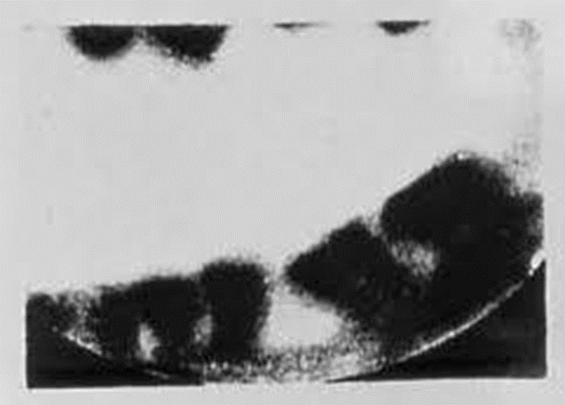
- Otto Walkhoff was the first dentist to take a radiograph of his tooth only 14 days later. Edmond Kells not only employed the first dental assistant, but he was the first to begin using xrays to visualize the roots of the teeth in his practice 1896 He unfortunately died as a result of overexposure and subsequently much work was done to safely implement the use of radiographs in dentistry and in medicine. In the early 20th century, radiographs quickly became a staple of most dental offices and an indispensable aid to detection, diagnosis, and treatment.
- The introduction of fluoride as a weapon in the fight against cavities brought dentistry into the forefront of public health around the world and solidified the value of the profession in the eyes of the public. It began with an observation in 1907 as Frederick McKay investigated into a common brown stain on the teeth of his patients in Colorado Springs. He collaborated his research with GV Black and discovered that high levels of fluoride in the water supply were creating this brown staining, and that these teeth were also uniquely resistant to caries.
- Further research into the relationship between caries and fluoride was conducted by H.
- Trendly Dean in the 1930’s. The research of Henry Klein revealed that safe levels of fluoride in drinking water, around 1 part per million, did not cause fluorosis and was actually beneficial to teeth. This had great significance for public health and Dean proposed that a widescale test be done. In 1945 the city of Grand Rapids, Michigan became the first city in the world to artificially fluoridate its drinking water. Analysis of the teeth of its school children over the following years yielded amazing results as there was a 60% reduction in the incidence of dental caries.
- Another central step in the advancement of the dental profession was the introduction of specialization within the field. Edward H. Angle was the first to devote his practice solely to orthodontics, or the study and treatment related to the positioning of the jaws and teeth. His classification of jaw relationship and tooth position is still used today. Angle essentially started the first dental specialty in 1900 by founding the first postgraduate school for dentists. He also organized the American Society of Orthodontists, which established its own publication journal in 1915.
- The first specialty-certifying agency in dentistry was the American Board of Orthodontics in 1929. In 1918, oral surgery and periodontics, or the treatment of the gums, were established as their own specialties. Pedodontics, or the treatment of children and adolescents, followed in 1927, then dental public health in 1937, oral pathology in 1946, and endodontics in 1959. Currently there are 12 dental specialties in addition to the practice of general dentistry. This degree of specialization allows dentists to treat a wider variety and intensity of conditions.
- Dentistry has continued to grow through an explosion of technological advancements in recent times. There are too many to fully cover, but there are some notable instances. In 1957, John Borden introduced the high-speed air driven handpiece which was able to reach speeds of 300,000 rpm and launched the new era of high-speed dentistry. In 1962, Rafael bowen developed BisGMA, the modern acrylic resin complex that is used in composite resin restorations, a landmark for modern cosmetic dentistry. In the 1970’s and 80’s, Per-Ingvar Branemark developed his techniques for the osseointegration of titanium implants and revolutionized the treatment for the replacement of missing teeth.
- In 1989, the first commercial tooth bleaching product was developed. Dr. Bill Dorfman, an alumnus of UOP class of ‘83, was an early adopter and developed and marketed the Zoom whitening system, bringing cosmetic dentistry within public reach. There is actually an interesting history of teeth bleaching showing there has always been a demand for white teeth and a price people were willing to pay for beauty. Ancient remedies included pumice, vinegar, and even urine. In the 1700s, barbers filed teeth surfaces and applied nitric acid, then in the 1800s dentists used oxalic acid, causing extensive tooth damage in the process. In 1918 it was discovered that a heated lamp and hydrogen peroxide would lighten teeth, and in the 1960’s carbamide peroxide was introduced and is still used today.
- In the early 1990’s enhancements in tooth colored composite and porcelain materials, porcelain veneers, and dental implants expanded on this trend, launching the new era satisfying the public demand for cosmetic and esthetic dentistry.
- One of the most exciting recent developments for the field of dentistry is the use of Silver Diamine Fluoride, or SDF. This topical treatment developed in 1972 in Japan, has the amazing property of being able to stop caries from developing and strengthening already affected tooth structure (23). It has been used around the world for decades and has more recently become implemented in the United States. This innovation has the potential to transform preventative dentistry as we know it.
- In the digital age, dentistry has been completely revolutionized. Access to databases of research has ushered in the movement of evidence-based dentistry. Digital radiographs and recordkeeping have streamlined patient care. Tele-dentistry and introduction of new legislature has evolved the level of public service and has expanded care to underserved populations. The advent of modern group practices has changed the business structure and allowed practitioners to focus more on treatment than running a business, facilitating interdisciplinary collaborative treatment.

