

Contents

Storyboard 2

Login 3

Page1 – Home page 3

Page2 – View Data 4

Page3 – View Graph 5

Prototype 5

# Storyboard

The application works as follows. The user will need a login given to them to access the application. Once the login is successful, then they will be able to start using the application. The first screen the user will be presented with is the home screen which would give information about the application is the user. From there, they can navigate between home, data and the graph pages.

## Login

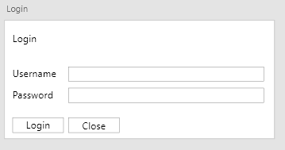

Simple login screen. A successful login will send the user to the home screen. Unsuccessful login should present a prompt saying “unsuccessful login” and the user will be returned to the login screen. The close button will close the application.

|  |  |
| --- | --- |
| Name | Type |
| Username Text | Text |
| Password Text | Text |
| Input Username | InputText |
| Input Password | InputText |
| Login Button | Button |
| Close Button | Button |
|  |  |

## Page1 – Home page

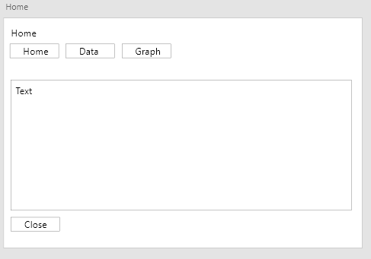

The home screen is the first screen the user will be presented with after a successful login. This screen is to greet users and will have a list of things that the application is capable of doing. It has a navigation system up the top with the title of the screen. Home will take you to the home screen, data will take you to the input data screen and the graph button will take you to the graph screen.

|  |  |
| --- | --- |
| Name | Type |
| Home Text | Text |
|  |  |

## Page2 – View Data

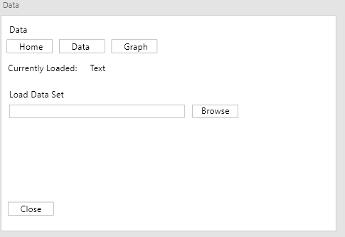

The Data page is where you can upload your data set to the application. It has a navigation system up the top with the title of the screen. Home will take you to the home screen, data will take you to the input data screen and the graph button will take you to the graph screen.

|  |  |
| --- | --- |
| Name | Type |
| Current Data Loaded Text | Text |
| Load Data Text | Text |
| Input Text for Data | InputText |
| Folder Browse Button | FolderBrowse |
|  |  |

## Page3 – View Graph

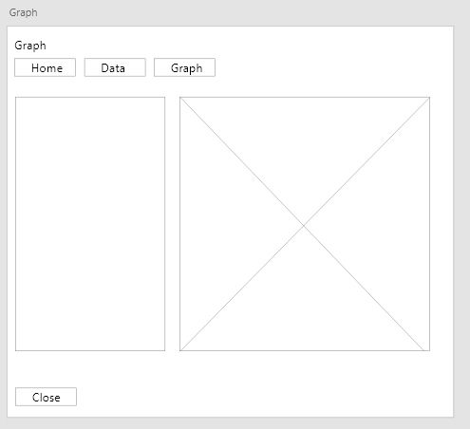

The graph screen is where you will be able to view the graph from the data set that you have selected. It has a navigation system up the top with the title of the screen. Home will take you to the home screen, data will take you to the input data screen and the graph button will take you to the graph screen.

|  |  |
| --- | --- |
| Name | Type |
| List box | Listbox |
| Seperator | VSeperator |
| Graph | Graph |
| Pan | Button |
| Zoom In | Button |
| Zoom Out | Button |
|  |  |

# Prototype

https://github.com/EzekielBrown/SDV602-EzekielBrown