CMPG325 – COMPUTER NETWORKS
MILESTONE 2
FINAL IMPLEMENTATION, TESTING AND VERIFICATION REPORT
Ramokoka & Partners Attorneys – Vryburg

Project Information | Details
Student | MOLEKWA, ER
Student Number | 45618070
Project ID | CMPG325-2026-082
Client ID | CLI-082
Industry | Legal Services
Implementation Platform | Cisco Packet Tracer
Assigned IPv4 Block | 172.30.52.0/23
Assigned Challenge | ACL Traffic Filtering

Milestone 2 focuses on the working implementation, testing evidence, troubleshooting and final verification of the approved Milestone 1 design.

Table of Contents
Section | Page
Cover Page | 1
Table of Contents | 2
1. Introduction | 3
2. Milestone 2 Objectives | 3
3. Network Implementation Overview | 3–4
3.1 Implemented Devices | 4
4. VLAN and Switching Implementation | 4–6
4.1 Trunk and Access Design | 6
5. IP Addressing and Routing Implementation | 6–8
5.1 Inter-VLAN Routing | 8
6. DHCP Implementation | 9–10
7. Public Wireless Implementation | 10–11
7.1 Wireless Device Adaptation | 11
8. ACL Traffic-Filtering Policy | 12–13
9. Connectivity and ACL Testing | 13
9.1 Staff Connectivity Test | 13–14
9.2 Public Client Upstream Test | 14
9.3 Public Client Internal-Denial Tests | 15
9.4 ACL Counter Verification | 15
10. Troubleshooting and Configuration Issues | 15–17
11. Final Implementation Verification | 17–18
12. Change Request CR6 – Future Branch Accommodation | 18
13. Evidence and GitHub Portfolio | 19
14. Conclusion | 19
Appendix A – Screenshot Evidence Register | 20
Appendix B – Final Verification Summary | 20–21

1. Introduction
This Milestone 2 report records the completed implementation and verification of the network designed for Ramokoka & Partners Attorneys in Vryburg. The network was built in Cisco Packet Tracer using the assigned 172.30.52.0/23 IPv4 address block and the requirements established during Milestone 1.
The working implementation covers the complete office network rather than only the assigned ACL feature. It includes the physical device layout, VLAN segmentation, access and trunk ports, inter-VLAN routing, VLSM-based addressing, DHCP services, static infrastructure addressing, management interfaces, the routed connection to the edge router, public-area wireless access and the required ACL traffic-filtering policy.
The main security requirement for this milestone is to keep public wireless users away from protected internal resources while still allowing the required upstream traffic. The final tests therefore cover both ordinary staff connectivity and the public wireless security boundary.
The report concentrates on what was actually configured and tested in Packet Tracer. Milestone 1 contains the broader design justification; this report records the transition from the approved design to a working implementation, including the problems encountered and the checks used to confirm the final result.
The selected screenshots are intentionally limited to the strongest evidence. The complete 01–38 evidence set is retained as a register and can be maintained in the GitHub portfolio as supporting project history.

2. Milestone 2 Objectives
The implementation phase was completed with the following objectives:
- Build the approved physical and logical topology in Cisco Packet Tracer.
- Create and use the required VLANs with the planned access and trunk assignments.
- Enable Layer 3 inter-VLAN routing on SW1-CORE-L3.
- Implement the approved 172.30.52.0/23 addressing plan using the selected VLSM subnets.
- Configure SRV1 to provide DHCP for the dynamic client VLANs and configure DHCP relay on SW1.
- Provide public-area wireless access through AP1-PUBLIC and the RAMOKOKA-PUBLIC SSID.
- Implement the PUBLIC_WIFI_FILTER extended ACL on VLAN 50.
- Test both allowed and denied traffic and verify ACL counters.
- Record genuine Packet Tracer configuration issues and the workarounds used.
- Perform a final verification and save the completed Packet Tracer implementation.

3. Network Implementation Overview
The final Packet Tracer network follows the approved hierarchical star arrangement. SW1-CORE-L3 is the central Layer 3 device. It provides the six VLAN gateway interfaces, performs inter-VLAN routing and enforces the public wireless ACL. R1-EDGE provides the routed edge connection. SW2-ACCESS-USERS handles the wired staff devices, while SW3-ACCESS-PUBLIC carries the public wireless segment.
SRV1 and PRN1 are connected directly to SW1 in VLAN 40. The eight staff workstations are connected to SW2 and distributed between the Attorneys, Support/Admin and Reception VLANs. AP1-PUBLIC connects to SW3 and provides wireless access to GUEST-LT01 and GUEST-LT02 in VLAN 50.

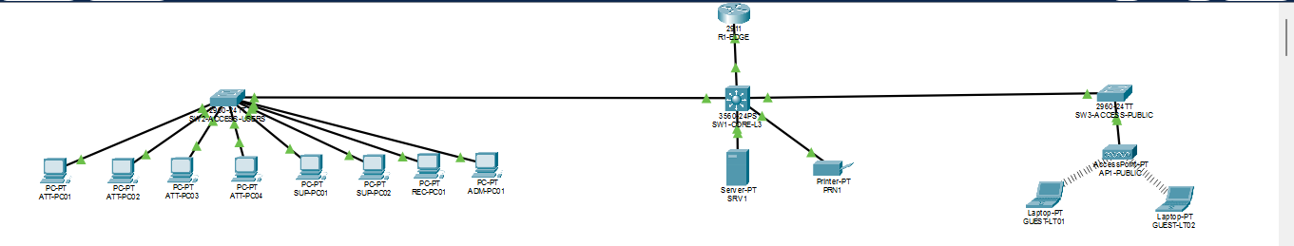Figure 1: Final Packet Tracer topology
Evidence purpose: Shows the completed physical implementation and the connectivity between the edge router, core switch, access switches, server, printer and wireless segment.

3.1 Implemented Devices
Device | Model | Role | Addressing / Network
R1-EDGE | Cisco 2911 | Edge router | 172.30.52.90/30
SW1-CORE-L3 | Cisco 3560 | Layer 3 core; SVIs, routing and ACL enforcement | VLAN gateways; .89/30 routed link
SW2-ACCESS-USERS | Cisco 2960 | Staff access switch | VLAN 99: 172.30.52.82/29
SW3-ACCESS-PUBLIC | Cisco 2960 | Public wireless access switch | VLAN 99: 172.30.52.83/29
SRV1 | Server-PT | DHCP server and shared service host | 172.30.52.74/29
PRN1 | Printer-PT | Shared network printer | 172.30.52.75/29
AP1-PUBLIC | Access Point-PT | Public wireless access | Connected to VLAN 50
ATT-PC01–04 | PC-PT | Attorney workstations | VLAN 10 / DHCP
SUP-PC01–02 | PC-PT | Support workstations | VLAN 20 / DHCP
ADM-PC01 | PC-PT | Administration workstation | VLAN 20 / DHCP
REC-PC01 | PC-PT | Reception workstation | VLAN 30 / DHCP
GUEST-LT01–02 | Laptop-PT | Public wireless clients | VLAN 50 / DHCP

4. VLAN and Switching Implementation
Six VLANs were implemented to separate the office functions and infrastructure. This gives each group a clear Layer 2 boundary and provides the Layer 3 structure needed for routing and traffic filtering.
VLAN | Name | Main Devices | Subnet | Gateway
10 | ATTORNEYS | ATT-PC01–04 | 172.30.52.32/28 | 172.30.52.33
20 | SUPPORT-ADMIN | SUP-PC01–02, ADM-PC01 | 172.30.52.48/28 | 172.30.52.49
30 | RECEPTION | REC-PC01 | 172.30.52.64/29 | 172.30.52.65
40 | SHARED-SERVICES | SRV1, PRN1 | 172.30.52.72/29 | 172.30.52.73
50 | PUBLIC-WIFI | AP1-PUBLIC, GUEST-LT01–02 | 172.30.52.0/27 | 172.30.52.1
99 | MANAGEMENT | SW1, SW2, SW3 | 172.30.52.80/29 | 172.30.52.81

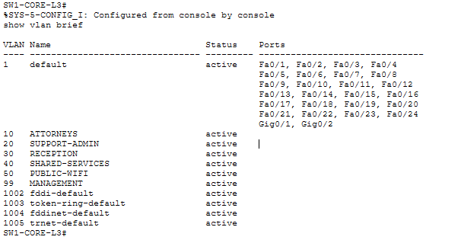
Figure 2: SW1 VLAN configuration
Evidence purpose: Shows the six VLANs created on the core Layer 3 switch.

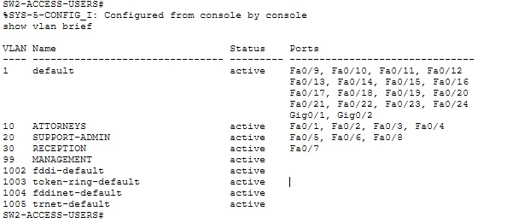
Figure 3: SW2 access-port assignments
Evidence purpose: Shows the staff switch ports mapped to the required user VLANs.

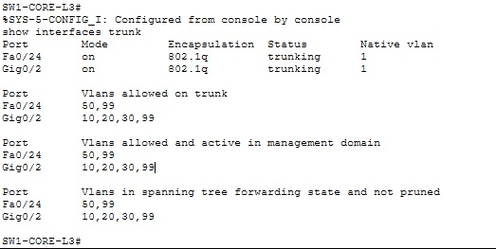
Figure 4: Trunk verification
Evidence purpose: Shows the switch trunking state and the VLANs allowed across the uplinks.

4.1 Trunk and Access Design
The SW1-to-SW2 trunk carries VLANs 10, 20, 30 and 99 because these are the VLANs required for staff access and management on that switch. The SW1-to-SW3 trunk carries VLANs 50 and 99 because SW3 is dedicated to the public wireless segment and its management interface.
On SW2, Fa0/1–Fa0/4 are assigned to VLAN 10, Fa0/5–Fa0/6 and Fa0/8 are assigned to VLAN 20, and Fa0/7 is assigned to VLAN 30. On SW1, the server and printer use VLAN 40 access ports. On SW3, AP1-PUBLIC uses an access port in VLAN 50.

5. IP Addressing and Routing Implementation
The assigned 172.30.52.0/23 block was divided using VLSM according to the approved Milestone 1 plan. The public wireless subnet was given the largest active client range because it supports more dynamic devices, while the smaller office and infrastructure networks use smaller subnets.
Network | Subnet | Gateway / Interfaces | Allocation | Purpose
VLAN 50 | 172.30.52.0/27 | 172.30.52.1 | DHCP .3–.30 | Public Wi-Fi
VLAN 10 | 172.30.52.32/28 | 172.30.52.33 | DHCP .34–.46 | Attorneys
VLAN 20 | 172.30.52.48/28 | 172.30.52.49 | DHCP .50–.62 | Support/Admin
VLAN 30 | 172.30.52.64/29 | 172.30.52.65 | DHCP .66–.70 | Reception
VLAN 40 | 172.30.52.72/29 | 172.30.52.73 | SRV1 .74; PRN1 .75 | Shared services
VLAN 99 | 172.30.52.80/29 | 172.30.52.81 | SW2 .82; SW3 .83 | Management
Routed link | 172.30.52.88/30 | SW1 .89 / R1 .90 | Point-to-point | Edge connection

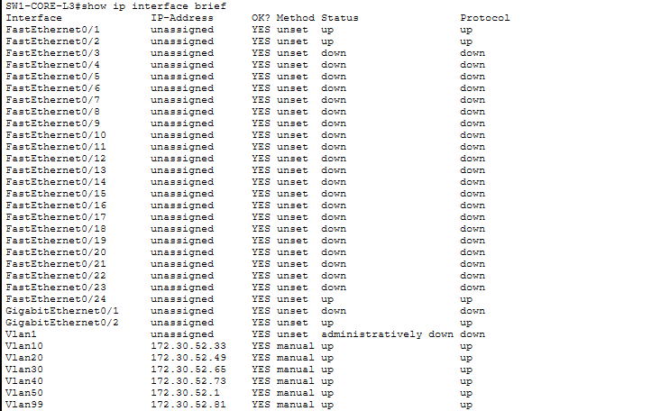
Figure 5: SW1 SVI gateway configuration
Evidence purpose: Shows the implemented gateway addresses for the VLAN interfaces on SW1.

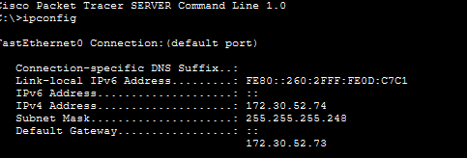
Figure 6: SRV1 static IP configuration
Evidence purpose: Shows the static address, mask and gateway used by the DHCP/shared-service server.

Figure 7: PRN1 static IP configuration
Evidence purpose: Shows the static address assigned to the shared network printer.

Figure 8: R1 routed interface
Evidence purpose: Shows R1-EDGE using 172.30.52.90/30 on the SW1-to-R1 routed link.

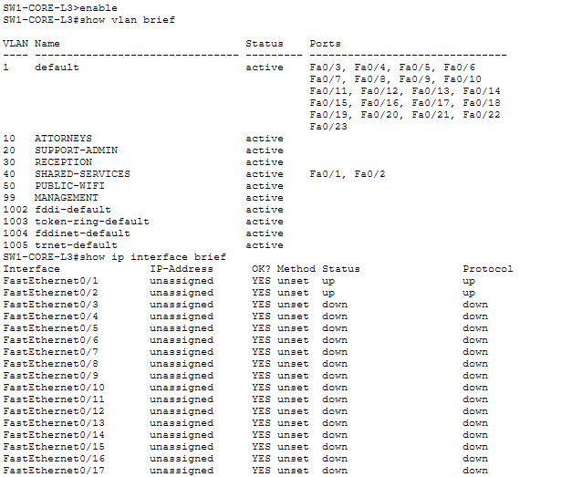
Figure 9: Final SW1 routing verification
Evidence purpose: Shows the connected VLAN routes, the routed link and the default route through R1-EDGE.

5.1 Inter-VLAN Routing
SW1-CORE-L3 was configured with IP routing enabled. Each of the six VLANs has an operational SVI and the gateway address planned for that subnet. The final routing table shows the six connected VLAN networks and the 172.30.52.88/30 link to R1-EDGE.
A default route on SW1 points to 172.30.52.90. R1-EDGE was given a route for the full 172.30.52.0/23 internal address block through 172.30.52.89. This creates the return path from the edge router toward the internal VLANs.

6. DHCP Implementation
SRV1 was configured as the DHCP server for the dynamic client networks. Four pools were created for VLANs 10, 20, 30 and 50. VLAN 40 contains shared infrastructure and VLAN 99 contains management interfaces, so those networks remain statically addressed.
VLAN | Pool | Starting IP | Gateway | Mask | Maximum Users
10 | VLAN10_ATTORNEYS | 172.30.52.34 | 172.30.52.33 | 255.255.255.240 | 13
20 | VLAN20_SUPPORT_ADMIN | 172.30.52.50 | 172.30.52.49 | 255.255.255.240 | 13
30 | VLAN30_RECEPTION | 172.30.52.66 | 172.30.52.65 | 255.255.255.248 | 5
50 | VLAN50_PUBLIC_WIFI | 172.30.52.3 | 172.30.52.1 | 255.255.255.224 | 28

Because SRV1 is located in VLAN 40 while the DHCP clients are in other VLANs, SW1 was configured with DHCP relay using 172.30.52.74 as the helper address on VLANs 10, 20, 30 and 50. The client tests confirmed that the relay and pools were working.

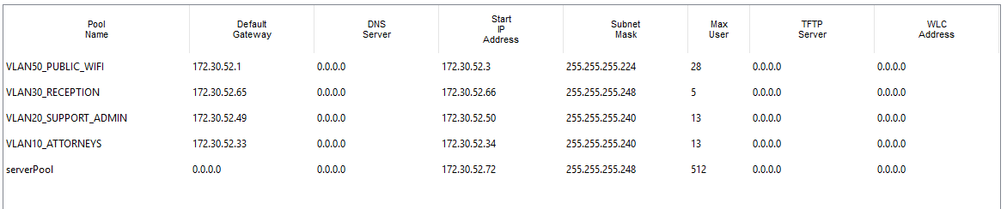
Figure 10: DHCP pools on SRV1
Evidence purpose: Shows the four DHCP pools configured for the dynamic client networks.

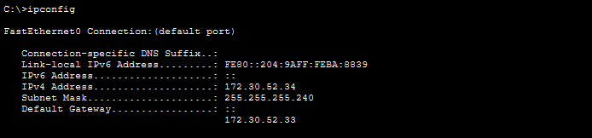
Figure 11: ATT-PC01 DHCP address
Evidence purpose: Shows an Attorney workstation receiving the correct VLAN 10 address, mask and gateway.

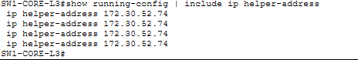
Figure 12: SW1 DHCP relay configuration
Evidence purpose: Shows the helper-address configuration used to forward DHCP requests to SRV1.

7. Public Wireless Implementation
Wireless access was provided only for the public areas specified by the project. AP1-PUBLIC is connected to SW3 and places wireless clients in VLAN 50. The configured SSID is RAMOKOKA-PUBLIC and WPA2-PSK authentication was enabled with the project passphrase.
Both guest laptops were connected to the wireless network. During setup, the laptops initially did not contain a compatible wireless interface and Packet Tracer reported that a WMP300N or WPC300N interface was required. The laptops were powered off, fitted with WPC300N modules and powered on again. After this change, both devices detected the SSID and obtained VLAN 50 DHCP addresses.

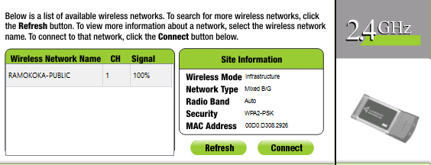
Figure 13: Public SSID detected
Evidence purpose: Shows a guest laptop detecting the RAMOKOKA-PUBLIC wireless network.

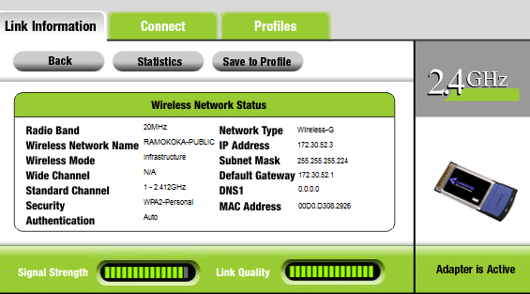
Figure 14: GUEST-LT01 network information
Evidence purpose: Shows the first guest client receiving its VLAN 50 DHCP configuration.

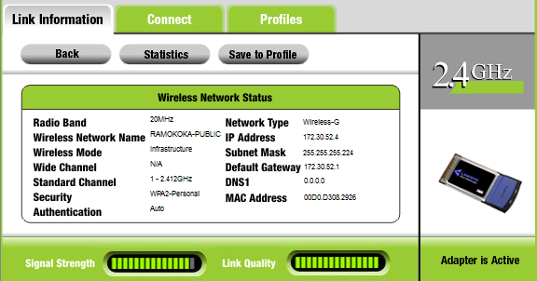
Figure 15: GUEST-LT02 network information
Evidence purpose: Shows the second guest client receiving its VLAN 50 DHCP configuration.

7.1 Wireless Device Adaptation
The Access Point-PT model used in the simulator did not expose IPv4 management address fields in its configuration interface. The device was therefore retained rather than replaced with another model, and the implementation focused on its required role as the public wireless access point in VLAN 50. This kept the Packet Tracer build aligned with the approved physical design.

8. ACL Traffic-Filtering Policy
The assigned project challenge was implemented as an extended ACL named PUBLIC_WIFI_FILTER. It was applied inbound on the VLAN 50 SVI on SW1. The policy prevents public wireless clients from directly reaching the protected internal networks while allowing traffic that is not destined for those protected ranges.
Rule | Action | Source | Destination | Purpose
1 | Deny | 172.30.52.0/27 | 172.30.52.32/28 | Protect Attorneys VLAN
2 | Deny | 172.30.52.0/27 | 172.30.52.48/28 | Protect Support/Admin VLAN
3 | Deny | 172.30.52.0/27 | 172.30.52.64/29 | Protect Reception VLAN
4 | Deny | 172.30.52.0/27 | 172.30.52.72/29 | Protect Shared Services VLAN
5 | Deny | 172.30.52.0/27 | 172.30.52.80/29 | Protect Management VLAN
6 | Permit | 172.30.52.0/27 | Any | Allow required upstream traffic

The wildcard masks in the ACL match the subnet boundaries from the addressing plan. The final permit statement was tested using the routed edge address 172.30.52.90. Protected destinations were tested separately so that both sides of the policy could be demonstrated.

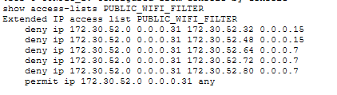
Figure 16: PUBLIC_WIFI_FILTER ACL configuration
Evidence purpose: Shows the six ACL entries configured for VLAN 50 traffic.

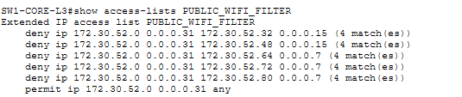
Figure 17: ACL deny counters
Evidence purpose: Shows matches on the five deny statements after protected-network tests.

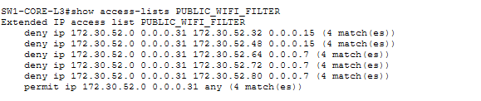
Figure 18: ACL permit counter
Evidence purpose: Shows the permit statement receiving matches during the upstream test.

9. Connectivity and ACL Testing
Testing was carried out from representative internal and public clients. The tests were used to verify normal network operation as well as the required security boundary. Some first ping attempts showed packet loss while ARP and link information were being established; repeated tests completed successfully.

9.1 Staff Connectivity Test
ATT-PC01 received 172.30.52.34/28 from DHCP with gateway 172.30.52.33. It successfully reached its local gateway, SRV1 at 172.30.52.74 and the VLAN 20 gateway at 172.30.52.49. These tests provide evidence for DHCP operation, local gateway reachability, inter-VLAN routing and access to the shared-services network.

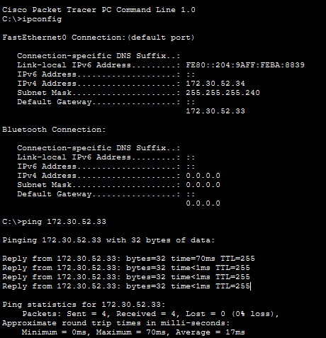
Figure 19: ATT-PC01 IP and gateway test
Evidence purpose: Shows the workstation address and successful communication with its local gateway.

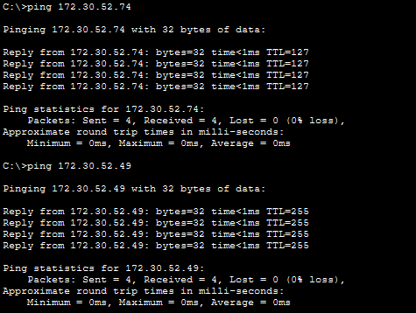
Figure 20: ATT-PC01 server and inter-VLAN tests
Evidence purpose: Shows successful communication with SRV1 and the VLAN 20 gateway.

9.2 Public Client Upstream Test
GUEST-LT01 received 172.30.52.3/27 with gateway 172.30.52.1. The final upstream test reached R1-EDGE at 172.30.52.90 with 0% packet loss. This demonstrates that the final permit statement was not blocking the tested routed-edge traffic.
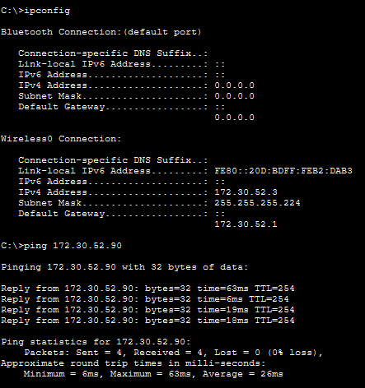
Figure 21: GUEST-LT01 permitted upstream test
Evidence purpose: Shows successful public-client communication toward the edge-router test address.

9.3 Public Client Internal-Denial Tests
The same guest client was tested against protected internal destinations. Traffic to SRV1 at 172.30.52.74 and ATT-PC01 at 172.30.52.34 was blocked, with the simulator returning destination-unreachable messages from the VLAN 50 gateway. These results match the intended ACL policy.

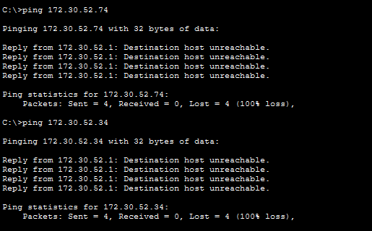
Figure 22: GUEST-LT01 protected-network denial test
Evidence purpose: Shows blocked communication from the public wireless client to protected internal resources.

9.4 ACL Counter Verification
The ACL counters provided a second layer of evidence. After the protected-network tests, each of the five deny statements showed matches. The final permit statement also recorded matches during the upstream test. This confirms that the ACL entries were not only present in the configuration but were actively processing the tested traffic.

10. Troubleshooting and Configuration Issues
Several genuine simulator and configuration issues were encountered during implementation. The approach was to diagnose each issue with the available Packet Tracer/Cisco commands and make the smallest change necessary without changing the approved network design.
Issue | Observed situation | Action taken
Access Point IP fields | The Access Point-PT model did not expose IPv4 management-address fields. | The existing AP was retained and used for its required VLAN 50 wireless function.
Guest wireless interface | The laptops initially lacked a compatible wireless interface. | The laptops were powered off, WPC300N modules were installed, and the devices were powered on again.
First ping packet loss | Some first pings returned partial loss during initial ARP/link convergence. | The same tests were repeated after convergence; the relevant final tests completed successfully.
VLAN 50 ACL status display | show ip interface vlan 50 reported an inbound ACL status inconsistent with the running configuration and counters. | The running configuration and ACL match counters were used to verify the effective configuration and behaviour.
Unsupported CLI command | show running-config interface vlan 50 was rejected by the Packet Tracer IOS implementation. | The full show running-config output was used to inspect the VLAN 50 interface configuration.

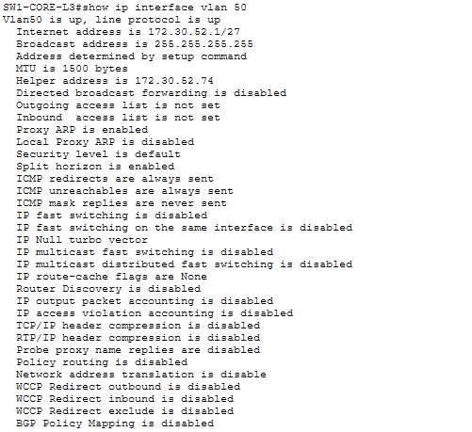
Figure 23: ACL interface status diagnostic
Evidence purpose: Documents the VLAN 50 ACL display discrepancy observed during verification.

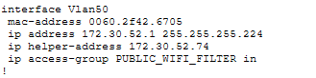
Figure 24: VLAN 50 ACL configuration
Evidence purpose: Shows the interface configuration checked while diagnosing the ACL application.

Figure 25: ACL access-group verification
Evidence purpose: Shows the access-group statement used to verify ACL application.

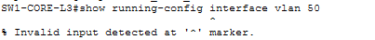
Figure 26: Unsupported CLI command
Evidence purpose: Documents the unsupported command and the workaround used.

11. Final Implementation Verification
A final verification pass was completed after the implementation and testing stages. SW1 showed VLAN 10, 20, 30, 40, 50 and 99 interfaces in the up/up state. The routing table contained the six connected VLAN networks, the routed SW1-to-R1 link and the default route via 172.30.52.90.
SW2 and SW3 were also checked for their required VLANs, trunks and management interfaces. The final end-to-end tests confirmed that an authorised internal workstation could reach required internal resources, while a public wireless client could reach the tested routed edge address but was prevented from reaching protected internal resources.
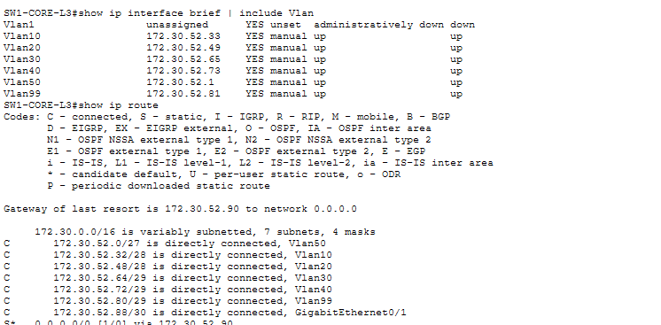
Figure 27: Final SW1 SVI verification
Evidence purpose: Shows the final VLAN interface state and gateway addresses.

Figure 28: Final SW1 routing verification
Evidence purpose: Shows the final connected routes and default route.

The final ACL behaviour is evidenced by Figures 36 and 37 in Section 9, together with the ACL counter evidence in Figures 26 and 27. The Packet Tracer file was saved after the final verification, and the switch configurations were saved to startup-config.

12. Change Request CR6 – Future Branch Accommodation
CR6 requires the future branch office to be accommodated through network design and addressing only. No second-site topology was built because that is outside the current implementation scope.
The reserved branch-office subnet is 172.30.53.0/25. Keeping this range reserved provides a dedicated address space for future expansion while leaving the current Vryburg network unchanged. No branch devices or branch-specific configurations were added to the current Packet Tracer implementation.

13. Evidence and GitHub Portfolio
The project evidence is maintained in the individual GitHub repository associated with CMPG325-2026-082. The evidence set contains configuration screenshots, DHCP and wireless evidence, ACL configuration and counters, troubleshooting records, final testing screenshots and the final topology.
GitHub repository: https://github.com/EzekielMolekwa/CMPG325-2026-082
The screenshots that were captured during the implementation but not yet uploaded to GitHub can be synchronized after the Word report is completed. The existing 01–38 numbering should be retained so that the report, GitHub evidence folder and final demonstration use the same evidence references.
The report does not rely on every screenshot as a figure. The selected figures show the major implementation stages and the most important final tests, while the full evidence register preserves the complete record.

14. Conclusion
The Milestone 2 work translated the approved Milestone 1 design into a functioning Cisco Packet Tracer network for Ramokoka & Partners Attorneys. The implementation includes the complete device topology, VLAN segmentation, access and trunk configuration, Layer 3 inter-VLAN routing, VLSM addressing, DHCP services, static infrastructure addressing, management interfaces, public-area wireless connectivity and the routed edge connection.
The assigned ACL challenge was implemented through PUBLIC_WIFI_FILTER on VLAN 50. The final tests showed the intended separation between public wireless users and protected internal networks while allowing the tested traffic toward the edge router. ACL match counters provided additional configuration-level evidence for both the deny and permit portions of the policy.
The project also records the practical issues encountered in Packet Tracer and the methods used to resolve or verify them. The future branch requirement was accommodated through reserved addressing only, as required. The completed Packet Tracer file, implementation report and supporting evidence therefore form a consistent Milestone 2 submission package.

Appendix A – Screenshot Evidence Register
This register preserves the complete screenshot numbering used during implementation. The report body uses selected screenshots as primary evidence; the remaining screenshots can remain in the GitHub evidence folder as supporting implementation history.
No. | Filename | Evidence purpose
01 | 01_Initial_Physical_Implementation.png | Initial physical implementation
02 | 02_SW1_VLAN_Configuration.png | SW1 VLAN configuration
03 | 03_SW2_Access_Port_Assignment | SW2 access-port assignments
04 | 04_Trunk_Verification | Trunk verification
05 | 05_SW1_SVI_InterVLAN_Gateways | SW1 SVI gateways
06 | 06_SW2_Management_SVI | SW2 management SVI
07 | 07_SW3_Management_SVI | SW3 management SVI
08 | 08_SW2_to_SW1_Management_Ping | SW2 to SW1 management ping
09 | 09_SW2_to_SW3_Management_Ping | SW2 to SW3 management ping
10 | 10_SW3_to_SW1_Management_Ping | SW3 to SW1 management ping
11 | 11_SW3_to_SW2_Management_Ping | SW3 to SW2 management ping
12 | 12_DHCP_Pools_on_SRV1 | DHCP pools
13 | 13_ATT-PC01_DHCP_Address | ATT-PC01 DHCP address
14 | 14_Staff_to_DHCP_Server_Ping | Staff to DHCP server ping
15 | 15_SW1_DHCP_Relay | SW1 DHCP relay
16 | 16_SRV1_Static_IP | SRV1 static IP
17 | 17_SRV1_to_VLAN40_Gateway | SRV1 to VLAN 40 gateway
18 | 18_PRN1_Static_IP | PRN1 static IP
19 | 19_SW1_Routed_Interface | SW1 routed interface
20 | 20_R1_Routed_Interface | R1 routed interface
21 | 21_SW1_Routing_Table | SW1 routing table
22 | 22_Guest_WiFi_SSID_Detected | Guest Wi-Fi SSID detected
23 | 23_GUEST-LT01_Network_Information | GUEST-LT01 network information
24 | 24_GUEST-LT02_Network_Information | GUEST-LT02 network information
25 | 25_PUBLIC_WIFI_ACL | PUBLIC_WIFI_FILTER ACL
26 | 26_PUBLIC_WIFI_ACL_Deny_Matches | ACL deny matches
27 | 27_PUBLIC_WIFI_ACL_Permit_Match | ACL permit match
28 | 28_ACL_Interface_Status_Diagnostic | ACL interface status diagnostic
29 | 29_VLAN50_ACL_Configuration | VLAN 50 ACL configuration
30 | 30_ACL_Access_Group_Verification | ACL access-group verification
31 | 31_Unsupported_CLI_Command | Unsupported CLI command
32 | 32_SW1_Final_SVI_Verification | Final SW1 SVI verification
33 | 33_SW1_Final_Routing_Verification | Final SW1 routing verification
34 | 34_ATT-PC01_IP_and_Gateway_Test | ATT-PC01 IP and gateway test
35 | 35_ATT-PC01_Server_and_InterVLAN_Test | ATT-PC01 server/inter-VLAN test
36 | 36_GUEST-LT01_Final_ACL_Upstream_Test | Final guest upstream test
37 | 37_GUEST-LT01_Final_ACL_Internal_Denial | Final guest internal denial
38 | 38_Final_Packet_Tracer_Topology | Final Packet Tracer topology

Appendix B – Final Verification Summary
Area | Final evidence/result | Status
VLANs | VLANs 10, 20, 30, 40, 50 and 99 active and used as designed. | Verified
SW1 SVIs | All six SVIs up/up with the approved gateway addresses. | Verified
Inter-VLAN routing | Connected VLAN routes present on SW1. | Verified
Routed edge link | SW1 .89/30 to R1 .90/30 operational. | Verified
Default route | SW1 default route via 172.30.52.90. | Verified
DHCP | Dynamic clients received addresses from the correct pools. | Verified
Public Wi-Fi | Guests detected the SSID and received VLAN 50 addresses. | Verified
ACL protected traffic | Guest traffic to protected internal networks was denied. | Verified
ACL permitted traffic | Guest traffic to R1 .90 was permitted in the final test. | Verified
Staff access | ATT-PC01 reached its gateway, SRV1 and the VLAN 20 gateway. | Verified
CR6 | 172.30.53.0/25 reserved; no second site built. | Verified
Final save | Packet Tracer file saved and switch configurations saved to startup-config. | Completed

END OF MILESTONE 2 REPORT

