1. A closed rigid container has 6 kg of air at an initial pressure of 100 kPa and volume of 25 m3. The air undergoes a process to a final pressure of 200 kPa. The pressure increase was a result of heat transfer. How much heat (energy) was transferred (kJ)?
2. An inventor has proposed the insulated device shown with air as the medium. Find T₃ (°C) if the mass flow rate in ports 2 and 3 are equal. How would you determine if this process is possible?
1
P₁ = 4.0 MPa
T₁ = 600°C
2
3
P₃ = 0.2 MPa
T₃ = ?
P₂ = 0.2 MPa
T₂ = 6°C

3. A sprinkler head fuse can be modeled as a cylinder of diameter 4 mm and length 12 mm. The density can be approximated as being 1000 kg/m³. The specific heat capacity is approximately 1 kJ/kgK. The heat transfer coefficient of the smoke gases is 20 W/m2K. If the smoke gases are 200 C and the fuse is initially at 20 C, how long will it take for the fuse to open if the activation temperature is 80C?
4. A composite wall for a furnace is made of two materials, an insulating material with thermal conductivity k_{A} and an exterior skin with thermal conductivity k_{B}. Within the furnace there is an internal heat transfer coefficient h_{c,i} and internal temperature Ti. Outside of this wall there is a heat transfer coefficient hc,o and external temperature To..
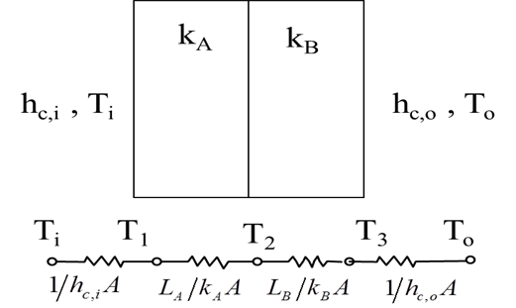 | Analyze a case with T_{i}=1000 C, T_{o}=300 C,  h_{ci} =30 W/(m²K), h_{co} = 10 W/(m²K),  L_{A}= 2 cm, L_{B}= 0.2 cm,  k_{A}= 1 W/(mK), k_{B}=20 W/(mK),.  a) Find the equivalent resistance.  b) Find the heat flux through the wall.

