
DEVELOPMENT OF AI-POWERED CHATBOT FOR CHRONIC KIDNEY DISEASE PREDICTION AND MANAGEMENT

EZEKWEM DESMOND
STUDENT NUMBER – 2327423
MODULE CODE – 7CS041

SUPERVISOR – PERVEZ ZEESHAN

INDEPENDENT PROJECT REPORT SUBMITTED FOR THE DEGREE OF MASTER OF SCIENCE IN ARTIFICIAL INTELLIGENCE

UNIVERSITY OF WOLVERHAMPTON

DECEMBER 2024

TABLE OF CONTENT

TABLE OF CONTENT i
List of Figures iv
List of Tables v
List of Abbreviations vi
ABSTRACT vii
CHAPTER 1 8
INTRODUCTION 9
1.1 Introduction 9
1.2 Background 9
1.2.1 Current State of CKD Prediction Methods 9
1.2.2 Evolution of AI in Healthcare 10
1.2.3 Rise of Chatbots in Medical Applications 10
1.3 Existing Limitations and Gaps 10
1.4 Problem Statement 10
1.5 Research Objectives 11
1.6 Research Questions: 11
1.7 Scope and Boundaries: 11
1.8 Study Significance 12
1.8.1 Theoretical Contribution 12
1.8.2 Practical Implications 12
1.8.3 Healthcare Impact 12
1.8.4 Technological Innovation 12
1.8.5 Societal Benefits 12
1.9 Research Approach Overview 12
CHAPTER 2 14
LITERATURE REVIEW 14
2.1 Limitations of Traditional Statistical Approaches 14
2.2 Traditional Machine Learning Approaches 15
2.3 Advanced Machine Learning Techniques 16
2.4 Deep Learning Applications 17
2.5 Explainable AI (XAI) in CKD Prediction 18
2.6 Healthcare Chatbots in CKD Management 19
2.7 Research Gaps and Future Directions 21
2.8 Conclusion 21
CHAPTER 3 23
RESEARCH METHODOLOGY 23
3.1 Business Understanding 23
3.1.1 Key Business Goals: 23
3.1.2 Success Criteria: 24
3.2 Data Understanding 24
3.2.1 Data Source and Characteristics 24
3.3 Data Preparation 25
3.3.1 Data Cleaning 25
3.3.2 Feature Engineering and Transformation 29
3.4 Modelling 30
3.4.1 Model Selection: 30
3.4.2 Why Random Forest Classifier for the CKD Prediction? 32
3.4.3 Overview of Random Forest Algorithm 32
3.4.4 Advantages of Random Forest 33
3.4.5 Application of Random Forest in CKD Prediction 34
3.5 Model Evaluation 35
3.5.1 Confusion Matrix 35
3.5.2 Evaluation Metrics 35
3.5.3 Cross-Validation 36
3.6 Model Refinement and Improvement 37
3.6.1 Feature Selection: 37
3.6.2 Hyperparameter Tuning: 41
3.7 Making Prediction with New Input Data 42
3.8 Deployment 44
3.8.1 Chatbot Implementation 44
3.8.2 Chatbot Workflow 48
3.8.3 Retrieval-Augmented Generation (RAG) in Chatbot Implementation 48
3.8.4 Software Requirements and Tools 51
CHAPTER 4 53
ANALYSIS, RESULTS AND FINDINGS 53
4.1 Exploratory Data Analysis (EDA) 53
4.1.1 Univariate Analysis 53
4.1.2 Bivariate Analysis: 65
4.1.3 Multivariate Analysis 70
4.2 Correlation Between Features and the Target Variable 72
4.3 Model Evaluation and Performance 74
4.3.1 Confusion Matrix Analysis 74
4.3.2 Evaluation Metrics 74
4.3.3 Cross-Validation Results 75
4.4 Model Improvement: Final Model Performance 76
4.4.1 Confusion Matrix: 76
4.4.2 Evaluation Metrics 76
4.5 Feature Importance Analysis 78
CHAPTER 5 80
CONCLUSION AND RECOMMENDATION 80
5.1 Conclusion 80
5.2 Summary of Key Findings: 80
5.3 Implications of the Findings: 81
5.4 Comparison with Existing Literature 81
5.5 Potential Limitations 82
5.6 Recommendations 82
5.7 Theoretical Contributions: 83
5.8 Healthcare Implications: 83
5.9 Technological Innovation: 83
5.10 Future Research Directions: 84
5.11 Closing Remarks 84
REFERENCES 86
Appendix 1 91
Appendix 2 91

  - List of Figures

Figure 3.1: Column names of the dataset 25
Figure 3.2: Python Code to convert object data type to numerical type 26
Figure 3.3: Python Code to remove whitespace from strings 26
Figure 3.4: Python Code to check for missing values in each column 27
Figure 3.5: Python Function to handle missing values in the dataset 28
Figure 3.6: Confirmation of no missing values 29
Figure 3.7: Python Code to check for duplicate rows 29
Figure 3.8: Python Code to scale the numerical features 30
Figure 3.9: Python Code to encode the categorical features and save the encoders 30
Figure 3.10: Confusion Matrix for the six classifiers experimented 31
Figure 3.11: Random Forest Classifier 32
Figure 3.12: Python Code for Stratified 10-Fold Cross-Validation 37
Figure 3.13: Top 15 features by ANOVA F-value 38
Figure 3.14: Top 15 features by Mutual Information 38
Figure 3.15: Top 15 features by Random Forest Feature Importance 39
Figure 3.16: Top 15 features by Recursive Feature Elimination 39
Figure 3.17: Python function for hyperparameter tuning 41
Figure 3.18: Python Code to preprocess raw new data 42
Figure 3.19: Python Code to make prediction on the new data 42
Figure 3.20: Flow Diagram: Building and Improving Random Forest Classifier 43
Figure 3.21: Flow Diagram: Prediction and Personalised Advice Process 43
Figure 3.22: Home Page/Chat Interface 46
Figure 3.23: Health Form 47
Figure 3.24: Prediction and Personalised Advice Page 48
Figure 3.25: RAG Workflow 51
Figure 4.1: Distribution of the Target variable 53
Figure 4.2: Age Distribution by CKD Status 54
Figure 4.3: Blood Pressure Distribution by CKD Status 55
Figure 4.4: Specific Gravity Distribution by CKD Status 56
Figure 4.5: Albumin Distribution by CKD Status 56
Figure 4.6: Sugar Distribution by CKD Status 57
Figure 4.7: Blood Urea Distribution by CKD Status 58
Figure 4.8: Blood Glucose Distribution by CKD Status 58
Figure 4.9: Serum Creatinine Distribution by CKD Status 59
Figure 4.10: Sodium Distribution by CKD Status 59
Figure 4.11: Haemoglobin Distribution by CKD Status 60
Figure 4.12: Packed Cell Volume Distribution by CKD Status 61
Figure 4.13: Red Blood Cell Count Distribution by CKD Status 61
Figure 4.14: Red Blood Cell in CKD Patients 62
Figure 4.15: Hypertension in CKD Patients 62
Figure 4.16: Diabetes Mellitus in CKD Patients 63
Figure 4.17: Coronary Artery Disease in CKD Patients 63
Figure 4.18: Appetite in CKD Patients 64
Figure 4.19: Pedal Edema in CKD Patients 64
Figure 4.20: Anaemia in CKD Patients 65
Figure 4.21: Scatterplot of Packed Cell Volume Vs Haemoglobin by CKD Status 66
Figure 4.22: Scatterplot of Red Blood Cell Count Vs Haemoglobin by CKD Status 67
Figure 4.23: Scatterplot of Blood Urea Vs Blood Glucose Random by CKD Status 68
Figure 4.24: Scatterplot of White Blood Cell Count vs Haemoglobin by CKD Status 68
Figure 4.25: Scatterplot of Packed Cell Volume vs Red Blood Cell Count by CKD Status 69
Figure 4.26: Scatterplot of Blood Pressure Distribution by Diabetes Status in CKD Patients 70
Figure 4.27: Symptoms Distribution by Hypertension Status in CKD Patients 71
Figure 4.28: Heatmap of the correlation between the features 73
Figure 4.29: Confusion matrix for the base Random Forest Classifier 74
Figure 4.30: ROC Curve for the base Random Forest Classifier 75
Figure 4.31: Confusion Matrix for the Improved Random Forest Classifier 76
Figure 4.32: ROC Curve for the improved Random Forest Classifier 77
Figure 4.33: Plot of Improved Random Forest Classifier Feature Importance 79

  - List of Tables

Table 3.1: Comparison Table for the six classifiers 31
Table 3.2: Confusion Matrix 35
Table 3.3: Top 15 selected features by combined method 40
Table 3.4: Hyperparameter and Best values 42
Table 4.1: Stratified 10-Fold Cross-Validation Results 75
Table 4.2: Evaluation Metrics for the improved Random Forest Classifier 77

  - List of Abbreviations

CKD - Chronic Kidney Disease
ML - Machine Learning
AUC-ROC - Area Under the Receiver Operating Characteristic Curve
RAG – Retrieval Augmented Generation
AI – Artificial Intelligence
KFRE - Kidney Failure Risk Equation
NLP - Natural Language Processing
DL - Deep Learning
GLMM - Generalized Linear Mixed Model
eGFR- Estimated Glomerular Filtration Rate
ESKD - End-Stage Kidney Disease
SMOTE - Synthetic Minority Over-sampling Technique
PSO-MLP - Particle Swarm Optimized Multi-Layer Perceptrons
ANN - Artificial Neural Networks
LSTM - Long Short-Term Memory
GRU - Gated Recurrent Unit
MLP - Multi-Layer Perceptron
RNN - Recurrent Neural Network
IoMT - Internet of Medical Things
EHR - Electronic Health Records
LMA-CNN - Lightweight Multi-Attention Convolutional Neural Network
SHAP - SHapley Additive exPlanations
LIME - Local Interpretable Model-Agnostic Explanations
XAI - Explainable AI
MBD - Mineral Bone Disease
eGFR and ACR
LLM - Large Language Model
CRISP-DM - Cross Industry Standard Process for Data Mining
KNN - K-Nearest Neighbours
OOB - Out-of-Bag
RFE - Recursive Feature Elimination
EDA - Exploratory Data Analysis
HIPAA - Health Insurance Portability and Accountability Act
GDPR - General Data Protection Regulation
SVM - Support Vector Machine
RF – Random Forest
DT – Decision Tree

  - ABSTRACT

Chronic Kidney Disease (CKD) represents a major global health challenge, requiring innovative approaches for early detection and effective management. This thesis focuses on the development of an AI-powered chatbot that integrates a machine learning (ML)-based prediction model with conversational AI to enhance CKD risk assessment and patient engagement. The research addresses limitations in traditional statistical models, such as demographic biases and reduced generalizability and limitations in traditional CKD management methods by combining predictive analytics with an intuitive conversational interface to provide personalized, actionable health recommendations.
The study employs a Random Forest Classifier trained on a curated dataset of clinical, demographic, and laboratory features, achieving exceptional predictive performance with an accuracy, precision, recall and Area Under the Receiver Operating Characteristic Curve (AUC-ROC) score of 1.00. The ML model is seamlessly integrated into a chatbot built on the Flask framework and LangChain architecture. Using Retrieval Augmented Generation (RAG), the chatbot enhances user interactions by combining CKD-specific knowledge retrieval with contextual natural language responses. It offers risk assessments, personalized prevention advice, and educational resources, creating an engaging and informative user experience.
Key findings demonstrate the model’s capability to predict CKD accurately and provide actionable insights. However, challenges such as dataset size, target imbalance, and interpretability highlight the need for larger, diverse datasets and advanced explainability techniques.
This research advances AI applications in nephrology, offering a scalable solution for CKD prediction and management. It underscores the transformative potential of integrating AI-driven diagnostics with conversational systems, paving the way for improved patient outcomes and healthcare accessibility.

  - INTRODUCTION

Introduction
Chronic Kidney Disease (CKD) poses a significant and escalating burden on global health systems, affecting approximately 10% of the global population (Kovesdy, 2022) and accounting for millions of deaths annually due to complications such as cardiovascular disease, reduced quality of life, and premature death (Eknoyan et al., 2004). Despite advancements in medical science, CKD remains underdiagnosed and undertreated, with many individuals progressing to advanced stages before receiving adequate care. This silent progression amplifies healthcare costs and reduces the quality of life for affected individuals, necessitating innovative approaches to early diagnosis and management.
Traditional healthcare systems face challenges in delivering timely and personalized care for CKD patients (Okpechi et al., 2017). Resource constraints, limited access to specialized care, and the reactive nature of conventional medical practices hinder effective disease management. Traditional predictive models like the Kidney Failure Risk Equation (KFRE) have offered valuable insights but remain constrained by limited datasets, underrepresentation of high-risk populations, and lack of adaptability to diverse clinical settings. The rapid evolution of artificial intelligence has provided an unprecedented opportunity to bridge these gaps, offering predictive precision and scalability previously unattainable with conventional methods. Integrating artificial intelligence (AI) into healthcare delivery presents a promising avenue to enhance early detection, patient engagement, and personalized management strategies for CKD.

Background

Current State of CKD Prediction Methods
Existing CKD prediction models primarily rely on statistical analyses of clinical and demographic data. While these models offer valuable insights, their predictive accuracy is often compromised by the complex interplay of various risk factors and the heterogeneity of patient populations. Additionally, the static nature of these models limits their applicability in dynamic clinical environments, underscoring the need for more adaptable and precise predictive tools.

Evolution of AI in Healthcare
The advent of AI has revolutionized healthcare by enabling the analysis of extensive datasets to uncover intricate patterns and associations. Machine learning (ML) algorithms, in particular, have demonstrated superior performance in disease prediction and diagnosis. In nephrology, AI applications have shown promise in enhancing diagnostic accuracy and facilitating personalized treatment plans, thereby improving patient outcomes.

Rise of Chatbots in Medical Applications
AI-driven chatbots have emerged as innovative tools in healthcare, providing real-time patient engagement, education, and support. These conversational agents leverage natural language processing (NLP) to simulate human-like interactions, offering personalized health information and guidance. In chronic disease management, chatbots have been instrumental in monitoring patient symptoms, promoting adherence to treatment regimens, and delivering tailored educational content.

Existing Limitations and Gaps
Despite the advancements in AI and chatbot technologies, several challenges persist. Many AI models operate as "black boxes," lacking transparency and interpretability, which can hinder clinical trust and acceptance. Additionally, the integration of predictive models with conversational AI remains underexplored, particularly in the context of CKD management. Existing chatbots often provide generic information without leveraging personalized predictive analytics, limiting their effectiveness in proactive disease management.

Problem Statement
The current landscape of CKD management is characterized by delayed diagnoses and suboptimal patient engagement, leading to poor health outcomes and increased healthcare expenditures. Traditional predictive models are limited in their ability to provide personalized, real-time risk assessments, and existing chatbots lack integration with advanced predictive analytics. This disconnect highlights the need for innovative solutions that combine ML-based prediction models with conversational AI to deliver personalized, timely, and actionable insights for CKD patients.
Addressing this gap is crucial to enhancing early detection, improving patient adherence to management plans, and ultimately reducing the progression of CKD to end-stage renal disease. An integrated AI-powered chatbot has the potential to transform CKD management by providing accessible and personalized care, thereby alleviating the burden on healthcare systems and improving patient quality of life.

Research Objectives
The primary aim of this research is to develop and evaluate an AI-powered chatbot that integrates ML-based CKD prediction with personalized management advice to enhance patient outcomes and healthcare delivery.
Specific objectives include:
- Designing a CKD Prediction Model: Develop an ML-based model utilizing clinical, demographic, and laboratory data to accurately predict CKD risk.
- Developing a Conversational AI Interface: Create a user-friendly chatbot interface that delivers real-time risk assessments and personalized health recommendations.
- Integrating Predictive Analytics with Conversational AI: Seamlessly combine the CKD prediction model with the chatbot to provide personalized, actionable insights during patient interactions.
- Evaluating System Performance: Assess the predictive accuracy of the model, user engagement with the chatbot, and the overall impact on patient outcomes.

Research Questions:
- How can ML algorithms be employed to develop an accurate and reliable CKD prediction model?
- How can a machine learning-based CKD prediction model be effectively integrated with conversational AI to deliver accurate, personalized and user-friendly health recommendations?
- To what extent does the AI-powered chatbot improve patient engagement and adherence to management plans?

Scope and Boundaries:
This research focuses on patients at risk of or diagnosed with CKD, utilizing available clinical, demographic, and laboratory data. The study emphasizes the integration of predictive analytics with conversational AI, without delving into the development of new ML algorithms or NLP techniques. The evaluation is limited to the system's performance in providing personalized risk assessments and management advice, without direct clinical trials to measure long-term health outcomes.

Study Significance

Theoretical Contribution
This research contributes to the body of knowledge on AI integration in healthcare by demonstrating the feasibility and effectiveness of combining ML-based predictive models with conversational AI for chronic disease management. It provides insights into the design and implementation of integrated systems that offer personalized, real-time health interventions.

Practical Implications
The development of an AI-powered chatbot for CKD management offers a scalable solution to enhance early detection and personalized care. By providing real-time risk assessments and tailored recommendations, the system can empower patients to take proactive steps in managing their health, potentially reducing the progression of CKD and alleviating the burden on healthcare providers.

Healthcare Impact
Implementing such a system can lead to earlier diagnoses, improved patient adherence to management plans, and better health outcomes. By facilitating timely interventions, the chatbot can help prevent the progression of CKD to more severe stages, thereby reducing the need for costly treatments like dialysis or transplantation.

Technological Innovation
The integration of ML-based prediction models with conversational AI represents a novel approach in healthcare technology. This innovation enhances the functionality of chatbots, enabling them to provide personalized and actionable insights rather than generic information, thus improving their utility in chronic disease management.

Societal Benefits
By improving access to personalized healthcare information and facilitating early detection of CKD, the AI-powered chatbot can contribute to reducing health disparities. It offers an accessible tool for individuals who may have limited access to traditional healthcare services, thereby promoting health equity and improving overall public health outcomes.

Research Approach Overview
This study employs a systematic approach to develop and evaluate the AI-powered chatbot:
- Data Collection and Preprocessing: Gather and preprocess clinical, demographic, and laboratory data relevant to CKD prediction.
- Model Development: Utilize ML algorithms to develop a CKD prediction model, optimizing for accuracy and reliability.
- Chatbot Development: Design and implement a conversational AI interface that integrates with the prediction model to deliver personalized risk assessments and recommendations.
- System Integration: Seamlessly combine the prediction model with the chatbot to ensure real-time, personalized interactions.
- Evaluation: Assess the system's predictive accuracy, user engagement, and impact on patient outcomes through user studies and performance metrics.

  - LITERATURE REVIEW

Chronic kidney disease (CKD) represents a significant and growing global health challenge, necessitating continual advancements in predictive tools and management strategies. While traditional statistical models have laid the foundation for CKD prediction, the advent of machine learning (ML) and deep learning (DL) techniques offers transformative potential. This review critically examines the evolution of CKD prediction methodologies, from traditional approaches to advanced AI-driven models and explores the role of explainable AI and conversational chatbots in clinical care.

Limitations of Traditional Statistical Approaches
While traditional statistical methods, such as the Cox proportional hazards model utilized by Tangri et al. (2011) in developing the Kidney Failure Risk Equation (KFRE), have demonstrated promising results with high predictive accuracy (C statistic: 0.917 development; 0.841 validation), their clinical applicability is hindered by certain limitations. Firstly, the generalizability of these models is questionable, as they often rely on nephrology-referred cohorts, potentially underrepresenting high-risk ethnic minorities. This demographic bias may limit the model's ability to accurately predict outcomes in diverse populations. Furthermore, the KFRE does not model all-cause mortality, raising concerns about its utility for comprehensive CKD management. Additionally, the study did not evaluate the long-term performance of the predictive model beyond the initial validation period. As CKD is a progressive disease, the model's effectiveness in predicting outcomes over extended periods remains uncertain.
Building on statistical methods, Yarkiner et al. (2013) applied Generalized Linear Mixed Models (GLMMs) to analyze the progression of CKD using longitudinal data from UK general practice records. The researchers addressed the challenges associated with analyzing unbalanced longitudinal data, particularly the non-normal distribution of response variables such as estimated glomerular filtration rate (eGFR). While the study provides valuable insights into the influence of co-morbidities like diabetes and cardiovascular disease on CKD progression, its applicability remains restricted. By excluding patients with early-stage CKD or undiagnosed conditions and limiting the sample to those aged 18–75 with a BMI under 30, the findings lack broad demographic representation.
These traditional statistical models have laid the groundwork for CKD prediction but fall short in capturing the full complexity of disease dynamics and handling the high-dimensional and complex large dataset often seen in medical records. These limitations have led to increasing interest in machine learning and AI approaches for CKD prediction.

Traditional Machine Learning Approaches
Machine learning approaches offer substantial improvements over traditional statistical models, particularly in their capacity to handle non-linear relationships and high-dimensional data. Bai et al. (2022) conducted a comparative analysis of ML models and the traditional Kidney Failure Risk Equation (KFRE) in predicting end-stage kidney disease (ESKD). Their findings suggest that ML models, including logistic regression, naïve Bayes, random forest, decision tree, and K-nearest neighbours, can achieve comparable predictive performance to KFRE while demonstrating improved sensitivity. Notably, these models can reliably predict ESKD using routine clinical variables, eliminating the need for urine-based tests. However, the study was limited to a single-center cohort in China, potentially affecting generalizability. The relatively small sample size and low event rate could have impacted model performance.
Boukenze and Quafafou (2023) explored the application of data mining and machine learning techniques to predict kidney failure. Their work centered on utilizing linear regression to predict glomerular filtration rate (GFR) values. To address the inherent class imbalance in medical datasets, the authors employed the Synthetic Minority Over-sampling Technique (SMOTE), which effectively balances the dataset and improves the accuracy of the predictive model. Their approach achieved an impressive average accuracy of 98.73%.
Guermah et al. (2018) introduced a novel approach to predict chronic kidney disease by combining context-aware systems with ontology-based prediction methods. Specifically, they employed a Linear Support Vector Machine (SVM) model to classify patients with CKD. By incorporating contextual properties into the prediction model, the authors aimed to enhance predictive accuracy. The study demonstrated that the Linear SVM model achieved an impressive accuracy of 93.3% in classifying patients, supported by a thorough evaluation through decision matrix analysis. The authors however, acknowledged certain limitations, such as the diversity of the dataset and the quality of the contextual data, which may impact the generalizability of the results.
To further highlight machine learning’s potential in CKD prediction, Samet, Laouar, and Bendib (2021) employed an optimized random forest algorithm to overcome issues of missing data and feature selection. Their approach, which integrated imputation techniques to tackle missing data and chi-square feature selection, achieved an impressive accuracy of 99.24%. This robust methodology underscores the importance of reducing dimensionality while preserving predictive power.

Advanced Machine Learning Techniques
Ensemble methods have further elevated the predictive capabilities of ML. Suganthi et al. (2022) combined AdaBoosting with various base classifiers, such as random forest, decision tree and K nearest neighbour, support vector machine, naive bayes and logistic regression. Their study showed that AdaBoosting, particularly when combined with random forests, achieved peak accuracy of 99% in detecting CKD, outperforming traditional classifiers. By optimizing classifiers through ensemble learning, the study highlighted the advantages of boosting in enhancing prediction robustness.
Similarly, Choudhary et al. (2023) proposed a robust ensemble model for the diagnosis and prediction of chronic kidney disease. By combining Random Forest and bagging techniques, their model achieved a commendable accuracy of 96.5%. This ensemble approach significantly enhanced the model's robustness and predictive performance compared to individual algorithms. The study emphasized the importance of large and diverse datasets to enhance model generalizability and accuracy while addressing the challenges of imbalanced datasets that can impact performance
Kumar, Tulasi, and Vigneswari (2019) introduced an ensemble multi-model approach for predicting CKD. Their proposed hybrid classifier, ABC4.5, combined the strengths of the C4.5 decision tree algorithm with adaptive boosting. The study utilized a dataset comprising 25 attributes and 400 observations from a private hospital in Tamil Nadu. The methodology involves a two-stage process: data preprocessing followed by the application of C4.5 classifiers and subsequent optimization using adaptive boosting. The performance of the ABC4.5 model was compared to other machine learning classifiers, including Support Vector Machines, Decision Trees, C4.5 and Particle Swarm Optimized Multi-Layer Perceptrons (PSO-MLP). Experimental results demonstrated that the ABC4.5 model achieves the highest accuracy of 92.76% in predicting CKD, outperforming other models. Furthermore, the model exhibits a faster execution time of 0.12 seconds.

Deep Learning Applications
Deep learning (DL) models further advance CKD prediction by leveraging complex architectures capable of capturing intricate patterns in patient data. Akter et al. (2021) evaluated multiple Deep Learning algorithms, which include Artificial Neural Networks (ANN), Long Short-Term Memory (LSTM), Gated Recurrent Unit (GRU), Bidirectional LSTM, Bidirectional GRU, Multi-Layer Perceptron (MLP), and Simple Recurrent Neural Network (RNN), with models such as artificial neural ANN achieving up to 99% accuracy. Additionally, the study highlighted the importance of feature selection in improving model performance. By identifying key risk factors for CKD, these DL models can contribute to early diagnosis and preventive measures. The integration of these DL models with the Internet of Medical Things (IoMT) has the potential to revolutionize CKD prediction and management. By leveraging real-time data from wearable devices and other medical sensors, these models can provide timely and accurate predictions, ultimately improving patient outcomes.
Similarly, Zhu et al. (2023) employed recurrent neural networks (RNNs) to analyze longitudinal electronic health records (EHRs) for predicting the progression of chronic kidney disease from early to late stages. By leveraging time-series data, particularly focusing on the estimated glomerular filtration rate (eGFR), the RNN model achieved impressive predictive accuracy, with an average area under the receiver operating characteristic curve (AUROC) of 0.957 when using a single variable and 0.967 with additional clinical variables. The study highlighted the advantages of utilizing longitudinal data over traditional cross-sectional methods, demonstrating that RNNs can effectively capture temporal relationships in patient data. However, the authors acknowledge certain limitations, including data dependency and potential challenges in generalizing the findings to diverse populations.
Kumar et al. (2024) introduced a novel deep learning architecture, the Lightweight Multi-Attention Convolutional Neural Network (LMA-CNN), for the early diagnosis of chronic kidney disease. The proposed model incorporates a preprocessing step that involves missing value prediction and data normalization to enhance data quality before feature extraction. Built upon the ResNet32 architecture, the LMA-CNN integrates an attention module within its residual blocks. This attention mechanism effectively captures significant features from the dataset, leading to improved classification accuracy. Experimental results demonstrate the superior performance of the LMA-CNN, achieving an accuracy of 98.89% on the CKD dataset, surpassing traditional classifiers such as SVM and ensemble models. The LMA-CNN is capable of classifying CKD into various stages—mild, moderate, and severe—facilitating timely medical intervention. This research represents a significant advancement in the field of CKD diagnosis, offering a promising approach for early detection and effective management of the disease.

Explainable AI (XAI) in CKD Prediction
Explainable AI models address the "black box" nature of ML, enhancing interpretability for clinical applications. Reddy et al. (2024) emphasized the use of SHapley Additive exPlanations (SHAP), Local Interpretable Model-Agnostic Explanations (LIME) and counterfactual analysis to elucidate the predictions of RF and decision tree algorithms. By focusing on key variables like eGFR and eGFR slope, the study highlights the clinical relevance of these models. These techniques provide insights into the decision-making process of the models, enabling clinicians to understand the underlying reasons for predictions and make informed decisions.
Similarly, Ghosh and Khandoker (2024) emphasized the role of explainable AI (XAI) in improving the interpretability of machine learning models for predicting chronic kidney disease stages. Using SHAP values, the study highlighted individual feature contributions, enhancing transparency and fostering trust in AI solutions. Among the evaluated algorithms, XGBoost achieved the highest accuracy in distinguishing CKD stages 1-2 and 3-5. The research underscores the potential of explainable ML models to aid early detection and management of CKD, enabling healthcare professionals to make informed, evidence-based decisions for improved patient outcomes.
Moreno-Sanchez (2021) explored the development of an explainable AI model for predicting chronic kidney disease, emphasizing early diagnosis and informed clinical decisions. The study employed ensemble tree algorithms with optimized feature selection, achieving high accuracy (99.2% on cross-validation, 97.5% on unseen data). Key predictors include packed cell volume, specific gravity, and hypertension. Using XAI techniques like SHAP and partial dependence plots, the model provides interpretability, fostering trust among healthcare professionals. Limitations include reliance on curated datasets, which may affect real-world applicability, and potential oversimplification in explainability methods, raising concerns about misinterpretation.
These studies collectively demonstrate the growing potential of ML techniques in CKD prediction and management. They highlight several key advantages, including improved prediction accuracy, ability to handle missing and complex data, convenient clinical utility, potential for personalized risk assessment and cross-population generalizability. However, they face challenges that must be addressed for effective clinical integration. A key issue is the "black box" nature of some AI models, particularly deep learning, which obscures the rationale behind predictions and limits interpretability for clinicians (Simeri et al., 2024). Other challenges such as limited generalizability and potential biases remain consistent themes across the literature. Future research should focus on external validation, improving model interpretability, integrating diverse data types and conducting prospective clinical trials to assess the impact of ML-guided interventions on patient outcomes.

Healthcare Chatbots in CKD Management
Conversational AI has emerged as a promising tool for CKD management, with applications ranging from risk assessment to patient engagement. Periyasamy, Kaivelikkal, and Iyer (2022) presented CKD Helper, a mobile application designed to assist healthcare professionals in diagnosing and managing chronic kidney disease. The app offers five key functions: CKD detection, anaemia detection, anaemia treatment, mineral bone disease (MBD) detection, and MBD treatment. Using medical parameters like eGFR and ACR, it stages CKD progression and provides treatment recommendations aligned with National Kidney Foundation guidelines. The authors recommend further research to assess the app's effectiveness in diverse clinical environments and explore integrating additional risk factors to enhance its utility for comprehensive CKD management.
Palanica et al. (2019) explored physicians' views on healthcare chatbots through a survey of 100 U.S. physicians. It found that 30% had experience with chatbots, and 42% recognized their importance in healthcare, with 44% likely to recommend them within five years. Administrative uses, like appointment scheduling and providing medication information, received strong support. Physicians highlighted benefits such as improved health management, better access to care, and enhanced patient adherence to nutrition, medication, and physical activity. However, concerns included chatbots' inability to address all patient needs, lack of emotional connection and risks of misdiagnosis or misinterpretation of medical advice.
Montagna et al. (2023) discussed the emergence of Large Language Models (LLMs) like GPT-4, as transformative tools in healthcare, specifically for supporting patients with chronic conditions. The paper highlighted LLM-based chatbots as capable of enhancing patient engagement and trust through empathetic interactions, which are vital in clinical settings. However, adoption faces significant challenges, including concerns over reliability, the need for clinical trials and privacy issues. To address this, the paper proposed a decentralized chatbot architecture that prioritises data protection, allowing patients to maintain control over their personal health data while enabling authorised healthcare professionals to access it as needed. The paper underscores the need for further research to integrate LLMs into clinical practice ethically and securely.
Dietary planning is another area where AI chatbots have shown potential. Qarajeh et al. (2023) assessed the performance of AI models including ChatGPT 3.5, ChatGPT 4, Bard AI, and Bing Chat in categorizing dietary items for CKD patients. The AI-generated responses were compared with dietary guidelines from the Mayo Clinic Renal Diet Handbook to validate their accuracy. ChatGPT 4 demonstrated high accuracy in identifying potassium content in foods for CKD patients. In contrast, Bard AI excelled in phosphorus classification, achieving 100% accuracy for high phosphorus foods. However, inconsistencies across models underscore the need for refinement before clinical implementation.
Retrieval-Augmented Generation (RAG) has emerged as a promising solution to address limitations of large language models (LLMs) such as hallucination, outdated knowledge and non-transparent reasoning processes (Huang, Y. and Huang, J.X., 2024). RAG emerges as a promising solution by integrating external knowledge from dynamic databases, thereby enhancing the accuracy and credibility of generated content, particularly for knowledge-intensive tasks. The RAG framework is built upon three key components: retrieval, generation, and augmentation. The retrieval component optimizes the selection of relevant information, the generation component utilizes this information to produce coherent and contextually appropriate responses, and the augmentation component enriches the model's capabilities by continuously updating its knowledge base. Together, these components synergistically improve the performance of LLMs, making them more effective in real-world applications and addressing the limitations inherent in their training data.
Despite the promising results, several challenges need to be addressed in the development and implementation of AI-powered chatbots for CKD prediction and management. These include ensuring accuracy and reliability of AI-generated responses, addressing privacy concerns and integrating these systems seamlessly into existing healthcare workflows. While users were generally satisfied with chatbot interactions and accessibility (Nadarzynski et al., 2019), they had concerns about privacy and the accuracy of medical information, with users worried about potentially inaccurate diagnostic suggestions (Saglam, Nurse and Hodges, 2021); (Fan et al., 2020).

Research Gaps and Future Directions
While significant progress has been made in CKD prediction and management, key challenges remain. These include:
- Limited Integration of Predictive Models with Conversational AI: Existing research on CKD prediction primarily focuses on standalone machine learning models or traditional statistical approaches. Few studies have explored how such models can be integrated with conversational AI systems to provide personalized, interactive and actionable insights for users.
- Dataset Size and Diversity: Many studies rely on single-center cohorts, limiting generalizability across populations.
- Interpretability: The "black box" nature of advanced AI models poses barriers to clinical adoption.
- Ethical and Privacy Concerns: Ensuring secure data handling and ethical AI use in healthcare is paramount.
- Clinical Validation: Prospective trials are needed to assess the impact of AI-guided interventions on patient outcomes.
Future research should emphasize developing hybrid models that integrate ML, DL, and explainable AI techniques to enhance performance and transparency. It should prioritize external validation, prospective clinical trials and the integration of diverse data types. Additionally, the ethical implications of AI adoption, particularly regarding privacy and accountability, warrant careful consideration. Collaborative efforts between clinicians, data scientists and AI researchers are essential to advancing precision nephrology.

Conclusion
The transition from traditional statistical methods to advanced ML and DL techniques marks a paradigm shift in CKD prediction and management. While traditional models like KFRE provided foundational insights, ML algorithms and DL architectures have demonstrated superior accuracy and scalability. The emergence of XAI and healthcare chatbots further bridges the gap between AI technologies and clinical practice. By addressing challenges related to data quality, interpretability and clinical validation, AI-powered tools have the potential to revolutionize CKD care, ultimately improving patient outcomes and reducing healthcare costs. The integration of these advanced methodologies into clinical workflows will be pivotal in combating the growing burden of CKD.

  - RESEARCH METHODOLOGY
This research employs a quantitative research methodology to develop and evaluate an AI-powered chatbot for Chronic Kidney Disease (CKD) prediction and management. The quantitative approach focuses on the analysis of numerical data from a curated dataset, utilizing statistical techniques and machine learning algorithms to achieve the research objectives. The methodology is grounded in the systematic application of data-driven techniques, encompassing data preprocessing, feature engineering, and predictive model development. By leveraging measurable variables such as clinical, demographic, and laboratory features, the study ensures the reliability and validity of the results. The integration of the prediction model into a conversational AI framework further enables the delivery of real-time, personalized health recommendations. This approach aligns with the research's focus on developing a scalable, accurate, and user-friendly solution for CKD management, emphasizing objectivity and empirical validation. Through a structured process based on the CRISP-DM framework, the study combines data-driven insights with technological innovation, advancing both healthcare delivery and AI applications. The CRISP-DM (Cross Industry Standard Process for Data Mining) framework consists of six phases: Business Understanding, Data Understanding, Data Preparation, Modelling, Evaluation and Deployment. Below is the detailed breakdown of the chatbot implementation through this framework.

Business Understanding
The objective of this project is to create an AI-driven chatbot that:
- Predicts Chronic Kidney Disease (CKD) risk based on user-provided health data.
- Offers personalized advice for CKD prevention and management.
- Enhances healthcare accessibility by providing educational resources on CKD symptoms, risk factors and treatment options.

Key Business Goals:
- Accessibility: Assist individuals with early detection of CKD through interactive assessments.
- Personalization: Deliver tailored health advice.
- Education: Empower users with CKD-related knowledge.

Success Criteria:
- High accuracy in CKD prediction (target: >95%).
- Seamless user experience with real-time chatbot interactions.
- Effective integration of machine learning models and medical knowledge.

Data Understanding

Data Source and Characteristics
The dataset for chronic kidney disease (CKD) prediction was sourced from UCI Machine Learning repository. It contains 400 samples with 26 features that capture demographic, clinical and laboratory data. It is a mix of numerical and categorical variables. The dataset is available at https://archive.ics.uci.edu/dataset/336/chronic+kidney+disease. Some key features include:
Age: The age of the individual (in years)
Blood Pressure: The pressure of blood exerted on artery walls (measured in mmHg)
Specific Gravity: A measure of urine concentration
Albumin: The presence of albumin (a protein) in urine
Blood Glucose Random: Random blood sugar level measurement (measured in mgs/dl)
Blood Urea: A measure of urea in the blood (measured in mgs/dl)
Serum Creatinine: A measure of creatinine levels in the blood (measured in mgs/dl)
Haemoglobin: The amount of haemoglobin in the blood (measured in gms)
Packed Cell Volume: The percentage of red blood cells in blood volume
Hypertension: Presence of high blood pressure
Diabetes Mellitus: Presence of diabetes
Pedal Edema: Swelling in the feet and ankles
Class: The target variable indicating the presence (ckd) or absence (notckd) of CKD.
Figure 3.1 shows all the features of the dataset.
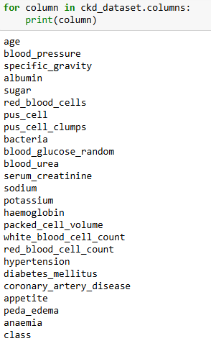
Figure 3.1: Column names of the dataset
Text-based resources relevant to CKD diagnosis and management, including prevention and treatment guidelines, were extracted from medical PDFs stored locally. These documents include:
- Brenner & Rector’s The Kidney (Yu et al., 2019).
- Chronic Kidney Disease, National clinical guideline for early identification and management in adults in primary and secondary care (NICE, 2014).
- ESPEN guideline on clinical nutrition in hospitalized patients with acute or chronic kidney disease (Fiaccadori et al., 2021).
- KDIGO 2012 Clinical Practice Guideline for the Evaluation and Management of Chronic Kidney Disease (KDIGO, 2012)
These documents were processed to provide domain-specific knowledge for the chatbot's knowledge base.

Data Preparation
Data preparation is a critical step in ensuring the dataset is clean, well-structured, and ready for model training. For the CKD chatbot, data preparation involved cleaning, imputing missing values, transforming features and selecting the most relevant ones.

Data Cleaning
The dataset required extensive cleaning to address issues such as incorrect data types, missing values and inconsistencies.
Incorrect Data Types: Some columns were incorrectly stored as strings (object type), even though they represented numerical data. Features such as packed_cell_volume, white_blood_cell_count, and red_blood_cell_count were stored as strings due to inconsistencies in the source data. The columns contain a tab character followed by a number. They were converted to numerical types using pd.to_numeric (). The function pd.to_numeric() automatically strips whitespace or non-visible characters (like tabs or spaces) around a value when attempting to convert it to a number.
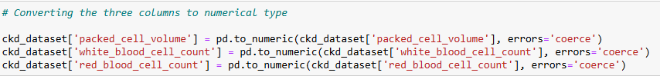
Figure 3.2: Python Code to convert object data type to numerical type
Removing Inconsistencies: Some values in the diabetes_mellitus, coronary_artery_disease and class columns contain leading or trailing tabs. String values with trailing spaces or tabs (e.g., '\tyes') were stripped of whitespace using Python's str.strip () method.
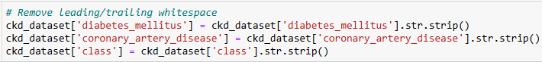
Figure 3.3: Python Code to remove whitespace from strings
Handling Missing Values: The dataset contained missing values across several features, requiring careful handling to prevent bias or inaccuracies. Given the medical nature of this dataset and its importance for predicting chronic kidney disease (CKD), handling missing values requires careful consideration. Numerical variables will be handled differently from categorical variables.
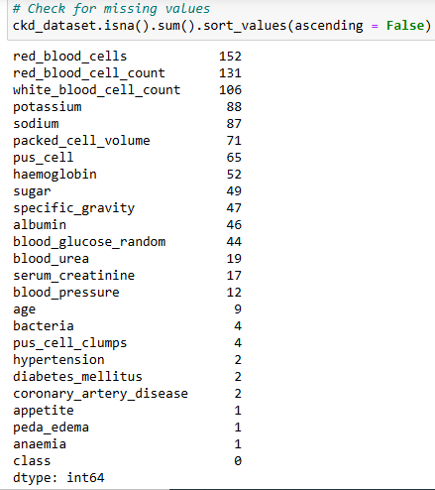
Figure 3.4: Python Code to check for missing values in each column
- Categorical Features: Mode imputation (filling with the most frequent value) was applied to the categorical features with missing values
- Numerical Variables: Missing values were imputed using the K-Nearest Neighbours (KNN) imputation. This method considers relationships among features to estimate missing values. It preserves correlations between variables and leverages patient similarities to provide realistic imputations
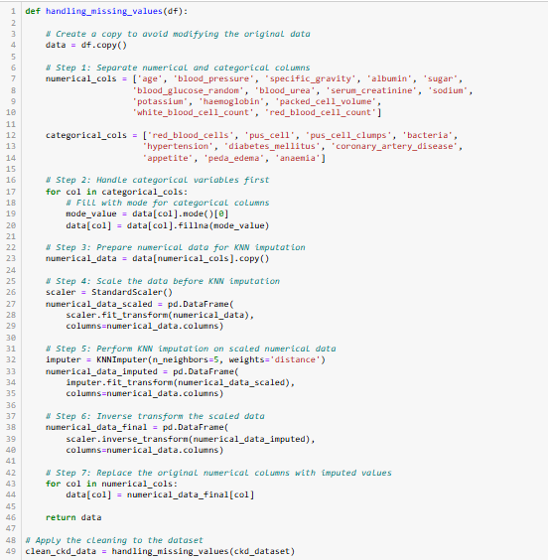
Figure 3.5: Python Function to handle missing values in the dataset

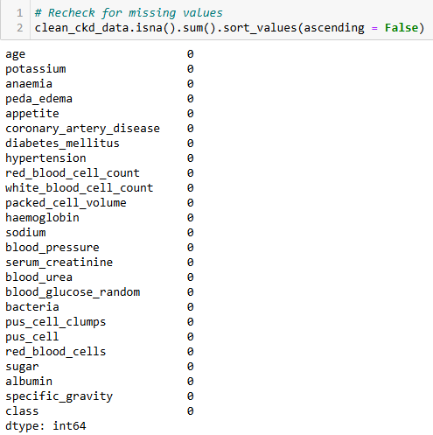
Figure 3.6: Confirmation of no missing values
Duplicate Rows: Checked and found no duplicates in the dataset.
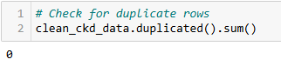
Figure 3.7: Python Code to check for duplicate rows

Feature Engineering and Transformation
Scaling Numerical Features: Numerical features were scaled using StandardScaler to normalize their distributions. This is essential for some machine learning algorithms, especially those based on distance metrics (like K-Nearest Neighbours) or gradient descent (like Logistic Regression), which can benefit from standardized input ranges. All numerical features were transformed to have a mean of 0 and a standard deviation of 1. This equalizes feature influence.
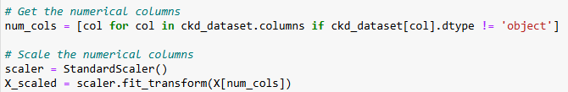
Figure 3.8: Python Code to scale the numerical features
Encoding Categorical Variables: Categorical features were converted into numerical values using LabelEncoder. This ensures compatibility with machine learning models.
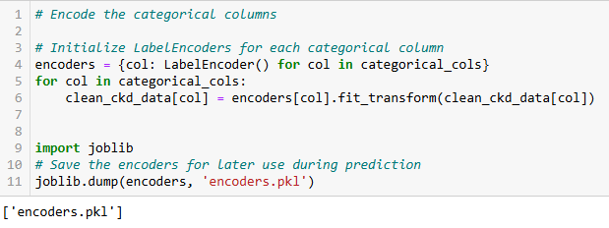
Figure 3.9: Python Code to encode the categorical features and save the encoders

Modelling
The goal of the modelling phase was to build a machine learning model that:
- Classifies patients as either CKD or No CKD.
- Ensures high sensitivity to reduce false negatives (critical in medical diagnostics).
- Generalizes well to unseen data.

Model Selection:
Several machine learning algorithms were evaluated to identify the best model for CKD prediction. Algorithms Considered were:
- Logistic Regression: A linear model for binary classification. Baseline for comparison.
- Naive Bayes: Based on probabilistic classification. Performs well with categorical data but assumes feature independence.
- Support Vector Machine (SVM): Finds the optimal hyperplane for class separation. Effective in handling non-linear relationships using kernels.
- Random Forest Classifier: An ensemble model based on decision trees. Reduces overfitting through bootstrapping and aggregation.
- Decision Tree Classifier: Simple, interpretable, and hierarchical decision-making process.
- K-Nearest Neighbours (KNN): Classifies based on proximity to labelled examples in feature space. Sensitive to data scaling and high dimensionality.
Figure 3.10 and Table 1.1 show respectively, the confusion matrices and evaluation metrics for the six classifiers experimented.
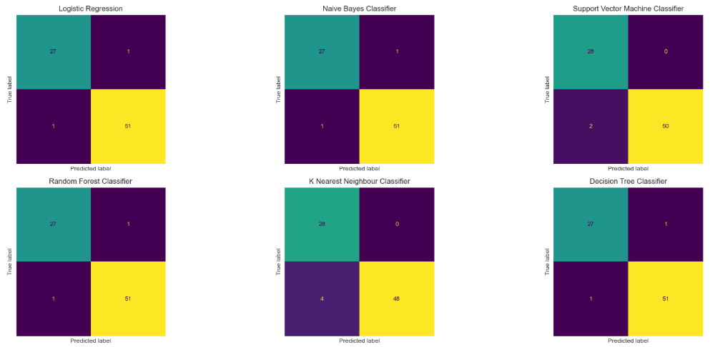
Figure 3.10: Confusion Matrix for the six classifiers experimented
Table 3.1: Comparison Table for the six classifiers
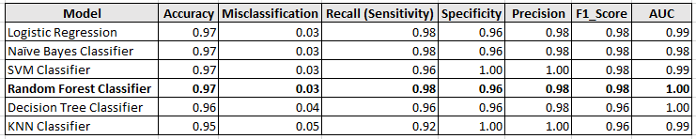
All models show high accuracy, with values above 0.95. The misclassification rate is low for all models, further confirming their accuracy.
Most models have high sensitivity and specificity, indicating their ability to correctly identify both positive (CKD) and negative (non-CKD) cases
The Random Forest and Decision Tree classifiers have the highest AUC of 1.00, indicating their excellent ability to distinguish between positive and negative classes.

Why Random Forest Classifier for the CKD Prediction?
- Considering the overall performance metrics, Random Forest classifier seems to be the best choice for CKD prediction. it exhibits high accuracy, sensitivity, specificity, precision, F1-score and perfect AUC score.
- Random Forest's ensemble nature makes it robust to noise and outliers, reducing the risk of overfitting.
- Random Forest can capture nonlinear relationships and interactions between features, which is often beneficial in medical datasets.
- Random Forest is more likely to generalize well to unseen data due to its ensemble structure and ability to handle complex feature interactions.
- Moreover, it can work well with datasets that have missing values (after simple imputations).

Overview of Random Forest Algorithm
Random Forest is a powerful and versatile algorithm that combines the strengths of multiple decision trees, utilizing randomness to enhance prediction accuracy and robustness (Biau and Scornet, 2016).
Random Forest Construction
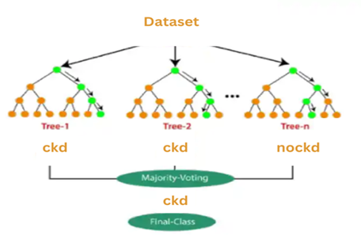
Figure 3.11: Random Forest Classifier
- Bootstrap Sampling: A random subset of data points (rows) and features (columns) (random sample with replacement) is selected from the original dataset. If the original dataset has N samples, each tree is trained on a sample of size N.
- Decision Tree Construction: For each subset, a decision tree is constructed using a specific algorithm. These trees are grown deep to maximize their individual accuracy
- Ensemble Creation: Multiple decision trees are created, each trained on a different random subset of the data.
- Prediction and Voting: When a new data point is presented, each decision tree in the forest makes an independent prediction. For classification tasks, the final prediction is determined by a majority vote among the trees.
- Error Estimation: Out-of-Bag (OOB) error is an internal validation method used in Random Forests to estimate model performance without requiring a separate validation set. Each decision tree in the forest is trained on a bootstrap sample, leaving approximately 37% of the data as "out-of-bag" samples. The out-of-bag error can be estimated as:
OOB Error $=\sum_{i = 1}^{N}{I(}$ 𝑦_{𝑖 ≠} 𝑦̂ _{𝑖, OOB}) (Abdulkareem & Abdulazeez, 2021) ----------------3. 1

Where:

- 𝑁 is the total number of observations.
- 𝑦_{𝑖} is the true class label for the 𝑖-th sample

- 𝑦̂ _{𝑖, OOB} is the predicted class label for the 𝑖-th sample based on the majority vote from trees where the sample was OOB.

- 𝐼 is the indicator function that equals 1 if the condition 𝑦_{𝑖 ≠} 𝑦̂ _{𝑖, OOB} is true (i.e., misclassification), and 0 otherwise.

Advantages of Random Forest
- Ensemble Learning: By combining multiple decision trees, Random Forest reduces the risk of overfitting that can occur with a single decision tree. This ensemble approach leads to more stable and accurate predictions (Talekar & Agrawal, 2020).
- Voting Mechanism: The final classification is determined by a majority vote among the individual trees, which helps to mitigate the impact of errors from any single tree. This collective decision-making process improves overall accuracy (Abdulkareem & Abdulazeez, 2021)
- Random Feature Selection: During the construction of each tree, Random Forest randomly selects a subset of features. This randomness helps to create diverse trees that capture different patterns in the data, leading to better generalization on unseen data
- Out-of-Bag Error Estimation: Random Forest uses out-of-bag samples (data not used in the training of a particular tree) to provide an unbiased estimate of the model's performance. This built-in validation method enhances the reliability of the accuracy assessment (Abdulkareem & Abdulazeez, 2021).
- Variable Importance Measurement: The algorithm provides insights into the importance of different features, allowing for better understanding and optimization of the model. This can lead to improved feature selection and model refinement (Talekar & Agrawal, 2020).
- Handling Missing Values: Random Forest can handle missing values effectively, making it suitable for real-world datasets with missing data.

Application of Random Forest in CKD Prediction
Feature Selection: The model was first trained on all the features
Data Splitting: The data was split into 80% training and 20% testing sets. Key hyperparameters for Random Forest classifier:
- Number of Trees (n_estimators): 100 trees were used to ensure stable predictions.
- Maximum Depth (max_depth): Set to None, (unrestricted) to allow full tree growth.
- Split Criterion (criterion): Gini impurity, which measures the likelihood of incorrect classification.
- Minimum Samples per Split (min_samples_split): Set to 2, requiring sufficient data at each split.
- Minimum Samples per Leaf (min_samples_leaf): Set to 1
Training Process: For each of the 100 trees, a random subset of the training data was selected with replacement. At each split, a random subset of features was considered to find the optimal decision boundary. Data was split at each node based on the feature that minimized Gini impurity. The splitting was stopped when maximum depth was reached and the number of samples in a node was less than min_samples_split (2). For the training set, each tree independently classified the data. The final prediction was determined by majority voting across all trees.

Model Evaluation
The evaluation phase is critical in assessing the performance, robustness, and reliability of the machine learning model for CKD prediction. Below is a detailed exploration of the metrics and validation techniques of the Random Forest Classifier, the chosen model for this task.

Confusion Matrix
A confusion matrix is a table that summarizes the performance of a classification model on a set of test data. It shows how many times the model correctly predicted each class and how many times it made incorrect predictions. This helps in identifying the areas where the model might need improvement.
Table 3.2: Confusion Matrix
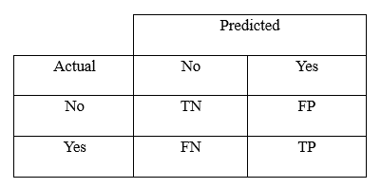
True Positives (TP): Correctly predicted positive cases.
True Negatives (TN): Correctly predicted negative cases.
False Positives (FP): Incorrectly predicted positive cases (Type I error).
False Negatives (FN): Incorrectly predicted negative cases (Type II error).

Evaluation Metrics
Evaluation metrics provide quantitative measures to gauge the model's accuracy, reliability, and overall effectiveness. To ensure comprehensive evaluation, multiple metrics were utilized to capture different aspects of the model's performance, particularly focusing on the medical implications of false negatives and false positives.
Accuracy: This is the ratio of correctly predicted instances to the total number of instances.
Accuracy = $\frac{TP + TN}{TP + TN + FP + FN}$ ---------------------------------------------------------3. 2
Precision: This is the proportion of true positive predictions among all positive predictions. High precision minimizes false positives, which is critical to avoid unnecessary medical interventions
Precision = $\frac{TP}{TP + FP }$ ------------------------------------------------------------------------------3.3
Recall (Sensitivity): This represents the proportion of true positive cases that were correctly identified. High recall ensures that most CKD cases are detected, reducing the likelihood of false negatives, which could delay critical medical attention.
Recall (Sensitivity) = $\frac{TP}{TP + FN }$ -----------------------------------------------------------------3.4
F1-Score: The harmonic mean of precision and recall, balancing false positives and false negatives.
F1 Score = 2 × $\frac{Precision × Recall}{Precision + Recall }$ ------------------------------------------------------ 3.5
AUC-ROC (Area Under the Receiver Operating Characteristic Curve)
The ROC curve plots the true positive rate (TPR) against the false positive rate (FPR) at various thresholds. It measures the ability of the model to distinguish between CKD and non-CKD classes. Area Under the Curve (AUC) values range from 0.5 (random guessing) to 1.0 (perfect discrimination).

Cross-Validation
Cross-validation ensures that the model generalizes well across different subsets of the data, reducing the risk of overfitting. It gives a better estimate of model performance on unseen data compared to a single train-test split. Stratified 10-Fold Cross-Validation was employed in order to maintains the same class distribution in each fold as the original dataset.
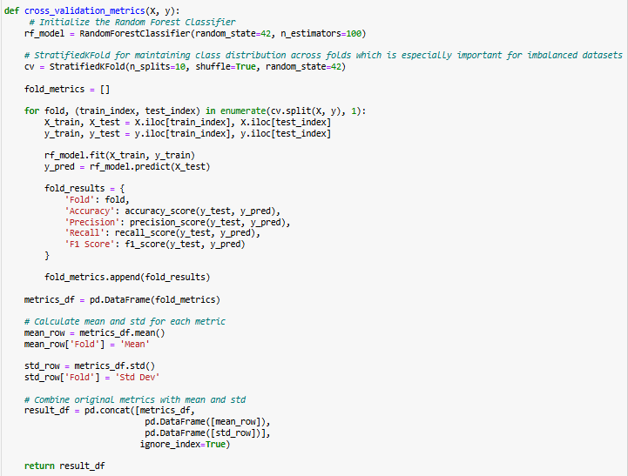
Figure 3.12: Python Code for Stratified 10-Fold Cross-Validation

Model Refinement and Improvement
The refinement of the Random Forest model involved two key processes: feature selection and hyperparameter tuning. These steps were essential for optimizing model performance, enhancing interpretability and ensuring the robustness of the CKD prediction system.

Feature Selection:
Feature selection was performed to identify the most relevant predictors of CKD. This process reduced dimensionality and improved model performance by removing irrelevant or redundant features. To identify the most relevant features for our CKD prediction model, we employed a multi-pronged approach, incorporating four complementary feature selection techniques:
- Univariate Selection (ANOVA F-value): Measured the linear dependency between features and the target variable. Higher F-values indicate stronger linear dependency.

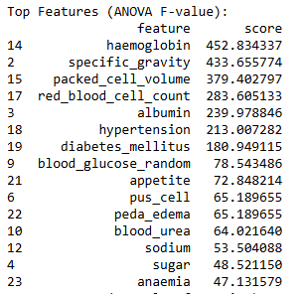
Figure 3.13: Top 15 features by ANOVA F-value
- Mutual Information: Captured both linear and non-linear relationships.

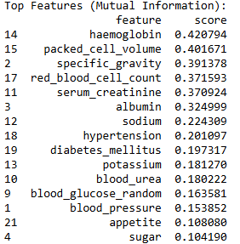
Figure 3.14: Top 15 features by Mutual Information

- Random Forest Feature Importance: Evaluated the reduction in classification error contributed by each feature.

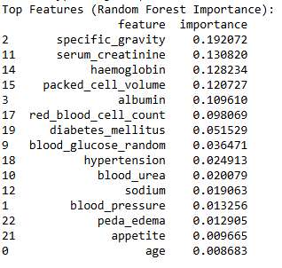
Figure 3.15: Top 15 features by Random Forest Feature Importance
- Recursive Feature Elimination (RFE): Iteratively removed the least significant features based on model performance.
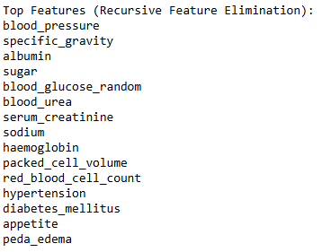
Figure 3.16: Top 15 features by Recursive Feature Elimination
Final Selected Features: The results from the four techniques were compared to identify consistently important features.
Table 3.3: Top 15 selected features by combined method
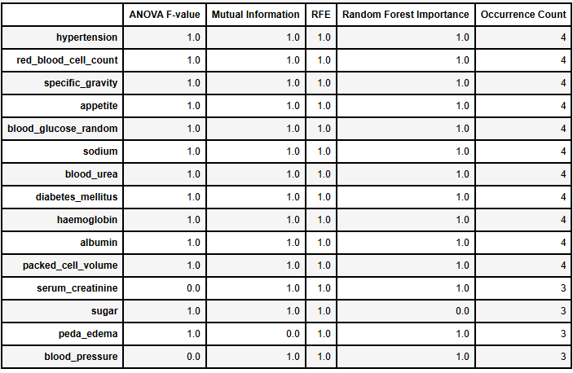
The selected features are:
- Hypertension
- Red Blood Cell Count
- Specific Gravity
- Appetite
- Blood Glucose random
- Sodium
- Blood Urea
- Diabetes Mellitus
- Haemoglobin
- Albumin
- Packed Cell Volume
- Serum Creatinine
- Sugar
- Pedal Edema
- Blood Pressure

Hyperparameter Tuning:
Hyperparameter tuning was conducted to optimize the Random Forest model, ensuring the best performance on the CKD dataset. It enhances accuracy, precision, recall, and F1-score and improves the model’s ability to generalize to unseen data. The following hyperparameters were optimized using GridSearchCV with 5-fold cross-validation.
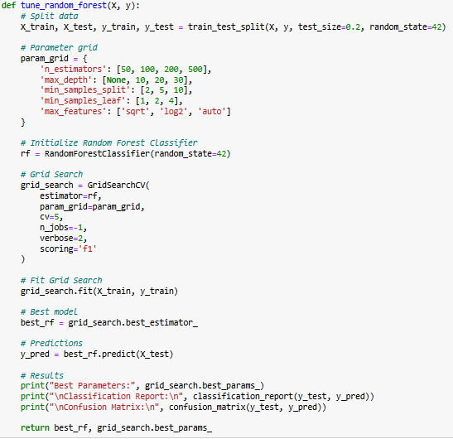
Figure 3.17: Python function for hyperparameter tuning

Table 3.4: Hyperparameter and Best values
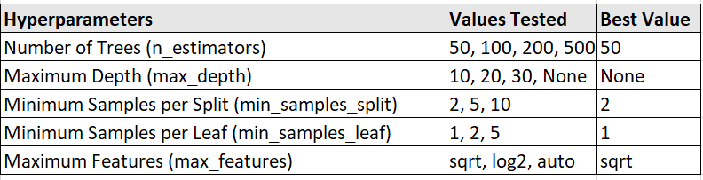

Making Prediction with New Input Data
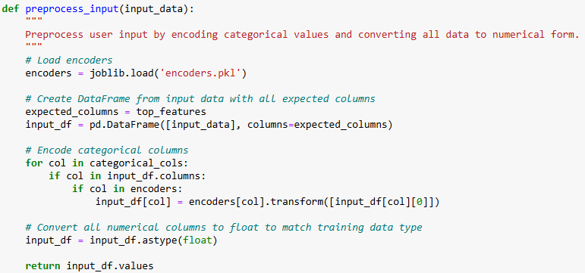
Figure 3.18: Python Code to preprocess raw new data
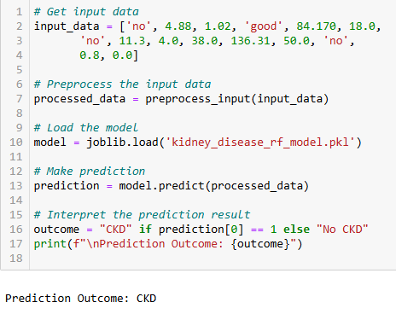
Figure 3.19: Python Code to make prediction on the new data
Figure 3.20 below visualizes the process of building the Random Forest model for the CKD prediction, from data cleaning to making prediction and the iterative nature of the process.
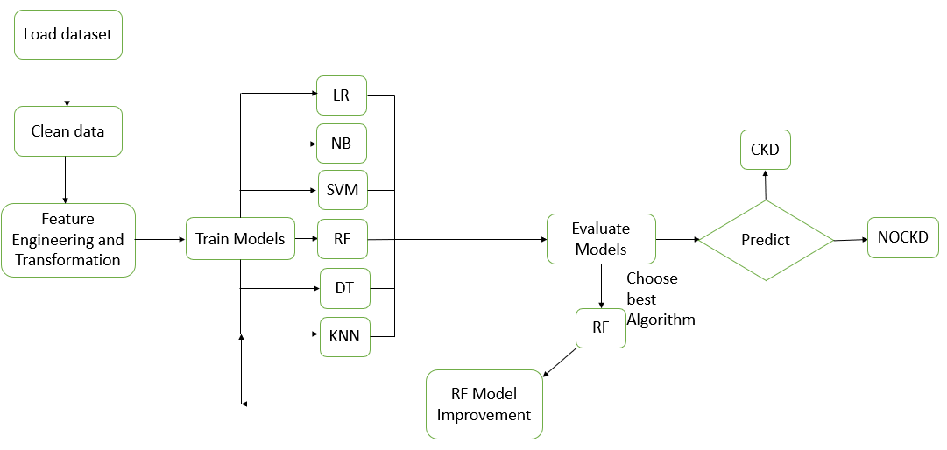
Figure 3.20: Flow Diagram: Building and Improving Random Forest Classifier
The flow diagram in Figure 3.21 visualizes how the predictive model and LLM collaborate to deliver actionable insights.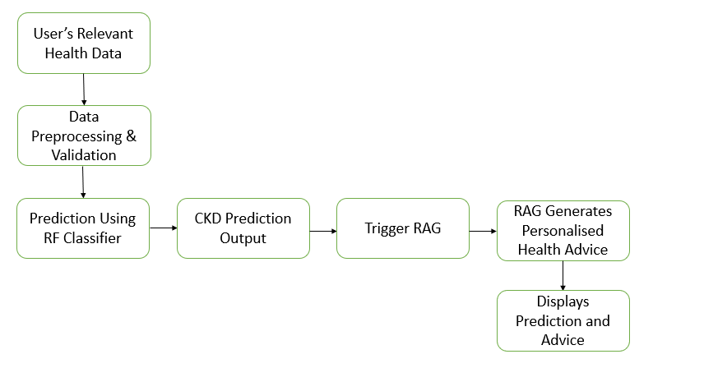
Figure 3.21: Flow Diagram: Prediction and Personalised Advice Process

Deployment

Chatbot Implementation
The Chronic Kidney Disease Prediction Chatbot is designed as an interactive tool that integrates machine learning predictions with conversational AI to assist users in understanding their CKD risk and managing their health. Below are the detailed components of the chatbot's implementation:
Chatbot Architecture: The chatbot leverages the Flask framework for the web interface and integrates LangChain for natural language processing (NLP) to enable conversational interactions. LangChain is a specialized framework for building complex, multi-step conversational AI systems. It bridges the gap between language models (e.g., OpenAI GPT) and external tools like databases, APIs, and document retrieval systems. Its modular architecture enables seamless integration of various components required for creating sophisticated chatbots. The chatbot architecture includes:
- Backend:
- Machine Learning Model: A pre-trained Random Forest Classifier for CKD prediction.
- RAG (Retrieval-Augmented Generation): Used to generate personalized advice by retrieving relevant knowledge snippets from a CKD knowledge base.
- API Integration: OpenAI GPT-based language model for generating human-like responses.
- Frontend:
- HTML/CSS for user interface design.
- JavaScript for dynamic interaction, such as displaying predictions and real-time chatbot responses on the same page.

- Data Flow:
- Users input health data via a form.
- The data is pre-processed and passed to the Random Forest model for prediction.
- Predictions and personalized advice are displayed within the chatbot interface.

Machine Learning Integration: The chatbot integrates the Random Forest prediction model with the conversational AI pipeline.
- Input Handling: User inputs, either via chat or a form, are pre-processed to align with the model's required input format (e.g., numerical scaling, categorical encoding).
- Prediction: The input data is passed to the pre-trained Random Forest Classifier.
- Response Generation: If CKD is predicted, the chatbot suggests lifestyle changes and medical follow-ups. If no CKD is predicted, the chatbot provides tips for maintaining kidney health.
Natural Language Processing (NLP): The chatbot uses OpenAI’s state-of-the-art language model; GPT-4o mini, which excels in understanding and generating human-like text.
- Intent Recognition: The chatbot uses intent detection to understand user questions, such as queries about CKD risk, symptoms, or lifestyle advice.
- RAG Integration: The system retrieves domain-specific information from a pre-indexed CKD knowledge base using Pinecone for similarity searches. Outputs are then passed to the GPT model for conversational response generation.
User Interface and Experience (UI/UX): The chatbot provides an intuitive and seamless experience:
- Interactive Forms: Users input data such as age, blood pressure, diabetes status, and lab results through a guided form. Fields include dropdowns for categorical features and spinners for numerical values.
- Dynamic Result Display: Predictions and advice are displayed on the same page without requiring users to navigate away.
- Real-Time Conversational AI: Users can interact with the chatbot to ask follow-up questions about their predictions or general kidney health.
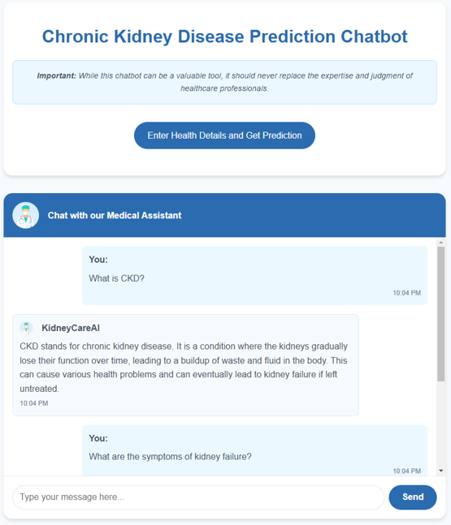
Figure 3.22: Home Page/Chat Interface

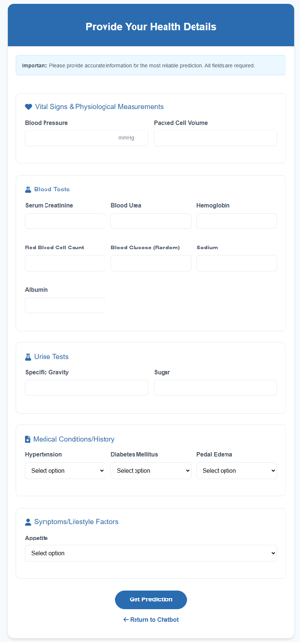
Figure 3.23: Health Form

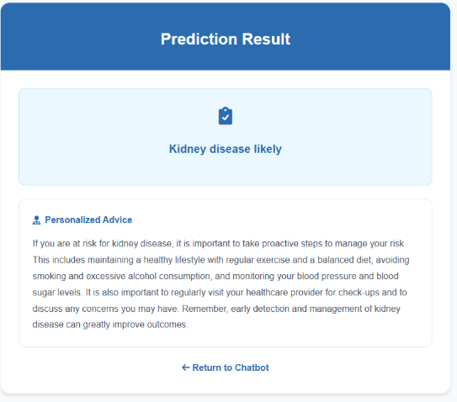
Figure 3.24: Prediction and Personalised Advice Page

Chatbot Workflow
Step 1: User Query or Data Input: Users either ask questions in the chat interface or fill out a health form.
Step 2: Data Preprocessing: Inputs are encoded to match the format required by the model.
Step 3: CKD Risk Prediction: The Random Forest model processes the input and predicts the CKD risk.
Step 4: Retrieval of Knowledge Base Information: Relevant information is retrieved using similarity-based searches.
Step 5: Response Generation: The chatbot combines the prediction results and retrieved knowledge to generate a personalized response.
Step 6: User Engagement: The chatbot responds with empathetic and actionable advice. Users can continue the conversation for further clarifications.

Retrieval-Augmented Generation (RAG) in Chatbot Implementation
Retrieval-Augmented Generation (RAG) enhances the chatbot's ability to provide accurate, personalized, and context-aware responses by combining generative capabilities of large language models (LLMs) with retrieval mechanisms for domain-specific knowledge. The retriever in a RAG system can retrieve relevant information from external resources like documents, web pages and databases.
Key Components of RAG
- Knowledge Base:
- Source: Relevant medical PDFs and documents, such as research papers, guidelines, and FAQs related to CKD.
- Embeddings: Embeddings are numerical representations of text that capture semantic meaning. The sentence-transformers/all-MiniLM-L6-v2 model, provided by Hugging Face, maps sentences or text chunks to dense vectors in a high-dimensional space. Texts with similar meanings are placed closer together in this vector space.
- Indexing: The data is processed into text chunks and indexed using a vector database (Pinecone) for efficient retrieval.
- Retriever: Retrieves the most relevant information based on the user's query. Pinecone is used for vector similarity searches to find the best-matching chunks from the indexed knowledge base.
- Generative Model (LLM): Open AI’s GPT-4o mini model is exposed to medical-specific prompts to ensure accurate and context-aware response generation
Workflow of RAG in the Chatbot
Step 1: User Input
- The user inputs a query, such as: "What are the early signs of CKD?", "How does hypertension affect kidney health?"

Step 2: Query Encoding
- The query is converted into a vector representation using pre-trained embeddings (sentence-transformers/all-MiniLM-L6-v2).
Step 3: Retrieval from Knowledge Base
- The vectorized query is used to perform a similarity search in the indexed database.
- Relevant chunks from the CKD medical PDFs are retrieved.
Step 4: Context Augmentation
- Retrieved text chunks are combined to provide the LLM (GPT-4o mini) with domain-specific context.
Step 5: Response Generation
- The augmented context and user query are passed to the LLM (GPT-4o mini) through LangChain.
- A conversational and user-friendly response is generated.
Step 6: Delivery to User
- The chatbot returns the generated response, ensuring empathy and actionable advice.
Integration of Medical PDFs
- PDF Loading: LangChain's PDF loaders extract content from CKD-related medical documents.
- Text Chunking: Content is divided into manageable chunks (e.g., 500 tokens) to ensure effective retrieval without overwhelming the LLM.
- Indexing: Pinecone indexes the chunks using embeddings generated by Sentence Transformers. Embeddings encode semantic meaning, enabling similarity searches.
- Continuous Updates: New documents can be added to the knowledge base, ensuring the chatbot remains up-to-date.
Below is a conceptual diagram illustrating the integration of RAG, LangChain, OpenAI LLM and medical PDFs.
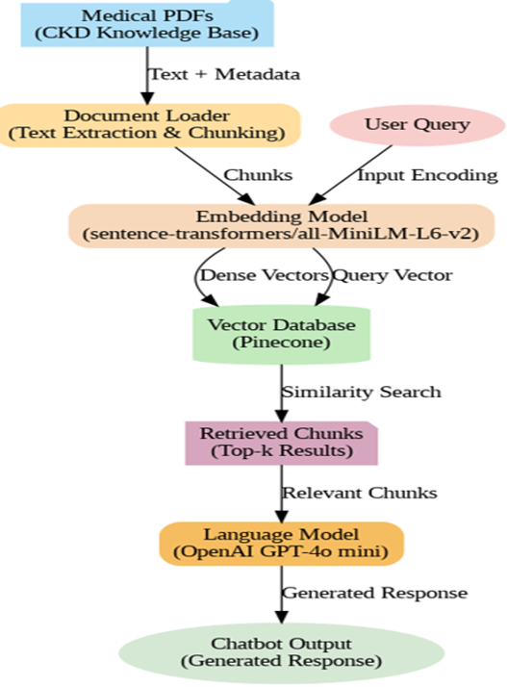
Figure 3.25: RAG Workflow

Software Requirements and Tools
Programming Languages:
- Python: For developing the machine learning model, integrating conversational AI, and backend functionalities.
- JavaScript: To add dynamic behavior to the front end
- HTML and CSS: For creating and styling the user interface.
Frameworks and Libraries:
- Machine Learning and Data Processing and Visualization:
- Pandas and NumPy: For data preprocessing, cleaning, and manipulation.
- Matplotlib and Seaborn: For exploratory data analysis (EDA) and presenting insights.
- Scikit-learn: For developing the Random Forest Classifier and feature selection techniques.
- Conversational AI:
- OpenAI LLM: Provides natural language understanding and generation capabilities for conversational AI.
- LangChain: Facilitates conversation management and integration of Retrieval-Augmented Generation (RAG) for delivering personalized advice.
- Sentence-Transformers (all-MiniLM-L6-v2): Used for semantic search and embedding generation in RAG systems.
Database:
- Pinecone Vector Database: For storing and retrieving vector embeddings efficiently as part of the RAG implementation.
Backend Development:
- Flask: To handle backend operations and API endpoints for predictions and chatbot interactions.
Development and Experimentation:
- Jupyter Notebook: Used for data preprocessing, feature selection, and iterative experimentation with the machine learning model.
- Visual Studio Code (VS Code): Employed as the primary code editor for writing, debugging, and managing project code.
Version Control:
- Git and GitHub: For version control, collaboration, and repository management

  - ANALYSIS, RESULTS AND FINDINGS
The data analysis phase serves as the backbone for building a robust CKD prediction model. In this section, a detailed, methodical and in-depth analysis of the dataset is provided. This includes univariate, bivariate and multivariate analyses, statistical assessments and feature exploration, supported by visualizations and insights.

Exploratory Data Analysis (EDA)

Univariate Analysis
Univariate analysis explores each feature individually to understand its distribution and potential relationship to CKD.
Class Distribution Analysis
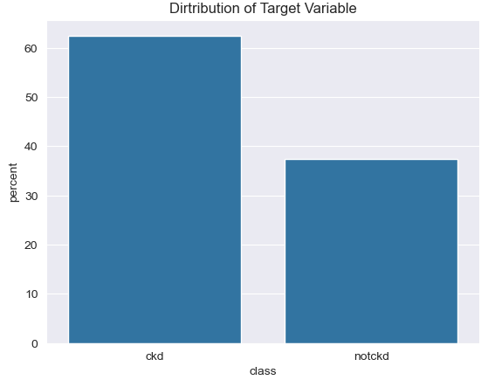
Figure 4.1: Distribution of the Target variable
The target variable, class, is slightly imbalanced:
- CKD Cases: 250 records (62.5%).
- Non-CKD Cases: 150 records (37.5%).
This class imbalance is critical because:
- Medical diagnosis applications prioritize recall to avoid false negatives (missed CKD cases).
- Precision is equally important to reduce unnecessary medical interventions due to false positives.
Numerical Features
- Age:
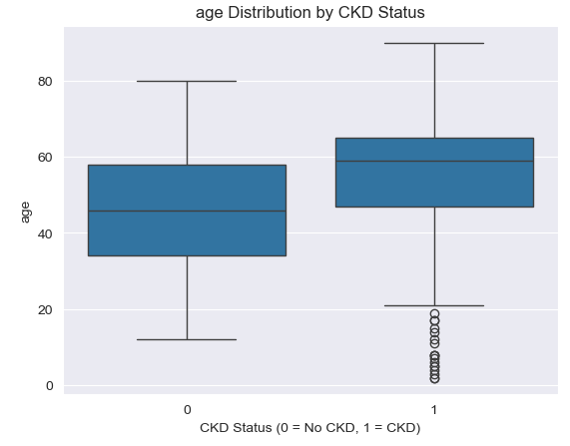
Figure 4.2: Age Distribution by CKD Status
The age distribution for CKD patients (CKD status = 1) is skewed to the left, with the majority of patients clustered towards the higher end of the age range. This indicates that while CKD can occur across a wide age spectrum, the incidence tends to be higher in older individuals. Patients with CKD (CKD status = 1) have a significantly higher median and overall age range compared to those without CKD (CKD status = 0). This suggests that increasing age is a risk factor associated with the development of CKD. The outliers in the CKD group primarily represent individuals who are significantly younger than the typical age range for CKD. This suggests that a subset of the CKD population may experience early-onset disease, possibly due to genetic factors, environmental exposures, or other underlying medical conditions.
- Blood Pressure:
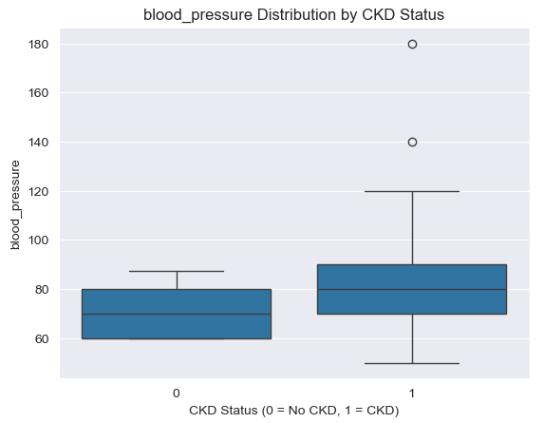
Figure 4.3: Blood Pressure Distribution by CKD Status
The median blood pressure for individuals with CKD (CKD Status = 1) is significantly higher than those without CKD (CKD Status = 0). This suggests a strong association between elevated blood pressure and the development of CKD. There are two notable outliers in the CKD group, representing individuals with significantly higher blood pressure than the typical range for people with CKD. These outliers could indicate cases of severe hypertension or measurement errors

- Specific Gravity of Urine:
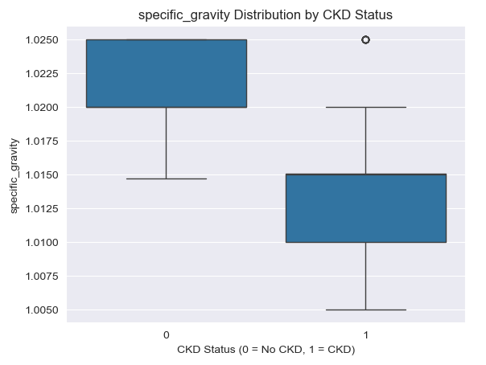
Figure 4.4: Specific Gravity Distribution by CKD Status
The median specific gravity for individuals with CKD (CKD Status = 1) is significantly lower than those without CKD (CKD Status = 0). This suggests a potential association between lower specific gravity and the development of CKD.
- Albumin:
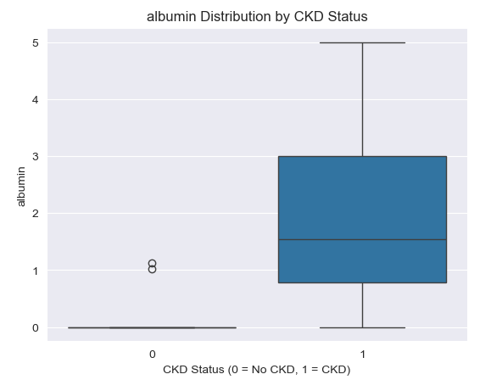
Figure 4.5: Albumin Distribution by CKD Status
The analysis reveals significant differences in albumin levels between CKD and non-CKD patients. CKD patients show higher albumin levels overall, with greater variability in their distribution. The boxplot demonstrates a clear separation between the two groups, suggesting albumin levels could be a useful diagnostic indicator for CKD.
- Sugar Level in Urine:
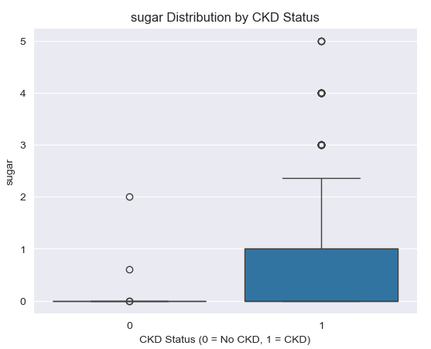
Figure 4.6: Sugar Distribution by CKD Status
CKD patients exhibit a wider range of sugar levels in urine, with some extreme outliers indicating significantly high sugar levels. This suggests that high sugar levels in urine might be more prevalent among CKD patients. Non-CKD patients show a more concentrated distribution of sugar levels, with fewer outliers and lower median values. This indicates that non-CKD patients generally maintain normal sugar levels.
- Blood Urea:
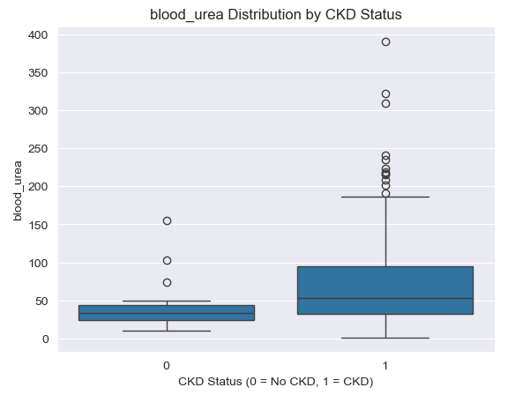
Figure 4.7: Blood Urea Distribution by CKD Status
The box plot demonstrates a strong association between elevated blood urea levels and CKD. Individuals with CKD tend to have higher blood urea compared to those without CKD.
- Blood Glucose Random:
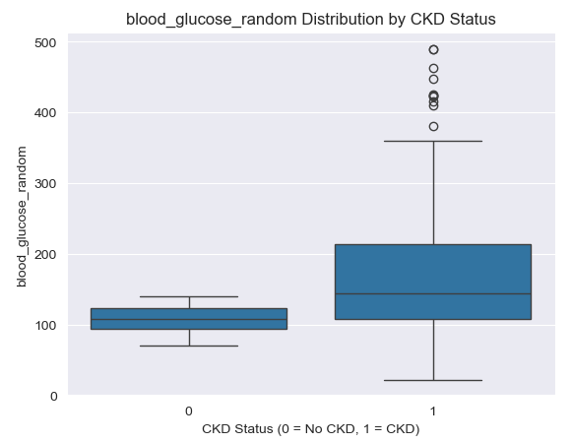
Figure 4.8: Blood Glucose Distribution by CKD Status
The median blood glucose level for individuals with CKD (CKD Status = 1) is significantly higher than those without CKD (CKD Status = 0). This suggests a strong association between elevated blood glucose and the development of CKD. The box plot demonstrates a strong association between elevated blood glucose levels and CKD. Individuals with CKD tend to have higher blood glucose compared to those without CKD.
- Serum Creatinine:
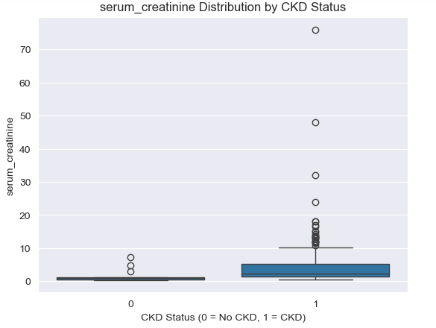
Figure 4.9: Serum Creatinine Distribution by CKD Status
The median serum creatinine level for individuals with CKD (CKD Status = 1) is significantly higher than those without CKD (CKD Status = 0). This suggests a strong association between elevated serum creatinine and the development of CKD.

- Sodium:
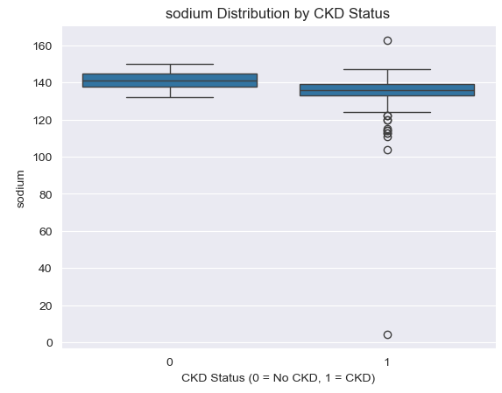
Figure 4.10: Sodium Distribution by CKD Status
The median sodium levels for individuals with CKD (CKD Status = 1) and those without CKD (CKD Status = 0) appear to be very similar. This suggests that sodium levels alone may not be a strong predictor of CKD status.
- Haemoglobin:
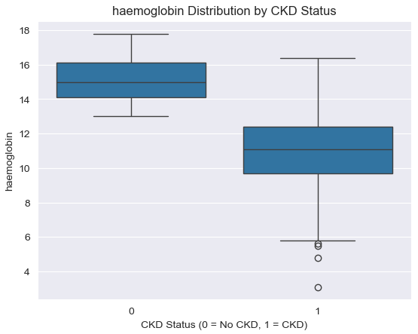
Figure 4.11: Haemoglobin Distribution by CKD Status
The box plot demonstrates a strong association between lower haemoglobin levels and CKD. Individuals with CKD tend to have lower haemoglobin compared to those without CKD. Monitoring haemoglobin levels is crucial for early detection, risk assessment, and management of CKD.

- Packed Cell Volume:
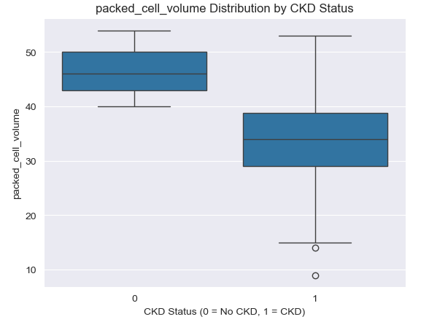
Figure 4.12: Packed Cell Volume Distribution by CKD Status
The median packed cell volume (PCV) for individuals with CKD (CKD Status = 1) is significantly lower than those without CKD (CKD Status = 0). This suggests a strong association between lower PCV and the development of CKD.

- Red Blood Cell Count:
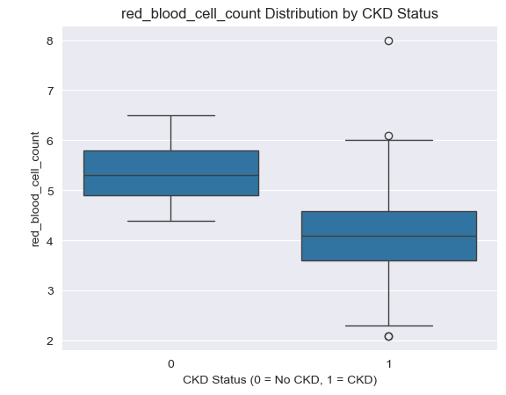
Figure 4.13: Red Blood Cell Count Distribution by CKD Status
The median red blood cell count for individuals with CKD (CKD Status = 1) is significantly lower than those without CKD (CKD Status = 0). This suggests a strong association between lower red blood cell count and the development of CKD.
Categorical Features
- Red Blood Cell:
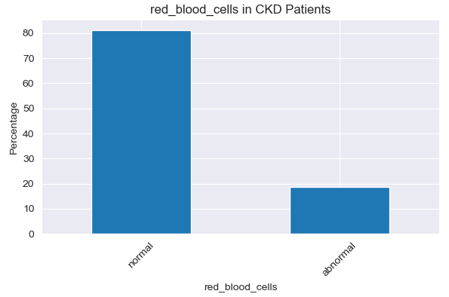
Figure 4.14: Red Blood Cell in CKD Patients
The proportion of CKD patients with normal red blood cells is significantly higher (about 80%) compared to those with abnormal red blood cells.
- Hypertension:
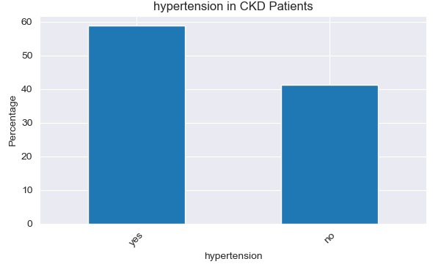
Figure 4.15: Hypertension in CKD Patients
A large proportion (around 60%) of CKD patients have hypertension. This is a well-established risk factor for CKD, as high blood pressure can damage the kidneys over time.
- Diabetes Mellitus:
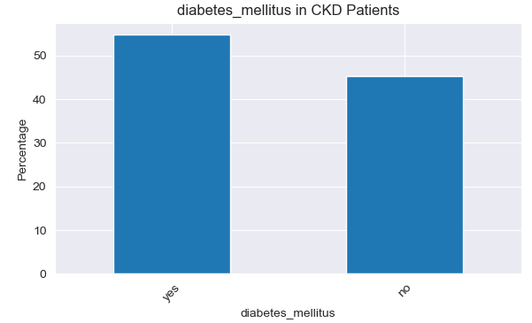
Figure 4.16: Diabetes Mellitus in CKD Patients
CKD patients show a notable presence of diabetes mellitus, with a significant proportion (around 55%) of patients exhibiting this comorbidity. This is another major risk factor for CKD, as high blood sugar levels can damage the kidneys and lead to diabetic nephropathy.
- Coronary Artery Disease:
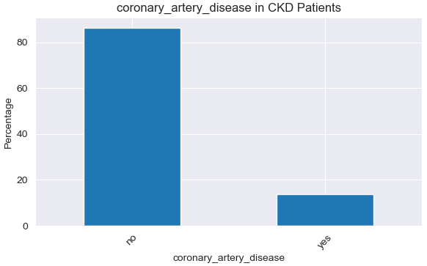
Figure 4.17: Coronary Artery Disease in CKD Patients
The percentage of CKD patients with coronary artery disease is around 15%
- Appetite:
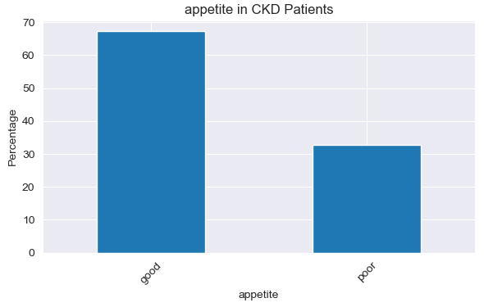
Figure 4.18: Appetite in CKD Patients
The percentage of CKD patients with poor appetite is approximately 35%
- Pedal Edema:
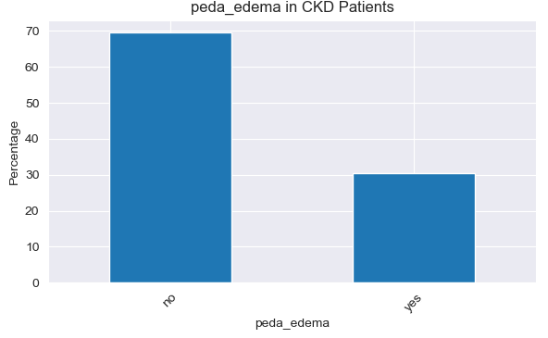
Figure 4.19: Pedal Edema in CKD Patients
Around 30% of CKD patients experienced pedal edema, which is swelling in the feet and ankles

- Anaemia:
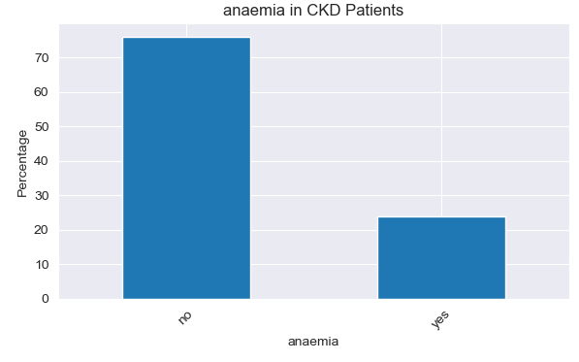
Figure 4.20: Anaemia in CKD Patients
The percentage of CKD patients suffering from anaemia is around 25%.
The low prevalence of some commonly associated conditions, like coronary artery disease and anaemia, may suggest the presence of data quality issues and small sample size data. With a small sample size, the percentages shown for the various conditions may not be representative of the broader CKD patient population. This calls for a need for larger, more diverse datasets

Bivariate Analysis:
- Packed Cell Volume Vs Haemoglobin by CKD Status
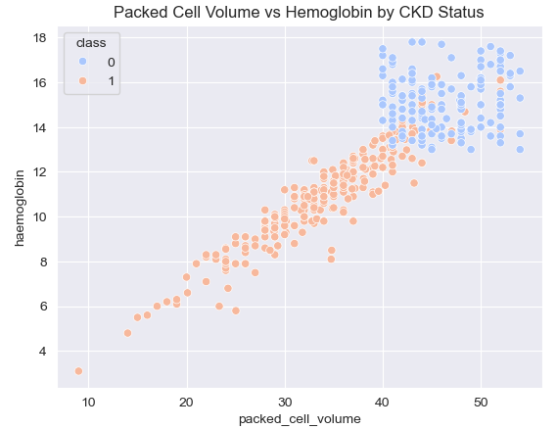
Figure 4.21: Scatterplot of Packed Cell Volume Vs Haemoglobin by CKD Status
The plot shows the relationship between packed cell volume (a measure of red blood cell concentration) and haemoglobin levels, with the data points colored by CKD status (0 for no CKD, 1 for CKD present). CKD-positive (class 1) patients generally exhibiting lower packed cell volume and haemoglobin levels compared to the non-CKD (class 0) patients, suggesting that CKD is associated with a reduction in both packed cell volume and haemoglobin.
- Red Blood Cell Count Vs Haemoglobin by CKD Status
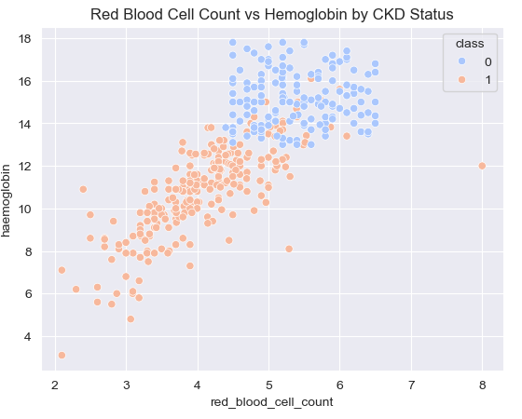
Figure 4.22: Scatterplot of Red Blood Cell Count Vs Haemoglobin by CKD Status
There is a clear positive correlation between RBC Count and Hemoglobin levels. Individuals with CKD (Class 1) tend to have lower RBC Counts and Hemoglobin levels compared to those without CKD (Class 0)
- Blood Urea Vs Blood Glucose Random by CKD Status
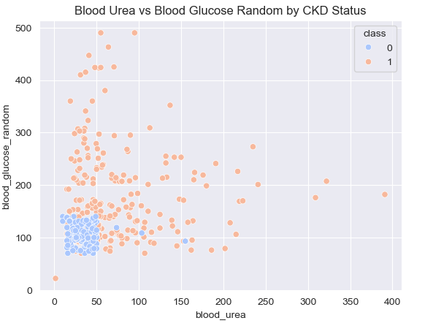
Figure 4.23: Scatterplot of Blood Urea Vs Blood Glucose Random by CKD Status
Individuals with CKD (Class 1) tend to have higher Blood Urea levels and blood glucose random compared to those without CKD (Class 0).
- White Blood Cell Count vs Haemoglobin by CKD Status
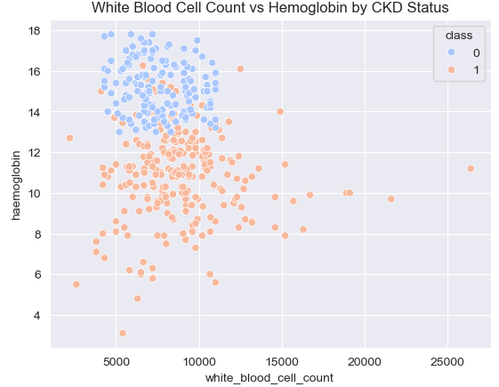
Figure 4.24: Scatterplot of White Blood Cell Count vs Haemoglobin by CKD Status
The plot reveals a negative correlation between white blood cell count and haemoglobin levels, with CKD-positive patients generally having lower haemoglobin and higher white blood cell counts compared to non-CKD patients.
- Packed Cell Volume vs Red Blood Cell Count by CKD Status
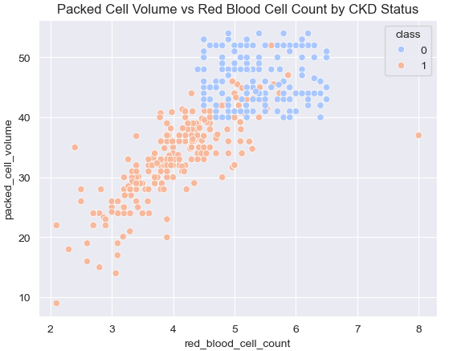
Figure 4.25: Scatterplot of Packed Cell Volume vs Red Blood Cell Count by CKD Status
There is a strong positive correlation between PCV and Red Blood Cell Count. Individuals with CKD (Class 1) tend to have lower PCV and Red Blood Cell Count compared to those without CKD (Class 0).
- Blood Pressure Distribution by Diabetes Status in CKD Patients
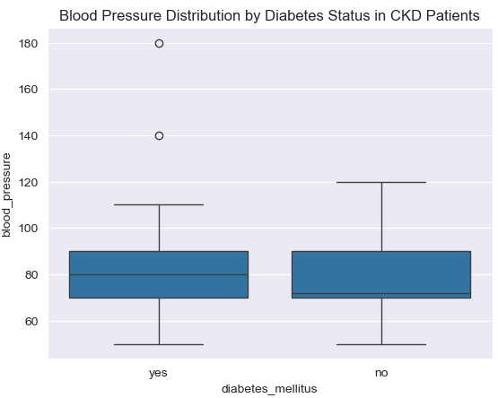
Figure 4.26: Scatterplot of Blood Pressure Distribution by Diabetes Status in CKD Patients
The analysis shows that CKD patients with diabetes tend to have slightly higher blood pressure (mean ~80 mmHg) compared to those without diabetes (mean ~70 mmHg), with more variability in their readings.

Multivariate Analysis
- Symptoms Distribution by Hypertension Status in CKD Patients
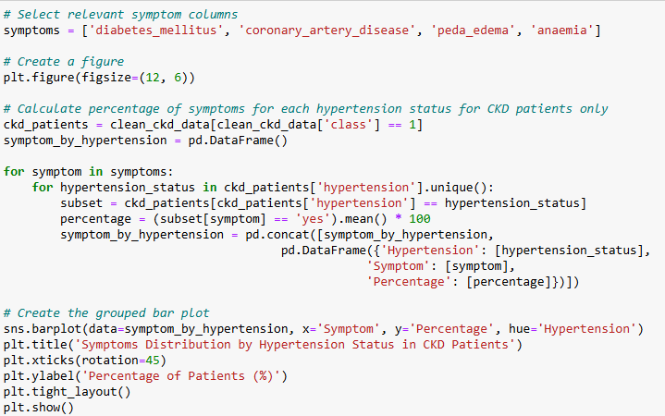
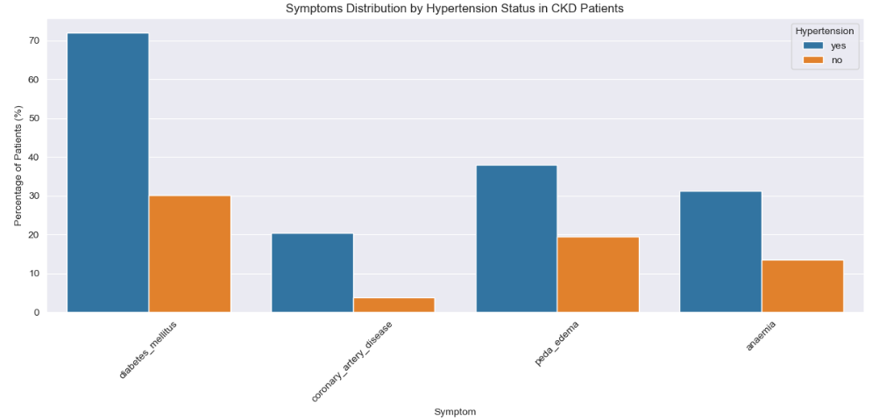
Figure 4.27: Symptoms Distribution by Hypertension Status in CKD Patients
The bar plot above shows the distribution of common symptoms among CKD patients categorized by their hypertension status ("yes" vs. "no"). Patients with hypertension generally report higher percentages of symptoms like diabetes mellitus, coronary artery disease, pedal edema and anaemia compared to those without hypertension.
- Symptoms Distribution by Appetite Status in CKD Patients
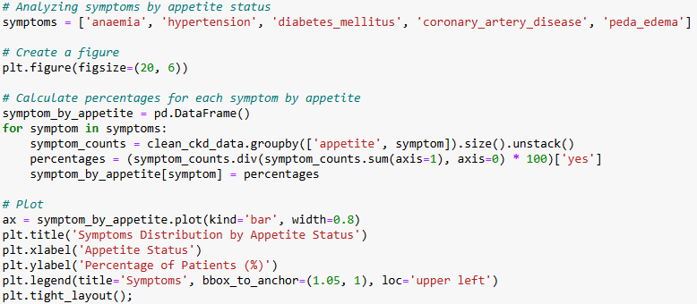
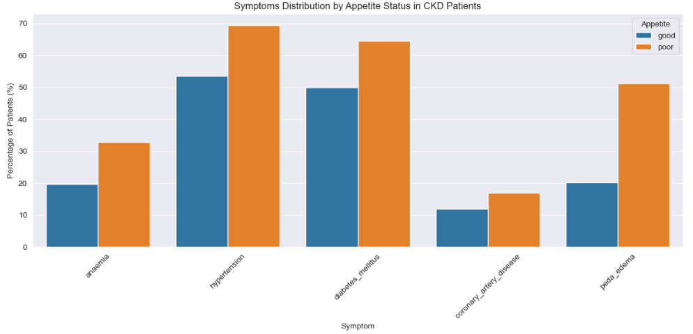
There's a clear correlation between poor appetite and increased prevalence of CKD symptoms. Patients with poor appetite show higher rates of all symptoms

Correlation Between Features and the Target Variable
The heatmap provides a comprehensive visual representation of the strength and nature of the relationship between individual features and the target variable
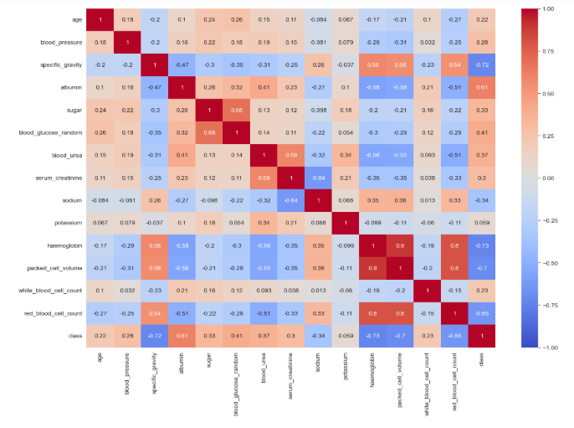
Figure 4.28: Heatmap of the correlation between the features
- Haemoglobin (r ≈ -0.73): Haemoglobin levels demonstrated a strong negative correlation with CKD status. Lower haemoglobin levels are prevalent in CKD patients, primarily due to reduced erythropoietin production by impaired kidneys, leading to anaemia.
- Specific Gravity (r ≈ -0.72): A strong negative correlation was observed between specific gravity and CKD status. CKD patients generally exhibit lower specific gravity due to the kidneys' diminished ability to concentrate urine, which is a hallmark of CKD progression.
- Packed Cell Volume (PCV) (r ≈ -0.70): PCV showed a strong negative correlation with CKD status, with lower values associated with CKD.
- Red Blood Cell Count (r ≈ -0.65): A moderate negative correlation was found between red blood cell count and CKD status. CKD patients generally have lower red blood cell counts due to reduced erythropoiesis.
- Albumin ((r ≈ -0.61): A correlation coefficient of 0.61 indicates a moderate positive correlation between albumin levels and CKD. This means that as albumin levels decrease, the risk of developing or worsening CKD tends to increase.

Model Evaluation and Performance

Confusion Matrix Analysis
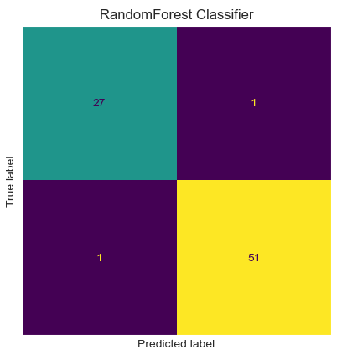
Figure 4.29: Confusion matrix for the base Random Forest Classifier
True Positives (TP): Correctly predicted positive cases. 51 cases of CKD were correctly identified
True Negatives (TN): Correctly predicted negative cases. 27 cases were correctly classified as non-CKD.
False Positives (FP): Incorrectly predicted positive cases (Type I error). 1 case was incorrectly classified as CKD.
False Negatives (FN): Incorrectly predicted negative cases (Type II error). 1 case of CKD was missed, requiring close examination due to medical implications.

Evaluation Metrics
Accuracy: The Random Forest Classifier achieved an accuracy of 97%, indicating that 97% of the predictions were correct.
Precision: The precision for the model was 98%. High precision minimizes false positives, which is critical to avoid unnecessary medical interventions
Recall (Sensitivity): The recall for the model was 98%. High recall ensures that most CKD cases are detected, reducing the likelihood of false negatives, which could delay critical medical attention
Specificity: The model’s specificity was 98%
F1 Score: The F1-score was 98%, indicating a balanced performance across precision and recall.
AUC Score: The model achieved an AUC-ROC of 1.00, demonstrating perfect discrimination.
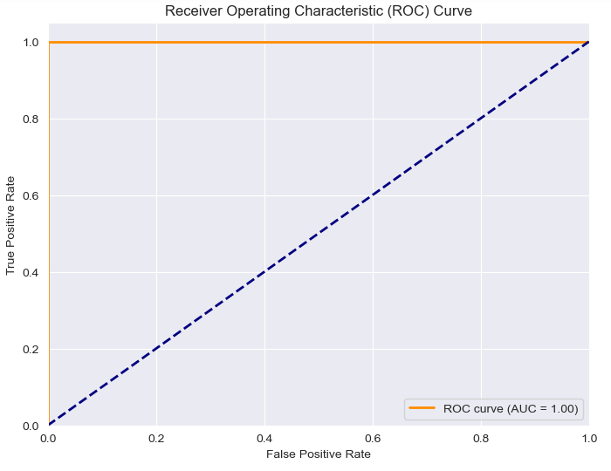
Figure 4.30: ROC Curve for the base Random Forest Classifier

Cross-Validation Results
Table 4.1: Stratified 10-Fold Cross-Validation Results
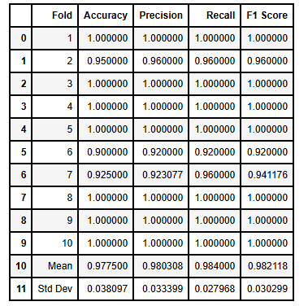
Results Across Folds:
- Mean Accuracy, Mean Precision, Mean Recall and Mean F1 Score = 98%
- Standard Deviation for Accuracy = 4%
- Standard Deviation for Precision, Recall and F1 Score = 3%

Model Improvement: Final Model Performance
After applying feature selection and hyperparameter tuning, the refined Random Forest model was evaluated on the test set.

Confusion Matrix:
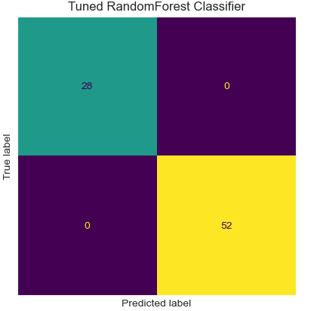
Figure 4.31: Confusion Matrix for the Improved Random Forest Classifier
True Positives (TP): 52
True Negatives (TN): 28
False Positives (FP): 0
False Negatives (FN): 0

Evaluation Metrics
The tuned model’s performance was evaluated using the test set. Perfect metrics (1.00 for all) demonstrated the Random Forest model’s exceptional predictive power.
Table 4.2: Evaluation Metrics for the improved Random Forest Classifier
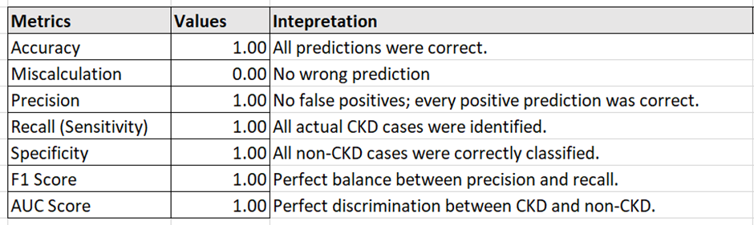

AUC-ROC (Area Under the Receiver Operating Characteristic Curve): The ROC curve forms a perfect diagonal line from the bottom left corner to the top right corner. This indicates that the model has achieved perfect classification. The AUC score is 1.00, which is the maximum possible value. This further confirms the model's exceptional performance for CKD Prediction.
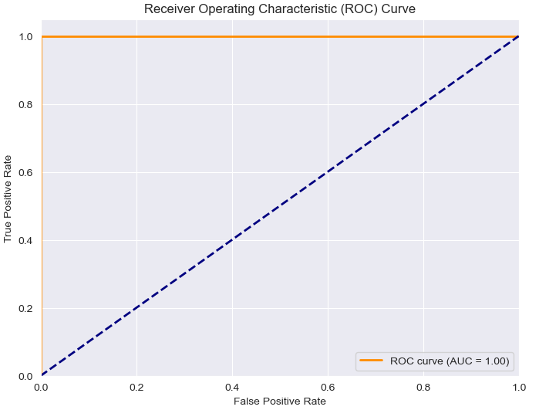
Figure 4.32: ROC Curve for the improved Random Forest Classifier
While the tuned Random Forest model achieved perfect metrics (accuracy, precision, recall, specificity, F1-score, and AUC-ROC all equal to 1.00), the small sample size and target variable imbalance can have significant implications on the reliability and generalizability of these results.
Small Sample Size
- With only 400 records, the model may capture noise or patterns specific to the training data rather than generalizable patterns. This could lead to overly optimistic metrics that do not hold up on new, unseen data.
- A small sample size may fail to capture the full diversity of CKD cases, such as variations in symptoms, comorbidities, and demographics. The model may perform well within the limited dataset but struggle with real-world variability.

Imbalanced Target Variable (63%-37%)
- In an imbalanced dataset, the model can achieve high accuracy by focusing on the majority class (CKD) at the expense of the minority class (non-CKD). While this does not appear to be the case with perfect precision and recall, the imbalance must still be scrutinized.
- Perfect recall (1.00) suggests that the model identified all CKD cases, but this may not be reliable in practice, especially if the minority class (non-CKD) is underrepresented. Precision might also be inflated because false positives are less likely in the imbalanced setup.
While the tuned Random Forest model achieved perfect metrics, caution is warranted due to the small sample size and target variable imbalance. These factors may inflate model performance and undermine its generalizability to real-world data. Addressing these issues through data augmentation, balanced sampling, and rigorous validation is crucial for deploying the model with confidence in a clinical setting.

Feature Importance Analysis
Feature importance scores were derived from the Random Forest model to interpret which predictors contributed most to CKD classification.
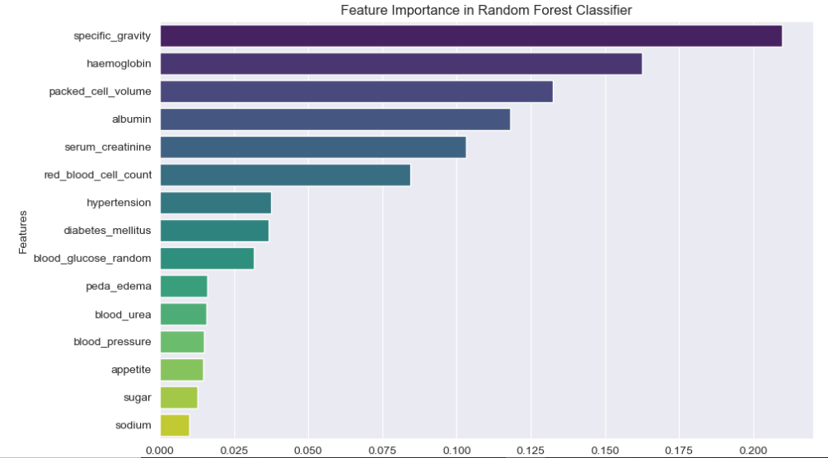
Figure 4.33: Plot of Improved Random Forest Classifier Feature Importance

- Specific Gravity: This is the most important feature, with the highest importance score. The high importance of specific gravity indicates that measuring the concentration of solutes in the urine is a critical factor in identifying CKD. This aligns with the fact that reduced kidney function leads to an imbalance in the filtration and excretion of waste products, which affects the specific gravity of urine.
- Haemoglobin: The second most important feature is haemoglobin level. This implies that the patient’s haemoglobin concentration is also a significant predictor of the condition. Haemoglobin is a protein in red blood cells that carries oxygen, and its imbalance can be associated with kidney disease.
- Packed Cell Volume: This feature, which measures the volume of red blood cells in the blood, is the third most important. This suggests that the packed cell volume is also a valuable predictor for the CKD
- Albumin: The fourth most important feature is albumin, a protein found in the blood. Albumin levels can provide information about kidney function. Damage to the kidney filtering mechanisms can lead to the leakage of albumin into the urine.
- Serum Creatinine: This feature, which measures the amount of creatinine in the blood, is the fifth most important. Creatinine is a waste product that is filtered out by the kidneys, and its elevated levels can be an indicator of kidney dysfunction.

  - CONCLUSION AND RECOMMENDATION

Conclusion
This study has successfully developed an innovative AI-powered chatbot for the prediction and management of Chronic Kidney Disease (CKD), addressing the limitations of traditional diagnostic methods and healthcare delivery systems. By integrating a machine learning (ML)-based prediction model with conversational AI, this research demonstrates the potential of advanced technology to revolutionize chronic disease management. The chatbot, underpinned by a Random Forest Classifier and Retrieval-Augmented Generation (RAG) architecture, delivers accurate CKD risk assessments and personalized health recommendations through an intuitive conversational interface.

Summary of Key Findings:
- High Predictive Accuracy: The Random Forest Classifier, trained on a curated CKD dataset, achieved an outstanding AUC-ROC score of 1.00, underscoring its efficacy in distinguishing CKD from non-CKD cases. The model's high sensitivity and specificity address critical healthcare needs by minimizing false negatives and reducing unnecessary interventions.
- Seamless Integration: The chatbot combines ML predictions with conversational AI, enabling real-time, patient-specific insights. The integration ensures technical reliability while maintaining user-friendliness, making it accessible to individuals with varying levels of technical expertise.
- Enhanced Engagement: The chatbot’s conversational capabilities effectively engage users, fostering trust and empowering patients to proactively manage their kidney health. This interaction model demonstrates the viability of chatbots as tools for health education and personalized care.
- Scalability and Accessibility: The system is designed to function in diverse settings, including resource-constrained environments, offering a scalable solution for CKD management and addressing health disparities.
These findings align with the research objectives, demonstrating the feasibility and impact of integrating predictive analytics with conversational AI to bridge gaps in CKD care. The chatbot serves as a valuable tool for early detection, patient education, and personalized management, contributing to improved health outcomes and reduced healthcare burdens.

Implications of the Findings:
The implications of this research extend across healthcare, technology, and public health domains:
- Healthcare Systems: The chatbot can alleviate the burden on healthcare systems by functioning as an initial triage tool, identifying high-risk individuals and directing them to appropriate medical care. Its ability to provide personalized advice enhances patient compliance and improves long-term outcomes.
- Patient Empowerment: By delivering real-time, actionable insights, the chatbot empowers individuals to take charge of their health, promoting preventive care and fostering a proactive approach to disease management.
- AI in Medicine: The study underscores the transformative potential of AI in healthcare, particularly in integrating advanced analytics with conversational systems to address complex medical challenges.
- Public Health Impact: The system’s scalability and accessibility make it an effective tool for CKD screening and education in underserved populations, contributing to health equity and improved population health.
- The study contributes to the growing body of knowledge on AI applications in nephrology and healthcare at large, highlighting the potential of integrated systems to bridge gaps between technology and patient-centered care.

Comparison with Existing Literature
Studies employing machine learning (ML) techniques, such as Support Vector Machines (SVM), Random Forests, and ensemble methods, have demonstrated superior accuracy compared to traditional models. For instance, Samet, Laouar, and Bendib (2021) achieved an accuracy of 99.24% using an optimized Random Forest algorithm, emphasizing the importance of dimensionality reduction and imputation methods. The Random Forest Classifier in this research aligns with the findings of Samet et al., achieving high predictive accuracy (100%) while addressing critical challenges such as missing data and feature selection. The use of hyperparameter tuning and cross-validation further enhances model reliability, contributing to the advancement of ML techniques in CKD prediction.
Existing conversational AI tools in healthcare, such as CKD Helper (Periyasamy, Kaivelikkal, and Iyer, 2022), focus on diagnostic support and patient engagement. However, they lack dynamic prediction capabilities and often rely on predefined knowledge bases. The chatbot developed in this research integrates a real-time predictive model with Retrieval-Augmented Generation (RAG), enabling it to deliver dynamic, personalized health recommendations. This enhances its utility over static systems by providing contextually relevant insights tailored to individual risk profiles.

Potential Limitations
- Sample Size:
- With 400 records, the dataset’s small size limits generalizability, as it may not capture the full diversity of CKD cases.
- The perfect performance metrics could be overly optimistic due to this constraint.
- Feature Selection Bias:
- Strong reliance on specific features might bias the model towards certain types of CKD manifestations.
- Class Imbalance:
- The 62.5%-37.5% distribution may skew results despite mitigation strategies, as the minority class remains underrepresented.

Recommendations
- Implementation in Clinical Settings: Healthcare institutions should adopt AI-powered chatbots as part of their CKD management programs. These systems can complement existing diagnostic tools, serving as decision support systems for clinicians and providing patients with preliminary risk assessments.
- Integration with Electronic Health Records (EHRs): By linking the chatbot with EHR systems, healthcare providers can streamline patient management workflows, ensuring that chatbot-generated insights are seamlessly incorporated into clinical decision-making.
- Public Health Campaigns: The chatbot can be deployed in community health initiatives to raise awareness about CKD risk factors and prevention strategies. Targeted campaigns can utilize the chatbot to engage individuals in at-risk populations, encouraging early screening and lifestyle modifications.
- Continuous Updates and Maintenance: To maintain accuracy and relevance, the chatbot's underlying models and knowledge base should be regularly updated with new clinical guidelines, research findings, and user feedback. Incorporating dynamic data sources will ensure that the system remains aligned with the latest medical standards.
- Regulatory Compliance and Ethical Considerations: Developers and stakeholders must prioritize compliance with data privacy regulations, such as General Data Protection Regulation (GDPR) and Health Insurance Portability and Accountability Act (HIPAA), to safeguard user information. Ethical guidelines should also govern the chatbot’s deployment, ensuring transparency, fairness, and inclusivity in its operations.

Theoretical Contributions:
- Advancing Predictive Analytics: This research contributes to the field of predictive modeling by demonstrating the effectiveness of Random Forest Classifiers in CKD risk prediction. The study provides a blueprint for integrating predictive models with real-time user interfaces, paving the way for future innovations in chronic disease management.
- Integration Framework: The study offers a detailed framework for integrating ML-based prediction models with conversational AI, which can be adapted for other medical conditions. This integration approach emphasizes technical reliability, user-centric design, and scalability, advancing the field of AI in healthcare.

Healthcare Implications:
- Improved CKD Management: The chatbot’s ability to provide timely and personalized insights can lead to earlier diagnosis and better management of CKD, reducing progression to end-stage renal disease (ESRD). By enhancing patient adherence to care plans, the system can improve long-term outcomes and reduce healthcare costs associated with advanced CKD.
- Addressing Health Disparities: The chatbot’s accessibility in remote and resource-limited settings makes it a valuable tool for addressing health disparities. By democratizing access to CKD screening and education, the system contributes to more equitable healthcare delivery.

Technological Innovation:
- AI-Powered Personalization: The integration of RAG with conversational AI represents a novel innovation, enabling the chatbot to deliver contextually relevant, personalized recommendations. This capability enhances user experience and demonstrates the potential of AI in providing tailored healthcare solutions.
- Scalable Architecture: The chatbot’s modular architecture ensures scalability, allowing it to be adapted for larger datasets, diverse populations, and additional healthcare domains. This scalability positions the system as a foundational tool for broader AI applications in healthcare.

Future Research Directions:
- Expansion of Dataset and Features: Future studies should incorporate larger and more diverse datasets to enhance the generalizability of the prediction model. Including additional features, such as genetic markers and lifestyle data, could improve the model’s accuracy and relevance.
- Integration with Wearable Devices: Combining the chatbot with wearable health monitors can provide continuous, real-time data for more precise risk assessments. Wearables could track key parameters like blood pressure, glucose levels, and hydration status, enriching the system’s predictive capabilities.
- Multi-Disease Applications: The framework developed in this study can be extended to other chronic diseases, such as diabetes, hypertension, and cardiovascular conditions. Future research should explore the adaptability of the chatbot for comprehensive chronic disease management.
- Multi-Language Support: Expanding the chatbot’s capabilities to include multiple languages can increase its accessibility and usability in diverse cultural and linguistic contexts, enhancing its global impact.
- Clinical Validation: Prospective clinical trials are essential to evaluate the chatbot’s effectiveness in real-world settings. Such studies should measure its impact on diagnostic accuracy, patient adherence, and long-term health outcomes, providing evidence for broader adoption.
- User-Centric Design Enhancements: Future research should explore advanced natural language processing (NLP) techniques to enhance the chatbot’s conversational abilities. Incorporating empathy-driven dialogue and improved context understanding can further improve user engagement and satisfaction.

Closing Remarks
This thesis highlights the transformative potential of integrating ML-based predictive analytics with conversational AI for CKD management. By addressing critical gaps in early detection, patient education, and personalized care, the research contributes to the evolving field of AI in healthcare. The findings emphasize the importance of leveraging technology to enhance accessibility, equity, and quality of care, particularly in managing chronic diseases.
The recommendations and future directions outlined in this section provide a roadmap for advancing the field and scaling the impact of AI-powered chatbots in healthcare. By fostering collaboration between AI researchers, clinicians, and policymakers, this innovation has the potential to revolutionize healthcare delivery, improving outcomes for CKD patients and beyond.

REFERENCES

Abdulkareem, N. M. and Abdulazeez, A. M. (2021) 'Machine Learning Classification Based on Random Forest Algorithm: A Review', International Journal of Science and Business, 5(2), pp. 128-142.
Akter, S., Habib, A., Islam, M. A., Hossen, M. S., Fahim, W. A., Sarkar, P. R. and Ahmed, M. (2021) 'Comprehensive Performance Assessment of Deep Learning Models in Early Prediction and Risk Identification of Chronic Kidney Disease', IEEE Access. Available at: https://doi.org/10.1109/ACCESS.2021.3129491 (Accessed: 20 October 2024)
Bai, Q., Su, C., Wen, T. and Li, Y. (2022) 'Machine learning to predict end stage kidney disease in chronic kidney disease', Scientific Reports, 12(1), p. 8377 Available at: https://doi.org/10.1038/s41598-022-12316-z (Accessed: 02 October 2024).
Biau, G. and Scornet, E. (2016) 'A Random Forest Guided Tour', Test. Available at: https://doi.org/10.1038/s41598-022-12316-z (Accessed at: 02 October 2024)
Boukenze, B. and Quafafou, M. (2023) 'Predictive health: Chronic kidney disease case study', Proceedings of the 2023 the 7th International Conference on Information System and Data Mining (ICISDM 2023), pp. 7-13. Available at: https://doi.org/10.1145/3603765.3603770 (Accessed: 12 October 2024)
Breiman, L. (2001) 'Random Forests', Machine Learning, 45(1), pp. 5-32. Available at: https://link.springer.com/article/10.1023/A:1010933404324 (Accessed: 6 December 2024).
Chase, H. (2022) LangChain [Software]. Available at: https://github.com/langchain-ai/langchain.
Choudhary, C., Nagra, L. S., Das, P., Singh, J. and Jamwal, S. S. (2023) 'Optimized Ensemble Machine Learning Model for Chronic Kidney Disease Prediction', 2023 International Conference on Computing, Communication, and Intelligent Systems (ICCCIS). Available at: https://doi.org/10.1109/ICCCIS60361.2023.10425073 (Accessed: 2 October 2024).
Eknoyan, G., Lameire, N., Barsoum, R., Eckardt, K.-U., Levin, A., Levin, N., Locatelli, F., MacLeod, A., Vanholder, R., Walker, R. and Wang, H. (2004) 'The burden of kidney disease: Improving global outcomes', Kidney International, 66(4), pp. 1310-1314.
Fan, X., Chao, D., Zhang, Z., Wang, D., Li, X. and Tian, F. (2021) 'Utilization of Self-Diagnosis Health Chatbots in Real-World Settings: Case Study', Journal of Medical Internet Research, 23(1). Available at: https://doi.org/10.2196/19928 (Accessed: 12 October 2024)
Fiaccadori, E., Sabatino, A., Barazzoni, R., Carrero, J. J., Cupisti, A., De Waele, E., Jonckheer, J., Singer, P. and Cuerda, C. (2021) 'ESPEN guideline on clinical nutrition in hospitalized patients with acute or chronic kidney disease', Clinical Nutrition, 40(4), pp. 1644-1668. Available at: https://doi.org/10.1016/j.clnu.2021.01.028
Ghosh, S. K. and Khandoker, A. H. (2024) 'Investigation on explainable machine learning models to predict chronic kidney diseases', Scientific Reports, 14, p. 3687. Available at: https://doi.org/10.1038/s41598-024-54375-4 (Accessed: 18 November 2024)
Guermah, H., Fissaa, T., Hafiddi, H., Nassar, M. and Bassma, G. (2018) 'Using Context Ontology and Linear SVM for Chronic Kidney Disease Prediction', LOPAL'18, May 2018, Rabat, Morocco.
Huang, Y. and Huang, J. X. (2018) 'The Survey of Retrieval-Augmented Text Generation in Large Language Models', Vol. 1, No. 1, Article. ACM.
Kasilingam, P., Athira, D. K. and Venkateshwaran, I. (2022) 'A Mobile Application for Chronic Kidney Disease (CKD) Diagnosis', ICMHI 2022, Association for Computing Machinery. Available at: https://doi.org/10.1145/3545729.3545740 (Accessed: 12 November 2024)
KDIGO (2012) 'KDIGO 2012 Clinical Practice Guideline for the Evaluation and Management of Chronic Kidney Disease', Kidney International Supplements, 3(1), pp. 1-150.
Komal Kumar, N., Lakshmi Tulasi, R. and Vigneswari, D. (2019) 'An ensemble multi-model technique for predicting chronic kidney disease', International Journal of Electrical and Computer Engineering (IJECE), 9(2), pp. 1321-1326. Available at: https://doi.org/10.11591/ijece.v9i2.pp1321-1326 (Accessed: 12 October 2024
Kovesdy, C. P. (2022) 'Epidemiology of chronic kidney disease: An update 2022', Kidney International Supplements, 12(1), pp. 7-11. Available at: Available at: https://doi.org/10.1016/j.kisu.2021.11.003 (Accessed at: 09 November 2024)
Montagna, S., Ferretti, S., Klopfenstein, L. C., Florio, A. and Pengo, M. (2023) 'Data Decentralisation of LLM-Based Chatbot Systems in Chronic Disease Self-Management', ACM International Conference on Information Technology for Social Good (GoodIT '23), Lisbon, Portugal. Available at: https://doi.org/10.1145/3582515.3609536 (Accessed: 02 October 2024)
Moreno-Sanchez, P. A. (2021) 'Development and evaluation of an Explainable Prediction Model for Chronic Kidney Disease Patients based on Ensemble Trees'. Available at: https://arxiv.org/abs/2105.10368.
Nadarzynski, T., Miles, O., Cowie, A. and Ridge, D. (2019) 'Acceptability of artificial intelligence (AI)-led chatbot services in healthcare: A mixed-methods study', Digital Health, 5, pp. 1-12. Available at: https://doi.org/10.1177/2055207619871808 (Accessed: 12 October 2024).
National Institute for Health and Care Excellence (NICE) (2014) Chronic kidney disease: National clinical guideline for early identification and management in adults in primary and secondary care. NICE guideline [NG13].
Okpechi, I. G., Bello, A. K., Ameh, O. I. and Swanepoel, C. R. (2017) 'Integration of care in management of CKD in resource-limited settings', Seminars in Nephrology, 37(3), pp. 260-272.
OpenAI (2024) GPT-4o: Optimized GPT-4 Model. OpenAI Documentation. Available at: https://platform.openai.com.
Palanica, A., Flaschner, P., Thommandram, A., Li, M. and Fossat, Y. (2019) 'Physicians' Perceptions of Chatbots in Health Care: Cross-Sectional Web-Based Survey', Journal of Medical Internet Research, 21(4), p. e12887. Available at: https://doi.org/10.2196/12887 (Accessed: 02 October 2024).
Pinecone (2024) 'Pinecone Vector Database'. Available at: https://www.pinecone.io.
Qarajeh, A., Tangpanithandee, S., Thongprayoon, C., Suppadungsuk, S., Krisanapan, P., Aiumtrakul, N., Garcia Valencia, O. A., Miao, J., Qureshi, F. and Cheungpasitporn, W. (2023) 'AI-Powered Renal Diet Support: Performance of ChatGPT, Bard AI, and Bing Chat', Clinical Practice, 13, pp. 1160-1172. Available at: https://doi.org/10.3390/clinpract13050104 (Accessed: 20 October 2024).
Reddy, S., Roy, S., Choy, K. W., Sharma, S., Dwyer, K. M., Manapragada, C. and Nakisa, B. (2024) 'Predicting chronic kidney disease progression using small pathology datasets and explainable machine learning models', medRxiv preprint. Available at: https://doi.org/10.1101/2024.04.08.24305414 (Accessed: 12 November 2024).
Reimers, N. and Gurevych, I. (2019) 'Sentence-BERT: Sentence Embeddings using Siamese BERT-Networks', Proceedings of the 2019 Conference on Empirical Methods in Natural Language Processing and the 9th International Joint Conference on Natural Language Processing (EMNLP-IJCNLP), pp. 3982-3992.
Reimers, N. and Gurevych, I. (2020) Pretrained Sentence Transformer Model: all-MiniLM-L6-v2. Sentence-Transformers Documentation. Available at: https://www.sbert.net.
Saglam, R. B., Nurse, J. R. C. and Hodges, D. (2021) 'Privacy Concerns in Chatbot Interactions: When to Trust and When to Worry', Communications in Computer and Information Science, vol 1420. Springer, Cham. Available at: https://doi.org/10.1007/978-3-030-78642-7_53 (Accessed: 02 October 2024)
Samet, S., Laouar, M. R. and Bendib, I. (2021) 'Predicting and Staging Chronic Kidney Disease using Optimized Random Forest Algorithm', 2021 International Conference on Information Systems and Advanced Technologies (ICISAT). Available at: https://doi.org/10.1109/ICISAT54145.2021.9678441 (Accessed: 18 November 2024)
Simeri, A., Pezzi, G., Arena, R., Papalia, G., Szili-Torok, T., Greco, R., Veltri, P., Greco, G., Pezzi, V., Provenzano, M. and Zaza, G. (2024) 'Artificial intelligence in chronic kidney diseases: methodology and potential applications', International Urology and Nephrology. Available at: https://doi.org/10.1007/s11255-024-04165-8 (Accessed: 12 November 2024)
Suganthi, N. M., Jemin, V. M., Rama, P. and Chandralekha, E. (2022) 'Chronic Kidney Disease Detection using AdaBoosting Ensemble Method and K-Fold Cross Validation', Proceedings of the International Conference on Automation, Computing and Renewable Systems (ICACRS 2022). IEEE Xplore.
Surendar Kumar, S., Karthik, B., Suraj, J. and Mahalakshmi, S. (2024) 'LMA-CNN: Lightweight Multi Attention Convolution Neural Network for Early Diagnosis of the Chronic Kidney Disease', Proceedings of 2nd International Conference on Sustainable Computing and Smart Systems (ICSCSS 2024). Available at: https://doi.org/10.1109/ICSCSS60660.2024.10625428 (Accessed: 8 November 2024)
Talekar, B. and Agrawal, S. (2020) 'A Detailed Review on Decision Tree and Random Forest', Special Issue, 13(14), pp. 245-248.
Tangri, N., Stevens, L. A., Griffith, J., Tighiouart, H., Djurdjev, O., Naimark, D., Levin, A. and Levey, A. S. (2011) 'A predictive model for progression of chronic kidney disease to kidney failure', Jama, 305(15), pp. 1553-1559.
Yarkiner, Z., Hunter, G., O'Neil, R. and de Lusignan, S. (2013) 'Applications of Mixed Models for Investigating Progression of Chronic Disease in a Longitudinal Dataset of Patient Records from General Practice', Journal of Biometrics & Biostatistics, 5(S9), pp. 001-008. Available at: https://doi.org/10.4172/2155-6180.S9-001 (Accessed: 20 October 2024)
Yu, A. S. L., Chertow, G. M., Skorecki, K., Luyckx, V. A., Taal, M. W., Marsden, P. A. and Wasser, W. G. (2019) Brenner and Rector's the Kidney. 2-Volume Set, Eleventh Edition. Elsevier.
Zhu, Y., Bi, D., Saunders, M. and Ji, Y. (2023) 'Prediction of chronic kidney disease progression using recurrent neural network and electronic health records', Scientific Reports, 13, p. 22091. Available at: https://doi.org/10.1038/s41598-023-49271-2 (Accessed: 02 October 2024)

  - Appendix 1
Useful Links
Link to the Chatbot Development: https://github.com/Ezekwemdesmond/Chatbot.git
Link to Jupyter Notebook: https://github.com/Ezekwemdesmond/Dissertation.git

  - Appendix 2
Chatbot in action
