Process

Where: Our data came from several different open sources and mostly from the OSM third party source.

We obtained raw data that needed to be cleaned up.

The data that we used are the roads shapefile, population dataset, the Luanda boundary shapefile, the hospital shapefile, and the supermarket shapefile. We had a set of datasets in Vector format,

After we clipped the data and perfuming query in each of the shapefile. So, then we projected each shapefile to UTM Zone 33S because this is where Luanda is located. The reason we did that is to be able to work with distance in metric not in degrees. Our analysis pretty much requires reprojection of the data into UTM Zone.

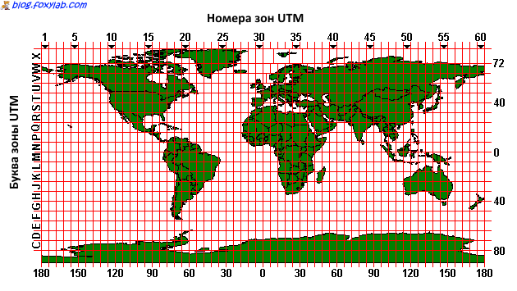

Source: <https://blog.foxylab.com/wp-content/uploads/2015/06/UTM_zones.png>.

Limitations:

In my process, we ran into problems when we were using cross software. Transferring data from QGIS to ArcGIS, most of the .dbf files were corrupted for some reason. The plan was to shift all our analysis to ArcGIS to avoid future problem.

We think that we will run our data online and perform our analysis using ArcGIS Online, I think we can get done this way. We basically will use the default dataset built into the ArcGIS. Or we can make the dataset analysis from the