Keyboard shortcuts when answering exercises in Bible Online Learner

12 January 2022 – Claus Tøndering

You can use keyboard keys as shortcuts when answering questions.

A “>” sign in the left part of the question wind indicates the question that is currently affected by your keystrokes:

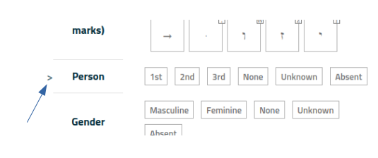
Use the keys Down Arrow or Up Arrow to move between lines in the current sub-question.

Use the keys Page Down or Page Up to move to the next/previous sub-question.

Use Ctrl-Down Arrow (in Windows) or Command-Down Arrow (on a Mac) to go to the next question. Note: There is no way to go back to the previous question! This is equivalent to clicking on the “Next” button below the question.

Ctrl-G (in Windows) or Command-G (on a Mac) is equivalent to clicking on the “Check answer” button.

Ctrl-J (in Windows) or Command-J (on a Mac) is equivalent to clicking on the "Show answer" button.

Ctrl-S (in Windows) or Command-S (on a Mac) turns shortcut indicators on and off (see below). By default, shortcut indicators are shown on large screen (typically, computers) and they are not shown on small screens (phones or tablets).

You can answer questions in this way:

- For most multiple-choice questions, press the key corresponding to the first letter of the answer you want to give. Press the key repeatedly to cycle between answers that start with the same letter. For example:

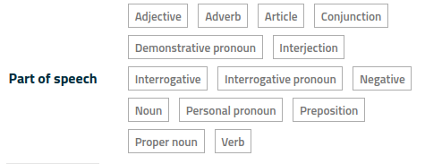
Here, you can use the “p” key to cycle between “Personal pronoun”, “Preposition” and “Proper noun”.

- For multiple-choice questions where the answer is a Hebrew or Greek word, a shortcut indicator (a small box next to the answer) contains the key to press to select that answer. For example:

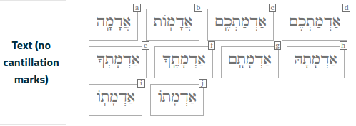
Here, you can use the “e” key to select the answer אַדְמָתְךָ.

- For verbal class questions in Hebrew, a shortcut indicator (a small box next to the answer) contains the key to press to turn the answer on or off:

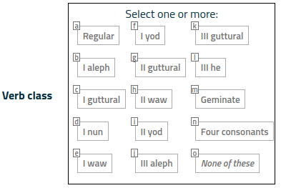
Here, you can use the “g” key to turn “II guttural” on or off.

- When typing Hebrew or Greek, a shortcut indicator (a small box next to the letter) contains the key to press to type that letter. Note: Not all Hebrew or Greek characters have shortcuts. In some cases you need to use your mouse to select a character. For example:

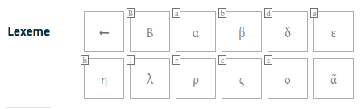

Here, you can use the “B” key to type the Greek letter Β and the “b” key to type the Greek letter β.
The letter ᾶ has no equivalent keystroke.

The Backspace key erases the last character typed.

Note that the keystroke is not necessarily the Latin equivalent of a Greek or Hebrew letter. In the example above, the keystroke “c” generates the Greek character ς.

