*The World is in a transition phase and energy is central to it. India has been responsible for almost 10% of the increase in global energy demand since 2000 pushing the country’s share in global demand up to 5.7% in 2013 from 4.4% at the beginning of the century. The primary energy demand in India has grown from about 441 MTOE (Million tonne of oil equivalent) in 2000 to about 775 MTOE in 2013. This demand is expected to increase to about 1250 (estimated by International Energy Agency) to 1500 (estimated in the Integrated Energy Policy Report) million toe in 2030. One of the biggest problems facing India today is the challenge caused by increased energy consumption and the increase of greenhouse gas emissions almost double since 2000.*

## **Problem Statement:**

In today’s era, Houses account for the major consumption (28%) of electrical energy and in this competitive market scenario. There is a huge demand for electrical energy from the houses, but they are facing two major hurdles one is scarcity of energy and the other is escalated cost of the available energy.

Alternate resources like Generators, Inverters have their own costs and supply limitations

Today’s Houses have great necessity of optimizing their energy needs and also to keep cost under control for the same level of activity due to increase in energy prices, operational cost and carbon emission.

***“We were looking for a system that could monitor a wide range of energy parameters, provide clear management information and that would keep disruption in homes to a minimum. “***

## **Benefits of having a Machine Monitoring System:**

* Track consumption of all the appliances in the house.
* Able to fix different consumption limits and once the limit of the consumption is reached, you will be notified.
* **Reduce maintenance** and **replacement costs** by monitoring and performing preventative maintenance.
* **Improve safety** by reducing the need for physical contact with the equipment’s.
* **24/7 alarm notifications** allow you to respond quickly to machine issues.
* Make **informed decisions** using accurate information that is automatically captured and consistently reported.
* Ability to access the appliances from anywhere and the ability to deactivate the devices remotely through the application.
* Save time by having **remote access to machine data** and pinpointing faults to specific individual equipments.

## **Solution:**

Energy consumption monitoring of machines in industries in real time using IOT. Displaying the real time insights on dashboard. Generating prediction using the collected data by data analysis and machine learning algorithms to empower the decision making of organization.

***ENIMO(Energy Information and Monitoring)****is the answer to all these problems.*

Enimo has two main objectives to complete and they are:

* Identify faults and weaknesses in the equipment early so preventative maintenance and replacement can be done in a safe and orderly way
* Ensure the equipment is maintained in an optimum environment to maximize performance and life.

## **How it works:**

An Example of the ENIMO

To Measure DC voltage, current and wattage for the machines in the real time model. We will be using the Raspberry Pi and an INA219 sensor.

This can be very useful in many applications such as tracking solar power generation, monitoring the amount of electricity consumption.

Here’s an [**INA219**](https://www.rototron.info/wp-content/uploads/INA219_datasheet.pdf)breakout board. 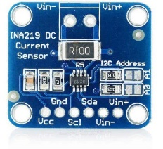

INA219 Sensor

The **INA219** chip can very precisely measure the voltage drop across the shunt. This is the difference between the voltage coming into the shunt and the voltage after the shunt.

It then uses this voltage drop along with the value of the resistor shunt to determine the current flow in amps because Ohm’s law states that

**Current (I) = Voltage (V) / Resistance (R).**

With voltage and current it can calculate wattage using

**Power (P) = Voltage(V) X Current (I).**

Once ENIMO Component is installed and configured with multiple machines, switch shares the data with Hub that analyzes & interprets data and stores in cloud server. ENIMO presents a comprehensive, user-friendly dashboard of electricity usage in real time. User instantly gets notified with fed alert.

All the Enimo hardware components are going to collect the data from the machines and then send the data to the main control hub(raspberry pi) and it will be sending this data to the server.

As you can see in the image:



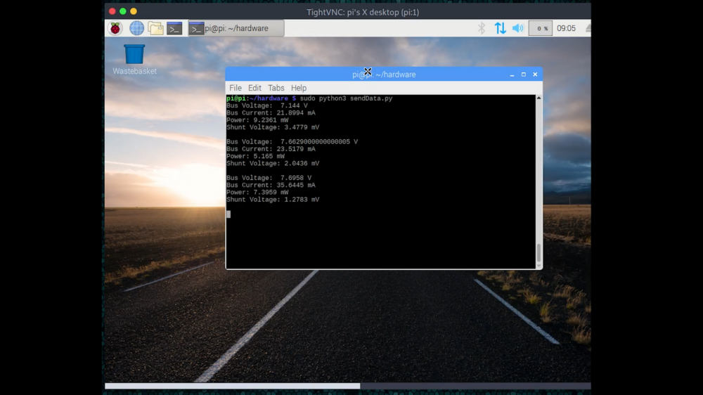

Raspberry Pi sending the data to the server.

## **Features of ENIMO:**

* **Quick Installations** (Everything installed within 30 minutes, no complex installations needed)
* Our systems are designed from the ground up to be easy to interact with due to an **attractive UI**.
* **Cross Platform Support**: You can access the ENIMO dashboard from your laptop, phone or tablets and start Controlling your machines via
* **Real Time Analysis** of the data which is being sent to the server.
* Detailed overview of the energy consumption with analysis of **individual device usage**. Interactive & customized graphs give you visual access to instant data. Get suggestions regarding the optimization of bill & power consumption. Receive real time data of the use and cost of your appliances
* The data produced by our systems is often highly sensitive, and can directly relate to production levels, environmental conditions or occupancy. So, All the requests which are made to the server are **encrypted requests**.
* ENIMO learns about the **behavior of the machines** and save up to 10% on your electricity bill. It can also anticipate the next month’s bills with predictive estimates, right from the dashboard
* **Best-in-class accuracy** (When reducing energy usage, sometimes by single figure % points, it’s essential that the data you collect is accurate. Our electricity meters are accurate to Class 1 (+/- 1%).
* **End to End System** (No prior experience needed to configure and hardware maintenance)

Dashboard Presets can be **easily customized** according to the users requirement(More than 10 pre-configured presets)

## **About the ENIMO Dashboard:**

The enimo gets the data from the control panel for every 20 seconds. It means that, it will send the data **4320 times** a day to the server. The dashboard also will be updated for every **20 seconds.**

This is an video of the dashboard:

## **Why ENIMO ?**

With ENIMO energy monitoring system, track live power consumption in real-time for single or multiple devices. Identify abnormal patterns of energy use, pointing to imminent problems of numerous appliances. Discover and reduce your carbon footprints. Estimate your energy bill, allowing you to see the overall impact of energy use on your wallet, that too in real time.

It has become a necessity for the Households to monitor the energy and control it. **ENIMO** is a solution that puts the customer in control of their energy consumption through continuous monitoring of the machines

**Live tracking** of the devices/assets. **Automatic alerts** to owner when the devices go out of normal range. Prioritized alerts based on the ENIMO software status.

## **How savings can be achieved ?**

Energy management projects can yield dramatic savings by highlighting areas of inefficiency so action can be taken. This can reduce the overall amount of energy used within a building, site or company by up to 35%, which reduces cost and the associated environmental impact.

To reduce power consumption and increase the quality of life, it is evident that these will not replace old equipment in all of these Industry’s today. We need a way for Industry’s to manage their consumption whilst using their existing machines.

## **Future Scope:**

**ESP8266**—

* This project can be extended using Esp8266 along with Arduino can be used as Wi-Fi module.
* It is cost efficient, reliable and portable.

**Power is knowledge-**

* Extends to Measure solar production versus power consumption. See which appliances use the most energy and how much they’re actually costing you. Track watts like footsteps or miles-per-gallon.
* And it also can be extended for schools colleges and Hospitals and Home appliances.

## **Cost Factor for this Project:**

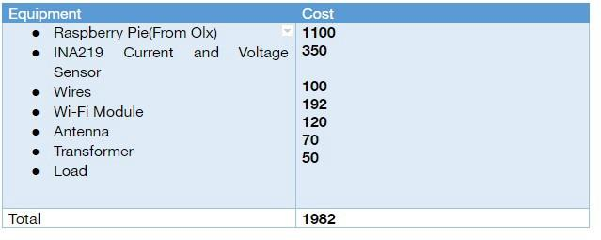

Cost for this project

## **Technologies used:**

* **ReactJS** — We have used ReactJS for this project because when there are new values is in the database then the whole page will be updated, if we use normal web technologies but in the case of the ReactJS only the single component will be updated whose value is changed.
* **Bootstrap** — We used bootstrap to make the website responsive even if the user opens the web page in his phone,tablet or laptop. The website will automatically adjust itself to the size of the screen
* **Python** — Now python was mostly used in hardware to send the data to the server which is fetched from the sensors.
* **Firebase** — As the back-end, we have used firebase as the database because all the connections/requests made will be secure. The read/write speeds of the database is very fast compared to any other database.
* **Google Cloud** — The Google Cloud comes into the picture to analyze the data that we receive from the firebase and send the results back to the firebase. So that the ENIMO dashboard will be able to fetch the values from the firebase.
* **Data Analysis** — After fetching the data from the firebase, we wrote an algorithm in google cloud which will keep on taking the data from the firebase and executing different algorithms on the data.
* **IOT** — As Computer Science Students, we haven’t learnt the IOT anywhere but for this challenge we gained knowledge about the IOT mostly about the different sensors and programming these sensors.

## **Project Duration:**

We have divided the whole project into two parts and they are

**Building the hardware** & **developing the Software**

* Fetching all the hardware components and then planning all the connections from the sensor to the raspberry pi took over around five days.
* In a parallel manner, it has took us around eight days to build the whole software and connect with the database.
* After the both, the parts were successfully completed; we took around two days to integrate both software and the hardware.

## **Team Members and their Roles:**

In our team, we have five members each having his unique skill set

* Ashfaq Nisar (Team Leader)
* Vamshi Krishna
* Vinay Reddy
* Teja