**CSE 1142**

**Computer Programming II ,**

**Spring 2019**

**Term Project :**

**Roll The Ball Game**

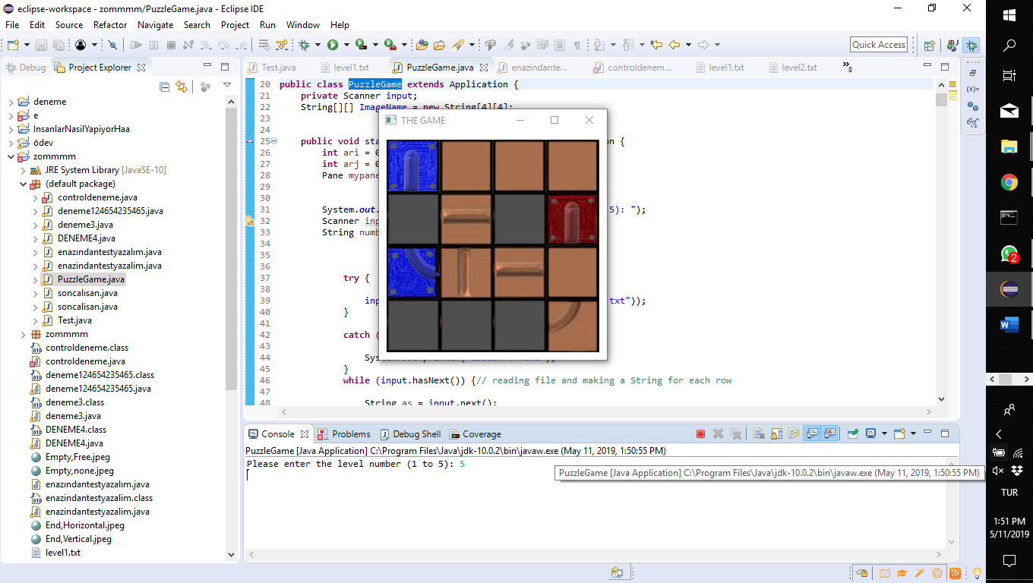

**Date Submitted : May 12, 2019 Ezgi DOĞRUER – 150117042**

**İsra Nur Alperen – 150117061**

**1) Problem Definition**

Roll the ball game is a puzzle game consisting of 5 levels. The game screen contain 16 stones. Some of these stones can move while some of them cannot move. In addition, the stones in which the moving stones can move are certain stones. The aim of the game is to complete the path on the stones and reach the end. When the road completes and reaches the end, the ball in the starting point comes to the end of the way and the level is completed and the game to the next level.

The game we write does not work correctly because of some problems. The first one of these problems is that our levels do not continue in sequence. The second is that our stones move only once. What's thing not in our game is ball animation.

**2)Implementation Details**

UML Diagram;

|  |
| --- |
| Roll The Ball Game |
| + ImageName: String [][]  + images: ImageView[]  + scene: Scene  + mypane: Pane  + width: int  + gap: int  + height: int  - input: Scanner |
| + start(stage: Stage)  + Swap(image1: ImageView, image2: ImageView, x: int, y: int, chosenX: int, chosenY: int, width: int, height: int, gap: int): void  + SwapImage(images: ImageView[], locationInArray1:int, locationInArray2:int)  + control(ImageName: String[][]): boolean |

First of all we thought to create 16 frames in the screen and we took the screenshot of each stone in the Project file. Since we needed the names to use these pictures, we took the names of the pictures in each line and put them into an ImageName array for each level. Then we determined the dimensions of the pictures we have cut and their position in the scene. We also took an input from the person to play a level what he/she wants.

In Motion section; we took the first stone we touched, as the stone we chose, and the place we scrolled as the place carried. We took as x and y the location of the stone that we chosed and the place that we want to carry the stone there. Then we controlled the motion section using if-else statement. If the chosen stone is one of pipes which is not static or Empty,none, and the stone which located on the place that we want to carry the stone is also Empty,Free, we may change the locations of the stones . In addition, we have checked every corner and also the movement of the stones on the sides of the square, such as lower, upper, right, left. We have called the swap methods we write in each if and else if statements. At the end of the statements, we also changed the stones in the ImageName array.

We changed the location of the stones we selected and took in the Swap(ImageView image1, ImageView image2, int x, int y, int chosenX, int chosenY, int width, int gap , int height) method. We also changed the stones we selected and took in the images array in the SwapImage(ImageView[] images, int locationInArray1, int locationInArray2) method. Thus, the movement part has been completed but for some reasons that are we cannot understand, every stone we choose in our movement code moves only once. Unfortunately we could not solve this problem.

In the control part, we checked the path to be completed in a method. In this control method, we evaluated the right path for each stone. For example, if the game starts with the Start of the Vertical stone, the stone in the direction of the path in order to complete the path should be Pipe, 01, PipeStatic, 01, Pipe, Vertical or Pipe, 00. In this way, we thought about the possibilities for each stone and checked using if else and switch case. We have also set a course for each stone and we have created the right path option in this direction. But unfortunately, because our motion code does not work as it should, our control method also works for the other levels other than 1.level but we cannot see the result because the level is not completed. However, if we use the imageName array in the control method with the correct completion, we can see that the result is returned to true. In addition, when we tested our method according to level 1, we confirmed that our method returned true and we saw the message that is "You Win !! " in the consol. We also designed our code dynamically.

**3)Test Case**

For level 1;

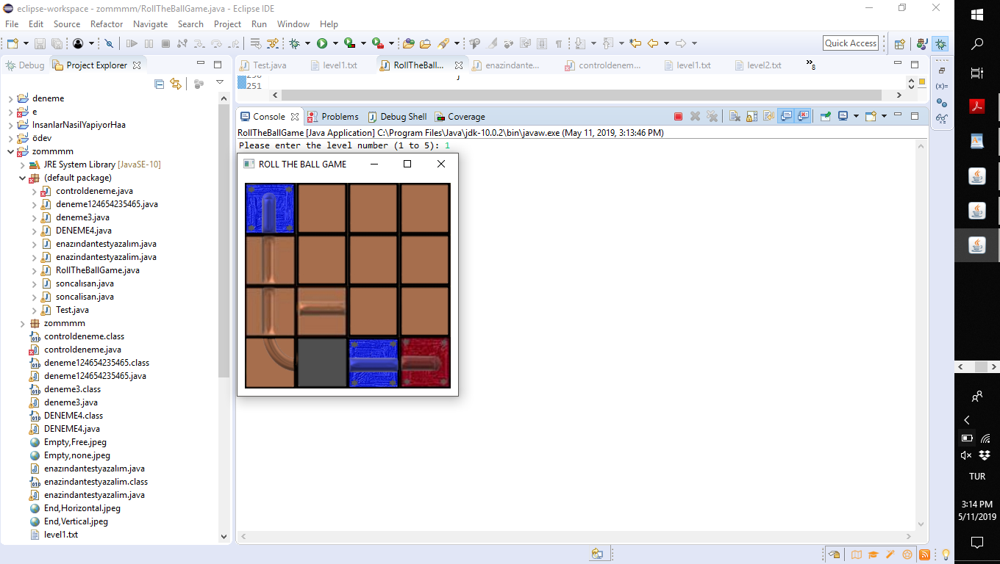

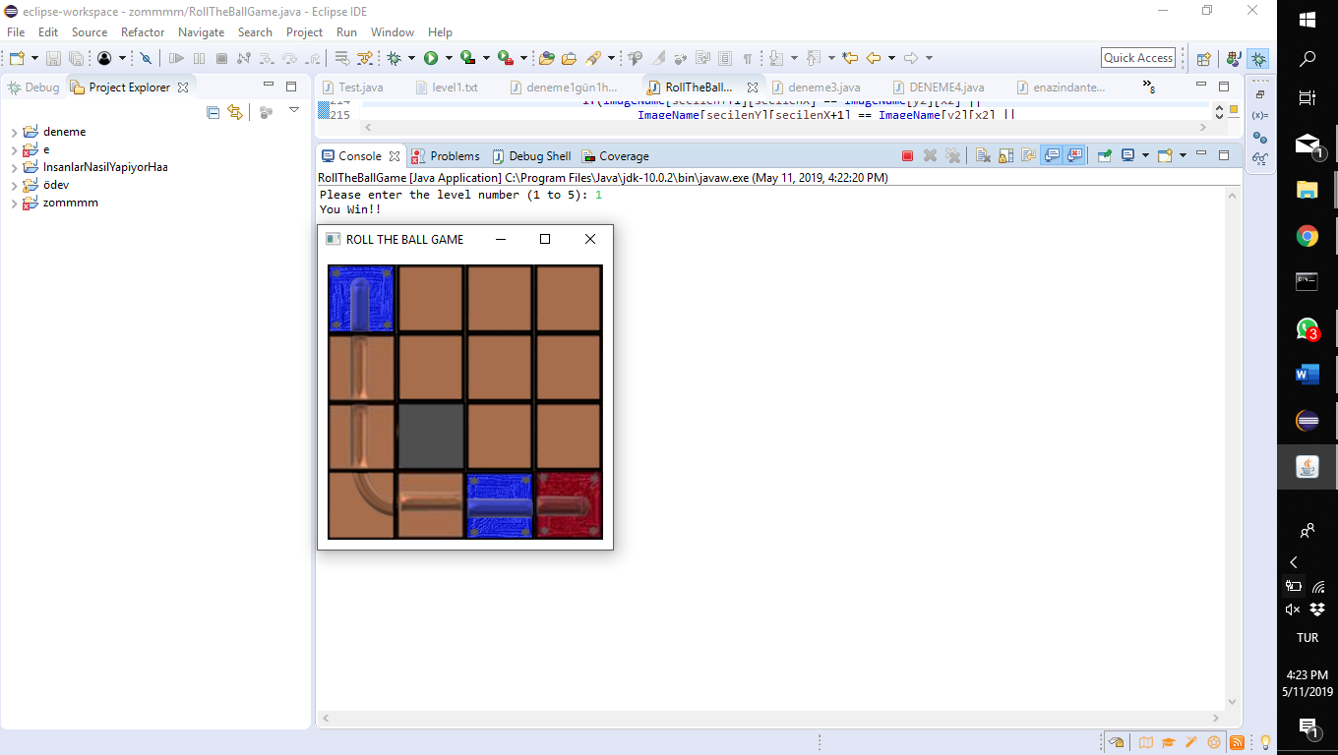

If you move the stones and complete the path as shown in the figure, the game screen will disappear and you will see the message in the console.

🡪 🡪

For level 2; For level 3;

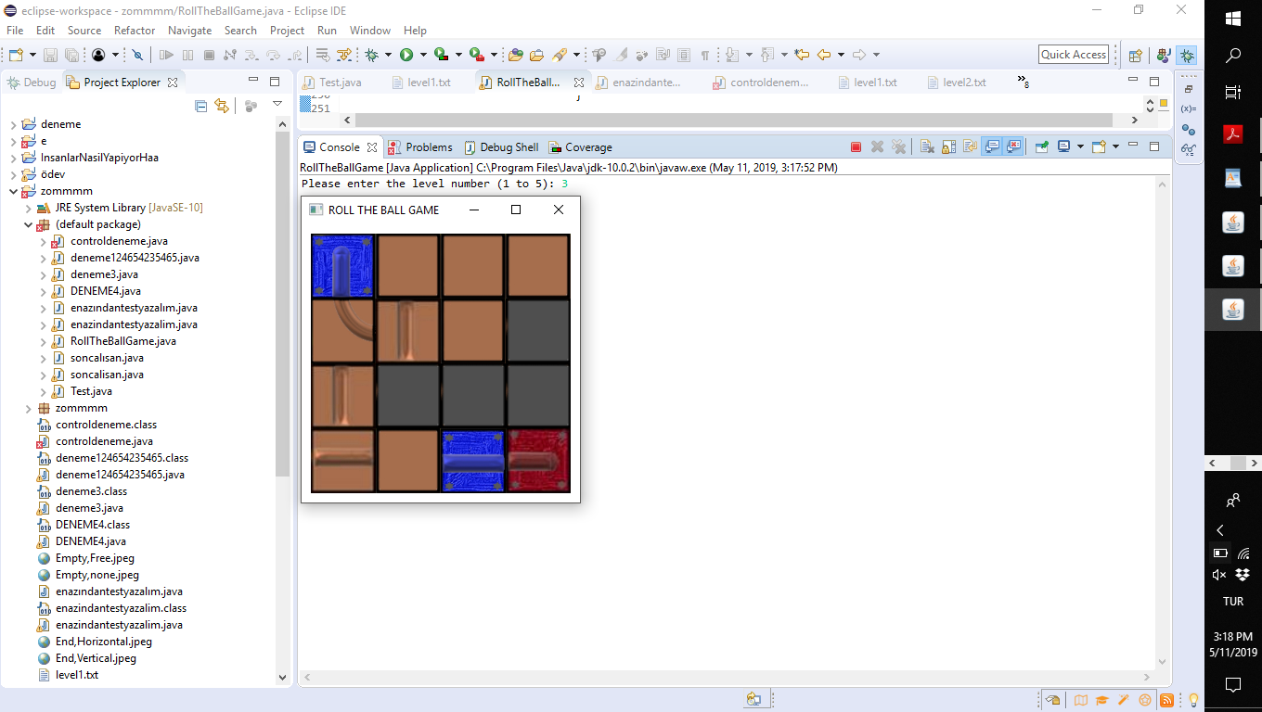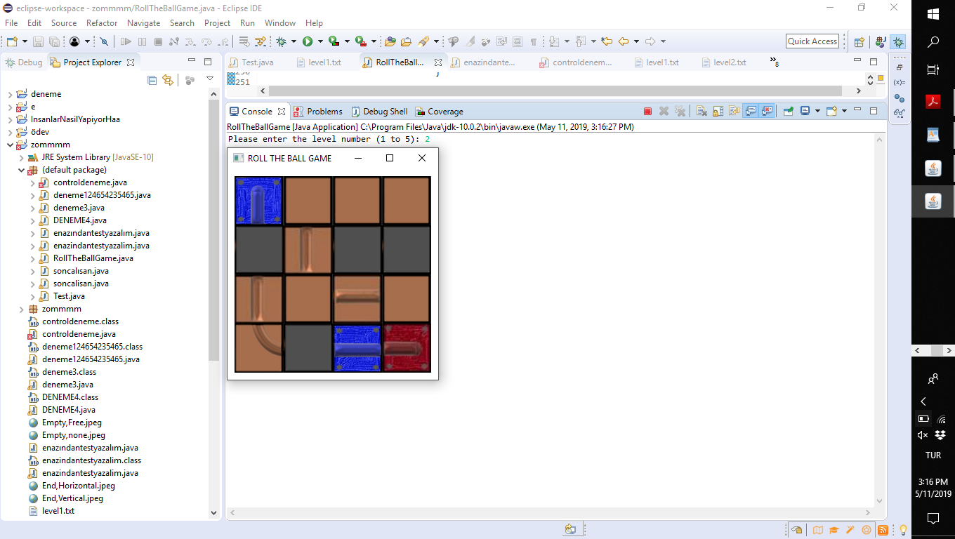

For level 4; For level 5;

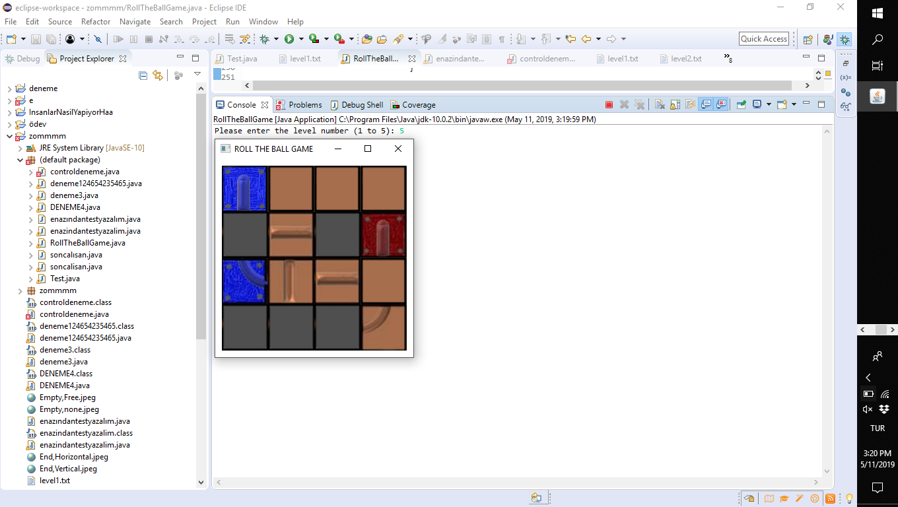

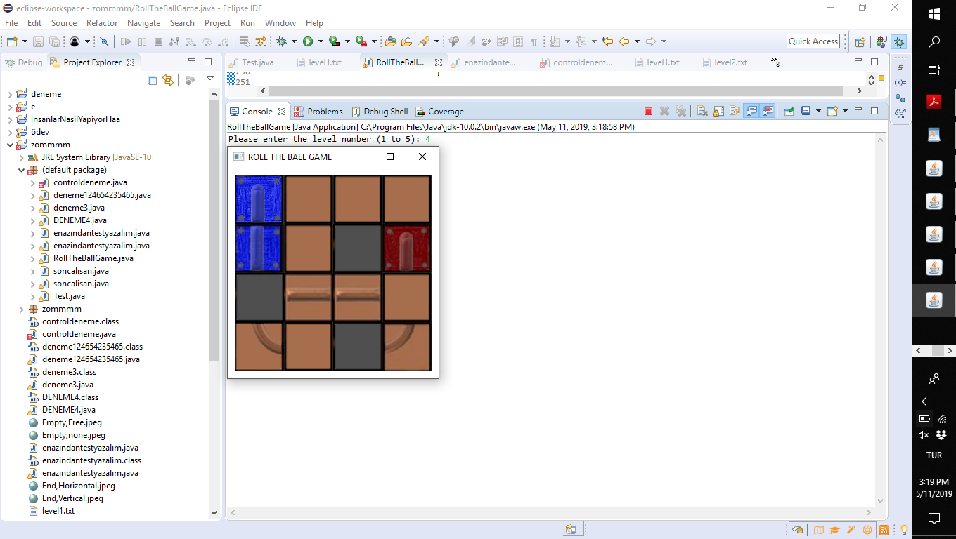

For other levels (level2-3-4-5):

The number of movements required for the completion of the road is more than 1 for each stone. In our game, because each stone moves only once, the levels cannot be completed and therefore the screen does not close.