Math of a Constant One-way Speed of Light

James Buckeyne
Independent Research
Fernandina Beach, FL 32034; United States
Email: d3ck0r@gmail.com
ORCID iD: 0009-0004-2865-6447

Abstract
This paper presents equations for the propagation of a constant one-way speed of light. The location of emission, and observation of photons and the time between form a rest frame. Differences between what is seen and the behavior the Lorentz Transform are notable, and challenges to the Theory of Special Relativity are made; the model that everything is relative can be broken. Space has, through time, been thought to be a medium which has properties, until Einstein, and Special Relativity. Space is thought to not exist as a medium because interferometer tests do not show any drag. This is further abstracted by Quantum Mechanics where space itself becomes emergent from interactions. This paper will show that, given the proper math, that a null result from interferometer experiments should have been expected even at the time, and that space as a medium can still exist.

Introduction
Starting from the ground up to derive the math of Special Relativity, by developing the math for the propagation of light at a constant speed in a stationary medium, or alternatively that there were at least three observers, who all agree that the speed of light was constant in any direction, they may have to consider their own velocity relative to the point the light was emitted from, and any effects their velocity may have on their own clock. The resulting equations challenge aspects of the Principle of Equivalence employed by Einstein. The math also results in a system that expects a null result from any interferometer experiments such as Michelson-Morley, or interferometer implementations such as The Laser Interferometer Gravitational-Wave Observatory (LIGO). Without any external influences like a passing gravitational wave, or accelerations, interferometers will never show any variation in the speed of light, in any direction, or velocity.

Postulates
- Light propagates at a constant speed, and their point of emission in time and space does not move.
- In a local frame, the two-way speed of light takes the same amount of time, on a local clock, in any direction.

Frames
Consider the idea of Reference Frame, Rest Frame, Inertial Frame, Non-Inertial Frame, and generalize the idea to just ‘Frame’.
Frames are also related to other frames. For simplification, frames that are ‘in’ another frame moves along the same trajectories as the frame they are contained ‘in’ which is also called a parent frame. Frames can be attached to other frames, in which case, the attachment has a function itself that translates any changes in forces of the body they are attached to the attachment and inversed. Frames can always be nested in another frame, so they can be related relative to each other within a frame. The exact metrics for the space the frames are in may differ from frame to frame, that includes the orientation of that space which may deviate from what might be called flat space. Locally a frame within another frame can be described with 7 coordinates, 3 for location, 3 for orientation, and 1 the time it was in such a location and orientation. Complex functions can relate what one frame is in relation to other frames.
Frames might additionally have acceleration, velocity, torque, and rotation characteristics. They may have a stress tensor field describing 3 vectors of where the normally orthogonal axes point in reality; allowing space to be skewed, experience torsion, and a variety of other fun transformations, although within the space being deformed by the tensor the space is experienced as locally flat everywhere. At a small enough scale, the values of electrostatic and magnetic gradients might also be in a frame or represented with a network of frames within another common containing frame.
For simplicity, this paper only considers frames in a flat space where there is a set of orthogonal axes which measure distances between locations within the frame, the orientation of the frame, measured by the three angles of rotation around each of the axes (this is done with Euler Axis, not Euler Angles), and a time. When a velocity is applied, the frame moves in the direction and speed of the velocity.
There are a minimum of 3 frames; a frame called global frame itself has no velocity, and is always in the same location, both the observer and observed have their own frames. The global frame is the outermost frame, and since there is no frame which contains the global frame, there is nothing to measure the global frame against, so it might as well be stationary. The global frame has an origin defined at a location defined as appropriate for the situation being evaluated. In this paper all frames share the same origin $\vec{X}=\left\{0,0,0\right\}$ and orientation $\vec{Q}=\{0,0,0\}$ at T=0$.$ The global frame is the frame light propagates in; given the constant clarity we observe in galaxies out to the edge of the universe, it can be assumed that the space this global frame represents does not have significant currents or motions, and represents space. There are minor oscillations in the density and curvatures in this space, but it’s not like looking through hot air currents. The lack of motion of space itself is indicated by the ability to see objects billions of light years away without any distortion or dispersion.
A ’local’ frame is a frame that describes the locality of a frame. Its location and velocity measured within a containing frame. The containing frame may be the global frame, it may be some other frame. Local frames have at least angular and linear momentum characteristics within their containing frame.
Defining 2 more frames that are the local frames where photons are emitted, and another where photons are received is required. These may be the same frame, but in that case, it’s somewhat uninteresting, and might as well just use standard physics, it’s more interesting when the frame emitting photons and the frame where photons are received are moving with their own independent 3-velocities.

On Light
Light is given a constant propagation speed of $C$ in the global frame.

Motion of Frames
Bodies move at some speed and direction or combining speed and direction into a single term, at a velocity. Bodies move through space, but the space in bodies or even between the atoms of a body does not move.

On Space
Space has no velocity or orientation, and the clock in the frame of space ticks at constant rate. The clock in this frame is called the global clock. The clock in the global frame has an ideal tick rate that is faster than any other clock. A frame which moves within the space frame, or global frame, is called a local frame. A local frame has a local clock, which may tick at a different rate than the global clock.
The specific density of space (the average distance between two points) in a frame may differ at various locations. This paper does not implement varied density, and only considers frames that have entirely homogeneous coordinates. It should not be entirely discounted given gravitational wave detection that space can move at least slightly.
A body can only be observed if it has emitted or re-emitted a photon. A photon on an observed body will come from a position on the observed body. The photon, once emitted, travels in the global frame, independent of the body it was emitted from. An observer has a body itself and will observe the photon from the observed body at some position in the frame of the observer a later time after the body emitted a photon.

Final Notes
Once the basic math of propagation of light at a constant speed in space, with an observed frame and an observer’s frame was developed, other aspects detailed by Special Relativity were considered, since they were not immediately obvious from the propagation. Those aspects being length contraction, and time dilation. Time dilation would be better called time contraction, since less time passes on a clock, much like length contraction there’s less distance than a real distance. The details of length contraction and time contraction will be discussed later.
Light aberration was the last missing factor from the system. Light aberration is an effect that for a moving body, the angle light is seen is advanced in the direction of the velocity of the viewer. While light propagation usually results in a time-lagged view of an observed body, light aberration advances the angle, which counteracts the effects of a delayed propagation. Light aberration then makes two bodies that are relatively stationary, at the same speed that are side-by-side still appear side-by-side, even though the photons seen by an observer would normally appear to be lagged to the observer.
Evaluating the resulting math with an interferometer demonstration, then led to the development of the expression for doppler effect, or the shift of frequency of photons emitted from a body at a velocity, or as seen from another body with another velocity. The doppler effect equation is quite dissimilar from Einstein’s equation. There are predicted red/blue shifts with Transverse Doppler Effect with Einstein’s equations, while these would show no frequency change in the transverse direction.

Conventions
Variables are upper case unless they come from an external reference. This makes variables mentioned in the text stand out.
- Equations with numbers that have been stricken are invalid, for example: $(999)$. They are provided for consideration only.
- Velocity is a vector $\vec{V}$.
- Speed refers to the magnitude of the velocity ( $||\vec{V}||$ ).
- Direction refers to the unit vector of velocity ( $\frac{ \vec{V}}{ ||\vec{V}||}$).
- Position is a vector of the same order as velocity, $\vec{V}$ is an example.
- $\vec{X}×\vec{Y}$ denotes a cross product.
- $\vec{X}⋅\vec{Y}$ denotes a dot product. This may also be written as $\vec{X}\vec{Y}$.
- ${\vec{X}}^{2}$ is the same as $\vec{X}⋅\vec{X}$.
- $||\vec{X}||$ is the same as $\sqrt{{\vec{X}}^{2}}$
- X ⋅ Y denotes a multiplication of two simple numbers; may also be written as XY.
- $\vec{X}×\vec{Y}$ denotes a cross product of two vectors.
Other typical vector math applies:
- $\vec{X}+ \vec{Y}$ or $\vec{X}- \vec{Y}$ Adds(or subtracts) each component of the vectors, and results in a vector. Subtraction might be considered as multiplying a vector by $-1$, then adding them together.
- $c\vec{X}$ or $\vec{X}c$ Multiplies each component of a vector by a scalar.
- (+ -) occasionally the math might result in a + and a – together, convention is to not write the +.
$C$ is the constant speed of propagation defined in light-seconds per second as used in this paper. It may also be used as a distance, in which case $C_{L}$ light-seconds and has the same value as $C$, but with units of length instead of speed. For example, $C$could be in meters per second (300,000,000 approximately), and then $C_{L}$ meters would be 300,000,000. The value is always actually identical to $C$ other than the units: $\frac{C}{C_{L}}= 1s^{-1}$ or $\frac{C_{L}}{C} = 1s$.
The phrase 'emits an event' is 'emits a photon that will be seen' describes the creation of a signal that propagates through space. A body that emits an event, emits a signal. It is the signal that propagates through space. Reception of a signal is also observation of an event.

Rotation
Rotations are 3D vectors $\vec{Q}$ is an example; they are effectively the log of a quaternion. This is used for light aberration.
- The angular rate is the magnitude of a rotation vector ( $||\vec{Q}||$ ).
- The axis of rotation is the unit vector of a rotation( $\frac{ \vec{Q}}{ ||\vec{Q}||}$).
- An applied rotation will be represented like a function Q(X) that results in X rotated around Q.
- Given a rotation vector $\vec{Q}$, the angular rate is $θ=\left\|\vec{Q}\right\|$ and axis $\vec{A}=\frac{\vec{Q}}{θ}$ used in the following equation:$\vec{X'} = cos(θ)\vec{X} + sin(θ) (\vec{A}×\vec{X})+(1- cos(θ))⋅(\vec{A}⋅\vec{X})\vec{A}$

A Thought Experiment
Before diving into the math, let me put forth my extended train through experiment.
Consider a somewhat extended thought experiment of an observer named Abe in the center of a train car with an observer by the train named Bonny. The train car is 2 light-seconds long, which makes the ends of the train 1 light second away from Abe in both directions on each of the ends of the train car are two light emitters. At the same position as the ends of the train are two light posts 2 light-seconds apart. Bonny is standing at the midway point between the two light posts, one light is mounted on each of the light posts. At time zero(0), Abe and Bonny are at their closest distance. The train car is moving at a speed of 50% of the speed of light and has been moving at that speed even before time zero. At time zero all 4 lights flash for a moment long enough to be seen; the four lights are the two on the ends of the train and the two on the light posts by the train.
The lights emit a pulse of light that is a certain frequency of green. Green is specified since it is a frequency between blue and red, blue is a higher frequency than green, and red is a lower frequency. The terms redshift and blueshift are a shift from green towards blue or red.
The notion of time contraction is ignored, so assume they can both use a clock that is in the frame of the train tracks.
Abe on the train will see the two flashes from the front of the train and the light post near the front of the train before the two flashes at the back of the train. The time that the flashes from the front of the train are seen is 0.5 seconds. The time that the flashes from the back of the train is 1.5 seconds. The flashes from the front and back of the train will be seen at the exact frequency that was emitted. The flash from the light post towards the front of the train is seen as blue shifted, and the flash from the light post towards the back of the train is seen as red-shifted. Table 1 below shows the frequency shifts in relation to each other, and Table 2 are the time delays.
Bonny by the train will see all four flashes at the same time 1 second after they are emitted. The flashes from the light posts by the train are seen at exactly the frequency that was emitted. The flash from the back of the train is seen as blueshifted, and the flash from the front of the train is seen redshifted.
Observer | Lights in Train |  | Lights by Train
Observer | Front | Back | Front | Back
Abe | green | green | blue | Red
Bonny | red | blue | green | green
Table 1: summary of frequency shifts by emissions from certain places as seen by each observer.
Observer | Lights in Train |  | Lights by Train
Observer | Front | Back | Front | Back
Abe | 0.5s | 1.5s | 0.5s | 1.5s
Bonny | 1s | 1s | 1s | 1s
Table 2: summary of length of time an observer will see the flashes from the time they are emitted.

Modified Experiment
The other experiment which is more in-line with special relativity, is to replace the emitters in the above thought experiment with mirrors and then give Abe and Bonny each a light emitter. When the emitter initially fires, it’s assumed there’s essentially 0 distance between Abe and Bonny and the emitter, so they don’t see the initial flash; though it can just note that first, almost instantaneously from the time of emission they see the flash, but it’s the subsequent information from the mirrors that are considered. The flash from Abe that is seen by Bonny and vice versa are not shifted in frequency; at time 0 when Abe is exactly passing Bonny their relative speed is 0.
The pulses are emitted at the same time, and for the time calculations, which light is used doesn’t matter. When considering what the frequency of the light is, it matters which emitted light is used. In the above case, the light only has a single emitter and single observer to consider. The lights from the train are seen by Abe and Bonny, and the lights from the light posts are seen by Abe and Bonny, and there’s only 4 combinations to consider. When introducing mirrors, there are 2 emitters and 2 observers along the path to consider and there are a total of 8 combinations to consider below.
Mirrors are both observers and emitters. An emitter that is moving emits a signal that is blue shifted to the front, and red shifted behind. One way of looking at it is that a photon is not instantaneously produced but is produced over a small amount of time; when the creation of the photon starts, the emitter is in a certain location, and before completion of the wave the emitter has moved. The motion of the emitter causes the wave to be compressed if the wave is ahead of the emitter along its velocity, while a wave trailing the emitter is elongated. An observer or detector moving into a wave sees the wave as more compressed, and is blue shifted, while an observer moving away from a wave sees the wave elongated. Redshift is associated with elongation, and blueshift is compression. A mirror that is moving into a wave will blue shift it on the observation side and produce a compressed version when sending it. Conversely, a mirror moving away from a wave will elongate the wave and double redshift the wave. Table 3 below shows these frequency shifts in relation to the signal Abe emits, and Table 4 shows the frequency shifts in relation to the signal Bonny emits.
Abe, on the train, will see the flashes reflected from the mirrors on the train 2.667 seconds after they were emitted, he will see the reflections from the light post at the back of the train 4 seconds after it was emitted, and will see the flashes reflected from the light post at the front of the train 1.333 seconds after the flash, while light from the back light post will be seen after 4 seconds.
The flash will hit the back mirror in the train only 0.667, because in the time the light is travelling, it will then take 2 seconds from the back mirror to get back to Abe.
The flashes will hit the back mirror on the light post in 1 second, and the train will have moved 0.5 light seconds forward and have a total distance from the mirror to Abe of 1.5 light seconds to cover (while still moving forward). In the next second, the light will be back at the starting position, and Abe will have moved another 0.5 light seconds, but now the light is only 1 light second from Abe. In the next second, the light will be where Abe was, and at the front light post, but Abe will have moved another 0.5 light seconds forward and be 0.5 light seconds away from the light. In the next second, which is a total of 4, the light will finally reach Abe.
The flashes will hit the front light post mirror in 1 second, and still the train will have move 0.5 light seconds forward. The return over 0.5 light seconds with the train moving at 0.5 light seconds into it is 0.333 seconds, for a total of 1.333 seconds.
Considering the case of Bonny looking at the reflections from the train’s mirrors, the trip times are different. The flash hits the back mirror in the train in 0.666 seconds, which the train will have moved forward 0.333 light-seconds, and reflect to Bonny another 0.666 seconds, for a total of 1.333 seconds. The flashes will hit the front mirror of the train in 2 seconds, and the train will have moved forward 1 light second in that time, making the return trip 2 seconds, for a total of 4 seconds. Table 5 below shows these times, as indicated by a stationary clock.
Abe will see the reflection of his own emitter unshifted in frequency from the mirrors on the train. The initial flash from Abe’s emitter is blue shifted towards the front of the train, and redshifted towards the back. When the mirror receives the light, it will undo the shift and go back to green, but then the front mirror will reflect the blueshifted signal as redshifted, and Abe will be heading into that wave and blue shift the signal back to green. A similar case, but the opposite, will happen with the back mirror.
Abe will see his own emitter reflected from the front light post blue shifted twice, once for the forward motion blue shifting emitted light and again from the reflection of the blue shifted light returning to him that he’s heading into, and from the back light post red shifted twice. The mirrors are not moving in this case, and so the blue- or redshifted light received is reflected with the same frequency.
Abe will see the reflected light from Bonny’s emitter from the front of the train is red shifted, and the light from the back of the train is blue shifted. Bonny is not moving, so the signal she emits is green, when it hits the front mirror, it will be red shifted, and when it’s emitted from the mirror again it will be red shifted again. Abe’s motion towards the front mirror’s location will blueshift one of the redshifts, and it will have 1 redshift component left.
Abe will see the reflected light of Bonny’s emitter from the front light post blue shifted, and the light from the back light post red shifted. The emitted light from Bonny will not be shifted, and the stationary mirrors will not additionally shift the frequency, the only shift that happens is when Abe observes the signal.
Bonny will see the reflection of her own emitter unshifted in frequency from the mirrors by the track each 2 seconds after the light is emitted. She will see the light reflected from the back of the train double blue shifted, 1.33 seconds after it was emitted. Bonny will see the light reflected from the front of the train double red shifted, 4 seconds after it was emitted. As mentioned earlier, when the mirrors receive the light, they always double-apply whatever shift they cause when first observing a signal.
Abe’s Emitter  Observer | Mirrors in Train |  | Mirrors by Train
Abe’s Emitter  Observer | Front | Back | Front | Back
Abe | Green | green | 2*blue | 2*red
Abe | blue emitted | red emitted | blue emitted | red emitted
Abe | red into mirror | blue into mirror | No shift | No shift
Abe | red from mirror | blue from mirror | No shift | No shift
Abe | Blue received | red received | blue received | red Received
Bonny | red  (blue+red+red+none) | blue  (red+blue+blue+none) | blue  (blue+none+none+none) | red  (red+none+none+none)
Table 3: summary of frequency shifts by emissions from certain places as seen by each observer.
Bonny’s Emitter  Observer | Mirrors in Train |  | Mirrors by Train
Bonny’s Emitter  Observer | Front | Back | Front | Back
Abe | red  (none+red  +red+blue) | blue  (none+blue  +blue+red) | blue  (none+none  +none+blue) | red  (none+none  +none+red)
Bonny | 2*red  (none+red  +red+none) | 2*blue  (none+blue  +blue+none) | green  (0+0+0+0) | green  (0+0+0+0)
Table 4: summary of frequency shifts by emissions reflected from Bonny’s emitter as seen by each observer.

Observer | Mirrors in Train |  | Mirrors by Train
Observer | Front | Back | Front | Back
Abe | 2.667s  (0.667+2) | 2.667s  (2+0.667) | 1.33s  (1+0.33) | 4s  (1+3)
Bonny | 4s  (2+2) | 1.33s  (0.66+0.67) | 2s | 2s
Table 5: Summary of length of time before an observer will see the reflected flashes from the time they are emitted.
If time and length contraction are also considered, Abe’s frame is contracted, Bonny’s is not, Abe’s clock is running slow by the same amount the length is contracted, so he will still see the flashes from his own mirrors in 2s. It does change the time that Bonny sees the flashes from the train’s mirrors because the train is contracted; the reflection from the front will be $2\sqrt{3}=3.464$, and from the back is $1.333\frac{\sqrt{3}}{2}=1.154$. Abe’s clock also changes the time he sees the flashes from the light posts because his clock is contracted. Table 6 considers the time on the moving clock which is time contracted.
Observer | Mirrors in Train |  | Mirrors by Train
Observer | Front | Back | Front | Back
Abe | 2s  (1.5+0.5) | 2s  (0.5+1.5) | 1.154s  (0.866+0.288) | 3.464s  (0.866+2.589)
Bonny | 3.464s  (1.732+1.732) | 1.154s  (0.577+0.577) | 2s  (1+1) | 2s  (1+1)
Table 6: Summary of length of time before an observer will see the reflected flashes including length and time contraction.
There are a bunch of numbers which are presented for which the math has not been presented yet. By the end of the paper, you should be able to revisit this and perform the math yourself.
Abe, in his own frame, with his own clock, sees reflections in the mirrors in his frame after 2 seconds. Bonny, in her own frame, with her own clock, sees reflections in mirrors in her frame after 2 seconds.
Abe, in his frame, sees reflections in the mirrors by the tracks after 1.154 seconds from the front mirror and 3.464 seconds from the back mirror; the partial trip times from the time of emission until the reflection and from the reflection to observation are not the same as the partial times that apply for Bonny in her frame. Bonny conversely sees the reflection from the back of the train in 1.154 seconds and from the front of the train after 3.464 seconds.
The length contraction means the signal travels a shorter path, and the time contraction means that the time it takes to cover that shorter path is longer. The overall effect is that in real time, Abe sees the signal from the front and back of the train at 2.309 seconds according to Bonny’s clock, which is after Bonny sees her simultaneous signals, but is still 2 seconds on his own clock, which matches the 2 seconds on Bonny’s clock.
A craft that is 2 light-second long travelling at 0.5c, with a photon emitter in the center and a beam splitter before a mirror at each ends of the craft, with a final detector in the middle of the craft will always see the signal from either end come back at the same time, and the distance divided by one-half of the time will equal the speed of light. The beam splitters allow for an external observer to register where the light pulse was detected, and two photon detectors placed externally can give the time the pulse is detected. The position of these detectors can be computed ahead of time to already be a constant distance.
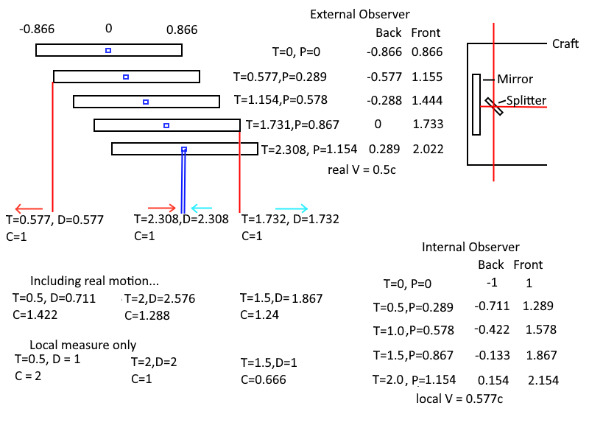
Figure 1: Modified experiment graph and calculations.
Figure 1 includes a calculation that, if the internal observer also included their position update, then the speed of light would be calculated as slightly faster than the speed of light. The inclusion of the frame’s velocity within the frame is usually not done; If you’re considering flying on a plane, and throwing a ball back and forth, the speed of the plane is usually not included in the calculated speed of the ball.
The above image includes length contraction of the moving body, and time contraction for the internal observer’s clock. Space outside of the frame is not contracted, and the position shown for the internal observer is the real position, that if they were to stop at that time value on their clock, both the internal and external observer would agree on the position of the train. The stationary observer external to the train can measure the time and distance signals happen within the craft, and using the one-way constant speed through space calculation this paper presents will observe that all segments of the trip, that light has traveled at the speed of light.
The internal observer will only calculate that the two-way path from the center to the ends and back to the center is the speed of light covering the contracted distance (which they do not observe as contracted, and assume that the length is still 1 light second), but they also have a contracted clock, which ticks slow, and means that their contracted distance divided by a slow clock is the speed of light.
If the internal observer does include the speed of their craft, then $\frac{C\sqrt{\left(C^{2}-V^{2}\right)}+V^{2}}{\sqrt{\left(C^{2}-V^{2}\right)}}$ is what they will calculate for the speed of light, which is entirely dependent on their velocity, and is already more than C; however, as mentioned before, this is not the usual calculation since they are assumed to be stationary and without the ability to measure their speed.

Clock Synchronization
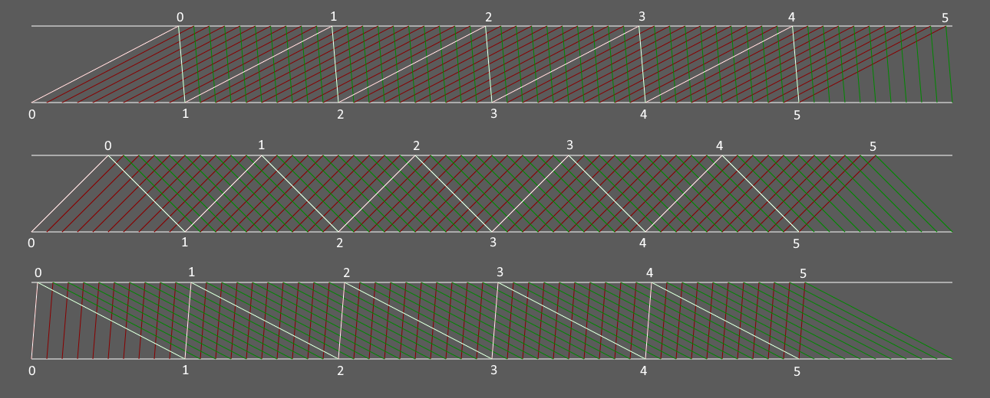
Figure 2: Various conditions of asynchronous clock transmission times. Transmission starts from the lower side and goes up; time goes from left to right.
In modern communications networks, sometimes the send path is faster than the receive path or vice versa or can be entirely symmetric. The case where the paths are symmetric is represented by the middle graph in the above figure. The path where the transmission from bottom to top is slower than the return path is the top graph; and the bottom graph represents the condition where the transmission is faster than reception path. There is no algorithm that can exactly synchronize the clocks in the above figures. Instead, what can be done will have a skew between the two clocks, indicated by the numbers above and below the graph, where transmitting from one point to another seems like it’s accurate, this is what happens if you synchronize to round-trip time divided by 2[Ref 8].
Figure 2 shows various examples of asynchronous communications, and the offset that would result using this method; the top is where the time from the authoritative clock to the clock being synchronized is slower than the return from the synchronizing clock back to the authoritative clock, the synchronized clock will be delayed from ideal. The middle graph indicates when the transmission times are identical, and the clocks will be in sync with each other. The bottom graph is when the time from the authoritative clock to the synchronizing clock is faster than the return trip from the synchronizing clock to the authoritative clock, and the resulting synchronized clock will be ahead of the real time. The multiple red and green lines are alternative transmission times, to show that at any time, if either clock sent extra data to the other, there wouldn’t be any additional information; a consideration that was attempted was if the synchronizing clock sent additional messages at some fixed delay from receiving synchronizing information, these additional messages have no benefit since they will be received exactly the same delay from the initially expected immediate response message.
This is a similar condition to what happens in Special Relativity with the mechanism specified by Einstein. It is potentially not true that the forward path from clock A to clock B is the same as the transmission time from B to A. If it was, an external observer would see the signal propagate at more than or less than the speed of light and would not meet the criteria that the speed of light is constant to all observers.

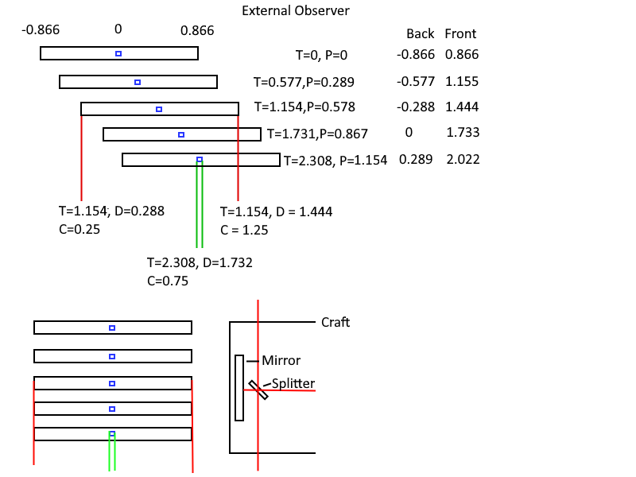
Figure 3: This is a diagram of what would be observed by an external observer if, as hypothesized by Einstein that the speed of light for any observer is always the same in any direction.
Figure 3 shows what an external observer would see if somehow the light emitted from the center hit both ends at 1 second according to the local clock and reflected to the outside. The overall speed of light the external observer would compute would be 0.75 times the speed of light. This means that the speed of light is not the same for an external frame. Not even the two-way speed is the speed of light.
The length is contracted to 0.866, and the clock of the local frame is also contracted by 0.866. For the external observer, the distance that the light would have to cover to the back of the craft is only 0.288 light seconds, while it would have to cover 1.444 light seconds to reach the front reflector. The return trips are the same, for a total of 1.732 light seconds (0.288+1.444), and the time it takes to return to the center is 2.308. It would only be the speed of light to an observer in the moving frame, which makes their frame privileged, and the only one that can compute their speed of light as the speed of light. While in the other case of a true one-way speed of light that propagates through stationary space, the local observer can compute a wo-way speed of light that is constant, which is all that experimental evidence has been able to prove. An external stationary observer would be able to say every segment of the trip is the speed of light, and it’s just relatively offset for the observer because they are able to move while the light is travelling.
The speed of light is not affected by the speed of the transmitter, and once transmitted light is moving through a stationary space. The speed of the receiver relative to space is what can affect their relative sense of the speed of light in one direction.

The Equivalence Principle
The equivalence principle is an idea which is used for thought experiments to equate one situation to another similar situation. The principle only applies within certain limits, or under certain conditions.
Two bodies that are moving at the same velocity to each other are relatively stationary, that is not equivalent to being stationary. Through the development of this it is shown that an observer moving at any velocity with an observed body will see the body exactly as if they were stationary ( see 3D Demo ). However, let us consider a more classical example, instead of locking the observer in a room with no access to the outside, they are freely able to go to the deck of a ship and observe things. On a boat that is stationary, let’s say it bobs up and down, and therefore emits waves in concentric circles around it. When it starts to move, a wake is formed, and the concentric circles from its bobbing motion are no longer concentric but are offset. If there were two boats stationary, and one takes off at some speed, it is illogical to say 'no, I'm not moving, it's the other boat moving, and it has a wake in front of it'. You can clearly see that your boat is making a wake, and that the other is still emitting concentric circles of waves. This is also true of light traveling at a one-way constant speed in space, that all observers can agree it is traveling at. A stationary body is one that is still near where it has previously emitted photons, while a moving body is one that has changed position from where it has previously emitted photons. This doesn't remove the idea of a frame being relatively stationary with another frame, or having a relative velocity to another, but it does have consequences which will be discussed later. The equivalence principle will not be used, and further issues will be discussed later.
Another case where the equivalence principle is not equivalent is in the case of gravity vs being in an accelerating rocket. While in gravity, the contraction/dilation of time is constant, while an accelerating craft will over time gain contraction/dilation. The time dilation from gravity is like being at a velocity and is equivalent to the escape velocity from the gravitational well [ref 12] [Appendix G]. When moving at a velocity through space, clocks must cover more space in a certain amount of time than they would have to cover when stationary. Similarly, the curvature of space around a gravitational source increases the amount of space in two directions tangent to the gravitational well and decreases the amount of space in the third direction, overall making the space larger than it would normally be if not near a source of curvature. When a craft is accelerating, there is no change to the amount of space a clock must cover; other than the cumulative velocity gained or lost, but certainly a craft travelling at a high velocity and decelerating does not experience more time contraction but will experience less contraction over time.

Consistency of Physics
There is a postulate of Special Relativity that no experiment to an isolated experimenter can determine the ambient velocity of the frame. This idea isolates an experimenter in a box with no ability to take note of information outside of the box. For example, an experimenter in the hold of a sea going ship, without senses to the outside world. For an observer that can look out a window, the aberration of stars and galaxies will give an idea of direction and speed of motion at relativistic speeds.
Quoted from Wikipedia: “The laws of physics are invariant (identical) in all inertial frames of reference (that is, frames of reference with no acceleration).“
This is essentially true, but like General Relativity modified Newton’s Gravity, there are certain physics laws that need additional correction factors.

Relative Light Speed
Once a photon is emitted, then it is in space and is no longer related to the body that emitted it. The photon travels at its own constant speed through space. This means that a photon emitted from the front of a moving body towards the back, where front and back are determined by the velocity of the body; the back is moving towards the photon moving at C with a speed of V, and the light effectively travels at C+V. Conversely, a photon emitted from the back, and moving towards the front is moving at C, and the front is moving away from the photon at V, which gives an effective velocity of C-V; that the photon is never relatively at the speed of light, unless the body is stationary.

One Way Constant Speed of Light(C)
(Postulate 1)
Given a propagation speed of C, in a stationary, frictionless, massless medium, bodies move at various speeds in various directions or combined into a single term at a certain velocity. This medium is called space. Space has no velocity, so there is nothing like length contraction or time contraction (this is a term that will be defined later) that applies, the clock in the frame of space ticks at a constant rate. This clock may also be called the global clock as opposed to a local clock on a moving body, or in a local frame.
The global clock’s ideal tick rate might be calculated, let us just say it is different to any local clocks. This calculation would have to include factors like gravitational time dilation, which includes a planet, a star, and a galaxy at least, in addition to all velocities again, planet rotation, orbit around star, orbit around galaxy, and motion of the galaxy at least.

Two Way Constant Duration of Light (local C)
(Postulate 2)
The time it takes for light to cover a span of space in a 2-way trip, within a frame, with all measurements done in that frame, will take the same amount of time on a clock in that frame, regardless of velocity.
A two-way trip is that light is emitted from a location, it goes some distance and is retroflected to the originating location to be detected. The length of time this two-way trip takes is constant. This will imply a requirement for time dilation, where the clock in the frame will run slower, to account for the fact the light takes a longer amount of time to cover that span at a velocity.
The other constraint this imposes is length contraction, which is required for the forward-backward path along the velocity to take the same amount of time as a perpendicular path to the velocity.

Light Propagation
Light propagation at a constant speed is the core of this system. It involves at least two points, one that emits an event at a time, and one that later observes that event. Since the initial consideration is only from points, transmitting a spherical signal, behaviors like length and time contraction do not apply.
A point observed on a body that emits an event is represented by $\vec{X_{E}}+T_{E}\vec{V_{E}}$ where $\vec{X_{E}}$ is the position on the body that emitted a signal, $\vec{V_{E}}$ is the velocity of the body, $T_{E}$ is a time in the frame of space (it is an un-contracted time).
The point representing an observer is $\vec{X_{O}}+T_{O}\vec{V_{O}}$ where $\vec{X_{O}}$ is the observer’s position in the observing frame, $\vec{V_{O}}$ is the velocity of the observer's frame, and $T_{O}$is a time in the frame of space which the observer sees the event.
The time of observation may be decomposed into the base time of emission plus time delta to observation: $T_{O}=T_{E}+T_{ΔO}$.
Propagation time is computed by taking the observer’s point and subtracting the observed point, to find the shortest directed distance from the observer to the emitter; this essentially treats emission as a perfect circle from the point of emission until observation. The distance calculated is then divided by $C$, which results in the time it takes of the observer to see the emitted event.
The order of the difference between the emitter and the observer in the math below is important; that is that the position of the observer is subtracted from the position of the emitter. If the order is reversed, then the resulting solution is also inverted, and a simple negative sign change in the solution does not fix the issue.
The time for the observer to see an emitted event is:
$$\begin{aligned}T_{O}=\frac{\left\|\left(\vec{X_{E}}+T_{E}\vec{V_{E}}\right)-\left(\vec{X_{O}}+T_{O}\vec{V_{O}}\right)\right\|}{C}+T_{E}\#(1. SEQ eq1 \backslash * MERGEFORMAT 1)\end{aligned}$$
The delta time for the observer to see the emitted event is:
$$\begin{aligned}T_{O}=T_{E}+T_{ΔO}\#\left(1. SEQ eq1 \backslash * MERGEFORMAT 2\right)\end{aligned}$$
$$\begin{aligned}T_{E}=T_{O}-T_{ΔE}\#\left(1. SEQ eq1 \backslash * MERGEFORMAT 3\right)\end{aligned}$$
Replace $T_{O}$ terms in equation [1.1] with equation [1.2]:
$$\begin{aligned}T_{E}+T_{ΔO}=\frac{\left\|\left(\vec{X_{E}}+T_{E}\vec{V_{E}}\right)-\left(\vec{X_{O}}+\left(T_{E}+T_{ΔO}\right)\vec{V_{O}}\right)\right\|}{C}+T_{E}\#\left(1. SEQ eq1 \backslash * MERGEFORMAT 4\right)\end{aligned}$$
Resulting with $T_{ΔO}$ equation, which is the delta from emission to observation:
$$\begin{aligned}T_{ΔO}=\frac{\left\|\left(\vec{X_{E}}+T_{E}\vec{V_{E}}\right)-\left(\vec{X_{O}}+\left(T_{E}+T_{ΔO}\right)\vec{V_{O}}\right)\right\|}{C}\#\left(1. SEQ eq1 \backslash * MERGEFORMAT 5\right)\end{aligned}$$
Can also replace $T_{E}$ terms in equation [1.1] with equation [1.3]:
$$\begin{aligned}T_{O}=\frac{\left\|\left(\vec{X_{E}}+\left(T_{O}-T_{ΔE}\right)\vec{V_{E}}\right)-\left(\vec{X_{O}}+T_{O}\vec{V_{O}}\right)\right\|}{C}+(T_{O}-T_{ΔE})\#\left(1.6\right)\end{aligned}$$
Resulting with $T_{ΔE}$ equation, which is the delta from observation to emission:
$$\begin{aligned}T_{ΔE}=\frac{\left\|\left(\vec{X_{E}}+\left(T_{O}-T_{ΔE}\right)\vec{V_{E}}\right)-\left(\vec{X_{O}}+T_{O}\vec{V_{O}}\right)\right\|}{C}\#\left(1.7\right)\end{aligned}$$

Solution for $T_{ΔE}$ from $T_{O}$
Calculation for the delta time before an event is observed that an event was emitted.
$$\begin{aligned}\vec{P_{ΔO}}=\vec{X_{E}}+T_{O}\vec{V_{E}}-\vec{X_{O}}-T_{O}\vec{V_{O}}\#\left(1.1.1\right)\end{aligned}$$
$$\begin{aligned}T_{ΔE}=\frac{\left\|\vec{P_{ΔO}}-T_{ΔE}\vec{V_{E}}\right\|}{C}\#\left(1.1.2\right)\end{aligned}$$
Solved for $T_{O}$:
$$\begin{aligned}\boxed{T_{ΔE}=\frac{C\left|\vec{P_{ΔO}}\right|+\vec{P_{ΔO}}\vec{V_{E}}}{CC-{\left|\vec{V_{O}}\right|}^{2}}}\#\left(1.1.3\right)\end{aligned}$$
Expanded $\vec{P_{ΔO}}$ term:
$$\begin{aligned}\boxed{T_{ΔE}=\frac{C\left|\vec{X_{E}}+T_{O}\vec{V_{E}}-\vec{X_{O}}-T_{O}\vec{V_{O}}\right|+\left(\vec{X_{E}}+T_{O}\vec{V_{E}}-\vec{X_{O}}-T_{O}\vec{V_{O}}\right)\vec{V_{E}}}{CC-{\left|\vec{V_{O}}\right|}^{2}}}\#\left(1.1.4\right)\end{aligned}$$

Event seen position, change in emitter position:
$$\begin{aligned}\vec{X_{P}}=\vec{X_{E}}+\left(T_{O}-T_{ΔE}\right)\vec{V_{E}}\#\left(1.1.5\right)\end{aligned}$$
$$\begin{aligned}\vec{X_{P}}=\vec{X_{E}}+\left(T_{O}-\frac{C\left|\vec{P_{ΔO}}\right|+\vec{P_{ΔO}}\vec{V_{E}}}{CC-{\left|\vec{V_{O}}\right|}^{2}}\right)\vec{V_{E}}\#\left(1.1.6\right)\end{aligned}$$

Solution for $T_{E}$ from $T_{O}$
This solution is used to find where an event was emitted that an observer sees at some point. It is the most used solution in the demonstration programs.
Equation (1.1) solved for $T_{E}$ (step-by-step solution in Appendix A), define partial expression $\vec{P_{O}}$, which is roughly base the position of the emitted event to the observer. $\vec{P_{O}}$ makes the solution somewhat shorter.
$$\begin{aligned}\vec{P_{O}}=\vec{X_{E}}-\left(\vec{X_{O}}+T_{O}\vec{V_{O}}\right)\#\left(1.2.1\right)\end{aligned}$$
$$\begin{aligned}T_{E}=\frac{\left\|\vec{P_{O}}-T_{E}\vec{V_{E}}\right\|}{C}\#\left(1.2.2\right)\end{aligned}$$
This results with time of emission from a time of observation:
$$\begin{aligned}T_{E}=\frac{C\left|\vec{P_{O}}+\vec{V_{E}}T_{O}\right|+C^{2}T_{O}+\vec{P_{O}}\vec{V_{E}}}{C^{2}-{\vec{V_{E}}}^{2}}\#\left(1.2.3\right)\end{aligned}$$
$$\begin{aligned}T_{E}=\frac{C\left|\vec{X_{E}}-\left(\vec{X_{O}}+T_{O}\vec{V_{O}}\right)+\vec{V_{E}}T_{O}\right|+C^{2}T_{O}+\left(\vec{X_{E}}-\left(\vec{X_{O}}+T_{O}\vec{V_{O}}\right)\right)\vec{V_{E}}}{C^{2}-{\vec{V_{E}}}^{2}}\#\left(1.2.4\right)\end{aligned}$$

The position the event was emitted is then:
$$\begin{aligned}\vec{X_{P}}=\vec{X_{E}}+T_{E}\vec{V_{E}}\#\left(1.2.5\right)\end{aligned}$$
$$\begin{aligned}\vec{X_{P}}=\vec{X_{E}}+\frac{C\left|\vec{P_{O}}+\vec{V_{E}}T_{O}\right|+C^{2}T_{O}+\vec{P_{O}}\vec{V_{E}}}{C^{2}-{\vec{V_{E}}}^{2}}\vec{V_{E}}\#\left(1.2.6\right)\end{aligned}$$

If the observer has a velocity, the resulting point should also have light aberration applied, and if the time on the observer’s local clock is shown, then $T_{O}$ should also have time contraction applied, but then maybe the delay to the position of the clock might also have to be calculated. An observer’s clock that is 1 light-second away from the observer may be lagged by a second.

Solution for $T_{O}$ from $T_{E}$
This is the solution that computes the time of observation from a time of emission. The stepwise solution for $T_{O}$ is in Appendix B:
This is roughly the position of the emitted event:
$$\begin{aligned}\vec{P_{E}}=\left(\vec{X_{E}}+\vec{V_{E}}T_{E}\right)-\vec{X_{O}}\#\left(1.3.1\right)\end{aligned}$$
$$\begin{aligned}T_{O}=\frac{\left\|\vec{P_{E}}-T_{O}\vec{V_{O}}\right\|}{C}\#\left(1.2.2\right)\end{aligned}$$
Solved for $T_{O}$:
$$\begin{aligned}T_{O}=\frac{C\left|\vec{P_{E}}+ T_{E}\vec{V_{O}}\right|+C^{2}T_{E}+\vec{P_{E}}\vec{V_{O}}}{C^{2}-{\vec{V_{O}}}^{2}}\#\left(1.3.3\right)\end{aligned}$$
Expanded $\vec{P_{E}}$ term:
$$\begin{aligned}T_{O}=\frac{C\left|\left(\vec{X_{E}}+\vec{V_{E}}T_{E}\right)-\vec{X_{O}}+ T_{E}\vec{V_{O}}\right|+C^{2}T_{E}+\left(\left(\vec{X_{E}}+\vec{V_{E}}T_{E}\right)-\vec{X_{O}}\right)\vec{V_{O}}}{C^{2}-{\vec{V_{O}}}^{2}}\#\left(1.3.4\right)\end{aligned}$$

The result is of the same format as equation [8], but the calculation is from T when an event is emitted and results with the time the event is observed. $\vec{X_{S}}$ is the position of an observer that sees the event.
$$\begin{aligned}\vec{X_{S}}=\vec{X_{O}}+T_{O}\vec{V_{O}}\#\left(1.3.5\right)\end{aligned}$$
$$\begin{aligned}\vec{X_{S}}=\vec{X_{O}}+\frac{C\left|\vec{P_{E}}+ T_{E}\vec{V_{O}}\right|+C^{2}T_{E}+\vec{P_{E}}\vec{V_{O}}}{C^{2}-{\vec{V_{O}}}^{2}}\vec{V_{O}}\#\left(1.3.6\right)\end{aligned}$$

Solution for $T_{ΔO}$ from time of emission
For completeness, can calculate just the delta time after an event is emitted until the event is observed.
$$\begin{aligned}T_{ΔO}=\frac{\left\|\left(\vec{X_{E}}+T_{E}\vec{V_{E}}\right)-\left(\vec{X_{O}}+\left(T_{E}+T_{ΔO}\right)\vec{V_{O}}\right)\right\|}{C}\#\left(1.5\right)\end{aligned}$$
Solution for equation [1.5] given a time of emission (Appendix C):
$$\begin{aligned}\vec{P_{ΔE}}=\vec{X_{E}}+\vec{V_{E}}T_{E}-\left(\vec{X_{O}}+T_{E}\vec{V_{O}}\right)\#\left(1.4.1\right)\end{aligned}$$
$$\begin{aligned}T_{ΔO}=\frac{\left\|\vec{P_{ΔE}}-T_{ΔO}\vec{V_{O}}\right\|}{C}\#\left(1.4.2\right)\end{aligned}$$
$$\begin{aligned}\boxed{\boxed{T_{ΔO}=\frac{\sqrt{{\left(\vec{P_{ΔE}}\vec{V_{O}}\right)}^{2}+\left(C^{2}-\vec{V_{O}}\vec{V_{O}}\right)\vec{P_{ΔE}}\vec{P_{ΔE}}}-\vec{P_{ΔE}}\vec{V_{O}}}{\left(C^{2}-\vec{V_{O}}\vec{V_{O}}\right)}}}\#\left(1.4.3\right)\end{aligned}$$
$$\begin{aligned}T_{ΔO}=\frac{\begin{aligned}\sqrt{\begin{aligned}{\left(\left(\vec{X_{E}}+\vec{V_{E}}T_{E}-\left(\vec{X_{O}}+T_{E}\vec{V_{O}}\right)\right)\vec{V_{O}}\right)}^{2} \\ +\left(C^{2}-\vec{V_{O}}\vec{V_{O}}\right){\left(\vec{X_{E}}+\vec{V_{E}}T_{E}-\left(\vec{X_{O}}+T_{E}\vec{V_{O}}\right)\right)}^{2}\end{aligned}} \\ -\left(\vec{X_{E}}+\vec{V_{E}}T_{E}-\left(\vec{X_{O}}+T_{E}\vec{V_{O}}\right)\right)\vec{V_{O}}\end{aligned}}{CC-\vec{V_{O}}\vec{V_{O}}}\#\left(1.4.4\right)\end{aligned}$$
The position an event is seen:
$$\begin{aligned}\vec{X_{S}}=\vec{X_{O}}+\left(T_{E}+T_{ΔO}\right)\vec{V_{O}}\#\left(1.4.5\right)\end{aligned}$$
$$\begin{aligned}\vec{X_{S}}=\vec{X_{O}}+\left(T_{E}+\frac{\sqrt{{\left(\vec{P_{ΔE}}\vec{V_{O}}\right)}^{2}+D_{E}\vec{P_{ΔE}}\vec{P_{ΔE}}}-\vec{P_{ΔE}}\vec{V_{O}}}{D_{E}}\right)\vec{V_{O}}\#\left(1.4.6\right)\end{aligned}$$

Special Case for V=C
The above equations are the propagation delay between any two points on two moving bodies each with their own independent velocities. The above solutions are only valid for $V < C$, or $V > C$; if $V > C$, then the negative of the square root should also be considered as a solution; this will show the craft going backwards towards where it came from, as the signals it had emitted when it was there will finally reach the viewer. If $V = C$, the following special case formula can used.

This solution also only works if $\vec{X_{E}}≠\vec{X_{O}}$; and then only when $T_{O}>T$, the observer can’t see an event before it is emitted. If the position an event is emitted is the same as the observer, then it can be assumed there is 0 time to observe the event.
Instead of the first equation:
$$\begin{aligned}T_{O}=T+\frac{\left\|\left(\vec{X_{E}}+T\vec{V_{E}}\right)-\left(\vec{X_{O}}+T_{O}\vec{V_{O}}\right)\right\|}{C}\#\left(1.1\right)\end{aligned}$$
Replace C with ||V_{e}||, and solve as normal (Appendix D):
$$\begin{aligned}T_{O}=T_{E}+\frac{\left\|\left(\vec{X_{E}}+T_{E}\vec{V_{E}}\right)-\left(\vec{X_{O}}+T_{O}\vec{V_{O}}\right)\right\|}{\left\|\vec{V_{E}}\right\|}\#\left(1.36\right)\end{aligned}$$
Solved for $T_{E}$:
$$\begin{aligned}T_{E}=\frac{C^{2}{T_{O}}^{2}-{\left(\vec{X_{E}}-\vec{X_{O}}-\vec{V_{O}}T_{O}\right)}^{2}}{2*\left(T_{O}C^{2}+\left(\vec{X_{E}}-\vec{X_{O}}-\vec{V_{O}}T_{O}\right)⋅\vec{V_{E}}\right)}\#\left(1.37\right)\end{aligned}$$
$$\begin{aligned}T_{E}=\frac{C^{2}{T_{O}}^{2}-{\left(\vec{X_{E}}-\vec{X_{O}}-\vec{V_{O}}T_{O}\right)}^{2}}{2*\left(T_{O}C^{2}+\left(\vec{X_{E}}-\vec{X_{O}}-\vec{V_{O}}T_{O}\right)⋅\vec{V_{E}}\right)}\#\left(1.37\right)\end{aligned}$$

Simplified with partial expression:
$$\begin{aligned}\vec{P_{O}}=\vec{X_{E}}-\left(\vec{X_{O}}+T_{O}\vec{V_{O}}\right)\#\left(1.8\right)\end{aligned}$$
$$\begin{aligned}A_{E}=C^{2}T_{O}^{2}-\vec{P_{O}}\vec{P_{O}}\#\left(1.10\right)\end{aligned}$$
$$\begin{aligned}B_{E}=C^{2}T_{O}+\vec{V_{E}}\vec{P_{O}}\#\left(1.11\right)\end{aligned}$$
$$\begin{aligned}T_{E}=\frac{A_{E}}{2B_{E}}\#\left(1.38\right)\end{aligned}$$

$$T_{Δ} solution for V=C$$

Instead of the first equation:
$$\begin{aligned}T_{∆}=\frac{\left\|\left(\vec{X_{E}}+T\vec{V_{E}}\right)-\left(\vec{X_{O}}+T_{O}\vec{V_{O}}\right)\right\|}{C}\#\left(1.1\right)\end{aligned}$$
Replace C with ||V_{e}||, and solve as normal (Appendix D):
$$\begin{aligned}T_{∆}=\frac{\left\|\left(\vec{X_{E}}+T_{E}\vec{V_{E}}\right)-\left(\vec{X_{O}}+T_{O}\vec{V_{O}}\right)\right\|}{\left\|\vec{V_{E}}\right\|}\#\left(1.36\right)\end{aligned}$$
Solved for $T_{E}$:
$$\begin{aligned}T_{E}=\frac{C^{2}{T_{O}}^{2}-{\left(\vec{X_{E}}-\vec{X_{O}}-\vec{V_{O}}T_{O}\right)}^{2}}{2*\left(T_{O}C^{2}+\left(\vec{X_{E}}-\vec{X_{O}}-\vec{V_{O}}T_{O}\right)⋅\vec{V_{E}}\right)}\#\left(1.37\right)\end{aligned}$$
$$\begin{aligned}T_{E}=\frac{C^{2}{T_{O}}^{2}-{\left(\vec{X_{E}}-\vec{X_{O}}-\vec{V_{O}}T_{O}\right)}^{2}}{2*\left(T_{O}C^{2}+\left(\vec{X_{E}}-\vec{X_{O}}-\vec{V_{O}}T_{O}\right)⋅\vec{V_{E}}\right)}\#\left(1.37\right)\end{aligned}$$

Simplified with partial expression:
$$\begin{aligned}\vec{P_{O}}=\vec{X_{E}}-\left(\vec{X_{O}}+T_{O}\vec{V_{O}}\right)\#\left(1.8\right)\end{aligned}$$
$$\begin{aligned}A_{E}=C^{2}T_{O}^{2}-\vec{P_{O}}\vec{P_{O}}\#\left(1.10\right)\end{aligned}$$
$$\begin{aligned}B_{E}=C^{2}T_{O}+\vec{V_{E}}\vec{P_{O}}\#\left(1.11\right)\end{aligned}$$
$$\begin{aligned}T_{E}=\frac{A_{E}}{2B_{E}}\#\left(1.38\right)\end{aligned}$$

Length Contraction
There is a phenomenon called Length Contraction, where the length of a body moving with a velocity is contracted in the direction of the velocity. The length of the body is physically contracted. It is impossible to measure length contraction of a frame because any ruler in the frame is likewise contracted, and even if LIDAR is used – the propagation time to a target and back in any direction takes the same time. The contraction comes from the fact that propagation of electromagnetic forces happens at the same speed as the propagation of light; therefore, even the electron clouds of atoms are contracted so the electrons orbit the same speed in any direction. The worst-case travel time of forward-backward gets scaled to the best-case lateral travel time; that is the time a photon travels perpendicular to the velocity, that scalar is then applied to the length in the direction of the velocity vector.
In the following equations, $\vec{V}$ is the velocity of a moving body, to determine contraction in the specified direction:
$$\begin{aligned}T_{W}=\frac{1}{2}\left(\frac{C_{L}}{C+\left\|\vec{V}\right\|}+\frac{C_{L}}{C-\left\|\vec{V}\right\|}\right)\#\left(2.1\right)\end{aligned}$$
$$\begin{aligned}T_{W}=\frac{1}{2}\left(\frac{{\left(C-\left\|\vec{V}\right\|\right)C}_{L}}{\left(C-\left\|\vec{V}\right\|\right)\left(C+\left\|\vec{V}\right\|\right)}+\frac{\left(C+\left\|\vec{V}\right\|\right)C_{L}}{\left(C+\left\|\vec{V}\right\|\right)\left(C-\left\|\vec{V}\right\|\right)}\right)\#\left(2.2\right)\end{aligned}$$
$$\begin{aligned}T_{W}=\frac{1}{2}\left(\frac{2CC_{L}}{C^{2}-\vec{V}\vec{V}}\right)\#\left(2.3\right)\end{aligned}$$
$$\begin{aligned}T_{W}=\frac{CC_{L}}{C^{2}-\vec{V}\vec{V}}\#\left(2.4\right)\end{aligned}$$
The best-case time is:
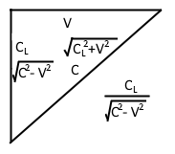
Figure 4: Graph relating C_{L} for distance related to velocity and C for velocity related to velocity. Used to show the geometric relation used for calculation T_{B}.
Figure 4 is used as a reference for the right triangle formed by a photon clock perpendicular to a moving body’s velocity, and the moving body’s velocity for the below math.

$$\begin{aligned}T_{B}=\frac{C_{L}}{\sqrt{C^{2}-\vec{V}\vec{V}}}\#\left(2.5\right)\end{aligned}$$
$$\begin{aligned}\frac{T_{B}}{T_{W}}=\frac{\frac{C_{L}}{\sqrt{{C_{L}}^{2}-\vec{V}\vec{V}}}}{\frac{CC_{L}}{C^{2}-\vec{V}\vec{V}}}=\frac{C_{L}}{\sqrt{C^{2}-\vec{V}\vec{V}}}\frac{C^{2}-\vec{V}\vec{V}}{CC_{L}}\#\left(2.6\right)\end{aligned}$$
$$\begin{aligned}\boxed{Γ=\frac{T_{B}}{T_{W}}=\frac{\sqrt{C^{2}-\vec{V}\vec{V}}}{C}}\#\left(2.7\right)\end{aligned}$$

Vector Expression to Apply Length Contraction
Compute the vector that is the position projected on the velocity vector. This vector is in the same direction as the velocity, scaled by the length of X projected on V.
$$\begin{aligned}\vec{A}=\frac{\vec{V}\left(\vec{X}⋅\vec{V}\right)}{\vec{V}∙\vec{V}}\#\left(2.8\right)\end{aligned}$$
Subtract the projected position vector, and then add the projection length contracted:
$$\begin{aligned}\vec{X^{'}}=\vec{X}-\vec{A}+\vec{A}\frac{\sqrt{CC-VV}}{C}\#\left(2.9\right)\end{aligned}$$
Refactor of the previous equation – subtract the amount of the projected vector that has been contracted out.
$$\begin{aligned}\vec{X^{'}}=\vec{X}-\vec{A}\left(1-\frac{\sqrt{CC-VV}}{C}\right)\#\left(2.10\right)\end{aligned}$$
Alternatively, given a ‘feels like’ velocity, the following equation performs the length contraction on a vector, resulting in a vector contracted in the direction of the velocity vector.
$$\begin{aligned}\vec{X^{'}}=\vec{X}-\vec{A}\left(1-\sqrt{\frac{CC}{CC+VV}}\right)\#\left(2.10\right)\end{aligned}$$

Light Aberration
"The discovery of the aberration of light in 1725 by James Bradle"(ref 1).
Light aberration is an effect that is seen as advancing the angle of a received photon in a moving frame. It also applies for photons that are emitted. It is demonstrated by synchrotron radiation for transmission, that the whole spectrum of doppler modified waves are projected ahead of the direction they would otherwise go. Figure 5 below is a representation of how light directions are modified due to light aberration, taken from the ‘lightSpeed4’ demonstration programs. Figure 6 below shows the direction of emitted photons from synchrotron radiation experiments; it is taken from a NASA paper about synchrotron [ref 10].

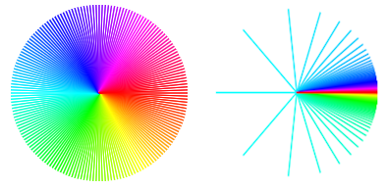
Figure 5: Hue map to show light aberration. Left is at 0 speed, and on the right is the map at 0.97c.

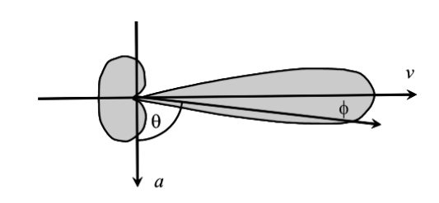
Figure 6: Representation of aberration cone from [ref 10].
I used the basic math for light aberration as derived by Einstein from Wikipedia 'Relativistic Aberration' [ref 2]:
$$\begin{aligned}\cos{θ_{o}}=\frac{\cos{θ_{s}} - \frac{V}{C}}{1- \frac{V}{C} \cos{θ_{s}}}\#\left(3.1\right)\end{aligned}$$
Where $θ_{o}$ is the observed angle for a frame moving at speed $V$. I extended the math slightly to include the direction part of the velocity:

$$\begin{aligned}\vec{dX}=\left(\vec{X_{E}}-\vec{X_{O}}\right)\#\left(3.2\right)\end{aligned}$$
Equation 3.4 is the cosine of the angle a body is observed:
$$\begin{aligned}\cos{θ_{s}=}J=\frac{\vec{dX}⋅\vec{V_{O}}}{\left|\left|\vec{dX}\right|\right|⋅\left|\left|\vec{V_{O}}\right|\right|}\#\left(3.4\right)\end{aligned}$$
$$\begin{aligned}ΔA=\cos^{-1}{\frac{ J + \frac{V_{o}}{C}}{1+J\frac{V_{o}}{C}}}-\cos^{-1}{J}\#\left(3.5\right)\end{aligned}$$
$ΔA$, the result of equation 3.5, is the change in the angle observed. This, again, applies for both transmission and reception. If this did not apply to transmission, then a light beam emitted at 90 degrees across a rocket of sufficient size, the light would drift down the wall by an amount relative to the speed of the rocket, and an interferometer would have a non-null result.
The above formula generally works for the 3D case, but because arccos aka $\cos^{-1}$ only returns $0$ to $π$, a correction needs to be applied based on the input angle.
$\left(A×D<0?-1:1\right)$ Given an input of $D$ which is the direction the body is travelling (where 0 is towards positive infinity on the X axis), and $A$ which is the angle the observer is travelling, the delta angle is $dA = D - A$. The multipart equation $N$ computes a multiplier based on the angle; every $π$ units the sign of the result flips; this is the absolute value of the floor of dA divided by $π$, mod 2, then if the result is 0 the value is 1, otherwise the value is -1:
$$\begin{aligned}dA=D-A\#\left(3.6\right)\end{aligned}$$
$$\begin{aligned}N=\left\{x=\left|\left\lfloor \frac{dA}{π}\right\rfloor \right|mod 2 \begin{aligned}1, &x=0 \\ -1, &x=1\end{aligned}\right.\#(3.7)\end{aligned}$$

And the aberrated angle for a body moving at $V$ is:
$$\begin{aligned}a=N*\cos^{-1}{\frac{\cos{dA}+\frac{V}{C}}{1+\frac{V}{C}\cos{dA}}}+D\#(3.8)\end{aligned}$$
The inverse calculation to determine the angle that resulted in an aberrated angle of $dA$ is:
$$\begin{aligned}b=N*\cos^{-1}{\frac{V-C\cos{dA}}{V\cos{dA}-C}}+D\#(3.9)\end{aligned}$$
Light aberration is one clue that a moving body has available to determine that they are the ones moving, although the parallax of the stars shifts too, distant galaxies are still going to be distant enough that their aberrated position can be compared to a base stellar map.
While experimenting with the simulation of a circular cavity with circular photons emitted from the center, the angle of light aberration ended up being the behavior of the waves reflecting in the cavity while the cavity is moving relative to their points of emission into space. When light hits an atom, the electron field is retarded slightly, and elongated, such that a beam arriving from behind itself hits an angle that would have been ahead of that position, if it were stationary relative to the photons. Conversely, when emitted, it seems that the process happens from the back of an atom and is projected forward around the nucleus which advances it’s angle because of the mutually retarded inside.

3D Aberration with Rotation
The partial expressions required for producing the angle of aberration can also be used to perform a rotation on a 3D vector. In the 3D case, the potential error from arccos only resulting with a value from 0 to pi are fixed by having the full cross product which is rotated around. Even in the case of the plane that is entirely edge-on to the observer, the cross-product Z axis is positive or negative whether the angle is on the left or right side, so the above N term does not have to be computed. The cross-product also gives the axis of rotation for the aberration.
Calculate delta position:
$\begin{aligned}\vec{ΔX_{d}}=\vec{X}-\vec{X_{O}}\#(3.10)\end{aligned}$

Compute cross product of position and observer's velocity:
$\begin{aligned}\vec{V_{c}}=\vec{ΔX_{d}}×\vec{V_{O}}\#(3.11)\end{aligned}$

Normalize the cross product (axis of rotation):
$$\begin{aligned}V_{cn}=\frac{\vec{V_{c}}}{\left\|\vec{V_{c}}\right\|}\#(3.12)\end{aligned}$$
Calculate dot product of position and normalized observer's velocity:
$$\begin{aligned}\vec{V_{d}}=\vec{ΔX_{d}}⋅\vec{V_{O}}\#(3.13)\end{aligned}$$
Normalize the dot product (cosine of angle between delta position and velocity)
$$\begin{aligned}\vec{V_{dn}}=\frac{\vec{V_{d}}}{\left\|\vec{V_{d}}\right\|}\#(3.14)\end{aligned}$$

Compute angle of aberration:
$$\begin{aligned}θ=cos^{-1}\frac{V_{dn}+\frac{\left\|V_{O}\right\|}{C}}{1+\frac{\left\|V_{O}\right\|V_{dn}}{C}}\#(3.15)\end{aligned}$$

Rotation of observed point $X_{d}$ plus position of observer:
$$\begin{aligned}X_{r}=\vec{X_{O}}+\cos\left(θ\right)\vec{ΔX_{d}}+\sin\left(θ\right)\left(\vec{V_{C}}×\vec{ΔX_{d}}\right)+\left(\left(1-\cos{θ}\right)\vec{V_{c}}⋅\vec{ΔX_{d}}\right)\vec{ΔV_{cn}}\#(3.16)\end{aligned}$$

Time Contraction
Time contracts according to the speed of a moving body. Contraction in the sense that clocks run slower. This contraction happens when normalizing the time it takes for worst-case time of forward and backward propagation across the contracted length, or by normalizing the lateral propagation time.
Forward and backward, the time light takes to cover the contracted distance of C light-seconds is:
$$\begin{aligned}T_{W}=\frac{1}{2}∙\frac{\sqrt{C^{2}-V^{2}}}{C}\left(\frac{C_{L}}{\left(C+V\right)}+\frac{C_{L}}{\left(C-V\right)}\right)\#\left(4.1\right)\end{aligned}$$
Multiplying the fraction for the distance of $C_{L}$ over $C+V$ by $C-V$ over $C-V$ and $C_{L}$ over $C-V$ by $C+V$ over $C+V$ reduces the expression to the following expression. The units will not change since $\frac{C+V}{C+V}$ cancels out the units and becomes just a scalar $\frac{x}{C^{2}-V^{2}}$ still has units of length over velocity, not velocity squared.
$$\begin{aligned}\frac{\sqrt{C^{2}-\vec{V^{2}}}}{2C}⋅\left(\frac{2C_{L}C}{C^{2}-\vec{V^{2}}}\right)\#\left(4.2\right)\end{aligned}$$

Which is then:
$$\begin{aligned}\frac{C}{\sqrt{C^{2}-\vec{V^{2}}}}\#\left(4.3\right)\end{aligned}$$
And the reciprocal, which scales the clock so 1 tick happens per light-tick is
$$\begin{aligned}\boxed{Γ=\frac{\sqrt{C^{2}-\vec{V^{2}}}}{C}} or \sqrt{1-{\left(\frac{\vec{V}}{C}\right)}^{2}}\#\left(4.4\right)\end{aligned}$$

Alternatively, it is possible to compute the time it takes for a photon clock mounted laterally to tick... and the result is the same as above. The time it takes for light to travel along the lateral path of C light-seconds is
$$\begin{aligned}\frac{C}{\sqrt{C^{2}-\vec{V^{2}}}}\#\left(4.5\right)\end{aligned}$$
And, again, the reciprocal, which scales the clock so 1 tick happens per light-tick is:
$$\begin{aligned}\boxed{Γ=\frac{\sqrt{C^{2}-\vec{V^{2}}}}{C}} or \sqrt{1-{\left(\frac{\vec{V}}{C}\right)}^{2}}\#\left(4.6\right)\end{aligned}$$

Moving Clocks
When clocks move within a frame, they have a slightly different time dilation factor than a clock that is stationary. Additionally, a clock moving forward relative to the velocity vector is slowed down, while a clock moving backward is faster. In a frame that is rotating, then the effective dilation of the frame is the rotation rate at that point, plus the overall velocity of the frame. The accumulated dilation resets back to zero.
The overall shift of clocks within a frame is basically $\frac{V}{C}$.

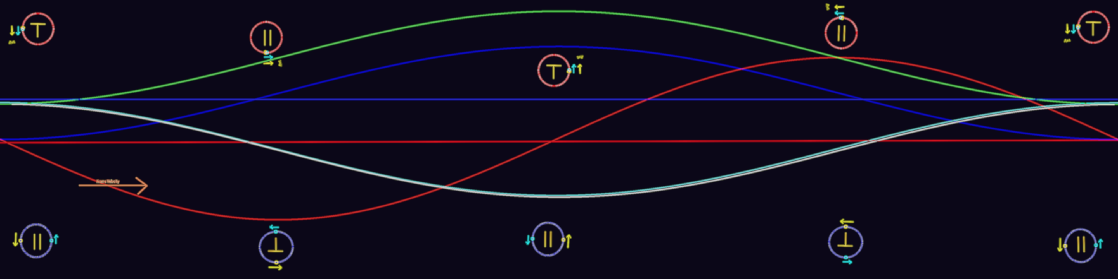
Figure (?) represents the accumulated time dilation of clocks in a rotating frame, with a base velocity. The blue rotation on the bottom, the clocks are on opposite sides of the rotating frame, which gives the maximum amount of separation between clocks. It relates to the blue curve above. The velocity vector of the overall frame is to the right. The red circles represent when the clocks are close to being on the same side of the rotation. The red sine wave below the red circles is out of phase with the blue, but then the relative orientation of the clocks is also different, as the angle approaches 0, the angle of the clocks approaches 90 degrees offset from being opposed on the rotating body.
The fraction of how much dilation occurs is the distance times $\frac{V}{C}$ according to local clocks. Across the Earth, there should be about 42 microseconds of separation of clocks on opposite side of the Earth, with the clocks positioned at 6am and 6pm sidereal time.
This is related to ‘slow clock transport’. Slow clock transport is the behavior that moving a clock, synchronized with another clock which remains stationary, within a frame, results in an offset of that clock that will make it behave as if the signal from that clock to its synchronized partner makes the one-way trip seem like it’s exactly at the speed of light. In the case of a rotating planet, all clocks on the surface are basically ‘slow clock transported’, resulting in a coordinated skew of their time that results in a one-way signal measured between the clocks always seem like it’s travelling at the speed of light, even though, if the clocks were able to tick at a single constant rate, a measurable difference in the one-way trip could be measured based on the overall motion of the containing frame.
This makes the experiment proposed later unable to detect the difference in two one-way speed-of-light paths.

Full Process to Compute Observation
Length contraction is applied to points on each body according to their own velocities.
The time between a point on the emitting body and observing body is computed using the observing body's real time coordinate, giving the emitting bodies real time when the event was emitted.
The absolute position can then be computed from emitter to observer, and then the light aberration for the observer based on the angle the signal is detected, resulting in a final actual position that the body being observed is perceived.
Given:
- $\vec{X}$ : Position being observed at T=0
- $\vec{V_{E}}$ : Velocity of body emitting a signal
- $\vec{X_{O}}$ : Position of observer at T=0
- $\vec{V_{O}}$ : Velocity of observer
Length contract points:
$$\begin{aligned}\vec{X^{'}}=\vec{X_{E}}-\frac{\vec{V_{E}}\left(\vec{X_{E}}⋅\vec{V_{E}}\right)}{{{\vec{V_{E}}}^{2}}^{2}}\left(1-\frac{\sqrt{CC-{V_{E}}^{2}}}{C}\right)\#\left(5.1\right)\end{aligned}$$
$$\begin{aligned}\vec{{X_{O}}^{'}}=\vec{X_{O}}-\frac{\vec{V_{O}}\left(\vec{X_{O}}⋅\vec{V_{O}}\right)}{{{\vec{V_{O}}}^{2}}^{2}}\left(1-\frac{\sqrt{CC-{V_{O}}^{2}}}{C}\right)\#\left(5.2\right)\end{aligned}$$
Propagation Delay from contracted point to observer:
$$\begin{aligned}\vec{P}=\vec{X^{'}}-\left(\vec{X_{O}'}+T_{O}\vec{V_{O}}\right)\#\left(5.3\right)\end{aligned}$$
$$\begin{aligned}T_{E}=\frac{\sqrt{{\left(C^{2}T_{O}+\vec{V_{E}}⋅\vec{P}\right)}^{2}-\left(C^{2}-\vec{V_{E}}\vec{V_{E}}\right)\left(C^{2}T_{O}^{2}-\vec{P}⋅\vec{P}\right)}+C^{2}T_{O}+\vec{V_{E}}⋅\vec{P}}{C^{2}-\vec{V_{E}}\vec{V_{E}}}\#\left(5.4\right)\end{aligned}$$
Light aberration:
$$\begin{aligned}\vec{X^{''}}=\vec{X'}+\vec{V_{E}}T_{E}\#\left(5.5\right)\end{aligned}$$
$$\begin{aligned}\vec{ΔX_{d}} =\vec{X^{'}}+\vec{V_{E}}T_{E}-\vec{{X_{O}}^{'}}\#\left(5.6\right)\end{aligned}$$
$$\begin{aligned}\vec{V_{d}}=\vec{ΔX_{d}}⋅\vec{V_{O}}\#\left(5.7\right)\end{aligned}$$
$$\begin{aligned}\vec{V_{dn}}=\frac{\vec{V_{d}}}{\left\|\vec{V_{d}}\right\|}\#\left(5.8\right)\end{aligned}$$
$$\begin{aligned}θ=cos^{-1}\frac{V_{dn}+\frac{\left\|V_{O}\right\|}{C}}{1+\frac{\left\|V_{O}\right\|V_{dn}}{C}}\#\left(5.9\right)\end{aligned}$$
$$\begin{aligned}\vec{V_{c}}=\vec{ΔX_{d}}×\vec{V_{O}}\#\left(5.10\right)\end{aligned}$$
$\begin{aligned}\vec{V_{cn}}=\frac{\vec{V_{c}}}{\left\|\vec{V_{c}}\right\|}\#\left(5.11\right)\end{aligned}$
$$\begin{aligned}X^{'''}=\vec{X^{''}}+\cos\left(θ\right)\vec{ΔX_{d}}+\sin\left(θ\right)\left(\vec{V_{cn}}×\vec{ΔX_{d}}\right)+\left(\left(1-\cos{θ}\right)\vec{V_{cn}}⋅\vec{ΔX_{d}}\right)\vec{V_{cn}}\#\left(5.12\right)\end{aligned}$$
Finally: $X^{'''}$ is the position of the point being observed relative to the observer.

Relativistic Velocity Addition
This is a different approach for relativistic velocity addition than Einstein’s and differs most at extremes of + the speed of light minus another thing with a large fraction of the speed of light and the inverse. It is very similar near zero, and where velocities are both positive or both negative.
When a frame is moving, its speed is limited effectively to $±C$. A frame that is moving has a contracted clock, which makes the real distance it travels according to its local clock result in a condition that they are moving at the speed of light, without being at the speed of light.
At 0.707c, the clock contraction is 1.414, so it takes 1.414 real seconds to tick 1 second on the clock. When moving at 0.707 for 1.414 seconds, they will cover 1 light second of space, which when measured against their local clock results in travelling at the speed of light or one light-second per second. This behavior of time dilation works all the way up to $±∞C$ results in a real velocity that is less than the speed of light but feels-like travelling at many times the speed of light.
The following equations capture this idea. $Γ$ is the length contraction/clock contraction factor, with a parameter of $v$. $V_{feel}(v)$ takes a velocity from $±C$, and results in a velocity that is $±∞$. $V_{real}(v)$ is the inverse function that takes a velocity from $±∞C$ and converts to $±C$.
$$\begin{aligned}Γ\left(v\right)=\frac{\sqrt{C^{2}-v^{2}}}{C}\#\left(6.1\right)\end{aligned}$$
$$\begin{aligned}V_{feel}\left(v\right)=\frac{v}{Γ\left(v\right)}\#\left(6.2\right)\end{aligned}$$
$$\begin{aligned}V_{feel}\left(v\right)=\frac{vC}{\sqrt{C^{2}-v^{2}}}\#\left(6.3\right)\end{aligned}$$
$$\begin{aligned}V_{real}\left(v\right)={V_{feel}}^{-1}(v)\#\left(6.4\right)\end{aligned}$$
$$\begin{aligned}V_{real}\left(v\right)=\frac{vC}{\sqrt{C^{2}+v^{2}}}\#\left(6.5\right)\end{aligned}$$

$V_{feel}(v)$ might also be called the local frame velocity. It is the real distance covered by the local proper time clock. Velocity addition could be done in this $±∞$ metric and converted back to a real velocity.
$$\begin{aligned}A(u,v)=V_{real}\left(V_{feel}\left(v\right)+V_{feel}\left(u\right)\right)\#\left(6.6\right)\end{aligned}$$
$$\begin{aligned}B(u,v)=\frac{C\left(\frac{v}{\sqrt{C^{2}-v^{2}}}+\frac{u}{\sqrt{C^{2}-u^{2}}}\right)}{\sqrt{1+{\left(\frac{v}{\sqrt{C^{2}-v^{2}}}+\frac{u}{\sqrt{C^{2}-u^{2}}}\right)}^{2}}}\#\left(6.7\right)\end{aligned}$$
Relativistic velocity addition formula for comparison:
$$\begin{aligned}A_{SR}(u,v)=\frac{v+u}{1+\frac{vu}{C^{2}}}\#\left(6.8\right)\end{aligned}$$
These two formulae are quite different, and certainly not equivalent; they are however very close to each other within the valid range of $±C$. The largest differences show up when the velocity is close to the speed of light, and there’s a large difference in the opposing direction; as in near +C and subtract near -C from it.
In feels-like terms, the speed 0.866c is 2c, and at -0.948 is 3c, so 2c-3c=1c, which is -0.707c; which means that moving at $+0.866c$, applying a $-.948c$ gets you to $-0.707c$ rather than $-0.082c$.
This would be a similar behavior in Einstein’s relativistic velocity addition formula also, but in the previous example would predict -0.458c instead of -0.780 (0.780 is what is computed from these 3 significant digit numbers, higher precision would be closer to 0.707).

More on Moving Clocks
At a small fraction of the speed of light for the overall frame, with a relative motion significantly less than the motion of the frame, which may include the rotation of the frame like the planet earth’s surface velocity. If the motion of the clock is larger than the largest of these, then the overall clock dilation can be detected. However, to accelerate enough atoms to constitute what might be a clock to one-one-thousandth of the speed of light or more is an engineering challenge for sure. The fastest man-made object so far is the Parker Solar Probe, and that itself is only moving at ½ the frame velocity of the solar system.
This would be an example of a fixed velocity along the X axis, with another velocity at all angles theta, adding them together, getting their real speed between 0 and C, and computing the gamma/time contraction factor, and for low speeds V2 the total is 0. The relation works out to be that for the extent of the body in the frame, the Earth’s diameter, any fraction of that curve is a linear scaled value from negative time to positive time and all parts in-between.
$$f\left(u,v\right)=V_{real}\left(|u+v|\right)$$
$$v=\left(V,0,0\right)$$
$$u\left(θ\right)=V_{2}(\cos{θ},\sin{θ},0)$$
$$\int{Γ\left(V_{real}\left(|\left(V,0,0\right)+V_{2}(\cos{θ},\sin{θ},0)|\right)\right)}$$
Desmos 3D graph demonstrating the above.
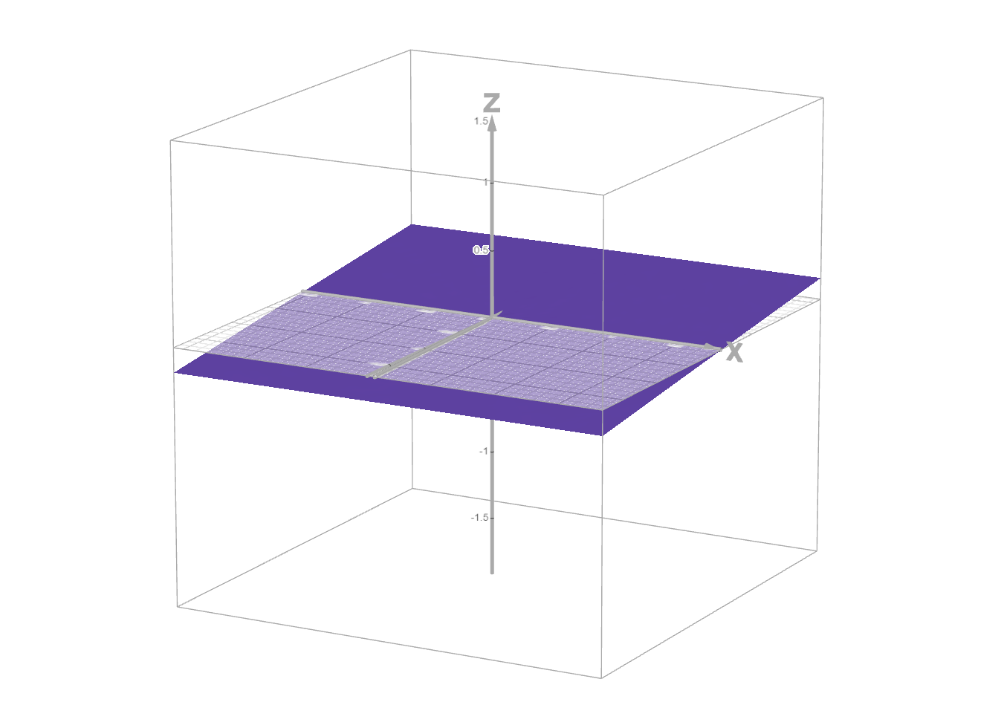
Figure 7 : the time dilation factor for any angle theta from the z axis on the x-y plane, r is the velocity, being moved, and within this range any positive velocity is the same as a negative velocity within this frame.
The above image shows a plane in the region of moving at 1/1000 the speed of light in the primary frame and moving at 1/100,000th the speed of light within that, which is about what the Earth’s surface velocity would be.
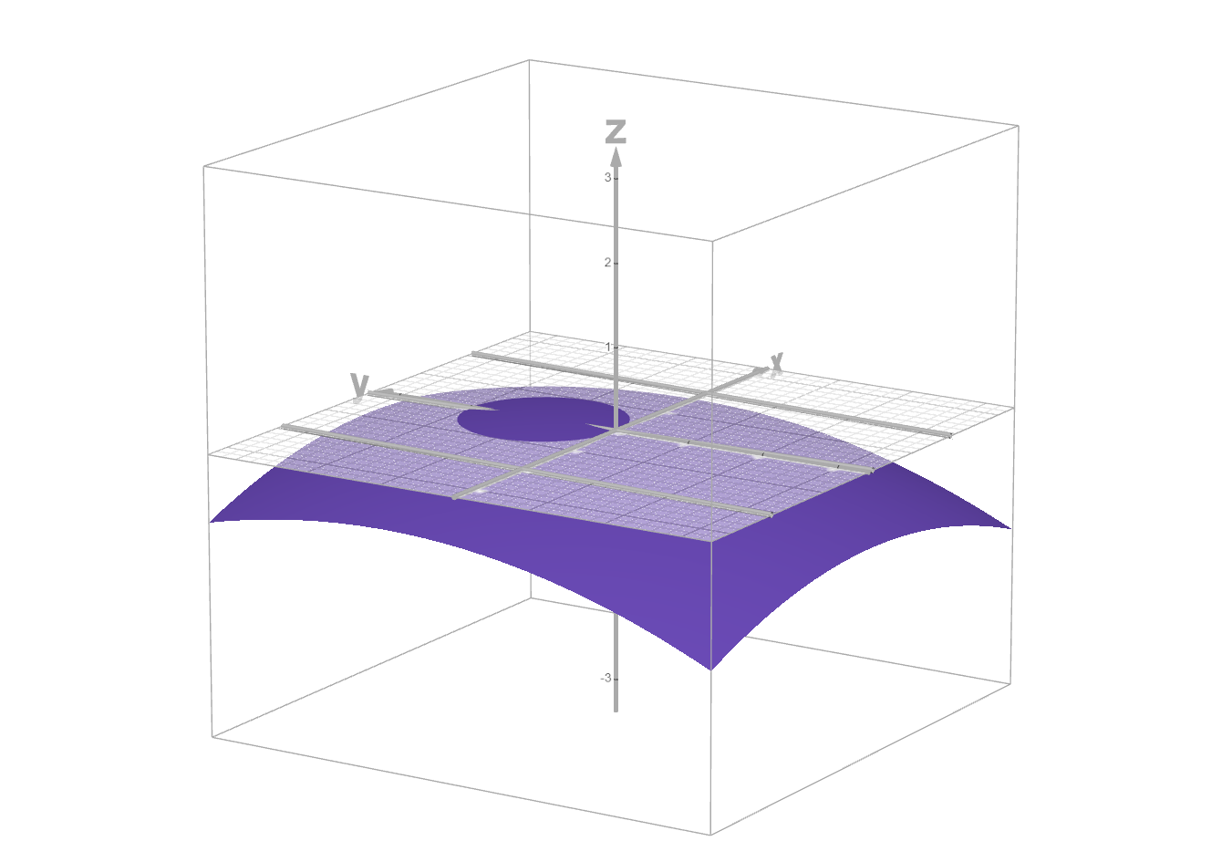
Figure 8 - Fragment of surface of the same graph as above, but R is scaled to be closer ot the frame's velocity, even larger, so there's a specific region where the time dilation is less than the overall frame, and a longer time when it's dilated more.
The above figure shows a larger region of relative velocity, if the clocks moved closer to or faster than the frame’s velocity, then there’s an asymmetry that can be observed; overall the clock will have more time dilation, and lose time, though there is a small range of angles and velocities that the clock runs faster than the standard clock of the frame it’s in.
The slow clock transport effect means that simultaneous events are scheduled by their clock’s cumulative retardation and advancement to be out of sync, but the resulting signal transmitted from the clock still appears to arrive at the same time. If one assumes this behavior is perfect, this effect is what gives the Lorentz Transform X axis a slope, and it represents how far out of sync the clocks are; this is specifically ‘slow’ clock transport though, and fast clocks do have different behavior. This result is that the light-cones from light events of those clocks end up aligned to still be as simultaneous as they would be at any other point in the rotation. One might say ‘always moves at the speed of light in any frame’ but that’s not really what that means.
In an Ideal frame, moving at 0 relative to the CMB, any clock moved away from the center and back would lose time, and a clock orbiting a central point would also always run slower than the clock at the center of the frame.

$$J\left(\vec{V},\vec{V_{2}}\right)= \frac{1}{\sqrt{1+\frac{\left(\vec{V}+\vec{V_{2}}\right)∙\left(\vec{V}+\vec{V_{2}}\right)}{C^{2}}}}-\frac{1}{\sqrt{1+\frac{\vec{V}∙\vec{V}}{C^{2}}}}$$
The following equation uses J for the difference between a small increment $±ϵ$ from the origin, which as $ϵ$ approaches 0, the slope approaches $\frac{V}{C}$ which is the slope of the x axis in the Lorentz transformation (give or take a gamma factor), and is the same as the Lorentz Transform’s generalized result (This is another place where the Lorentz Transform is only valid at 0 and is a projection of the differential at 0 to all conditions). As the difference in the velocities increases, the deviation from the Lorentz Transform is greater. At some point the delta velocity $V_{2}$ is greater than $V$, which is outside of the Lorentz transform’s predictions.
$$dJ\left(\vec{V}\right)=\frac{\left(J\left(\vec{V},\left(ϵ,0,0\right)\right)-J\left(\vec{V},\left(-ϵ,0,0\right)\right)\right)}{2}$$
Expressing the above expressions as a limit…
$$\lim_{x→0}\left(\frac{1}{\sqrt{1+\frac{\left(V+x\right)}{C^{2}}}}-\frac{1}{\sqrt{1+\frac{\left(V-x\right)}{C^{2}}}}\right)\frac{C}{2x}=-\frac{VC^{2}}{{\left(C^{2}+V^{2}\right)}^{\frac{3}{2}}}$$
Results in an expression based on the frame’s velocity, and as V approaches 0 the approximation from the Lorentz Transformation’s X axis’ slope. For example, at $V=0.001$ the difference is only 1.5 in $1{x10}^{9}$.
$$\lim_{V→0}{\frac{VC^{2}}{{\left(C^{2}+V^{2}\right)}^{\frac{3}{2}}}}\sim \frac{V}{C}$$
‘Slow’ is almost anything up to the frame’s speed, but it’s not a perfect correction like the Lorentz Transform would lead you to believe, the Thornson Levy experiment with planes flying atomic clocks showed differences, partially from elevation, and being higher in the gravitational field that the clocks both ran faster, but then the planes moved fast enough for long enough that the clock accumulated error was different from the frame.

Doppler Effect or Frequency Shift
The frequency shift depends on the angle the light was emitted before aberration is applied (emissions from synchrotron radiation contain a spread of frequencies, indicating that the doppler happens before aberration). Theta ($θ$) in the equation is the emission angle relative to the velocity direction, and V is just the speed component of the velocity.
$$\begin{aligned}F=\frac{1}{\sqrt{1+\frac{V^{2}}{C^{2}}-\frac{2V}{C}\sin\left(θ\right)}}\#\left(7.1\right)\end{aligned}$$
The above factor is a scalar on the frequency, and $\frac{1}{F}$ should be used to scale the wavelength.
The composite frequency shift and light aberration function:
$$\begin{aligned}F=\frac{1}{\sqrt{1+\frac{V^{2}}{C^{2}}-\frac{2V}{C} cos\left(N*{\cos^{-1}\left(\frac{\cos\left(dA\right)+\frac{V}{C}}{1+\frac{V}{C}\cos\left(dA\right)}\right)}\right)}}\#\left(7.2\right)\end{aligned}$$

Derivation of Doppler Shift
$A_{O}$ is the angle observed. (same as in aberration)
$D$ is the direction the emitter is travelling. (same as in aberration)
Equation [57] is the distance the signal travels in 1 tick:
$\begin{aligned}\vec{A}=\{C\cos\left(A_{O}\right),C\sin\left(A_{O}\right)\}\#\left(7.3\right)\end{aligned}$Equation [58] is the distance the body travels in 1 tick:
$$\begin{aligned}\vec{B}=\left\{V\cos\left(D\right),V\sin\left(D\right)\right\}\#\left(7.4\right)\end{aligned}$$
This is the difference between the distance traveled by 1 wave in 1 tick minus the distance traveled by the body:
$$\begin{aligned}\vec{A-B}=\left\{C\cos\left(A\right)-V\cos\left(D\right),C\sin\left(A\right)-V\sin\left(D\right)\right\}\#\left(7.5\right)\end{aligned}$$
Square both sides, to work towards getting the length of the vector:
$$\begin{aligned}{\vec{A-B}}^{2}=\left(\begin{aligned}\left(C^{2}\cos^{2}\left(A\right)-2CV\cos\left(A\right)\cos\left(D\right)+V^{2}\cos^{2}\left(D\right)\right) \\ +\left(C^{2}\sin^{2}\left(A\right)-2CV\sin\left(A\right)\sin\left(D\right)+V^{2}\sin^{2}\left(D\right)\right)\end{aligned}\right)\#\left(7.6\right)\end{aligned}$$

Combine common terms:
$$\begin{aligned}{\vec{A-B}}^{2}=\left(\begin{aligned}C^{2}\left(\cos^{2}\left(A\right)+\sin^{2}\left(A\right)\right) \\ -2CV\left(\cos\left(A\right)\cos\left(D\right)+\sin\left(A\right)\sin\left(D\right)\right) \\ +V^{2}\left(\cos^{2}\left(D\right)+\sin^{2}\left(D\right)\right)\end{aligned}\right)\#\left(7.7\right)\end{aligned}$$
Remove terms that combine to be 1, and simplify complex trig identity:
$$\begin{aligned}{\vec{A-B}}^{2}=C^{2}-2CV\left(\sin\left(D-A\right)\right)+V^{2}\#\left(7.8\right)\end{aligned}$$
Take square root of both sides to result in length, and divide both sides by C to convert the distance to a time:
$$\begin{aligned}\frac{\left\|\vec{A-B}\right\|}{C}=\frac{\sqrt{C^{2}-2CV\left(\sin\left(D-A\right)\right)+V^{2}}}{C}\#\left(7.9\right)\end{aligned}$$
Resulting equation:
$$\begin{aligned}\boxed{\frac{\left\|\vec{A-B}\right\|}{C}=\sqrt{1+\frac{V^{2}}{C^{2}}-\frac{2V}{C}\left(\sin\left(D-A\right)\right)}}\#\left(7.10\right)\end{aligned}$$

Results
The first thing that was learned through the development of the above system of equations is that a body that is approaching an observer at a high speed appears expanded, while a body that is leaving an observer appears contracted. This is only an apparent expansion and contraction, the physical length contraction of a moving body is not related to this appearance; the appearance expands the body even longer than it is non-contracted, and the apparent contraction is even more than the contracted length (even if the body was not calculated to have any length contraction).
The propagation of light delays when an observer sees a body, so the observer sees the body in a position that is always behind a moving body’s real position. If the observer is also moving, at a similar speed to the body being observed, then the observer’s perception is advanced in angle by light aberration. The light aberration makes it appear that the body is further forward.
The application of perspective to the result is also important; just plotting points as they would appear from light propagation, length contraction, and light aberration in a 2D space-time graph makes the graphs very distorted; or in the following case plogging the x-y change of a square body that is observed moving (See Figure 7). 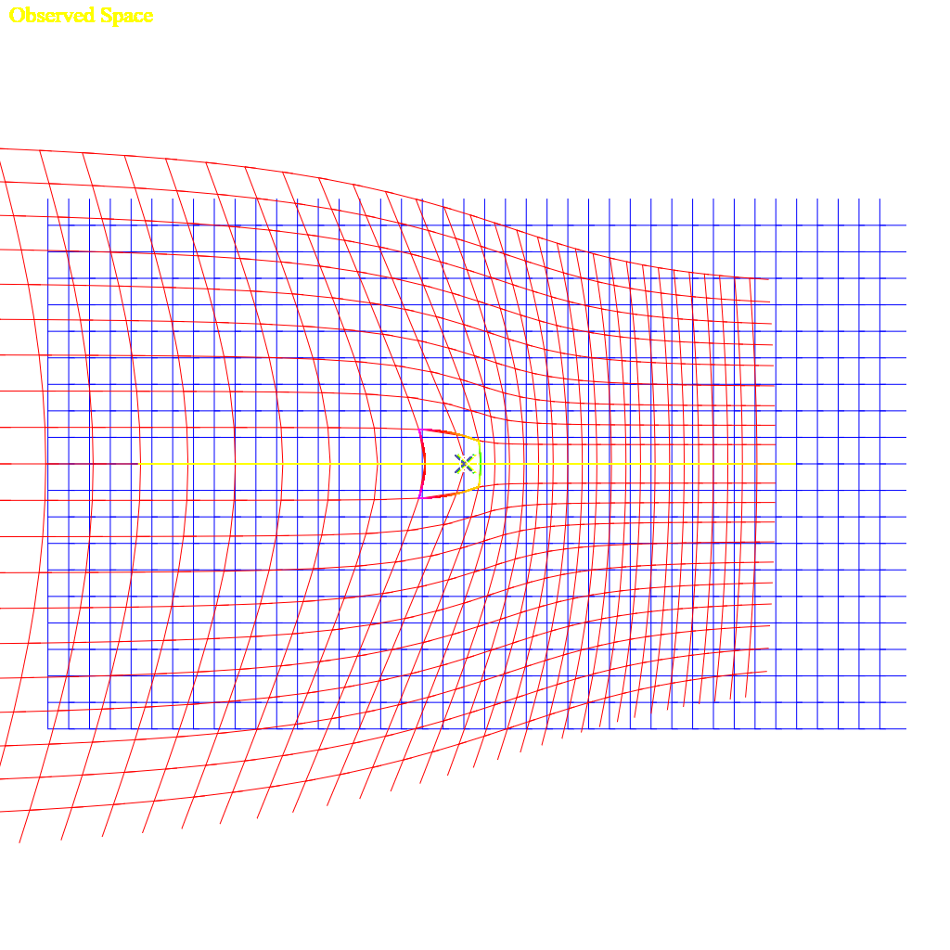
Figure 9: Distortion of an observed space that is moving at 0.61c for an observer moving at 0.31c. This from this demo. The demonstration program allows toggling length contraction and aberration, but light propagation effects are always applied.
This showed that there is a distinct asymmetry to the equations.

Relative Velocities
An observer which is offset from the path of an observer has several relative velocities while the body only has a constant velocity. An observed body will at the furthest extent be seen as traveling towards the observer with a velocity that points towards the observer (-V in a 2D sense), will slowly change to 0, and then appear to accelerate back to velocity V away from the observer. If there is 0 distance (or an insignificant fraction of the speed of light-seconds away), then the velocity instantly changes from -V (towards the observer) to V (away from the observer).
In the following equation, D is the distance to the straight line (1 in the graph), V is the velocity (1 in the graph), T is the time (x in the graph).
These equations give the position of an object some distance from an observer at some time at a given velocity:
$$\begin{aligned}X=VT,Y=D,X^{'}=V\left(T-0.001\right)\#\left(8.1,8.2,8.3\right)\end{aligned}$$
The change position between a ‘now’ and ‘now’ minus one one-thousandth of a time unit, dividing the change in distance by 1/1000 is the same as multiplying by 1000:
$$\begin{aligned}v_{x}=\left(\sqrt{\left(X^{2}+Y^{2}\right)-\left({\left(X^{'}\right)}^{2}+Y^{2}\right)}\right)∙1000\#\left(8.4\right)\end{aligned}$$
Expanded:
$$\begin{aligned}v_{x}=\left(\sqrt{{\left(VT\right)}^{2}+DD}-\sqrt{DD+{\left(V\left(T-0.001\right)\right)}^{2}}\right)⋅1000\#\left(8.5\right)\end{aligned}$$
Gives the graph in Figure 8 below.

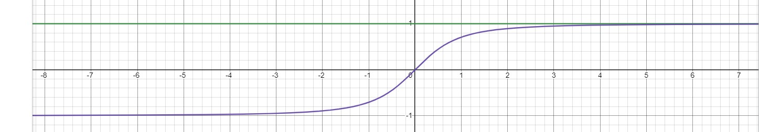
Figure 10: a constant velocity (V) at an offset distance (D on the Y axis) is shown as the green line, while the relative time to an observer at X=0 is shown in purple. The X-axis is a distance from the observer. The Y-axis for the purple line is the relative velocity.
The Lorentz Transform does not account for this sort of relative velocity. It does not even consider that before passing an observer the relative velocity is negative, or toward the observer, and positive after a body has passed an observer.

The Lorentz Transform
In an attempt to get from propagation to derive the Lorentz Transform[Ref 4], there are a few points discovered to be issues with the Lorentz Transform. First, the Lorentz Transform does not include any consideration to change any propagation delay from an offset of the body, instead falling back to a Galilean Transform for the Y and Z coordinates, or from an offset on the observer; the further away a point is in any direction, the longer it takes to see that point, and the more lagged the position along the velocity of the observed body. Second, there’s no support for relative velocity. The velocity is instead treated as a differential between the two absolute velocities. A train going 60mph and a car on the highway going 80mph, the train has a differential velocity of -20mph compared to the car, but the relative velocity changes as the car passes the train. Before the car passes the train, the relative velocity between the two bodies is negative as they get closer together, the delta is -20mph; and after the car passes the train the velocity is positive and is 20mph. During the passing of the train, relative to a particular point on the train, the relative velocity to a specific point on the train is 0mph when it is at the closest distance to the car. The velocity slowly changes from -20mph to 0mph to 20mph relative to any point on the train.
The Lorentz Transform is also only valid for an event at the origin, with an observer at the origin.
This isn’t an attempt to get the same result, since the behaviors are not the same, it’s more to identify where the differences are. In the case of basic light propagation calculation, there are two independent velocities relative to a third frame. This might be $G$, $L_{1}$ and $L_{2}$ frames, where $L_{1}$ and $L_{2}$ are local frames moving with independent constant velocities within the frame of $G$.

Lorentz Transform Equations
$$\begin{aligned}γ=\frac{1}{\sqrt{1-\frac{v^{2}}{c^{2}}}}=\frac{c}{\sqrt{c^{2}-v^{2}}}\#\left(8.6\right)\end{aligned}$$
$$\begin{aligned}t^{'}=γ\left(t-\frac{vx}{c^{2}}\right)\#\left(8.7\right)\end{aligned} \\ \begin{aligned}x^{'}=γ\left(x-vt\right)\#\left(8.8\right)\end{aligned}$$
$$\begin{aligned}y^{'}=y\#\left(8.8\right)\end{aligned} \\ \begin{aligned}z^{'}=z\#\left(8.10\right)\end{aligned}$$

The above set of equations are a solution for an event occurring at the origin, and the primed frame is the observer also at the origin and is the one is moving[ref 5]; this is a pretty typical derivation, expanded in Appendix I. But then that means the resulting equations have only a limited scope of applicability. The offset in the $y$ or $z$ directions also changes when an event is received, and it becomes apparent that although the solved set of equations claims to use $ct$ as the propagation time of an event, that at some time $t$ that the signal is $ct$ units from the origin, the solution doesn’t include that factor, and only really tracks time dilation and length expansion. The gamma term as defined increases to infinity as the velocity approaches the speed of light.
Einsteins derivation in 1920 [ref 6] assumes a lot and does not give a step-by-step derivation.
The sequence of steps given to work from a Galilean transform to the Lorentz Transform seems plausible, but it appears that the solution is really reversed between the time direction and the space direction, when considered from specialized consideration of light propagation formulae given above. To approach the Lorentz Transform equivalent math, the emitted event an observed event must be located at the origin of the frame, which might also be, at an insignificant fraction of a light-time-unit from the origin; given that the speed of light is very fast, anything within a lab-scale distance is also 0. Lab-scale in this sense is approximately anything up to the scale of the Earth, but maybe 1/40th of the radius of Earth is a more reasonable limit.

Another Derivation
The Wikipedia derivation of the Lorentz Transform starts with two stationary points, $\{x_{1},y_{1},z_{1}\}$ and $\{x_{2},y_{2},z_{2}\}$. The distance between those points takes an amount of time from $t_{1}$ to $t_{2}$, times the speed of light [ref 7]. It does immediately present that $ct$ is somehow a meaningful value itself, rather than the differential length divided by c is equal to the delta time between the events; which then c can later be moved over to the time side, and squared.
$$\begin{aligned}c^{2}{\left(t_{2}-t_{1}\right)}^{2}={\left(x_{2}-x_{1}\right)}^{2}+{\left(y_{2}-y_{1}\right)}^{2}+{\left(z_{2}-z_{1}\right)}^{2}\#\left(8.11\right)\end{aligned}$$
or
$$\begin{aligned}c^{2}{\left(t_{2}-t_{1}\right)}^{2}-{\left(x_{2}-x_{1}\right)}^{2}-{\left(y_{2}-y_{1}\right)}^{2}-{\left(z_{2}-z_{1}\right)}^{2}=0\#\left(8.12\right)\end{aligned}$$
Equation [65] itself I cannot find fault in; other than it is for the time between two stationary events and does not include any motion.
The next point is establishing invariance of interval [ref 7]:
$$\begin{aligned}ds^{2}=c^{2}dt^{2}-dx^{2}-dy^{2}-dz^{2}\#\left(8.13\right)\end{aligned}$$
Then this $ds$ term is used to apply a relative velocity. Although since $ds^{2}=0$, it does seem to just be an exercise. But as mentioned above, there isn’t a single relative velocity between two bodies, except when the two bodies have the same velocity and are relatively stationary with 0 relative velocity between them. Additionally, $ds$ being an infinitesimal since $ds^{2}=0$, this is still only valid near 0.

Comparison working from Light Propagation
Starting with equation [1]:
$$\begin{aligned}T_{O}=T+\frac{\left\|\left(\vec{X_{E}}+T\vec{V_{E}}\right)-\left(\vec{X_{O}}+T_{O}\vec{V_{O}}\right)\right\|}{C}\#\left(1.1\right)\end{aligned}$$
To match equation [71], which specifies that the emission of the event (subscript 1) invert some signs. However, the right side will always be positive, so the left side the observed event must be after the emission, so it would be untrue to reverse the signs on the left. In the above equations, $t_{2}-t_{1}$is a negative term, but it shouldn’t matter after squaring.
$$\begin{aligned}T_{O}-T=\frac{\left\|\left(\vec{X_{O}}+T_{O}\vec{V_{O}}\right)-\left(\vec{X_{E}}+T\vec{V_{E}}\right)\right\|}{C}\#(8.14)\end{aligned}$$
Convert magnitude expression to square root of squared difference:
$$\begin{aligned}T_{O}-T=\frac{\sqrt{{\left(\left(\vec{X_{O}}+T_{O}\vec{V_{O}}\right)-\left(\vec{X_{E}}+T\vec{V_{E}}\right)\right)}^{2}}}{C}\#\left(8.15\right)\end{aligned}$$
Move C to the left side, and square both sides to remove radical:
$$\begin{aligned}C^{2}{\left(T_{O}-T\right)}^{2}={\left(\left(\vec{X_{O}}+T_{O}\vec{V_{O}}\right)-\left(\vec{X_{E}}+T\vec{V_{E}}\right)\right)}^{2}\#\left(8.16\right)\end{aligned}$$
At this point we can introduce another variable that makes the equation non-zero on the left… though the invariance interval above (equation [66]) is already in a delta, dropping the static initial points that defined the terms. Also simplify to a single dimension instead of a vector here.
$$\begin{aligned}{dS}^{2}=C^{2}{\left(T_{O}-T\right)}^{2}-{\left(\left(\vec{X_{O}}+T_{O}\vec{V_{O}}\right)-\left(\vec{X_{E}}+T\vec{V_{E}}\right)\right)}^{2}\#\left(8.17\right)\end{aligned}$$
But then the velocities are already part of the math, and don’t have to be applied to the $dS$ term. If there was a single differential (not relative) velocity specified, then we could define:
$$\begin{aligned}\vec{V_{E}}=-\vec{V};\vec{V_{O}}=0\#\left(8.18,8.19\right)\end{aligned}$$
Substitute velocity expressions [71] and [72] into [70]:
$$\begin{aligned}{dS}^{2}=C^{2}{\left(T_{O}-T\right)}^{2}-{\left(\left(\vec{X_{O}}\right)-\left(\vec{X_{E}}-T\vec{V}\right)\right)}^{2}\#\left(8.20\right)\end{aligned}$$
Remove some parenthesis:
$$\begin{aligned}{dS}^{2}=C^{2}{\left(T_{O}-T\right)}^{2}-{\left(\vec{X_{O}}-\vec{X_{E}}-T\vec{V}\right)}^{2}\#\left(8.21\right)\end{aligned}$$
Change $T_{O}$ to $T+T_{Δ}$, and $\vec{X_{O}}-\vec{X_{E}}$ to $\vec{X_{∆}}$
$$\begin{aligned}{dS}^{2}=C^{2}{\left(T+T_{Δ}-T\right)}^{2}-{\left(\vec{X_{∆}}-T\vec{V}\right)}^{2}\#\left(8.22\right)\end{aligned}$$
Simplify expressions, and this resembles equation[73], but still has a differential velocity that works as a relative velocity in the equation:
$$\begin{aligned}{dS}^{2}=C^{2}{T_{Δ}}^{2}-{\left(\vec{X_{∆}}+T_{Δ}\vec{V}\right)}^{2}\#\left(8.23\right)\end{aligned}$$

Solving Light Propagation at the Origin
Alternatively, a shorter method that approaches the Lorentz Transform, but doesn’t quite get there is to start with Equation 2:
$$\begin{aligned}T_{O}=T+\frac{\left\|\left(\vec{X_{E}}+T\vec{V_{E}}\right)-\left(\vec{X_{O}}+T_{O}\vec{V_{O}}\right)\right\|}{C}\#\left(1.1\right)\end{aligned}$$
Define gamma:
$$\begin{aligned}γ=\frac{C}{\sqrt{C^{2}-V^{2}}}\#\left(8.24\right)\end{aligned}$$
Simplify so there is 0 distance between the observers, the point being observed is 0, and a 0 velocity for the emitter, gives the following equation:
$$\begin{aligned}C\left(T_{O}-T\right)=\left\|\left(-T_{O}\vec{V_{O}}\right)\right\|\#\left(8.25\right)\end{aligned}$$
Converting the magnitude expression to the square root of the vector squared:
$$\begin{aligned}C\left(T_{O}-T\right)=\sqrt{{\left(-T_{O}V\right)}^{2}}\#\left(8.26\right)\end{aligned}$$
$$\begin{aligned}C^{2}T_{O}T_{O}-{2C^{2}T}_{O}T+{C^{2}T}^{2}={\left(-T_{O}V\right)}^{2}\#\left(8.27\right)\end{aligned}$$
$$\begin{aligned}C^{2}T_{O}T_{O}-V^{2}T_{O}T_{O}-{2C^{2}T}_{O}T=-C^{2}T^{2}\#\left(8.28\right)\end{aligned}$$
$$\begin{aligned}\left(C^{2}-V^{2}\right)T_{O}T_{O}-{2C^{2}T}_{O}T=-C^{2}T^{2}\#\left(8.29\right)\end{aligned}$$
$$\begin{aligned}{\left(\sqrt{\left(C^{2}-V^{2}\right)}T_{O}-\frac{C^{2}T}{\sqrt{\left(C^{2}-V^{2}\right)}}\right)}^{2}=\frac{{C^{4}T}^{2}}{\left(C^{2}-V^{2}\right)}-{C^{2}T}^{2}\#\left(8.30\right)\end{aligned}$$
$$\begin{aligned}T_{O}=\frac{\sqrt{\frac{{C^{4}T}^{2}}{\left(C^{2}-V^{2}\right)}-{C^{2}T}^{2}}+\frac{CT}{\sqrt{\left(C^{2}-V^{2}\right)}}}{\sqrt{\left(C^{2}-V^{2}\right)}}\#\left(8.31\right)\end{aligned}$$
$$\begin{aligned}{T_{O}}^{}=\frac{\sqrt{{C^{4}T}^{2}-{\left(C^{2}-V^{2}\right)C^{2}T}^{2}}+C^{2}T}{C^{2}-V^{2}}\#\left(8.32\right)\end{aligned}$$
$$\begin{aligned}\boxed{T_{O}=\frac{\sqrt{V^{2}C^{2}T^{2}}+C^{2}T}{C^{2}-V^{2}}}\#\left(8.33\right)\end{aligned}$$
Which, naively, the square root of the square simplifies (incorrectly):
$$\begin{aligned}T_{O}=\frac{C^{2}T ± VCT}{C^{2}-V^{2}}\#\left(8.34\right)\end{aligned}$$
Scaled by gamma, this should be equivalent the $t^{'}$ equation of the Lorentz Transformation:
$$\begin{aligned}T_{O}=γCT\left(\frac{C±V}{C^{2}-V^{2}}\right)\#\left(8.35\right)\end{aligned}$$
$$\begin{aligned}T_{O}=γCT\left(\frac{1}{C±V}\right)\#\left(8.36\right)\end{aligned}$$
$$\begin{aligned}X_{O}=γVCT\left(\frac{1}{C±V}\right)\#\#\left(8.37\right)\end{aligned}$$
Should be:
$$\begin{aligned}t'=γ\left(t-\frac{vx}{c^{2}}\right)\#\left(8.7\right)\end{aligned}$$
Or:
$$\begin{aligned}X=\frac{tv}{C}\#\left(8.38\right)\end{aligned}$$
$$\begin{aligned}t'=γ\left(t-\frac{v}{C}\frac{vt}{C}\right)\#\left(8.39\right)\end{aligned}$$
$$\begin{aligned}x^{'}=γ\left(x-vt\right)\#\left(8.8\right)\end{aligned}$$

It can be noted, the simplification between [105] and [106] is not correct, and the results are not equivalent. The result of the square root should always be positive (except if V > C, at which point, the observer can notice the event in two places, and the negative solution that is greater than T should also be considered), since observation always occurs at a time after a signal is emitted, so it should at least be an absolute value. This is invariably why the graph is taken as symmetric across the origin, when with the full expression there is an asymmetry to the observed space. Propagation is not a coordinate transformation though, but when scaled with gamma correction factors, the results are very close near the slow speed the Earth is moving through the universe.
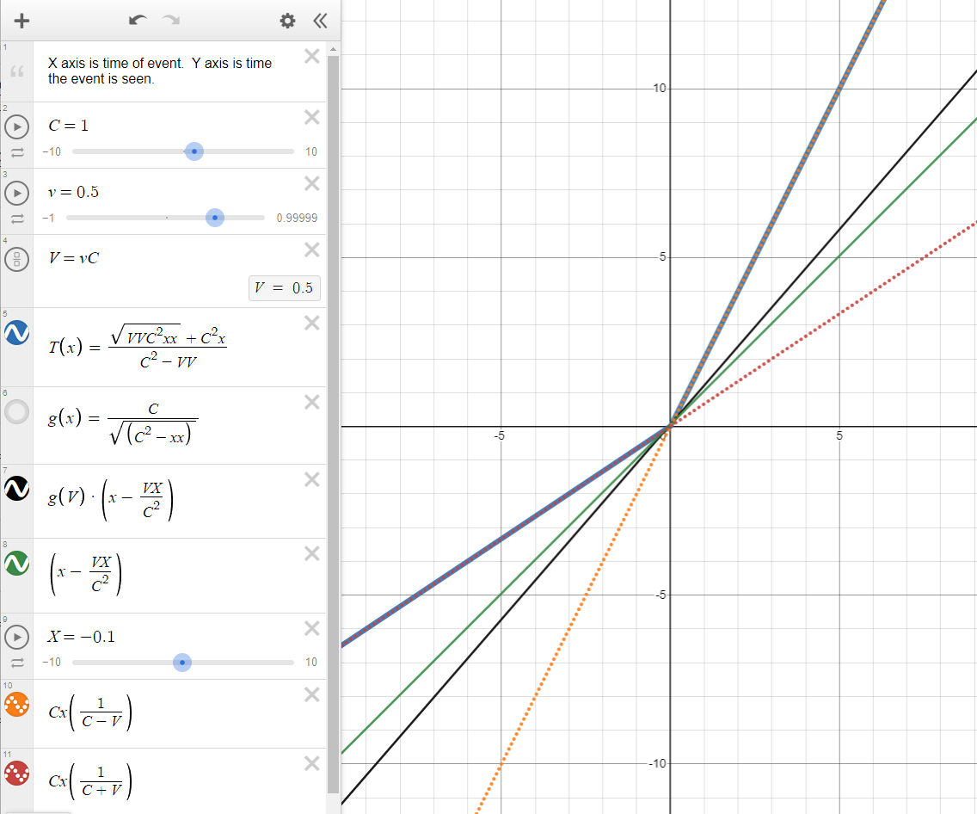
Figure 11: Graph comparing Lorentz Transform vs Light Propagation.
Figure 9: https://www.desmos.com/calculator/vrvjp9vzcr. This is a comparison of Lorentz Time plot vs Light Propagation time. The blue line is the correct plot, at time $T=-5$, the event will be observed at nearly $T_{O}=-3.33$, because the observer is before the event at the origin when it goes off, and it will run into the signal from the event as it goes to the origin. At T=1, the event will be seen at $T_{O}=2$, because the observer will have already passed the event, and will take twice the time for the event to catch up to the observer. The orange and red dashed lines are the incorrect simplification for equation [106]. They each represent part of the blue line, but continued, without following the blue line. The black line is the Lorentz Transform, which results in an inexplicable graph. The green line is the Lorentz time transformed without the gamma term.

Another Approach, working from solved equation for propagation:
$$\begin{aligned}\vec{P_{O}}=\vec{X_{E}}+\vec{V_{E}}T-\vec{X_{O}}\#\left(8.8\right)\end{aligned}$$
$$\begin{aligned}\boxed{T_{O}=\frac{\sqrt{{\left(C^{2}T+\vec{P_{O}}\vec{V_{O}}\right)}^{2}-\left(C^{2}-{\vec{V_{O}}}^{2}\right)\left(C^{2}T^{2}-\vec{P_{O}}\vec{P_{O}}\right)}+\left(C^{2}T+\vec{P_{O}}\vec{V_{O}}\right)}{C^{2}-{\vec{V_{O}}}^{2}}}\#\left(8.9\right)\end{aligned}$$
Again, simplify for $\vec{X_{E}}=\vec{0}$, $\vec{X_{O}}=\vec{0}, \vec{V_{E}}=\vec{0}$, $\vec{V_{O}}=\vec{V}$:
$$\vec{P_{O}}=0$$
$$\begin{aligned}T_{O}=\frac{\sqrt{{\left(C^{2}T\right)}^{2}-\left(C^{2}-{\vec{V}}^{2}\right)\left(C^{2}T^{2}\right)}+C^{2}T}{C^{2}-{\vec{V}}^{2}}\#\left(8.49\right)\end{aligned}$$
Expand terms:
$$\begin{aligned}T_{O}=\frac{\sqrt{C^{4}T^{2}-C^{2}C^{2}T^{2}+{\vec{V}}^{2}C^{2}T^{2}}+C^{2}T}{C^{2}-{\vec{V}}^{2}}\#\left(8.50\right)\end{aligned}$$
$$\begin{aligned}\boxed{T_{O}=\frac{\sqrt{{\vec{V}}^{2}C^{2}T^{2}}+C^{2}T}{C^{2}-{\vec{V}}^{2}}}\#\left(8.51\right)\end{aligned}$$
Incorrect simplification here:
$$\begin{aligned}T_{O}=\frac{\left\|\vec{V}\right\|CT+C^{2}T}{C^{2}-{\vec{V}}^{2}}\#\left(8.52\right)\end{aligned}$$
$$\begin{aligned}T_{O}=\frac{\left(\left\|\vec{V}\right\|+C\right)\left(CT\right)}{C^{2}-{\vec{V}}^{2}}\#\left(8.53\right)\end{aligned}$$
$$\begin{aligned}T_{O}=\frac{\left(\vec{V}+C\right)\left(CT\right)}{\left(C-\left\|\vec{V}\right\|\right)\left(C+\left\|\vec{V}\right\|\right)}\#\left(8.54\right)\end{aligned}$$
$$\begin{aligned}T_{O}=\frac{\left(CT\right)}{\left(C-\left\|\vec{V}\right\|\right)}\#\left(8.55\right)\end{aligned}$$
Again, the simplification removing the radical between [114] and [115] is incorrect. The squaring of the terms and the square root is effectively an absolute value on the T and V terms.

$E=mc^{2}$?
The expression for energy and mass only depends on time dilation gamma[ref 3], and the gamma term is the same; there is no consequence or modification for this expression.

The Problems
The following sections are problems that were found with the above math. They are places where the idea of relativity and the equivalence principle do not match what would happen in reality.

Relative Time Dilation
This is an issue with Relativity as a concept.
It's said that only the relative difference matters between two bodies. Consider a scenario where 8 craft pass by Earth at the same time (T=0), and their clocks are all exactly synchronized. Each craft is 0.1c faster than the previous.
Each ship has an additional distance of 0.1 light seconds per second, which is a lag of +0.1 seconds per second, or after 10 seconds there's 1 light-second between them which is an additional delay of 1 second. Between the first and last ship then is 8 seconds of delay per 10 seconds of travel.
If considered entirely relatively, then each ship has a relative time contraction of 0.995 compared to the previous ship, or the same as the contraction between the earth and the first ship. After 1 second, each ship’s clock is 10*(1-0.995) = 0.050 slower seconds per 10 seconds of travel slower than the previous ship.
A side note: obviously the Lorentz Transform that results in 0.05 second contraction does not include the 1 second of propagation time between each ship. Each ship would see the next as 1.05 seconds per 10 seconds slower when including the propagation delay. The total difference from the first ship to the last is at least 7 seconds of lag.
The time contraction for the 8th ship relative to the earth is (1-0.6 = 0.4 which indicates it loses 4 seconds in 10) and 8*(1-0.995) is 0.040, which is the total contraction the 8th ship would have if considered as only relative to the prior ship. 0.040(total relative) is not equal to 0.40(relative to earth).

Table 7 shows the actual and relative differences for their local clock.

0 | 1 | 2 | 3 | 4 | 5 | 6 | 7 | 8 | Comments
1.0  0 | 0.995  0.005 | 0.978  0.022 | 0.954  0.046 | 0.917  0.073 | 0.866  0.134 | 0.800  0.200 | 0.714  0.276 | 0.600  0.400 | Actual time contraction; how much time each clock loses
1.0  0 | 0.995  0.005 | 0.990  0.010 | 0.985  0.015 | 0.980  0.020 | 0.975  0.025 | 0.970  0.030 | 0.965  0.035 | 0.960  0.040 | Total time contraction if time was relative to the previous
Table 7: All relative times between each body, both with relative time contraction and absolute time contraction.

The following is across 10 seconds, and including propagation delay:

- Observer 1 sees 2 as 1 second + 10(0.995-0.978)=0.15 seconds ... so 1 sees 2 lagged by 1.15 seconds.
- Observer in 7 sees 8 as 1 second + 10(0.714-0.600)=1.14 seconds ... so 7 to 8 sees 8’s clock lagged by 2.14 seconds per 10 seconds compared to its own clock.
Remember 7 to 8 and 1 to 2 are both relative to each other by only 0.1c, so the time dilation that 7 sees from 8 should still be just 0.995 seconds from time dilation according to Special Relativity.

The Twin Paradox
There is no paradox in this system. Every observer can agree which is moving and which is stationary. The moving twin ages slower, and at a known rate compared to their twin back in the nearly stationary frame of Earth.
The Twin Paradox stems from equivalence where the moving twin pretends that they are stationary, and therefore the stationary twin is the one that is moving, and therefore has the slow clock, when really the slow clock is always on the side which is really moving.
The moving ship can use the aberration of the stars compared to the aberration the twin on earth sees, if they send stellar charts back and forth, they can identify which is moving, and which clock is running slow. If the situation is addressed as the ship is stationary and the universe was acceleration, the aberration of light from the stars would just show a different side of the star, not change its angular position.
Relativity and the Equivalence principle says it’s just as valid that the ship is not moving and the earth is moving away, therefore the twin on the earth is aging slower; this is not what happens. It’s been said that the other solution to this is to measure the acceleration, and the body that has undergone more acceleration is the one with the slow clock, but then that implies it’s acceleration that causes time contraction, and that not accelerating or coasting at a velocity will have non-contracted time, which is untrue… acceleration may lead to a velocity which then is a cause of contracted time, but it is not directly responsible for the contraction of time.

Demonstrations and Simulations
While developing this I made a series of demonstration programs to investigate various behaviors. This is not a comprehensive list.
https://github.com/d3x0r/STFRPhysics/blob/master/LightSpeedSim.md Is the main document for the project that has the list of demos, and more information about the demonstrations.
Stationary Observer, Moving Observable, at V>C – This was the first idea – just to see what the behavior was for a body that was able to move faster than the speed of light (or speed of sound, or speed of water waves); an interesting realization was that for a supersonic plane, as I often heard when living in Las Vegas from Nellis Air Force Base, there would be a loud noise, followed by very loud jet sounds; but the sound would actually appear to go towards the base and away from the base. It was very hard to know if they were returning or leaving, since the plane was closest before I ever heard it, and then the sound for whatever direction it came from would overlap the sound from the direction it was going.
Stationary Observer, moving Observable, V as a fraction of C – This is the same as the first demonstration, but limits velocity to a maximum of C.
Stationary Observable, moving observer – this becomes mostly about light aberration, since the position the observes sees the stationary thing from is always the same. The length does not contract for things that are not moving relative to the moving observer; this is another place where the symmetry of the Lorentz Transform, and when claiming that the moving observer is stationary, while the body that is stationary is the one that is moving, is invalid.
Moving body with an observer in it – this would be like a train with a passenger inside the train. This demonstration only supported one direction.
Moving body with observer, supports changing direction of velocity
2D Bodies, each with their own velocity and direction – This showed the transform of space and was part of trying to match the Lorentz Transform space-time graphs; there’s an option to enable X-T Graph specifically about that. This compares how a 2D space is transformed for an observer in a square ship, watching another square ship with its own velocity and directions. This employs length contraction and light aberration, and I had an inspiration that maybe because of light aberration of the propagation delayed points might look more correct in perspective. In 2D, however, this would just be a circle, and not being a flatlander, I’m not very good with interpreting a perspective of a plane in a circle.
3D Orthogonal vs Perspective Test – I implemented another test in another project that had a voxel cube. I implemented moving the points according to the velocity and delay of propagation and light aberration in the shader which changes the shape of the geometry in real time. The orthogonal view and perspective views do the same transformation, and the camera position and orientation is also exactly the same. This shows, when velocity and direction are locked, that even though the geometry is highly deformed by the propagation time of where a point on the moving body is seen from, and the light aberration, that at any speed the frame still looks exactly square. Even with VR enabled, other than the color changes, there is no perceivable difference between moving along with the body at any speed and being stationary in that body. The wide aspect ratio of this expect
Testing Time dilation and propagation delays – This demonstration was to challenge an entrance exam question for college. I further implemented various clocks to test time contraction.
Interferometer demonstration, I implemented various versions of an interferometer which used light aberration, and length contraction, and this final version allows choosing an arbitrary angle, to show the identical lengths of each path of light takes, demonstrating the expected null result. This version has a ‘4’ at the end of its link, there is also (no number), 2 and 3 versions; 3 is almost like 4, but for also includes multiple photons emitted at the nodes of a specified wavelength and assisted in deriving the doppler shift equation.

Consequences
Several consequences of a one-way speed of light are immediately obvious.
- For all clocks to behave the same in all frames, acceleration due to a specific force is no longer constant. Instead, the velocity imparted due to a specific acceleration must be scaled depending on the direction of the force relative to the velocity of the frame it is in. An acceleration applied backward must be scaled by $A\frac{C}{\left(C-V\right)}$ and applied forward must be scaled by $A\frac{C}{\left(C+V\right)}$; or more generally an acceleration applied in a direction θ is $A\frac{C}{C+cos\left(θ\right)V}$ (approximately). I don’t know if the acceleration itself just ends up scaled or if it’s just effectively different than it would seem. Here are a few clock ideas for 0G clocks like an hourglass in a centrifuge, a machine that launches marbles in various directions until they hit a detector, similarly a turntable with marbles in a cage, that the cage drops launching the ball centrifugally. (With a spring-plunger mechanism, with a magnetic field, etc. In the case of the magnetic field, then it behaves like photons, and the ball in one direction would see more flux from the field in one direction that some other direction, which would mean the force was actually changed, rather than just resulting in a different momentum).
- The one-way velocity of light is not constant, and adding the velocity of the two directions is not a constant, but what is constant is the amount of time it takes light to cover a certain distance two-ways. The time can be expressed as A + B = 2C (C here is just a variable, not the speed of light constant). A distance divided by a time is a velocity, but it’s not the velocity of light in either direction.
- The experience of travelling at a velocity ends up meaning that for a given velocity V, with the time factor scaled by the time contraction of $\sqrt{C^{2}-V^{2}}$, means that at 0.707c, that the frame ‘feels like’ it is travelling at 1c. It travels 1 light second in what feels like 1 second in the frame. If the ship emitted a signal every second, a pulse would be seen by external observers every 1 light second, but there would be more than 1 second between pulses (ignoring light propagation time). At 0.861 the ship would emit a pulse every 2 light seconds every second... a ship would feel like it was going many times the speed of light before it reached the speed of light. (this could probably be expanded). (This idea has been criticized as not making any sense since nothing can go faster than the speed of light - but it's not faster than light, it just 'feels like' it's going faster than the speed of light.)
  - $y=\frac{XC}{\sqrt{CCCC+XX}}$ . in this case Y is the fraction of the speed of light for the speed of the observer as X. Some observer feels like they are going 20c, then they are only going 0.99875c.
  - $\sqrt{\frac{CCCC}{CCCC+XX}}$ . This is then the time dilation that a body that feels like they are going X speed experiences. G(x)=sqrt(CC-xx)/CC; S(x)=xc/sqrt(C^4+x^2); G(S(x)).
- The universe doesn't contract when a body is moving through it - a stationary object that is bounded by say 2 walls that emit a signal that is its local time, will always be seen as 2 light seconds apart (other than effects from light aberration).
- An observer that is traveling with a body at some speed will always see that body in perspective as the same as when it was stationary. The length contraction and light aberration causes the various observed positions to look, in perspective (as in 3D graphics perspective, or as light is projected on the retina as a 2D surface) to be the same.... the light from the back of the craft takes a longer time to reach the observer, and intuitively it would seem like it would come from further away, but the light aberration from the back widens out the perceived distance, and results after a perspective correction as the same perspective as being stationary. Similarly light from the front of the craft would arrive sooner, and the front wall should appear closer to the viewer, but light aberration contracts the width of it, and ends up looking in perspective exactly as it did when the frame was stationary. If there was a perceivable cycling signal of lights say going red-green-blue-red-etc, then the light that is closest to 'now' would come from further in front of the observer, and the back would lag behind; but within reasonable limits, (since we don't build space craft that are 300,000km long), there is no notable difference.
- As mentioned before, light aberration takes place on transmission too - this is somewhat like a transfer of inertia to the emitted light. If this aberration did not take place, then a laser light shining across a craft moving at some speed would drift down the wall when not under acceleration, but at increased speeds; this doesn't happen. That means the light from the laser when it leaves the last bit of the lens medium and enters free space, will have been aberrated by some angle such that it will cross the craft at exactly 90 degrees; similarly if there is a reflective surface like a mirror, the mirror will aberrate the light it receives, and appear to have received the light from directly across, instead of an angle lagged behind, and on reflection, will aberrate the light further forward. This is part of the reason that interferometers like LIGO or Michelson-Morley experiment don't detect any drag on the light. The other part that plays a part is length contraction. Between the two effects, the time light travels between splitters, and mirrors is the same in any direction; but depending on the direction of the device may take a longer or shorter time, but the time along each path the light takes will still be the same, and the light will come back in phase with itself and interfere as expected.
- The Lorentz Transform is incomplete; and is truly only valid considering bodies that are 0 distance from each other, or at best an insignificant fraction of a light-second. I tried several times to bias a space-time graph to the Lorentz Transform space-time graph, but it truly only aligns at T>0 and X>0 if V>0 or X<0 if V<0; there is an asymmetry that is induced when you consider the propagation delay. A ship that is travelling towards an observer is elongated, even factoring in the length contraction, it’s still seen as longer; while a ship that is moving away from an observer is contracted, even more than the length contraction applies.
- General Relativity – A side project included applying the Einstein Field equations to space, and performing the curvature directly, without a factor of time; more information in Appendix G

Proposed Experiment

A fore word on experiments
The most common question on this experiment involves synchronization. Requiring synchronization is a good way to force all constructed experiments to be constructed as two-way tests of the speed of light. The nature of this experiment employs asynchronous emitters, which do have a form of synchronization, but over time, since they tick a constant rate, like every time a stop watch is clicked when a runner completes a lap around a track.
As mentioned earlier in Moving Clocks, the behavior of moving clocks, especially within a rotating frame causes any differences this could measure to be unmeasurable. The clocks will drift and hide any variations. If synchronized, and moved perpendicular to the motion of the frame, both clocks would have the same dilation factor; but then as the earth rotates over the next 6 hours, the clocks will accumulate a difference between them that will make the leading clock emit a signal slightly later. The leading clock’s signal will travel to the central detector in less time, effectively arriving at the same time, according to the detector’s clock, as the signal from the other clock, which has a different accumulated drift, equal and opposite as the drift from the center detector to the leading clock.
I’m going to describe the experiment fully, as if clocks were able to always tick at a constant rate, but they won’t, and can’t, so this will produce a null result.

This would be a test for differences in the one-way speed of light, rather than strictly measuring the speed of light. To stress the point, this experiment would not measure a one-way speed of light, which for several reasons cannot be done. What this measures is the difference between the ideal speed of light and the relative speed of light that a body in motion relative to the emitted signal will perceive the speed to be. The moving body, while the signal is travelling, has time to move into or away from the emitted signal, depending on the direction of the signal and receiver. The speed of the emitter of the signal does not change the speed of light, though it may change the direction of the light based on light aberration. The speed of the emitter may also change the frequency of the light, which is actually changing how the wave is formed.
Using unsynchronized clocks, an apparatus with 2 devices, called emitters, which have stable clocks, so they always emit a pulse of light (or radio > 5Ghz) with a fixed interval. The clocks on the emitters do not have to tick at the same rate, the relative delta for pulses from each emitter are only compared against their own previous tick rates. The pulse should be short, but only needs to be off long enough to register a distinct 'on' event later. The time between the pulses should be more than the transmission time between pulse generator and detector, given a standard speed of light; this is really to say a continuous emission is not desirable. The pulses should have a notable difference between them.
A third device called a detector detects the pulses from the emitters and records the time from a local clock when the leading edge of the pulse is detected, or when the pulse is first able to be detected. The detector records a local clock for each emitter. This is a single clock which is latched to two different registers, one for each emitter. The values latched into the registers are then sent to a host system which can store the values along with a rough time of day stamp into a database or file for later processing.
Figure 10 shows the short pulse and long delay, or at least as much delay as between the detector and emitter. (This isn't strictly a requirement, but a higher frequency isn't going to add any information either.)
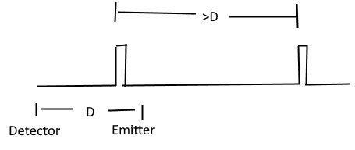
Figure 12: Example of pulse generation, which has a very short period of on-time, and a delay between pulses that is longer than the transmission delay between emitter and detector.

The arrangement
The detector should receive from two emitters, which are placed in opposing directions at the same distance from the detector. This clock needs to be at least a few hundred picoseconds in resolution, at least in this experimental setup, a longer distance can allow for a clock that has a lower tick rate.
Arms are formed from the center detector and each emitter; the angle between the arms should be 180 degrees to catch the worst and best cases. If one arm is 90 degrees to the other, then there will always just be an average case on one; and the maximum difference will not be found. This experiment could also be done with a single path, but then factors like barometric pressure and humidity will change the index of refraction over the course of the experiment, and affect the outcome. If two arms are used, then atmospheric changes will affect both arms the same amount, and in the final computation will disappear. For example, if the base propagation time is B and C, and a change of A for the atmosphere is applied to both then B+A – C+A = B-C, and A is irrelevant.
The emitters should be 10,000ft away from the central detector, which makes the total length 20,000ft or about 4 miles. This give an approximate base propagation time of $≈10$ microseconds along each arm.
This is about the limit of what can be seen – the horizon at 2.67ft is 2 miles away; at 5ft is 2.73 miles away, much further than 2 miles would require a tower to mount the emitters to be seen by the detector. ($d≈\sqrt{2hR}$, R = 20,856,000ft, h is height, d is distance to horizon).
The emitters should be aligned with the horizon at approximately 92 degrees east or 272 degrees west. Figure 11 shows the overall sky (depending on resulting resolution, both Cetus and Virgo in Figure 12 and 13 are visible with the compass degrees, Figure 12 show Cetus rising on the horizon and the associated compass position, Figure 13 shows Virgo Setting on the horizon with its associated compass position.
Figure 14 below shows the overall night sky in the opposite configuration with Cetus setting and Virgo rising. Figure 15 shows the compass position for Virgo rising on the horizon, and Figure 16 shows the compass position for Cetus setting on the horizon.
The following screenshots are taken from Stellarium open source planetarium.
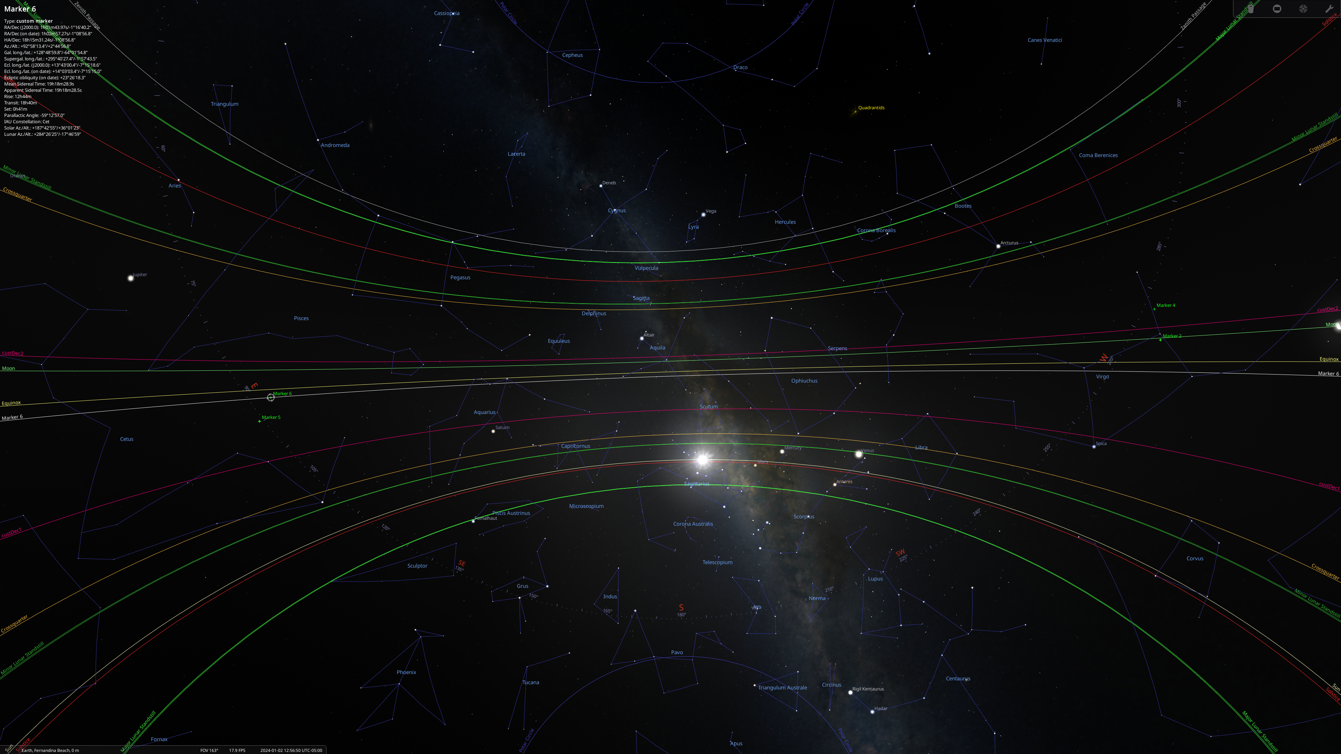
Figure 13: This is a star chart showing Virgo and Cetus/Pisces on opposite extents of the sky, and compass marks in the center.

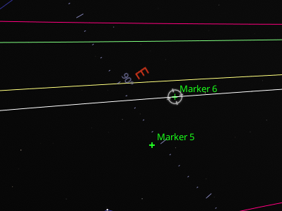
Figure 14: Zoom in on one side where Cetus/Pisces is when it’s on the rising Horizon. This is approximately 93 degrees.
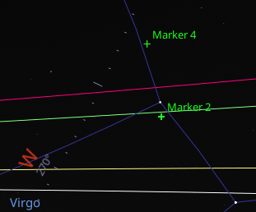
Figure 15: Zoom in on one side where Virgo is on the setting Horizon. This is approximately 267 degrees.

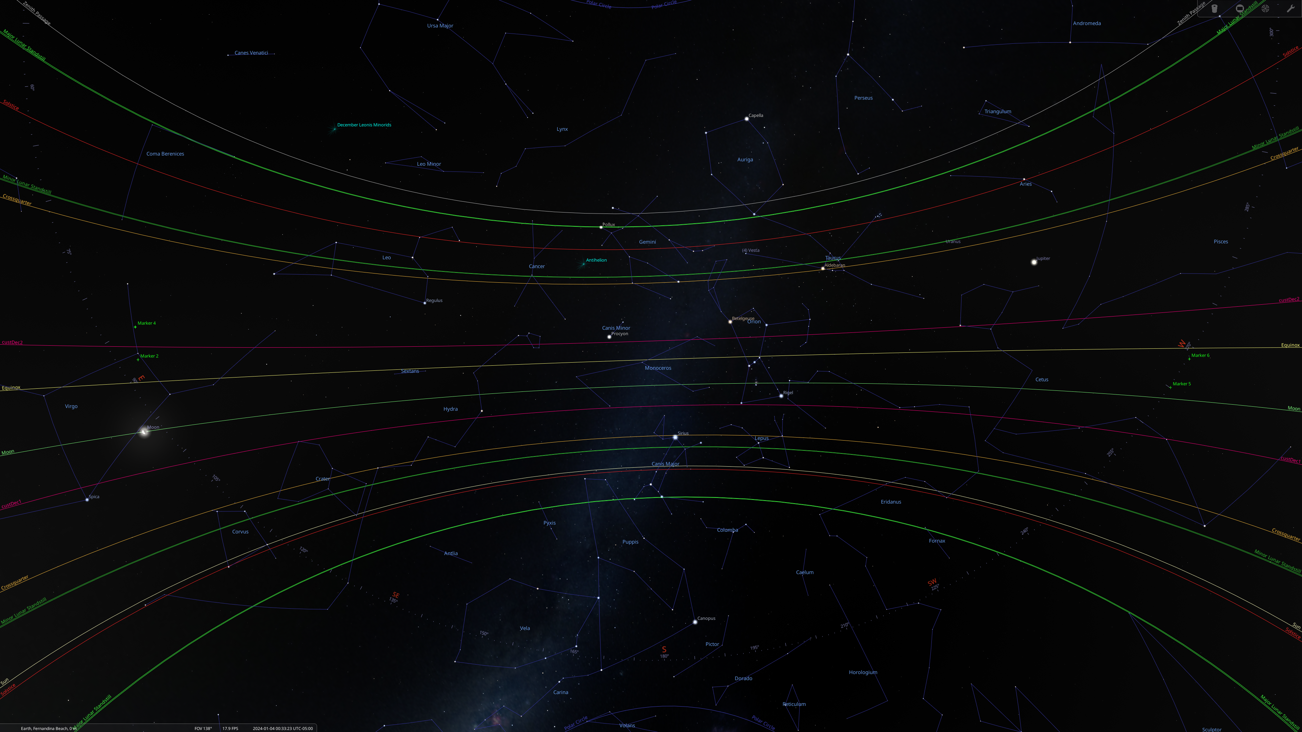
Figure 16: Shows Cetus on the right and Virgo on the left
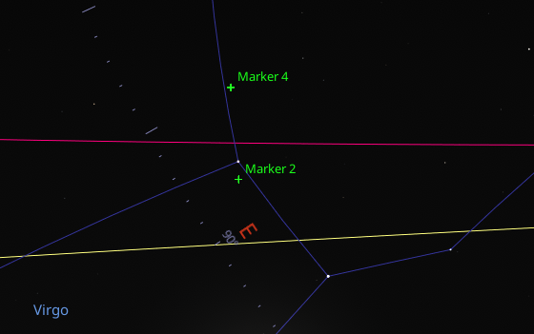
Figure 17: Virgo rising, this is like 88 degrees.

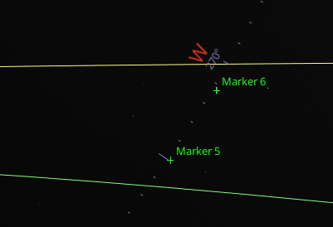
Figure 18: Cetus/Pisces setting. This is approximately 272 degrees.
You can only align, at most places on Earth, the arms for one best case – at 12 hours later, the angle of the setup will be opposing the best-case direction, but 12 hours later will get back to the best case detection. The angle may be greater than this – it’s hard to tell exactly where the best alignment with the CMBR is – it might be as much as +/-17 degrees rather than +/-2-3 degrees. But, since the target is so close to the equator, this alignment generally works no matter what latitude the experiment is performed at (although if +/-17 is used, it may be worth computing more exactly, and changing by the additional 2-3 degrees of alignment change).

Notes on clocks
Relativistic time dilation effects don't matter once the device is placed, and the clock in the central detector is used to record the time the remote clocks are seen; the clocks in the pulse generators are used to generate stable span between leading edges of the pulse they emit. The modulation might be something like a moving mirror, or a wheel with a notch, rather than having to warm up a laser diode or some other emission source.
Gravitational time dilation might affect the clocks of the various devices depending on where they are placed. It's more important that the pulse generators are in a similar gravitational gradient; otherwise, a constant skew will be in the data also; which can be removed when analyzing the signals but would of course be best if the skew wasn't there. The exact tick rates of the emitters versus the central detector are irrelevant; the span recorded between the pulses may be contracted or dilated vs the emitters, the interval will still be a constant against the local clock. Drift on independent emitter clocks will be factored out, since it will appear as a constant skew to the overall periods between ticks, similarly the gravitation dilation will be factored out as skew.

Hypothesis
The clocks end up varied, which buries the information that there is a difference in the propagation rate measured at a detector by being offset in time to compensate for the difference. This is effectively what Special Relativity tells us, but without a physical process description.

Some relevant speeds
- 370,000m/s: We are moving at 370km/s relative to the CMB in the direction of the constellation of Virgo.
- 30,290 m/s: Earth orbits the sun so +/-10%(roughly) deviation.
- 460 m/s: Earth spins this fast, so +/-0.1%(roughly) deviation (1/100 orbit speed)
The most significant part is the motion towards the Virgo constellation as demonstrated by the redshift of the CMB.

Expected Result
No measurable difference, since the condition of each clock is complicated by time dilation, and slow clock transport.

Other Hints that a difference could be measured
While doing research for accurate clocks, I came across some other information such as the variations in radioactive decay[Ref 15]. When the earth is moving in the direction of the axis of evil, the cosmic velocity vector, then radioactive decay is slightly increased vs when it is moving counter to the velocity. This could just be that CMB fluctuations influence the decay of radioactive isotopes, rather than anything about the speed the isotopes are moving.

Existing Experiments on One Way Speed of Light
There was an experiment in 1984 that was performed and found an imprecise signal detectable. This is essentially the same setup as above. This paper says they are detecting the motion of the earth around the galaxy; this is wrong, since the test was aligned east-west, and our motion in the galaxy is mostly polar. The forward motion of the galaxy is more likely the detection. But there are issues with this experiment, sending the signal over coax introduces a drag on the signal because of the motion of the medium it’s travelling in (Fizeau’s Telescope). However, the signal is also slowed down. The separation was 500m, or 1640ft which would be +/- 3.2ns approximately, which is what was normally measured. Another issue is that they seem to have groups the data according to local solar time instead of local sidereal time; which one might find strange since they were testing for motion in the galaxy and should be aware of the differences. They do measure sidereal days, but at no time mention sidereal time. Given the slow clock transport conspiracy, I’m not sure what about this experiment gave them a signal.
https://ivanik3.narod.ru/TorrKolen/Experiment.pdf This isn’t a great scan, but it’s the best available apparently. A note on research gate regarding this paper indicates that it used to be more widely available but other copies disappeared.
Many existing experiments that have been performed have generally resulted with no measurable effect. None take note of specifical astrometric alignment and can easily only show a difference on the order of ${5e}^{-12}$, which was beyond detection. That number is computed from the earth’s speed through the universe of $≈0.001c$, and the earth’s rotation being 1/1000th of that. $\sqrt{{0.001}^{2}+{0.000001}^{2}}=0.001000000005$.
Many experiments expect that motion of the source of photons is responsible for a change, and this is inaccurate, other than changing the angle by light aberration effects, the speed of the light is not changed.
Some experiments tried to measure distant x-rays from stars, which have already travelled many years, and then the earth’s rotation around the sun, plus or minus the rotation of the earth should give a small difference in time the signals are received, but again, it’s probable that these sources are perpendicular to the motion of the Earth, and have a very small effect on the time of measurement.
https://en.wikipedia.org/wiki/De_Sitter_double_star_experiment - based on the idea that speed of light changes with motion of the source, which it does not. Its frequency is shifted, that is the specific wave formed in space is determined by the motion of the source, but the speed is independent of the speed of the emitter.
https://en.wikipedia.org/wiki/One-way_speed_of_light This article has many fallacies at the time of this writing (12-29-2023). In the second paragraph “Experiments that attempt to directly probe the one-way speed of light independent of synchronization have been proposed, but none have succeeded in doing so.” References a book by Michael Tooly ‘Time, tense, and causation’, (which is a rather expensive book to read a few pages in). What it actually says is ‘many proposals have been advanced, and continue to be advanced, concerning experiments that could be used to determine the one-way speed of light—though as yet, no satisfactory experiment seems to have been devised.’ No experiments have been devised. It also talks about ‘synchrony-free’ Special Relativity, but not about ‘synchrony-free’ experiments.
Much further down the Wikipedia article also says, “Although experiments cannot be done in which the one-way speed of light is measured independently of any clock synchronization scheme,” which is somewhat true, but that does not discount that a difference in the speed of light can be measured.
Many words can be used to address each situation, but I haven’t yet seen an experiment that is either like the proposed experiment, or really deserves any more than the above thoughts.
It is possible that the 2011 OPERA faster-than-light neutrino anomaly [ref 9] is not entirely an error, but it depends on the time of day the experiment was conducted, the date and is known. OPERA used GPS to synchronize distant clocks.

Alternative deployments
LISA - The interferometer satellite array could measure +/-10ms; millisecond resolution is surely notable - although it does have bent arms, so the difference between the arms is minimal.
Although, not exactly about light, DAMA/LIBRA (DL) experiment detects a signal that is a different rate of detection of some sort of photon (neutrino? Dark matter?), which varies over a year. July and December are the noted points of interest, which is also when the Earth’s orbit around the sun is parallel to the axis of evil, or the vector between Cetus and Virgo.

What about GPS?
The following reasoning is based on a viewpoint that does not include slow clock transport effects; and given that GPS satellites end up non-length contracted with the earth, there is still a small correction that needs to be applied to satellites. The following argument only counts on gravity propagating at the speed of light; which itself means the time dilation from the gravitational field differences may still have to be accounted for with a position correction. When orbiting closer, its clock would run the slowest, but it’s faster, so it’s slower still, it’s not length contracted, but the earth is but that’s only 8 feet for the diameter. So going backward against the velocity the clock is faster, and fires sooner, and then becomes closer, and the clock is slowed to be the same, and then the clock is with the velocity, and runs slower, so it ticks its pulses to be delayed and be emitted later and covers a longer distance on the fast path.
GPS satellites are synchronous clocks that emit pulses and are clocked over a distance for the speed of light. GPS satellites orbit at an altitude of 20,200km or 12,550 miles (66,264,000 feet). It was argued that if there was an anisotropic speed of light, then they would be off by a significant amount of time when received; they would be off by potentially approximately 81 microseconds.
$$\frac{Altitude}{C±V}$$
Gravity also propagates at the speed of light. This means that in the direction of travel of the solar system relative to the CMBR (370km/s or 0.00123 light-seconds per second) that effectively the orbit of the satellites in the direction of the velocity is 24.9km (15.5 miles or 81,624ft) further from the earth, as the gravity field has not yet extended as far, compensating for the shorter reception time as the earth moves into the emitted signal. Conversely, the gravity field on the trailing side is extended, and makes the orbit closer, compensating for the earth moving away from the emitted signal. This is only extreme in a specific alignment.
It’s not that the space of that whole system is contracted; space does not contract with velocity, only the matter in the space.
This then goes to what about laser ranging satellites. They rely on a two-way communication, and if there was such an elevation difference, that would show up in their measurements, and the model they would be offset. Satellite programs that map the elevation of Earth have low orbit, and the difference would only be a couple hundred meters, which is larger than the difference of their perigee-apogee.
- ICESat-2 orbits @ 479-482km.
- Cryosat-2 @ 718-732km
- ADM-Aeolus @ 320km
- TanDEM-X & TerraSAR-X @ 514-516km

Data availability
The datasets used and/or analyzed during the current study are available from the corresponding author on reasonable request.

Code availability
Example code and demonstrations are available on Github at https://github.com/d3x0r/STFRPhysics. All sources are open, and run without any additional processing or compilation process, although it does require some sort of HTTP server to serve the content, which should mount the cloned repository as a root directory. I use https://www.npmjs.com/package/sack.vfs sources are at which is https://github.com/d3x0r/sack.vfs and requires compiling, but node package http-server might be another alternative.

References
- https://en.wikipedia.org/wiki/Special_relativity
- https://en.wikipedia.org/wiki/Relativistic_aberration
- Physics Explained, “Deriving Einstein's most famous equation: Why does energy = mass x speed of light squared?”: https://www.youtube.com/watch?v=KZ8G4VKoSpQ
- https://en.wikipedia.org/wiki/Derivations_of_the_Lorentz_transformations
- For the Love of Physics, “Derive Lorentz Transformations”, https://www.youtube.com/watch?v=6pj1f8x3APg
- https://www.bartleby.com/lit-hub/relativity-the-special-and-general-theory/appendix-i-simple-derivation-of-the-lorentz-transformationsupplementary-to-section-xi/ - Albert Einstein (1879–1955). Relativity: The Special and General Theory. 1920.
- Author Unknown, “Lorentz Transformation Derivation”, https://byjus.com/physics/derivation-of-lorentz-transformation
- Craig Gidney (https://cs.stackexchange.com/users/535/craig-gidney), Clock synchronization in a network with asymmetric delays, URL (version: 2012-03-21): https://cs.stackexchange.com/q/605
- https://en.wikipedia.org/wiki/2011_OPERA_faster-than-light_neutrino_anomaly, (2024-01-05).
- https://asd.gsfc.nasa.gov/Volker.Beckmann/school/download/Longair_Radiation2.pdf (2024-01-25).
- “The Dark Energy Survey Supernova Program: Slow supernovae show cosmological time dilation out to 𝑧 ∼ 1.” https://arxiv.org/abs/2406.05050 (24-08-30)
- https://en.wikipedia.org/wiki/Gravitational_time_dilation (2024/10/07), section “Important features of gravitational time dilation”.
- https://www.youtube.com/watch?v=eKkH4IH-zmw Dialect – “What Time Dilation ACTUALLY Is In Relativity (Hint: It has nothing to do with time)”
- https://ivanik3.narod.ru/TorrKolen/Experiment.pdf “An experiment to Measure Relative Variations in the One-Way Velocity of Light” D.G. Torr and P. Kolen.
- https://www.researchgate.net/publication/304619871_Experimental_Evidence_for_Variability_in_Planck%27s_Constant “Experimental Evidence for Variability in Planck’s Constant” Richard Hutchin, January 2016 Optics and Photonics Journal 06(06):124-137 DOI: 10.4236/opj.2016.66015.

Other Interesting Articles
These have some content that was mentioned in passing, but are not directly referenced.
- https://en.wikipedia.org/wiki/Relativistic_Doppler_effect
- https://en.wikipedia.org/wiki/Aberration_(astronomy)

Author Contributions
Single author, no other contributions.

Competing Interests
The author declares no competing interest.

Appendix A ($T_{E}$ solve)
Solve equation [1.1] for $T_{E}$ from a time Observed; compute when the event was emitted. From the time emitted, the position of the emitter is known.

$$\begin{aligned}T_{O}=\frac{\left\|\left(\vec{X_{E}}+T\vec{V_{E}}\right)-\left(\vec{X_{O}}+T_{O}\vec{V_{O}}\right)\right\|}{C}+T_{E}\#\left(1.1\right)\end{aligned}$$

Can also be written as:
$$\begin{aligned}T_{O}=\frac{\sqrt{{\left(\left(\vec{X_{E}}+T_{E}\vec{V_{E}}\right)-\left(\vec{X_{O}}+T_{O}\vec{V_{O}}\right)\right)}^{2}}}{C}+T_{E}\#\left(A.1\right)\end{aligned}$$
Use partial term [3] for base position:
$$\begin{aligned}\vec{P}=\vec{X_{E}}-\left(\vec{X_{O}}+T_{O}\vec{V_{O}}\right)\#\left(3\right)\end{aligned}$$
Substitute $\vec{P}$:
$$\begin{aligned}T_{O}=\frac{\sqrt{{\left(\vec{P}+T_{E}\vec{V_{E}}\right)}^{2}}}{C}+T_{E}\#\left(A.2\right)\end{aligned}$$
Move $T$ to the left side, substitute $\vec{P}$, and multiply both sides by $C$, then square both sides to remove the square root.
$$\begin{aligned}C^{2}{\left(T_{O}-T_{E}\right)}^{2}=\left(\vec{P}+T_{E}\vec{V_{E}}\right)∙\left(\vec{P}+T_{E}\vec{V_{E}}\right)\#\left(A.3\right)\end{aligned}$$
Expand expressions which have $T_{E}$ in them, expand right side:
$$\begin{aligned}C^{2}T_{O}-{2C}^{2}T_{O}T_{E}+C^{2}{T_{E}}^{2}={\vec{P}}^{2}+2\vec{P}T_{E}\vec{V_{E}}+{T_{E}}^{2}{\vec{V_{E}}}^{2}\#\left(A.4\right)\end{aligned}$$
Move T terms to the left, else to the right; also combined terms, reorder right side terms with a negation:
$$\begin{aligned}C^{2}{T_{E}}^{2}-2C^{2}T_{O}T_{E}-2T_{E}\vec{P}\vec{V_{E}}-{T_{E}}^{2}{\vec{V_{E}}}^{2}=-\left(C^{2}{T_{O}}^{2}-{\vec{P}}^{2}\right)\#\left(A.5\right)\end{aligned}$$
Combine coefficients of T ² and T:
$$\begin{aligned}\left(C^{2}-{\vec{V_{E}}}^{2}\right){T_{E}}^{2}-2T_{E}\left(C^{2}T_{O}+\vec{P}\vec{V_{E}}\right)=-\left(C^{2}{T_{O}}^{2}-{\vec{P}}^{2}\right)\#\left(A.6\right)\end{aligned}$$
Combine expressions with T, factor to a simple square:
$$\begin{aligned}{\left(T_{E}\sqrt{\left(C^{2}-{\vec{V_{E}}}^{2}\right)}-\frac{\left(C^{2}T_{O}+\vec{P}\vec{V_{E}}\right)}{\sqrt{\left(C^{2}-{\vec{V_{E}}}^{2}\right)}}\right)}^{2}-\frac{{\left(C^{2}T_{O}+\vec{P}\vec{V_{E}}\right)}^{2}}{C^{2}-{\vec{V_{E}}}^{2}}=-\left(C^{2}{T_{O}}^{2}-{\vec{P}}^{2}\right)\#\left(A.7\right)\end{aligned}$$
Move $T_{O}$ expression to right side, take the square root of both sides:
$$\begin{aligned}T_{E}\sqrt{\left(C^{2}-{\vec{V_{E}}}^{2}\right)}-\frac{{\left(C^{2}T_{O}+\vec{P}\vec{V_{E}}\right)}^{2}}{\sqrt{\left(C^{2}-{\vec{V_{E}}}^{2}\right)}}=\sqrt{\frac{{\left(C^{2}T_{O}+\vec{P}\vec{V_{E}}\right)}^{2}}{C^{2}-{\vec{V_{E}}}^{2}}-\left(C^{2}{T_{O}}^{2}-{\vec{P}}^{2}\right)}\#\left(A.8\right)\end{aligned}$$
Move $T_{O}$ term to the right, and divide by coefficient of $T$, group left expression under radical, and negate sign of group:
$$\begin{aligned}T_{E}=\frac{\sqrt{\frac{{\left(C^{2}T_{O}+\vec{P}\vec{V_{E}}\right)}^{2}}{C^{2}-{\vec{V_{E}}}^{2}}-\left(C^{2}{T_{O}}^{2}-{\vec{P}}^{2}\right)}+\frac{\left(C^{2}T_{O}+\vec{P}\vec{V_{E}}\right)}{\sqrt{\left(C^{2}-{\vec{V_{E}}}^{2}\right)}}}{\sqrt{\left(C^{2}-{\vec{V_{E}}}^{2}\right)}}\#\left(A.9\right)\end{aligned}$$

Multiply right-side top and bottom by $\frac{\sqrt{\left(C^{2}-{\vec{V}}^{2}\right)}}{\sqrt{\left(C^{2}-{\vec{V}}^{2}\right)}}$

$$\begin{aligned}T_{E}=\frac{\sqrt{{\left(C^{2}T_{O}+\vec{P}\vec{V_{E}}\right)}^{2}-\left(C^{2}-{\vec{V_{E}}}^{2}\right)\left(C^{2}{T_{O}}^{2}-{\vec{P}}^{2}\right)}+C^{2}T_{O}+\vec{P}\vec{V_{E}}}{C^{2}-{\vec{V_{E}}}^{2}}\#\left(A.10\right)\end{aligned}$$

Expand expressions under the square root:
$$\begin{aligned}T_{E}=\frac{\begin{aligned}\sqrt{\left(\begin{aligned}C^{2}T_{O}C^{2}T_{O}+2C^{2}T_{O}\vec{P}\vec{V_{E}}+\vec{P}\vec{V_{E}}\vec{P}\vec{V_{E}} \\ -C^{2}C^{2}{T_{O}}^{2}+{\vec{V_{E}}}^{2}C^{2}{T_{O}}^{2}+C^{2}{\vec{P}}^{2}-{\left(\vec{P}\vec{V_{E}}\right)}^{2}\end{aligned}\right)} \\ +C^{2}T_{O}+\vec{P}\vec{V_{E}}\end{aligned}}{C^{2}-{\vec{V_{E}}}^{2}}\#\left(A.10\right)\end{aligned}$$
Remove common terms and simplify remaining terms to a simple square.
$$\begin{aligned}T_{E}=\frac{C\sqrt{{\left(\vec{P}+\vec{V_{E}}T_{O}\right)}^{2}}+C^{2}T_{O}+\vec{P}\vec{V_{E}}}{C^{2}-{\vec{V_{E}}}^{2}}\#\left(A.11\right)\end{aligned}$$
$$\begin{aligned}T_{E}=\frac{C\left|\vec{P}+\vec{V_{E}}T_{O}\right|+C^{2}T_{O}+\vec{P}\vec{V_{E}}}{C^{2}-{\vec{V_{E}}}^{2}}\#\left(A.12\right)\end{aligned}$$

Fully expanded form (s):
$$\begin{aligned}T_{E}=\frac{\begin{aligned}C\left|\vec{X_{E}}-\left(\vec{X_{O}}+T_{O}\vec{V_{O}}\right)+\vec{V_{E}}T_{O}\right| \\ +C^{2}T_{O}+\vec{X_{E}}\vec{V_{E}}-\vec{X_{O}}\vec{V_{E}}-T_{O}\vec{V_{O}}\vec{V_{E}}\end{aligned}}{C^{2}-{\vec{V_{E}}}^{2}}\#\left(A.13\right)\end{aligned}$$

Appendix B ($T_{O} solve)$
Solve propagation equation for $T_{O}$. From a time that an event was emitted, compute when it is seen.
$$\begin{aligned}T_{O}=\frac{\sqrt{{\left(\left(\vec{X_{E}}+\vec{V_{E}}T_{E}\right)-\left(\vec{X_{O}}+\vec{V_{O}}T_{O}\right)\right)}^{2}}}{C}+T_{E}\#\left(B.1\right)\end{aligned}$$
Define position term $\vec{P_{E}}$ This is the displacement of the event from the observer at the time an event was emitted:
$$\begin{aligned}\vec{P_{E}}=\left(\vec{X_{E}}+\vec{V_{E}}T_{E}\right)-\vec{X_{O}}\#\left(1.16\right)\end{aligned}$$
Substitute P into the expression:
$$\begin{aligned}T_{O}=T_{E}+\frac{\sqrt{{\left(\vec{P_{E}}-\vec{V_{O}}T_{O}\right)}^{2}}}{C}\#\left(B.3\right)\end{aligned}$$
Isolate the radical, move T to the left, multiply both sides by C:
$$\begin{aligned}C\left(T_{O}-T_{E}\right)=\sqrt{{\left(\vec{P_{E}}-\vec{V_{O}}T_{O}\right)}^{2}}\#\left(B.4\right)\end{aligned}$$
Square both sides:
$$\begin{aligned}C^{2}{\left(T_{O}-T_{E}\right)}^{2}={\left(\vec{P_{E}}-\vec{V_{O}}T_{O}\right)}^{2}\#\left(B.5\right)\end{aligned}$$
Expand squared expressions:
$$\begin{aligned}C^{2}{T_{E}}^{2}-2C^{2}T_{E}T_{O}+C^{2}{T_{O}}^{2}=\vec{P_{E}}\vec{P_{E}}-2\vec{P_{E}}\vec{V_{O}}T_{O}+{\vec{V_{O}}}^{2}{T_{O}}^{2}\#\left(B.6\right)\end{aligned}$$
Move terms with $T_{O}$ to the left, and terms with only $T$ to the right.
$$\begin{aligned}-2C^{2}T_{E}T_{O}+2\vec{P_{E}}\vec{V_{O}}T_{O}+C^{2}{T_{O}}^{2}-{\vec{V_{O}}}^{2}{T_{O}}^{2}=\vec{P_{E}}\vec{P_{E}}-C^{2}{T_{E}}^{2}\#\left(B.7\right)\end{aligned}$$
Reverse right hand terms by negation:
$$\begin{aligned}-2C^{2}T_{E}T_{O}+2\vec{P_{E}}\vec{V_{O}}T_{O}+C^{2}{T_{O}}^{2}-{\vec{V_{O}}}^{2}{T_{O}}^{2}=-(C^{2}{T_{E}}^{2}-\vec{P_{E}}\vec{P_{E}})\#\left(B.8\right)\end{aligned}$$
Combine common factors of $T_{O}$:
$$\begin{aligned}\left(C^{2}-{\vec{V_{O}}}^{2}\right){T_{O}}^{2}-2T_{O}\left(C^{2}T_{E}-\vec{P_{E}}\vec{V_{O}}\right)=\vec{P_{E}}\vec{P_{E}}-C^{2}{T_{E}}^{2}\#\left(B.9\right)\end{aligned}$$
Define partial expression to simplify terms later; D is just an available letter and has no significance:
$$\begin{aligned}D_{O}=C^{2}-\vec{V_{O}}\vec{V_{O}}\#\left(B.10\right)\end{aligned}$$
Substitute $D_{O}$ partial expression:
$$\begin{aligned}D_{O}{T_{O}}^{2}-2T_{O}\left(C^{2}T_{E}-\vec{P_{E}}\vec{V_{O}}\right)=\vec{P_{E}}\vec{P_{E}}-C^{2}{T_{E}}^{2}\#\left(B.11\right)\end{aligned}$$
Factor left side into a square expression, plus a correction for the extra term that shows up:
$$\begin{aligned}{\left(\sqrt{D_{O}}T_{O}-\frac{\left(C^{2}T_{E}-\vec{P_{E}}\vec{V_{O}}\right)}{\sqrt{D_{O}}}\right)}^{2}-\frac{{\left(C^{2}T_{E}-\vec{P_{E}}\vec{V_{O}}\right)}^{2}}{D_{O}}=\vec{P_{E}}\vec{P_{E}}-C^{2}{T_{E}}^{2}\#\left(B.12\right)\end{aligned}$$
Move expression with T in it to the right side:
$$\begin{aligned}{\left(\sqrt{D_{O}}T_{O}-\frac{\left(C^{2}T_{E}-\vec{P_{E}}\vec{V_{O}}\right)}{\sqrt{D_{O}}}\right)}^{2}=\frac{{\left(C^{2}T_{E}-\vec{P_{E}}\vec{V_{O}}\right)}^{2}}{D_{O}}-\left(C^{2}{T_{E}}^{2}-\vec{P_{E}}\vec{P_{E}}\right)\#\left(B.13\right)\end{aligned}$$
Take square root of both sides:
$$\begin{aligned}\sqrt{D_{O}}T_{O}-\frac{\left(C^{2}T_{E}-\vec{P_{E}}\vec{V_{O}}\right)}{\sqrt{D_{O}}}=\sqrt{\frac{{\left(C^{2}T_{E}-\vec{P_{E}}\vec{V_{O}}\right)}^{2}}{D_{O}}-\left(C^{2}{T_{E}}^{2}-\vec{P_{E}}\vec{P_{E}}\right)}\#\left(B.14\right)\end{aligned}$$
Move expression with T to the right side:
$$\begin{aligned}\sqrt{D_{O}}T_{O}=\sqrt{\frac{{\left(C^{2}T_{E}-\vec{P_{E}}\vec{V_{O}}\right)}^{2}}{D_{O}}-\left(C^{2}{T_{E}}^{2}-\vec{P_{E}}\vec{P_{E}}\right)}+\frac{\left(C^{2}T_{E}-\vec{P_{E}}\vec{V_{O}}\right)}{\sqrt{D_{O}}}\#\left(B.15\right)\end{aligned}$$
Divide by Coefficient of $T_{O}$:
$$\begin{aligned}T_{O}=\frac{\sqrt{\frac{{\left(C^{2}T-\vec{P_{O}}\vec{V_{O}}\right)}^{2}}{D_{O}}-\left(C^{2}T^{2}-\vec{P_{O}}\vec{P_{O}}\right)}+\frac{\left(C^{2}T-\vec{P_{O}}\vec{V_{O}}\right)}{\sqrt{D_{O}}}}{\sqrt{D_{O}}}\#\left(B.16\right)\end{aligned}$$
Multiply right-side by $\frac{\sqrt{D_{O}}}{\sqrt{D_{O}}}$, substituting $D_{O}$ will give equation (12).
$$\begin{aligned}\boxed{T_{O}=\frac{\sqrt{{\left(C^{2}T_{E}-\vec{P_{O}}\vec{V_{O}}\right)}^{2}-D_{O}\left(C^{2}{T_{E}}^{2}-\vec{P_{O}}\vec{P_{O}}\right)}+\left(C^{2}T_{E}-\vec{P_{O}}\vec{V_{O}}\right)}{D_{O}}}\#\left(B.17\right)\end{aligned}$$
$$\begin{aligned}\boxed{T_{O}=\frac{\sqrt{{\left(C^{2}T_{E}-\vec{P_{O}}\vec{V_{O}}\right)}^{2}-\left(CC-\vec{V_{O}}\vec{V_{O}}\right)\left(C^{2}{T_{E}}^{2}-\vec{P_{O}}\vec{P_{O}}\right)}+\left(C^{2}T_{E}-\vec{P_{O}}\vec{V_{O}}\right)}{D_{O}}}\#\left(B.17\right)\end{aligned}$$
$$\begin{aligned}\boxed{T_{O}=\frac{\sqrt{{\left(C^{2}T_{E}-\vec{P_{O}}\vec{V_{O}}\right)}^{2}-C^{2}C^{2}{T_{E}}^{2}+C^{2}\vec{P_{O}}\vec{P_{O}}+\vec{V_{O}}\vec{V_{O}}C^{2}{T_{E}}^{2}-\vec{V_{O}}\vec{V_{O}}\vec{P_{O}}\vec{P_{O}}}+\left(C^{2}T_{E}-\vec{P_{O}}\vec{V_{O}}\right)}{D_{O}}}\#\left(B.17\right)\end{aligned}$$

Expand $D_{O}$ terms to find terms that cancel out; ${\left(P∙V\right)}^{2}≠\left(P∙P\right)\left(V∙V\right)$:
$$\begin{aligned}T_{O}=\frac{\begin{aligned}\sqrt{\left(\begin{aligned}C^{2}T_{E}C^{2}T_{E}-2C^{2}T_{E}\vec{P_{O}}\vec{V_{O}}+\vec{P_{O}}\vec{V_{O}}\vec{P_{O}}\vec{V_{O}} \\ -C^{2}C^{2}{T_{E}}^{2}+{\vec{V_{O}}}^{2}C^{2}{T_{E}}^{2}+C^{2}{\vec{P_{O}}}^{2}-{\vec{V_{O}}}^{2}{\vec{P_{O}}}^{2}\end{aligned}\right)} \\ +C^{2}T_{E}-\vec{P_{O}}\vec{V_{O}}\end{aligned}}{C^{2}-{\vec{V_{O}}}^{2}}\#\left(B.18\right)\end{aligned}$$
Remove canceled terms, turn remaining into a squared product:
$$\begin{aligned}T_{O}=\frac{\begin{aligned}\sqrt{C^{2}{(\vec{P_{O}}- T_{E}\vec{V_{O}})}^{2}+{\left(\vec{P_{O}}\vec{V_{O}}\right)}^{2}-{\vec{V_{O}}}^{2}{\vec{P_{O}}}^{2}} \\ +C^{2}T_{E}-\vec{P_{O}}\vec{V_{O}}\end{aligned}}{C^{2}-{\vec{V_{O}}}^{2}}\#\left(B.19\right)\end{aligned}$$

Appendix C ($Δ$T solve)
Delta time can be the delta from emitted time or from observed time.
$$\begin{aligned}T_{O}=T_{E}+T_{ΔO}\#\left(C.1\right)\end{aligned}$$
$$\begin{aligned}T_{E}=T_{O}-T_{ΔE}\#\left(C.2\right)\end{aligned}$$

Solve for $T_{ΔO}$ from $T_{E}$(1)
From the time an event was emitted, compute how long until the observer sees that event. $T_{E}$ is when the event was emitted.
(Follows the same basic steps as above, description of steps omitted)
$$\begin{aligned}T_{ΔO}=\frac{\left\|\left(\vec{X_{O}}+\left(T_{E}+T_{ΔO}\right)\vec{V_{O}}\right)-\left(\vec{X_{E}}+T_{E}\vec{V_{E}}\right)\right\|}{C}\#\left(1.1\right)\end{aligned}$$
$$\begin{aligned}\vec{P_{ΔE}}=\left(\vec{X_{O}}+T_{E}\vec{V_{O}}\right)-\left(\vec{X_{E}}+\vec{V_{E}}T_{E}\right)\#\left(1.23\right)\end{aligned}$$
$$\begin{aligned}T_{ΔO}=\frac{\sqrt{{\left(\vec{P_{ΔE}}-T_{ΔO}\vec{V_{O}}\right)}^{2}}}{C}\#\left(C.1.1\right)\end{aligned}$$
$$\begin{aligned}{\left(CT_{ΔO}\right)}^{2}={\left(\vec{P_{ΔE}}-T_{ΔO}\vec{V_{O}}\right)}^{2}\#\left(C.1.2\right)\end{aligned}$$
$$\begin{aligned}C^{2}{T_{ΔO}}^{2}=\vec{P_{ΔE}}\vec{P_{ΔE}}-2\vec{P_{ΔE}}T_{ΔO}\vec{V_{O}}+T_{ΔO}\vec{V_{O}}T_{ΔO}\vec{V_{O}}\#\left(C.1.3\right)\end{aligned}$$
$$\begin{aligned}C^{2}{T_{ΔO}}^{2}-{\vec{V_{O}}}^{2}{T_{ΔO}}^{2}+2\vec{P_{ΔE}}\vec{V_{O}}T_{ΔE}=\vec{P_{ΔE}}\vec{P_{ΔE}}\#\left(C.1.4\right)\end{aligned}$$
$$\begin{aligned}D_{Δ}=C^{2}-{\vec{V_{O}}}^{2}\#\left(C.1.5\right)\end{aligned}$$
$$\begin{aligned}D_{Δ}{T_{ΔO}}^{2}+2T_{ΔE}\vec{P_{ΔE}}\vec{V_{O}}=\vec{P_{ΔE}}\vec{P_{ΔE}}\#\left(C.1.6\right)\end{aligned}$$

$$\begin{aligned}{\left(\sqrt{D_{Δ}}T_{ΔO}+\frac{\vec{P_{ΔE}}\vec{V_{O}}}{\sqrt{D_{Δ}}}\right)}^{2}-\frac{{\left(\vec{P_{ΔE}}\vec{V_{O}}\right)}^{2}}{D_{Δ}}=\vec{P_{ΔE}}\vec{P_{ΔE}}\#\left(C.1.7\right)\end{aligned}$$
$$\begin{aligned}{\left(\sqrt{D_{Δ}}T_{ΔO}+\frac{\vec{P_{Δ}}\vec{V_{O}}}{\sqrt{D_{Δ}}}\right)}^{2}=\vec{P_{ΔE}}\vec{P_{ΔE}}+\frac{{\left(\vec{P_{ΔE}}\vec{V_{O}}\right)}^{2}}{D_{Δ}}\#\left(C.1.8\right)\end{aligned}$$
$$\begin{aligned}\sqrt{D_{Δ}}T_{ΔO}+\frac{\vec{P_{ΔE}}\vec{V_{O}}}{\sqrt{D_{Δ}}}=\sqrt{\vec{P_{ΔE}}\vec{P_{ΔE}}+\frac{{\left(\vec{P_{ΔE}}\vec{V_{O}}\right)}^{2}}{D_{Δ}}}\#\left(C.1.9\right)\end{aligned}$$
Move non $T_{Δ}$ expression to the right, divide by coefficient of $T_{ΔE}$
$$\begin{aligned}T_{ΔO}=\frac{\sqrt{\vec{P_{ΔE}}\vec{P_{ΔE}}+\frac{{\left(\vec{P_{ΔE}}\vec{V_{O}}\right)}^{2}}{D_{Δ}}}-\frac{\vec{P_{ΔE}}\vec{V_{O}}}{\sqrt{D_{Δ}}}}{\sqrt{D_{Δ}}}\#\left(C.1.10\right)\end{aligned}$$
Multiply by $\frac{\sqrt{D_{Δ}}}{\sqrt{D_{Δ}}}$, reorder terms under radical:
$$\begin{aligned}\boxed{T_{ΔO}=\frac{\sqrt{{\left(\vec{P_{ΔE}}\vec{V_{O}}\right)}^{2}+D_{Δ}\vec{P_{ΔE}}\vec{P_{ΔE}}}-\vec{P_{ΔE}}\vec{V_{O}}}{D_{Δ}}}\#\left(C.1.11\right)\end{aligned}$$
$$\begin{aligned}\boxed{\boxed{T_{ΔO}=\frac{\sqrt{{\left(\vec{P_{ΔE}}\vec{V_{O}}\right)}^{2}+\left(C^{2}-\vec{V_{O}}\vec{V_{O}}\right)\vec{P_{ΔE}}\vec{P_{ΔE}}}-\vec{P_{ΔE}}\vec{V_{O}}}{\left(C^{2}-\vec{V_{O}}\vec{V_{O}}\right)}}}\#\left(1.4.3\right)\left(C.1.12\right)\end{aligned}$$

Solve for $T_{ΔE}$ from $T_{O}$(2)
Solve for $T_{ΔE}$, which from a time an event was observed $T_{O}$, compute how long ago it was emitted $T_{ΔE}$. The result should be a positive quantity.
$$T_{E}=T_{O}-T_{ΔE}$$
(Follows the same basic steps as above, description of steps omitted)
$$\begin{aligned}T_{ΔE}=\frac{\left\|\left(\vec{X_{E}}+\left(T_{O}-T_{ΔE}\right)\vec{V_{E}}\right)-\left(\vec{X_{O}}+T_{O}\vec{V_{O}}\right)\right\|}{C}\#\left(1.7\right)\end{aligned}$$
Partial term for displacement of the observer from the event at the time it was observed.
$$\begin{aligned}\vec{P_{ΔO}}=\vec{X_{E}}+T_{O}\vec{V_{E}}-\vec{X_{O}}-T_{O}\vec{V_{O}}\#\left(1.1.1\right)\end{aligned}$$
$$\begin{aligned}T_{ΔE}=\frac{\left\|\vec{P_{ΔO}}-T_{ΔE}\vec{V_{E}}\right\|}{C}\#\left(1.1.2\right)\end{aligned}$$
Replace magnitude operator with square root of square:
$$\begin{aligned}T_{ΔE}=\frac{\sqrt{{\left(\vec{P_{ΔO}}-T_{ΔE}\vec{V_{E}}\right)}^{2}}}{C}\#\left(C.2.1\right)\end{aligned}$$
Move C term, square both sides:
$$\begin{aligned}{\left(CT_{ΔE}\right)}^{2}={\left(\vec{P_{ΔO}}-T_{ΔE}\vec{V_{E}}\right)}^{2}\#\left(C.2.2\right)\end{aligned}$$
Expand square:
$$\begin{aligned}C^{2}T_{ΔE}=\vec{P_{ΔO}}\vec{P_{ΔO}}-2\vec{P_{ΔO}}T_{ΔE}\vec{V_{E}}+T_{ΔO}\vec{V_{E}}T_{ΔE}\vec{V_{E}}\#\left(C.2.3\right)\end{aligned}$$
Combine $T_{ΔE}$ terms to the left:
$$\begin{aligned}C^{2}{T_{ΔE}}^{2}-{\vec{V_{E}}}^{2}{T_{ΔE}}^{2}-2\vec{P_{ΔO}}T_{ΔE}\vec{V_{E}}=\vec{P_{ΔO}}\vec{P_{ΔO}}\#\left(C.2.4\right)\end{aligned}$$
Define temporary term for
$$\begin{aligned}D_{ΔE}=C^{2}-{\vec{V_{E}}}^{2}\#\left(C.2.5\right)\end{aligned}$$
Substitute [C.2.5] into [C.2.4]:
$$\begin{aligned}D_{ΔE}{T_{ΔE}}^{2}-2T_{ΔE}\vec{P_{ΔO}}\vec{V_{E}}=\vec{P_{ΔO}}\vec{P_{ΔO}}\#\left(C.2.6\right)\end{aligned}$$
Find square expression for left side:
$$\begin{aligned}{\left(\sqrt{D_{ΔE}}T_{ΔE}-\frac{\vec{P_{ΔE}}\vec{V_{E}}}{\sqrt{D_{ΔE}}}\right)}^{2}-\frac{{\left(\vec{P_{ΔO}}\vec{V_{E}}\right)}^{2}}{D_{ΔE}}=\vec{P_{ΔO}}\vec{P_{ΔO}}\#\left(C.2.7\right)\end{aligned}$$
Move extra partial expression to right side:
$$\begin{aligned}{\left(\sqrt{D_{ΔE}}T_{ΔE}-\frac{\vec{P_{ΔO}}\vec{V_{E}}}{\sqrt{D_{ΔE}}}\right)}^{2}=\vec{P_{ΔO}}\vec{P_{ΔO}}+\frac{{\left(\vec{P_{ΔO}}\vec{V_{E}}\right)}^{2}}{D_{ΔE}}\#\left(C.2.8\right)\end{aligned}$$
Take square root of both sides:
$$\begin{aligned}\sqrt{D_{ΔE}}T_{ΔE}-\frac{\vec{P_{ΔO}}\vec{V_{E}}}{\sqrt{D_{ΔE}}}=\sqrt{\vec{P_{ΔO}}\vec{P_{ΔO}}+\frac{{\left(\vec{P_{ΔO}}\vec{V_{E}}\right)}^{2}}{D_{ΔE}}}\#\left(C.2.9\right)\end{aligned}$$
Move non $T_{ΔE}$ expression to the right, divide by coefficient of $T_{ΔE}$, reorder terms under radical:
$$\begin{aligned}T_{ΔE}=\frac{\sqrt{\frac{{\left(\vec{P_{ΔO}}\vec{V_{E}}\right)}^{2}}{D_{ΔE}}+\vec{P_{ΔO}}\vec{P_{ΔO}}}+\frac{\vec{P_{ΔO}}\vec{V_{E}}}{\sqrt{D_{ΔE}}}}{\sqrt{D_{ΔE}}}\#\left(C.2.12\right)\end{aligned}$$
Multiply by $\frac{\sqrt{D_{ΔE}}}{\sqrt{D_{ΔE}}}$:
$$\begin{aligned}\boxed{T_{ΔE}=\frac{\sqrt{{\left(\vec{P_{ΔO}}\vec{V_{E}}\right)}^{2}+D_{ΔE}\vec{P_{ΔO}}\vec{P_{ΔO}}}+\vec{P_{ΔO}}\vec{V_{E}}}{D_{ΔE}}}\#\left(C.2.13\right)\end{aligned}$$
$$\begin{aligned}\vec{P_{ΔO}}=\vec{X_{E}}+T_{O}\vec{V_{E}}-\vec{X_{O}}-T_{O}\vec{V_{O}}\#\left(1.1.1\right)\end{aligned}$$
$$\begin{aligned}\boxed{T_{ΔE}=\frac{\begin{aligned}\sqrt{\begin{aligned}{\left(\left(\vec{X_{E}}+T_{O}\vec{V_{E}}-\vec{X_{O}}-T_{O}\vec{V_{O}}\right)∙\vec{V_{E}}\right)}^{2} \\ +D_{ΔE}\left(\left(\vec{X_{E}}+T_{O}\vec{V_{E}}-\vec{X_{O}}-T_{O}\vec{V_{O}}\right)\right)\end{aligned}} \\ +\left(\vec{X_{E}}+T_{O}\vec{V_{E}}-\vec{X_{O}}-T_{O}\vec{V_{O}}\right)∙\vec{V_{E}}\end{aligned}}{D_{ΔE}}}\#\left(1.1.4\right)\left(C.2.17\right)\end{aligned}$$

This last version is probably the most useful and was done last. From the time an observer sees an event, this is an amount backward in time to where the event would have been when it was emitted. It is computed from the magnitude of the displacement between the observer and the event at the time the event was observed, plus the dot product of the velocity of the emitter on that current displacement. That final quantity is scaled by the C times one over the difference between C and the emitters velocity.

Appendix D (V=C)
When V=C, then the equations can be solved by substituting C for the appropriate velocity. Later in the process the V term that was replaced can be restored back to C, but then this covers the singularity of dividing by $C^{2}-V^{2}=0$ when it equals 0.

Solve for T when $\left\|\vec{V_{E}}\right\|$=C…
This only works if $\vec{X_{E}}≠\vec{X_{O}}$.
$$\begin{aligned}T_{O}=T+\frac{\left\|\left(\vec{X_{E}}+T\vec{V_{E}}\right)-\left(\vec{X_{O}}+T_{O}\vec{V_{O}}\right)\right\|}{\left\|\vec{V_{E}}\right\|}\#\left(1.1\right)\end{aligned}$$
Convert magnitudes to square root of vectors squared:
$$\begin{aligned}T_{O}=T+\frac{\sqrt{{\left(\left(\vec{X_{E}}+T\vec{V_{E}}\right)-\left(\vec{X_{O}}+T_{O}\vec{V_{O}}\right)\right)}^{2}}}{\sqrt{\vec{V_{E}}\vec{V_{E}}}}\#\left(D.1\right)\end{aligned}$$
Define partial expression P to simplify later operations:
$$\begin{aligned}\vec{P}=\vec{X_{E}}-\left(\vec{X_{O}}+\vec{V_{O}}T_{O}\right)\#\left(3\right)\end{aligned}$$
Substitute P into expression:
$$\begin{aligned}T_{O}=T+\frac{\sqrt{{\left(\vec{P}+T\vec{V_{E}}\right)}^{2}}}{\sqrt{\vec{V_{E}}\vec{V_{E}}}}\#\left(D.2\right)\end{aligned}$$
Move T expression to left side, preparing to square both sides:
$$\begin{aligned}T_{O}-T=\frac{\sqrt{{\left(\vec{P}+T\vec{V_{E}}\right)}^{2}}}{\sqrt{\vec{V_{E}}\vec{V_{E}}}}\#\left(D.3\right)\end{aligned}$$
Square both sides:
$$\begin{aligned}{T_{O}}^{2}-2T_{O}T+T^{2}=\frac{{\left(\vec{P}+T\vec{V_{E}}\right)}^{2}}{\vec{V_{E}}\vec{V_{E}}}\#\left(D.4\right)\end{aligned}$$
Expand squares, move $\vec{V_{E}}\vec{V_{E}}$ to the left side:
$$\begin{aligned}\vec{V_{E}}\vec{V_{E}}{T_{O}}^{2}-2\vec{V_{E}}\vec{V_{E}}T_{O}T+\vec{V_{E}}\vec{V_{E}}T^{2}=\vec{P}\vec{P}+2T\vec{P}\vec{V_{E}}+T^{2}\vec{V_{E}}\vec{V_{E}}\#\left(D.5\right)\end{aligned}$$
Move expressions with only $T_{O}$ to the right:
$$\begin{aligned}-2\vec{V_{E}}\vec{V_{E}}T_{O}T+\vec{V_{E}}\vec{V_{E}}T^{2}=\vec{P}\vec{P}+2T\vec{P}\vec{V_{E}}+T^{2}\vec{V_{E}}\vec{V_{E}}-\vec{V_{E}}\vec{V_{E}}{T_{O}}^{2}\#\left(D.6\right)\end{aligned}$$
$\vec{V_{E}}\vec{V_{E}}T^{2}$ is removed since it’s on both sides, move T term to left:
$$\begin{aligned}-2\vec{V_{E}}\vec{V_{E}}T_{O}T-2T\vec{P}\vec{V_{E}}=\vec{P}\vec{P}-\vec{V_{E}}\vec{V_{E}}{T_{O}}^{2}\#\left(D.7\right)\end{aligned}$$
Factor out common $-2T$ term:
$$\begin{aligned}-2T\left(\vec{V_{E}}\vec{V_{E}}T_{O}+\vec{P}\vec{V_{E}}\right)=\vec{P}\vec{P}-\vec{V_{E}}\vec{V_{E}}{T_{O}}^{2}\#\left(D.8\right)\end{aligned}$$

Divide both sides by coefficient of T:
$$\begin{aligned}T=-\frac{\vec{P}\vec{P}-\vec{V_{E}}\vec{V_{E}}{T_{O}}^{2}}{2\left(\vec{V_{E}}\vec{V_{E}}T_{O}+\vec{P}\vec{V_{E}}\right)}\#\left(D.9\right)\end{aligned}$$
Remember $\sqrt{\vec{V_{E}}\vec{V_{E}}}=C$ so replace some expressions with $C^{2}$, distribute negative sign:
$$\begin{aligned}T=\frac{C^{2}{T_{O}}^{2}-\vec{P}\vec{P}}{2\left(C^{2}T_{O}+\vec{P}\vec{V_{E}}\right)}\#\left(D.10\right)\end{aligned}$$
Simplify with partial expressions:
$$\begin{aligned}\vec{P}=\vec{X_{E}}-\left(\vec{X_{O}}+\vec{V_{O}}T_{O}\right)\#\left(14\right)\end{aligned}$$
$$\begin{aligned}A_{O}=C^{2}{T_{O}}^{2}-\vec{P}\vec{P}\#\left(15\right)\end{aligned}$$
$$\begin{aligned}B_{O}=C^{2}T_{O}+\vec{V_{O}}\vec{P}\#\left(16\right)\end{aligned}$$
$$\begin{aligned}T=\frac{A_{O}}{2B_{O}}\#\left(12\right)\end{aligned}$$

Solve for $T_{O}$ when $\left\|\vec{V_{O}}\right\|$=C…
This only works if $\vec{X_{E}}≠\vec{X_{O}}$.
$$\begin{aligned}T_{O}=T+\frac{\left\|\left(\vec{X_{E}}+T\vec{V_{E}}\right)-\left(\vec{X_{O}}+T_{O}\vec{V_{O}}\right)\right\|}{\left\|\vec{V_{O}}\right\|}\#\left(D.11\right)\end{aligned}$$
Convert magnitudes to square root of vectors squared:
$$\begin{aligned}T_{O}=T_{E}+\frac{\sqrt{{\left(\left(\vec{X_{E}}+T\vec{V_{E}}\right)-\left(\vec{X_{O}}+T_{O}\vec{V_{O}}\right)\right)}^{2}}}{\sqrt{\vec{V_{O}}\vec{V_{O}}}}\#\left(D.12\right)\end{aligned}$$
Define partial expression P to simplify later operations:
$$\begin{aligned}\vec{P_{O}}=\vec{X_{E}}+\vec{V_{E}}T_{E}-\vec{X_{O}}\#\left(11\right)\end{aligned}$$
Substitute P into expression:
$$\begin{aligned}T_{O}=T_{E}+\frac{\sqrt{{\left(\vec{P_{O}}-T_{O}\vec{V_{O}}\right)}^{2}}}{\sqrt{\vec{V_{O}}\vec{V_{O}}}}\#\left(D.13\right)\end{aligned}$$
Move T expression to left side, preparing to square both sides:
$$\begin{aligned}T_{O}-T_{E}=\frac{\sqrt{{\left(\vec{P_{O}}-T_{O}\vec{V_{O}}\right)}^{2}}}{\sqrt{\vec{V_{O}}\vec{V_{O}}}}\#\left(D.14\right)\end{aligned}$$
Square both sides:
$$\begin{aligned}{T_{O}}^{2}-2T_{O}T_{E}+{T_{E}}^{2}=\frac{{\left(\vec{P_{O}}-T_{O}\vec{V_{O}}\right)}^{2}}{\vec{V_{O}}\vec{V_{O}}}\#\left(D.15\right)\end{aligned}$$
Expand squares, move $\vec{V_{O}}\vec{V_{O}}$ to the left side:
$$\begin{aligned}\vec{V_{O}}\vec{V_{O}}{T_{O}}^{2}-2\vec{V_{O}}\vec{V_{O}}T_{O}T_{E}+\vec{V_{O}}\vec{V_{O}}{T_{E}}^{2}=\vec{P_{O}}\vec{P_{O}}-2T_{O}\vec{P_{O}}\vec{V_{O}}+{T_{O}}^{2}\vec{V_{O}}\vec{V_{O}}\#\left(D.16\right)\end{aligned}$$
$\vec{V_{O}}{T_{O}}^{2}$ is removed since it’s on both sides, move T term to left:
$$\begin{aligned}-2\vec{V_{O}}\vec{V_{O}}T_{O}T_{E}+2T_{O}\vec{P_{O}}\vec{V_{O}}+\vec{V_{O}}\vec{V_{O}}{T_{E}}^{2}=\vec{P_{O}}\vec{P_{O}}\#\left(D.17\right)\end{aligned}$$
Factor out common $-2T_{O}$ term:
$$\begin{aligned}-2T_{O}\left(\vec{V_{O}}\vec{V_{O}}T_{E}+\vec{P_{O}}\vec{V_{O}}\right)=\vec{P_{O}}\vec{P_{O}}-\vec{V_{O}}\vec{V_{O}}{T_{E}}^{2}\#\left(D.18\right)\end{aligned}$$
Divide both sides by coefficient of $T_{O}$:
$$\begin{aligned}T_{O}=-\frac{\vec{P_{O}}\vec{P_{O}}-\vec{V_{O}}\vec{V_{O}}{T_{E}}^{2}}{2\left(\vec{V_{O}}\vec{V_{O}}T_{E}+\vec{P_{O}}\vec{V_{O}}\right)}\#\left(D.19\right)\end{aligned}$$
Remember $\sqrt{\vec{V_{O}}\vec{V_{O}}}=C$ so replace some expressions with $C^{2}$, distribute negative sign:
$$\begin{aligned}T_{O}=\frac{C^{2}{T_{E}}^{2}-\vec{P_{O}}\vec{P_{O}}}{2\left(C^{2}T_{E}+\vec{P_{O}}\vec{V_{O}}\right)}\#\left(D.20\right)\end{aligned}$$
Simplify with partial expressions:
$$\begin{aligned}\vec{P_{O}}=\vec{X_{E}}+\vec{V_{E}}T_{E}-\left(\vec{X_{O}}\right)\#\left(11\right)\end{aligned}$$
$$\begin{aligned}A_{E}=C^{2}{T_{E}}^{2}-\vec{P_{O}}\vec{P_{O}}\#\left(15\right)\end{aligned}$$
$$\begin{aligned}B_{E}=C^{2}T_{E}+\vec{P_{O}}\vec{V_{O}}\#\left(16\right)\end{aligned}$$
$$\begin{aligned}T_{O}=\frac{A_{E}}{2B_{E}}\#\left(12\right)\end{aligned}$$

Solve for T delta.
Setup initial position term, in terms of Time Observed; this will be solved for when the emitter’s velocity is the same as C.
$$\begin{aligned}\vec{P_{ΔO}}=\vec{X_{E}}+T_{O}\vec{V_{E}}-\vec{X_{O}}-T_{O}\vec{V_{O}}\#\left(1.27\right)\end{aligned}$$
$$\begin{aligned}T_{ΔE}=\frac{\left\|\vec{P_{ΔO}}-T_{ΔE}\vec{V_{E}}\right\|}{C}\#\left(1.28\right)\end{aligned}$$
$$\begin{aligned}T_{ΔE}=\frac{\left\|\vec{P_{ΔO}}-T_{ΔE}\vec{V_{E}}\right\|}{\left|\vec{V_{E}}\right|}\#\left(D.21\right)\end{aligned}$$
$$\begin{aligned}T_{Δ}=\frac{\sqrt{{\left(\vec{P_{ΔE}}-T_{Δ}\vec{V_{E}}\right)}^{2}}}{\sqrt{\vec{V_{E}}\vec{V_{E}}}}\#\left(D.22\right)\end{aligned}$$

$$\begin{aligned}{T_{Δ}}^{2}=\frac{{\left(\vec{P_{ΔE}}-T_{Δ}\vec{V_{E}}\right)}^{2}}{\vec{V_{E}}\vec{V_{E}}}\#\left(D.23\right)\end{aligned}$$
Expand squares, move $\vec{V_{O}}\vec{V_{O}}$ to the left side:
$$\begin{aligned}\vec{V_{E}}\vec{V_{E}}{T_{Δ}}^{2}=\vec{P_{ΔE}}\vec{P_{ΔE}}-2T_{Δ}\vec{P_{ΔE}}\vec{V_{E}}+{T_{Δ}}^{2}\vec{V_{E}}\vec{V_{E}}\#\left(D.24\right)\end{aligned}$$
$\vec{V_{O}}{T_{O}}^{2}$ is removed since it’s on both sides, move T term to left:
$$\begin{aligned}2T_{Δ}\vec{P_{ΔE}}\vec{V_{E}}=\vec{P_{ΔO}}\vec{P_{ΔO}}\#\left(D.25\right)\end{aligned}$$
$$\begin{aligned}T_{Δ}=\frac{\vec{P_{ΔO}}\vec{P_{ΔO}}}{2\vec{P_{ΔE}}\vec{V_{E}}}\#\left(D.25\right)\end{aligned}$$

Appendix E (Exam Question)
Having developed the math, even though it was different from the Lorentz Transformation, I figured it would be good to test in answering some questions on a forum; unfortunately, I found that although the answers were correct, they were incorrect if the Lorentz Transform was required to be applied. Here’s the question.

"While you're having breakfast in the morning, a creature in the Andromeda galaxy is doing the same. We call the two breakfast events event X (on Earth) and event Y (in the Andromeda galaxy). "Simultaneously" means simultaneous in your reference frame. If instead we describe the two events in another reference frame, that of a space traveler who is traveling at a very high speed from the Andromeda galaxy towards Earth, which of the following statements is correct?

- A. Event X and event Y are simultaneous.
- B. Event X occurs before event Y.
- C. Event Y occurs before event X.
- D. The question is not well-defined, as we cannot define simultaneity for events that do not occur at the same place in space.

I get that it has something to do with that the traveler is going at relativistic speeds which means things will move slower relative to him. I just don't get how the gamma factor ties in to the problem context"

To get a single answer, I had to interpret that the breakfast was simultaneous *to 'you' while eating breakfast* (that you were watching them eat breakfast on a monitor while you are also eating), which makes the answer ‘C’. (The ‘correct’ answer is ‘B’) Otherwise there are multiple choices. And even made an image.

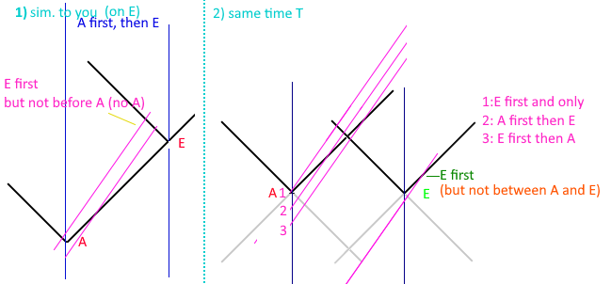
Figure 19: Example worldlines for problem.
In figure 21 On the left, would be based on the reasoning applied to get a single answer. On the right, however, at some real time A(ndromeda) and E(arth) have breakfast, and the light cones of those events are drawn in black; probably the thickness of the line is the entire duration of that event. Depending on when the ship passes Andromeda at some high speed, they could see (1) earth first, and then never Andromeda, if they passed Andromeda after breakfast was eaten. (2) that they see andromeda first and then earth. Or (3) that they could see earth first and then andromeda. Another line between 2 and 3 could be drawn that would intersect in the middle when the light cones intersect, and they could say they were simultaneous. The 4th line off the bottom would also show Earth first and Andromeda some long time later; but they would be past earth when they saw the earth event catch up to them. This doesn’t even really care about the relatively variable speed of light for the observing ship; it’s just a flat world line graph.
The light cones in Figure 21 would be pretty much the constant speed of light every frame can agree with. It’s also not a matter of poor phrasing of the question, but rather is an inherent flaw in Lorentz Transform that students will just have to ‘shut up and calculate’ since there’s no other means to reason the solution.
https://phys.libretexts.org/Bookshelves/University_Physics/Book%3A_University_Physics_(OpenStax)/University_Physics_III_-_Optics_and_Modern_Physics_(OpenStax)/05%3A__Relativity/5.06%3A_The_Lorentz_Transformation This link has a section about halfway down that is basically the same scenario, and uses the Lorentz Transform in the same way that would get ‘B’ as an answer. I didn’t record the math of another person who helped the questioner, since it was the same sort of terms as this.
In these scenarios the observer that is ‘between’ Andromeda and Earth or in the train is chained to the center of the train and is unable to move. An observer that is ‘near the train’ is really under the train, or the train is passing through them. Given those constraints, then since the ship is moving from andromeda to earth, they must see the earth event first and then andromeda. There is no freedom to intersect anywhere in-between, but rather they must start from the center between Andromeda and Earth.

Appendix F (Wayback Demo Links)
Wayback Machine links to demos
These pages were captured to make sure they will exist – it is doubtful the github sources will disappear… but anything can happen.
https://web.archive.org/web/20231205094627/https://d3x0r.github.io/STFRPhysics/math/indexLightSpeed.html
https://web.archive.org/web/20231205115312/https://d3x0r.github.io/STFRPhysics/math/indexLightSpeed1.html
https://web.archive.org/web/20231205115526/https://d3x0r.github.io/STFRPhysics/math/indexLightSpeed2a.html
https://web.archive.org/web/20231205095133/https://d3x0r.github.io/STFRPhysics/math/indexLightSpeed3.html
https://web.archive.org/web/20231205094911/https://d3x0r.github.io/STFRPhysics/math/indexLightSpeed4.html
https://web.archive.org/web/20231205095346/https://d3x0r.github.io/STFRPhysics/math/indexLightSpeed-Clocks.html
https://web.archive.org/web/20231205084208/https://d3x0r.github.io/STFRPhysics/math/indexInterferometer4.html
The Voxelarium demo is too complex – and relies on import; wayback wraps the javascript in a function which makes the imports fail though.

Appendix G (GR Hypothesis)
General Relativity was developed on the back of Special Relativity. There are several factors of Special Relativity which have been challenged, and probably in the case of the reality of relativity will in turn affect General Relativity. There was influence from external sources on some of these ideas, such as Youtube video by Dialect about ‘What Time Dilation ACTUALLY is’ [ref 12].
Before developing math for the one-way constant speed of light through space, I had researched General Relativity and Einstein Field Equations. I found that it would be possible to curve space directly, rather than over time. The equation of $S^{2}=cT^{2}+V^{2}$ is not symmetric in this case; the propagation equations would be something of a replacement for this expression. In General Relativity it’s taken that everything moves at the speed C through space-time. Moving at the speed of C for an object which has a low velocity means it’s moving quickly through time to compensate. This idea would require each body to have its own time, when in reality it seems there is only a single ‘now’ across the whole universe; a single moment of time. During each moment of time things move, emit and receive photons, but there is nothing that has already happened, which would be something that happens after ‘now’, and things that have already happened no longer exist in that state, there is no before ‘now’ that one could return to. The only thing about time that changes is the speed of clocks, so having a different velocity through time would be meaningless.
I started testing the compression idea using Geogebra, which provides a free 3D graphing calculator.
- Geogebra 3D graph - I started testing the math here but subtracting |x| and |y| independently from the hyperbolic displacements make more of a bell curve instead of an arc; especially very close to 0.
Then I did some demos to test displacing straight lines by an extrinsic curvature. Light travels straight lines through space, although due to a displacement or curvature of space, the path may not be actually straight.
- Single Source - This shows curvature for a single point displacement.
- 4 Sources - This is four point displacements; the points do not move and do not scale with the displacement they generate.
- 3D 4 sources - 3D stack of multiple planes; with the 'zLevel' set near 0, the planes of 'geodesic light paths' include the plane of the displacements.
- Inner Rotation Curve Explorer - This explores what the frames are for the proposed filler curve; turns out to be geodesic rotations of a frame from one pole through the other and back to the start with the originating orientation.
It has been proposed that to curve space, one additional dimension is required. In the case of a 1-dimensional, straight line, it only requires one dimension to represent but requires 2 in a higher level to bend the line, and 3 to curve the line into a helix. Similarly, if you have a 2D plane, and make a hill in it, it requires an additional dimension to represent, but you can also maintain the flat plane orientation and curve it only in that plane. Finally, in the case of a 3D space, it might seem logical to propose that a 4th dimension is required to curve it, but it doesn’t take a 4th dimension to curve a block of clay into a vase.
Space as an incompressible medium could also be curved by just applying a force to displace the space from its original position. This would stretch/elongate the space around the displacement source, and to maintain the same volume, would shorten in the direction perpendicular to the displacement. The Geogebra graph (Figure 22) below has a hyperbolic plane that represents the ratio of compression of various levels.
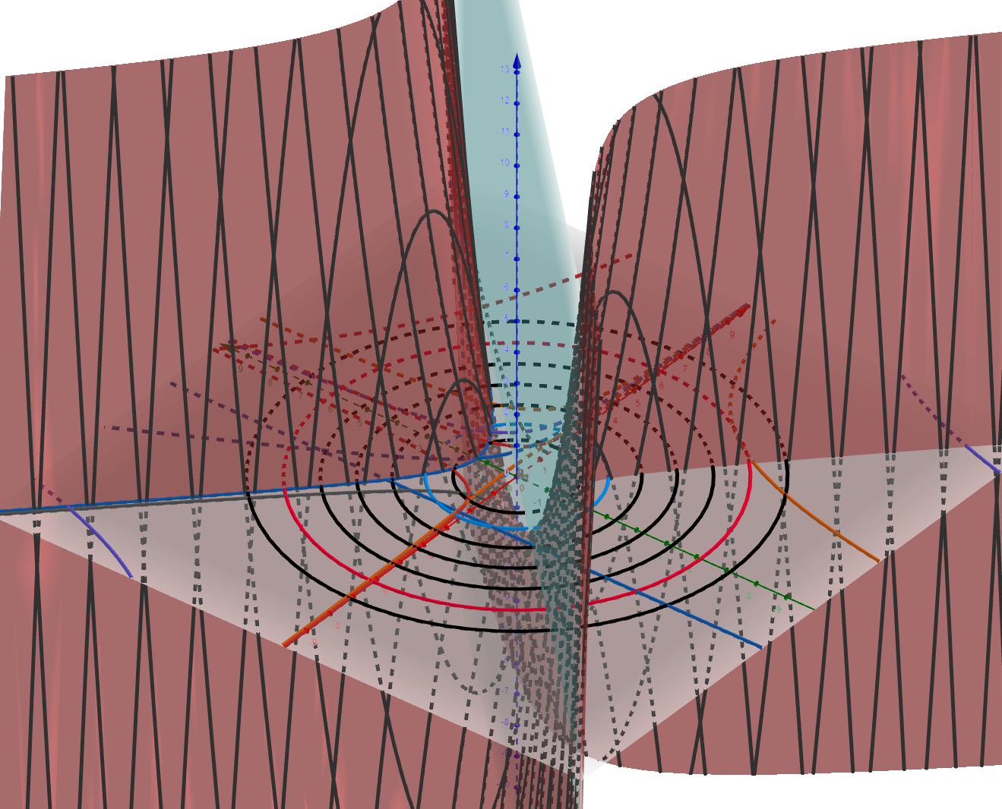
Figure 20: Example graph from Geogebra calculator showing hyperbolic surface, and falloff rings.
The falloff of the compression is $\frac{1}{r^{2}}$, which is the same as the falloff of gravity. I haven’t fully developed and applied the math for this to physics but did experiment with curvature as seen by the Eddington Experiment. (I don’t find the notes I made, was somewhat temporary, so there may be glaring errors) The displacement required at the surface of the sun is only 9000km, to displace the path of light through space the 1.75 arcseconds that was seen. Computing how much space from the total mass of the sun, if it was filled entirely with hydrogen atoms, gave a number for the size of a proton as 200fm. The actual size is expected to be 3.3fm; there is a rather large discrepancy and gets worse if considering that heavier atoms don’t displace much more space.

Hypothesis regarding the difference between calculation and experiment
Hypothetically, this difference is because of the way space is curved around a mass. Since photons travel through space, the space very near a mass will deflect the photon around the mass and not actually interact with it. If the photon is exactly head on, then there isn’t so much distinction about what direction to go around the mass, and there’s a high degree of uncertainty. Since the wavelength of the measurement occupies some lateral space, it will only really be able to detect the displacement in space at a distance of the wavelength of the wave; otherwise, the wave would likely all go around one side or another of the mass, and not actually interact with it.

Some other papers
These are some other long notes with images and examples.
https://github.com/d3x0r/STFRPhysics/blob/master/math/TheNotBang.md
https://github.com/d3x0r/STFRPhysics/blob/master/math/mathSphereDecay.md

Gravitational Redshift
The Pound-Rebka experiment tested red and blue shift of heated Iron emitting photons up and down a very tall tower at Harvard. Light emitted from lower in a gravity well, will be in space that is stretched, but is also compressed along the gravitational gradient, and as it goes up enters space, which is less stretched, but relaxes in the length of the space along the gravity gradient which is less compressed. Additionally, the detector will be in space that is less stretched and is smaller than expected; relatively it will detect a photon as red shifted from space that is more stretched, while additionally the photon will already be emitted as a wider version of itself and would seem red shifted compared to a photon emitted in more compressed space. This process reverses and causes a blue shift when light is emitted in compressed space and enters more stretched space; the detector will be wider than a detector higher in the gravity well and receive the wavelength as longer than it is, but additionally the photon will be more compressed along the direction of the gravitational gradient. It may be that the lateral stretching/compression which happens affects the amplitude of the wave while the stretching/compression along the length of a photon (although at the speed of light, one would expect a photon to be contracted to 0 length, but it may be that this length contraction doesn’t apply as much as the time it takes – since light is emitted in a wave the start and end of the wave happen at different times, so the overall length of a photon depends on the amount of time it took to emit it.
Any displacement that occurs is persistent and never actually disappears. The space between galaxies across the universe is cumulatively stretched by al the galaxies that exist. Light which passes through this space is progressively red shifted since the space is effectively more and more stretched from the point of emission until the point of reception. We only see photons that do not collide/interact with something along the way. At one point I did a random source of displacements of various sizes to see what the cumulative effect might be. Figure 23 shows the cumulative expansion of several randomly placed gravitational sources. While this may be a cause of red shift, it is not the dominant redshift source.
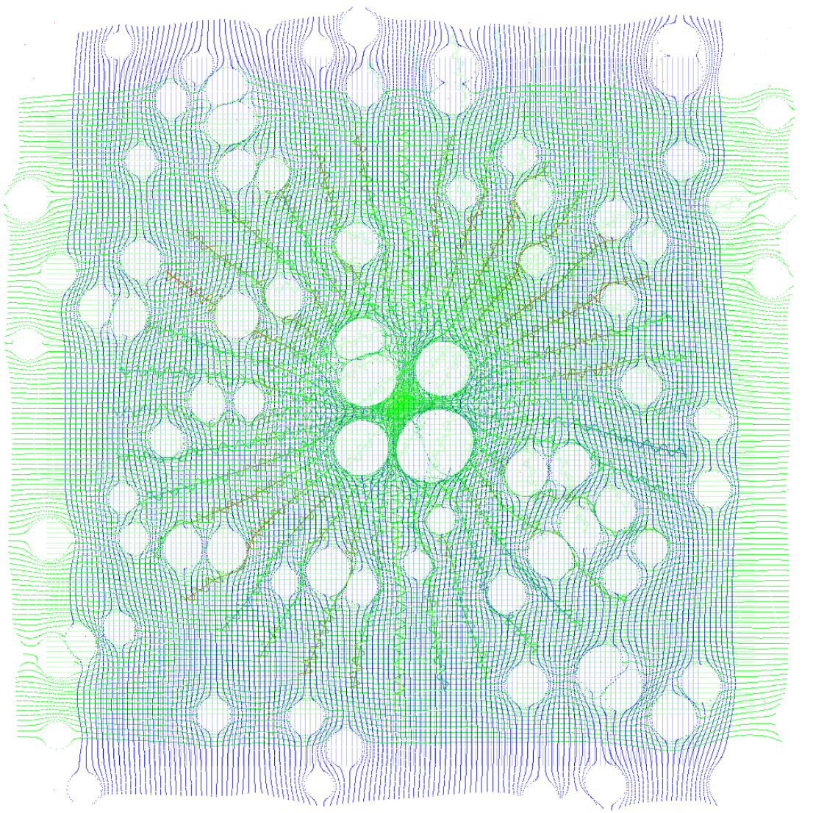
Figure 21: An example of a bunch of displacements of space scattered around. This makes for a fairly homogeneous expansion of space.

I later turned it into a more algorithmic demonstration:
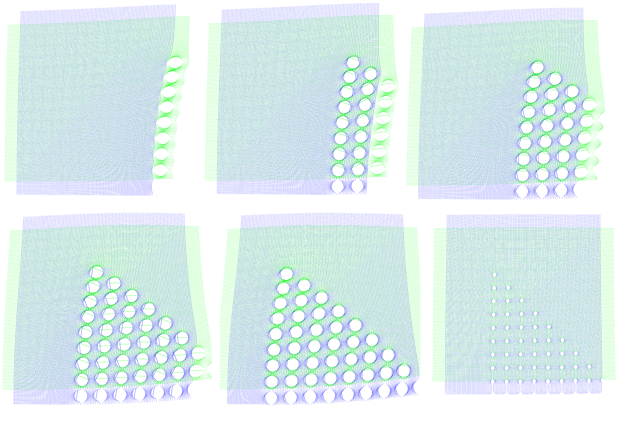
Figure 22: Progressive expansion with a geometric distribution. Showing how space has definitive cumulative expansion.
Figure 24 are several frames, moving the gravitational displacements more onto the display; the position of the mouse in the demonstration program controls the offset of what is seen. As more sources of displacement are passed, space is stretched cumulatively. But even this is not actually so obvious, since all displacements along the bottom row also shove the space to the left, which makes it look further to the left… until they are all visible, then the right edge is somewhat stretched to the right (mostly visible in the blue light geodesics).
The basic math is just $\sqrt{D^{2}+X^{2}+Y^{2}+Z^{2}}$ where D is the displacement. This could be negative to test a negative curvature, but in experimentation, a negative curvature, as it is assumed space currently has around massive objects, would mean that a black hole would block out an arc of the light behind it, and there would be space missing; though hypothetically it could be a pocket into a imaginary 3 dimensions or an additional 3 dimensions beyond X,Y, and Z.
This calculation is really a very one-dimensional sort of calculation, since it’s just a radial offset of a distance from its original position. The $L=\sqrt{X^{2}+Y^{2}+Z^{2}}$ is just the distance from a point of displacement to some point in space, and the displacement might as well be $d=\sqrt{D^{2}+L^{2}}$. The summation of multiple points of displacement must also be done such that the closest point of displacement to the point is applied last. This allows space to flow over a displacement, without being counter-displaced by the last displacement. Algorithmically, just maintain 1 closest displacement, until a closer displacement is found, and then replace the closest with the new closest, then after all other displacements have been applied, apply the closest.
A recent study using the length of time a supernova is observed was published [ref 11]. It was observed that galaxies further away have a longer time that supernova are observed, this means that during the time that the supernova happens, the galaxies move further away. This shows an active expansion of the universe. Assigning the expanding as already expanded would not account for this time difference; if it was only that the light was red shifted, then expanded space, rather than expanding space, could account for that. So presumably – the actual distance the light travels should be compared to the distance it started at; giving a red-shift from space expanding.

On Curvature
I had investigated parallel transport curvature on a surface for a while, and setup this curvature explorer demo. It takes 100 steps of some length around a curved surface and then turns a specified angle 5 times. I also included taking one step, turning by a fixed amount, and then taking another step for 100 steps. This was to compare what taking a long chain of 100 step and turn to the step-turn result ending up back at the pole (or at some point on the sphere).
The curvature of the sphere initially starts at very near 0, so it is basically like walking on a plane, the curvature can go up quite high, such that you can walk all the way around back to the pole before turning, or that it might only take one turn to get back to the starting pole by going 180 degrees around the sphere to its opposite pole.
The 3D rotation vectors are plotted too, and the difference in the Y direction might be compared as the Ricci Tensor… (might as in, it’s something like that but not exactly).
I realized that as curvature increased more and more (as one might expect for a black hole), that really the radius was just tighter, and effectively would be somewhat meaningless. The universe as far as we can see IS flat, but space is locally curved. At that point, I dug deeper into the Einstein Field Equations, to see what they would effectively generate, and found they simplified to just adding a 4th dimension to the length; although, it’s not really a 4th dimension, it’s just a force that is otherwise outside of the 3D field that photons travel through, but still within the 3 dimensions of space. Figure 25 shows the difference between a positive expansion of space and a negative contraction.
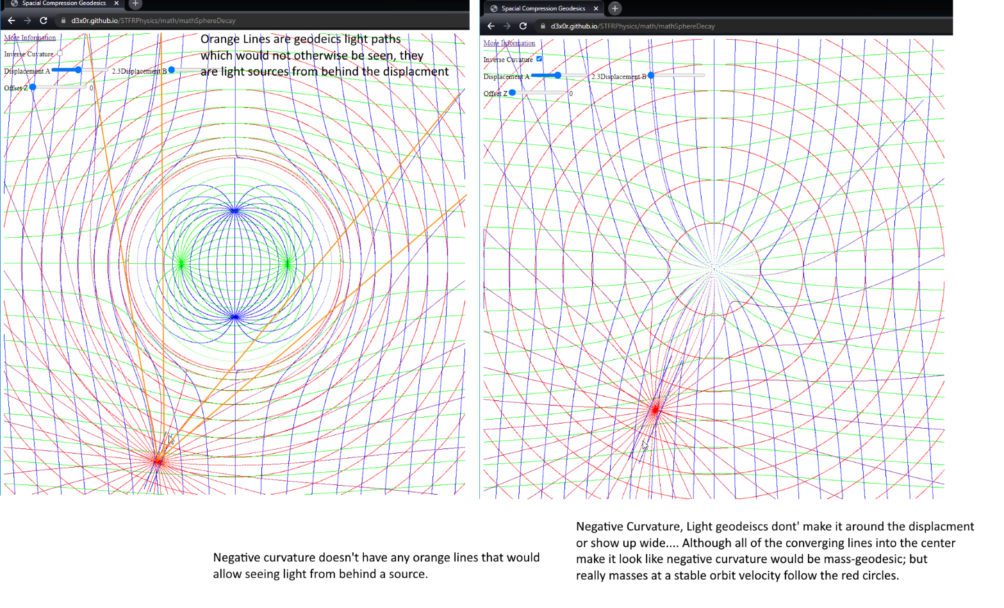
Figure 23: Comparison graph of positive curvature (on the left), and negative curvature (on the right). Positive curvature inserts volume into space, while negative curvature would subtract a volume of space.

Gravity and Time Dilation (Contraction)
The time dilation caused by gravity is the same as travelling at the escape velocity from that gravity well [ref 12]. Since time contraction is caused by a clock having to cover more space in a certain time than it would if it was stationary, this also gives how much space is stretched at a level in a gravitational well.

Black-hole Spaghettification
If space were curved in this way, then the radial compression and lateral expansion of space would counteract the difference in gravitational field strength between one’s head and their feet. This would make their overall pull identical relative to their center of mass for whatever relative length they were. The curved space shortens their height making that difference the same in any frame relative to the field. The lateral stretching is probably more what gets you; since a solar mass black hole is ~3km diameter, the incredible stretch of space would almost certainly allow you to pass around the black hole and not actually hit it. There is some question about the length though, when one measures the 3km black hole with a meter stick, when you’re on its surface, that space is in reality much longer , and the black hole larger than what you measure, since it would still be 3km. A much larger black hole would be less of an issue, since the relative light-speed escape velocity relative to the size of the black hole itself would make it a much more stable surface to stand on.
An experiment that is X meters long would show the same relative time dilation between a clock closer to gravity and another further away would always show the same relative time dilation. (to be tested added 2025-10-14)

Appendix H (Paradoxes)
Since the inception of Special Relativity, people have challenged the idea with many wonderful thought experiments.

A Rotating Body
https://en.wikipedia.org/wiki/Ehrenfest_paradox
The radius does not contract, and light aberration happens, so an observer in the middle of the wheel spinning with it observes no particular change.
The specific moments at tangents to the wheel do contract, which increases the space between the atoms, lowering their coupling forces, and results in the wheel flying apart far before it gets to a huge fraction of the speed of light. The lowered cohesion is overwhelmed by centrifugal forces.
But assuming an ideal virtual spinning body, the local area of the disk is always the same for an observer at any point on the disk. If the disk is viewed from an external source, then distortions to the disk may be observed. The opposing side of a disk viewed from a point on the disk will travel potentially at 2c if the edge you’re on is rotating at c.

A Neutral Buoyant Body
https://en.wikipedia.org/wiki/Supplee%27s_paradox
A contracted body which previously displaced an amount of water to maintain its depth no longer displaces as much water around it, and appears heavier, sinking.

Two Ships Attached with a Thread
https://en.wikipedia.org/wiki/Bell%27s_spaceship_paradox
As the ships contract, and the thread contracts, it will eventually break in many places at once at a sufficiently high velocity.
Saving property – the thread’s contraction can drag on the forward ship causing it to not accelerate as much, since the force it applies get amplified; if the ships were already going at a very fast rate, the thread’s drag would be enough to stop them from contracting away; but at a low speed, the thread would undoubtedly break.

Ladder Passing Through a Barn
https://en.wikipedia.org/wiki/Ladder_paradox
This one is interesting. It depends on the observer’s position in the situation. This is assuming also that the contracted length of the ladder makes it still be longer than the barn; but even a ladder that does fit in the barn, can be seen as extending past the barn, based on the observation of the doors, or fitting entirely within the barn.
- An observer in the barn, centered between the doors, only one door is open at a time.
- An observer outside the barn, centered between the doors will see both doors open at some point, and the ladder didn’t fit.
- An observer biased towards the first door that opens sees both doors closed at a time, and the ladder fit in the barn.
- An observer biased towards the second door sees both doors open, and the ladder did not fit in the barn.

Appendix I (Lorentz Transform Derivation)
Transcribed from https://www.youtube.com/watch?v=6pj1f8x3APg,
For the Love of Physics, “Derive Lorentz Transformations“
Starting with two frames $S$ and $S^{'}$. $S$ is a non-moving frame, $S^{'}$ is a moving frame relative to $S$. Coordinates of $S\{x,y,z,t\}$ and $S'\{x',y',z',t'\}$.
$$\begin{aligned}x^{'}=x-vt\#\left(I.1\right)\end{aligned}$$
Generalizing the formula, the constants $a$ and $b$:
$$\begin{aligned}x^{'}=ax+bt\#\left(I.2\right)\end{aligned}$$
First assumption, an event takes place at the origin of $S^{'}$:
$$\begin{aligned}x=vt\#\left(I.3\right)\end{aligned} \\ \begin{aligned}x^{'}=0\#\left(I.4\right)\end{aligned}$$Substituting into Equation [I.2]:
$$\begin{aligned}0=a\left(vt\right)+bt\#\left(I.5\right)\end{aligned}$$
$$\begin{aligned}avt=bt\#\left(I.6\right)\end{aligned}$$
$$\begin{aligned}b=-av\#\left(I.7\right)\end{aligned}$$
Substitute result back into I.2:
$$\begin{aligned}x^{'}=ax-avt\#\left(I.8\right)\end{aligned}$$
$$\begin{aligned}x^{'}=a\left(x-vt\right)\#\left(I.9\right)\end{aligned}$$
Second assumption, an event takes place at the origin of $S$:
$$\begin{aligned}x'=vt\#\left(I.10\right)\end{aligned} \\ \begin{aligned}x=0\#\left(I.11\right)\end{aligned}$$Results with an equation similar to equation [I.9]:
$$\begin{aligned}x=a\left(x^{'}+vt\right)\#\left(I.12\right)\end{aligned}$$
Third assumption, at the origin a bulb flashes, and the light propagates a distance in time of $ct$ at $t=0$:
$$\begin{aligned}S:x=ct\#\left(I.13\right)\end{aligned}$$
$$\begin{aligned}S^{'}:x^{'}=ct^{'}\#\left(I.14\right)\end{aligned}$$Substitute into [I.9]:
$$\begin{aligned}ct^{'}=a\left(ct-vt\right)\#\left(I.15\right)\end{aligned}$$
$$\begin{aligned}ct^{'}=a\left(c-v\right)t\#\left(I.16\right)\end{aligned}$$
$$\begin{aligned}\frac{t}{t'}=\frac{c}{a\left(c-v\right)}\#\left(I.17\right)\end{aligned}$$
Substitute into [I.12]:
$$\begin{aligned}ct=a\left(ct^{'}-vt^{'}\right)\#\left(I.18\right)\end{aligned}$$
$$\begin{aligned}ct=a\left(c+v\right)t^{'}\#\left(I.19\right)\end{aligned}$$
$$\begin{aligned}\frac{t}{t'}=\frac{a\left(c+v\right)}{c}\#\left(I.20\right)\end{aligned}$$
Since [I.17] and [I.20] are equal to the same value assign them:
$$\begin{aligned}\frac{c}{a\left(c-v\right)}=\frac{a\left(c+v\right)}{c}\#\left(I.21\right)\end{aligned}$$
$$\begin{aligned}a^{2}=\frac{c^{2}}{\left(c-v\right)\left(c+v\right)}=\frac{c^{2}}{c^{2}-v^{2}}\#\left(I.22\right)\end{aligned}$$
$$\begin{aligned}a=\frac{c}{\sqrt{c^{2}-v^{2}}}=\frac{1}{\sqrt{1-\frac{v^{2}}{c^{2}}}}\#\left(I.23\right)\end{aligned}$$

Substituting a and b into [I.9]:
$$\begin{aligned}\boxed{x^{'}=\frac{x-vt}{\sqrt{1-\frac{v^{2}}{c^{2}}}}}\#\left(I.24\right)\end{aligned}$$
Substituting a and b into [I.12]:
$$\begin{aligned}\boxed{x=\frac{x'+vt}{\sqrt{1-\frac{v^{2}}{c^{2}}}}}\#\left(I.25\right)\end{aligned}$$
Define gamma:
$$\begin{aligned}γ=\frac{1}{1-\frac{v^{2}}{c^{2}}}\#\left(I.26\right)\end{aligned}$$
$x^{'}=γ\left(x-vt\right)$ and $\begin{aligned}x=γ\left(x'-vt'\right)\#\left(I.27,I.28\right)\end{aligned}$
$$\begin{aligned}x=\frac{x'+vt^{'}}{\sqrt{1-\frac{v^{2}}{c^{2}}}}\#\left(I.29\right)\end{aligned}$$

$$\begin{aligned}x\sqrt{1-\frac{v^{2}}{c^{2}}}=\frac{\left(x-vt\right)}{\sqrt{1-\frac{v^{2}}{c^{2}}}}+vt^{'}\#\left(I.30\right)\end{aligned}$$
$$\begin{aligned}x\sqrt{1-\frac{v^{2}}{c^{2}}}=\frac{\left(x-vt\right)+vt^{'}\sqrt{1-\frac{v^{2}}{c^{2}}}}{\sqrt{1-\frac{v^{2}}{c^{2}}}}\#\left(I.31\right)\end{aligned}$$
Multiply both sides by
$$\begin{aligned}x\left(1-\frac{v^{2}}{c^{2}}\right)=\left(x-vt\right)+vt^{'}\sqrt{1-\frac{v^{2}}{c^{2}}}\#\left(I.32\right)\end{aligned}$$
Expand terms:
$$\begin{aligned}x-\frac{xv^{2}}{c^{2}}=x-vt+vt^{'}\sqrt{1-\frac{v^{2}}{c^{2}}}\#\left(I.33\right)\end{aligned}$$
X on both sides cancels, divide remaining terms by v to remove one v:
$$\begin{aligned}-\frac{xv}{c^{2}}=-t+t^{'}\sqrt{1-\frac{v^{2}}{c^{2}}}\#\left(I.34\right)\end{aligned}$$
$$\begin{aligned}t^{'}=\frac{t+\frac{xv}{c^{2}}}{\sqrt{1-\frac{v^{2}}{c^{2}}}}\#\left(I.35\right)\end{aligned}$$
$$\begin{aligned}t^{'}=γ\left(t+\frac{xv}{c^{2}}\right)\#\left(I.36\right)\end{aligned}$$
‘similarly by substituting the equations the other direction’:
$$\begin{aligned}t=γ\left(t^{'}-\frac{xv}{c^{2}}\right)\#\left(I.37\right)\end{aligned}$$

To recap derived equations, these are the Lorentz Transformation equations:
$$\begin{aligned}\boxed{t^{'}=γ\left(t-\frac{vx}{c^{2}}\right)}\#\left(I.36\right)\end{aligned}$$
$$\begin{aligned}\boxed{x^{'}=γ\left(x-vt\right)}\#\left(I.24\right)\end{aligned}$$
$$\begin{aligned}\boxed{t=γ\left(t^{'}-\frac{xv}{c^{2}}\right)}\#\left(I.37\right)\end{aligned}$$
$$\begin{aligned}\boxed{x=γ\left(x'-vt'\right)}\#\left(I.28\right)\end{aligned}$$
In the y and z directions, there’s no relative motion taking place, so they are just equal to each other $y'=y$ and $z'=z$. This makes application of rotating the frame slightly difficult, plus, if one body has a velocity along x and the other along y and z only, then these equation do not address that situation at all.
The first assumption in Equation $[I.3$] and $[I.4$], event is at the origin, and second assumption is that an event happens at the origin of S, given in equations [I.10] and [I.11]. This means the solution is only specifically for an event at the origin, that radiates from the origin, with an observer that is also at the origin.

What happens if a more general solution is attempted? Even just along a 1D situation, where you are able to see an event at a non-zero position?
$$\begin{aligned}x^{'}=ax+bt\#\left(I.2\right)\end{aligned}$$
First assumption, an event takes place at the origin of $S^{'}$:
$$\begin{aligned}x=d+vt\#\left(I.29\right)\end{aligned} \\ \begin{aligned}x^{'}=d\#\left(I.30\right)\end{aligned} \\ \begin{aligned}d=a\left(d+vt\right)+bt\#\left(I.31\right)\end{aligned}$$
$$\begin{aligned}d-a(d+vt)=bt\#\left(I.32\right)\end{aligned}$$
$$\begin{aligned}\frac{d-a(d+vt)}{t}=b\#\left(I.33\right)\end{aligned}$$
Substitute [I.33] into [I.2]:
$$\begin{aligned}x^{'}=ax+\frac{(d-a(d+vt))}{t}t\#\left(I.34\right)\end{aligned}$$
$$\begin{aligned}x^{'}=ax+(d-a(d+vt))\#\left(I.35\right)\end{aligned}$$
$$\begin{aligned}x^{'}=ax+d-ad-avt\#\left(I.36\right)\end{aligned}$$
$$\begin{aligned}\boxed{x^{'}=a(x-d-vt)+d}\#\left(I.37\right)\end{aligned}$$
Begin inverse substitution:
$$\begin{aligned}x=d\#\left(I.38\right)\end{aligned} \\ \begin{aligned}x^{'}=d-vt^{'}\#\left(I.39\right)\end{aligned}$$
Assume this is the inverse equation:
$$\begin{aligned}x=a\left(x^{'}-d+vt^{'}\right)+d\#\left(I.40\right)\end{aligned}$$
Substitute propagation time into [I.37]:
$$\begin{aligned}ct^{'}=a(ct+d-vt)-d\#\left(I.41\right)\end{aligned}$$
$$\begin{aligned}ct^{'}=act+ad-avt-d\#\left(I.42\right)\end{aligned}$$
$$\begin{aligned}ct^{'}=at( c-v ) +ad-d\#\left(I.43\right)\end{aligned}$$
$$\begin{aligned}\frac{t^{'}-ad/c+d/c}{t}=\frac{a( c-v ) }{c}\#\left(I.44\right)\end{aligned}$$

Substitute propagation time into [I.40]:
$$\begin{aligned}ct=a\left(ct^{'}+d+vt^{'}\right)-d\#\left(I.45\right)\end{aligned}$$
$$\begin{aligned}ct=a\left(ct^{'}+d+vt^{'}\right)-d\#\left(I.46\right)\end{aligned}$$
$$\begin{aligned}ct=act^{'}+ad+avt^{'}-d\#\left(I.47\right)\end{aligned}$$
$$\begin{aligned}ct=a(c+v)t^{'}+ad-d\#\left(I.48\right)\end{aligned}$$
$$\begin{aligned}\frac{t-ad/c+d/c}{t^{'}}=\frac{a(c+v)}{c}\#\left(I.49\right)\end{aligned}$$
Looks like the ratio does not result to be the same. This path to getting a more generic solution looks like a dead end.
The next approach to try would be the approach taken in the first place – calculating the time light propagates from one moving point to another moving point.

Appendix J (Another Derivation of Lorentz Transform using Geometry)
eigenchris, “Relativity 104a: Special Relativity - Lorentz Transformation Geometry (no equations)”, https://www.youtube.com/watch?v=5bSy18w8Dh0
eigenchris, “Relativity 104b: Special Relativity - Lorentz Transform Equations Derivation”, https://www.youtube.com/watch?v=240YGZmV1b0
This approach uses Einsteins definition of simultaneity to determine the geometry of how the axes must be transformed. This approach does not consider the propagation of events, instead assigns the hypothetical $\frac{T_{2}-T_{1}}{2}$ definition of simultaneity to define the intersection of the time on the side that wasn’t reflecting the signal and defining between that point and the other point where the light did reflect at a real time to determine iso-chronic axis transform.
This approach only captures length contraction and time contraction and says nothing about when an event is seen by any other observer. It also assumes that the transformation is symmetric across the origin.
He does discuss how the Lorentz Transformation differs from a Galilean Transform, which would only shift the spatial axis, and cause the speed of light to be non-constant.
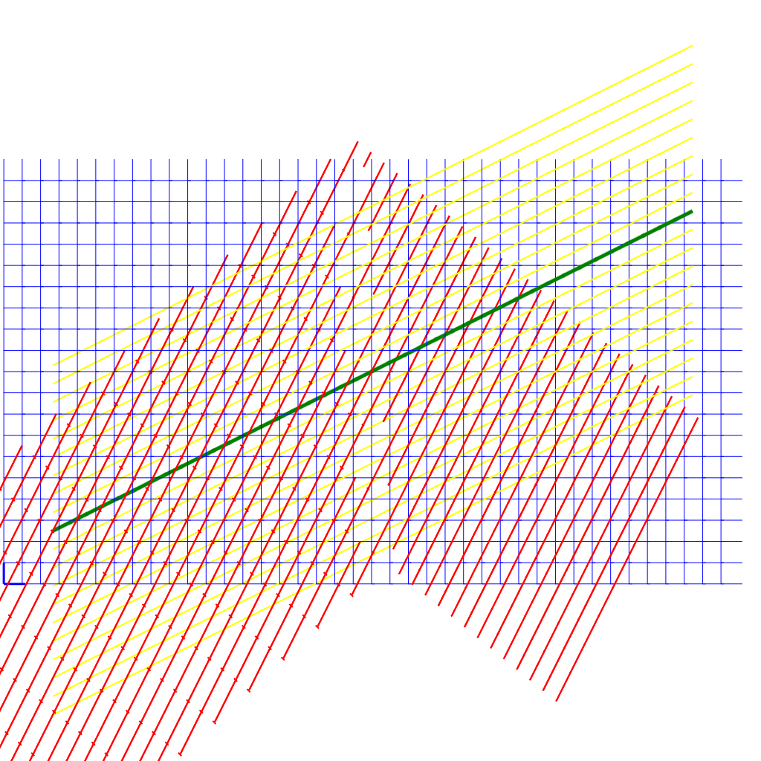
Figure 24: Lorentz Transform isometric graph vs Light Propgation graph.
In figure 26 above, lines from left to right are iso-time lines in this idea, which makes the vertical lines from bottom to top be iso-position lines at a given velocity. That as the body moves at a velocity, the position moves to the right. When a body is at a velocity, then a clock sync pulse has midway points on the left at (t2-t1)/2. But then that only addresses synchronizing the forward moving clock to the back moving clock, and the time of simultaneity would be to the upper-left.
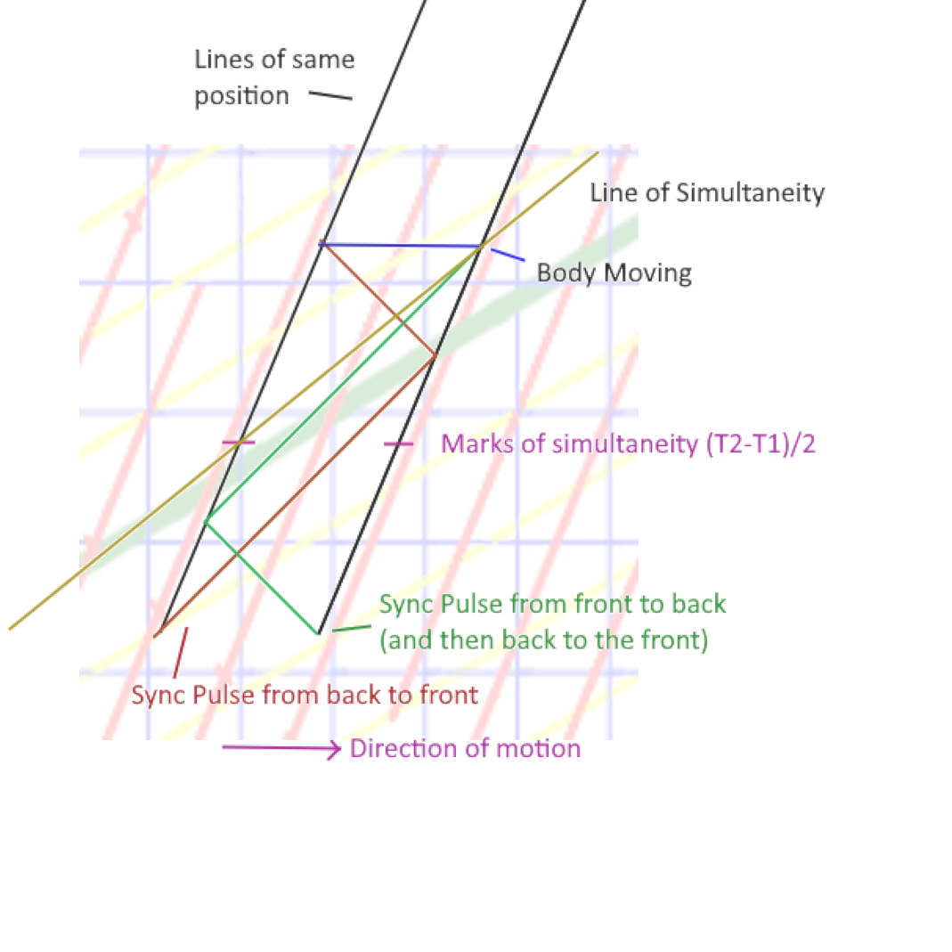
Figure 25: Attempt to overlay pulses sent back and forth, and align with Lorentz Transform graph.
Figure 27 would be a comparable image.
Then, if the two people with clocks at the ends of the craft move together, they will find they are not synchronized – but then they would have moved at a different velocity, so it wouldn’t have ticked at the same rate. That and the background yellow line doesn’t match the line of simultaneity from the halfway point either. The velocity is the same as in figure (?).
Let’s use Alice($A$) and Bob($B$) as people at the ends of the craft that is 1 light second long. The craft they are in is moving at 0.5c. $A$ and $B$ want to synchronize their clocks. $A$ sends a pulse to $B$ which $B$ then sets their clock to 0 and returns the signal. $A$ receives the signal and sets their clock at 1. The round-trip time from when $A$ sent the signal until $A$ received the signal would be 2 seconds. When $A$ sees the clock B has, it reads 0.5 seconds slower than A’s clock. When B sees clock A, then it sees the clock is ($1-1.5=$)0.5 seconds slower than their own clock.
Assuming the clocks in the front and back of the craft are synchronized when it is stationary, and given the contracted length is 0.866, the back sees the front -0.433 seconds slower than its own clock, the front sees the back at -1.299 seconds slower than its own clock. The total time from back to front and back to the back is then (-0433-1.299= -1.732) seconds, across two times the contracted length (0.866*2=1.732)/1.1732=1c. Which is fine, but neither side is ½ of the other. If the clock is synchronized as above, then the back sees the clock as (1-0.433= .567) seconds slower than their own clock, and when the craft stops, and they compare their clocks, just walking the clock over, does not apply a significant time dilation, they find their clocks are 0.164(?) seconds different, and aren’t in sync at all.
There is no synchronization scheme that works for asymmetric delays in transmission speed[ref 8].

Appendix K (Ives-Stillwell)
This experiment is about time dilation and doppler shifts, this is not about the speed of light; in fact, if the speed of light was changed by the source motion, then the frequency wouldn’t be compressed.
This experiment [https://en.wikipedia.org/wiki/Ives%E2%80%93Stilwell_experiment] is about time dilation and doppler shifts. It is exactly because of a constant speed of light that the frequency shifts. So still, this stands as is, with no modification. I can make a model of how the hydrogen is accelerated relative to a moving frame and the apparatus itself is also moving, and still the light aberration, time and length contraction factors are identical to Special Relativity. Predicted results from this model would be identical to those produced with SR.

Appendix L (Changelog)
- Renumbered some equations using (section.number) style.
- Inserted Appendix I for the transcription of a derivation of the Lorentz Transforms.
- Inserted Appendix J for Eigenchris’ approach to the Lorentz Transform.
- Added note in experiment ‘No Clock Transport’ about using a medium to considering synchronizing with a signal slower than light.
- (2024-08-30) Converted text under images to captions associated with the images. Updated links to figures and tables. Added additional note about experimental data showing an expanding universe at the end of Appendix G.
- (2024-09-19) Added Appendix K (Ives-Stillwell) to address why this wasn’t previously addressed.
- (2025-05-10) Added Appendix M (Slow Clock Transport)
- (2025-06-03) Added second local, two-way constancy postulate.
- (2025-09-27) Added comments in slow clock transport, experiment description, added appendix on ‘sidereal normal time’.
- (2025-10-12) Added further comments on the motion of clocks and updated experimental results and expectations to remove many words and conclude with expected null results.
- (2025-10-13) added Relativistic Velocity Addition section.
- (2025-10-14) Added comments on spaghettification in appendix G.

Appendix M (Slow Clock Transport)
Even in this system (unless the speeds are beyond what humans can generate for acceleration) the math for time dilation of a moving clock along the velocity vector the frame is moving in, then the difference on the clocks is exactly what you would expect the measurable difference to be. However, since the proposed experiment in this paper happens over a day, then one could wait until 6pm sidereal normal time, which would make both clocks move away from each other perpendicular to the velocity, and both be dilated by the same amount, and both run slower. Then wait 6 hours to measure how far off their synchronization has drifted…. But while moving they would be synchronized.
Or really, just wait until the clocks are at 6am/pm
The following paper suggests that the only time slow clock transport would be exactly the same amount shifted as moving at any other speed, is when the frame is stationary with regard to space; this is far from the case since we at least orbit the sun; the Earth’s rotation during the day cancels out some of this velocity though – 30,000-300’ish m/s.
https://www.researchgate.net/publication/226579519_A_test_theory_of_special_relativity_I_Simultaneity_and_clock_synchronization January 1977

The following paper suggests to use a triangular interferometer; the light path has 4 light sensors, and reports independently each of the 4 times to a common clock at 45 degrees from the path measured. I think the expected time shift is still recovered in the ½ return to the center… but these are just some rough notes.
Length contraction $\sqrt{1-\frac{VV}{CC}}$
time to cover diagonal $\frac{\sqrt{1+\frac{C-V}{C+V}}}{C}$
Length(time) of base $\sqrt{\frac{2\left(CC-VV\right)}{CC{\left(C+V\right)}^{2}}}=\frac{\sqrt{\frac{2\left(C-V\right)}{\left(C+V\right)}}}{C}$

time of return diagonal $\frac{\sqrt{1+\frac{C+V}{\left(C-V\right)}}}{C}$
Difference around 0 is + (sqrt(2) + 0.000000707 to 0.00000159)*D; where a dead straight beam offset would be +/-0.001 to 0.0015*D. This manages to capture ½ of the difference of ½ of the trip. The two-way path in the diagonal arms is canceled out (at least where the direction is along the base of the triangle. However, this might be able to be implemented on LISA, where the distance is millions of miles.

(turned 90 degrees) the times along both diagonal are the same, and the uncontracted length along the base; which doesn’t have any effect; so basically turning the device 90 degrees cannot identify any isotropic time… and turned 45, then one leg is uncontracted and the base is contracted, and the other arm is contracted; still has more data in it than is needed – but maybe this direction gets a reading (probably not)
https://www.ej-physics.org/index.php/ejphysics/article/view/288 Vol. 5 No. 6 (2023) “Theoretical Model of an Experiment to Test the Isotropy of the Speed of Light“ (last version of the year – first submission to nature – 12/4/23)
Some other trivial values, however, given the equivalence of the escape velocity to time dilation, the escape velocity of the earth is 11km/s, which is 0.0000366c. The escape velocity from the sun at the earth’s orbit is 42.1km/s or 0.00014c. The escape velocity from the galaxy at the sun’s location is 550km/s or 0.00183c. While each of these are actually a very small time contraction/space expansion, each one does matter, and variations within that range aren’t felt. Wikipedia - Hafele–Keating experiment this article mentions that the dilation from the rotational speed is countered because the earth’s equator is also more distant, and has less time dilation, effectively cancelling the rotational variation. The Hafele–Keating experiment was coincidentally performed along the Axis of Evil, looking up the date of the experiment, and assuming it was done during the day, their net velocity was also against the net velocity of the galaxy moving through space (mostly, one of them probably would have ended up not having a delta against this vector and their speed became irrelevant; the eastward would be with the speed of the planet while westward could maintain a delta against our motion in the universe.
Within the context of my experiment that covers 4 miles, and I want to move the clocks 2 miles at 20mph, it’ll take 6 minutes. The time dilation experiments on aircraft were many hours long, and at a much higher speed, and they measured the difference in -40 to +240nano seconds. The difference that would be applied to clocks walked such a small distance over a slow speed would have at least +/-0.02 nanoseconds; and the signal I’m looking for is in the range of +/-12 nanoseconds or 24 nanoseconds total… any deviation from ‘synced’ at the center to the edge of the experiment isn’t even going to be in the data, since once placed, there’s no further motion of the clocks (other than the rotation of earth, orbiting the sun, around a galaxy, which is moving through the universe (and this last bit of motion is what I intend to focus on), which is hypothetically larger change in velocity than any of the other velocities, and the total gravitational time dilation is also less than the signal (other than at very short distances). The difference in observed relative velocities is amplified with distance, while distance has no time dilation effect.
https://user.it.uu.se/~marlu734/relativity/Alley1979-relativity_and_clocks.pdf (1979 translation of 1905 paper, Carroll O. Alley, University of Maryland, College Park Maryland ) (I didn’t read this before adding this notation)

Appendix N (Sidereal Normal Time)
I would propose a new time value.
A sidereal day is shorter than a solar day by about 5 minutes. This means, that if the seconds on a sidereal clock, and on a solar clock are expected to tick at the same rate, then the clock only goes up to 23:55:00, and does not map nicely to a 360 degree offset.
An additional multiplier of approximately 1.002 can be applied, so each standard second on a solar 24 hour clock ticks 1.002 ticks on a sidereal normal clock, which makes the day 24:00:00 hours. This doesn’t do anything to help the calendar though, because a calendar year also differs from a solar calendar year. It does standardize time to something that easily maps to 360 degrees, so times like 6pm and 6am don’t have to be expressed as 5:57:30pm (that’s a rough guess, not an accurate value)
Programmatically get the current millisecond of the day since 1970 (standard millisecond ticks), subtract 1547138420000 (which biases it to 2019 January 10 @16:40:20 UTC to be ‘0’). Then also subtract your current latitude converted to 24-hour clock units. Finally divide by 86164100 to get the days, and fraction of a day; and/or mod by 86164100 to get the sidereal milli-second of the day, in solar seconds. And multiply by $1.0027378$ or $8640000/86164100$ to convert to a 24-hour clock.
$$24*60*60*1000 = 8640000$$
Local Sidereal Normal Time includes an offset by longitude. This makes local noon always point in the same direction in the universe. There is a coordinated UTC time where a specific longitude on the planet determines where that noon is, and everyone else is a bias +/- that. GMT longitude may be interpreted as 0.0098degrees west, which becomes (0.0098/360)*86164100 or a small bias of 2345.5782 milliseconds, which could be included in the initial 1547138420000.

