**RAJALAKSHMI ENGINEERING COLLEGE**

**RAJALAKSHMI NAGAR, THANDALAM – 602 105**

|  |
| --- |
| **CS23332**  **DATABASE MANAGEMENT SYSTEM LAB** |
| **Laboratory Observation Note Book** |

2nd Year/ AIML / A

Ezhil Adhithya P

2024-2025

3rd Semester

231501045



**CS23332 DATABASE MANAGEMENT SYSTEMS**

|  |  |
| --- | --- |
| Name | Dilip Kannan K |
| Roll No | 231501040 |
| DEPT | AIML |
| SEC | A |

**INDEX PAGE**

|  |  |  |  |  |  |
| --- | --- | --- | --- | --- | --- |
| **SL.NO** | **DATE** | **NAME OF THE EXPERIMENT** | **PAGE NO** | **MARK** | **FACULTY SIGNATURE** |
| **01** | 24-7-2024 | CREATION OF BASE TABLEAND DML  OPERATIONS |  |  |  |
| **02** | 26-07-2024 | DATA MANIPULATIONS |  |  |  |
| **03** | 30-07-2024 | WRITING BASIC SQL SELECTSTATEMENT |  |  |  |
| **04** | 02-08-2024 | WORKING WITH  CONSTRAINTS |  |  |  |
| **05** | 07-08-2024 | CREATING VIEWS |  |  |  |
| **06** | 14-08-2024 | RESTRICTING AND SORTINGDATA |  |  |  |
| **07** | 27-08-2024 | USING SET OPERATORS |  |  |  |
| **08** | 03-09-2024 | WORKING WITH MULTIPLETABLES |  |  |  |
| **09** | 10-09-2024 | SUB QUERIES |  |  |  |
| **10** | 20-09-2024 | AGGREGATING DATAUSING GROUP FUNCTIONS |  |  |  |
| **11** | 24-09-2024 | PL SQL PROGRAMS |  |  |  |
| **12** | 01-10-2024 | WORKING WITH CURSORPROCEDURES AND FUNCTIONS |  |  |  |
| **13** | 08-10-2024 | WORKING WITH TRIGGER |  |  |  |
| **14** | 18-10-2024 | MONGO DB |  |  |  |
| **15** | 25-10-2024 | OTHER DATABASE OBJECTS |  |  |  |
| **16** | 1-11-2024 | CONTROLLING USER ACCESS |  |  |  |

|  |  |  |
| --- | --- | --- |
| **Ex.No.: 1** | | **CREATION OF BASE TABLE AND**  **DML OPERATIONS** |
| **Date:** | 24/7/24 |

1. Create MY_EMPLOYEE table with the following structure

|  |  |  |
| --- | --- | --- |
| NAME | NULL? | TYPE |
| ID | Not null | Number(4) |
| Last_name |  | Varchar(25) |
| First_name |  | Varchar(25) |
| Userid |  | Varchar(25) |
| Salary |  | Number(9,2) |

CREATE TABLE MY_EMPLOYEE (ID NUMBER(4) NOT NULL, Last_name VARCHAR2(25), First_name VARCHAR2(25), Userid VARCHAR2(25),Salary NUMBER(9, 2));

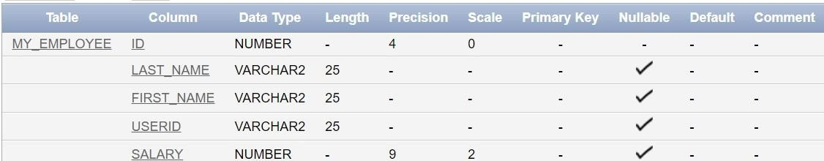

1. Add the first and second rows data to MY_EMPLOYEE table from the following sample data.

|  |  |  |  |  |
| --- | --- | --- | --- | --- |
| **ID** | **Last_name** | **First_name** | **Userid** | **salary** |
| 1 | Patel | Ralph | rpatel | 895 |
| 2 | Dancs | Betty | bdancs | 860 |
| 3 | Biri | Ben | bbiri | 1100 |
| 4 | Newman | Chad | Cnewman | 750 |
| 5 | Ropebur | Audrey | aropebur | 1550 |

Begin

INSERT INTO MY_EMPLOYEE VALUES (1, 'Patel', 'Ralph', 'rpatel', 895); INSERT INTO MY_EMPLOYEE VALUES (2, 'Dancs', 'Betty', 'bdancs', 860);

End;

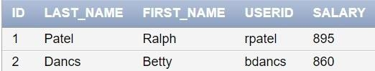

1. Display the table with values.

Select * from My_Employee;



1. Populate the next two rows of data from the sample data. Concatenate the first letter of the first_name with the first seven characters of the last_name to produce Userid.

Begin

INSERT INTO MY_EMPLOYEE (ID, Last_name, First_name, Userid, Salary) VALUES (3, 'Biri', 'Ben', SUBSTR('Biri', 1, 1) || SUBSTR('Biri', 1, 7), 1100);

INSERT INTO MY_EMPLOYEE (ID, Last_name, First_name, Userid, Salary)

VALUES (4, 'Newman', 'Chad', SUBSTR('Newman', 1, 1) || SUBSTR('Newman', 1, 7), 750);

End;

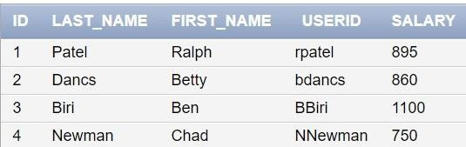

1. Delete Betty dancs from MY _EMPLOYEE table.

DELETE FROM MY_EMPLOYEE WHERE Last_name = 'Dancs';

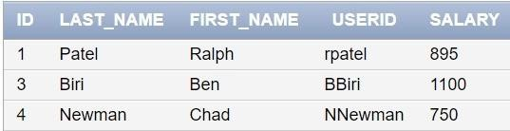

1. Empty the fourth row of the emp table.

DELETE FROM MY_EMPLOYEE WHERE ID = 4;

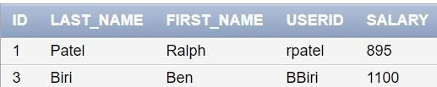

1. Make the data additions permanent.

COMMIT;

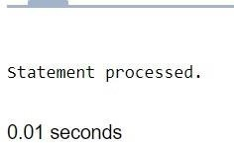

1. Change the last name of employee 3 to Drexler.

UPDATE MY_EMPLOYEE SET Last_name = 'Drexler' WHERE ID = 3;

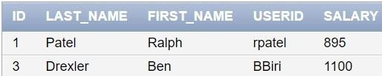

1. Change the salary to 1000 for all the employees with a salary less than 900.

UPDATE MY_EMPLOYEE SET Salary = 1000 WHERE Salary < 900;

