**DATABASE MANAGEMENT**

**SYSTEM PROJECT**

**ONLINE FOOD ORDERING**

**MANAGEMENT SYSTEM**

***TEAM MEMBERS***

***EZHIL OVIYA C – 2021115034***

***SUMATHI K – 2021115112***

***YUTHIKSHAA M – 2021115123***

***INDEX:***

*1. AIM*

*2. INTRODUCTION*

*3.TECHNICAL SPECIFICATIONS*

*4.DATABASE DETAILS*

*5. IMPORTED MODULES AND FILES USED*

*6. USER DEFINED FUNCTIONS*

*7. SOURCE CODE OF THE PROGRAM*

*8. SAMPLE OUTPUT*

*9. WEBPAGE*

*10. CONCLUSION*

*11. BIBLIOGRAPHY*

*12. CONTRIBUTIONS*

**AIM:**

*Our proposed system is an online food ordering system that enables ease for the customers. It overcomes the disadvantages of the traditional queueing system. Our proposed system is a medium to order online food hassle free from restaurants as well as mess service. This system improves the method of taking the order from customer. The*

*online food ordering system sets up a food menu online and customers can easily place the order as per their wish. Also with a food menu, customers can easily track the orders. This*

*system also provides a feedback system in which user can rate the food items. Also, the proposed system can recommend hotels, food, based on the ratings given by the user, the hotel staff will be informed for the improvements along with the quality. The payment canbe made online or pay-on-delivery system. For more secured ordering separate accounts are maintained for each user by providing them an ID and a password.*

**INTRODUCTION:**

*The online food ordering system sets up a food menu online and customers can easily place the order as per they like. Also with a food menu, online customers can easily track the orders. The management maintains customers database, and improve food delivery service. The Restaurant management systems motivates us to develop the system. There are various*

*facilities provided so that the users of the system will get service effectively. Also, the system considers Restaurants as well as Mess facility to the customers. Again, the idea comes that mostly mess users are person who are shifted for various reason in new cities. So, they are interrelated. Increasing use of smart phones is also considered as a motivation, so that any*

*users of this system get all service on single click. Another motivation can be considered as the system will be designed to avoid users doing fatal errors, users can change their own can provide feedback and recommendations and can give ratings, it will give appropriate feedbacks to Restaurants / Mess service providers.*

*Due to lack of a full fledge application that can fulfill the customer requirements by providing him food from restaurants as well as from mess service, there is a need for the system. This proposed system will be used by the people who keep shifting from cities to cites. As well as, it will be useful for the students studying in different cities.*

*proﬁle, users can track their food items through GPS, user*

**BASIC MODULES:**

1. *Display Product*
2. *Insert Product*
3. *Update Product*
4. *Delete Product*
5. *Display Cart*
6. *Insert Cart*
7. *Update Cart*
8. *Delete Cart*
9. *Truncate Cart*
10. *Display Food Orders*

**TECHNICAL SPECIFICATIONS:**

**HARDWARE SPECIFICATIONS:**

o *PROCESSOR :* PENTIUM DUAL CORE or Above

o *RAM* : 2 GB

o *HARD DISK* : 500 GB

o *MONITOR* : 14’’ LED or Above

o *KEYBOARD* : 104 KEYS

**SOFTWARE SPECIFICATIONS:**

o *OPERATING SYSTEM* : WINDOWS 10

o *FRONT END* : HTML CSS

o *BACKEND* : PHP and MySQL

**DATABASE DETAILS:**

**TABLES USED IN MYSQL: Products**

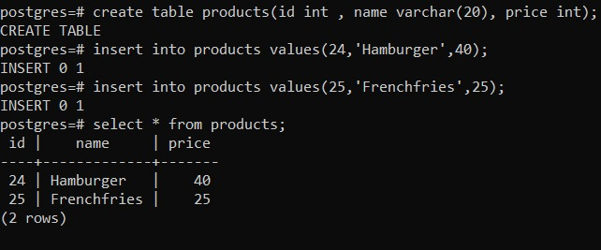

**Cart**

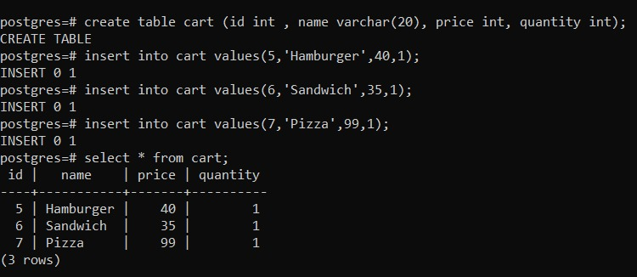

**Food orders**

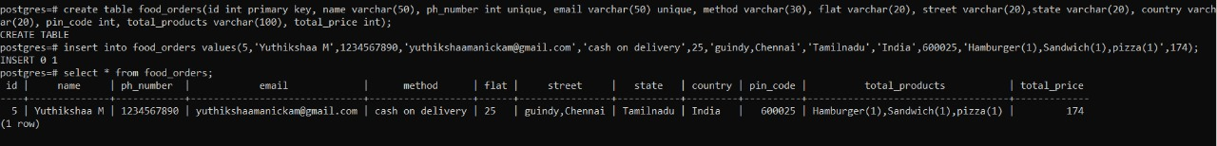

**MODULES USED:**

1. mysqli_fetch_assoc
2. mysqli_num_rows
3. number_format
4. isset
5. implode
6. mysqli_query
7. connect
8. confirm
9. header

**USER DEFINED FUNCTIONS:**

1. move_uploaded_file
2. order_btn
3. select_cart
4. add_to_cart
5. add_product
6. update_product
7. cart_query
8. detail_query
9. update_update_btn
10. delete_all
11. remove

**SOURCE CODE:**

FILE: admin.php

<?php

@include 'config.php';

if(isset($_POST['add_product'])){

   $p_name = $_POST['p_name'];

   $p_price = $_POST['p_price'];

   $p_image = $_FILES['p_image']['name'];

   $p_image_tmp_name = $_FILES['p_image']['tmp_name'];

   $p_image_folder = 'uploaded_image/'.$p_image;

   $insert_query = mysqli_query($conn, "INSERT INTO `products`(name, price, image) VALUES('$p_name', '$p_price', '$p_image')") or die('query failed');

   if($insert_query){

      move_uploaded_file($p_image_tmp_name, $p_image_folder);

      $message[] = 'product add succesfully';

   }else{

      $message[] = 'could not add the product';

   }

};

if(isset($_GET['delete'])){

   $delete_id = $_GET['delete'];

   $delete_query = mysqli_query($conn, "DELETE FROM `products` WHERE id = $delete_id ") or die('query failed');

   if($delete_query){

      header('location:admin.php');

      $message[] = 'product has been deleted';

   }else{

      header('location:admin.php');

      $message[] = 'product could not be deleted';

   };

};

if(isset($_POST['update_product'])){

   $update_p_id = $_POST['update_p_id'];

   $update_p_name = $_POST['update_p_name'];

   $update_p_price = $_POST['update_p_price'];

   $update_p_image = $_FILES['update_p_image']['name'];

   $update_p_image_tmp_name = $_FILES['update_p_image']['tmp_name'];

   $update_p_image_folder = 'uploaded_img/'.$update_p_image;

   $update_query = mysqli_query($conn, "UPDATE `products` SET name = '$update_p_name', price = '$update_p_price', image = '$update_p_image' WHERE id = '$update_p_id'");

   if($update_query){

      move_uploaded_file($update_p_image_tmp_name, $update_p_image_folder);

      $message[] = 'product updated succesfully';

      header('location:admin.php');

   }else{

      $message[] = 'product could not be updated';

      header('location:admin.php');

   }

}

?>

<!DOCTYPE html>

<html lang="en">

<head>

   <meta charset="UTF-8">

   <meta http-equiv="X-UA-Compatible" content="IE=edge">

   <meta name="viewport" content="width=device-width, initial-scale=1.0">

   <title>admin panel</title>

   <!-- font awesome cdn link  -->

   <link rel="stylesheet" href="<https://cdnjs.cloudflare.com/ajax/libs/font-awesome/6.0.0/css/all.min.css>">

   <!-- custom css file link  -->

   <link rel="stylesheet" href="css/style.css">

</head>

<body>

<?php

if(isset($message)){

   foreach($message as $message){

      echo '<div class="message"><span>'.$message.'</span> <i class="fas fa-times" onclick="this.parentElement.style.display = `none`;"></i> </div>';

   };

};

?>

<?php include 'header.php'; ?>

<div class="container">

<section>

<form action="" method="post" class="add-product-form" enctype="multipart/form-data">

   <h3>add a new product</h3>

   <input type="text" name="p_name" placeholder="enter the product name" class="box" required>

   <input type="number" name="p_price" min="0" placeholder="enter the product price" class="box" required>

   <input type="file" name="p_image" accept="image/png, image/jpg, image/jpeg" class="box" required>

   <input type="submit" value="add the product" name="add_product" class="btn">

</form>

</section>

<section class="display-product-table">

   <table>

      <thead>

         <th>product image</th>

         <th>product name</th>

         <th>product price</th>

         <th>action</th>

      </thead>

      <tbody>

         <?php

            $select_products = mysqli_query($conn, "SELECT * FROM `products`");

            if(mysqli_num_rows($select_products) > 0){

               while($row = mysqli_fetch_assoc($select_products)){

         ?>

         <tr>

            <td><img src="images/<?php echo $row['image']; ?>" height="100" alt=""></td>

            <td><?php echo $row['name']; ?></td>

            <td>₹<?php echo $row['price']; ?>/-</td>

            <td>

               <a href="admin.php?delete=<?php echo $row['id']; ?>" class="delete-btn" onclick="return confirm('are your sure you want to delete this?');"> <i class="fas fa-trash"></i> delete </a>

               <a href="admin.php?edit=<?php echo $row['id']; ?>" class="option-btn"> <i class="fas fa-edit"></i> update </a>

            </td>

         </tr>

         <?php

            };

            }else{

               echo "<div class='empty'>no product added</div>";

            };

         ?>

      </tbody>

   </table>

</section>

<section class="edit-form-container">

   <?php

   if(isset($_GET['edit'])){

      $edit_id = $_GET['edit'];

      $edit_query = mysqli_query($conn, "SELECT * FROM `products` WHERE id = $edit_id");

      if(mysqli_num_rows($edit_query) > 0){

         while($fetch_edit = mysqli_fetch_assoc($edit_query)){

   ?>

   <form action="" method="post" enctype="multipart/form-data">

      <img src="uploaded_img/<?php echo $fetch_edit['image']; ?>" height="200" alt="">

      <input type="hidden" name="update_p_id" value="<?php echo $fetch_edit['id']; ?>">

      <input type="text" class="box" required name="update_p_name" value="<?php echo $fetch_edit['name']; ?>">

      <input type="number" min="0" class="box" required name="update_p_price" value="<?php echo $fetch_edit['price']; ?>">

      <input type="file" class="box" required name="update_p_image" accept="image/png, image/jpg, image/jpeg">

      <input type="submit" value="update the prodcut" name="update_product" class="btn">

      <input type="reset" value="cancel" id="close-edit" class="option-btn">

   </form>

   <?php

            };

         };

         echo "<script>document.querySelector('.edit-form-container').style.display = 'flex';</script>";

      };

   ?>

</section>

</div>

<!-- custom js file link  -->

<script src="js/script.js"></script>

</body>

</html>

FILE: cart.php

<?php

@include 'config.php';

if(isset($_POST['update_update_btn'])){

   $update_value = $_POST['update_quantity'];

   $update_id = $_POST['update_quantity_id'];

   $update_quantity_query = mysqli_query($conn, "UPDATE `cart` SET quantity = '$update_value' WHERE id = '$update_id'");

   if($update_quantity_query){

      header('location:cart.php');

   };

};

if(isset($_GET['remove'])){

   $remove_id = $_GET['remove'];

   mysqli_query($conn, "DELETE FROM `cart` WHERE id = '$remove_id'");

   header('location:cart.php');

};

if(isset($_GET['delete_all'])){

   mysqli_query($conn, "DELETE FROM `cart`");

   header('location:cart.php');

}

?>

<!DOCTYPE html>

<html lang="en">

<head>

   <meta charset="UTF-8">

   <meta http-equiv="X-UA-Compatible" content="IE=edge">

   <meta name="viewport" content="width=device-width, initial-scale=1.0">

   <title>shopping cart</title>

   <!-- font awesome cdn link  -->

   <link rel="stylesheet" href="<https://cdnjs.cloudflare.com/ajax/libs/font-awesome/6.0.0/css/all.min.css>">

   <!-- custom css file link  -->

   <link rel="stylesheet" href="css/style.css">

</head>

<body>

<?php include 'header.php'; ?>

<div class="container">

<section class="shopping-cart">

   <h1 class="heading">shopping cart</h1>

   <table>

      <thead>

         <th>image</th>

         <th>name</th>

         <th>price</th>

         <th>quantity</th>

         <th>total price</th>

         <th>action</th>

      </thead>

      <tbody>

         <?php

         $select_cart = mysqli_query($conn, "SELECT * FROM `cart`");

         $grand_total = 0;

         if(mysqli_num_rows($select_cart) > 0){

            while($fetch_cart = mysqli_fetch_assoc($select_cart)){

         ?>

         <tr>

            <td><img src="uploaded_img/<?php echo $fetch_cart['image']; ?>" height="100" alt=""></td>

            <td><?php echo $fetch_cart['name']; ?></td>

            <td>₹<?php echo number_format($fetch_cart['price']); ?>/-</td>

            <td>

               <form action="" method="post">

                  <input type="hidden" name="update_quantity_id"  value="<?php echo $fetch_cart['id']; ?>" >

                  <input type="number" name="update_quantity" min="1"  value="<?php echo $fetch_cart['quantity']; ?>" >

                  <input type="submit" value="update" name="update_update_btn">

               </form>

            </td>

            <td>₹<?php echo $sub_total = number_format($fetch_cart['price'] * $fetch_cart['quantity']); ?>/-</td>

            <td><a href="cart.php?remove=<?php echo $fetch_cart['id']; ?>" onclick="return confirm('remove item from cart?')" class="delete-btn"> <i class="fas fa-trash"></i> remove</a></td>

         </tr>

         <?php

           $grand_total += $sub_total;

            };

         };

         ?>

         <tr class="table-bottom">

            <td><a href="products.php" class="option-btn" style="margin-top: 0;">continue shopping</a></td>

            <td colspan="3">grand total</td>

            <td>₹<?php echo $grand_total; ?>/-</td>

            <td><a href="cart.php?delete_all" onclick="return confirm('are you sure you want to delete all?');" class="delete-btn"> <i class="fas fa-trash"></i> delete all </a></td>

         </tr>

      </tbody>

   </table>

   <div class="checkout-btn">

      <a href="checkout.php" class="btn <?= ($grand_total > 1)?'':'disabled'; ?>">procced to checkout</a>

   </div>

</section>

</div>

<!-- custom js file link  -->

<script src="js/script.js"></script>

</body>

</html>

FILE: checkout.php

<?php

@include 'config.php';

if(isset($_POST['order_btn'])){

   $name = $_POST['name'];

   $number = $_POST['number'];

   $email = $_POST['email'];

   $method = $_POST['method'];

   $flat = $_POST['flat'];

   $street = $_POST['street'];

   $city = $_POST['city'];

   $state = $_POST['state'];

   $country = $_POST['country'];

   $pin_code = $_POST['pin_code'];

   $cart_query = mysqli_query($conn, "SELECT * FROM `cart`");

   $price_total = 0;

   if(mysqli_num_rows($cart_query) > 0){

      while($product_item = mysqli_fetch_assoc($cart_query)){

         $product_name[] = $product_item['name'] .' ('. $product_item['quantity'] .') ';

         $product_price = number_format($product_item['price'] * $product_item['quantity']);

         $price_total += $product_price;

      };

   };

   $total_product = implode(', ',$product_name);

   $detail_query = mysqli_query($conn, "INSERT INTO `order`(name, number, email, method, flat, street, city, state, country, pin_code, total_products, total_price) VALUES('$name','$number','$email','$method','$flat','$street','$city','$state','$country','$pin_code','$total_product','$price_total')") or die('query failed');

   if($cart_query && $detail_query){

      echo "

      <div class='order-message-container'>

      <div class='message-container'>

         <h3>thank you for shopping!</h3>

         <div class='order-detail'>

            <span>".$total_product."</span>

            <span class='total'> total : $".$price_total."/-  </span>

         </div>

         <div class='customer-details'>

            <p> your name : <span>".$name."</span> </p>

            <p> your number : <span>".$number."</span> </p>

            <p> your email : <span>".$email."</span> </p>

            <p> your address : <span>".$flat.", ".$street.", ".$city.", ".$state.", ".$country." - ".$pin_code."</span> </p>

            <p> your payment mode : <span>".$method."</span> </p>

            <p>(*pay when product arrives*)</p>

         </div>

            <a href='products.php' class='btn'>continue shopping</a>

         </div>

      </div>

      ";

   }

}

?>

<!DOCTYPE html>

<html lang="en">

<head>

   <meta charset="UTF-8">

   <meta http-equiv="X-UA-Compatible" content="IE=edge">

   <meta name="viewport" content="width=device-width, initial-scale=1.0">

   <title>checkout</title>

   <!-- font awesome cdn link  -->

   <link rel="stylesheet" href="<https://cdnjs.cloudflare.com/ajax/libs/font-awesome/6.0.0/css/all.min.css>">

   <!-- custom css file link  -->

   <link rel="stylesheet" href="css/style.css">

</head>

<body>

<?php include 'header.php'; ?>

<div class="container">

<section class="checkout-form">

   <h1 class="heading">complete your order</h1>

   <form action="" method="post">

   <div class="display-order">

      <?php

         $select_cart = mysqli_query($conn, "SELECT * FROM `cart`");

         $total = 0;

         $grand_total = 0;

         if(mysqli_num_rows($select_cart) > 0){

            while($fetch_cart = mysqli_fetch_assoc($select_cart)){

            $total_price = number_format($fetch_cart['price'] * $fetch_cart['quantity']);

            $grand_total = $total += $total_price;

      ?>

      <span><?= $fetch_cart['name']; ?>(<?= $fetch_cart['quantity']; ?>)</span>

      <?php

         }

      }else{

         echo "<div class='display-order'><span>your cart is empty!</span></div>";

      }

      ?>

      <span class="grand-total"> grand total : $<?= $grand_total; ?>/- </span>

   </div>

      <div class="flex">

         <div class="inputBox">

            <span>your name</span>

            <input type="text" placeholder="enter your name" name="name" required>

         </div>

         <div class="inputBox">

            <span>your number</span>

            <input type="number" placeholder="enter your number" name="number" required>

         </div>

         <div class="inputBox">

            <span>your email</span>

            <input type="email" placeholder="enter your email" name="email" required>

         </div>

         <div class="inputBox">

            <span>payment method</span>

            <select name="method">

               <option value="cash on delivery" selected>cash on devlivery</option>

               <option value="credit cart">credit cart</option>

               <option value="paypal">paypal</option>

            </select>

         </div>

         <div class="inputBox">

            <span>address line 1</span>

            <input type="text" placeholder="e.g. flat no." name="flat" required>

         </div>

         <div class="inputBox">

            <span>address line 2</span>

            <input type="text" placeholder="e.g. street name" name="street" required>

         </div>

         <div class="inputBox">

            <span>city</span>

            <input type="text" placeholder="e.g. mumbai" name="city" required>

         </div>

         <div class="inputBox">

            <span>state</span>

            <input type="text" placeholder="e.g. maharashtra" name="state" required>

         </div>

         <div class="inputBox">

            <span>country</span>

            <input type="text" placeholder="e.g. india" name="country" required>

         </div>

         <div class="inputBox">

            <span>pin code</span>

            <input type="text" placeholder="e.g. 123456" name="pin_code" required>

         </div>

      </div>

      <input type="submit" value="order now" name="order_btn" class="btn">

   </form>

</section>

</div>

<!-- custom js file link  -->

<script src="js/script.js"></script>

</body>

</html>

FILE: config.php

<?php

$conn = mysqli_connect('localhost','root','','shop_db') or die('connection failed');

?>

FILE: header.php

<header class="header">

   <div class="flex">

      <a href="#" class="logo">foodies</a>

      <nav class="navbar">

         <a href="admin.php">add products</a>

         <a href="products.php">view products</a>

      </nav>

      <?php

      $select_rows = mysqli_query($conn, "SELECT * FROM `cart`") or die('query failed');

      $row_count = mysqli_num_rows($select_rows);

      ?>

      <a href="cart.php" class="cart">cart <span><?php echo $row_count; ?></span> </a>

      <div id="menu-btn" class="fas fa-bars"></div>

   </div>

</header>

FILE: products.php

<?php

@include 'config.php';

if(isset($_POST['add_to_cart'])){

   $product_name = $_POST['product_name'];

   $product_price = $_POST['product_price'];

   $product_image = $_POST['product_image'];

   $product_quantity = 1;

   $select_cart = mysqli_query($conn, "SELECT * FROM `cart` WHERE name = '$product_name'");

   if(mysqli_num_rows($select_cart) > 0){

      $message[] = 'product already added to cart';

   }else{

      $insert_product = mysqli_query($conn, "INSERT INTO `cart`(name, price, image, quantity) VALUES('$product_name', '$product_price', '$product_image', '$product_quantity')");

      $message[] = 'product added to cart succesfully';

   }

}

?>

<!DOCTYPE html>

<html lang="en">

<head>

   <meta charset="UTF-8">

   <meta http-equiv="X-UA-Compatible" content="IE=edge">

   <meta name="viewport" content="width=device-width, initial-scale=1.0">

   <title>products</title>

   <!-- font awesome cdn link  -->

   <link rel="stylesheet" href="<https://cdnjs.cloudflare.com/ajax/libs/font-awesome/6.0.0/css/all.min.css>">

   <!-- custom css file link  -->

   <link rel="stylesheet" href="css/style.css">

</head>

<body>

<?php

if(isset($message)){

   foreach($message as $message){

      echo '<div class="message"><span>'.$message.'</span> <i class="fas fa-times" onclick="this.parentElement.style.display = `none`;"></i> </div>';

   };

};

?>

<?php include 'header.php'; ?>

<div class="container">

<section class="products">

   <h1 class="heading">latest products</h1>

   <div class="box-container">

      <?php

      $select_products = mysqli_query($conn, "SELECT * FROM `products`");

      if(mysqli_num_rows($select_products) > 0){

         while($fetch_product = mysqli_fetch_assoc($select_products)){

      ?>

      <form action="" method="post">

         <div class="box">

            <img src="images/<?php echo $fetch_product['image']; ?>" alt="">

            <h3><?php echo $fetch_product['name']; ?></h3>

            <div class="price">₹<?php echo $fetch_product['price']; ?>/-</div>

            <input type="hidden" name="product_name" value="<?php echo $fetch_product['name']; ?>">

            <input type="hidden" name="product_price" value="<?php echo $fetch_product['price']; ?>">

            <input type="hidden" name="product_image" value="<?php echo $fetch_product['image']; ?>">

            <input type="submit" class="btn" value="add to cart" name="add_to_cart">

         </div>

      </form>

      <?php

         };

      };

      ?>

   </div>

</section>

</div>

<!-- custom js file link  -->

<script src="js/script.js"></script>

</body>

</html>

**SAMPLE OUTPUT:**



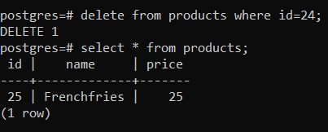

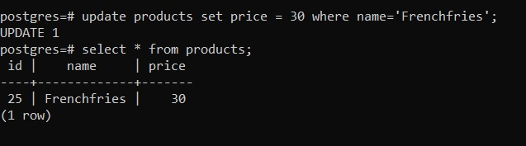



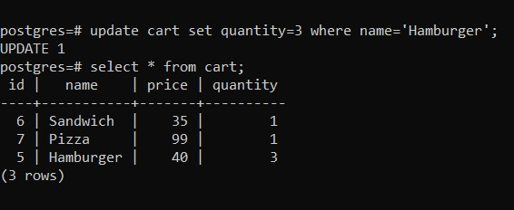

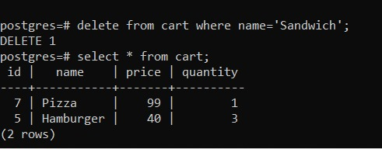

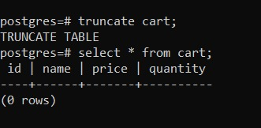



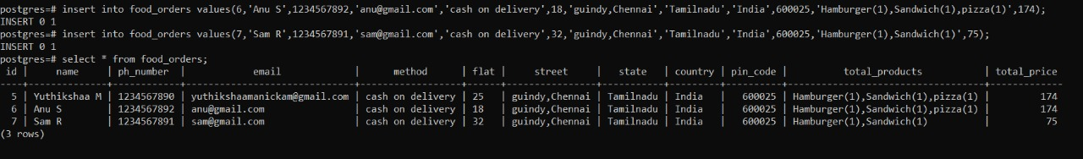

**WEBPAGE:**

**ADD A NEW PRODUCT**

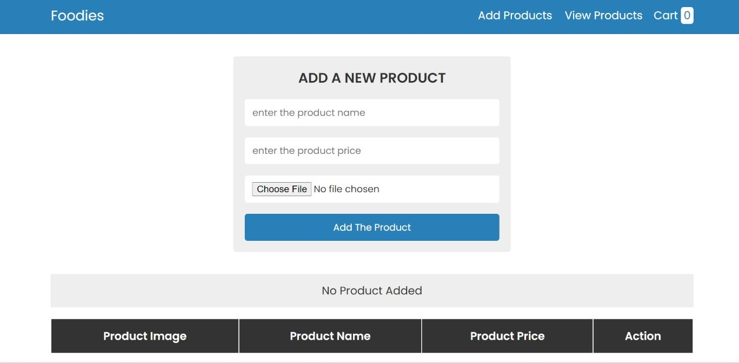

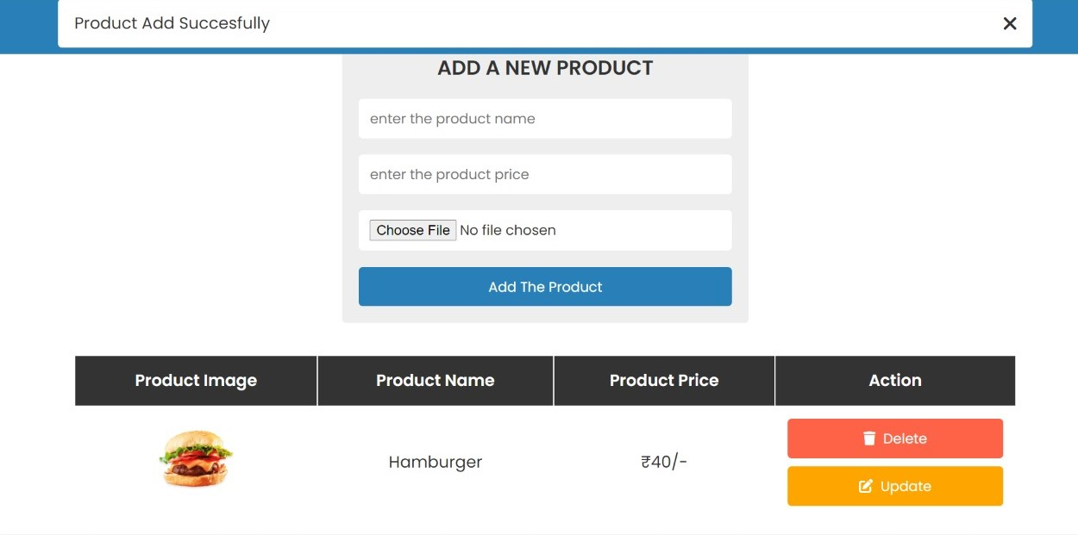

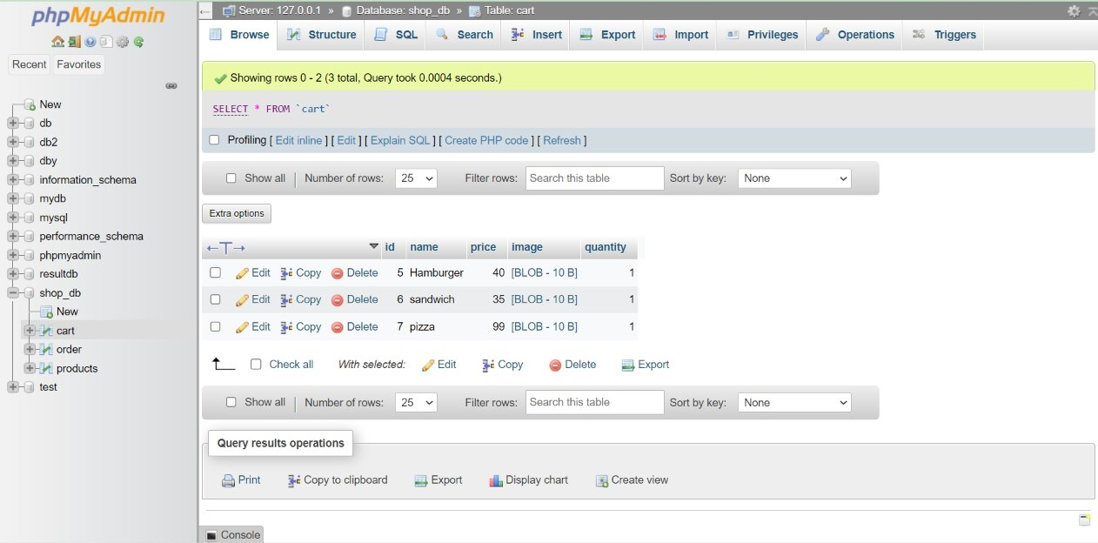

**SHOPPING CART**

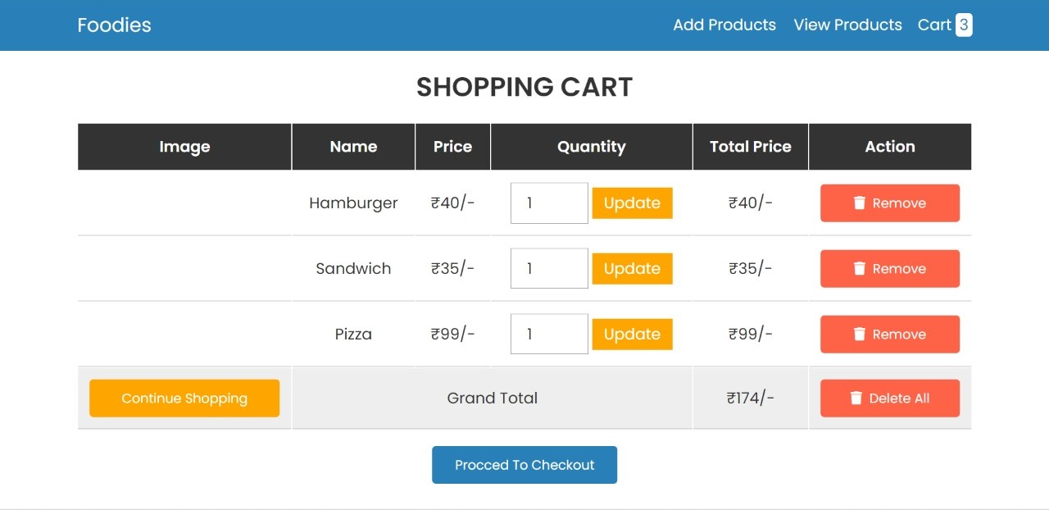

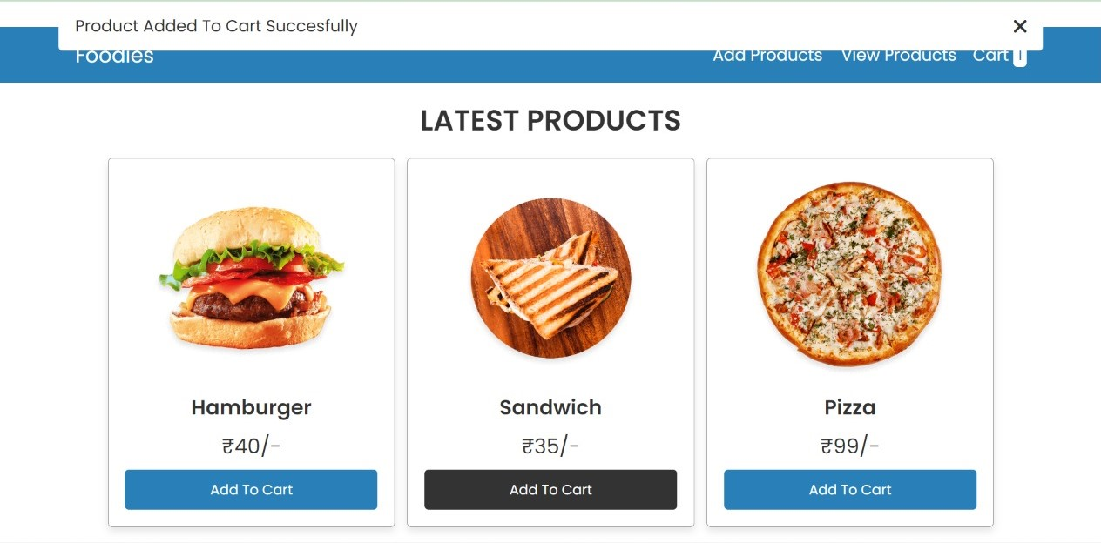

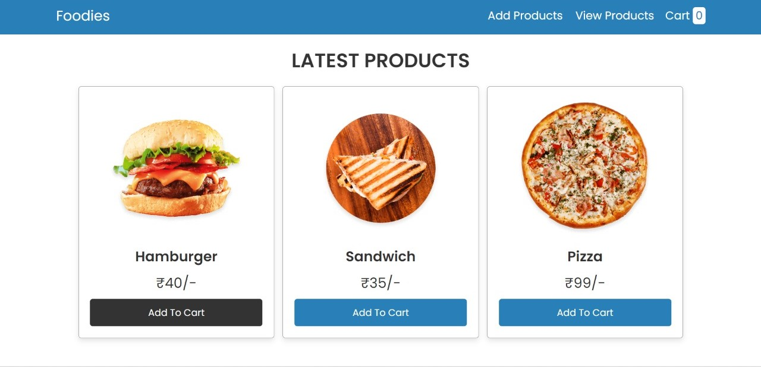

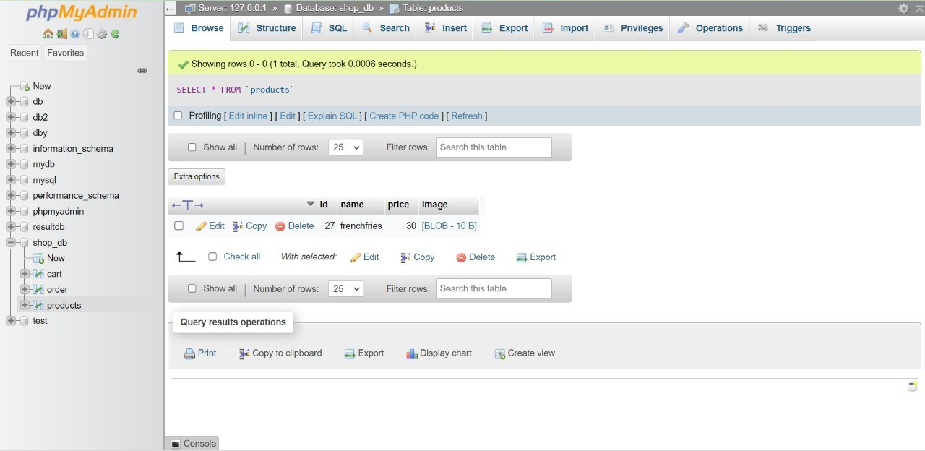

**ADD A NEW PRODUCT**

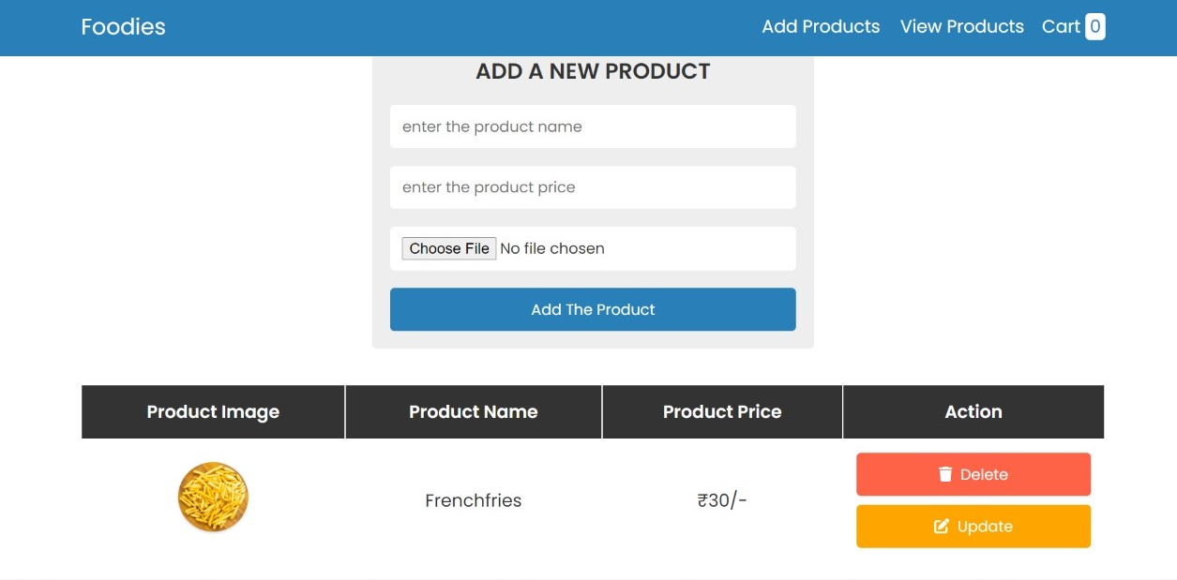

**UPDATE THE PRODUCT**

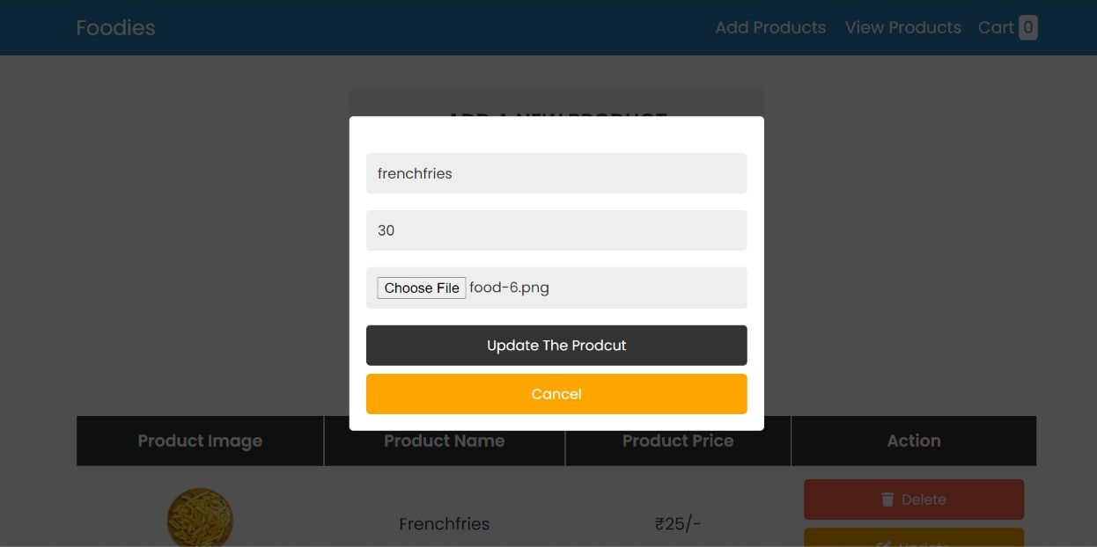

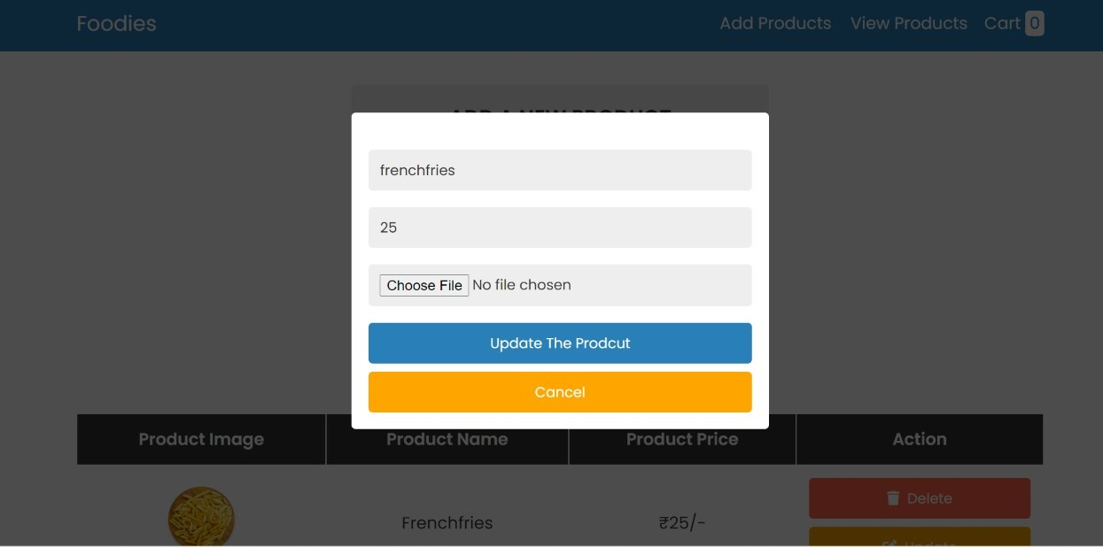

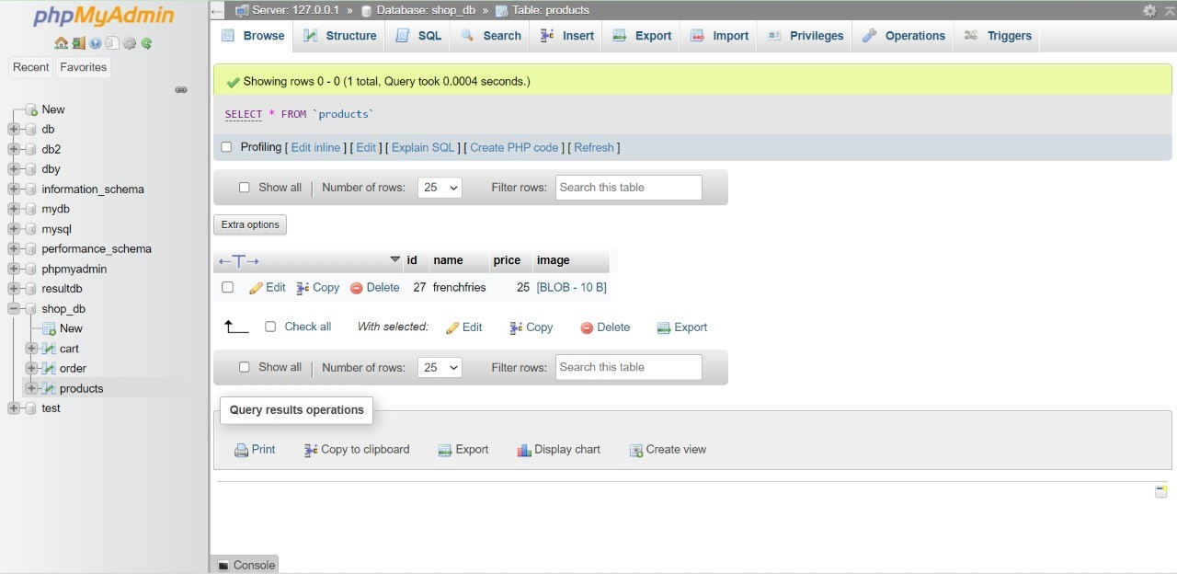

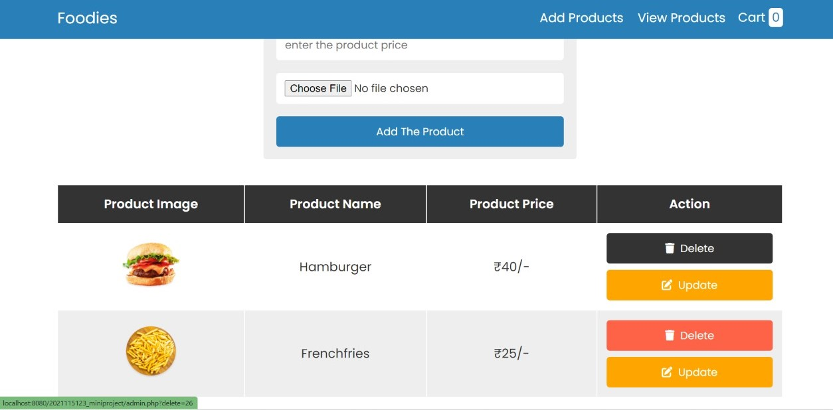

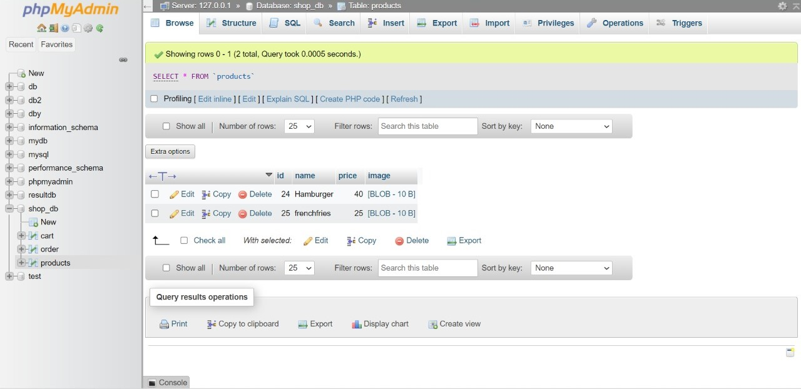

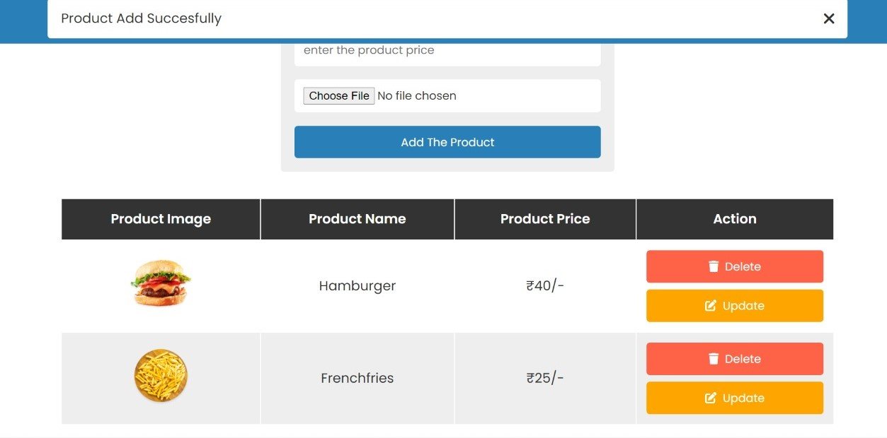

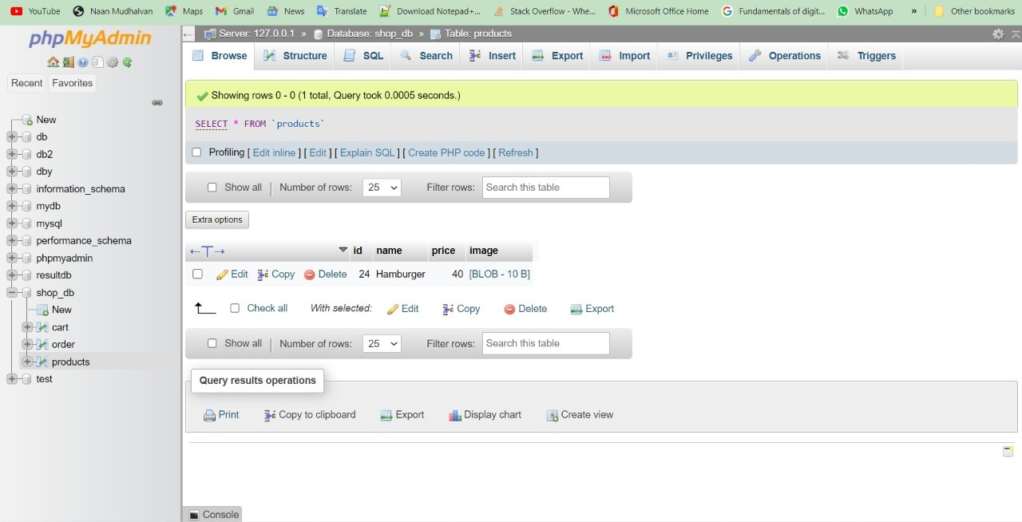

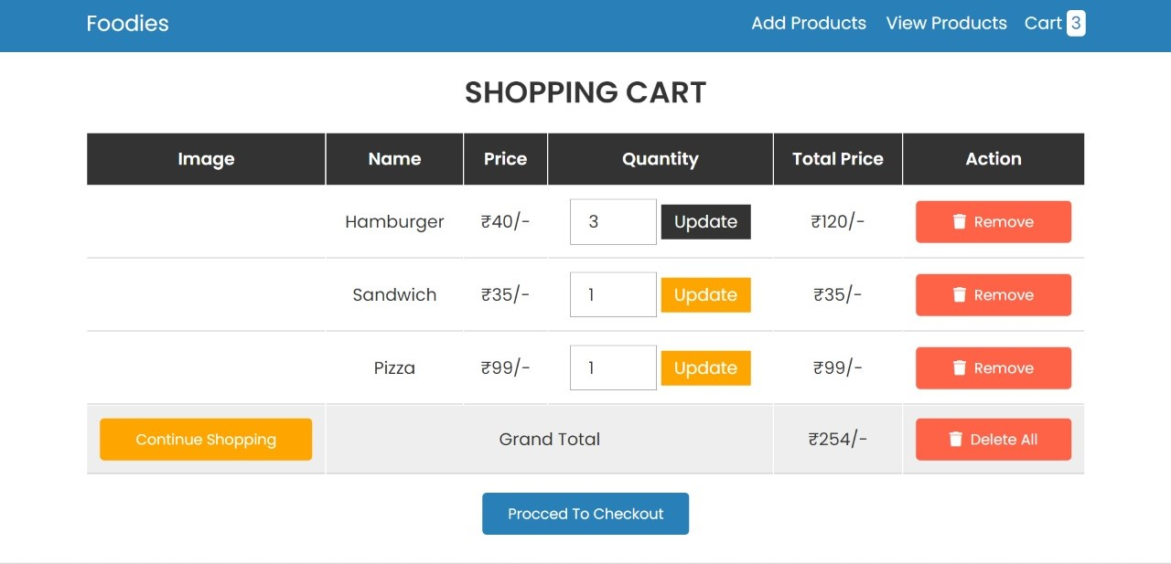

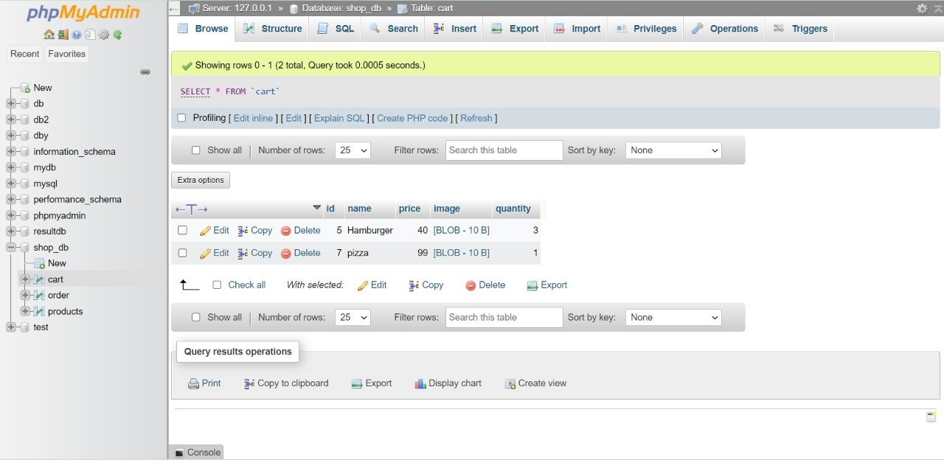

**REMOVE THE PRODUCT**

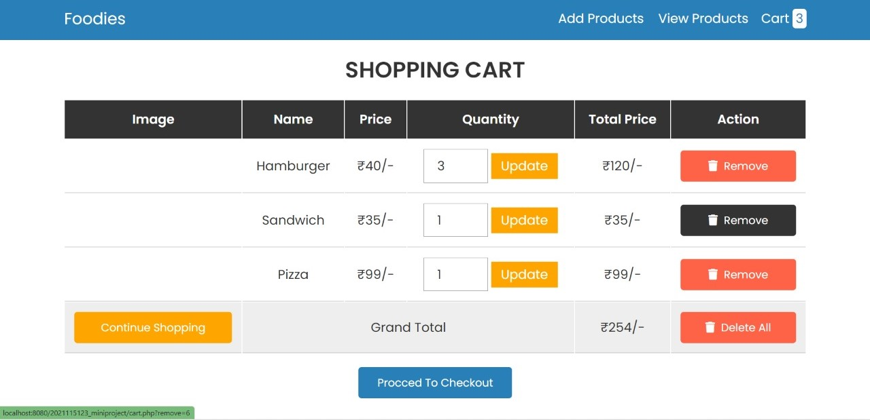

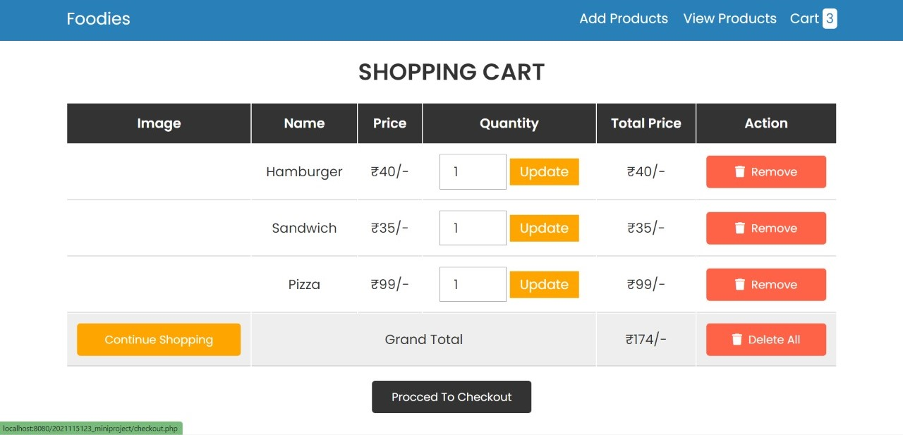

**CHECKOUT**

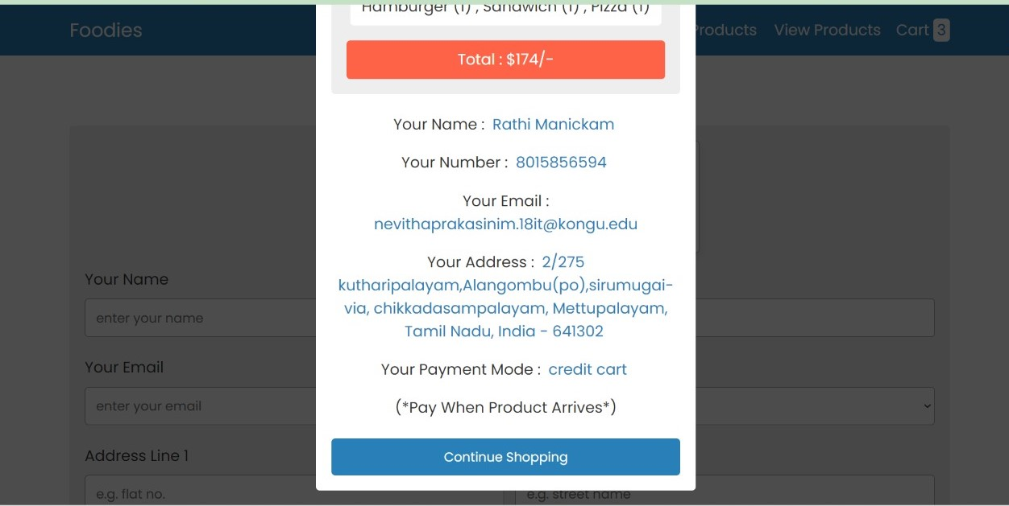

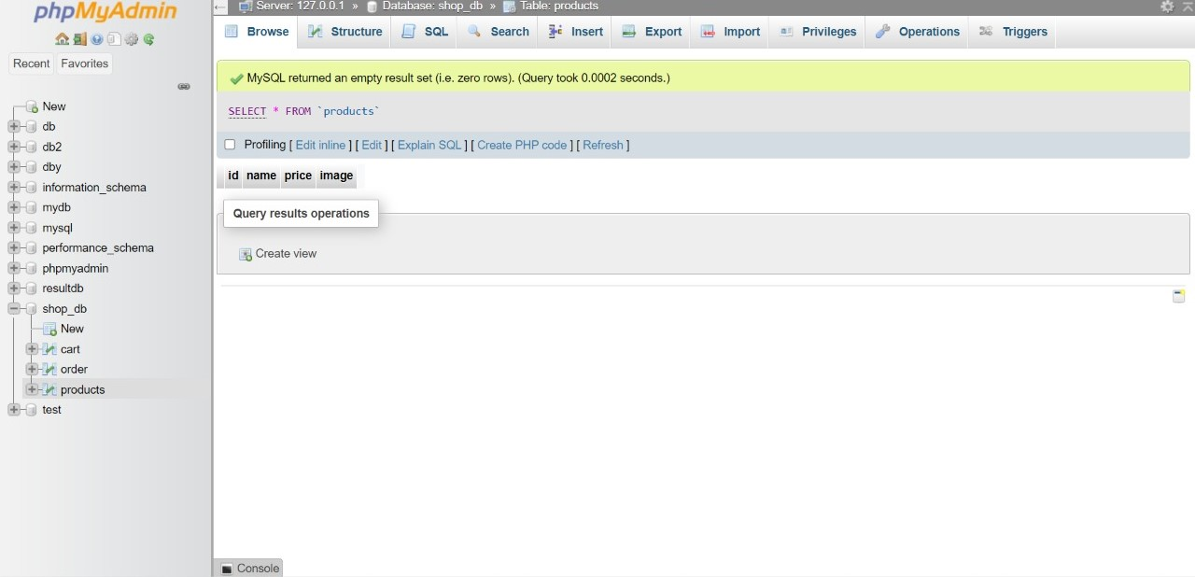

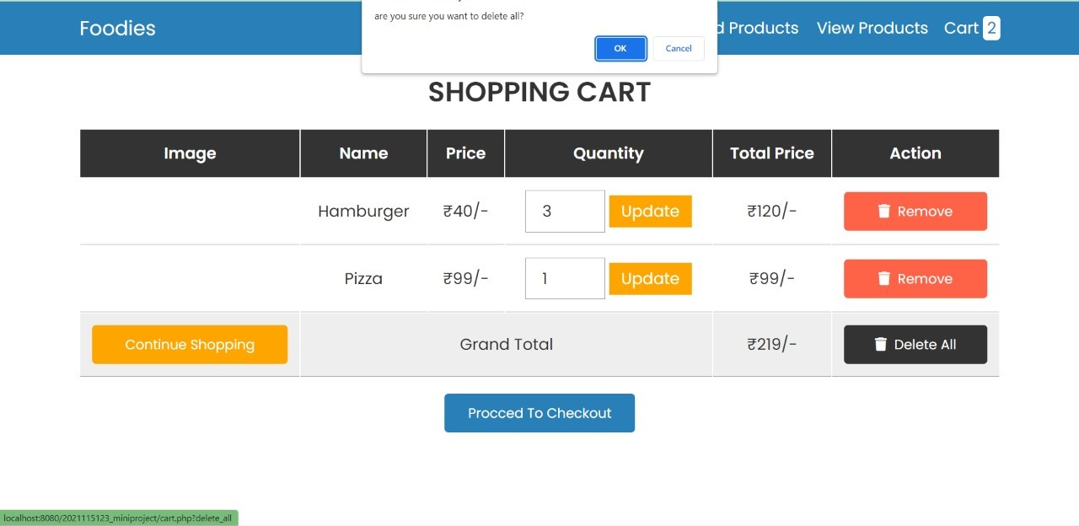

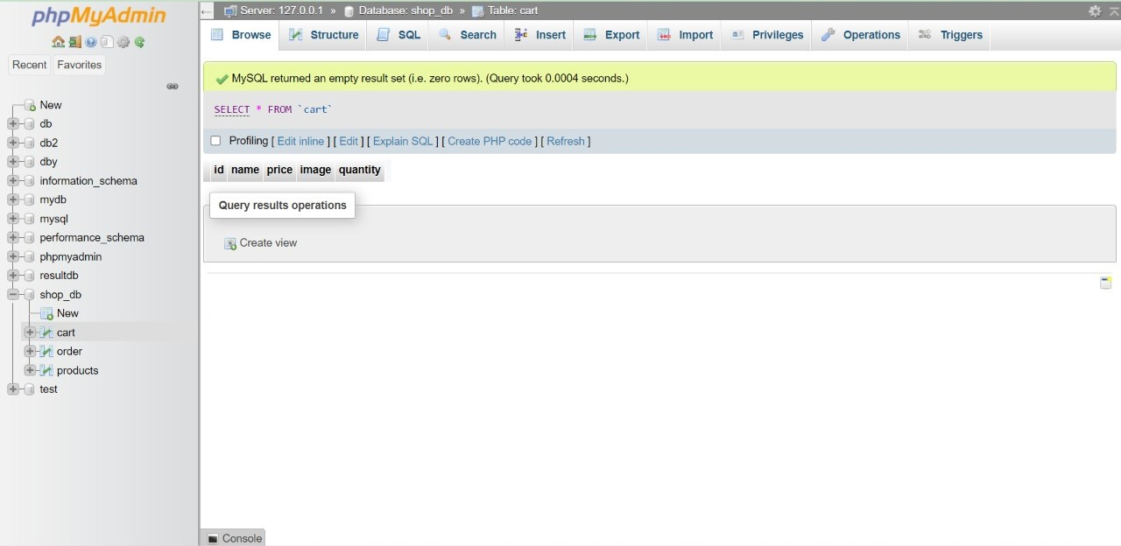

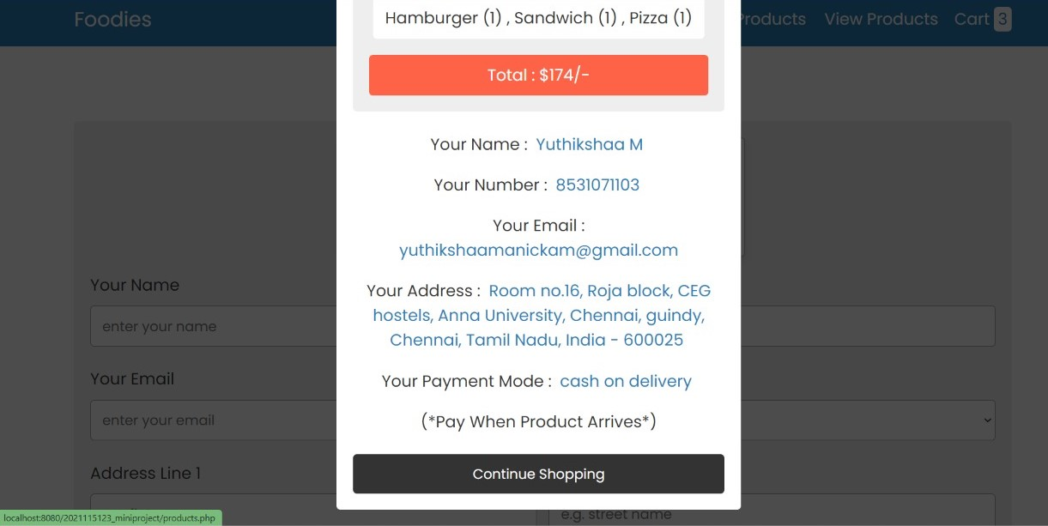

**ADDING CUSTOMER INFO**

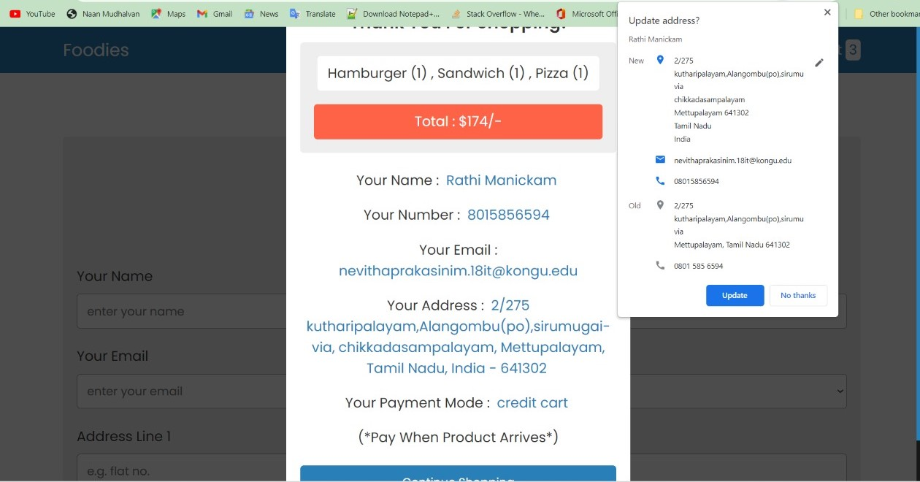

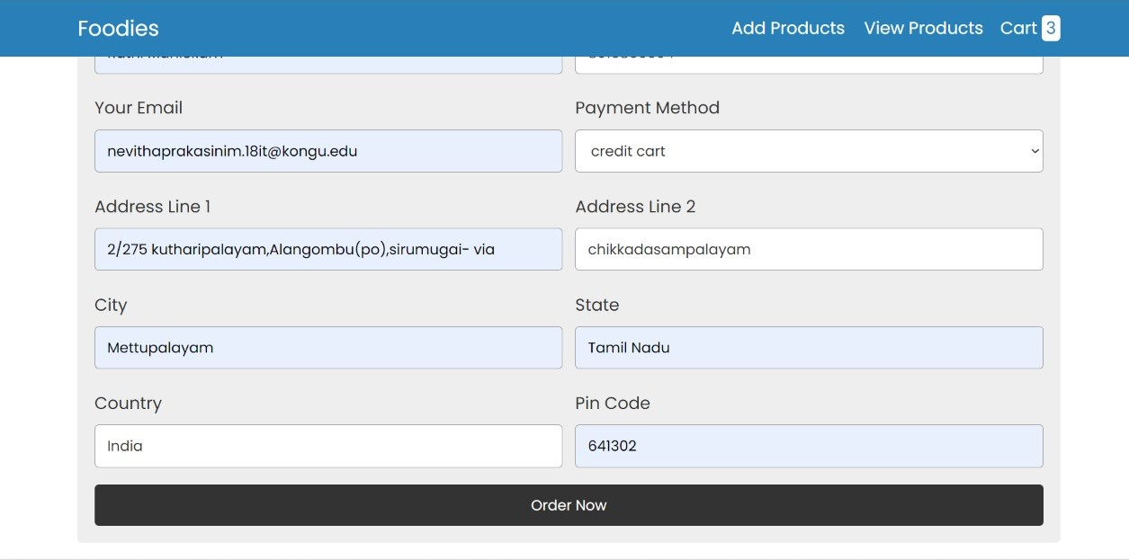

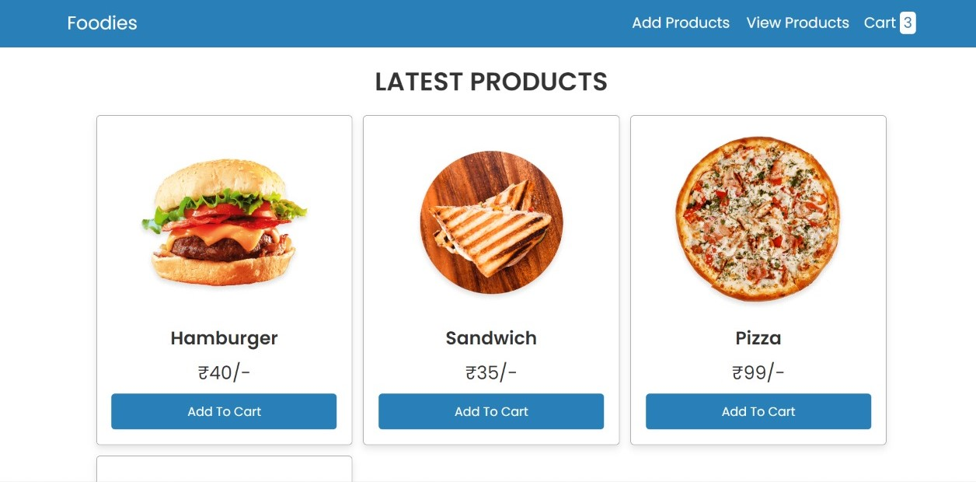

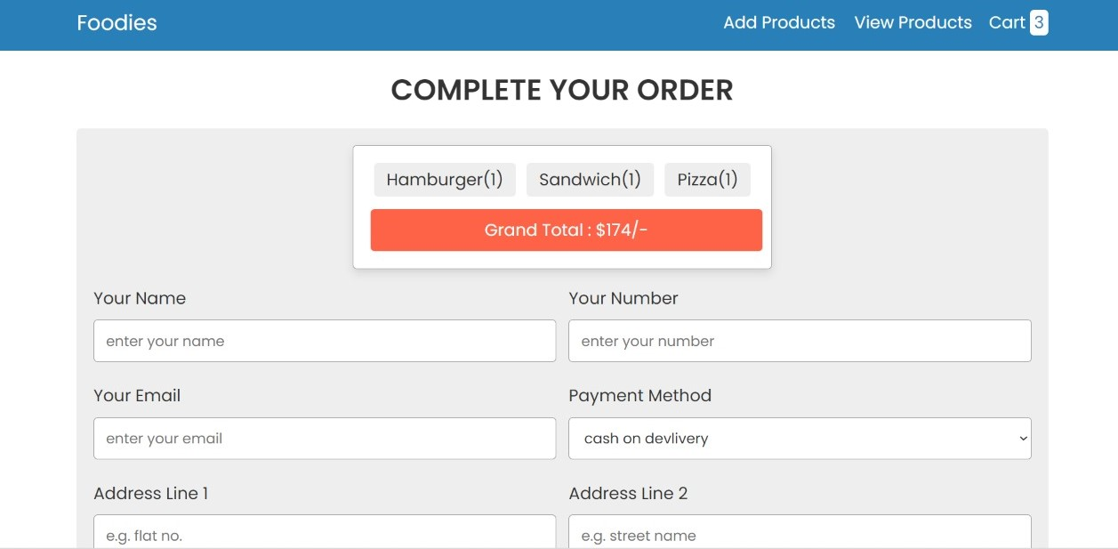

**COMPLETING THE ORDER**

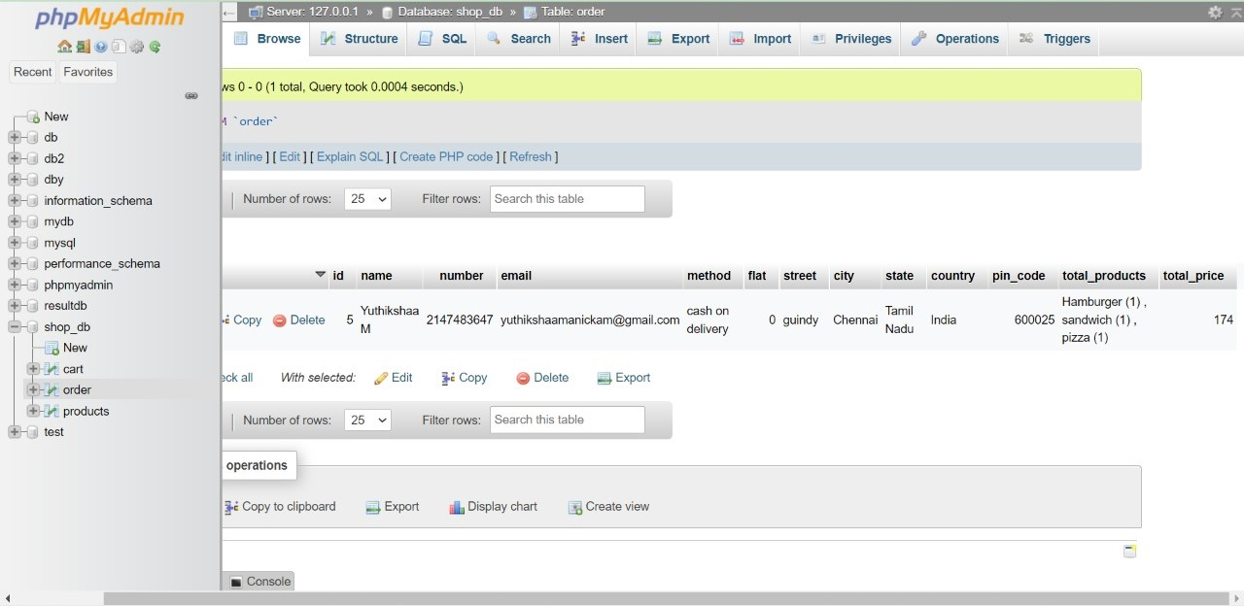

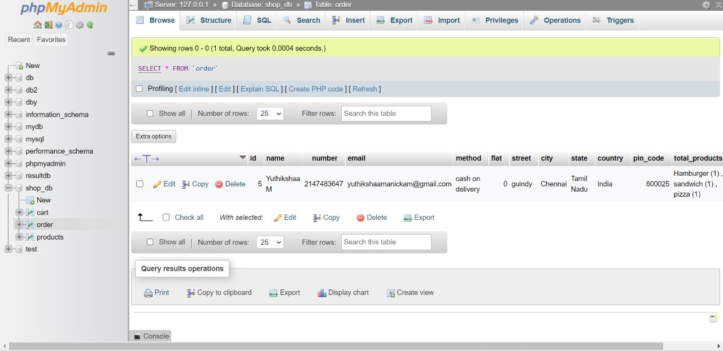

**CONCLUSION:**

*To conclude the description about the project, the project, developed using php with the database is based on the requirement specification of a user and the analysis of the existing system ,with flexibility for future enhancement. Based on the result of this research, it can be concluded: It helps customer in making order easily; It gives information needed in making order to customer. With online food ordering system, a restaurant and mess online can be set up and the customers can easily place order.*

*The database connections are made to make the website more effective and make it simple for the users. Hence this software project has been developed to fulfil the academic learning in DBMS Semester 3.*

**BIBLIOGRAPHY:**

1. Kirti Bhandge, Tejas Shinde, Dheeraj Ingale, Neeraj Solanki, Reshma Totare - “A Proposed System for Touchpad Based Food Ordering System Using Android Ap[lication” .
2. Patel Krishna, Patel Palak, Raj Nirali, Patel Lalit - “Automated Food Ordering System” .

**CONTRIBUTIONS:**

1. *Frontend Developing -Ezhil Oviya C*

*Yuthikshaa M*

*Sumathi K*

1. *Backend Developing – Ezhil Oviya C*

*Yuthikshaa M*

*Sumathi K*

1. *Database Table Creation – Yuthikshaa M*
2. *Hardware Copy Designing – Ezhil Oviya C*