**A NOVEL MACHINE LEARNING APPROACH**

**TO PREDICT THE BAND GAP OF BINARY COMPOUNDS**

A thesis submitted in partial fulfilment of the requirements for

the award of the degree of

**B.Tech**

**in**

**Metallurgical and Materials Engineering**

By

**Anantha Natarajan S (112112008)**

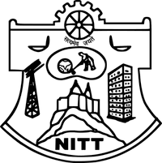

**DEPARTMENT OF METALLURGICAL**

**AND MATERIALS ENGINEERING**

**NATIONAL INSTITUTEOF TECHNOLOGY TIRUCHIRAPALLI-620015**

**MAY 2016**