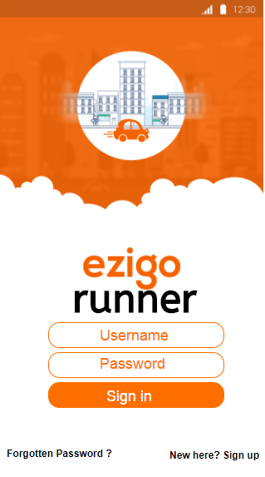 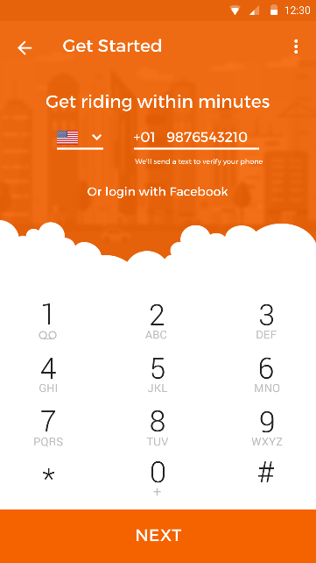 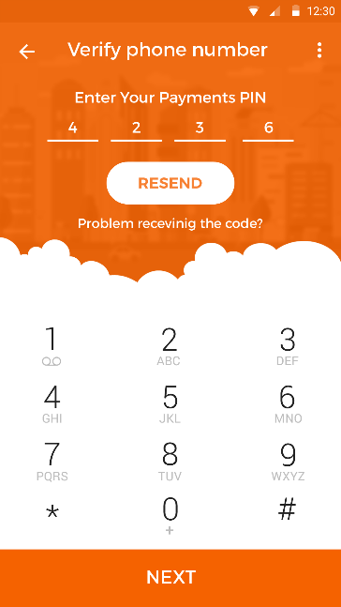 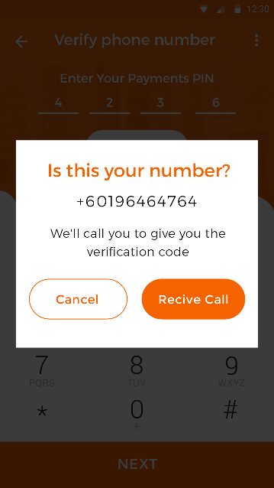 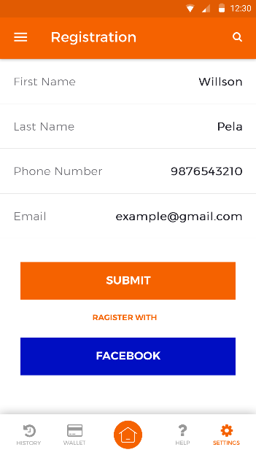

If not get OTP number

* Verify via call (get OTP)

Flash screen

* Username
* Password
* Sign in
* Sign up
* Forgotten password

Register detail

* Name & email

Verify phone number

* Enter OTP number

Phone number registration

* Get OTP number

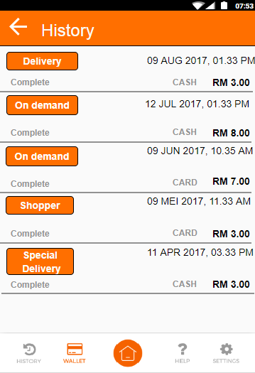 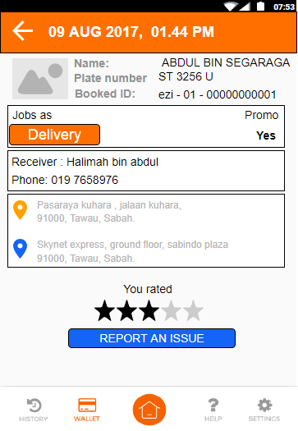

order history detail

order history

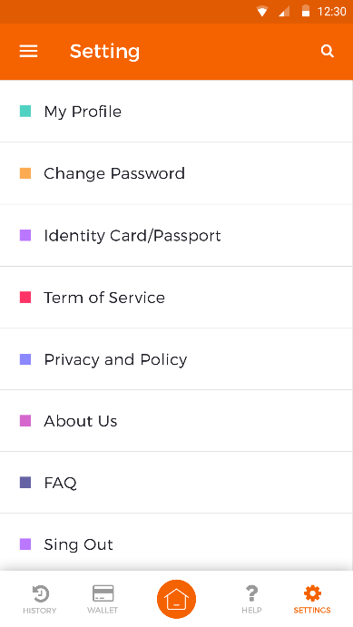 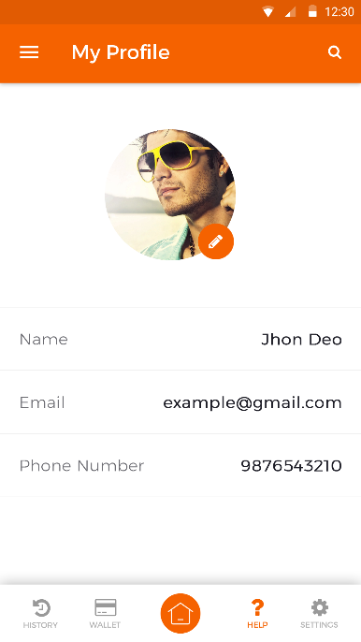 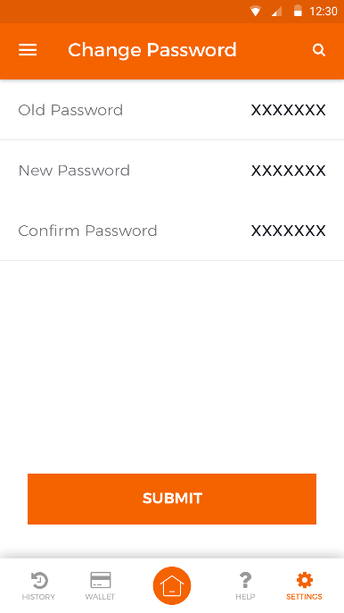 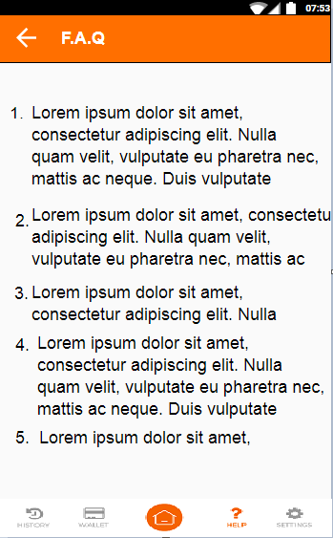 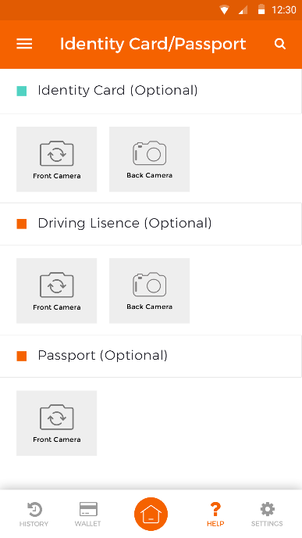

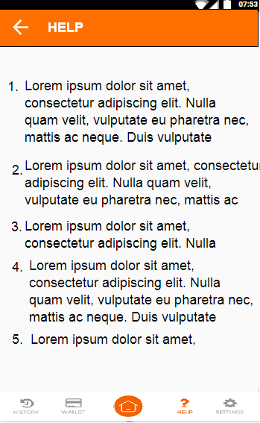 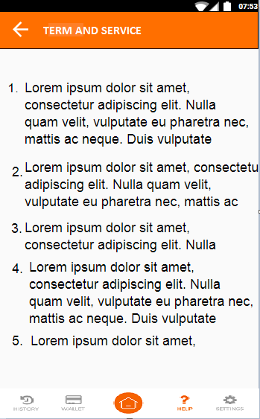

Same with FAQ

* Detail will make in dashboard admin
* Address company
* Phone company
* Email company

Same with FAQ

* Detail will make in dashboard admin

Advertisment(screen can slide) 3 -6 advertisment

* Add can be add from dashboard admin
* Can be link to advertise screen

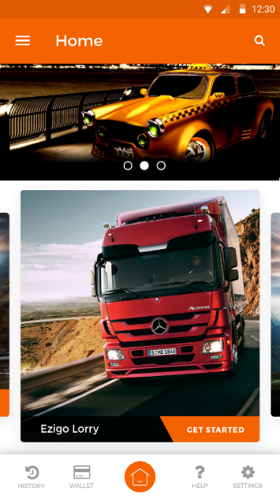other

Other screen (screen can slide)

* Can be add more module if this first (runner) module success
* It will be 14 modules more
* Ezigo car
* Ezigo lorry
* And etc.
* If not ready yet just keep the slide “coming soon”

Ezigo (screen can slide)

* Can be add more module if this first (runner) module success
* It will be 14 modules more
* Ezigo car
* Ezigo lorry
* And etc

Home screen

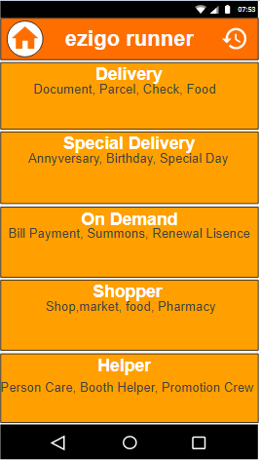 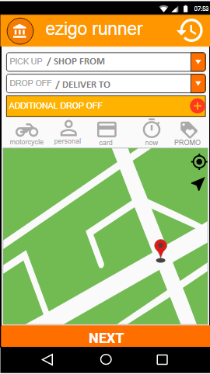 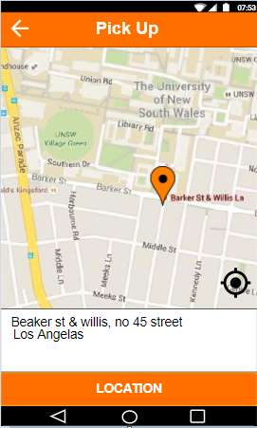 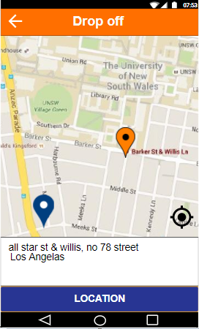

Address:

Pin the point to address

Or

ENTER

1. Address
2. Building
3. Street
4. postcode

* Shopper

1. Address(Shop/restaurant)
2. Drop off

* Helper

1. Address (work places)

# can add on till 4 drop off address

* Invisible if only one drop off
* Visible when additional drop off

After select the service, set the address:

* Delivery

1. Pick up
2. Drop off
3. Addition drop off

* Special delivery

1. Address (Pick up/shop)
2. Drop off

* On demand

1. Pick up
2. Drop off
3. Addition drop off

Select the service, either:

* Delivery
* Special delivery
* On demand
* Shopper
* Helper (out off the app)

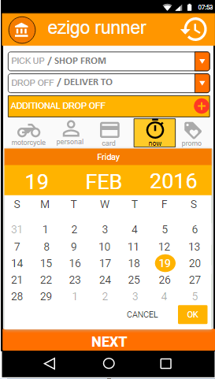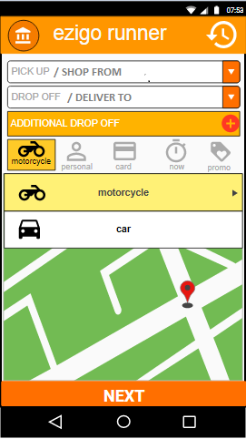 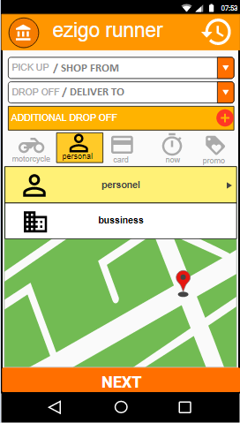 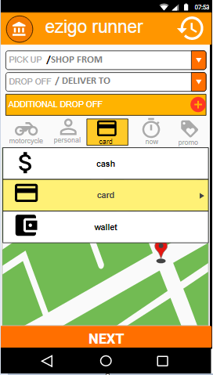 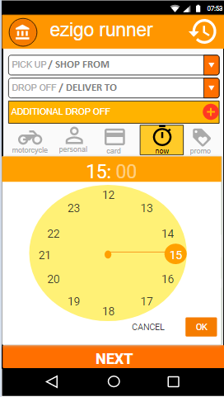

select type vehicles

(different price)

* Motorcycle
* Car
* First 3 KM (RM 3.00)
* Every KM (RM 0.60)
* Prices set at dashboard admin

select when the job was needed?

* Now
* Later

Choose date and time

select type payment

* cash
* card

select type jobs

* Personel
* company

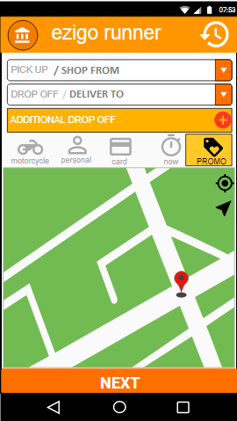 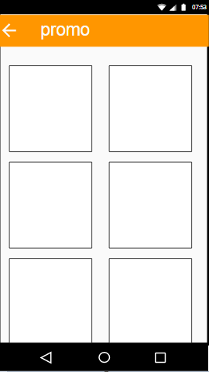

select if there is any promo available

* Promo will be set at dashboard

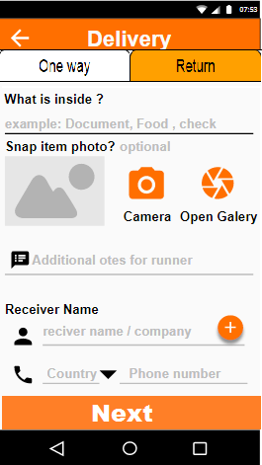 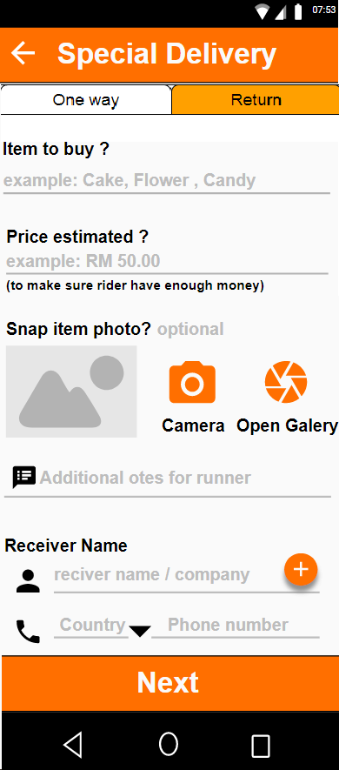 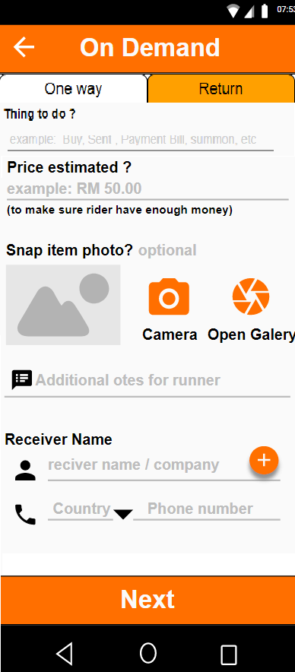 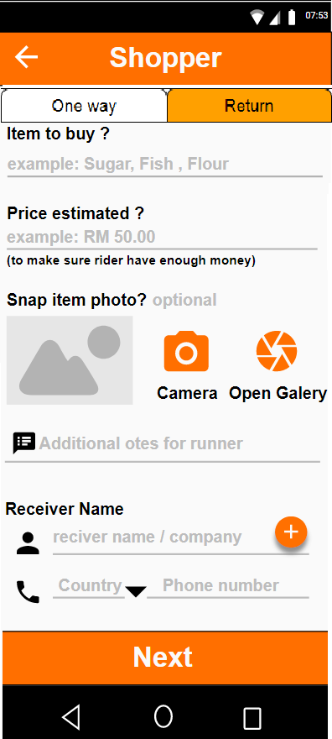 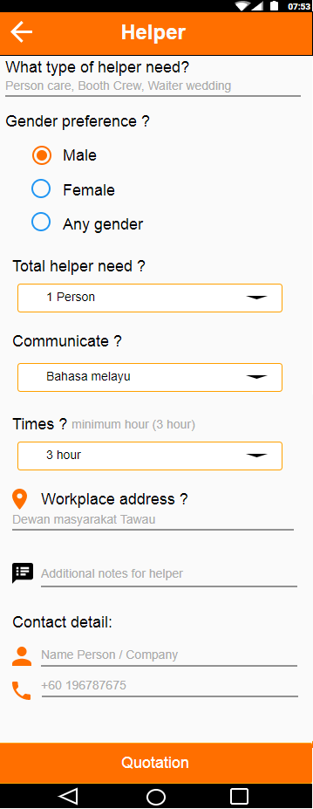

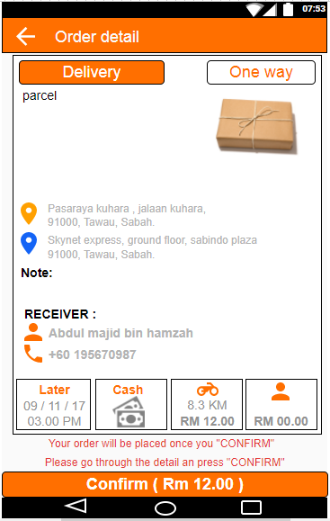 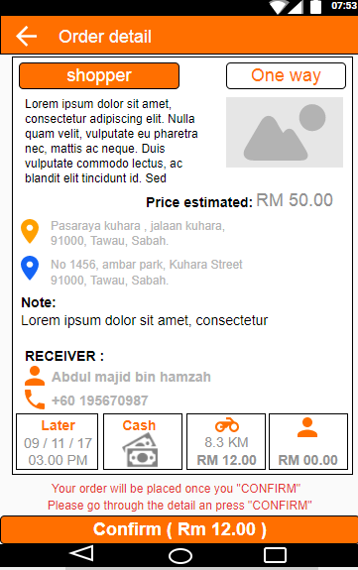 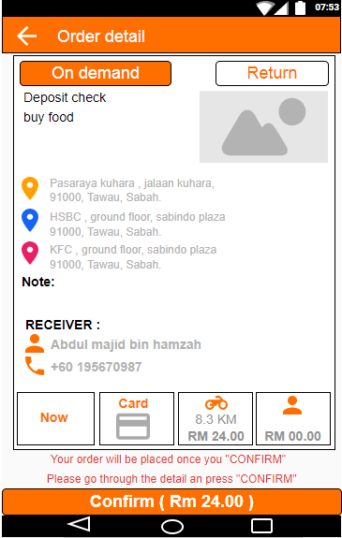

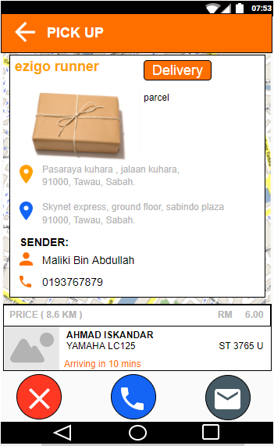 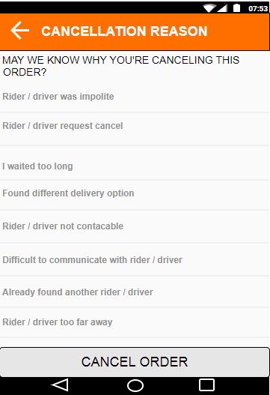 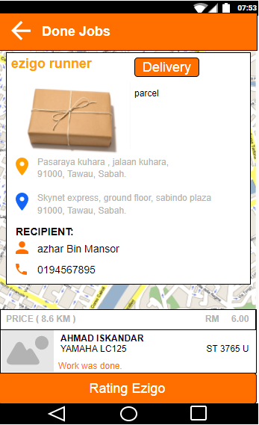

If payment use card (debit or credit)

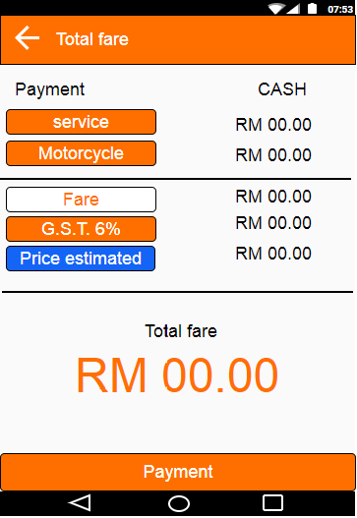 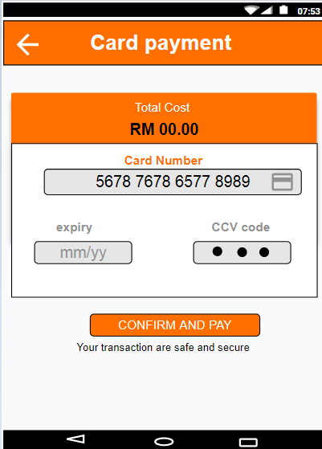 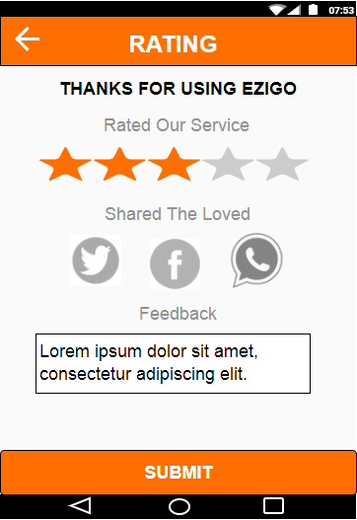

G.S.T = 6% FARE (TAX)

Fare =Service + distance

Motorcycle/ car

* Price for distance

Service

* Delivery
* Special delivery
* On demand
* Shopper
* helper

TOTAL FARE = ALL SUM

Will get total price after runner key in the price into rider apps

* After payment settled. customer need to give rating for service.
* The rating for the runner will be total in dashboard and driver apps.