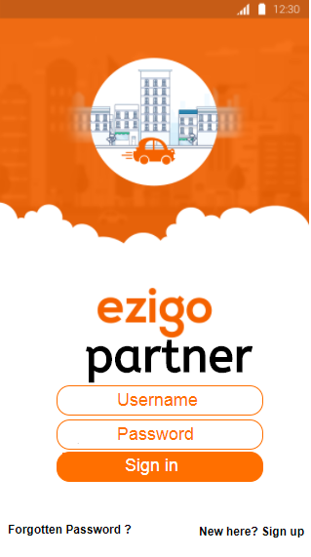 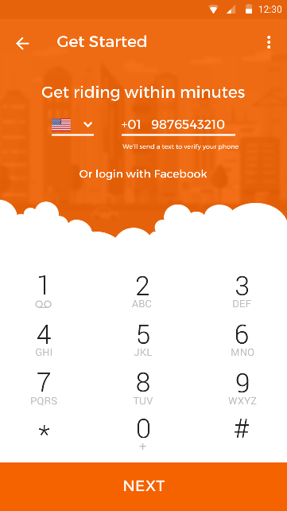 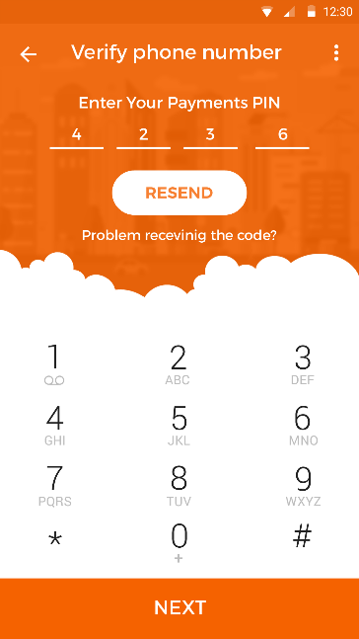 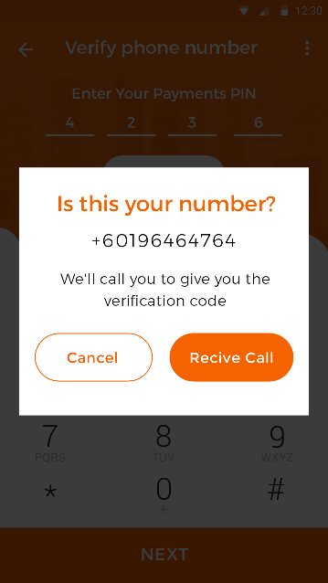 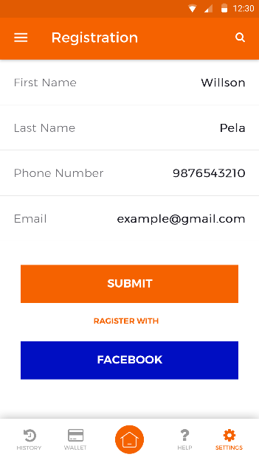

Flash screen

* Username
* Password
* Sign in
* Sign up
* Forgotten password

Register detail

* Name & email

Phone number registration

* Get OTP number

If not get OTP number

* Verify via call (get OTP)

Verify phone number

* Enter OTP number

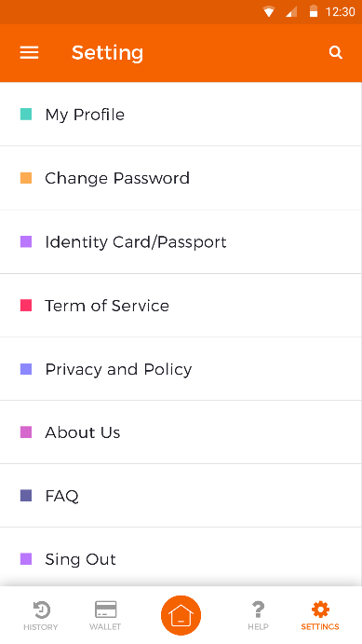 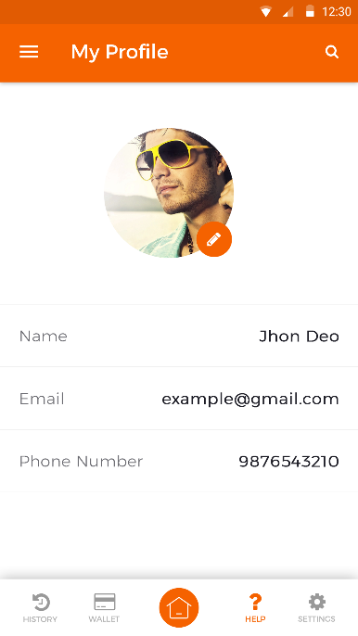 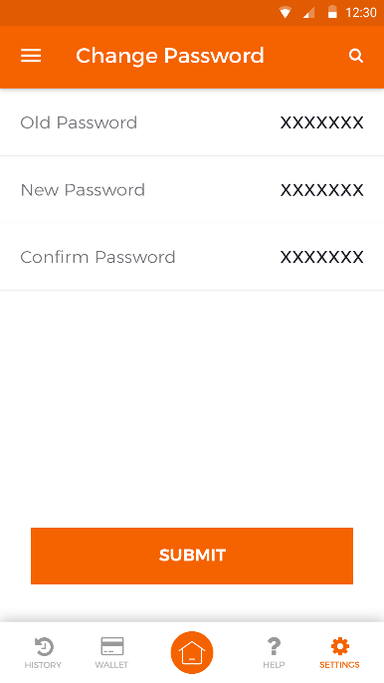

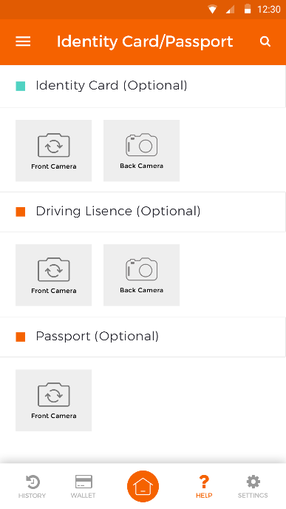 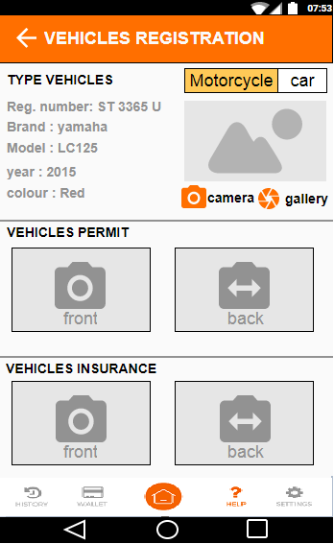

Upload/entry / capture / scan

* Type of registery vehicles
* Registry/plate number
* Brand
* Model
* Year
* Colour
* Vehicle permit
* Scan /capture the document
* Vehicle permit
* Scan /capture the document

Upload/ capture / scan

* Identity card
* Driving lisence
* Passport

Both front page & back page

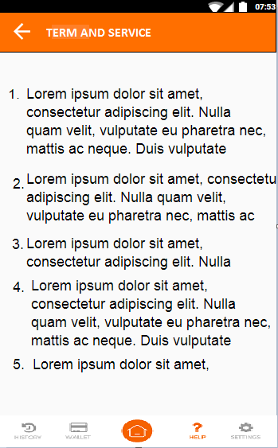 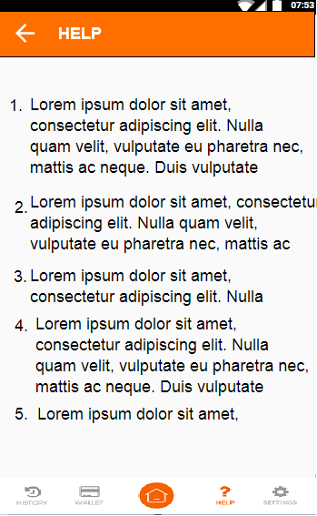 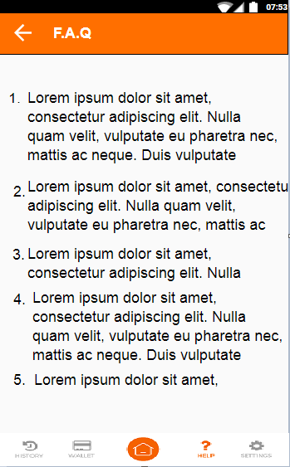

FAQ/HELP/TERM AND CONDITION

* Same with custumer app
* Setting be done in admin panel

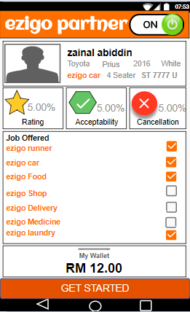 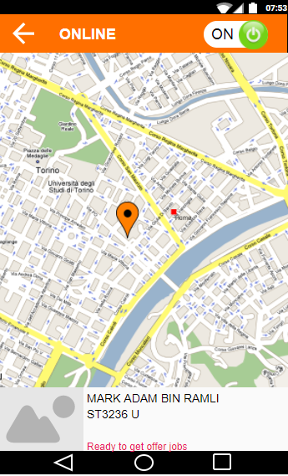

Personal detail

* Name
* Registry/plate number
* Brand
* Model
* Year
* Color

Cancelation rate

Acceptable rate

runner rating by customer

On/off button

* **ON** (ready to online an detectable by custumer)
* **OFF**(offline not detectable)

**Notification:**

Online screen

* State where are you at that time
* Ready to get job

Job offered:

* Thick acceptable job offer by
* Untick if don’t want to get offer

notification

* offer
* newsfeed
* information

My wallet

* Must have money here to get job
* Minimum RM 20.00.
* Money will Auto deduct 25% if runner get cash payment
* Runner need to get job

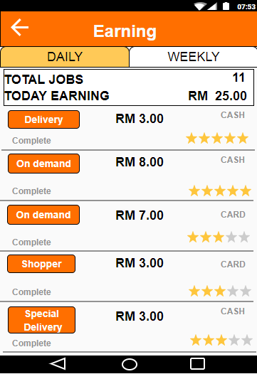 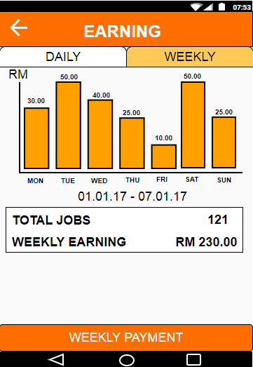 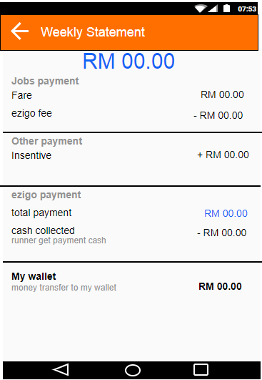

Money transfer to bank detail.

Money transfer weekly

Admin panel will make auto transfer but left some money in wallet.

Minimum money will set

History of job complete

* How much earning weekly with the detail

History of job complete

* How much earning daily with the detail

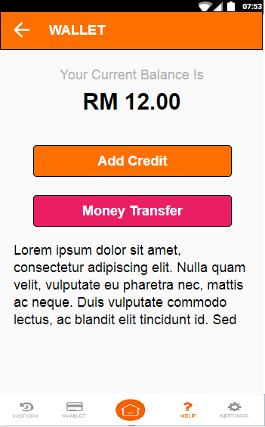 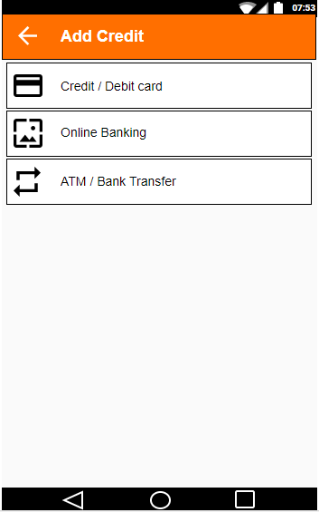 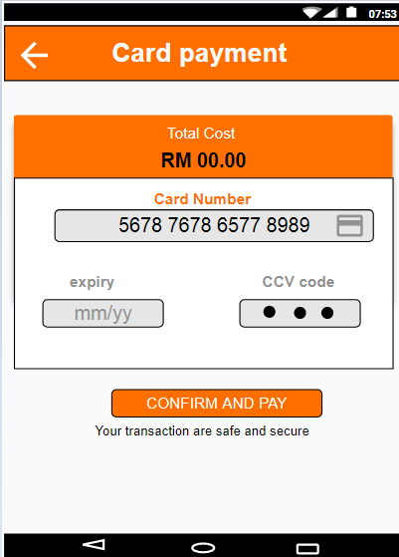

My wallet

* Add credit
* Money transfer

Type of money top up

* Debit/ credit card
* On line banking.
* ATM

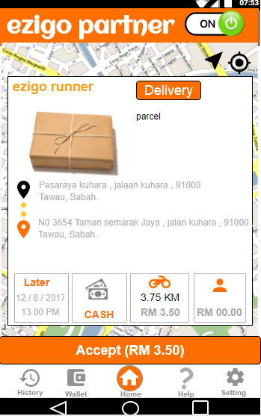 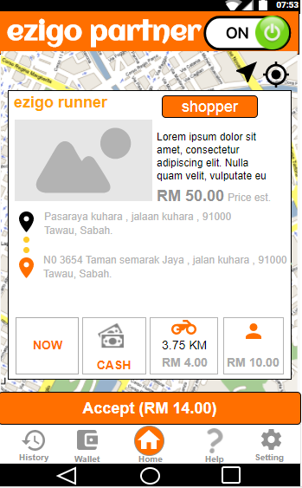 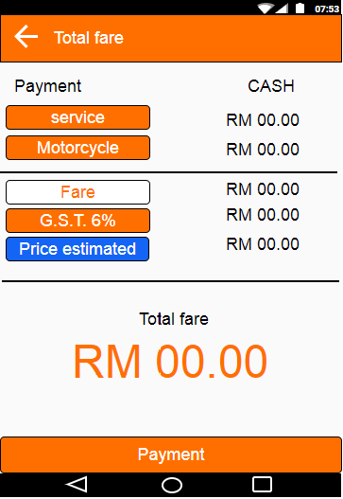

TOTAL FARE = ALL SUM

Will set by runner and send to customer

PRICE ESTIMATED

* Price to buy order
* Will add on in final after buying order

G.S.T = 6% FARE (TAX)

Fare =Service + distance

Motorcycle/ car

* Price for distance

Service

* Delivery
* Special delivery
* On demand
* Shopper
* helper

Get offer by customer app.

* Runner will accept the offer
* Runner have 15 second to accept offer
* If not accept in that time.
* Offer will go to nearest Runner
* If not acceptable for five runners. Will auto accept and ezigo admin will search nearest runner

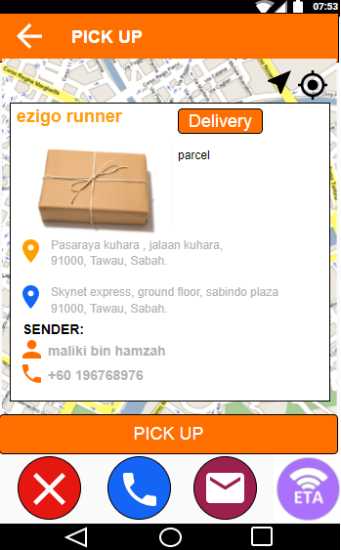 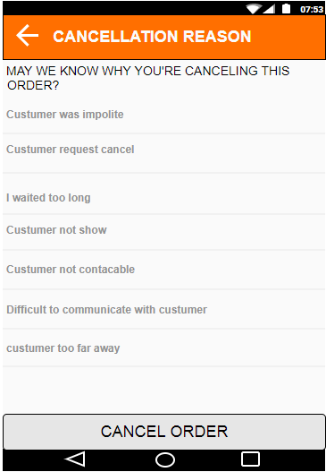 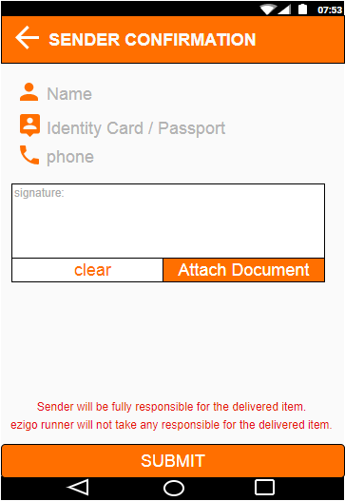

After arrive and get the item

* Runner ask for confirmation signature by sender
* Name
* Number identity card
* Phone number

cancel screen

After accept job

The screen change to pick up screen

* Cancel button
* Phone button
* Message button
* ETA (location runner and how long it takes time to reach customer)

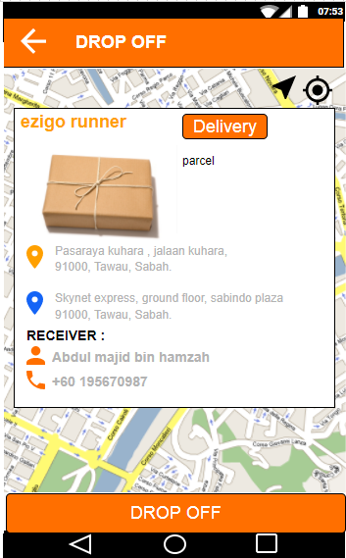 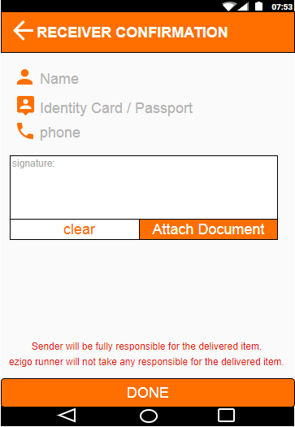

Drop off screen

* The item was in progress to destination
* When achieve the destination runner will find the customer by phone or message.

After drop off the item

* Runner ask for confirmation signature by receiver
* Name
* Number identity card
* Phone number