Ezm Smailah M. Basoc

TM191/HRO191

What is Flowchart & Pseudocodes?

***Flowcharts*** are written with program flow from the top of a page to the bottom. Each command is placed in a box of the appropriate shape, and arrows are used to direct program flow. The following shapes are often used in flowcharts:

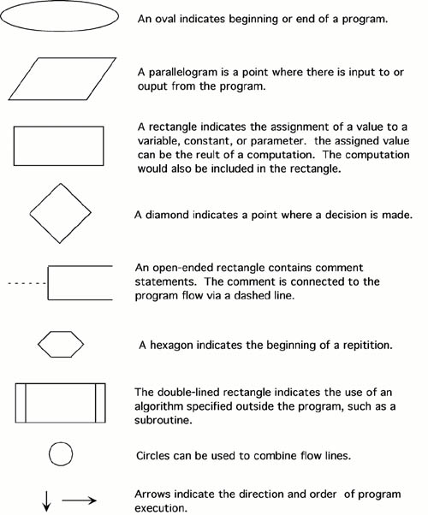

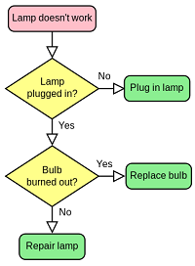***Pseudocode*** is a method of describing computer algorithms using a combination of natural language and programming language. It is essentially an intermittent step towards the development of the actual code. It allows the programmer to formulate their thoughts on the organization and sequence of a computer algorithm without the need for actually following the exact coding syntax.

**Pseudocode and its importance**

(Jackson, 2017) Pseudo coding is the process of using comments in your code in order to keep track of what is actually going on. Pseudo coding allows not only the person writing the code, but also the reader, to understand what's happening inside of the code.

**Why are flowcharts and pseudocode needed?**

(Techwalla, 2019) **Flowcharts** provide an easy method of communication about the logic and offer a good starting point for the project because they are easier to create than **pseudocode** in the beginning stages. **Pseudocode** provides a beneficial bridge to the project code because it closely follows the logic that the code will.

# References

Jackson, D. (2017). Pseudocode and its importance. *M*. <https://medium.com/@andremj013090/pseudocode-and-its-importance-5f71e38a0d95>

<http://www.owlnet.rice.edu/~ceng303/manuals/fortran/FOR3_3.html>