1.

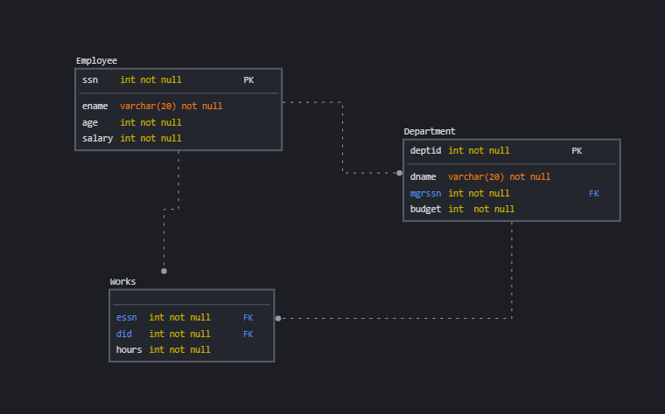

2. primary key,not null,foreign key

3. alter table Employee add check( age>25);

4.

a.

|  |  |
| --- | --- |
| Ray Diaz | 89000 |
| Phylliss Bonacci | 55000 |
| Bryan Decimali | 65000 |

b.

|  |  |  |  |
| --- | --- | --- | --- |
| Software | Phyllis Bonacci | 678000 | 55000 |
| Hardware | Ray Diaz | 531000 | 89000 |
| Firmware | Ray Diaz | 420000 | 89000 |
| Sleepware | Hiram Pottanoose | 88000 | 100000 |

c.

|  |  |
| --- | --- |
| Hardware | 89000 |
| Firmware | 232000 |
| Software | 120000 |
| Sleepware | 165000 |

5.

a.

|  |  |
| --- | --- |
| Nathan Logg | 42 |
| Phyllis Bonacci | 34 |
| Bryan Decimali | 32 |

|  |
| --- |
| Bryan Decimali |
| Nathan Logg |

b.

c.

|  |  |
| --- | --- |
| Phylliss Bonacci | 678000 |

6.

select dname,sum(salary) from Employee inner join Works on ssn=essn inner join Department1 on deptid=did where hours>=20 group by deptid,dname;

7.

while(!isempty(rs.ename))

8.

Bunun üçün əlavə supervisor cədvəli yaradardım və bunu employee cəvəli ilə əlaqələndirərdim.