Apache Solr Open Ended Lab Report
Indexing, Importing and Searching Data in Apache Solr
Faculty | Faculty of Computing
Course Code | CS-347
Class | BSCS-13AB
Lab Title | Lab 13 Open Ended Lab
Prepared On | 08 May 2026
Project Folder | C:\Users\hts\Downloads\PDC-OEL

This report presents a complete Apache Solr implementation built around a research article discovery portal. The work includes SolrCloud collection creation, schema design, dataset indexing, query experimentation, a responsive web search interface, and a final analysis of performance and search quality.

Problem Statement
The objective of this lab was to design and implement a practical Solr based search solution using a self selected real world style dataset. The system needed to support indexing, flexible search queries, filtering, sorting, faceted navigation, highlighting, and a web based interface suitable for interactive searching.
Dataset Description
A curated dataset of eighteen research articles was created to simulate a university or enterprise research portal. This dataset was selected because it contains both descriptive metadata and meaningful searchable text, making it suitable for demonstrating full text retrieval as well as structured filtering.
Field | Type | Purpose
title | text_general | Main searchable heading with higher boost during query time
abstract | text_general | Body text used for contextual matching and highlighting
authors | text_general multivalued | Author names included in search scope
category | string | Exact facet and filter field
year | pint | Numeric sorting and filtering
venue | string | Exact source or publication venue
document_type | string | Document classification for filtering
keywords | text_general multivalued | Supplementary topical vocabulary
citations | pint | Ranking support for popularity based sorting
access_type | string | Access control facet such as Open Access or Subscription
all_text | text_general | Copy field used to improve recall across combined content
Configuration Details
The collection named research_portal was created in SolrCloud mode with 2 logical shards and a replication factor of 1. The default configset was extended through the Schema API so that text fields, exact filter fields, and numeric sort fields were explicitly defined instead of depending on automatic field inference.
Configuration Item | Value
Collection mode | SolrCloud on a single local node
Shard count | 2
Indexed documents | 18
Schema strategy | Explicit fields with copyField into all_text
Autocomplete approach | Terms based title suggestions through the web proxy
Frontend stack | Vanilla HTML, CSS, JavaScript served by a lightweight Node server
Implementation Steps
The implementation was automated through local scripts so the system could be reproduced consistently. The setup script created the collection and schema, the indexing script imported the dataset, the query script saved representative result sets, and the analysis script measured query responsiveness.
Step | Command or Action
Start Solr | solr.cmd start -p 8983
Create collection and schema | powershell -ExecutionPolicy Bypass -File scripts\setup_solr.ps1
Index research dataset | powershell -ExecutionPolicy Bypass -File scripts\index_data.ps1
Export query outputs | powershell -ExecutionPolicy Bypass -File scripts\run_queries.ps1
Measure query timings | python scripts\analyze_results.py
Launch web interface | node web\server.js
Search Experiments and Results
Several search experiments were executed to demonstrate plain keyword search, filtered retrieval, faceted exploration, sorting by citation count, and visual term highlighting. The responses show that the collection returns meaningful matches for academic search terms and supports exact filtering without sacrificing recall.
Experiment | Representative Query | Observed Result | QTime
Full text relevance | neural search | Neural Ranking Strategies for Academic Search Portals | 196
Filtered open access search | retrieval with access_type = "Open Access" | Vector Search and Lexical Search Hybridization in Solr | 59
Citation sorted retrieval | search sorted by citations desc | Search Personalization with Research Interest Profiles | 35
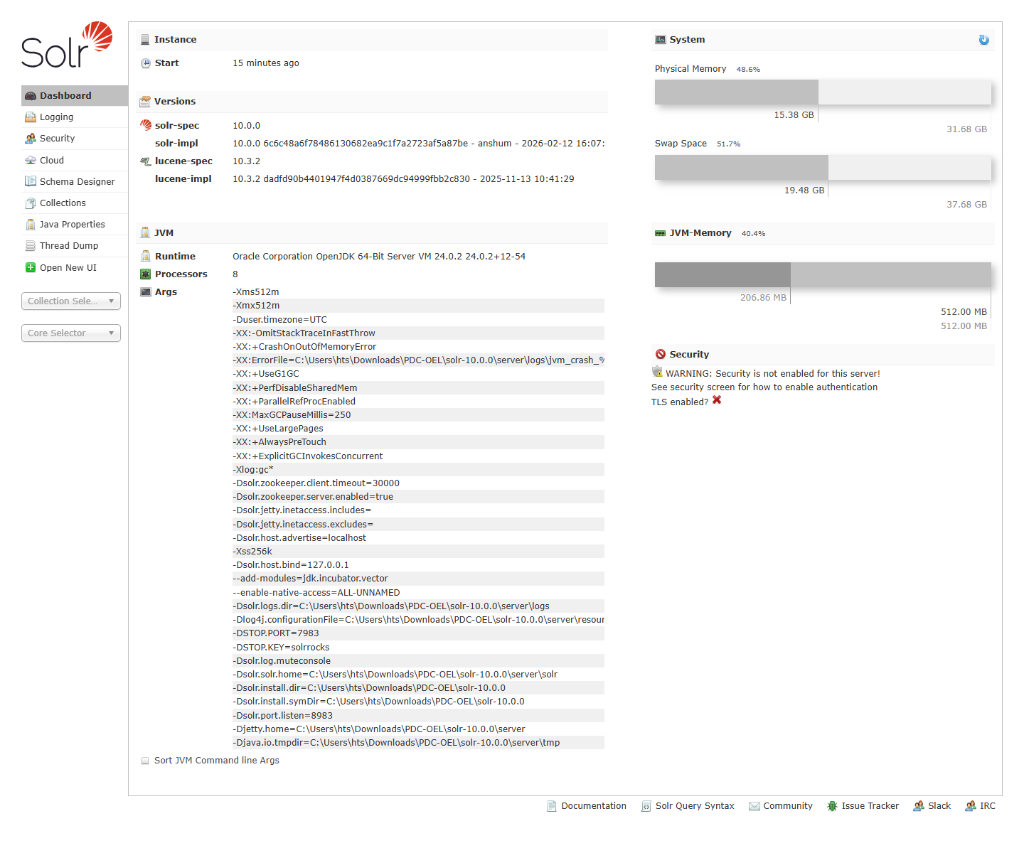
Figure 1. Solr Admin interface showing the running local Solr instance.

Figure 2. Responsive research portal homepage integrated with Solr.

Web Integration
A lightweight Node based server was created to serve the frontend and proxy search requests to Solr. This design avoids cross origin complications and makes the interface easy to run on any local machine. The frontend supports live query submission, autocomplete suggestions, category facets, access and year filters, sorting options, pagination controls, and highlighted search snippets.
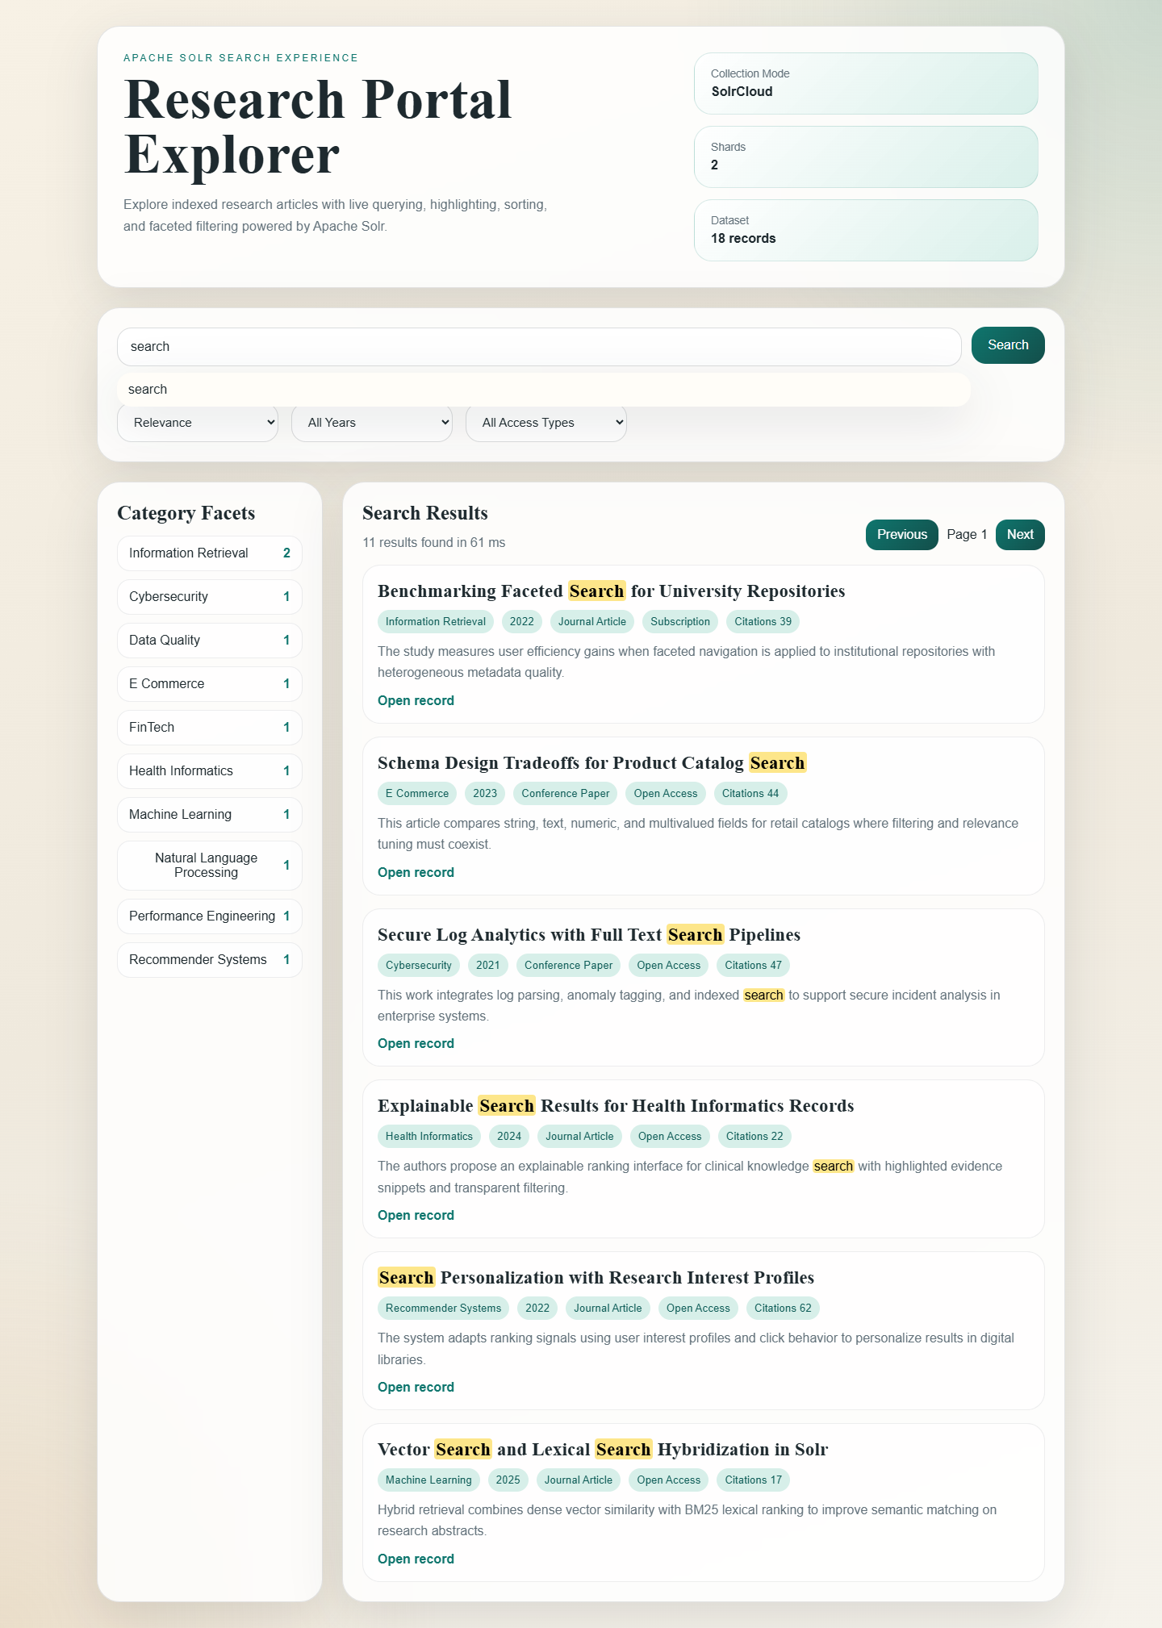
Figure 3. Query results with highlighting, facets, pagination, and metadata pills.
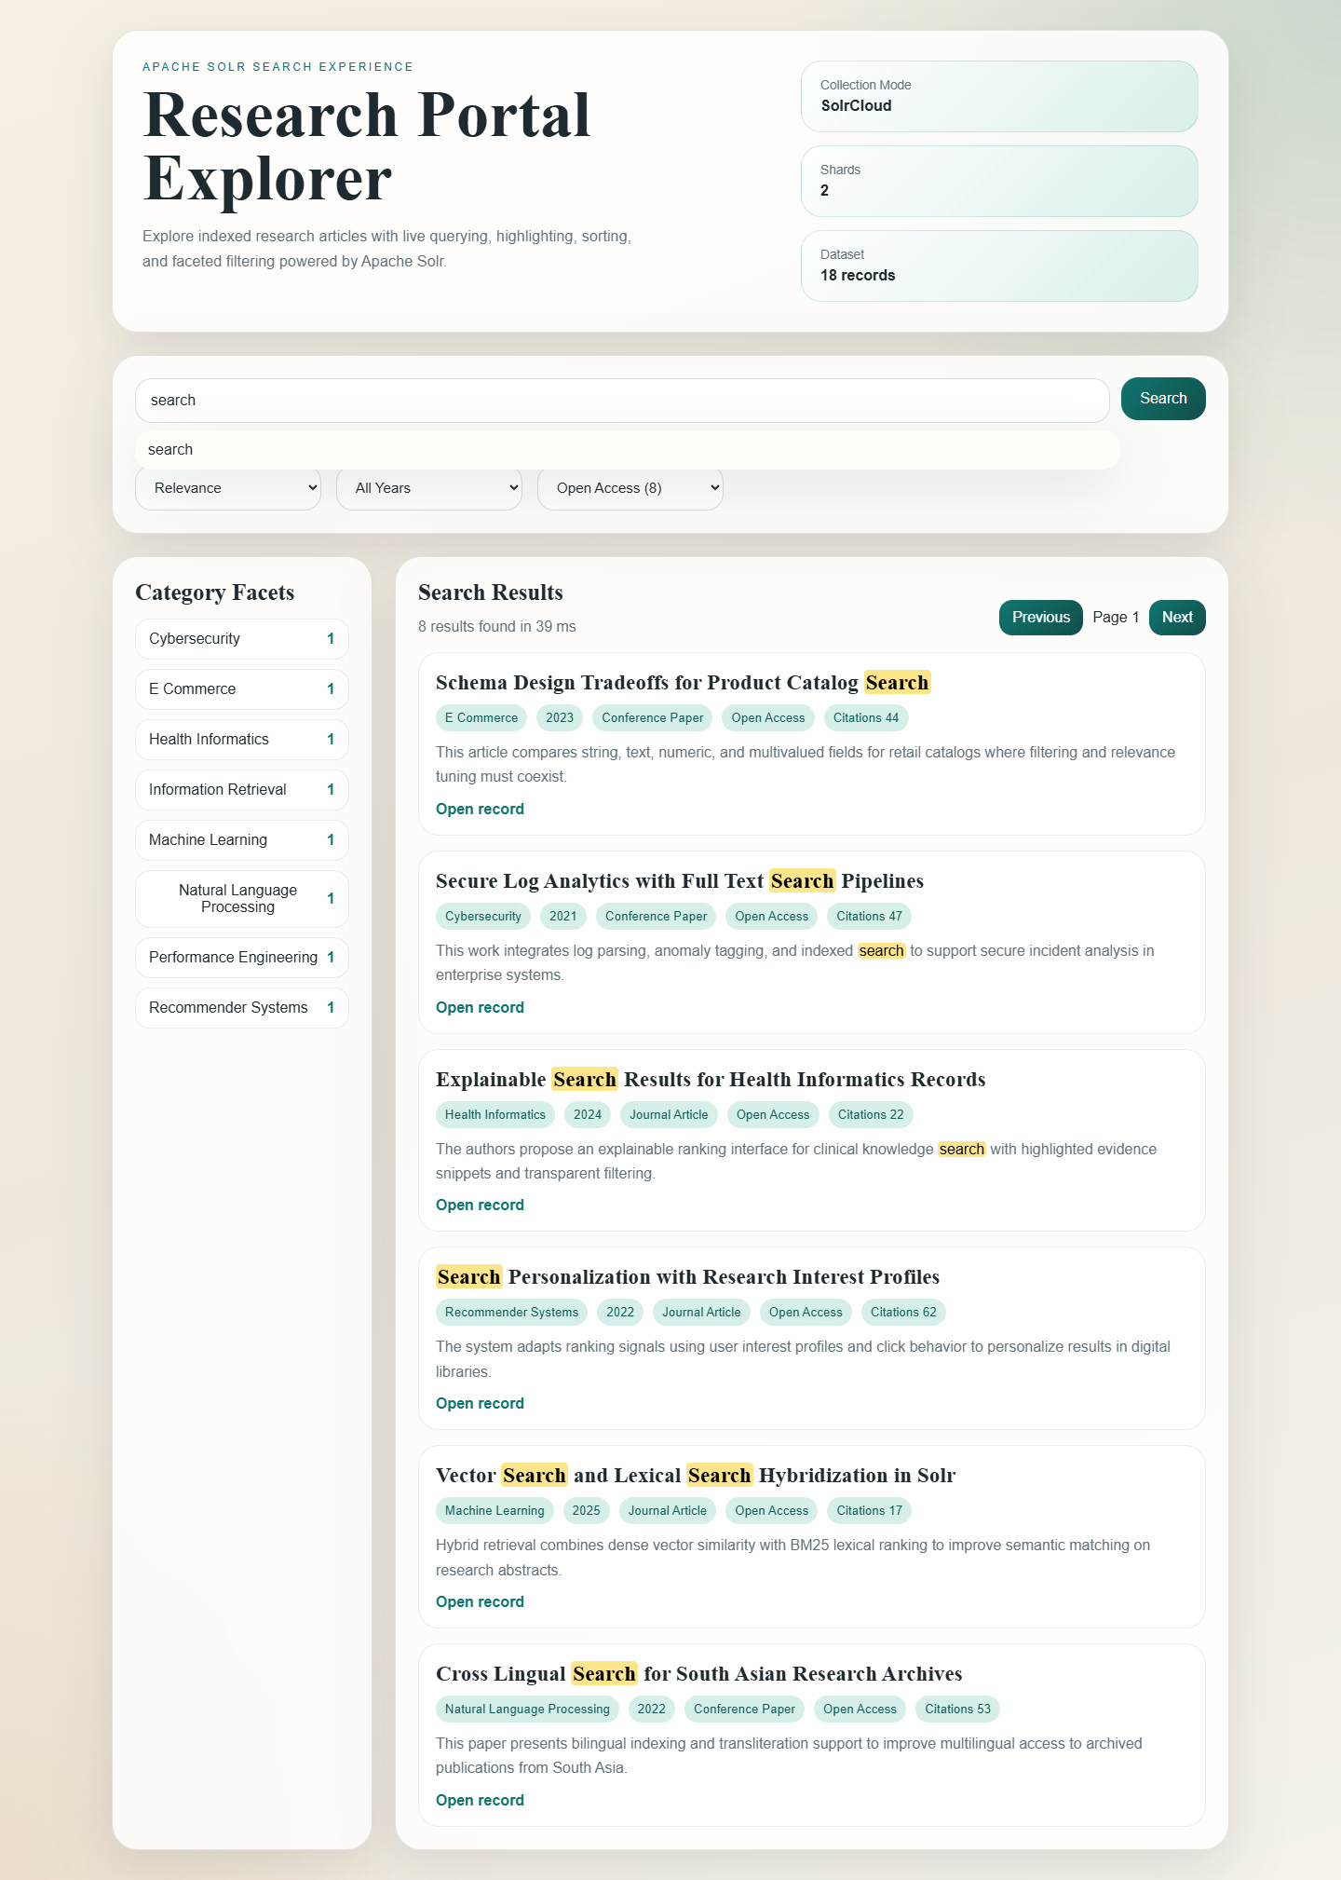
Figure 4. Filtered result view using access type controls.
Performance and Accuracy Analysis
The generated benchmark summary indicates that Solr handled the dataset comfortably, with low internal query times and consistently relevant top results. The measured wall time from the analysis script includes local request overhead, but the Solr QTime values remain the primary indicator of search engine responsiveness.
Scenario | Average QTime ms | Average Wall Time ms | Interpretation
Neural search relevance query | 72.2 | 2117.87 | Field boosting prioritized title evidence and kept the most relevant paper at the top.
Open access retrieval query | 34.6 | 2085.06 | Exact filtering preserved access constraints while still returning meaningful records.
Performance cache query | 31.8 | 2070.14 | The combined all_text field improved recall for performance related queries.
Accuracy was evaluated qualitatively by reviewing the top returned articles for each scenario. Queries such as neural search and retrieval returned documents whose titles and abstracts directly matched the search intent. Highlighting improved result interpretability because users could identify the matched evidence without opening each record.
Challenges Faced and Solutions
Challenge | Resolution
Solr 10 uses newer API entry points that differ from many older online examples. | The implementation was updated to use the live API paths that worked on the installed Solr version.
Execution policy restrictions prevented direct script execution from PowerShell. | Each project script was run through the Bypass policy option so the workflow stayed reproducible.
The first captured UI screenshots exposed low contrast facet buttons. | The CSS was refined and the screenshots were regenerated so the submission remained visually professional.
Conclusion
The final system demonstrates a complete Solr search workflow from collection setup to user facing web integration. The project successfully indexed a custom dataset, supported advanced retrieval features, and produced a polished interface suitable for search driven applications such as digital libraries, repositories, and knowledge portals.
GitHub Repository Note
The full source code is organized inside the local project folder and is ready to be pushed to a personal GitHub repository. A final GitHub URL cannot be generated automatically without user account credentials, so the repository link should be added after publishing this folder to GitHub.

