# DECLARATION

I, EZRA MDETELE declare that

This project, is my original work and has not been submitted for any degree or examination at any other university.

This project does not contain other persons’ data, pictures, graphs or other information,  
unless specifically acknowledged as being sourced from other persons.

This project does not contain other persons’ writing, unless specifically acknowledged  
as being sourced from other researchers. Where other written sources have been quoted, then, their words have been re-written but the general information attributed to them has  
been referenced and where their exact words have been used, their writing has been placed inside quotation marks, and referenced.

Signed ……………………. Date ………………………………

Ezra Mdetele

Signed ……………………... Date………………………………...

Dr. Nicodemus Msafiri Mbwambo

# ACKNOWLEDGEMENT

Foremost, I thank the Lord for energy and passion to pursue this project to completion, His words from Matthew 5:16 AMPC that is written “Let your light so shine before men that they may see your moral excellence and your praiseworthy, noble, and good deeds and recognize and honor and praise and glorify your father who is in heaven” always encourages me to try new things.

Thanks also to Kennedy, Aika-Crista, Rachelle and Furaha for correcting grammatical mistakes in this project. Thanks to my family for financial support. Thank you to my supervisor Dr. Nicodemus Msafiri Mbwambo for your guidance over the project. Without your support and patient tolerance, I would not accomplish this project.

# ABSTRACT

Vital signs refer to indicators of a person general physical condition. These are temperature, heart rate, blood pressure, cardiac output, respiration rate, oxygen saturation, brain activity and muscle activity. Vital sign simulator is a device that provides electrical or electromechanical signals that emulate human physiological parameters so that patient monitors and diagnostic equipment can be tested for reliability, accuracy, performance and important diagnostic capabilities. However, the current commercially available vital sign simulators are expensive and most hospitals in our country cannot afford to have them, and most are designed to perform single function which require hospitals to have many simulators depending on diagnostic equipment available.

The focus of this project is to design a vital sign simulator which is expected to have the capability to simulate heart rate, non-invasive blood pressure as well as oxygen saturation.

TABLE OF CONTENTS

DECLARATION i

ACKNOWLEDGEMENT ii

ABSTRACT iii

1.1 General Introduction 0

1.2 Historical Background of Simulators in Medical Field 1

1.3 Problem Statement 2

1.4 Main Objective of the Project 2

1.5 Specific Objectives 2

1.6 Significances of the Project 3

CHAPTER TWO 4

LITERATURE REVIEW 4

2.1 Basics of Heart, Blood and Blood Pressure 4

2.2 The Heart 4

2.3 The Blood 6

2.5 Existing Systems 8

2.6 Proposed System 12

CHAPTER THREE 13

METHODOLOGY 13

3.1 Literature Review 13

3.2 Data Collection 13

3.3 Data Analysis 13

3.4 System Design 14

3.5 Circuit Simulation 14

3.6 Circuit Implementation and Testing 14

CHAPTER FOUR 15

DATA COLLECTION AND DATA ANALYSIS 15

4.1 INTRODUCTION 15

4.2 PRIMARY DATA 15

4.2.1 Data from manufacturers 15

4.2.2 Data from technicians working in various hospitals 16

4.3 SECONDARY DATA 17

4.4 DATA ANALYSIS 26

CHAPTER FIVE 27

CIRCUIT DESIGN AND SIMULATION 27

5.1 Power supply design 27

5.2 Filtering capacitor analysis 28

5.3 Output waveform of integrator 29

5.4 Simulation results 32

5.4 Prototype before testing 33

5.5 testing results 33

CHAPTER SIX 34

CONCLUSION AND RECCOMMENDATIONS 34

REFERENCES 35

APPENDICES 36

APPENDIX I 36

APPENDIX II 39

LIST OF FIGURES

Figure 2.1 Human heart 4

Figure 2.2 Electrical Conductivity of the Human Heart 5

Figure 2.3 Normal Human Heartrate Waveform 6

Figure 2.4 Ventricular Fibrillation Waveform 6

Figure 2.5 hemoglobin molecule 7

Figure 2.6 Prosim 8 vital sign simulator 9

Figure 2.7 Pronk simCube simulator 10

Figure 2.8 Rigel medical simulator 10

Figure 2.9 block diagram of existing systems 11

Figure 2.10 block diagram of proposed system 12

Figure 4:11 graphical representation of data from field. 17

Figure 4.12: chart representation of data from field. 17

Figure 4.17: ESP 32 21

Figure 4.18: 4017 counter 22

Figure 4.19: photodiodes 24

Figure 4.20: amplifiers 25

Figure 5.21: buck converter 28

Figure5.21: integrator 29

Figure 5.22: integrator waveform 30

Figure 5.23: differentiator 31

Figure 5.24: differentiator waveform 31

Figure5.24: schematic diagram of the system 32

Figure5.25: Normal ECG signal 33

Figure 5.27: prototype before testing 34

Figure 5.28: testing results 34

LIST OF TABLES

Table 1.1 : historical background of simulators in medical field ,adapted from (Ahmed, 2020). 1

Table 4.1: Existing vital sign simulators and their cost 16

Table 4.2: Data about cost of existing vital sign simulators 16

Table 4.4: Feature of PWM integrated circuit 23

Table 4.5: Features of photodiodes 24

Table 4.6: Features of amplifiers 25

CHAPTER ONE

## 1.1 General Introduction

Human body is studied into six distinct level starting from atomic level where atoms like oxygen and hydrogen bond to form molecules, cellular level where various molecules combines to form the fluid and organelles of body cells, tissue level where a similar cells combines to form body tissues, organ level where many tissues combines to form organs, system level where many organs combines to form a system and organism level where many organs work together to perform the functions of independent organism (Brooks, 2016).

Studies shows human beings cannot survive few minutes without oxygen, few days without water and few weeks without carbohydrates, lipids, proteins, fat and other nutrients obtained from food. Human beings also require pressure that is enough to ensure blood reaches all body parts but low enough so that not to damage blood vessels. Atmospheric pressure is important too to facilitate gaseous exchange in the body (Brooks, 2016).

Thus the indicators for general physical condition of a person are known as vital signs. These are temperature, heart rate, blood pressure, cardiac output, respiration rate, oxygen saturation, brain activity and muscle activity. Annex FF of ISO Standard 80601-2-61 states that “simulator” is a device capable of producing electronic signals or optical responses identical to a human subject.

Vital sign simulators are for testing the performance and accuracy of diagnostic equipment. According to AAMI (Association for advanced medical instrumentation) testing of diagnostic equipment must be performed on actual human subjects. This is a significant challenge as a single human being cannot have different physiological conditions to be tested hence testing based on human subjects requires a lot of people with different conditions. Therefore, simulators are used to alleviate the use of actual human subject.

## 1.2 Historical Background of Simulators in Medical Field

Table 1.1 : historical background of simulators in medical field ,adapted from (Ahmed, 2020).

|  |  |
| --- | --- |
| TIMELINE | ACHIEVEMENT |
| 1027 | Emperor of china manufactured adult sized wooden toy for teaching acupuncture |
| 1570 | Andres Alcazar introduced wooden dummy to train surgeons to fix wounds |
| 1763 | Juseppi Salernova used a model composed of human skeleton and other components to teach blood circulation |
| 1910 | Chases made a doll to teach nurses anatomy |
| 1960 | Peter Safar with Norwegian doctors made a cardiopulmonary resuscitation dummy |
| 1967 | Abraham and Denson presented the first computer guided dummy the “sim one” intended for anesthesiologist training. |
| 1967 | Michael Gordon inverted a dummy for cardiology which allowed to simulate several cardiac pathologies |
| 1990’s | Dr. Howard barrows introduced an actor simulating a patient |
| 2000’s | Advancement in technology and programming led to development of more sophisticated simulators |

## 1.3 Problem Statement

Like other electronic equipment performance accuracy of monitors decreases over time, and can be minimized by regular calibration through the use of simulators which depicts patient and provides known signal to view on a machine. In case of inaccuracy a machine has to be maintained. The existing Vital sign simulators are very expensive, most hospitals in Tanzania do not afford to purchase them. Hence in most of hospitals calibration of patient monitors is not performed. Dr. Rotich from Kenya Bureau of Standards said,” Uncalibrated equipment has been linked to misdiagnoses, which have led to the administration of wrong medication, we cannot talk of saving patient’s life before we look into the issue of calibrating the equipment” (Merab, Doctors blame fault machines for most treatment and surgical mistakes, 2021).

## 1.4 Main Objective of the Project

The objective of the project is to develop a low cost multiparameter vital sign simulator for testing the performance and accuracy of monitoring and diagnostic equipment.

## 1.5 Specific Objectives

To design a circuit for simulation of normal and abnormal electrocardiography signal.

To design a circuit for normal and abnormal SPO2.

Assembling designed circuits to form a single device.

## 1.6 Significances of the Project

By offering a reliable calibration solution, healthcare facilities can ensure that Vital Signs Monitors and diagnostic equipment produce accurate results and improve patient care.

It can be used as a teaching aid to help students interpret physiological parameters prior using machines with patients.

# CHAPTER TWO

# LITERATURE REVIEW

## 2.1 Basics of Heart, Blood and Blood Pressure

## 2.2 The Heart

The heart has four chambers. The upper two chambers (left and right atria) are entry points into the heart, while the lower two chambers (left and right ventricles) are contraction chambers that send blood out to the body. Blood circulation is divided into systemic circulation which means circulation of blood throughout the body and pulmonary circulation which means circulation of blood to the lungs and back to the heart (Brooks, 2016).



Figure 2. Human heart

The action of empting and filling the chambers is known as cardiac cycle and the frequency of filling and empting the chambers is known as heart rate. The contractions of the heart occur spontaneously, but are sensitive to nervous or hormonal influences, particularly to sympathetic (arousing) and parasympathetic (decelerating) activity. Contraction of the heart occurs due to electrical activity that starts at the sinus node, situated in the right atrium, then proceeds quickly through the atria to the atrioventricular node, and then down the bundle of His to the left and right bundle branches. The total time elapsed from the initiation of the impulse in the sinus node until depolarization of the ventricles is approximately 225 milliseconds (Brooks, 2016).

The electrical activity is caused by the difference in potential between cardiac conductive cells and cardiac conductive cells. Conductive cells contain a series of sodium ion channels that allow a normal and slow influx of sodium ions that causes the membrane potential to rise slowly from an initial value of -60 mV up to about–40 mV. The resulting movement of sodium ions creates spontaneous depolarization. At this point, calcium ion channels open and Ca2+ enters the cell, further depolarizing it at a more rapid rate until it reaches a value of approximately +5 mV. At this point, the calcium ion channels close and K+ channels open, allowing outflux of K+ and resulting in repolarization. When the membrane potential reaches approximately -60 mV, the K+ channels close and Na+ channels open and cycle begins again (Brooks, 2016).

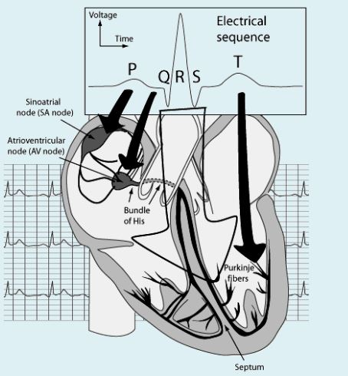

Figure .2 Electrical Conductivity of the Human Heart

ECG (electrocardiography) is a method of collecting electrical signals generated by the heart, which propagate in pulsating electrical waves towards the skin. It can be picked up reliably with ECG electrodes attached to the skin (Brooks, 2016).

When a person has a normal sinus rhythm on their EKG, these beats are in a regular, orderly rhythm. Each should look like the previous and will be as evenly spaced with each other.

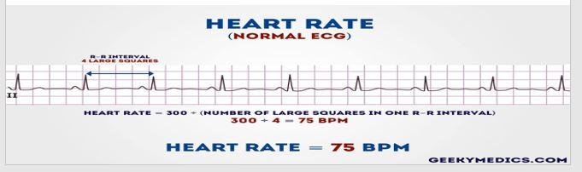

Figure 2. Normal Human Heartrate Waveform

Ventricular fibrillation occurs when action potentials fire very rapidly within the pulmonary veins or atrium in a chaotic manner. The result is a very fast heart rate of up to about 400 to 600 beats per minute.

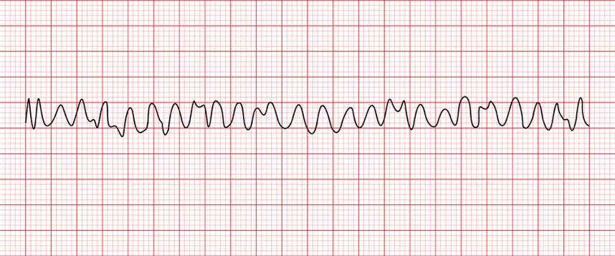

Figure 2.4 Ventricular Fibrillation Waveform

Full ECG is taken by four leads, the variations of these leads are for allowing more flexible recording.

## 2.3 The Blood

Blood is a connective tissue. It is made up of cellular elements and an extracellular matrix. The cellular elements are Red blood cells, White blood cells and platelets. The extracellular matrix is plasma which is a fluid. This fluid, which is mostly water, suspends the formed elements and enables them to circulate throughout the body (Brooks, 2016).

The functions of blood are to deliver Oxygen and nutrients, remove wastes from body cells, distribution of heat throughout the body, defense against diseases and infections and maintenance of homeostasis. Blood also helps to maintain the chemical balance of the body. Proteins and other compounds in blood act as buffers, which thereby help to regulate the pH of body tissues. Blood also helps to regulate the water content of body cells (Brooks, 2016).

Hemoglobin (Hb) is a large molecule in red blood cells made up of proteins and iron. It consists of four folded chains of a protein called globin, designated alpha 1 and 2, and beta 1 and 2. Each of these globin molecules is bound to a red pigment molecule called heme, which contains an ion of iron (Fe2+). Each iron ion in the heme can bind to one oxygen molecule, therefore, each hemoglobin molecule can transport four oxygen molecules also gives blood its color (Brooks, 2016).

Blood that has just taken up oxygen in the lungs is bright red, and blood that has released oxygen in the tissues is a duskier red. Oxyhemoglobin (HbO2) is hemoglobin bounded to O2 that delivers 98% of oxygen to cells. This protein forms an unstable and reversible bond with O2. Thus, Hb in its oxygenated state is called HbO2. Hb can carry up to four O2 molecules (Brooks, 2016).

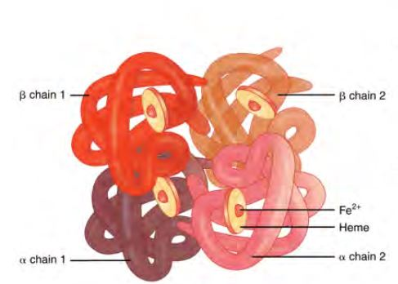

Figure 2. hemoglobin molecule

The measurement and calculation of the percentage of HbO2 in arterial blood is known as oxygen saturation (SpO2). Pulse oximetry derives SpO2 and pulse rate (PR) from a photoplethysmogram (PPG). PPG is the time dependent volumetric changes in living tissues. The PPG is obtained by measuring changes in light absorbed by the blood. Red and infrared wavelengths are used to obtain the PPG because these wavelengths are easily transmitted through tissues, allowing SpO2 to be calculated from the ratio of the absorption of the red and infrared light (Brooks, 2016).

The light beams travel through the tissue and are absorbed not only by the hemoglobin but also by other tissues (such as bone, muscle) in the light path. In addition, as the diameters of the capillaries are pulsating according to the blood pressure, the optical path length is not a constant. Therefore, the variation in light absorption produces AC signal which is used to calculate oxygen saturation and to obtain a PPG, The AC signal also gives Heart Rate (HR). Constant signal caused by absorption of light in other tissues are eliminated. The same Red and IR sensitive phototransistorcan detect both LED’s, one at a time (rapidly turned on and off) (Brooks, 2016).

## 2.5 Existing Systems

There are two categories of simulators employed in medical field, the first category is of simulators that uses the signals that were recorded from real patients typical 3000 up to 4000 then stored on a MIT-BIH Database. The files from database are downloaded and stored in a simulator memory then, during testing the microprocessor coverts them to analog signal which can be applied to a monitor for testing its functionality. Some designs also allow adjustment of the recorded signal by the end user for different testing requirements. It includes simulators such as Prosim 8 vital sign simulator from fluke biomedical, NASCO lifeform simulators and BC biomedical simulators. These simulators are widely very expensive and widely used since Association for advanced medical instrumentation requires all testing and calibration to be performed on actual human subjects (Michalek, 2006).

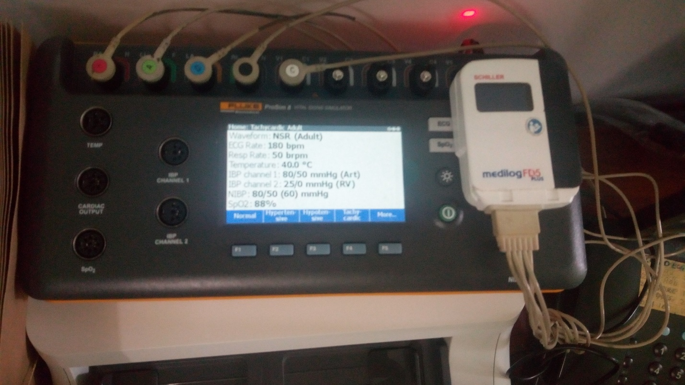

Figure 2.6 Prosim 8 vital sign simulator

The second category is of simulators that electronically generates signals that replicate physiological condition of actual patients, through the use of various active and passive components. These are designed to alleviate the need of recording physiological signals from patients to reduce cost. These are least used since they are still on emerging trend. It includes simulators such as Rigel medical, Pronk Technology simCube simulator and bioTek Lionheart 3. (Michalek, 2006). These are least expensive but most are designed to simulate single parameter which require hospitals to have many simulators as per diagnostic equipment available. The aim is to develop a simulator with multiple parameters using locally available materials to reduce the cost.

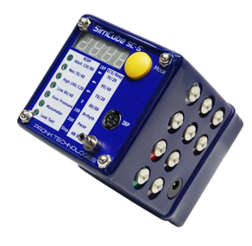

Figure 2.7 Pronk simCube simulator

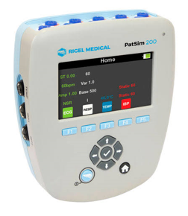

Figure 2.8 Rigel medical simulator

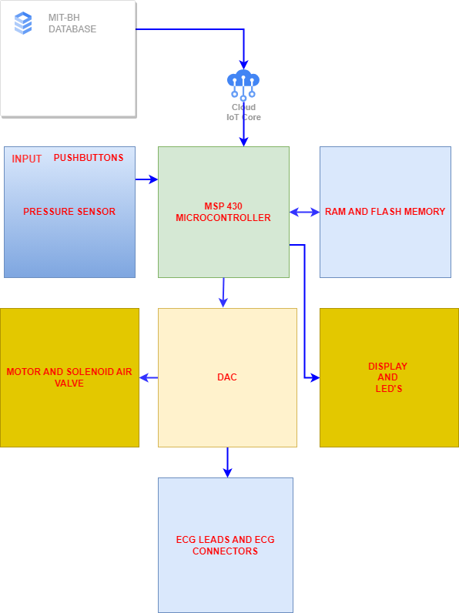

Figure 2.9 block diagram of existing systems

## 2.6 Proposed System

To make it low cost proposed system will not include databases to store physiological parameters from real patients. The waveforms will be generated using passive and active electronic components that are locally available.

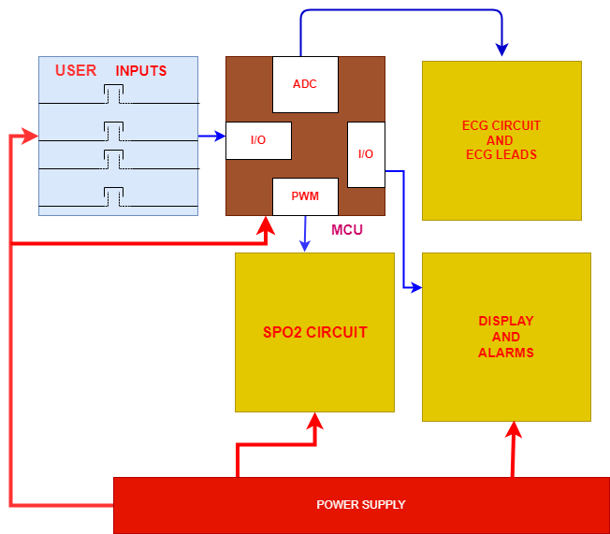

Figure

# CHAPTER THREE

# METHODOLOGY

## 3.1 Literature Review

Throughout the development process, comprehensive documentation of the system design, testing methodologies, and results will be maintained. Dissemination of findings through academic publications, books, and other educational materials will be adopted facilitate understanding of the problem and to come out with a logical design.

This project will adopt a mixed methods approach that are Code and fix method which will be employed to develop a program for controlling a system. The program will be written in several versions and tested until it meets all project requirement. Incremental and iterative method will be used to design a circuit where it will be divides into several parts which will be built independently then tested until all are working as desired then they will be combined to a single circuit.

## 3.2 Data Collection

Data will be collected using online questionnaire and various websites. The focus is cost of available devices, knowledge of how to use them as well as their availability. These data reflect project objectives.

## 3.3 Data Analysis

Analysis of the collected data which will be used in the design to come up withthe suitable values of components, type of software, integrated circuits together with the powersupplies for the proposed system.

## 3.4 System Design

The circuit design will base on information collected in order to meet the objective of the project.This section will involve the physical layout of the circuit by using available and required materials. The values which will be used in this project are according to ratings and requirementsof the circuit.Different parts of this system after design will be simulated in order to observe results of each partbefore implementing the complete circuit. This phase aims to ensure seamless integration and reliable functionality of the hardware components.

## 3.5 Circuit Simulation

This involves the use of software to replicate the behavior of the actual circuit. Itallows determination of the correctness and efficiency of the design before actual systemconstruction. Proteus software is expected to be used for circuit design.

## 3.6 Circuit Implementation and Testing

After verifying the performance of circuit in the software the actual circuit will be implemented based on the components used in the simulation.

# CHAPTER FOUR

# DATA COLLECTION AND DATA ANALYSIS

## 4.1 INTRODUCTION

In accomplishment of the report data were collected from various websites which sells vital sign simulators to make approximation of the cost of existing vital sign simulators. Another dataset was collected from several hospitals in the country to make analysis of the number of hospitals that have the device and that do not have the device. From the hospitals that have the device parameters which are frequently used in the calibration process were recorded aid in deciding which parameters to include in the design of a low cost multiparameter vital sign simulator. Form hospitals which do not have the device data were collected using questionnaire to determine the need of the device. Data were collected from manufacturers to know the technology behind their design that makes their devices expensive.

## 4.2 PRIMARY DATA

### 4.2.1 Data from Manufacturers

Two categories of vital sign simulators exist in the market. First category is of simulators that uses data collected from real patients. These are most expensive since Association for Advancement in Medical Instrumentation(AAMI) requires that data should be collected at least form 3000 patients since abnormalities vary among patients. This increases cost of devices since the process requires permit which are paid and patients consent to take their data. Also, it takes very long time to obtain required data and the device must be updated periodically. Second category is of simulators that generate vital sign signals electronically. These are less expensive, but their cost is mostly because of a lot of parameters they include in their design of which most of them are not used for calibration purposes.

Table 4.1: Existing vital sign simulators and their cost

|  |  |
| --- | --- |
| DEVICE | TECHNOLOGY |
| Prosim 8 Vital sign simulator | Parameters are from actual human being data |
| Multi –pro 2000 ECG simulator | Parameters are electronically generated |
| Rigel medical patient simulator | Parameters are electronically generated |
| DELTA 3000 | Parameters are electronically generated |

Table 4.2: Data about cost of existing vital sign simulators

|  |  |  |
| --- | --- | --- |
| DEVICE | COST | SOURCE |
| Prosim 8 Vital sign simulator | 11,999.06 USD | <https://www.ciamedical.com>  accessed on April 28, 2024 |
| Multi-pro 2000 ECG simulator | 3764.00 USD | <https://www.medicaldevicedepot.com>  accessed on April 28, 2024 |
| Rigel medical patient simulator | 3500 Euros | <https://www.evrostia.co.uk>  accessed on April 28, 2024 |
| Pronk simCube simulator | 495.00 USD | <https://www.ebay.com>  accessed on April 28, 2024 |

### 4.2.2 Data from Technicians Working in Various Hospitals

The first bar is those who replied no to the first, second and forth questions question that asked “does your workplace have vital sign simulator?”, “do you have knowledge or training on how to use the device?” and “do you find the device useful?” respectively. This implies that most institution do not have the device because of the cost, from Table 2 above the cheapest device cost 495 USD. That is the minimum cost. Therefore, cheaper solution for vital sign simulator is feasibly needed. Knowledge and training on how to use the device is to be included in annual trainings since most replied they do not know how to use the device but they find it is important.

The second bar is of those who replied that they know the device, it is there in their workplace and they find that it is important

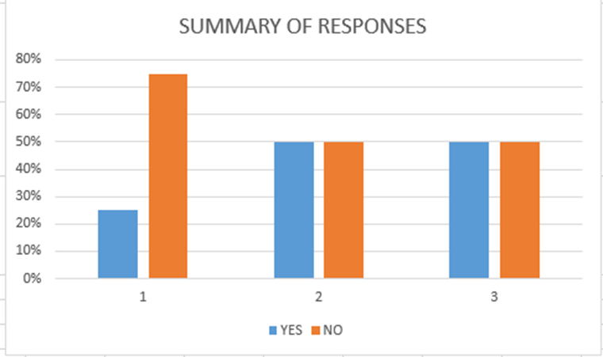

Figure 4:11 graphical representation of data from field.

Chart below summarizes most used parameter in calibration of medical equipment using vital sign simulators. Majority replied that the most used parameter is normal ECG signal, therefore the proposed device will have capability of simulating normal ECG signal and other few parameters that are abnormal ECG and Normal and abnormal SPO2.

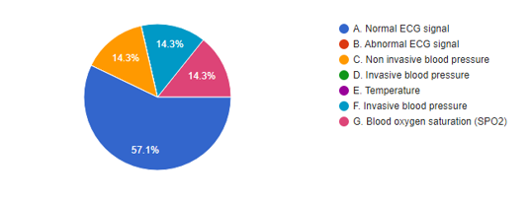

Figure 4.12: chart representation of data from field.

## 4.3 SECONDARY DATA

From collected data vital sign simulators that generate signals electronically found to be cheaper than those which uses actual human data. Therefore, the proposed design will generate signals electronically. Also since ECG signal and SPO2 signal are among the commonly used by technicians and engineers for calibration, the device will have Normal ECG signal, Abnormal ECG signal, Normal SPO2 and abnormal SPO2 signals.

ECG signals can be generated by using pulse width modulation technique where a square wave signal passes through a series of components to obtain ECG signal or it can be generated using programmed algorithms or pattern. Using pulse width modulation is easier as it does not involve a lot of coding also can be achieved without programming. Pulse width modulation signal can be generated by using outlined integrated circuits;

555 timer

It is a highly stable device for generation of accurate time delays or oscillation. The free running frequency and duty cycle are accurately controlled by external resistor and capacitor.

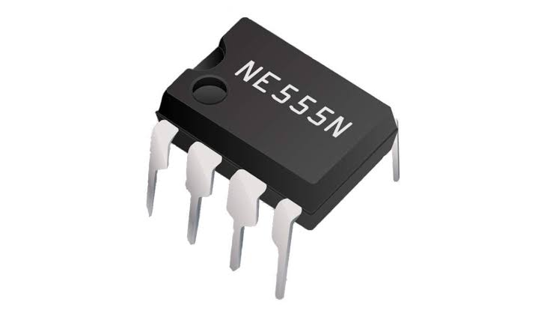

Figure4.13: 555 timer

4047

It consists of a gatable astable multivibrators with logic techniques incorporated to permit positive and negative edge-triggered monostable multivibrators action with retriggering and external counting options. In all operations external capacitor and resistors must be connected to adjust duty cycle.

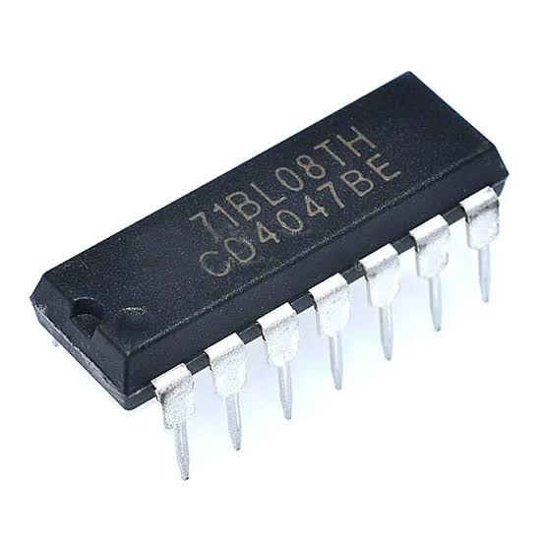

Figure 4.14: 4047 multivibrator integrated circuit

4521

Consists of an oscillator and 24 ripple binary counter stages. To get output or to trigger it the reset pin has to be kept on power.

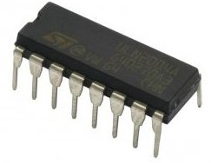

Figure 4:15 4521 timer integrated circuit

ATMEGA 328P

It is a low-power CMOS 8-bit microcontroller based on the AVR enhanced RISC architecture. By executing powerful instructions in a single clock cycle, the ATmega328/P achieves throughputs close to 1 MIPS per MHz. This empowers system designers to optimize the device for power consumption versus processing speed.

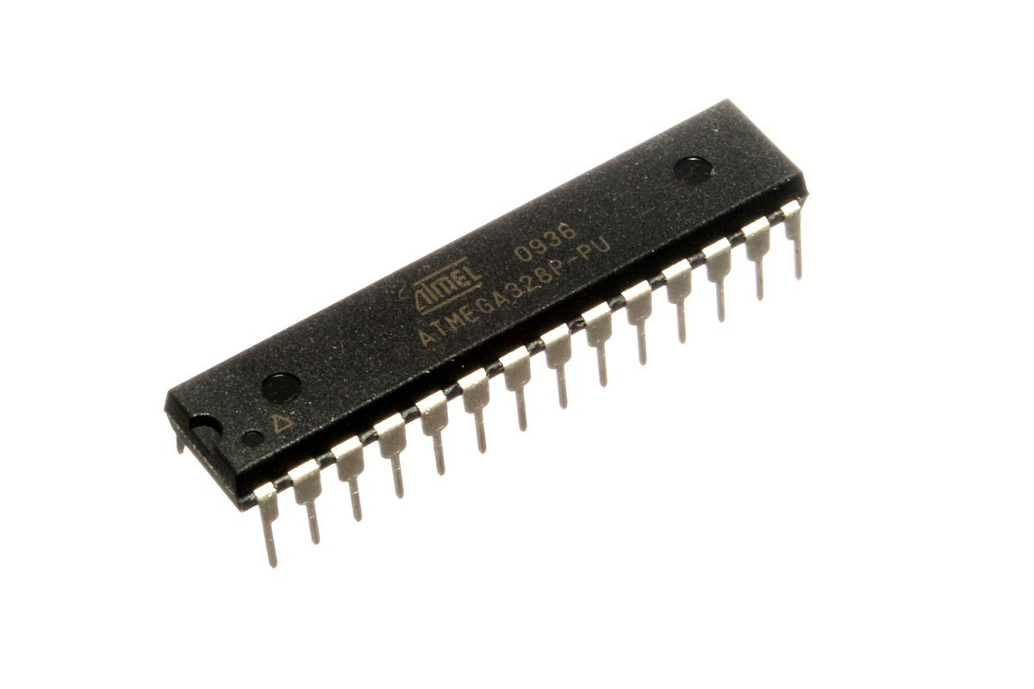

Figure 4.16: ATMEGA 328P

ESP 32

ESP32 is a single 2.4 GHz Wi-Fi-and-Bluetooth combo chip designed with the TSMC low-power 40 nm technology. It is designed to achieve the best power and RF performance, showing robustness, versatility and reliability in a wide variety of applications and power scenarios.

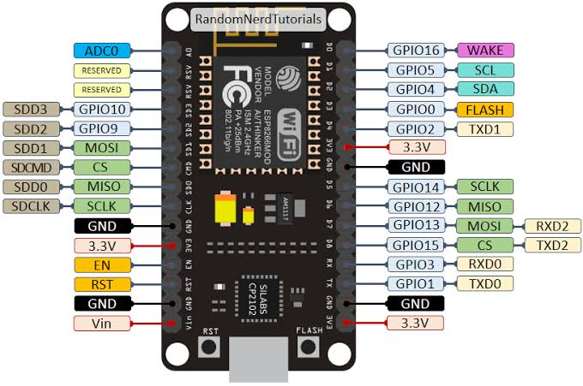

Figure 4.17: ESP 32

For obtaining a wave at proper sequence pulse width modulation signal has to undergo frequency division and it can be achieved by frequency dividing integrated circuits or counters such as;

4017

It is a 5 stage Johnson counter having 10 decoded output. It is used for counting applications and has a capability to turn ON 10 outputs sequentially in a pre-defined time and reset the count or hold it when required. Schmitt trigger action in the clock input circuit provides pulse shaping that allows unlimited clock input pulse rise and fall times. Using Johnson counter configuration permits high speed operation and spark free decoded outputs. Ant-lock gating is provided ensuring proper counting sequence.

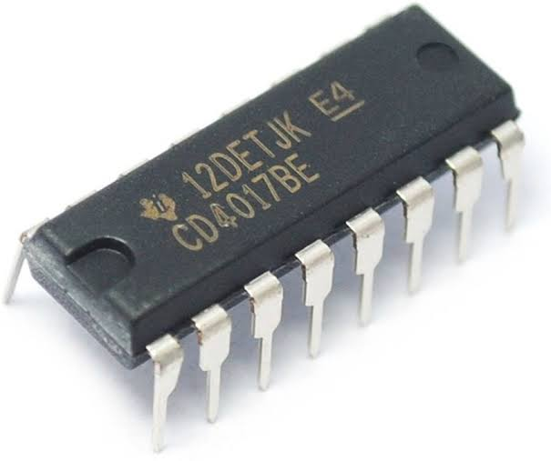

Figure 4.18: 4017 counter

4022

It is a 4 stage Johnson counter having 8 decoded output. Schmitt trigger action in the clock input circuit provides pulse shaping that allows unlimited clock input pulse rise and fall times. Using Johnson counter configuration permits high speed operation and spark free decoded outputs. Ant-lock gating is provided ensuring proper counting sequence.

Table 4.4: Feature of PWM integrated circuit

|  |  |  |  |  |  |  |
| --- | --- | --- | --- | --- | --- | --- |
| DEVICE | 555 | 4017 | 4047 | 4521 | ATMEGA 328 P | ESP 32 |
| Features | Multivibrator integrated circuit | Counter | Multivibrators integrated circuit | Multivibrator integrated circuit | microcontroller | microcontroller |
| Number of (PWM) outputs | 1 | 10 of variable frequency | 2 | 1 | 6 | 16 |
| Power modes | Active | Active | Active | Active | Active , Idle, standby, extended standby ,power save, power down, idle and noise reduction | Active, modem sleep, light sleep, deep sleep and hibernation |
| Timers | 1 | 1 | 1 | 1 | two 8-bit timers with prescaler mode and, one 16-bit timer with prescaler, compare and capture mode. One watchdog timer | One 64-bit timer and one watchdog timer |
| Power consumption | 1mW | 1mW | 5mW | 1mW | 0.1µA in sleep mode | 10µA in sleep mode |
| Peripheral | - | - | - | - | 15 digital pins and 6 analog pins programmable for controlling other devices and has data retention of 20 years | 32 programmable pins for controlling peripherals ,also supports wifi and Bluetooth communication |
| Cost | 1500 TSH | 2000TSH | 2000TSH | 2500TSH | 10000TSH | 28000TSH |

For SPO2 testing, photodiode will be detecting light form SPO2 and convert it to electrical signal. Signal from photodiode will be amplified by amplifier, the output of amplifier applied to microcontroller for analysis. Available photodiodes are as outlined,

QSD2030F photodiode S1223 photodiode

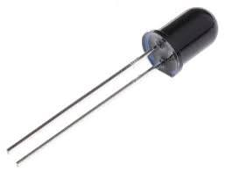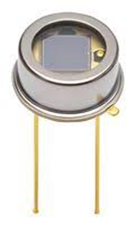

Figure 4.19: photodiodes

Table 4.5: Features of photodiodes

|  |  |  |
| --- | --- | --- |
| DEVICE | QSD2030F | S1223 photodiode |
| Sensitivity | 880nm | 990nm |
| Breakdown voltage | 50V | 30V |
| Operating temperature | -40 to 100 degrees of centigrade | Operation temperature is from -40 to 100 degrees of centigrade. |
| Power dissipation | 150mW | 100mW |

Lm358 LM393

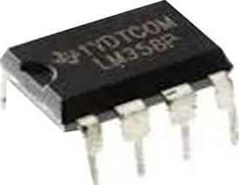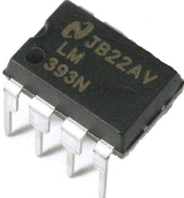

Figure 4.20: amplifiers

Table 4.6: Features of amplifiers

|  |  |  |
| --- | --- | --- |
| DEVICE | LM358 | LM393 |
| power | Single supply voltage 2-32V | Single supply from 1-18V |
| Operating temperature | -40 to 150 degrees of centigrade. | -40 to 150 degrees of centigrade. |
| Bias current | 10mA | 1mA |
| Offset voltage | 10mV | 5mV |

## 4.4 DATA ANALYSIS

ATMEGA 328P is selected because of the following reasons;

* It has three built –in timers which allows for division of signal at a consistent rate.
* It has 6 PWM channels and the project requires 4 PWM channels hence it meets design criteria.
* It has an extensive collection of peripherals, including SPI, UART, I2C, I2S as communication protocols.
* It has interrupt pin which allow for connection of push button which will trigger the microcontroller to produce specific.
* It is cheaper than if other devices were to be used.

4017 is selected for frequency division because it has the following properties

* It has full static operation
* It has ten sequential output and frequency of each output is half of previous output.

Liquid Crystal display (LCD) is used because;

* It has improved contrast and backlight for better visualization.
* It is cheap than other displays.

QSD2030F photodiode is chosen because it is locally available.

Lm 393 is chosen because;

* It has very low offset voltage.
* It can amplify very weak signals with greater accuracy and linearity, hence it is good for amplifying signals from photodiodes.
* It uses low power compared to LM358.
* Input Common Mode Range to Ground Level
* Differential Input Voltage Range Equal to Power Supply Voltage
* Output Voltage Compatible with DTL, ECL, TTL and MOS.

# CHAPTER FIVE

# CIRCUIT DESIGN AND SIMULATION

## 5.1 Power Supply Design

For the proposed system 12V voltage regulator will be used. Since most of components use 5volts, simple buck converter will be used to reduce 12V to 5V.

Buck converter schematics

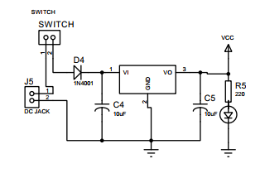

Figure 5.21: buck converter

The voltage regulator reduces voltage as well as maintains a constant output voltage. Appropriate heat sink should be placed since the difference between output and input voltage is released as heat. Appropriate size of heat sink can be calculated from the formula

Heat generated= (input voltage-5) *output current.

Input voltage is 12

Heat generated = (12-5) *0.5

Heat generated =3.5Watts.

LED is used to indicate power on, and diode prevents opposite polarity from damaging circuit components. The peak voltage of power adapter (Vp) is 12 considering ripples caused by length of power cables maximum peak voltage can be obtained by the following equation;

==16.968V

The peak value of rectified voltage (Vpr) (forward and reverse rectification)

=15.568V

So the best diode for this application is 1N4007 which has maximum current of 1A and voltage of 50V.

## 5.2 Filtering Capacitors Analysis

Capacitors are needed to reduce AC ripple that are caused by length of cables. They help in maximizing voltage regulation. The voltage of capacitors must be higher than input voltage to prevent capacitor from blowing off. Capacitor also keep control loop stable and keep ripple voltage low. Usually rectifier output has pulsating signal which has to be smoothen for better performance of electronic circuits. The simplest method of ripple filtering is the use of shunt capacitors. R.M.S ripple current in a filter capacitor can be 2 to 3 times D.C load current the larger the value of the capacitor in microfarads the better will be the smoothening of the output.

Ripple factor equations

Ripple factor of unfiltered waves x100%.

x100%. therefore, r = 48.38%.

Value of filtering capacitor is given by

Where R is the regulator resistance typical 240Ω, and ripple factor typical is 5.

Therefore, =470μF.

Integrator circuit is for changing a PWM signal into a triangular which resembles to P-wave of an ECG signal. Waveform of integrator depends on time constant of the circuit. If time constant is short compared to the period of input pulses, the capacitor will fully charge and discharge.

Integrator, outputs the integral of the input signal over a frequency range based on the circuit time constant. When time varying voltage is applied to the input of an integrator, uncharged capacitor has a very little resistance and allows maximum current to flow through input resistor. As capacitor continuous to charge its impedance increases slowly in proportion to capacitor rate of charge. This produces a linearly increasing ramp output voltage that continues to increase until the capacitor is fully charged.

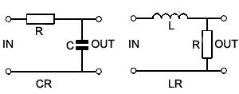

Figure5.21: integrator

## 5.3 Output Waveform of Integrator

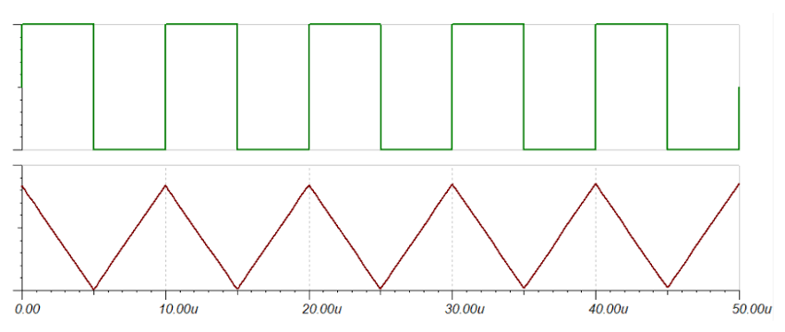

Figure 5.22: integrator waveform

Differentiator circuit is for changing PWM to a narrow triangular like voltage that varies from negative to positive and resembles to a QRS complex wave of an ECG signal.

A differentiator produces an output voltage proportional to the rate of change of its input voltage. When time varying voltage is applied at the input of differentiator a small current flows which charges input capacitor. Output voltage becomes zero when capacitor is charging, when capacitor discharge output voltage increases rapidly the decreases to negative threshold as capacitor continues to discharge.

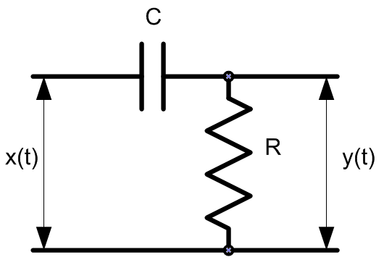

Figure 5.23: differentiator

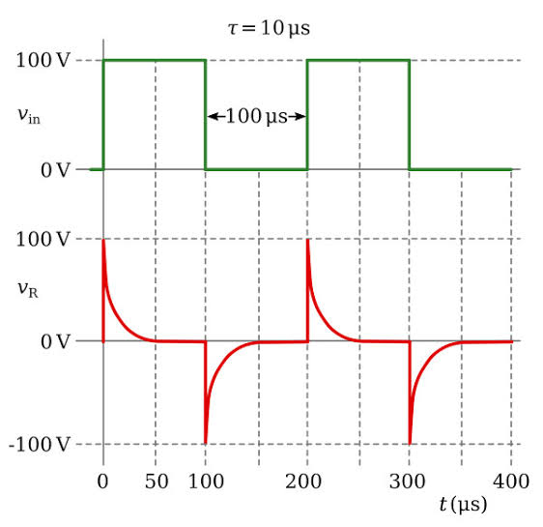

Figure 5.24: differentiator waveform

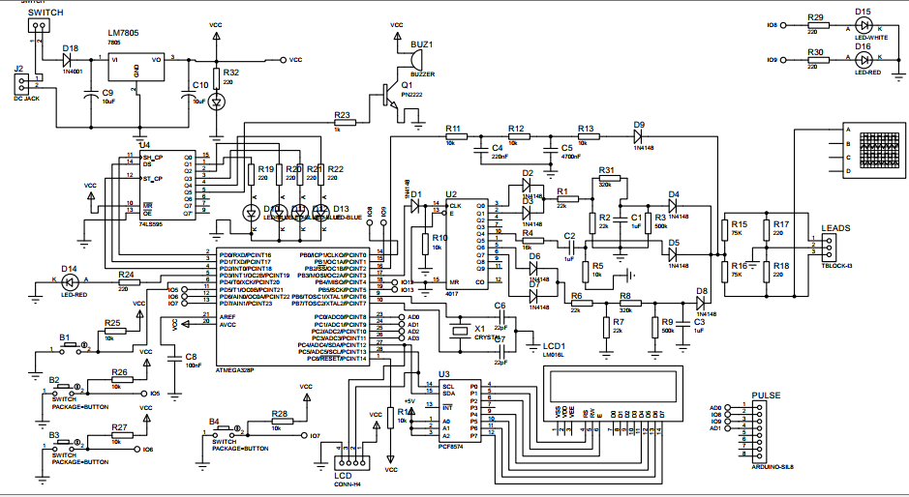

Figure5.24: schematic diagram of the system

For generation of normal electrocardiography signal microcontroller (ATMEGA 328P) produces a PWM signal at a frequency of 50Hz. Pulse Width Modulation or PWM is a technique for supplying electrical power to a load that has a relatively slow response. The supply signal consists of a train of voltages pulses such that the width of individual pulses controls the effective voltage level to the load. The output from microcontroller triggers pin 14 of 4017 IC, whenever input at pin 14 is high, the counter produces sequential output. When pin 2 and 3 are high current flows through diode D3 and D4 to resistor R12 and capacitor C3 which converts the square wave signal to analog signal and crates a P wave, when pin 10 is high current flows through resistor R7 and Capacitor C1 which creates QRS complex wave, when pin 5 and 6 are high current flows through diode D5 and D6 to resistor R8, R9, R10, R11 to capacitor C2 and creates T wave. The diodes D7, D8 and D9 reduces the negative portion of waves and does the sequencing to obtain the full electrocardiography signal. Resistors R15 and R16 are voltage divider which reduces the voltage to millivolt range since the maximum amplitude of the electrocardiography signal is 5 millivolts. The resistors R17 and R18 are used to obtain a reference point for right leg lead.

Abnormal ECG signal circuit can be implemented using integrator to obtain CRS complex wave only that resembles to third degree block. It occurs when some of the impulses initiated by SA node do not reach AV node while others do. The current flows through resistor R11, capacitor C4, resistor R12 and capacitor C5 which is a two stage low pass filter. Diode D9 used to block reverse current. Resistors R15 and R16 are voltage divider which reduces the voltage to millivolt range since the maximum amplitude of the electrocardiography signal is 5 millivolts. The resistors R17 and R18 are used to obtain a reference point for right leg lead.

## 5.4 Simulation Results

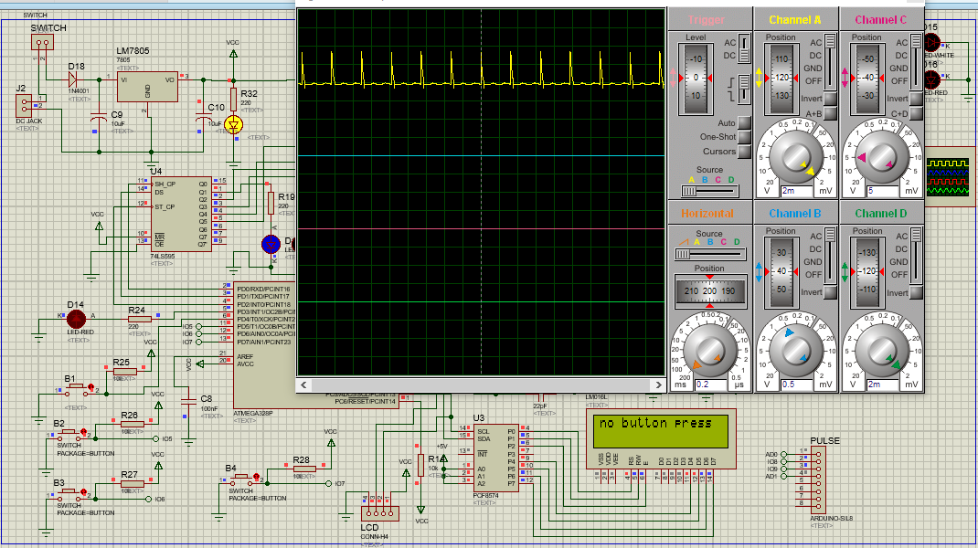

Figure5.25: Normal ECG signal

## 5.4 Prototype Before Testing

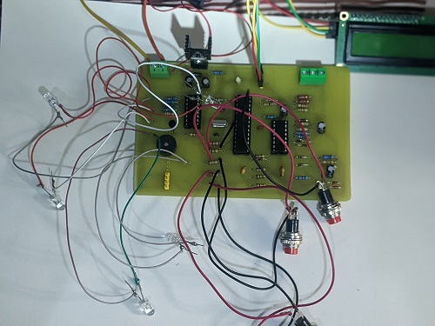

Figure 5.27: prototype before testing

## 5.5 Testing Results

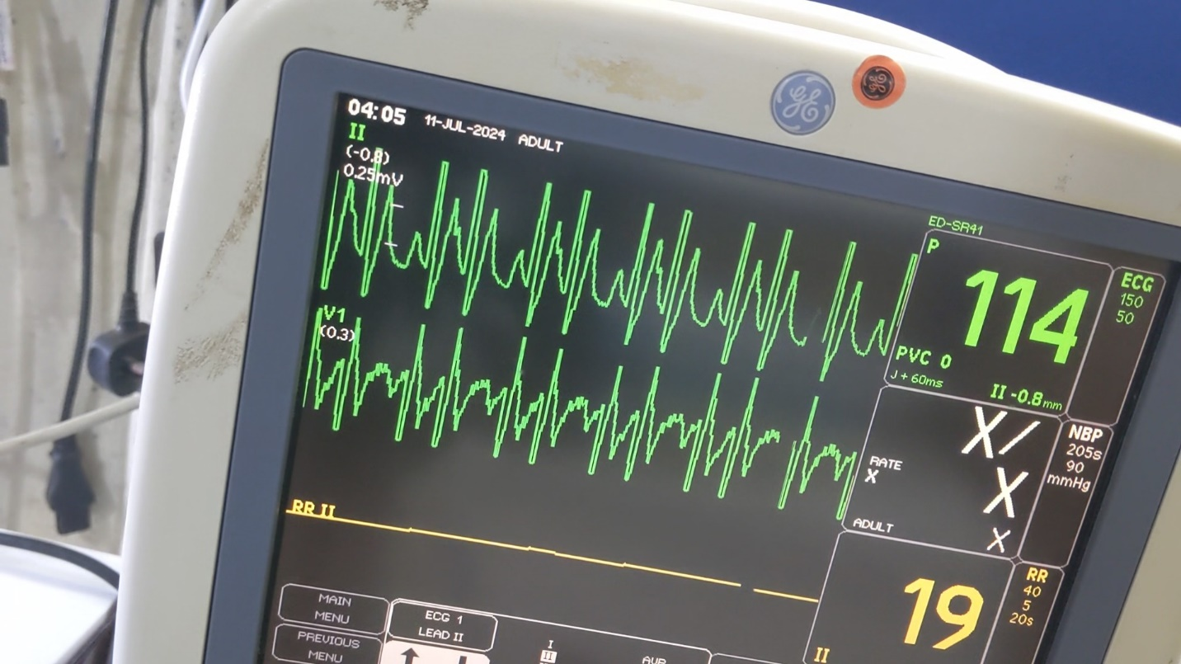

Figure 5.28: testing results

# CHAPTER SIX

# CONCLUSION AND RECCOMMENDATIONS

For normal signal heartrate was expected to be 75 beats per minute but it was 91 beats per minute, and for abnormal signal heartrate was expected to be 120 beats per minute but it was 114 beats per minute. This can be due to machine settings as they vary among manufacturers.

It is recommended in the future the device should be connected with medical databases so that results should be compared with existing data in databases to improve reliability of the device.

# REFERENCES

Ahmed, H. B. (2020). History of medical simulation. *Medical Simulation*, 1-3. Retrieved December 18, 2023, from http://honorismedicalsimulation.net

Brooks, K. (2016). *Anatomy and Physiology.* Texas: OpenStax College.

Edelmann, J.-C., Mair, D., D. Z., Burtscher, M., & Ussmueller, T. (2018). An ECG simulator with a novel ECG profile for. *Journal of Medical Engineering & Technology*, 1-10.

FF, A. (2011). Particular requirements for the basic safety and essential performance of pulse oximeter equipment. *Medical electrical equipment*, 1-10.

Merab, E. (2021, June 01). *Doctors blame fault machines for most treatment mistakes and surgical mistakes*. Retrieved from Nation newsplex website: http://nation.africa

Michalek, P. (2006). *An Authentic ECG simulator.* Florida: University of Central Florida.

Monteiro, L., Couto, C. S., & Nicolau, A. (2020). Vital Signs Monitor Simulator. *VitalSignSim*, 3-10.

Özdemir, M., Budak1, E. İ., & Eroğul, O. (2020). Development of Invasive Blood Pressure Simulator. *Development of Invasive Blood Pressure Simulator Design for Testing and calibration* (pp. 1-5). Turkey: TOBB .

Pu zhang, J. C. (2010). Design of pulse oximeter simulator calibration equipment. *I*.

Reid, D., Robertson, H., & Sonntag, M. (2011). *PULSE OXIMETER CALIBRATOR.* Turkey: WORCESTER POLYTECHNIC INSTITUTE.

Shin, H. (2016). Ambient temperature effect on pulse rate variability as an. *Journal of Clinical Monitoring and Computing*, 1-7.

Zhang, P., Chen, J., & Yang, Y. (2014). Design of pulse oximeter simulator calibration equipment. *Journal of Biomedical sciences*, 1-5.

# APPENDICES

## APPENDIX I

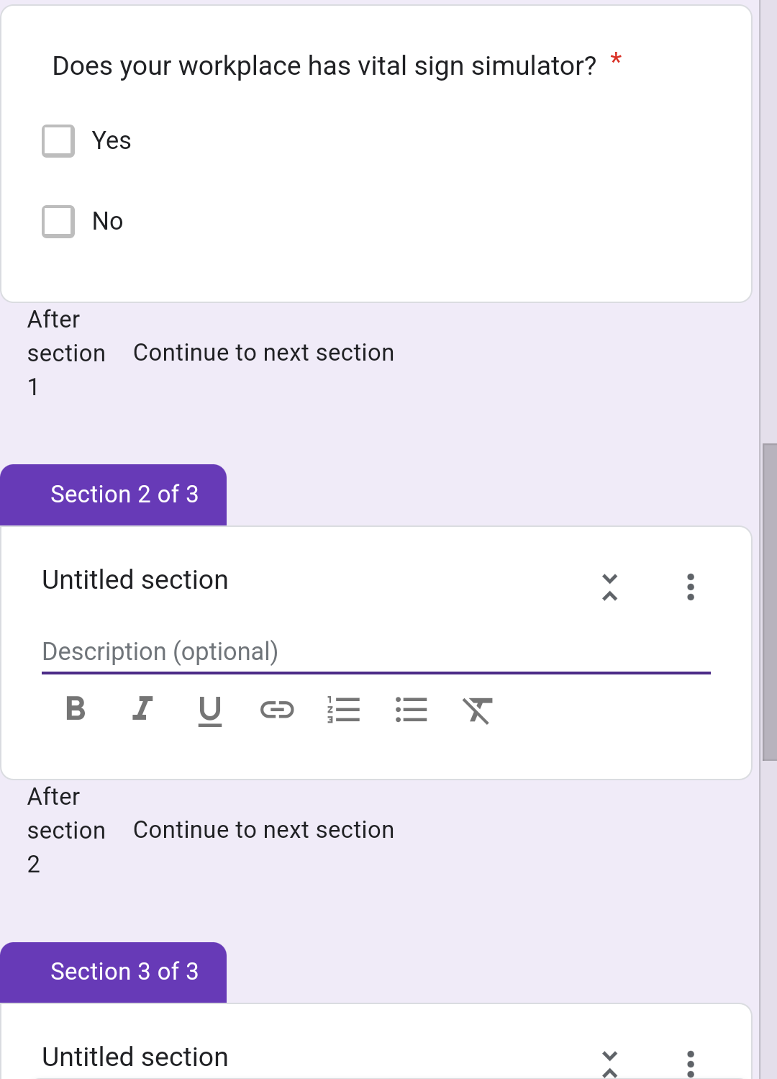

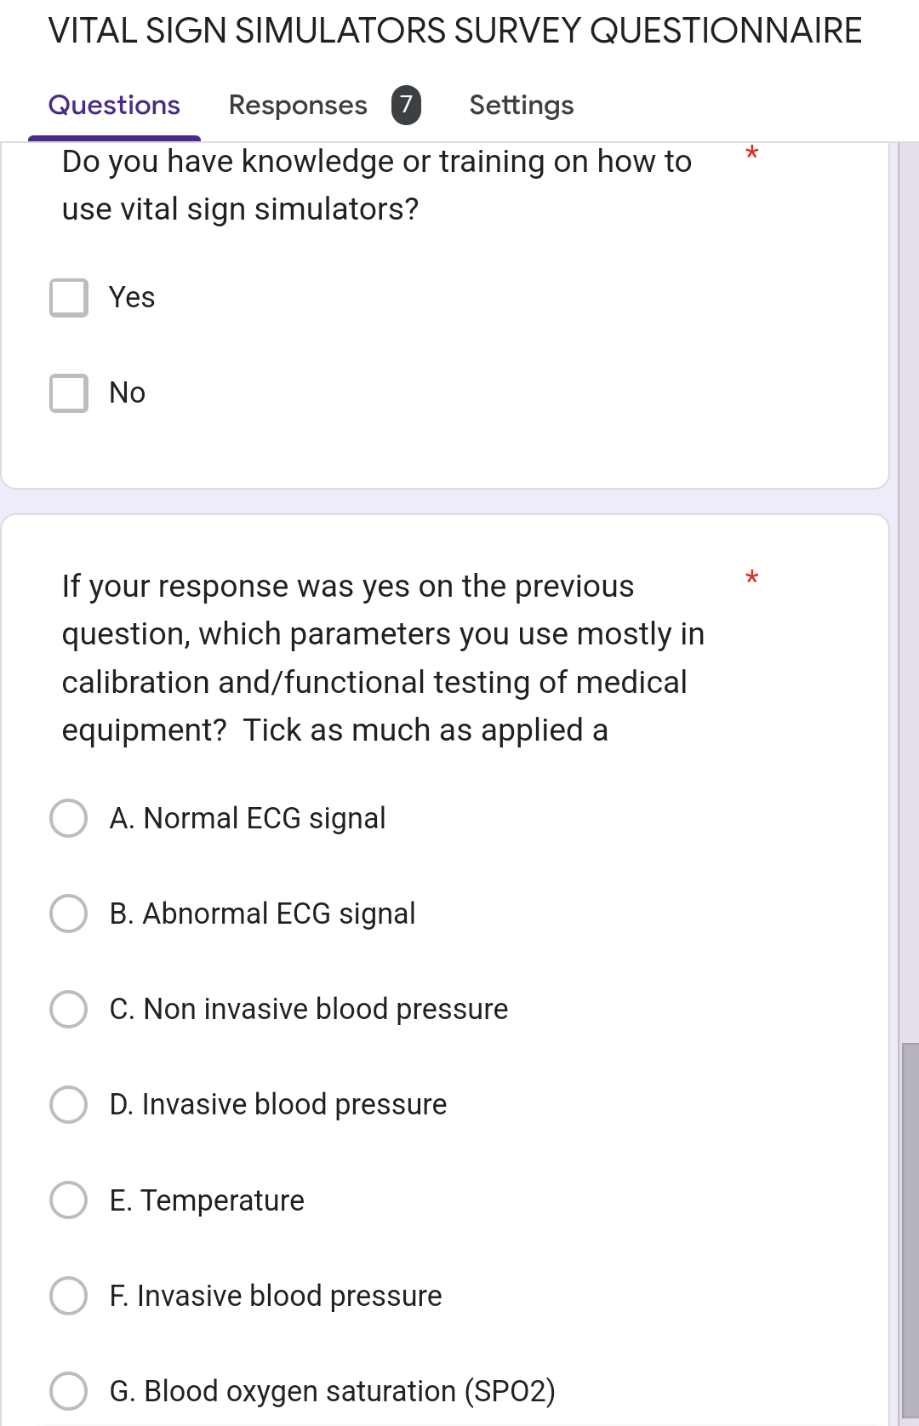

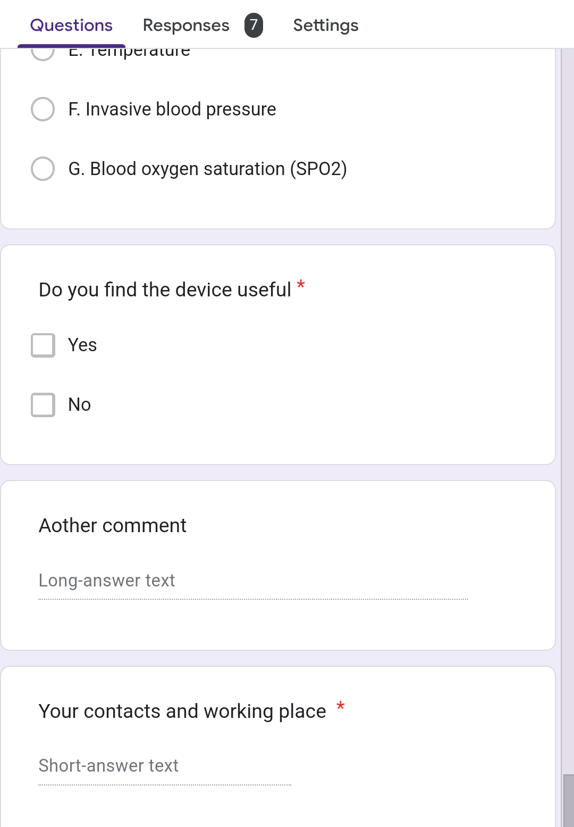

## APPENDIX II

SOURCE CODE

#define ENABLE_MODE_SELECTOR

#define ENABLE_RESP_LED

#define SPEED_8_MHZ

#define PINOUT 9

#ifndef SPEED_8_MHZ

#define F_CPU 16000000UL

#else

#define F_CPU 8000000UL

#endif

enum hr_rate {

BPM40 = 0x3C,

BPM80 = 0x1E,

BPM120 = 0x14,

TACH = 0xF,

};

#ifndef SPEED_8_MHZ

enum resp_rate {

RESP12 = 150,

RESP38 = 50

};

#else

enum resp_rate {

RESP12 = 75,

RESP38 = 25

};

#endif

uint8_t nsr_fragment[] = {

35, 38, 35, 20, 20, 20, 25, 5,

140, 255, 0, 20, 20, 20, 25,

35, 45, 55, 58, 56, 25

};

uint8_t pwm_norm_sr[0x40];

uint8_t pwm_vtach[0x10] {

0, 100, 150, 200, 220, 240, 250, 240,

255, 210, 180, 140, 100, 80, 40, 10,

};

uint8_t pwm_vfib[0x40]; // these values are dynamically computed in setup()

#ifdef ENABLE_MODE_SELECTOR

PORTD 2,3,4;s

uint8_t __attribute__((always_inline)) get_mode(void) {

return((PIND >> 2) & 0x7);

}

#endif

void __attribute__((always_inline)) disable_resp(void) {

TCCR2B = 0;

}

void __attribute__((always_inline)) enable_resp(void) {

TCCR2B = 0x7; // (clk/1024) prescaler

}

// Since there is only one PWM pin used that has been pre-set in setup(),

// this routine is faster than calling analogWrite()

void __attribute__((always_inline)) pwm_dc(const uint8_t duty_cycle) {

OCR1A = duty_cycle;

}

void __attribute__((hot)) pwm_array_sequence(const uint8_t *const sequence_array, const uint8_t rate) {

static uint8_t counter;

uint8_t value = sequence_array[counter];

counter = (counter + 1) % rate;

pwm_dc(value);

PORTD = PORTD & ~0x20;

if(value == 255)

PORTD = PORTD | (1 << PD5);

}

// This routine controls the respiratory simulation. Unfortunately, TIMER2 must be

// used as TIMER1 is governing the PWM signal. Even with the highest prescaler, the

// timer overflows too quickly. So, we have to use a second counter to further

// divide the signal down to a reasonable rate. The interrupt flag is cleared in

// hardware when this routine is called.

static long resp_rate = RESP12;

ISR(TIMER2_OVF_vect) {

static uint8_t counter = 0;

counter = (counter + 1) % resp_rate;

if(counter == 0) {

DDRB = DDRB ^ 0x4;

PORTB = PORTB & ~0x4;

#ifdef ENABLE_RESP_LED

PORTB = (PORTB ^ 0x1);

#endif

}

}

// Since this function is only called once, we can use the Arduino-core functions

// Arduino-core functions should be avoided when optimizing for speed.

// NOTE: this microcontroller must have at least three, independent interrupt timers

// TIMER0 is reserved for the delay function and can't be used.

void setup(void) {

pinMode(5, OUTPUT);

pinMode(10, OUTPUT);

pinMode(PINOUT, OUTPUT);

#ifdef ENABLE_RESP_LED

pinMode(8, OUTPUT);

#endif

// Enable non-inverted, high-speed PWM for pin 9 (PB1) on TIMER1

// OCR1A register determines duty cycle in this mode (range 0 - 255).

// Registers and constant values taken from ATMega328P datasheet

cli();

TCCR1A |= _BV(COM1A1) | _BV(WGM10);

TCCR1B |= _BV(CS10) | _BV(WGM12);

// Enable TIMER2 overflow interrupt for respiration routine

// Allows the respiratory simulation to run asynchronously to the cardiac

// waveforms

TCCR2A = 0;

enable_resp();

TCNT2 = 0;

TIMSK2 = _BV(TOIE2); // enable TIMER2 overflow interrupt

sei();

// precompute vfib values

// This trig algorithm roughly simulates the random-yet-cyclical nature

// of V-FIB. Enough to trigger the V-FIB alarms, usually. It will still

// occasionally be seen as a V-RUN.

for(uint8_t i = 0; i < sizeof(pwm_vfib); i++)

pwm_vfib[i] = (50 * (sin(i / 3) * sin((i / 3) * 2))) + 50;

// create normal sinus rhythm sequence from nsr_fragment and baseline offset

for(uint8_t i = 0; i < sizeof(pwm_norm_sr); i++)

pwm_norm_sr[i] = 20;

for(uint8_t i = 0; i < sizeof(nsr_fragment); i++)

pwm_norm_sr[i] = nsr_fragment[i];

}

void __attribute__((hot)) loop(void) {

uint8_t *current_sequence = pwm_norm_sr;

uint8_t heart_rate = BPM80;

uint8_t master_delay = 25;

uint8_t current_mode = 0;

while(1) {

pwm_array_sequence(current_sequence, heart_rate);

#ifdef ENABLE_MODE_SELECTOR

uint8_t mode = get_mode();

if(mode != current_mode) {

current_mode = mode;

current_sequence = pwm_norm_sr;

heart_rate = BPM80;

resp_rate = RESP12;

enable_resp();

switch(current_mode) {

case 0: // normal sinus rhythm, 80BPM

break;

case 1: // normal sinus rhythm, 40BPM

heart_rate = BPM40;

break;

case 2: // normal sinus rhythm, 120BPM

heart_rate = BPM120;

break;

case 3: // normal sinus rhythm, tach

heart_rate = TACH;

break;

case 4: // normal sinus rhythm, bpm80, apnea

heart_rate = BPM80;

disable_resp();

break;

case 5: // normal sinus rhythm, bpm80, hyperventilation

resp_rate = RESP38;

break;

case 6: // V-tach

current_sequence = pwm_vtach;

heart_rate = TACH;

resp_rate = RESP38;

break;

case 7: // V-fib

current_sequence = pwm_vfib;

disable_resp();

break;

}

}

#endif // ENABLE_MODE_SELECTOR

delay(master_delay);}