Altium Setup for Arduino Project

Table of Contents

To Setup the Arduino Project on Workspace (Quick Reference) 1

To Setup the Arduino Project on Workspace (Detailed) 3

Unzip and Organize Project and Library Files and Folders 3

Open KBS_Arduino_Uno_Project_Lxx.PrjPcb as a Local Project 3

Add the Integrated Library to the Project 4

Make Project Available Online 4

Specify Online Project Share Settings 5

To Open an Existing Online Project (Quick Reference) 7

To Open an Existing Online Project (Detailed) 8

Set Local Path 8

Set Active Server 9

Browse to and Open Project 9

To Edit a Component in the Integrated Library 11

Edit SchLib 11

Edit PcbLib 11

Recompile Integrated Library 11

Replace old Integrated Library with Recompiled One 12

Save to Server 12

To Synchronize Integrated Library on Another Computer 14

Update Schematic to new Integrated library 15

# To Setup the Arduino Project on Workspace (Quick Reference)

1. Unzip and Organize Project and Library Files and Folders.
   1. Unzip ECEN430_Altium_Arduino_Uno_S24.zip
   2. Copy the folder KBS_Arduino_Uno_Project.
   3. Paste it in the folder %UserDefault%\Desktop\ECEN430\Altium\.
   4. Rename KBS_Arduino_Uno_Project to KBS_Arduino_Uno_Project_Lxx   
      where xx is your bench number.
   5. Open the folder KBS_Arduino_Uno_Project_Lxx.
   6. Rename KBS_Arduino_Uno_Project to KBS_Arduino_Uno_Project_Lxx  
      where xx is your bench number.
   7. Create a subfolder Libraries in the KBS_Arduino_Uno_Project_Lxx folder.
   8. Copy the integrated library KBS_Arduino_Uno_Library.IntLib
      1. Located in Subfolder .\KBS_Arduino_Uno_Library\Project Outputs for KBS_Arduino_Uno_Library
   9. Paste it in the Libraries folder created above.
2. Open KBS_Arduino_Uno_Project_Lxx.PrjPcb as a local project in Altium Designer.
3. Add the Integrated Library to the Project.
   1. Right click KBS_Arduino_Uno_Project_Lxx.PrjPcb.
   2. Select Add Existing to Project.
   3. Browse to %UserProfile%\Desktop\ECEN430\Altium\KBS_Arduino_Uno_Project_Lxx\Libraries.
   4. Select All files (*.*) for the file type.
   5. Select KBS_Arduino_Uno_Library.IntLib.
   6. Select Open.
   7. Select File > Save All.
4. Make Project Available Online
   1. Right click KBS_Arduino_Uno_Project_Lxx.PrjPcb.
   2. Select Make Project Available Online.
   3. Select Advanced.
   4. Select … to browse.
   5. Expand ECEN430_S24 in the Choose Folder dialog box.
   6. Select Lxx where xx is your assigned bench (e.g., L01).
   7. Select OK to close the Choose Folder dialog box.
   8. Select OK to close the Make Available Online dialog box.
   9. Select Close to close the Project Available in Altium 365 Workspace.
5. Set Share Permissions: Add ECEN430_Lxx can Edit and Remove Workspace
   1. Open Explorer panel.
   2. Expand ECEN430_S24 > Lxx where xx is your bench number.
   3. Select KBS_Arduino_Uno_Project.
   4. Select Share.
   5. Select Shared with:.
   6. Enter and select ECEN430_L16
   7. Select Can Edit.
   8. Select Share to close Share dialog.
   9. Select Who has access .
   10. Select Remove for Workspace Can Assess.
   11. Select Save.
   12. Select OK to close Share “KBS_Arduino_Uno_Project.”

# To Setup the Arduino Project on Workspace (Detailed)

## Unzip and Organize Project and Library Files and Folders

1. Download and Unzip ECEN430_Altium_Arduino_Uno_S24.zip.
2. Copy the folder KBS_Arduino_Uno_Project.
3. Paste it in the folder %UserDefault%\Desktop\ECEN430\Altium\.
4. Rename KBS_Arduino_Uno_Project to KBS_Arduino_Uno_Project_Lxx   
   where xx is your bench number.
5. Open the folder KBS_Arduino_Uno_Project_Lxx.
6. Rename KBS_Arduino_Uno_Project to KBS_Arduino_Uno_Project_Lxx  
   where xx is your bench number.
7. Create a subfolder named Libraries in the KBS_Arduino_Uno_Project_Lxx folder.

1. Copy the integrated library KBS_Arduino_Uno_Library.IntLib
   1. Located in the unzipped subfolder .\KBS_Arduino_Uno_Library\Project Outputs for KBS_Arduino_Uno_Library
2. Paste it in the Libraries folder created above.

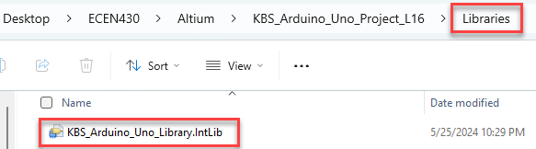

## Open KBS_Arduino_Uno_Project_Lxx.PrjPcb as a Local Project

1. Start Altium Designer.
2. Sign in and Use License.
3. Select File > Open Project.
4. Select Local File.
5. Select Browse.
6. Browse to %UserProfile%\Desktop\ECEN430\Altium\KBS_Arduino_Uno_Project_Lxx.
7. Select KBS_Arduino_Uno_Project_Lxx.PrjPcb.
8. Select Open.

## Add the Integrated Library to the Project

1. Right click KBS_Arduino_Uno_Project_Lxx.PrjPcb.
2. Select Add Existing to Project.
3. Browse to %UserProfile%\Desktop\ECEN430\Altium\KBS_Arduino_Uno_Project_Lxx\Libraries.
4. Select Library file (*.intlib;*.lib;*.schlib;*.pcblib) for the file type.
5. Select KBS_Arduino_Uno_Library.IntLib.
6. Select Open.
7. Select File > Save All.

The project should now look like this:

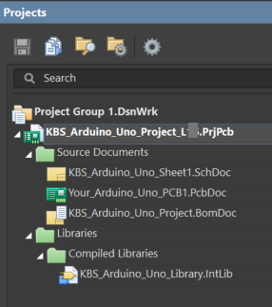

## Make Project Available Online

1. Select Workspace 
2. Right click KBS_Arduino_Uno_Project_Lxx.PrjPcb.
3. Select Make Project Available Online.
4. Select Advanced.
5. Select … to browse.
6. Expand ECEN430_S24 in the Choose Folder dialog box.
7. Select Lxx where xx is your assigned bench (e.g., L01).
8. Select OK to close the Choose Folder dialog box.

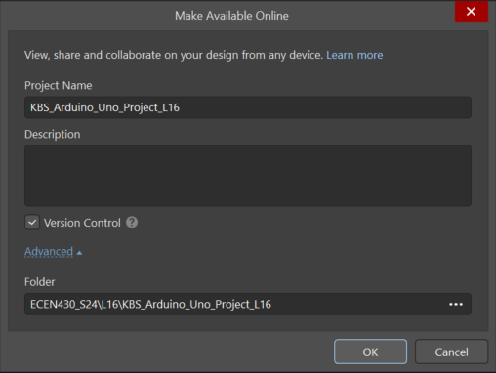

1. Select OK to close the Make Available Online dialog box.
2. Select Close to close the Project Available in Altium 365 Workspace.

The Projects panel should look like this:

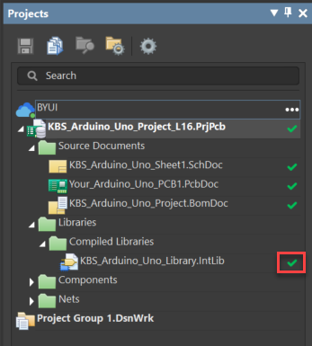

Notice the green check next to .IntLib indicating that the library is also saved to the server.

## Specify Online Project Share Settings

1. Open Explorer panel.
2. Expand ECEN430_S24 > Lxx where xx is your bench number.
3. Select KBS_Arduino_Uno_Project_Lxx.
4. Select Share.

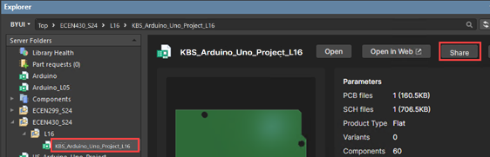

1. Select Shared with:.
2. Enter and select ECEN430_L16
3. Select Can Edit.

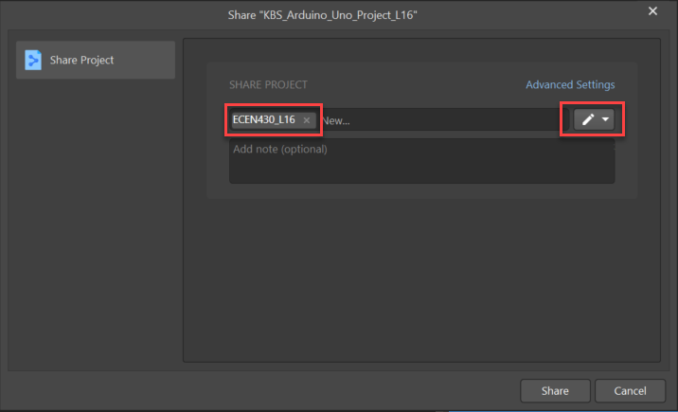

1. Select Share to close Share dialog.
2. Select Who has access .
3. Enter ECEN430_S24_TA.
4. Select Can View.

1. Select Share to close Share dialog.
2. Select Who has access .
3. Select Remove for Workspace Can Assess.

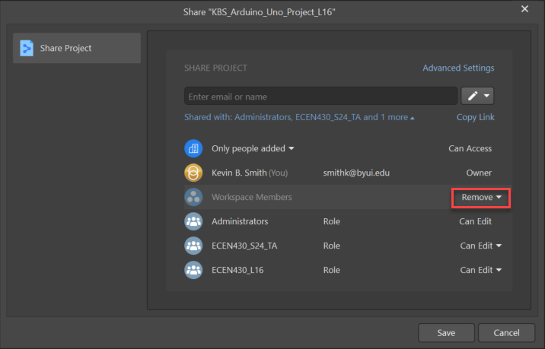

1. Select Save.
2. Select OK to close Share “KBS_Arduino_Uno_Project_Lxx.”

# To Open an Existing Online Project (Quick Reference)

1. Set Local Path
   1. Setup System Preferences  > Data Management > Design Repositories > Properties.
   2. **Browse** to the Local Path (e.g., %UserProfile%\Desktop\ECEN299\Altium).
   3. (The folder must exist. If you want a fresh copy, verify that the folder is empty of the project to download)
2. Set Active Server .
3. Browse to and Open online project.
   1. Open Explorer panel.
   2. Select Online Project to open.
   3. Select Open 

# To Open an Existing Online Project (Detailed)

## Set Local Path

1. Start Altium Designer.
2. Sign in and use license.
3. Select Setup System Preferences icon.

1. Select Data Management > Design Repositories.
2. Select Properties.
3. **Browse** to the Local Path (e.g., %UserProfile%\Desktop\ECEN430\Altium).
4. (The folder must exist. If you want a fresh copy, verify that the folder is empty of the project to download)

1. Select OK to close Git Repository.
2. Select OK to close Preferences.

## Set Active Server

1. Open Altium Designer, Sign in, and Choose a license.
2. Select BYUI as you active workspace server.

## Browse to and Open Project

1. Select Panels > Explorer.
2. Expand your Shared Team Folder (e.g., L16)
3. Select the project (e.g., KBS_Arduino_Uno_Project_L16).
4. Select Open.

The Projects panel should look like:

# To Edit a Component in the Integrated Library

1. Right click on the integrated library.
2. Select Extract Sources.

(You can also just double click on the Integrated Library, but only do it once or you will get multiple copies.)

A library package project is created locally where the integrated library is located.

1. Right click KBS_Arduino_Library.LibPkg.
2. Select Save.

A Save As dialog box opens.

Use the default location of

%UserProfile%\Desktop\ECEN430\Altium\KBS_Arduino_Uno_Project_L16\Libraries\KBS_Arduino_Uno_Library

1. Select Save to close the Save As dialog box.

## Edit SchLib

1. Open KBS_Arduino_Uno_Library.SCHLIB.
2. Open SCH Library panel.
3. Select and edit the desired items.

## Edit PcbLib

1. Open KBS_Arduino_Uno_Library.PcbLib.
2. Open PCB Library panel.
3. Select and edit the desired items.

## Recompile Integrated Library

1. Open ProjeSelect Panels > Projects.
2. Select File > Save All.
3. Right click KBS_Arduino_Uno_Library.LibPkg.
4. Select Compile Integrated Library xxx.LibPkg.

## Replace old Integrated Library with Recompiled One

1. Right click KBS_Arduino_Uno_Library.LibPkg.
2. Select Explore.

A File Explorer opens.

1. Open “Project Outputs for KBS_Arduino_Uno_Library” folder.
2. Right click on KBS_Arduino_Uno_Library.IntLib.
3. Select Copy.
4. Back up two levels to the Libraries folder, i.e.,  
   %UserProfile%\Desktop\ECEN430\Altium\KBS_Arduino_Uno_Project_Lxx\Libraries.
5. Right Click and select Paste.
6. Select Replace the file in the destination.

### Save to Server

1. Go back to Altium Designer.
2. Open Projects panel if it is not already open.
3. Rick click KBS_Arduino_Uno_Project_Lxx.PrjPrb.
4. Select History & Version Control > Refresh.
5. Select Save to Server.

A Save dialog box opens.

1. Enter “The integrated library was updated.” as a comment.

1. Select OK to close.

The Project panel now shows that the files are synchronized.

# To Synchronize Integrated Library on Another Computer

1. Right click KBS_Arduino_Uno_Project_L16.PrjPcb.
2. Select History & Version Control > Refresh.

The Project panel now appears as:

1. Select Update Project from Server.

The Integrated Library is now updated on the local computer and the Project panel appears as:

# Update Schematic to new Integrated library

1. Select Panels > Components.
2. Select Operations .
3. Select Library Preferences.

Verify:

1. Select Close.
2. Open Projects panel.
3. Open KBS_Arduino_Uno_Sheet1.SchDoc.
4. Set filter on only components.

1. Select all components on the sheet.
2. Right Click a component.
3. Select Find Similar Object.
4. Select Object Kind: Part.

1. Select OK.
2. Select Source.
3. Select KBS_Arduino_Uno_Library.IntLib.

1. Select Do not change.

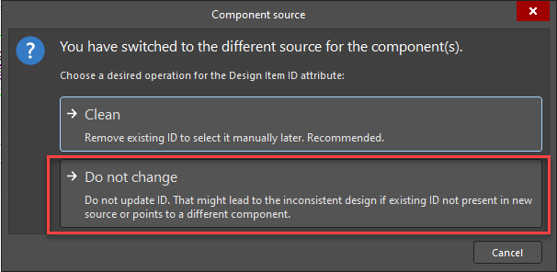

1. Select File > Save All.
2. Select Save to Server.
3. Add comment.

1. Select OK to close save.

The Projects panel should look like:

