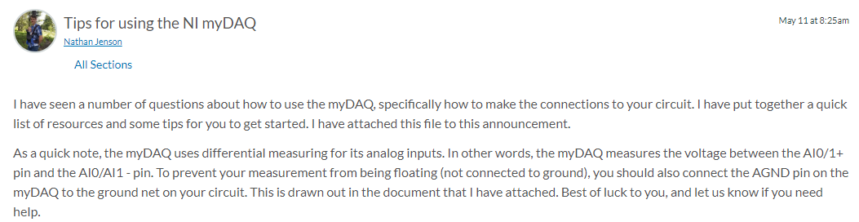

1. Install the NI myDAQ software. Instructions to this are found [here](https://byui.instructure.com/courses/88242/files/35425996/download?wrap=1).
2. Connect the myDAQ device to your computer USB port, then open the NI Elvismx instrument launcher from the Start menu of your computer.
3. Open the function generator and oscilloscope instruments from the instrument launcher.
4. Plug in the plastic header to the side port of the myDAQ device. It should look like this:

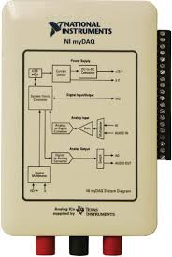

Figure : Plastic header on the myDAQ

1. Connect the male end of a male to female wire to the AGND port on the myDAQ. You should notice that when you turn the flathead screw in the plastic header, a metal gate within the header will open and close. Insert the wire lead into the gate, then close the gate by turning the screw clockwise to lock the wire into place.
2. Now that you’ve figured out how to connect wires to the myDAQ device, lets look at how to connect the rest of the wires. Here’s a quick sketch showing the myDAQ connections to be used for the o-scope and function generator.

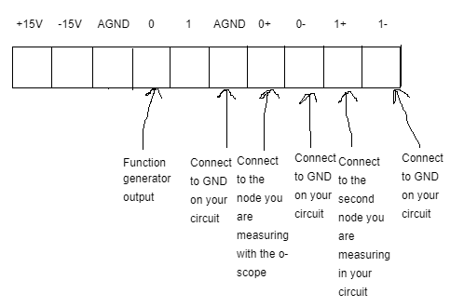

Figure 2: myDAQ connections for using the o-scope and function generator

1. If you are testing your daughter board outside of the chassis, you would want to use the DC Level instrument (Found in the NI Elvismx instrument launcher widow) for a power supply to the op amp. You would want to use AO pin 1 and AGND for the power supply.
2. Here are some online resources from NI for using the oscilloscope:

<https://www.ni.com/en-us/support/documentation/supplemental/10/using-mydaq-with-the-ni-elvismx-oscilloscope-soft-front-panel.html>

1. Here is a video showing how to use the oscilloscope and function generator:

<https://www.youtube.com/watch?v=E92mI4n0zvo>

When you perform the measurements, you should use one of the o-scope channels to measure the input signal (the function generator connected to the circuit input) and the other o-scope channel to measure the circuit output.

Another helpful resource is the mother and daughter board jumpers and header pins document found on canvas or here:

<https://byui.instructure.com/courses/88242/files/34385628/download>