Lab 2 Schematic and Simulation

Table of Contents

Prerequisite 1

Set Schematic Preferences 1

Set up the Grid. 2

Place Components on the Schematic 2

Set Grid 2

Align Components to the Grid 7

Set Up for Simulation 8

Install Extension (Mixed Simulation) 8

Place Voltage Sources 8

Assign Simulation Models to Placed Components 10

Resistor Simulation Model 10

KBS_7pin_Header_Buffer Component 12

Op Amplifier with footprint kbs_SO14_w_Guide_Pin_Holes 13

Adding Simulation Models to ECEN299_Library.LibPkg 16

Run Simulation 16

DONT FORGET TO SAVE!!!! 21

Appendix A 22

## Prerequisite

1. Complete Lab 1.
2. If the project for Lab 1 is not already open in Altium Designer then follow these steps.
   1. Select Windows Start > Altium Designer.
   2. If not already done, open the Projects panel (View > Panels > Projects).
   3. Verify that ECEN299_Library.PcbPkg is open. (If not, open it.)
   4. Verify that Lab1_Buffer.PrjPcb is open. (If not, open it.)

## Background

The circuit that will be built is shown in Figure 1. It is called an inverting amplifier circuit, and it is being used as a buffer circuit. It is called a buffer circuit because the inputs Lin and Rin will always see regardless of what the outputs Lout and Rout are attached to. The Left output voltage, Lout, is calculated as

This equation holds when the Op Amp is not saturated. Saturation occurs if the output is being driven to a value outside of the supply voltages. That is, the output voltage is bounded by

For example, if then On the other hand, if then the calculated value is , However, before it reaches that value the Op Amp will go into saturation which holds to roughly -

Figure 1 Buffer Circuit Schematic

## Set Schematic Preferences

1. Open preferences by selecting the gear icon in the top right corner.

Note: to open documentation on a topic, select any topic in the preferences and hit F1.

1. Open the Schematic > General Options section.
2. Select Display Cross-Overs.

Now arcs will be displayed where wires cross but are not connected.

1. Open Schematic > Graphical Editing section.
2. Select Always Drag.

This will keep wires attached to a symbol while moving the symbol around.

Hold the control button down before moving the symbol to temporarily toggle between modes. Click Apply to save the new preferences.

## Set up the Grid.

If you accidentally use a small grid, it can be extremely difficult to see if wires are currently tied to a component without zooming in very far. And this could lead to a lot of accidental opens in your productivity.

1. Double click Buffer_Sheet1.SchDoc so it is open and select View>Panels > Properties.
2. Expand the General tab. Note: Your Properties panel changes based on what you are currently working on. For example, if you have a component selected, this panel will show you the properties of that component. So, in this case you should have the Buffer_Sheet1.SchDoc open.
3. Enter Visible Grid as 100mil.
4. Enter Snap Grid as 200mil.

Note: Any grid value can be entered using the Properties panel. Using the hotkey G, you are limited to the 3 options of 10, 50, 100 that are set up in Preferences > Schematic > Grids.

# Place Components on the Schematic

1. Double click **Buffer_Sheet1.SchDoc** in the Project panel to open it.

### Set Grid

1. Press the g key to cycle through grid spacing. Stop on Grid: 100mil. To see the current grid spacing look at the bottom left of the program.
2. Select **View>Panels > Components** if the panel is not already open.
3. To place the components on your Buffer_Sheet1.SchDoc shown in Figure 1, select Components panel.
4. Double Click on **CMP-014-00002-1** to select the Op-Amp. The Op-Amp should follow your cursor. Before placing the Op-Amp in the schematic sheet, press the Tab key to open the properties of your selected component.
5. Change the Designator from U?? To U1, and then click on the pause button to exit the Properties panel of the Op-Amp. 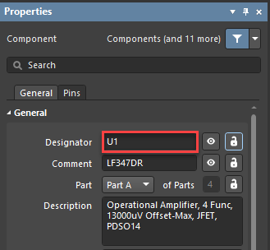
6. Place the Op-Amp by left-clicking anywhere in the Buffer_Sheet1.SchDoc and press the Tab key again before placing the second Op-Amp.
7. In the properties panel, select Part D for the second Op-Amp and then click on the pause button to exit the Properties panel. (Note: The first op amp was automatically assigned PartA) 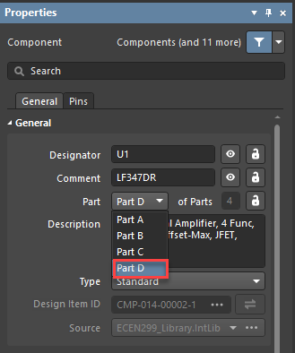
8. Place the Second Op-Amp and then press the Esc key to exit.
9. In the Components Panel, double click on the **CMP-009-00177-1** to place the resistor. Before placing the resistor, press the Tab key and change the Designator from R?? To R1.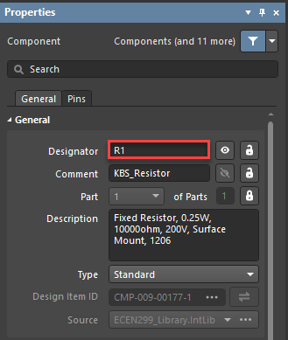
10. Click on the pause button to exit the Properties panel of the resistor and start placing the resistors as shown in Figure 1. Notice that the designators of the resistors start increasing as they are being placed.
11. To change the resistance value for R2 and R4, click on the value of the resistor. 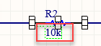
12. Change the resistance value in the Properties Panel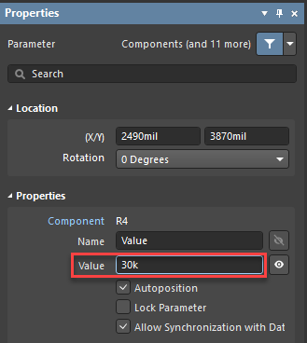
13. In the Components Tab, double-click or drag the **CMP-002-00071-2** to place the 7 Pin Header.
14. Make sure to change the Designator of the 7 Pin Header from *? To U2.
15. To connect your components with wires, click the double-blue wavy line (Which is the wire tool) as shown below.



1. Click on the place you want to start then click again where you want to end the wire. When you are finished with the wire tool, you can either right click or press the escape button. Hint: A shortcut to create a wire without using the wire tool is by dragging a component next to the one you want to connect to until the leads touch. Then, drag them apart, and a wire will be created.
2. To add a ground to your schematic, click on the ground symbol and click to place it.
3. To place a circle style power port for V+ and V-, right-click on the ground symbol and select 'Place Circle style power port’ as shown below. 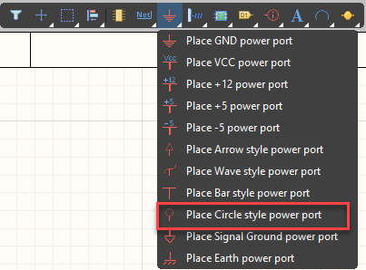
4. Make sure to change the names to match V+ and V-. (If you need to flip the power port just type 270 in the degrees option when you hit tab)
5. Add net labels by right clicking the wire tool and selecting the net label as shown. Note: Net Labels are the labels on the 7-pin header and wires. This shows where the 7-pin header connects to the components in the schematic. For example, Lin is the left input which will connect to R1. So, we place a net label, Lin, on the 7-pin header and where we want the input to go, in this case the left side of R1.

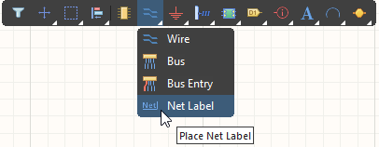

1. Click to place. Right click or press escape to exit.
2. Then rename the net label by clicking on it. Then under Net Name change it to be the name specified in the schematic. (The net labels in the schematic are Lin, Lout, Rin, Rout, GND, V+, and V-) note: All the labels on the 7pin header are net labels. Those net labels will connect to the ground symbols and the Circle style power ports. For example, the GND net label on the 7-pin header will connect to the ground symbol placed on the positive lead of the Op-Amp. Likewise, the two power ports V+ and V- will connect to the net labels V+ and V-.
3. Select **File > Save All**.

# Align Components to the Grid

If the components get placed off grid, they may be difficult to wire together. Follow these steps to align the components back to the grid.

1. Type g to cycle the grid resolution to the desired value.
2. Select all the components on the schematic.
3. Select Edit > Align > Align To Grid.

# Set Up for Simulation

# Install Extension (Mixed Simulation)

1. Start Altium Designer.
2. Sign in.
3. Select User Icon (top right).
4. Select Extensions and Updates.
5. Select Purchased Tab.
6. Hover over Mixed Simulation
7. Select the download icon that appears. If already downloaded, it will show a check mark as shown below. 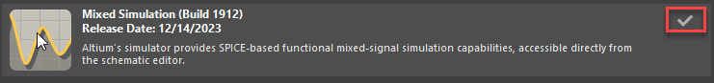
8. Select OK to restart Altium Designer message.
9. Close Altium Designer.
10. Start Altium Designer.

## Place Voltage Sources

1. Select Simulate tab > Place Sources > **Voltage Source**.
2. Create two DC sources, one at +14 volts and the other at –14 volts as shown in the image below on the left.
3. Create two Sinusoidal sources both at 1 amplitude and a frequency of 1k as shown below on the right.

The DC Magnitude parameter value is used when running an Operating Point analysis.

The AC Magnitude parameter value is used when running an AC Sweep (or frequency) analysis.

The Amplitude parameter value is used when running a Transient analysis.

1. As shown in the schematic below add ground labels to the newly created voltage sources as previously explained (see place components on the schematic step 18)
2. Add circle style power ports to each voltage source with names as the schematic below specifies. (For a reminder see place components on the schematic step 19)

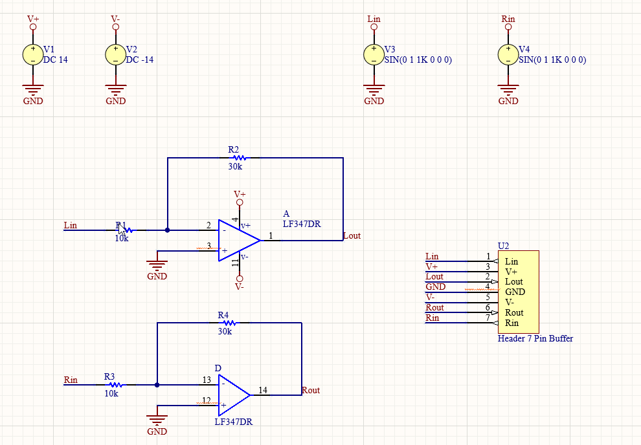

Include a screenshot of your Buffer_Sheet1.SchDoc schematic sheet in your lab report.

## Assign Simulation Models to Placed Components

### Resistor Simulation Model

1. Right Click on R1 and select Properties.
2. Expand Parameter.
3. Select Models.
4. Select Add > Simulation.

1. Change the Model Type to Resistor.

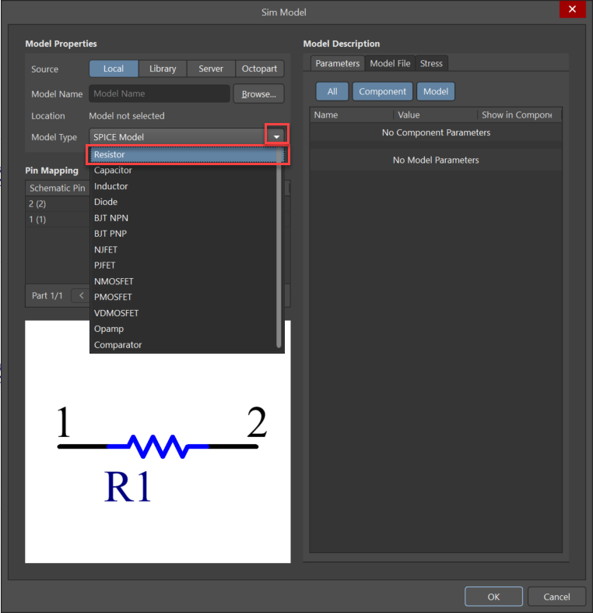

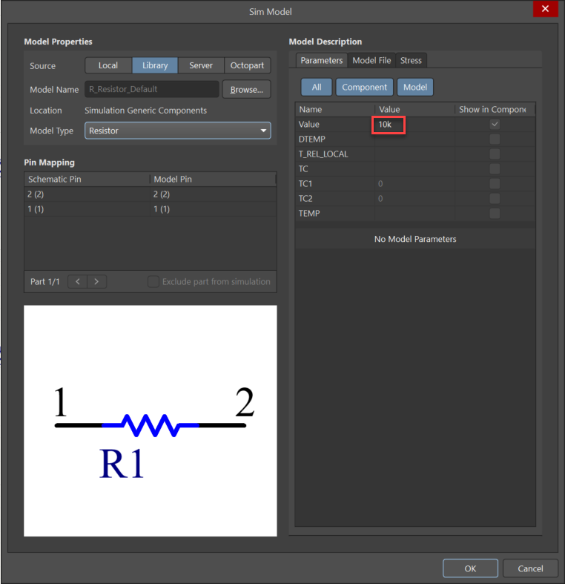

1. Change Value from 10k to a desired value.
2. Click OK exit Sim Model.
3. Repeat steps above to add a simulation model to resistors R2, R3, and R4.

### KBS_7pin_Header_Buffer Component

1. Open notepad and create a document with the name DONOTHINGSPICEMODEL.CIR with the following two lines :

.SUBCKT NOTSIMULATED 1

.ENDS NOTSIMULATED

1. Click on the 7-pin header that was previously placed on the schematic.

The Properties window will open.

1. Make sure ‘Models’ is selected in the Parameters section.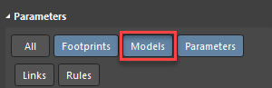

Note:The selected Parameters are blue as shown in the picture.

1. Select Add at the bottom of the Parameters section.
2. Select Simulation.
3. Select Local as the Source.
4. Select Browse.
5. Select DONOTHINGSPICEMODEL.CIR. Note: This document is made by you.

This is a text file with the following two lines in it:

.SUBCKT NOTSIMULATED 1

.ENDS NOTSIMULATED

1. Select Open.
2. Select Model File in the Model Description section.

The contents of DONOTHINGSPICEMODEL.CIR are displayed.

1. Update the Pin Mapping as follows.

1. Select OK to close the Sim Model window.

### Op Amplifier with footprint kbs_SO14_w_Guide_Pin_Holes

1. Click on one of the Op-amps previously placed. The properties panel will open.
2. Double-Click on Simulation 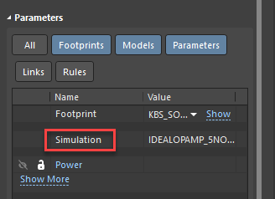
3. The Model Name of the Op-Amp should be ‘IDEALOPAMP_5NODES’ as shown below. In case your Op-Amp doesn’t have this Model, refer to Appendix A. 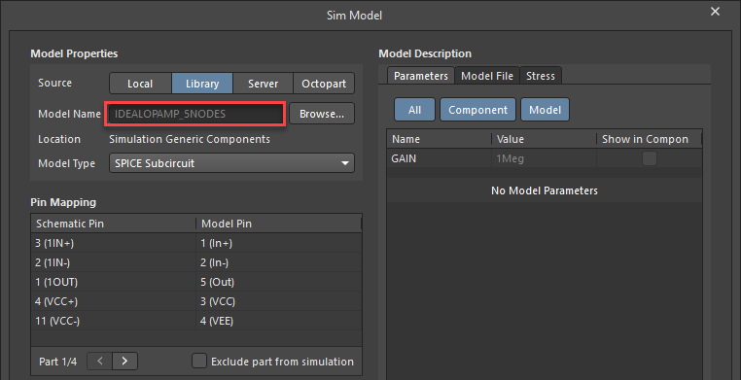
4. Correct Pin Mapping for Part 1/4, Part 2/4, Part 3/4, and Part 4/4.A screenshot of a computer

   Description automatically generated

Select OK to close the Sim Model window.

## Adding Simulation Models to ECEN299_Library.LibPkg

The simulation models can also be added to the components in ECEN_Library.SchLib. The steps are basically the same as described above for place components. As explained in Lab 1, when you are finished modifying the components, right click on ECEN299_Library.LibPkg and select Compile Integrated Library ECEN299_Library.LibPkg. Now, components placed components from the integrated library will now have the assigned models.

## Run Simulation

1. Select Simulate > Simulation Dashboard.
2. Select Start Verification. Note: If your Electrical Rule Check is not a green check, it means your schematic has an issue. For example, a resistor is unconnected.
3. After verification is complete, expand **3. Analysis Setup & Run** section in the simulation dashboard.
4. Expand the Transient tab, then click on +Add under the Output Expressions. To add a simulation output for v(Lin), click on the three dots as indicated below. A new window will open. Scroll down until you locate v(Lin), select it, and click on 'Create'. 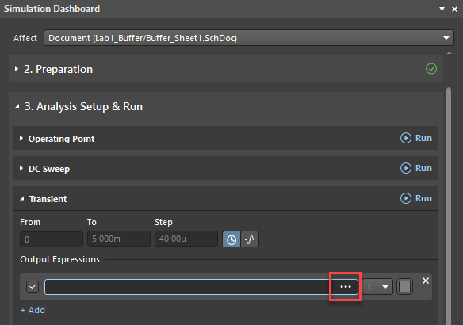
5. Repeat step 6 for v(Lout), v(Rin), and v(Rout).
6. Assign the left channel to plot 1 and the right channel to plot 2. To create a new plot, open the drop-down menu labeled with the number 1 and choose 'New Plot'. Additionally, consider customizing the plot colors, as they will initially appear gray by default.

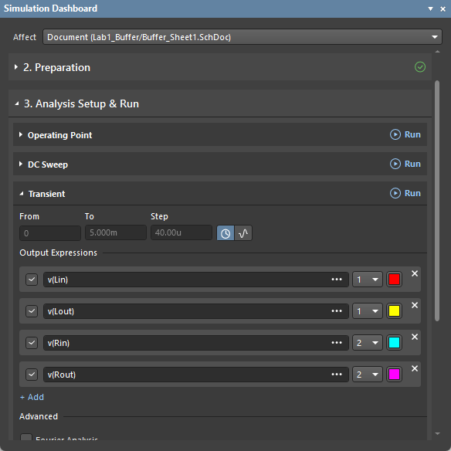

1. Select Simulate > Run Simulation.

Lab3_Buffer.sdf will open.

1. Select Transient Analysis Tab at the bottom to see your simulation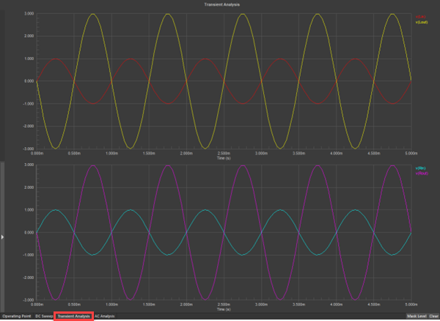
2. Go back to the Schematic.
3. Select Simulate > Simulation Dashboard.
4. Expand 3. Analysis Setup & Run.
5. Select Operating > Run.

The window with plots will open.

1. Select Panels > Sim Data.
2. In the Source Data box find v(Lout) then Add Wave to Plot. Repeat this step for v(rin) and v(rout).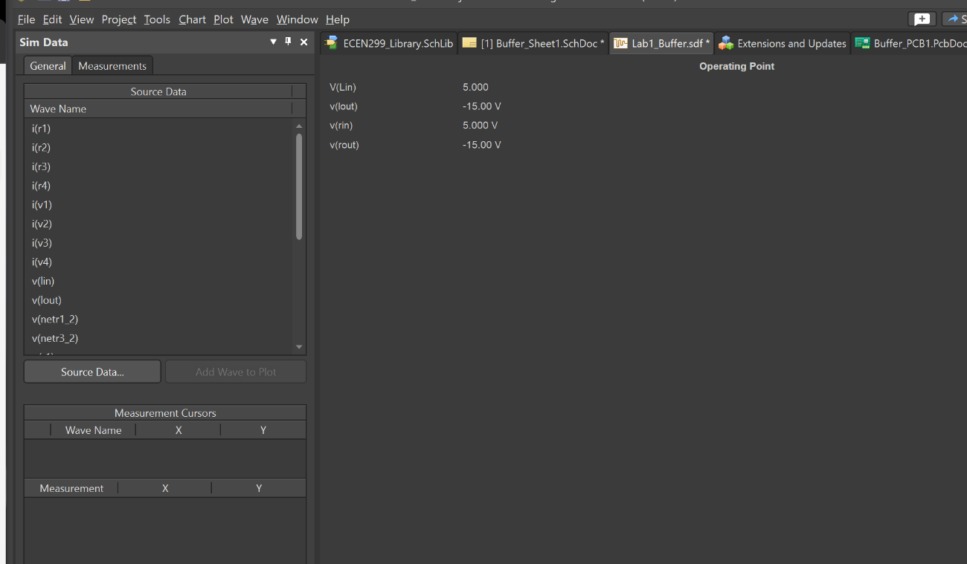
3. Go back to the Schematic.
4. Select Simulate > Simulation Dashboard.
5. Expand 3. Analysis Setup & Run.
6. Expand Operating Point.
7. Select Voltage.

Voltage value labels appear on the schematic.

1. Toggle the Power button and the Current button as well to see Power value labels and Current value labels appear on the schematic.

Include a screenshot in your report of the Transient Analysis as shown on Lab1_Buffer.sdf, the Operating point as shown on Lab1_Buffer.sdf, and the circuit with the Voltage value labels turned on as shown on Buffer_Sheet1.SchDoc. Does the design operate as expected? Explain why or why not. Is saturation modeled as expected? Also include the equations for gain using an inverting op-amp configuration. Does the design meet design specifications, based on your simulation?

# DONT FORGET TO SAVE!!!!

1. Select File > Save All.

# Appendix A

1. Select Add in the Parameters section.
2. Select Simulation.
3. Select Library as the Source in the Model Properties section of the Sim Model window.
4. Select Browse.
5. Select Simulation Generic Components.
6. Select Op-Amp with power terminals.
7. Select OK