Lab 3 Layout and Gerber Files

Table of Contents

Duplicate Lab1 and Rename as Lab3 3

Open Lab3_Buffer.PrjPcb Project 3

Validating in Altium Designer 3

Constraint Manager 4

Transfer Schematic to PCB 4

PCB Editor Environment 5

View Modes (View > top three options) 5

2D Layout Mode – View Manipulation 5

Active layer 5

3D Layout Mode – View Manipulations 5

Shaping the Board Outline 6

Change Grid to 100mil. 7

Place a Rectangle 8

Constraints and Clearances (PCB Design Rules) 9

Placement and Routing 12

Adding Text to the Layout 15

Creating a Ground Plane 16

Make Bottom Layer a Ground Plane 16

Access Polygon Connect Style (Thermal Relief) 17

Repour Polygon Pours to Update 19

Create Manufacturing Files (Gerber and NC Drill) 19

Verify Drill and Gerber Files Will Upload to JLCPCB 22

Altium Viewer 23

Sharing Projects through workspace 23

Items to Include in Your Report 25

Appendix A 26

Import Components from Schematic 26

Appendix B 27

Routing with Vias 27

Appendix C 28

Changing File type in Windows 10 or 11 28

# Duplicate Lab1 and Rename as Lab3

1. Open Window Explorer.
2. Change directory to %UserProfile%\Desktop\ECEN299.
3. Copy and paste the folder Lab1_Buffer.
4. Rename ‘Lab1_Buffer – Copy’ to Lab3_Buffer.
5. Open the Lab3_Buffer folder.
6. Rename Lab1_Buffer.PrjPcb to Lab3_Buffer.PrjPcb.

# Open Lab3_Buffer.PrjPcb Project

1. Double click Lab3_Buffer.PrjPcb.

# Validating in Altium Designer

Validation refers to making sure the design meets our specifications for the electrical rules check or ERCs.

1. Select Project > Project Options.
2. Select Error Reporting tab if it is not already open.
3. Select **Set To Installation Defaults** in bottom left and click confirm.

|  |
| --- |
| * + The ***Error Reporting*** tab will help us with drafting checks.   + The ***Connection Matrix*** will help us with connectivity checks.   + The ***Options*** tab has some features that affect the net list.   + The ***Error Reporting*** tab displays violation types and are separated by category. Hit F1 from this window to access the full list of errors in what they mean.   + The Report Mode column shows their respective reported severity. With choices of No Report, Warning, Error, and Fatal Error.   + You can click on the column header to sort each category by error severity.   + The **Set To Installation** Defaults is a great starting point. |

1. Select OK to close the Options window.
2. Double click Buffer_Sheet1.SchDoc to open the schematic.
3. Select Tools > Preferences > System > Navigation.
   * 1. Adjust how close you zoom into graphical objects using the slider here.
     2. Adjust how the level to which non-matching objects are dimmed out with the slider.
     3. Select Set To Defaults  > Default (Page).
     4. Select OK to close the Preference window.
4. Select Project > Validate PCB Project <Project_Name.PrjPcb> to run the validation.
5. Select Panels > Messages to view the report if it does not open on its own because of Warnings.

If you select a line item, you'll see more details at the bottom about the warning or error and the features involved.

You can also double click on any line item in the panel to navigate to the location that is causing the warning or error.

1. Review the Warnings for problems.

# Constraint Manager

1. Select **Project > Project Options**.
2. Select **Connection Matrix** tab.
3. Toggle **Power Pin to HiZ Pin** **until it is** **generating no Report**

1. Select **OK**.

# Transfer Schematic to PCB

With our connectivity completed and the project validated and free of errors, we are ready to transfer to the PCB.

1. From Project panel, check if Buffer_PCB1.PcbDoc exists under Source Documents.
   1. If it does NOT exist, Right click on the project in the Projects panel and select Add New to Project and then select PCB.
2. Go back to the schematic page.
3. Select Design > Update PCB Document.
   * 1. Select Yes to Continue and create ECO.

The ECO dialogue that appears will show a list of the changes that need to be made in the PCB file with categories for each type of action.

1. Select Validate Changes in bottom left.
2. Select Execute Changes.
3. Select Only Show Errors.

Nothing listed is good. However, because of your voltage sources for simulation you may have some errors/warnings that don’t apply.

1. Select Close.

# PCB Editor Environment

Closer look at the PCB editor environment. We'll go over some basic preferences and navigation techniques.

## View Modes (View > top three options)

1. Select View > Board Planning Mode.

This mode is useful for board shape creation as well as rigid flux designs.

1. Select View > 2D Layout Mode.

This is the default mode used for most design steps including component placement and routing.

1. Select View > 3D Layout Mode.

Used to view the board in 3D space. You can't route in the 3D view mode, but you can move parts or labels such as silkscreen.

## 2D Layout Mode – View Manipulation

1. Pan – Hold down your right mouse button to pan in any direction.
2. Zoom – Hold down control and use the wheel to zoom in and out.
3. Move Vertically – Use the mouse wheel to move vertically.
4. Move Horizontally – Hold shift and use the mouse wheel to move horizontally.
5. View Menu – Use the letter V to access all of your view menu commands by paying attention to the underlined letters in the menu.
   1. For example, VD for view document. Or VF for fit board.
   2. To zoom in and out, you can use VI and VO by typing the letters.
   3. The A will allow you to define a rectangular area to view.
   4. VP will allow you to define an area around a point.

## Active layer

* The active layer is the highlighted tab among those located at the bottom of your screen.
* Click a tab to make it the active layer.

### 3D Layout Mode – View Manipulations

**View Orientation**

Using the numbers above your letters (not the 10-key pad):

* 8 will provide an orthogonal rotation.
* 9 will provide a 90 degree rotation.
* 0 will bring you back to 0 rotation.

**Rotation Orb Control**

* Hold down the shift key to bring up a rotation orb control.
* Use your right mouse button to manipulate it. While holding down shift, click **and hold** the right mouse button on any of the objects in the orb.

# Shaping the Board Outline

1. Select View> 2D Layout Mode.
2. Zoom out to see the origin symbol.

1. Select View > Panels > View Configuration.
2. Select the pulldown for Active Layer.
3. Select Mechanical 1 as the active layer as shown below.

(Or select the Mechanical 1 tab at the bottom of the main screen.)

### Change Grid to 100mil.

Change the grid to something larger to make the board shape easier to work with.

1. Type Control G on your keyboard to pull up the grid configuration.
2. Change the step to 100mil.
3. Select Lines for both Fine and Course instead of dots to make the grid easier to see.

1. Select Apply.
2. Select OK.

## Place a Rectangle

1. Select Place > Rectangle.
2. Click the PCB origin to define the lower left corner of the rectangle.
3. Move the cursor to X:1300mil Y:900mil.
4. Click again to define the top-right corner.
5. Right click to cancel placing another rectangle.

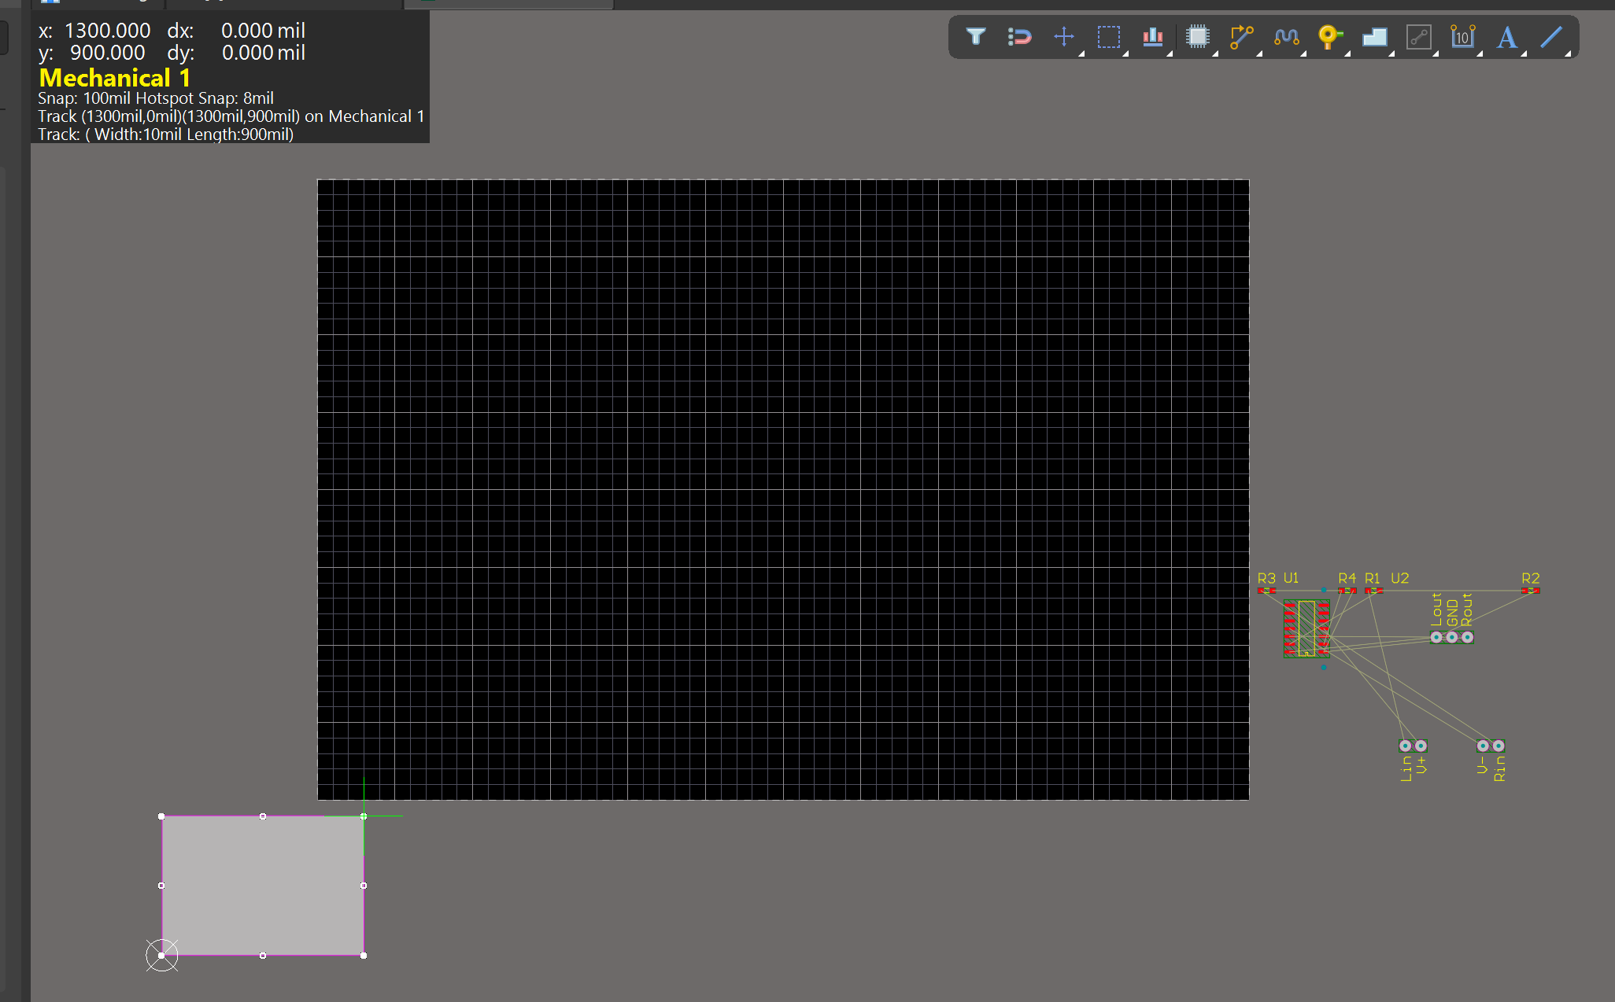

The rectangle should now be selected.

1. Select Design > Board Shape > Define Board Shape from Selected Objects.
2. Click on the screen to update the screen which should now look like this:

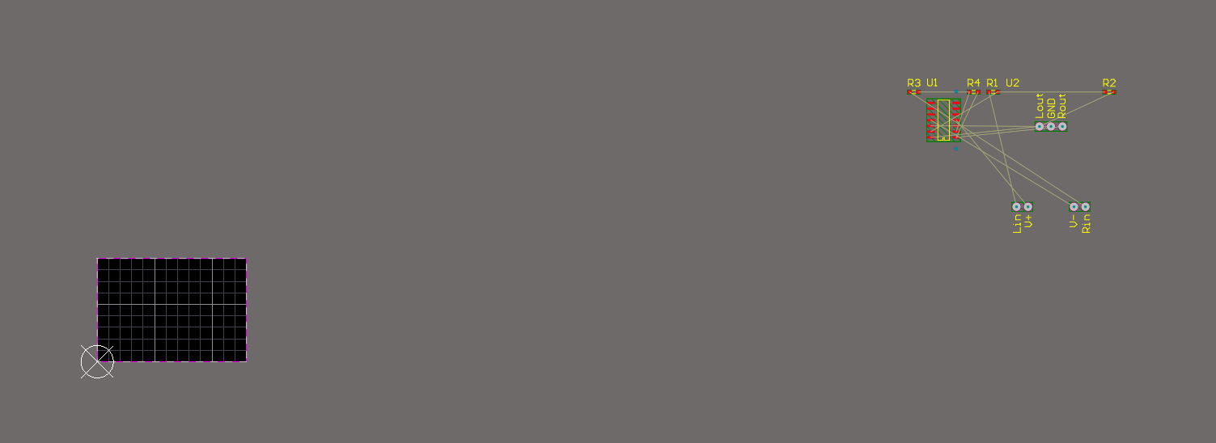

1. Select View > Fit Document.
2. Select [1] Top Layer to make it the active layer.

# Constraints and Clearances (PCB Design Rules)

It is important to make sure the boards we create in this class fit the constraint needs of the PCB fabrication company JLCPCB. These important constraints include trace width, via sizes, and clearance between conductors. To set these important constraints use the following steps

1. Go to design > constraint manager.
2. In the Properties Pannel, look under General and make sure the Units are set to mils.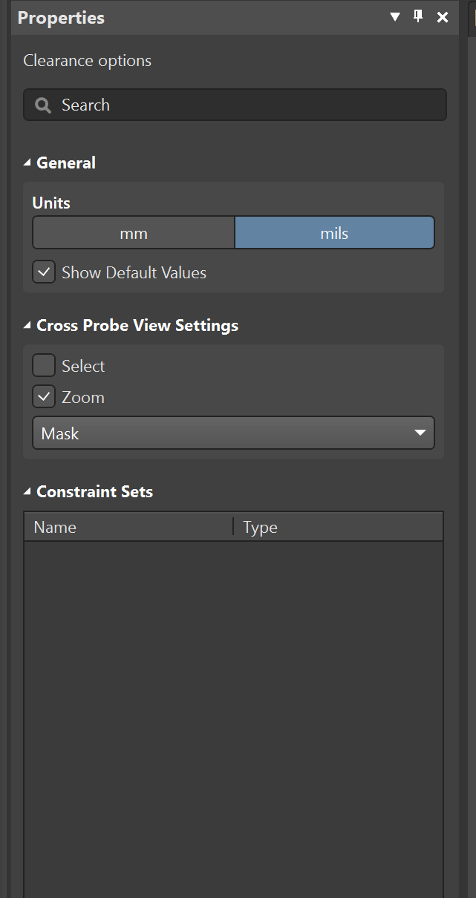
3. To the right there should be a Clearances tab open. Make sure that All Net Classes are set to 10mil as shown in this picture. If you need to change that value, you need to edit the diagram at the bottom of the screen. 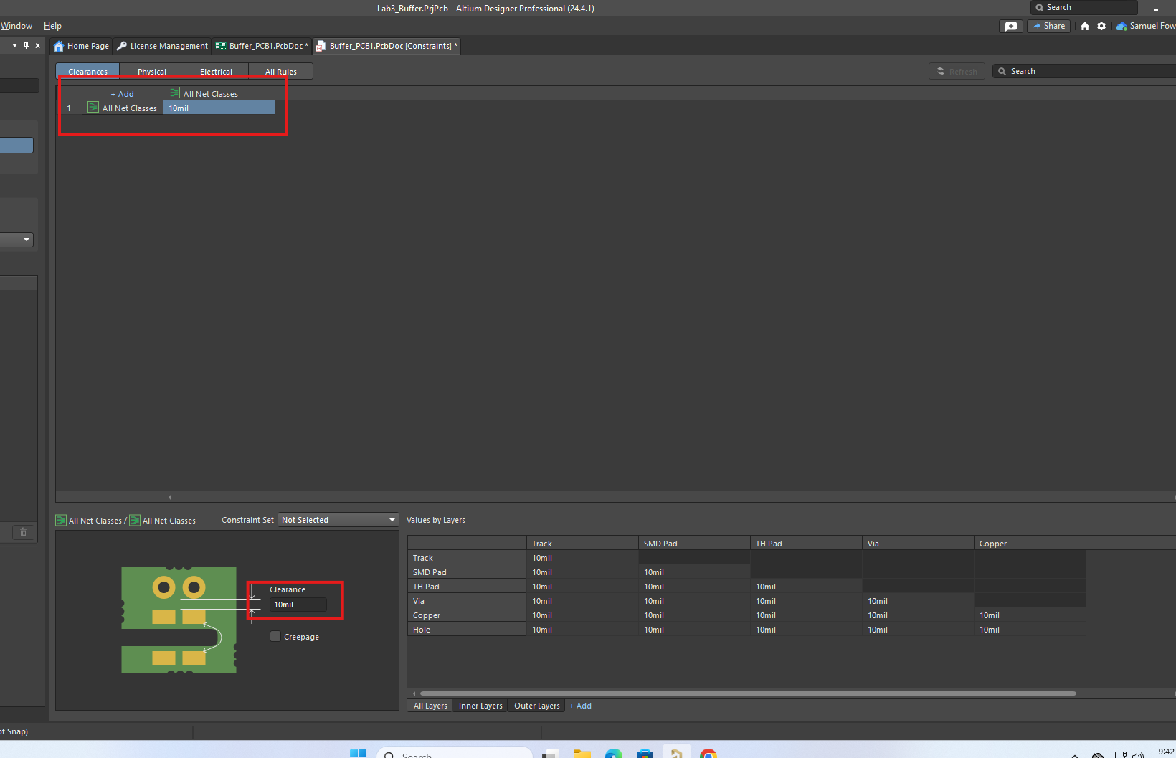
4. Click on the tab labeled Physical, and check the following constraints for “All Nets". A screenshot of a computer

   Description automatically generated
   1. Ensure Min Width, Preferred Width, Preferred Diff Pair Gap, and Clearance is set to 10mil.
   2. Check to make sure Via Style is set to 24mil, 12 mil (for diameter and hole size).
   3. Check to make sure Polygon Connect is set to Relief connect, 10mil, 10mil, 4, 90.
   4. To edit these constraints, click on the current value and then go to the corresponding diagram that shows up near the bottom of the page. 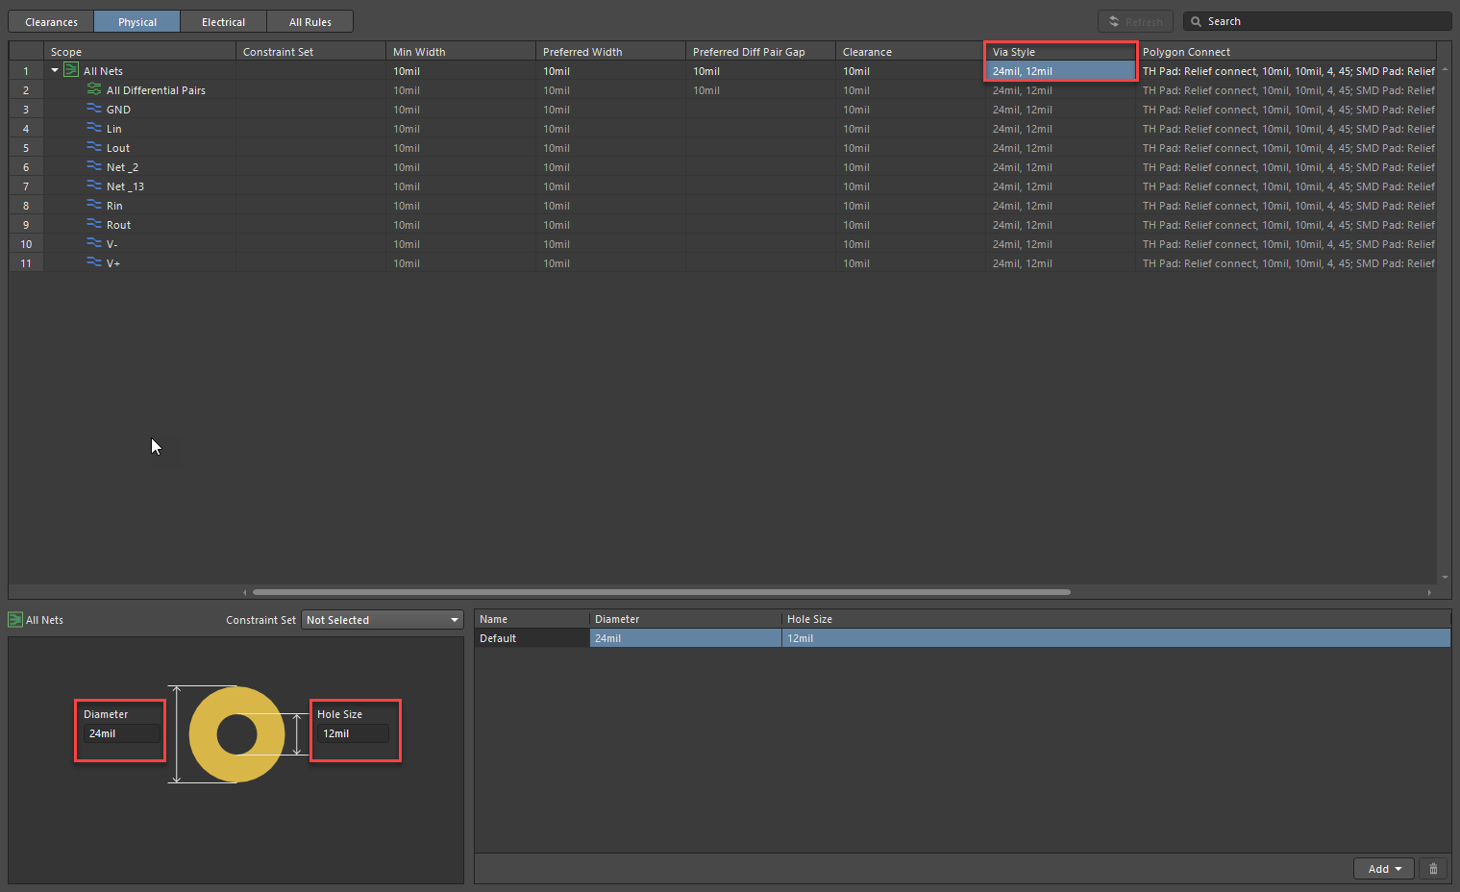
5. After ensuring the correct constraints there will be a new file created, called Buffer_PCB1.PcbDoc [Constraints]. Go to view>panels>projects and save any files that need saving up to this point.

# Placement and Routing

1. Place the Op-amp first.
2. Click and hold to drag the Op-amp to place it within the defined board shape near the center (Note: to make placing components easier consider changing the grid configuration to a smaller value).
3. Rotate the part so that pin 1 is oriented upwards.

**Note**: to rotate a component, grab the component and press the Spacebar to rotate counterclockwise or Shift + Spacebar to rotate the component clockwise. 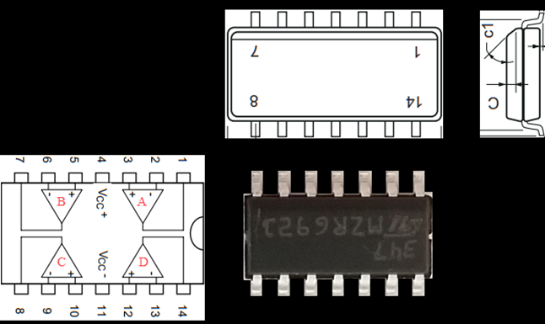

1. Followed by the Op-amp, place the 7 Pin header and resistors as shown below. **Note: When setting up your schematic there was a mistake in the second lab. Your inputs, outputs, and Resistor names are incorrect and are attaching to the wrong nodes. Before you continue you need to open the Buffer_Sheet1.SchDoc and swap the OP amps or rename the nets to the following. Lout to Rout, Rout to Lout, Rin to Lin, Lin to Rin, R1 to R3, R3 to R1, R2 to R4, and R4 to R2. If you need help renaming your resistors in your schematic, please see Lab 2 instructions. Once that change is made save your schematic file and follow** **Appendix A** **for details on updating your PCB(Appendix A is at the bottom of this lab).**

Here is corrected version of Schematic.

When you ensure your schematic is correct continue to place parts on your board in the following configuration.

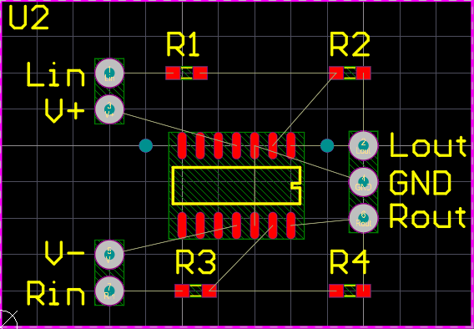

1. To start routing, first make the **Top Layer** active. Then, select **Route > Interactive** **Routing** or **Ctrl+W**. After launching the command, click on a pad from which you want to start routing. After launching the command, click on the pad from which you want to start routing. Then, move to the next pad and click on it to place your trace.

**Tip**: While routing, you can toggle the corner direction by pressing the **Spacebar**. Click to place a fixed segment. After clicking, you will see that the fixed segment has a solid fill and the ‘unfixed’ segment has a grid fill. When you move the mouse, only the unfixed segments will change. This allows you to build a trace on any path you want.

**Tip:** For more precise routing, you can change the **grid size** to a smaller one by pressing **G** then selecting the required grid size.

1. Route all your electrical connections except for those requiring the GND connection, as a Ground Plane will facilitate this. Later in this lab, you will learn how to create a Ground Plane.

1. Sometimes, routing on the top layer may not be possible due to other traces obstructing our desired path. To resolve this issue, Vias are utilized to establish vertical connections between two or more electrical layers. For detailed instructions on vias and their creation, please consult Appendix B.

## Adding Text to the Layout

1. To add a string to your layout design, first make sure you are working on the **Top Layer** and then click on Letter **A** as shown below.



1. The word ‘String’ will follow your cursor. Press the ‘Tab’ key to edit the properties of your string.
2. In the Text field, change it to your name. If you were working with a lab partner, also include your lab partner’s name.
3. In the Layer field, change it to ‘**Top Overlay**’.
4. Adjust the **Text Height** to 40 mil and the **Stroke Width** to 10 mil.

1. Click on the **Pause** button located in the middle of the screen to exit the Properties window.
2. Click to place your text, ensuring it falls within the board limits. Avoid placing it directly on top of a pad, via, trace, or pin.

# Creating a Ground Plane

Optional Video: View How to Create Polygons in Altium Designer | PCB Layout at <https://youtu.be/RM18_zJs31E>.

Optional Reference: <https://resources.altium.com/p/creating-ground-plane-your-pcb-design>.

## Make Bottom Layer a Ground Plane

1. Open Buffer_PCB1.PcbDoc.
2. Select Tools > Polygon Pours > Polygon Manager.
3. Select New Polygon from > Board Outline.

1. Select Net: **GND** and Layer: **Bottom Layer**.

1. Select Apply and Yes.
2. Select OK.

## Access Polygon Connect Style (Thermal Relief)

1. Select Design > Constraint Manager.
2. Select All Rules.
3. Select Plane > Polygon Connect Style.
4. Select PolygonConnect. A screenshot of a computer

   Description automatically generated
5. Select "Advanced" and change the rotation to 45 for the Through Hole Pad, and set the Via Connection Style to "Direct connect."

1. Go to Projects. Right click on the Buffer_PCB1.PcbDoc[Constraints] and select **Save**.

1. Make sure the Top Layer is active and start routing from a GND Pin of the Op-Amp IC.
2. Press Tab and in the Properties panel, change Layer to Bottom Layer. A via will be displayed

1. Click the pause button in the middle of the screen.
2. Click to place the via. Right click to exit.
3. Repeat **steps 7-10** to connect the remaining GND pin of the Op-Amp IC to the ground plane.

## Repour Polygon Pours to Update

If anything is done (such as adding vias or traces) that affects the shape of the ground plane, then you must repour the polygon.

1. Select Tools > Polygon Pours > Repour All.

This command needs to be repeated each time changes are made that affect the ground plane.

# Create Manufacturing Files (Gerber and NC Drill)

1. Open View > Panels > Projects.
2. Right click Lab3_Buffer.PrjPcb and select save.
3. Right click Lab3_Buffer.PrjPcb.
4. Select Add New to Project > Output Job File.
5. Under Fabrication Outputs, right click [Add New Fabrication Output] > NC Drill Files > [PCB Document], then press Enter.
6. Double click NC Drill Files
7. Make changes as shown:

1. Select OK
2. Under Fabrication Outputs, right click [Add New Fabrication Output] > Gerber Files > [PCB Document], then press Enter.
3. Double click Gerber Files.
4. Make only these selections:

1. Select Apply.
2. Select Folder Structure under Output Containers.
3. Select Enabled button for NC Drill Files.
4. Select Enabled button for Gerber Files.

1. In the **Projects** Panel, right click Job1.Outjob tab.
2. Select Save.
3. Save Job1.Outjob in the project folder (\Desktop\ECEN299\Lab3_Buffer).
4. Select Generate content on Folder Structure.

1. In the Projects Panel, right click Job1.Outjob > Explore.
2. Create a folder named Fab_Files_for_JLCPCB.
3. **Open Project Outputs for Lab3_Buffer (If you don’t find this folder save the project and repeat step 19 and come back to this step).**
4. Open the Gerber folder. Copy **all the files** to Fab_Files_for_JLCPCB.
5. Open the NC Drill folder. Copy Buffer_PCB1.TXT to Fab_Files_for_JLCPCB.
6. Change the file extension of **Buffer_PCB1.TXT** to **Buffer_PCB1.XLN**. If you require assistance, refer to Appendix C for guidance.
7. Select all files in Fab_Files_for_JLCPPCB. Right click on select files.
8. Select 7-Zip > Add to archive (verify it is a .Zip format). Select OK.
9. Fab_Files_for_JLCPCB.zip is now ready to be uploaded to JLCPCB.com.

## Verify Drill and Gerber Files Will Upload to JLCPCB

To verify that the NC Drill and Gerber files will upload to JLCPCB, using Chrome browse to JLCPCB.com (<https://jlcpcb.com/>). Click on Instant Quote. Select Add gerber file, then browse to your Fab_Files_for_JLCPCB.zip Gerber file, and open it. The page should show the front and back side of the PCB, as shown below. The silkscreen layer is in white. Traces in tan. Solder Mask in green. Drill holes in light grey. (If the page does not show the PCB, then go back to Layout and run through this section again.)

# Altium Viewer

Altium offers a way that you can view and share electronic designs online.

<https://www.altium.com/viewer/>

<https://www.altium.com/viewer/#how-it-works>

Experiment with this by uploading your project and/or your Gerber files.

# Sharing Projects through workspace

When you finish with the above steps and everything is saved, right click on the ‘Lab3_Buffer.PrjPcb’ project and click share. Type in the email space [fow22008@byui.edu](mailto:fow22008@byui.edu). This will be the process by which we grade future labs and submit files for fabrication. Click ok and share. When it askes if you want to share outside of workspace say yes.

## Items to Include in Your Report

* Screenshot of layout in Altium Designer.
* Screenshot of PCB as uploaded to JLCPCB.
* Explain steps to do the layout and lessons learned.
* Document changes made to the Constraint Manager.

# Appendix A

## Import Components from Schematic

If you need to update a change from your schematic to your PCBdoc follow these steps.

1. Select Projects in the bottom left corner
2. Open Buffer_PCB1.PcbDoc.
3. Select Design > Import Changes from Lab3_Buffer.PrjPcb.
4. Select yes to create ECO
5. Select Validate Changes.
6. Select Execute Changes.
7. Check the box to Only Show Errors. You will have a list of errors connect to the sources you made during simulation. These errors are ok. A screenshot of a computer program

   Description automatically generated
8. Select Close

# Appendix B

## Routing with Vias

Watch video: <https://www.youtube.com/watch?v=ty696kwd-h8>.

1. Select Route > Interactive Routing (Ctrl+W).
2. Click on a pad from which you want to start routing.
3. Press the Tab key to open the trace properties.
4. Change to the Layer you want to route. For this project, change to the Bottom Layer. A screenshot of a computer

   Description automatically generated

A via will be displayed.

1. Click the pause button in the middle of the screen.
2. Click to place the via.
3. Continue routing the trace.
4. If the destination of the trace is on the Top Layer, press the Tab key, and change to the Top Layer. A via will be displayed.
5. Click on the pause button and click to place the via.
6. Continue routing and click on the desired Pad to complete the trace.

# Appendix C

## Changing File type in Windows 10 or 11

**Windows 11**

* 1. Open File Explorer and navigate to the file you want to change. 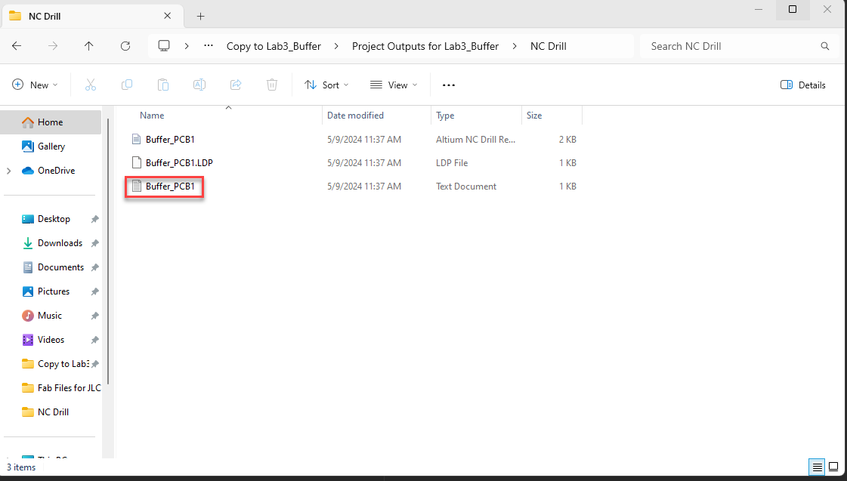
  2. Next, make sure you have file extensions turned on. Go to **View > Show > File name extensions**. 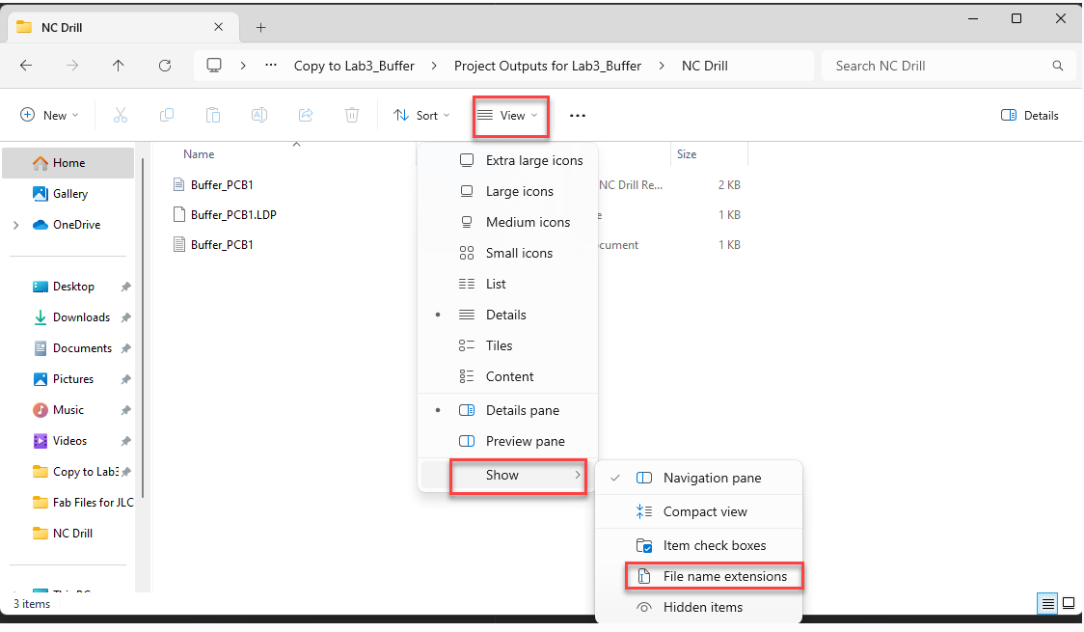
  3. Right-click on the file, then select ‘Rename’ from the menu. Modify the file extension accordingly.

**Windows 10**

1. Open File Explorer and navigate to the file you want to change.
2. Find the view tab. Then click on **File name extensions**.

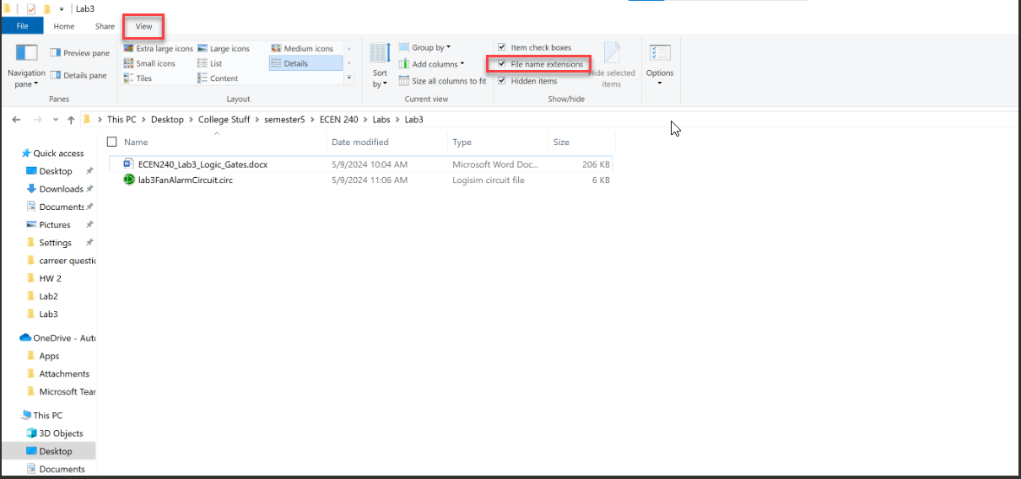

1. Right-click on the file, then select ‘Rename’ from the menu. Modify the file extension accordingly.