|  |
| --- |
| Project  Brain Food: A FeedBC Initiative at VIU  Ezra Boersma [ezra.boersma@itas.ca](mailto:mezra.boersma@itas.ca)  Windows Clustered File Services with FreeNAS  Ezra Boersma Vancouver Island University Project Guide Manual |

### 

### Last Updated:

### April 19th, 2023

Contents

Introduction 3

Project Components: 4

Modify and Manage Site Content 7

Troubleshooting 12

Resources 13

Map Marker Update Tutorial Video:

<https://youtu.be/3veE7ZDEx2s>

GitHub Code Repository:

<https://github.com/EzraBoersma/ezrab_feedbc>

Software Required:

**Microsoft Office Excel**

**Any Web Browser**

**Microsoft VS Code** or other editor (only needed for developers.)

Introduction

This is the companion guide to the ***VIU Food Services -  
Brain Food: FeedBC Initiative***. Here we will explain each of the project’s website components: the *four outlet menus*, *Food Services ‘Online Order’ platform*, and the *Local Food map* - and give a concise overview of how they work.

Most importantly, this guide will help to provide information about maintaining, modifying, or troubleshooting the website application – which includes the ***supplier map markers*** and ***outlet menu items***.

** Be sure to follow all steps in the procedure guides, as they contain important steps for creating backups as you work. **

For more technical information than is available in this guide, you may want to visit the [project repository](https://github.com/EzraBoersma/ezrab_feedbc) on GitHub, review code comments, or [contact](mailto:ezra.boersma@itas.ca) the project developer.

**Project Components:**

FeedBC Interactive Local Food Map

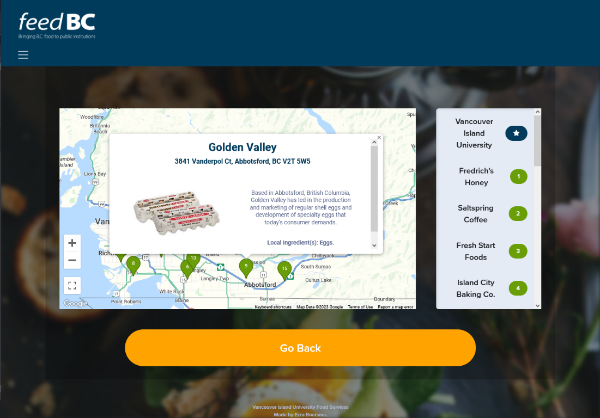**The heart of the application, the interactive map is a JavaScript vector map which displays dynamically generated** [Advanced Map Markers](https://developers.google.com/maps/documentation/javascript/reference/advanced-markers) **and a corresponding map legend. Each marker and legend item will bring up information about the selected food supplier and will show their location on our food map.**

**This uses the following components:**

* **Implemented using the** [Google Maps API](https://developers.google.com/maps)
* **Dynamically generated** [Advanced Map Markers](https://developers.google.com/maps/documentation/javascript/reference/advanced-markers) **and Legend**
* **JavaScript AJAX to load data from an excel workbook which is exported as a CSV -  
  to allow easy editing and adding of components.**

Food Services Interactive Outlet Menus

***</ Information in this section will change, pending completion of site deployment >***

**Another primary activity in this app is the accordion sections that contain the menu items for each of the food outlets operating under Food Services. These items will provide information about nutritional data, local food-sourcing, dietary compatibility, and allergen presence, in each of the food offerings currently available.**

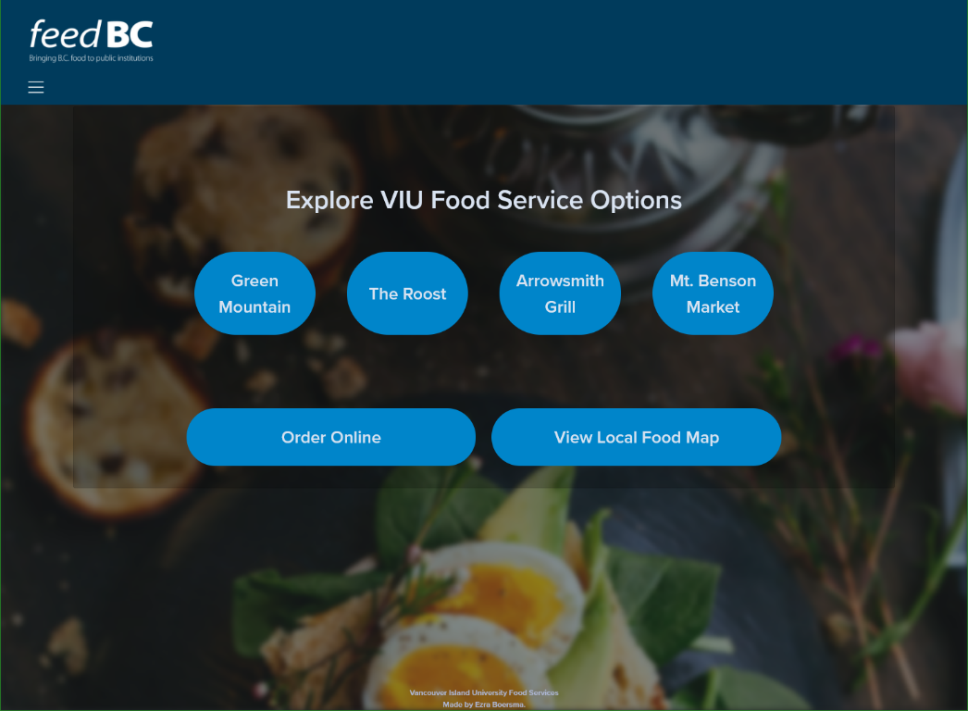

**This uses the following components:**

* **Dynamically generated menus**
* **Bootstrap Grid Layout**
* **JavaScript AJAX to load data from an excel workbook which is exported as a CSV -  
  to allow easy editing and adding of components.**

Food Services ‘Order Online’ Platform

***</ Information in this section will change, pending completion of site deployment >***

**The home will be linked into the online ordering platform for Food Services. There is no authentication outside that which already exists on that platform – and the kiosk management software will prevent any user data from being stored on the browser or device.**

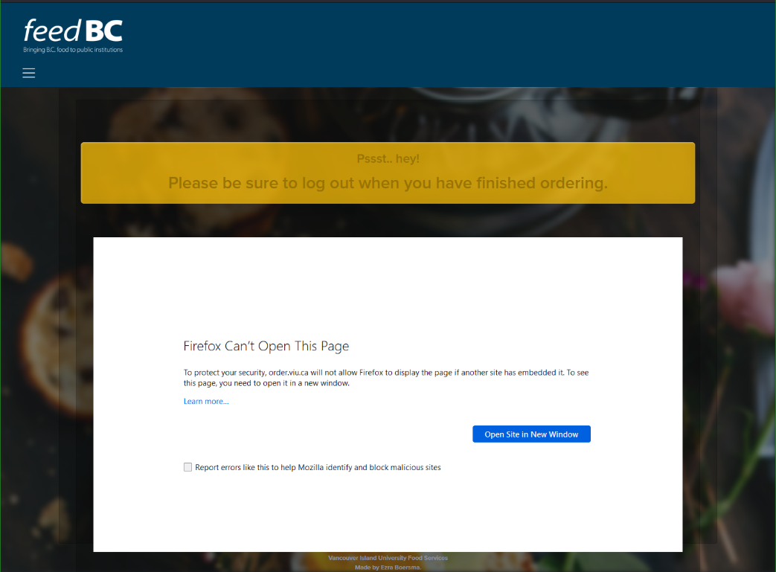

**This uses the following components:**

* **Food Services Online Ordering Site**
* **Scalefusion MDM Kiosk Lockdown**

Modify and Manage Site Content

Before You Begin

**Please review the information on this page prior to making any data changes:**

****1.)** In Microsoft Excel, go to: **File** > **Options** > **Advanced****

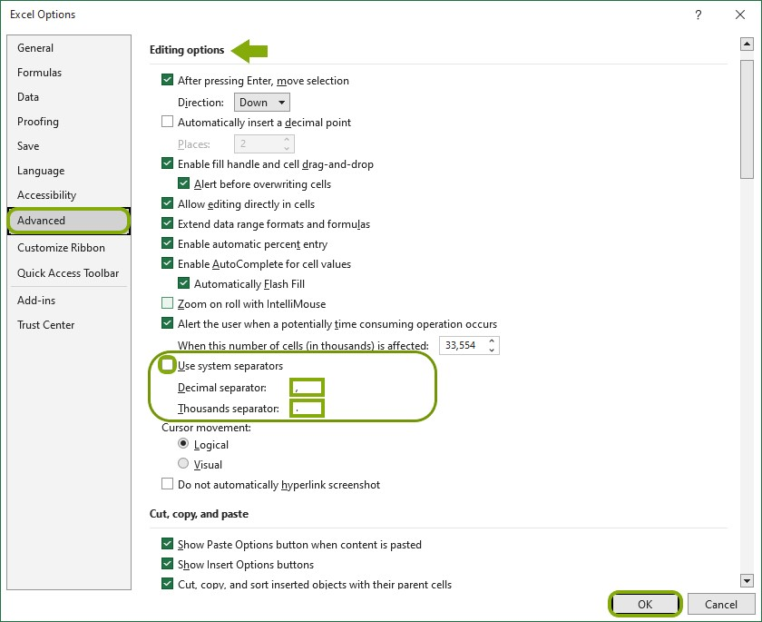

Figure 1 - Make sure your settings reflect those seen in the image, then click OK.

**At the bottom of the   
'Editing options' section, do the following:**

* ****Uncheck**   
  "Use system separators"**
* **Set the **Decimal** separator to COMMA ,**
* **Set the **Thousands** separator to DECIMAL .**

**Then click **OK**.   
[See Figure 1]   
**Save** the worksheet as a **UTF-8 CSV** file. This will set the system delimiter to a semicolon. *Reverse the process if you need to revert it on your system.***

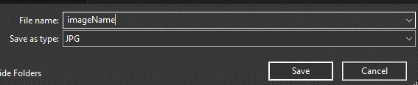

Figure 2 - Save ALL website images in JPG format.

****2.)** **ALL images MUST be JPG format.**When saving, select the .jpg file type.**

****3.)** **Do not leave empty cells of data.**   
All columns need to have data for each supplier.   
The only exception is the website cell for a supplier – this is not required.**

**How To Change Map Marker or Menu Data Workbooks**

**Introduction:**

**This section has instructions on how to update the data that the website uses for supplier map markers and menu items on the VIU Food Services FeedBC website.**

**Requirements:**

* **Microsoft Excel**
* **Web Browser of choice**
* **Ability and permission to edit live website data.**

**Instructions:**

1. **Download a copy of the excel workbook from the website files.**
2. **Create a copy of these files, as a backup in case of any issues with editing.  
   Do not skip this step.**

**Name the files like this, adding the part in <>: supplier_markers.csv<.bak>  
(This is so that the file has a name that informs you this is a backup. If we make a mistake, just remove the .bak to access your backup file.)**

1. **Review the data in the workbook. Complete any updates or modifications.  
   *Find the tables at the end of this section for more about the information you will need to add.***
2. **Save the file as a CSV UTF-8. When the ‘Save As’, prompt asks to overwrite the file, click OK.**
3. **Test the changes to the website.   
   *If things aren’t behaving or looking how you’d expect, see the troubleshooting tips at the end of this section.***

**Change Map Marker or Menu Data Workbooks (*Continued*)**

1. **Review the data once more. Save the files.  
   Save the .xlsx file.   
   Save the file again, but this time as a CSV UTF-8.**

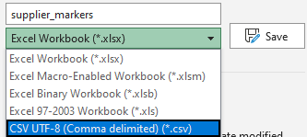

Figure 3 - Select the CSV UTF-8 file type when saving.

1. **Upload the CSV and xlsx files to the appropriate folder on the website.**

**Be sure to overwrite the old files.**

1. **Verify that your changes have been made by reloading the page.**

**If a cell is missing data, the site will alert you. Make sure all data is complete and as accurate as possible.**

1. **Verify that your changes have been made by reloading the page.**

***Repeat this process as needed. Be sure to follow the instructions closely, and view the tables in the following section for further clarification.***

**Change Map Marker or Menu Data Workbooks (*Continued*)**

The following tables provide instructions for completing or updating the information for the supplier and menu excel workbooks. This information is also covered in the [video guide](https://youtu.be/3veE7ZDEx2s).

|  |  |  |
| --- | --- | --- |
| **What are you modifying?** | **Required Information** | **Instructions** |
| *****Supplier Map Marker***** | ***Supplier Name*** | **You will need to know the name of this before you begin.** |
| ***Address Name*** | **Information available on supplier site or Google Maps** |
| ***Coordinates*** | **Right click pin on google maps search and copy the Lat,Long coordinates AS IS** |
| ***Ingredients*** | **Simple list of ingredients or product category supplied.** |
| ***Description*** | **From the site, or in our own words.  Keep to 1 simple paragraph.** |
| ***Image Name*** | **Choose any image you want to use. You MUST save the file as a JPG.**  **Save it as something like: fredrichs.jpg**  **Move this file to the "images\feedbc" folder of this project.**  **On the Excel sheet, simply type the name: fredrichs** |
| ***Image Description*** | **Accessibility Feature: The description of the image that screen readers will use** |
| ***Supplier Site*** | **This is to keep track of where the supplier information is from.** |

|  |  |  |
| --- | --- | --- |
| **What are you modifying?** | **Required Information** | **Instructions** |
| *****Menu Items***** | ***Item Name*** | **This is the name of the item on the menu.** |
| ***Ingredients*** | **This is the list of ingredients that make up this food item.** |
| ***Allergens*** | **List any** [priority allergens](https://www.canada.ca/en/health-canada/services/food-allergies-intolerances/avoiding-allergens-food/allergen-labelling.html) **found in this food item/ingredients.** |
| ***Local Ingredients*** | **Simple comma separated list of locally supplied ingredients if there are any.** |
| ***Diet*** | **This will be a comma separated list of abbreviations that specify if this food complies with a special diet type.**  **VEG = vegetarian**  **VGN = vegan**  **GF = gluten free**  **GFO = gluten free options**  **DF = dairy free** |
| ***Nutrition Label*** | **Export a Standard Format English 4.8cmX6.31cm label in MenuSano. Disable allergens, dietary, and ingredients.**  **Save it as something like: “waffles.jpg”.**  **Move this file to the “images\NutritionLabels” folder of this project.**  **On the Excel sheet, simply type the name: “waffles”.** |
|  | | |

**Troubleshooting**

The following tables provide instructions for completing or updating the information for the supplier and menu excel workbooks. This information is also covered in the [video guide](https://youtu.be/3veE7ZDEx2s).

|  |  |  |
| --- | --- | --- |
| **Issue** | **Cause** | **Solution Instructions** |
| **The map loads with an error stating that there is a cell at row X in column Y which requires data.** | ***You left a blank column or row of data when editing the workbook.*** | **You will need to add the missing data or restore to the most recent backup file.** |
| **There is an empty legend item at the bottom of the list.** | ***There is an empty row at the bottom of the workbook.*** | **Highlight the extra cell – right click and select delete. This will clear the empty row completely.** |
| **There is description text showing up in the map legend.** | ***The text in the description column of the last working supplier has an ‘enter’ in it, making it more than one paragraph.*** | **Check the description of the last working supplier row. Make sure this is one paragraph and does not contain any ‘enter’ characters. Otherwise restore the most recent backup file.** |
| **I’ve added a supplier but the image doesn’t appear.** | ***The image name doesn’t match, the image is the wrong type, or the image is not in the right folder.*** | **Save the image with a simple lowercase name. Make sure it is a .jpg image, and that it is moved to the correct website folder.** |
|  |  |  |
|  |  |  |
|  |  |  |
|  |  |  |
|  |  |  |

Resources

For Demo:

**Start:** <http://127.0.0.1:3000/index.html> (Index at Internal Server)

**Food Services Order Online Platform:** <https://order.viu.ca/2050/7779>

<https://www.w3schools.com/jsref/event_onclick.asp>

<https://developers.google.com/maps/documentation/javascript/advanced-markers/start>

[**Alternate to Google Maps**](https://www.mapbox.com/)

[**Google Cloud Platform**](https://www.google.com/aclk?sa=l&ai=DChcSEwjF4Ozr-of9AhVqFq0GHfcLBD8YABAAGgJwdg&sig=AOD64_0V1c8nuqQehrYvRvl6VcYfuqTW3g&q&adurl&ved=2ahUKEwjhpObr-of9AhXdHTQIHeDzCHoQ0Qx6BAgEEAE)

[**Generate an API key (video)**](https://www.youtube.com/watch?v=2_HZObVbe-g)

[**Restrict/Generate an API Key (Google Doc)**](https://developers.google.com/maps/documentation/javascript/get-api-key)

[**Scalefusion MDM**](https://scalefusion.com/)

[**https://scalefusion.com/kiosk-lockdown-software**](https://scalefusion.com/kiosk-lockdown-software)

[**Tabletop Tablet**](https://www.displays2go.ca/P-54742/Accessible-Touch-Screen-Table-Android-7-1-OS-Pre-Loaded-DiViEX-SildeShow-App?gclid=Cj0KCQiAw8OeBhCeARIsAGxWtUwFSTPQ4wEPfi4yW4wGz8mNJ0t-6Qu3bxbK5nvItHJS1C1Bi19nZMYaAjaeEALw_wcB)

Consider script and animation quality on OS version.

**Operating System type**

Android

Operating System Version

7.1

**Screen resolution**

1920 x 1080

**Screen size**

43" 10pt