|  |
| --- |
| Project  Brain Food: A FeedBC Initiative @ VIU  Ezra Boersma [ezra.boersma@itas.ca](mailto:mezra.boersma@itas.ca)  Windows Clustered File Services with FreeNAS  Ezra Boersma Vancouver Island University Technical Manual |

### 

### Last Updated:

### March 25th 2023

Contents

Introduction 3

Project Components: What Makes Up This Application? 4

Update, Modify or Remove Site Content 6

Resources 11

Citations 12

Github Plan Board:

<https://github.com/users/EzraBoersma/projects/3/views/1>

Github Code Repository:

<https://github.com/EzraBoersma/ezrab_feedbc>

Introduction

This document will outline of the details of the FeedBC VIU information terminal project. It will cover important information regarding components of the application, as well as providing detailed instructions for updating and troubleshooting the supplier map markers and menus.

wdawd

Software Required:

**Microsoft Office Excel**

**Microsoft VS Code** or other editor (if making changes to actual code)

**Project Components:**

FeedBC Interactive Local Food Map

**The heart of the application, the interactive map is a JavaScript vector map which displays dynamically generated** [Advanced Map Markers](https://developers.google.com/maps/documentation/javascript/reference/advanced-markers) **and a corresponding map legend. Each marker and legend item will bring up information about the selected food supplier and will show their location on our food map.  
  
This uses the following components:**

* **Implemented using the** [Google Maps API](https://developers.google.com/maps)
* **Dynamically generated** [Advanced Map Markers](https://developers.google.com/maps/documentation/javascript/reference/advanced-markers) **and Legend**
* **JavaScript AJAX to load data from an excel workbook which is exported as a CSV -  
  to allow easy editing and adding of components.**

Food Services Interactive Outlet Menus

**Another primary activity in this app is the accordion sections that contain the menu items for each of the food outlets operating under Food Services. These items will provide information about nutritional data, local food-sourcing, dietary compatibility, and allergen presence, in each of the food offerings currently available.  
  
This uses the following components:**

* **Dynamically generated menus**
* **Bootstrap Grid Layout**
* **JavaScript AJAX to load data from an excel workbook which is exported as a CSV -  
  to allow easy editing and adding of components.**

Food Services Order Online Hook-in

**Lastly, this platform will be linked into the online ordering platorm for Food Services. There is no authentication outside that which already exists on that platform – and the kiosk MDM software will prevent any user data from being stored on the browser or device.  
  
This uses the following components:**

* **Food Services Online Ordering Site**
* **Scalefusion MDM Kiosk Lockdown**

Update, Modify or Remove Site Content

Before You Begin

**Please review the information on this page prior to making any data changes:**

****1.)** In Microsoft Excel, go to: **File** > **Options** > **Advanced****

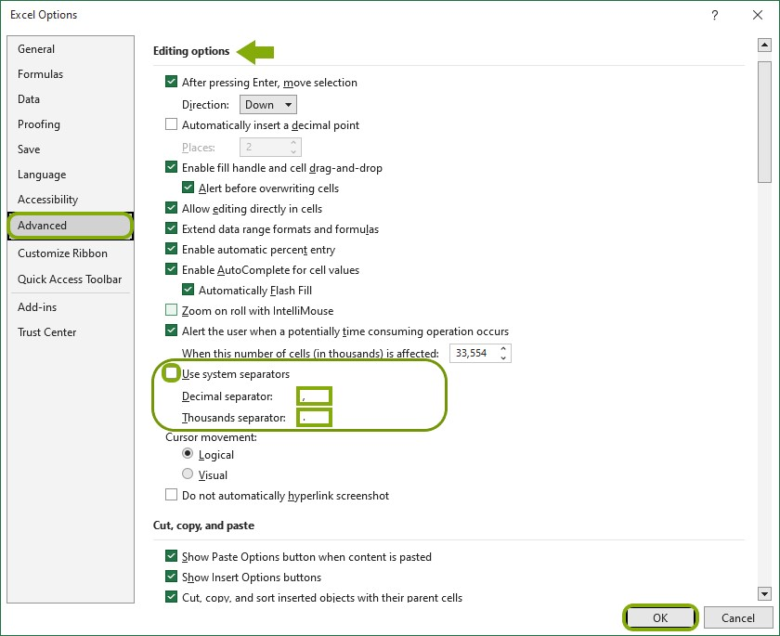

Figure 1 - Make sure your settings reflect those seen in the image, then click OK.

**At the bottom of the   
'Editing options' section, do the following:**

* ****Uncheck**   
  "Use system separators"**
* **Set the **Decimal** separator to COMMA ,**
* **Set the **Thousands** separator to DECIMAL .**

**Then click **OK**.   
[See Figure 1]   
**Save** the worksheet as a **UTF-8 CSV** file. This will set the system delimiter to a semicolon. *Reverse the process if you need to revert it on your system.***

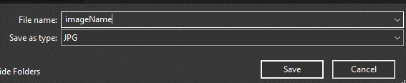

Figure 2 - Save ALL website images in JPG format.

****2.)** **ALL images MUST be JPG format.**When saving, select the .jpg file type.**

****3.)** **Do not leave empty cells of data.**   
All columns need to have data for each supplier.   
Only exception is the website cell for a supplier – this is not required.**

**How To Change Map Markers or Menu Data**

**Introduction:**

**This section has instructions on how to update the data that the website uses for supplier map markers and menu items on the VIU Food Services FeedBC website.**

**Requirements:**

* **Microsoft Excel**
* **Ability and permission to edit live website data.**

**Instructions:**

1. **Download a copy of the excel workbook from the website files.**
2. **Create a copy of these files, as a backup in case of any issues with editing.  
   Do not skip this step.**

**Name the files like this, adding the part in <>: supplier_markers.csv<.bak>**

1. **Review the data on the workbook. Complete any updates or modifications.  
   *Find the tables at the end of this section for more about the information you will need to add.***
2. **Save the file as a CSV UTF-8. When the ‘Save As’ prompt asks to overwrite the file, click OK.**
3. **Test the changes to the website.   
   *If things aren’t behaving or looking how you’d expect, see the troubleshooting tips at the end of this section.***

|  |  |  |
| --- | --- | --- |
| **Data You’d Like to Change** | **Required Information** | **Where to Find Required Info** |
| **Map Markers** | * **Supplier Name** * **Address  ( Information available on supplier site or Google Maps )** * **Coordinates  ( Right click pin on google maps search and copy the Lat,Long coordinates AS IS )** * **Ingredients  ( Simple list of ingredients or product category supplied )** * **Description  ( From the site, or in our own words. Try to keep it simple. 1-2 paragraphs. )** * **Image Name  ( Choose any image you want to use. You MUST save the file as a JPG.**   **Save it as as something like: fredrichs.jpg**  **Move this file to the "images" folder of this project.**  **On the Excel sheet, simply type the name: fredrichs )**  **- Image Description ( Accessibility Feature : The description of the image that screen readers will use )** |  |
| **Menu Items** |  |  |

1. **Review the data once more. Save the files.  
   Save the xlsx file.   
   Save the file again, but this time as a CSV UTF-8.**

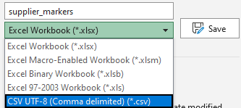

Figure 3 - Select the CSV UTF-8 file type when saving.

1. **Upload the CSV and xlsx files to the appropriate folder on the website.**

**Be sure to overwrite the old files.**

**How To Change Site Data (*Continued*)**

1. **Verify that your changes have been made by reloading the page.**

**If a cell is missing data, the site will alert you. Make sure all data is complete and as accurate as possible.**

1. **Verify that your changes have been made by reloading the page.**

Resources

For Demo:

**Start:** <http://127.0.0.1:3000/index.html> (Index at Internal Server)

**Food Services Order Online Platform:** <https://order.viu.ca/2050/7779>

[**Alternate to Google Maps**](https://www.mapbox.com/)

[**Google Cloud Platform**](https://www.google.com/aclk?sa=l&ai=DChcSEwjF4Ozr-of9AhVqFq0GHfcLBD8YABAAGgJwdg&sig=AOD64_0V1c8nuqQehrYvRvl6VcYfuqTW3g&q&adurl&ved=2ahUKEwjhpObr-of9AhXdHTQIHeDzCHoQ0Qx6BAgEEAE)

[**Generate an API key (video)**](https://www.youtube.com/watch?v=2_HZObVbe-g)

[**Restrict/Generate an API Key (Google Doc)**](https://developers.google.com/maps/documentation/javascript/get-api-key)

[**Scalefusion MDM**](https://scalefusion.com/)

[**https://scalefusion.com/kiosk-lockdown-software**](https://scalefusion.com/kiosk-lockdown-software)

[**Tabletop Tablet**](https://www.displays2go.ca/P-54742/Accessible-Touch-Screen-Table-Android-7-1-OS-Pre-Loaded-DiViEX-SildeShow-App?gclid=Cj0KCQiAw8OeBhCeARIsAGxWtUwFSTPQ4wEPfi4yW4wGz8mNJ0t-6Qu3bxbK5nvItHJS1C1Bi19nZMYaAjaeEALw_wcB)

Consider script and animation quality on OS version.

**Operating System type**

Android

Operating System Version

7.1

**Screen resolution**

1920 x 1080

**Screen size**

43" 10pt

Citations

<https://www.w3schools.com/jsref/event_onclick.asp>

<https://developers.google.com/maps/documentation/javascript/advanced-markers/start>