Business Requirement Gathering

Carezno Business Requirement Document for Project 3 – Fifteen Puzzle

## 1. Objectives & Purpose

1.1 The purpose of this documents is to detail the requirements for the Fifteen Puzzle

1.2 This project can help improve our Web Development Skills and be on the way to gathering and applying requirements properly.

1.3

|  |  |
| --- | --- |
| ***Stakeholders Name*** | ***Roles & Responsibilty*** |
| Leader, Programmer | *Oversee overall system...* |
| *Designer* | *Design CSS to be incorporated with HTML* |
| *Tester/User* | *Test game and make sure all interfaces work properly* |
| Professor | Check completion of overall project |

1.4 List the stakeholders “pain-points” and specify problem you are trying to solve.

|  |  |
| --- | --- |
| ***Stakeholder*** | ***Pain-Points*** |
|  |  |
|  |  |

1.5 Describe your current solution if exist? and why it is not adequate

1.6 Are there similar application available?, state reasons you feel these are not viable solution.

|  |  |  |  |
| --- | --- | --- | --- |
| ***Application name*** | ***Company*** | ***Pros*** | ***Cons*** |
| *MS Excel* | *Microsoft* | *Flexible* | *Not easily accessible and no audit trails* |
|  |  |  |  |

1.7 Create list of Functional requirement and indicate the priority (Must Have, Should Have, Could Have, Nice to have)

*e.g:*

|  |  |  |
| --- | --- | --- |
| ***Stakeholder*** | ***Function*** | ***Priority*** |
| *Customer* | *Place an order and pay for the order* | *Must Have* |
| *Customer* | *Check order status and amend order* | *Should Have* |
| *Product Manager* | *Upload and create new product* | *Must Have* |
| *Product Manager* | *Export customer list into Excel* | *Nice to have* |
|  |  |  |
|  |  |  |
|  |  |  |
|  |  |  |

1.8 Terminology, describe any specific terminology used in this application.

|  |  |
| --- | --- |
| ***Terminology*** | ***Description*** |
|  |  |
|  |  |

## 2. Technology

2.1. How do you envisage this application will be delivered to your audience?

*e.g: via Web, Mobile/ Tablet apps ?*

2.2. Is there any particular technology platform you are currently using and if it has impact to this deployment of application ?

*e.g: Exclusive to Apple devices...*

2.4. Hardware: is it going to be hosted in the server locally or in the cloud

## 3. Budget and Timescale

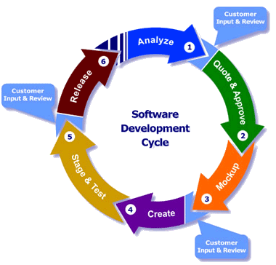

*Typical Software Development Process*

3.1. What is your rough budget for this application

3.2. Timescale

## 4. Miscellaneous

2.3. Is there any IP, Patents in which we'll need to be aware of

2.4 Who is the subject matter expert for this project

2.5 List project team contact and what are their roles and responsibility to this project

|  |  |  |  |
| --- | --- | --- | --- |
| ***Name*** | ***Company*** | ***Email*** | ***Roles & Responsibility*** |
| Claire Matthew | Claromentis | name@email.com | Project Owner |
|  |  |  | Client |
|  |  |  | Business Analyst |
|  |  |  | Information Architect |
|  |  |  | Subject Matter Expert |
|  |  |  |  |

**4. Wireframe**

Sketch the wireframe here if you have any visual idea.

### 