**Sequence** 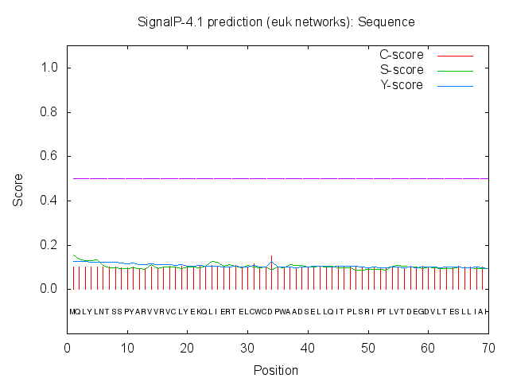

# Measure Position Value Cutoff signal peptide?

max. C 34 0.151

max. Y 34 0.125

max. S 1 0.155

mean S 1-33 0.108 D 1-33 0.115 0.450

NO Name=Sequence SP='NO' D=0.115 D-cutoff=0.450

Networks=SignalP-noTM