TMpred prediction output for : TMPRED.8152.9729.seq

Sequence: MQL...TFE length: 200

Prediction parameters: TM-helix length between 17 and 33

1.) Possible transmembrane helices

==================================

The sequence positions in brackets denominate the core region.

Only scores above 500 are considered significant.

Inside to outside helices : 2 found

from to score center

90 ( 90) 110 ( 108) 396 100

152 ( 154) 170 ( 170) 1532 162

Outside to inside helices : 2 found

from to score center

86 ( 91) 110 ( 110) 552 100

152 ( 152) 172 ( 170) 1477 162

2.) Table of correspondences

============================

Here is shown, which of the inside->outside helices correspond

to which of the outside->inside helices.

Helices shown in brackets are considered insignificant.

A "+" symbol indicates a preference of this orientation.

A "++" symbol indicates a strong preference of this orientation.

inside->outside | outside->inside

( 90- 110 (21) 396 ) | 86- 110 (25) 552 +

152- 170 (19) 1532 | 152- 172 (21) 1477

3.) Suggested models for transmembrane topology

===============================================

These suggestions are purely speculative and should be used with

EXTREME CAUTION since they are based on the assumption that

all transmembrane helices have been found.

In most cases, the Correspondence Table shown above or the

prediction plot that is also created should be used for the

topology assignment of unknown proteins.

2 possible models considered, only significant TM-segments used

*** the models differ in the number of TM-helices ! ***

-----> STRONGLY prefered model: N-terminus outside

2 strong transmembrane helices, total score : 2084

# from to length score orientation

1 86 110 (25) 552 o-i

2 152 170 (19) 1532 i-o

------> alternative model

1 strong transmembrane helices, total score : 1532

# from to length score orientation

1 152 170 (19) 1532 i-o

[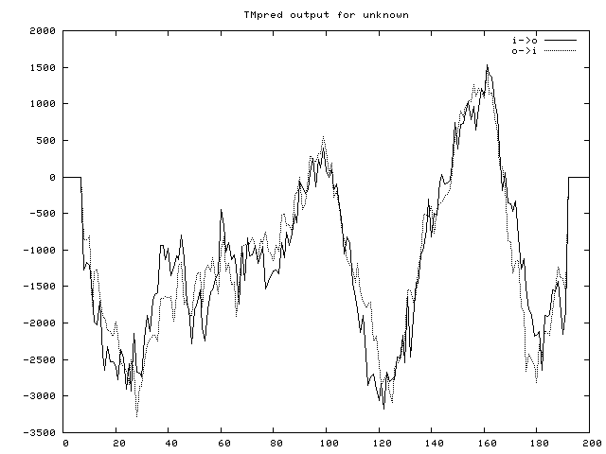](https://embnet.vital-it.ch/download.php?file=TMPRED.8152.9729.gif)  
You can get the prediction graphics shown above in one of the following formats: