M-learning: A Mobile Cloud Application
  - Mahmood B. Shaheen, 120190728, mahmoood.shah2en@gmail.com
  - Ezz N. Moqayad, 120191768, ezz.n.moq@gmail.com
  - Khalil E. Hothot,120190678, hthtkhlyl24@gmail.com

  - Cloud Computing and its Applications
  - Department of Mobile Computing and Applications of Smart Devices
  - Faculty of Information Technology
  - Islamic University of Gaza

Abstract

We students of mobile computing in our group of three students have developed a cloud-based mobile application for mobile learning (M_learning), This application is based on two main parts, The first part is used for the teacher, in which the teacher can add videos related to the training material and add the training files explaining, and the teacher can add assignments for students to measure their level of success, While in the other second part, the student has the learner, through which he can review and browse what the teacher has added of training materials, videos explaining, or assignments and assignments for them.

M-Learning cloud server linked to a huge database (Firestore as NoSql); It is located in cloud. Registered users access the cloud through their smart devices (Mobile phones) by adding the user and password that is stored in the cloud. In this way, after checking the authentication, the file information will be shared from the server as per client/user request. and process flow, From mobile learning in the form. Storage is used to temporarily store and distribute data information between clients. Memory management refers to the organization and management of data coming from the cloud to users of mobile devices. The processing layer interacts with security and memory management and all of these features are used dynamically by the cloud.

Introduction
We pave the beginning with the idea of ​​the application, which lies in developing an application on the mobile phone as an educational application (M_learning) that aims to:
- Facilitate the study process for students
- Facilitate student communication with the teacher
- Facilitate the process of controlling educational resources through the mobile application
- Easy access to data from the mobile phone to the cloud, in which educational resources are completely stored and flown to the customer at the time of their request. All of these advantages lead to better productivity across educational sectors.

The methodology of the program is based on providing the specific requirements of the project idea and its design with the features and requirements, which are:

The advantage of registering the user in two types (lecturer and student) by adding important information, namely: in the name of (first, middle, and family) Date of birth, address, email, mobile number, password and confirmation.

Browse the course where the list of available courses will be displayed.
- Course selection, registration, viewing, and assignment submission.
- Where the user is able to register in the courses offered and choose the course he wishes to attend, in this way he will be provided with the educational resources that the teacher has added for this course.
- We also emphasize that if a video is viewed during the course, it is not downloaded, but rather is broadcast in the form of a series displayed on the student's screen.
- There is also a mechanism for delivering appointments via the student screen and sending them to the teacher.
- Enable the manager to track all operations on the application from adding courses, deleting and modifying, and the ability to track the delivery of assignments and duties.
- When performing any of the operations on the application, it sends a notification and an email to the person responsible for managing operations.
- The application allows users to display banners.
- All operations, including storage, management, display, and others are performed on the cloud, with the possibility of exploiting the video on the user's resources.

Cloud Software Application Requirements
a short user story: we are in an educational academy, we want to facilitate education and communication between the student and the teacher, so we decided to develop an educational application where the teacher was able to add educational resources such as files, videos and assignments on this platform. Explanations with documents and videos, as well as I can carry out assignments and duties and upload them through this application. It is really great for studying.
I will explain the working mechanism of the application with an engineering drawing that explains the mechanism of work between the user and the cloud platform used, as we mentioned earlier, explaining the features and the mechanism.
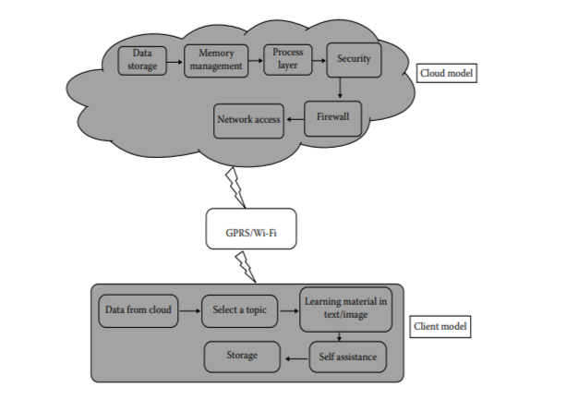

Software Architecture and Design
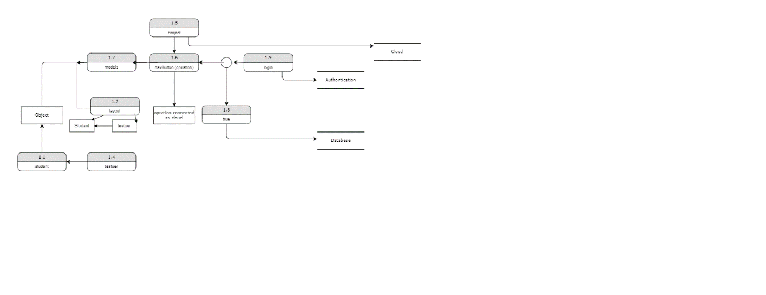

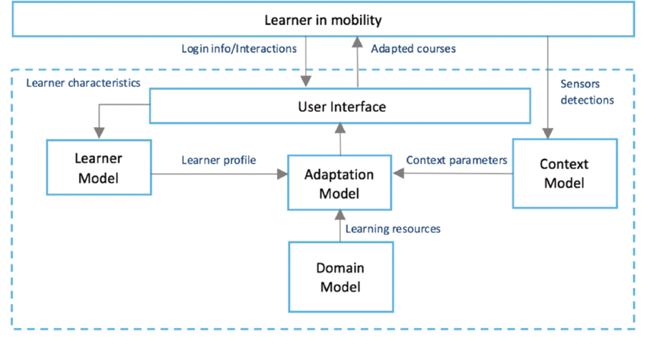

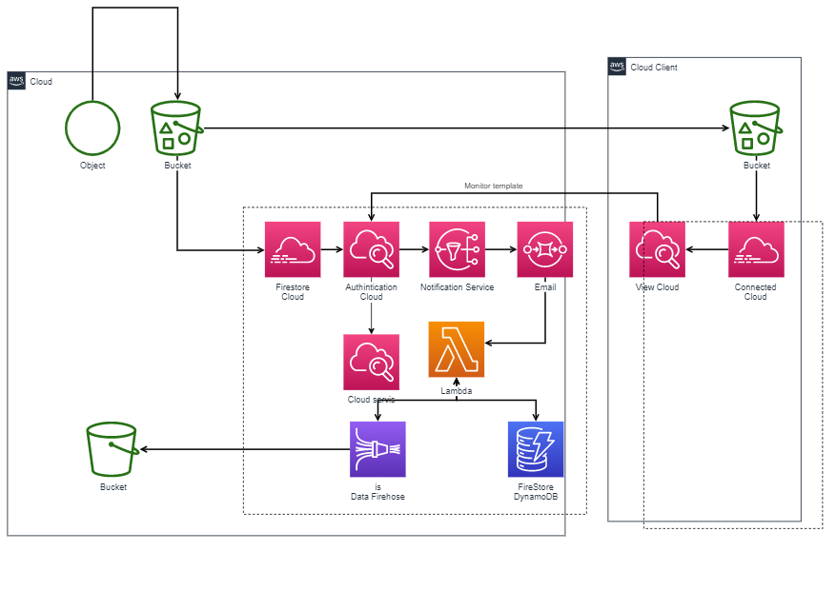

Used Cloud Services and its Interfaces

We have used the Firestore service from the cloud Firebase because of its many advantages that enabled us to do important things to the requirements of the program that we prepared an educational application via the cloud. Starting from storing the data and educational resources that the teacher adds, as well as giving the advantages of adding, deleting and modifying educational resources.

Another is to use cloud authentication through the various login in the application as a teacher or student.

And the use of cloud analysis of groups of operations performed by users in the program.

As an advanced feature, we used the cloud test of the application and made sure of the correct working mechanism for it.

Implementation
In this section, some of the most important features that have been worked on during the application and clarification of the programming part of the most important functions and methods that have been created are explained, and we explain that cloud services have been dealt with.
Code the splash Screen:
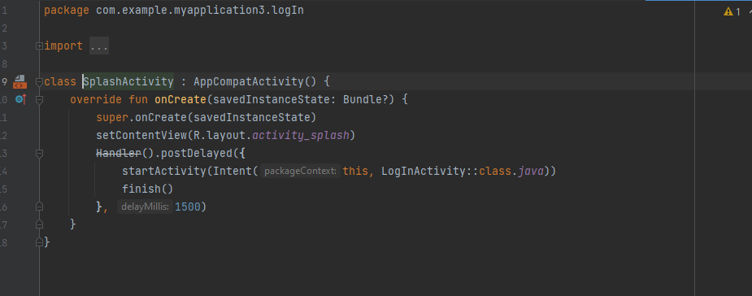
Code create Account
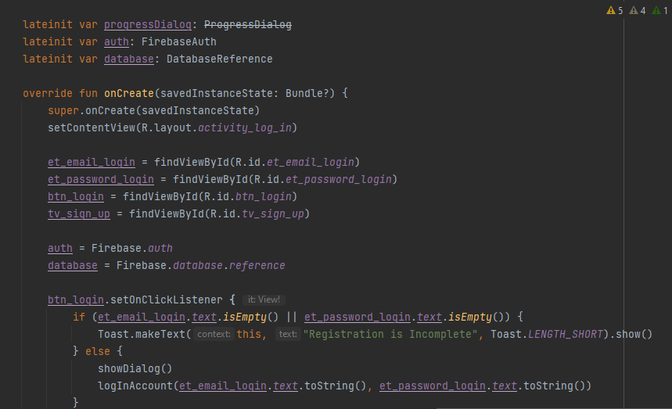

Code login on app
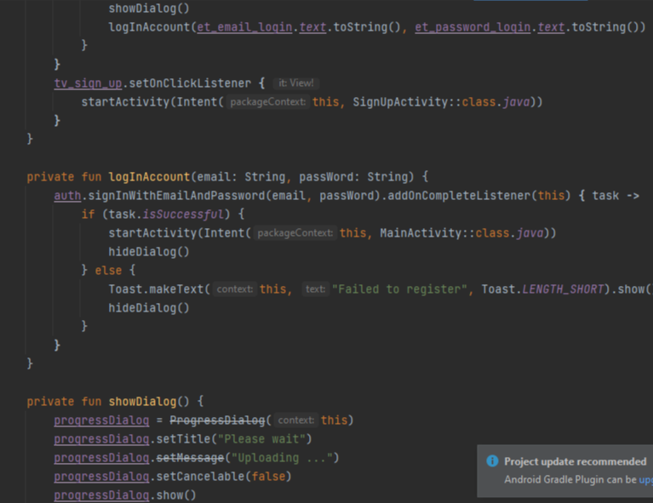

Code Sign up
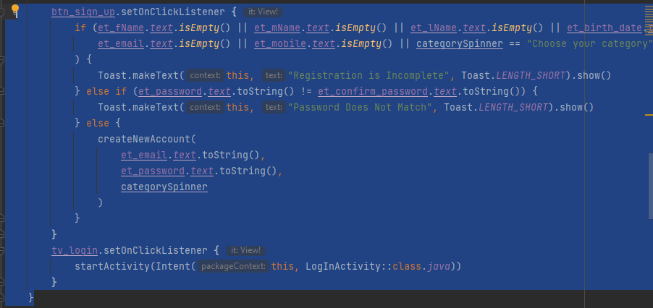

Code model Video
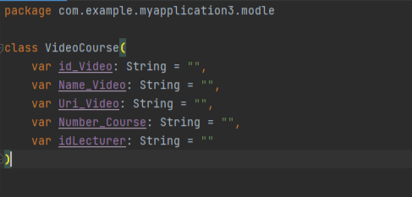

Code model file course
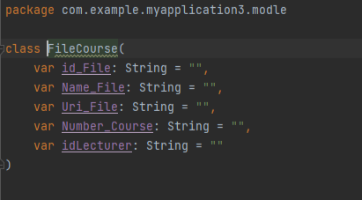

Code model assumente
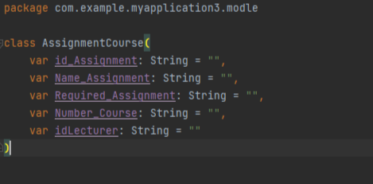

Code a waiting of dialog when upload file or media
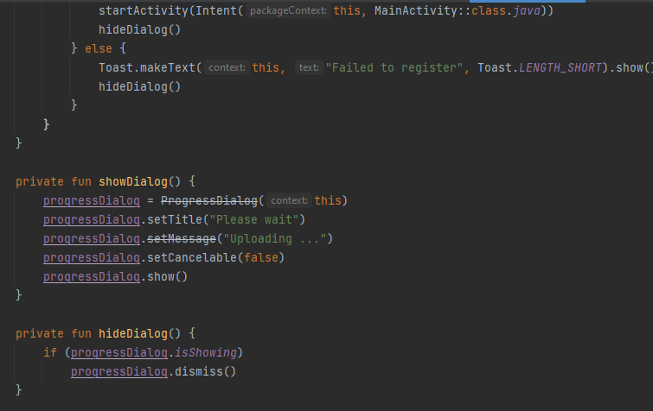

Code track by date of create operation
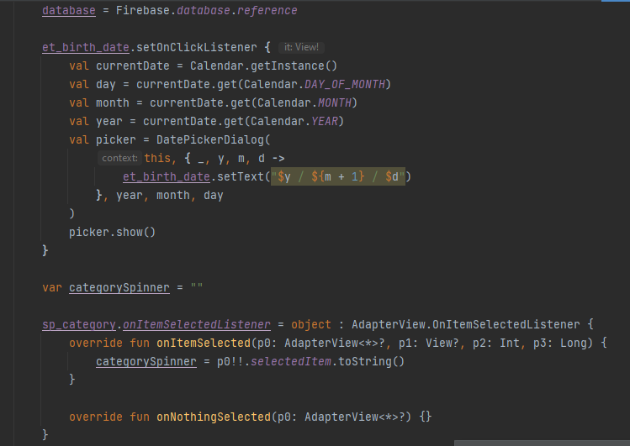

Code model Student
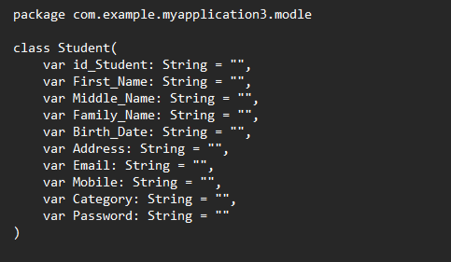

Code model lecturer
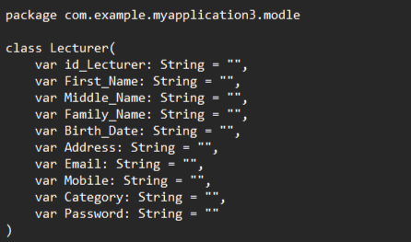

Code get data profile
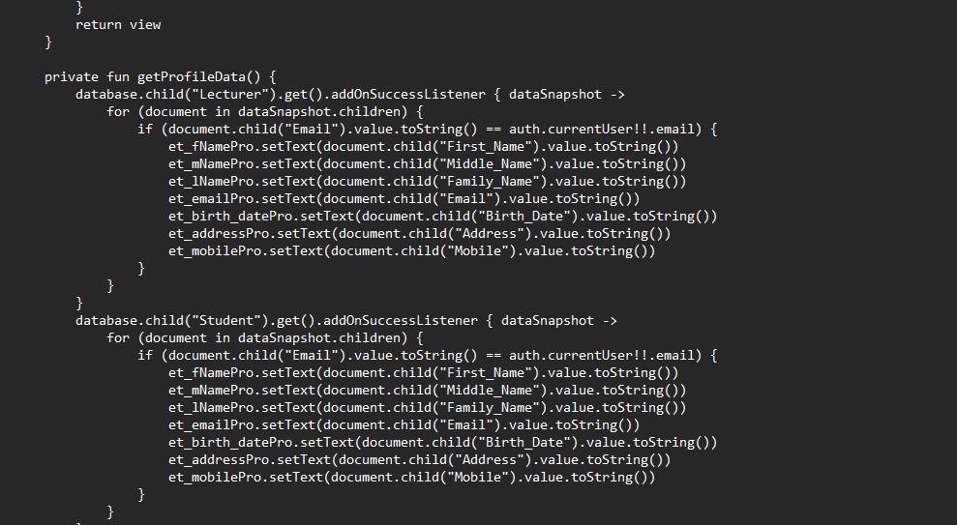

Code add course
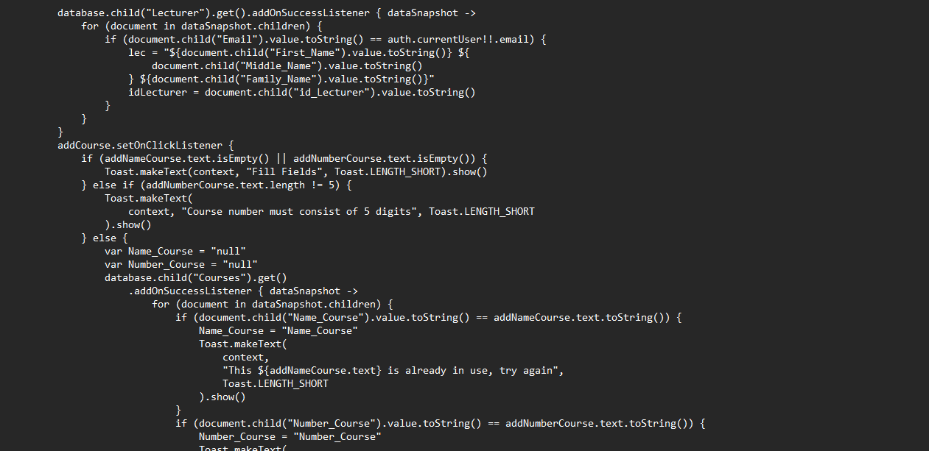
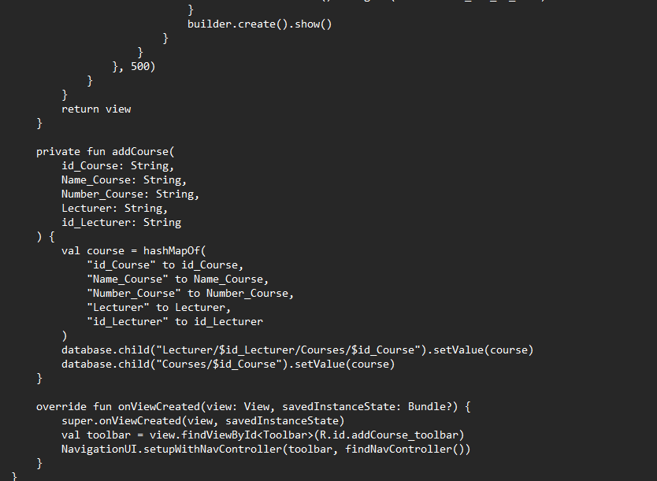

Code get profile
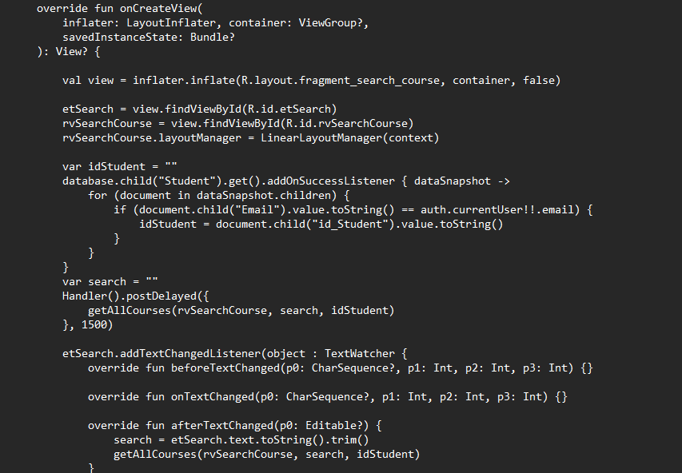

Code edit user
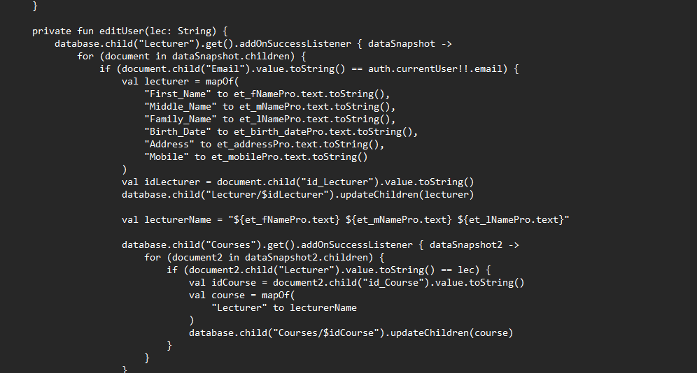

There are many other features, but for the sake of space, the complete code is attached in detail with how the application relates to the cloud and the use of cloud services:

Firestore

Cloud storage

Authentication

Cloud analysis etc.

Data

Firestore is a cloud-hosted NoSQL database that iOS, Android, and web apps can access directly via native SDKs.

Firestore works with the NoSql database, which depends in its operation on storing a key_value, where in the application the courses are stored in the form of an id for each course that contains information from videos, documents, assignments and assignments, and thus it is stored as a document in the collection.

The main advantage of using this storage with the cloud is that the Cloud Firestore data model supports flexible hierarchical data structures. Store your data in documents organized into groups. Documents can contain nested complex objects in addition to subgroups.

Architecture of the Used Cloud Platform

Deployment targets for an education application are as short-name identifiers for service resources in a Firebase project, as a hosting site with unique fixed assets, or as a group of instances that share the same security rules. It is one of the most useful goals to publish your application on the platform examples:

Configure hosting for each of your hosting sites.

Fixed assets from your project directory for each of your hosting sites.

Security rules are shared by multiple Firestore instances or multiple cloud storage groups.

Deployment on the Platform

The mapping between the application and the cloud is done by raising and linking the educational project to the public cloud and enabling links and calling the cloud services that were used in the application through software calls in linking the project files to that cloud through your account in the cloud, thus enabling the cloud for the project creator to view and edit all the operations that are implemented in the application and this project is published via the cloud by enabling SaaS solutions or for users with your own definition and publishing the available apk for use.

User Support

In the event that the application is used by a teacher, he registers with his own account for the application and then an authenticated login for his account to the application and is transferred to his own interfaces from use on several aspects of adding a course and the possibility of modification and deletion of it recently and enables him to add many forms such as a document or video or assignment and assignment For students and can fully manage these operations and see the results by recent student users.

In the case of using the application for the student, he also registers in the application, certifies his registration, and enters the interfaces of the student, during which he displays the available training courses, which are the courses that have been added by the teacher. It enables him to review and watch the video without downloading it to his own device. He can also read the document or submit the assignments and assignments that he demands in the educational course. These operations are monitored by the teacher and administrator via the cloud.

Conclusion

We, the students of the honorable Dr. Ribhi Baraka, cannot do in this regard but extend our thanks, appreciation and gratitude to you for the educational methods you have provided us in this chapter and urging us to develop ourselves in the field in which we were. He who does not thank people does not thank God and we wish you further progress and progress. In business, to see you again. Thank you.

References

- The project was created and submitted in full with a file attached to the delivery via the model of the Islamic University.
- https://cloud.google.com
- https://cloud.google.com/storage
- https://cloud.google.com/firestore
- https://cloud.google.com/s/results/?q=authentication

