**Defect 1: Invalid Username Handling in User Registration**

* **Title**: Registration allows usernames with spaces.
* **Steps to Reproduce**:
  + Go to the Sign-Up page.
  + Enter a username with a space (empty) (e.g., " ").
  + Fill in with any password in field.
  + Submit the form.
* **Expected Result**: An error message should be displayed indicating that the username format is invalid and spaces are not allowe or username can’t be empty.
* **Actual Result**: The system displays a generic error message "This user already exists." Which is wrong
* **Attachments**:
* **Severity**: Medium
* **Priority**: High : Also based on business impact

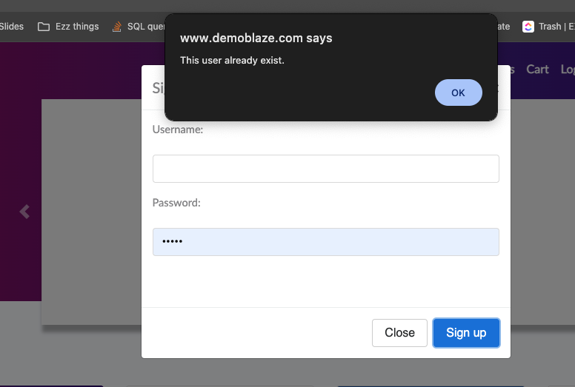

**Defect 2: Invalid Username Handling in User Login**

* **Title**: Login allows usernames with empty state.
* **Steps to Reproduce**:
  1. Go to the Login page.
  2. Enter a username with a space (e.g., " ").
  3. Fill in the password field.
  4. Submit the form.
* **Expected Result**: An error message should be displayed indicating that the username format is invalid and spaces are not allowed.
* **Actual Result**: The system displays a generic error message "Wrong password."
* **Severity**: Medium
* **Priority**: High : Also based on business impact

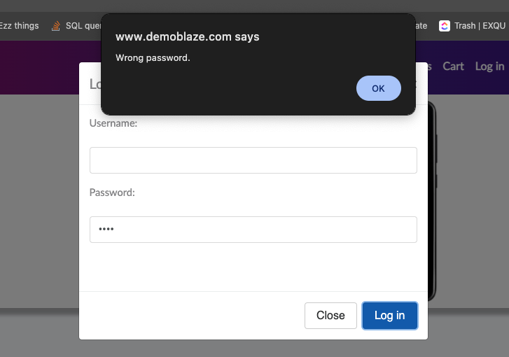

**Defect 3: Cart Management Issue**

* **Title**: Product added to cart without updating cart view or number when not logged in.(UI) , nothing indicates how many products added
* **Steps to Reproduce**:
  1. Ensure you are not logged in.
  2. Navigate to the product details page for any product (e.g., Samsung Galaxy S6).
  3. Click on the "Add to Cart" button.
* **Expected Result**: The cart icon should update to reflect the added product, and the number of items in the cart should be displayed.
* **Actual Result**: A message "Product added" is displayed, but the cart view and number of items in the cart do not update.
* **Attachments**:
* **Severity**: Medium
* **Priority**: Medium : Also based on business impact

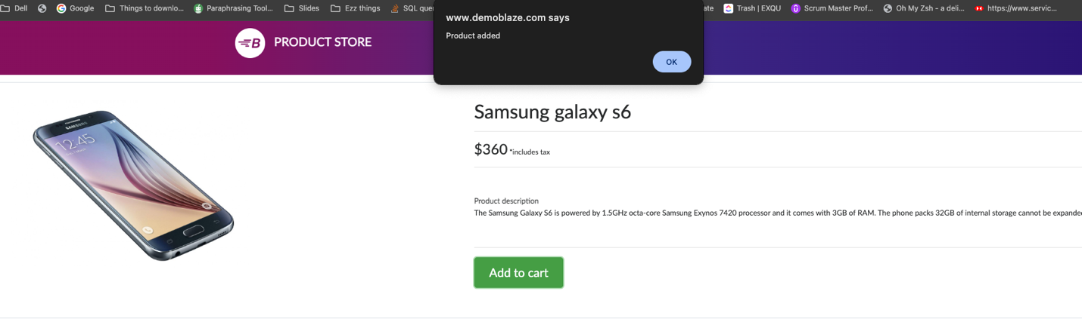

**Defect 4: Cart Displays Duplicate Products Instead of Updating Quantity**

* **Title**: Cart displays duplicate products instead of updating quantity.
* **Steps to Reproduce**:
  1. Ensure you are not logged in.
  2. Add the same product (ex : Samsung Galaxy S6) to the cart multiple times.
  3. Navigate to the cart page.
* **Expected Result**: The cart should show a single entry for the product with the correct quantity and total price.
* **Actual Result**: The cart shows multiple entries for the same product instead of updating the quantity.
* **Attachments**:
* **Severity**: Medium
* **Priority**: High: Also based on business impact

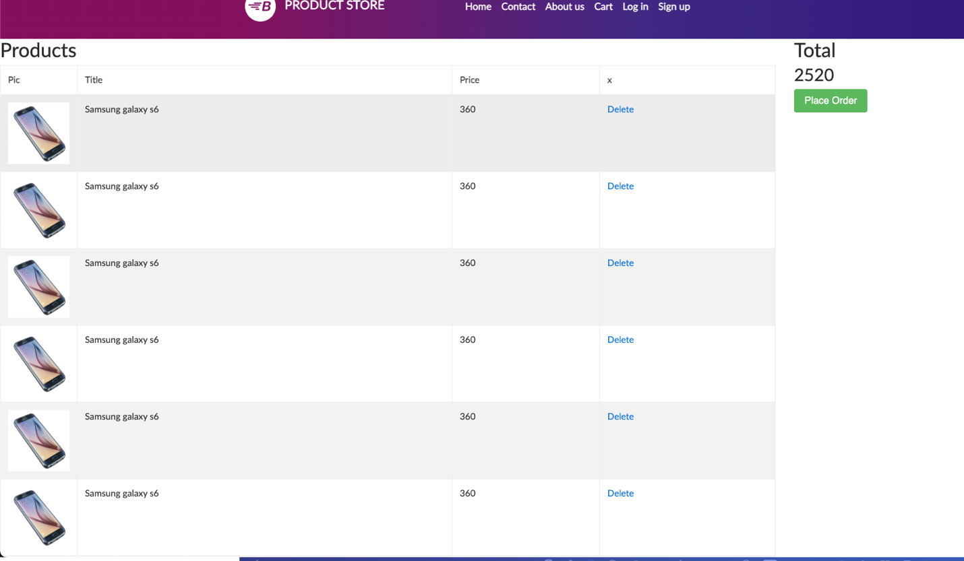

**Defect 5: Checkout Process Issues**

**Issue 1: Order Placed Without Adding Anything to Cart**

* **Title**: Order can be placed without any items in the cart.
* **Steps to Reproduce**:
  1. Ensure the cart is empty.
  2. Proceed to the checkout page.
  3. Fill in the checkout form with any details.
  4. Click on the "Purchase" button.
* **Expected Result**: The system should prevent the user from placing an order with an empty cart.
* **Actual Result**: The order is placed even though the cart is empty.
* **Attachments**:   
  **Severity**: High
* **Priority**: High

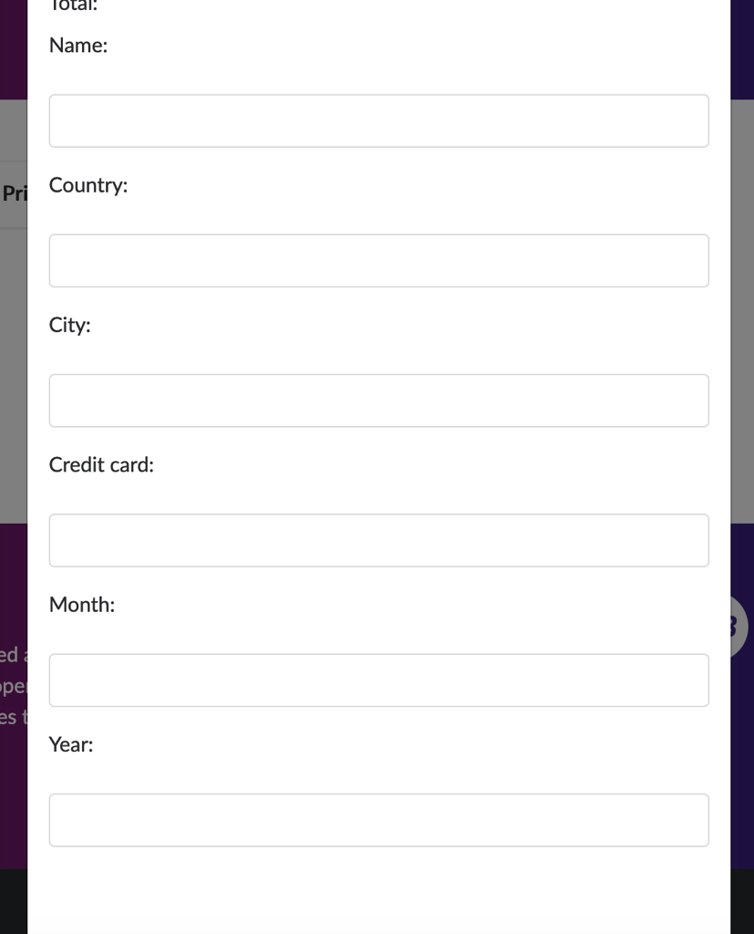

**Defect number 6 :Order Placed with Invalid Data and without login**

* **Title**: Order can be placed with invalid data. Without login
* **Steps to Reproduce**:
  1. Add any product to the cart.
  2. Proceed to the checkout page.
  3. Fill in the name, country, city, and credit card fields with invalid data (e.g., "<https://www.demoblaze.com/>").
  4. Leave the month and year fields empty.
  5. Click on the "Purchase" button.
* **Expected Result**: The system should validate the input fields and prevent the order from being placed with invalid data , user should login
* **Actual Result**: The order is placed despite the invalid data.
* **Severity**: High
* **Priority**: High : Also based on business impact

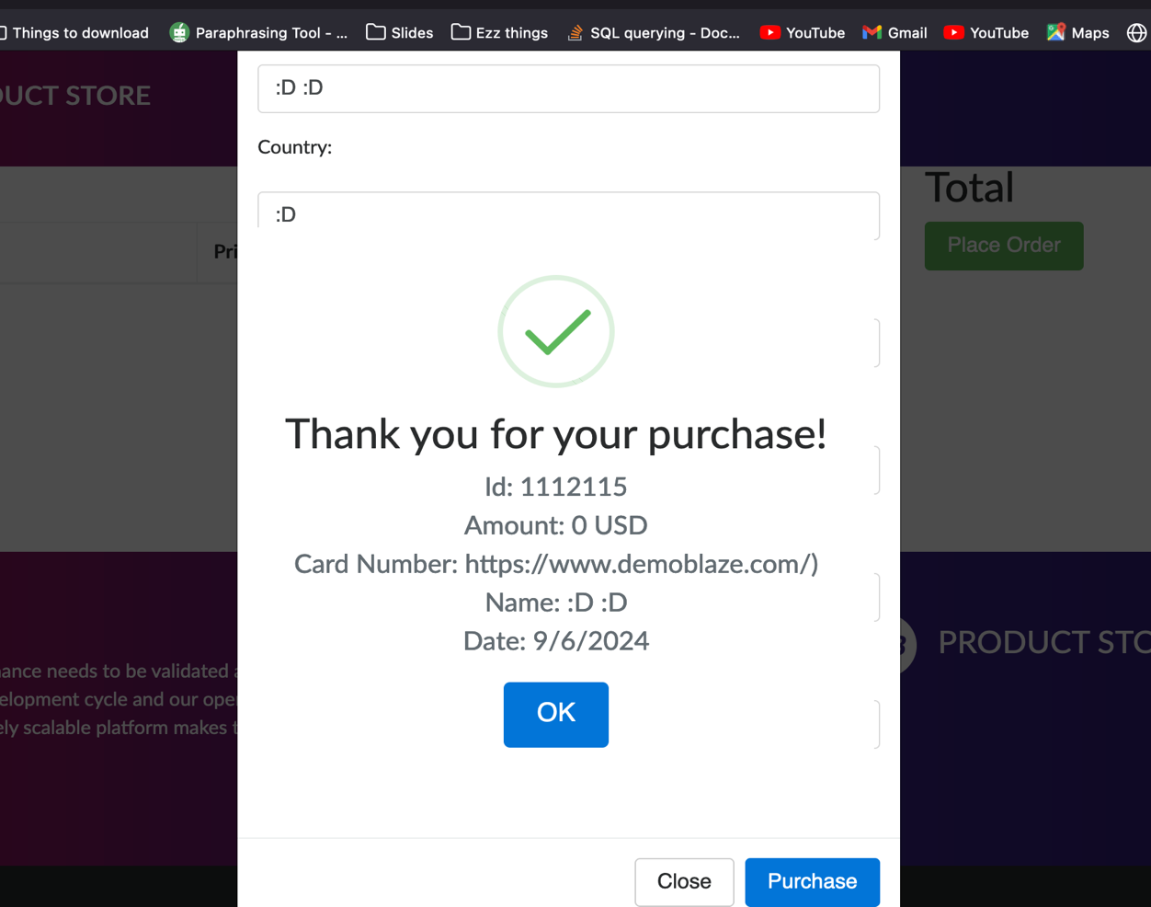

**Defect number 7: Improper Handling of Empty Contact Form Submission**

**Steps to Reproduce:**

1. Navigate to the "Contact Us" section.
2. Leave the "Contact Email," "Contact Name," and "Message" fields empty.
3. Click the "Send Message" button.
4. Observe the response pop-up.

**Expected Result:** The system should validate the input fields and display an error message prompting the user to fill out the required fields.

**Actual Result:T**he system displays a pop-up message saying "Thanks for the message!" without validating the empty fields.  
  
**Severity**: Medium

**Priority**: Medium 