

Shoubra Faculty of Engineering

Benha University

Student Name: Ezz El-Din Ashraf Mohamed Shaban

Group: 4

Section: 22

Student ID: 499

Github Link: <https://ezz522ashraf.github.io/ece001/>

**Project Title:**

***Cryptography***

***Under Supervision of:***

Dr. Ahmed Bayoumi

**Introduction:**

This website contains five pages that are built with Html language with some Css codes and a little JavaScript. The website discusses Cryptography, its definition, uses and its Application in real life. The website is also responsive using bootstrap styles so if u open the website on the phone it will appear the same as PC. There is a navbar that u can move between pages.

**The First webpage (Main Webpage):**

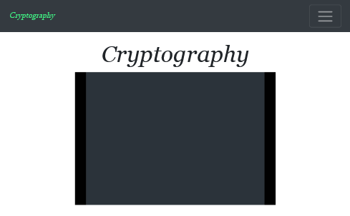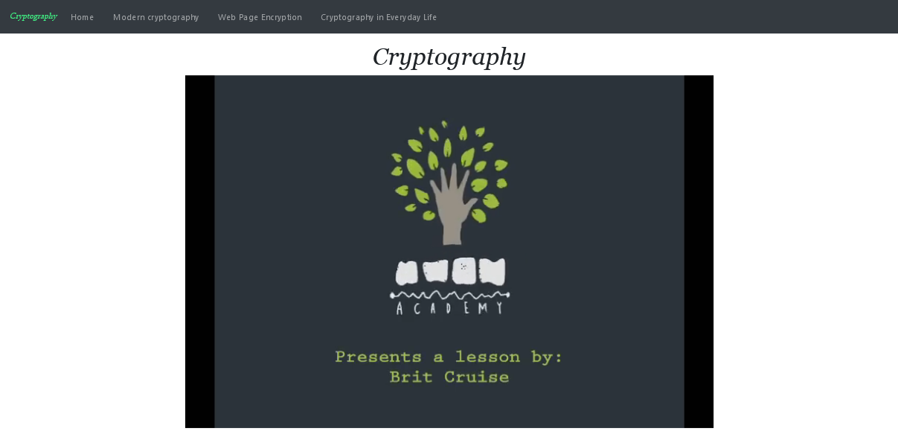This page contains a video [1] that shows some information about Cryptography and its definition.

**The Second Page (Information about Cryptography):**

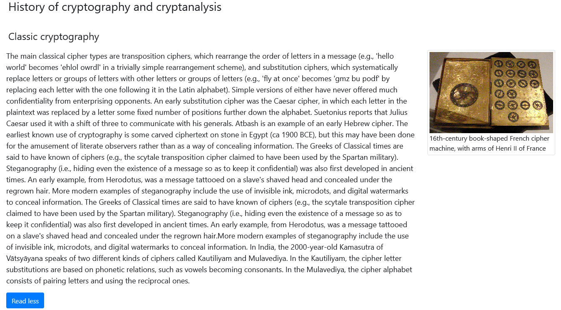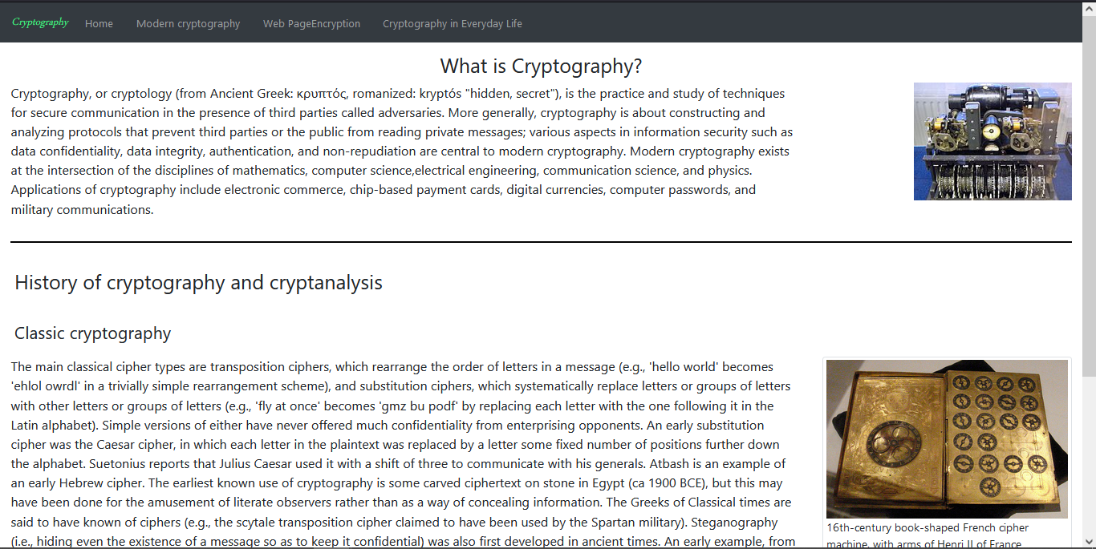This page contains all the information everyone needs to know about Cryptography. What is cryptography? The History of Cryptography. As there was a classic cryptography and how letters and numbers were encrypted in the past. In the addition to the new ways and Technologies of Cryptography [2].

**The Third Page (Modern Cryptography):**

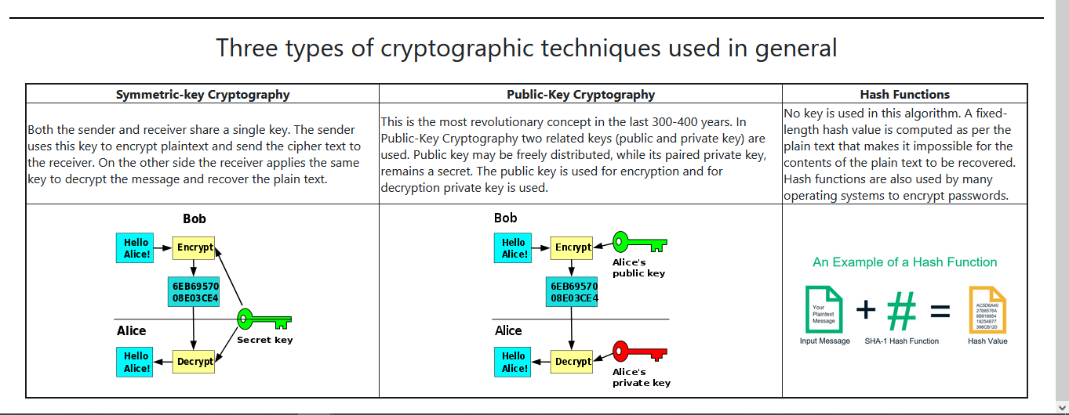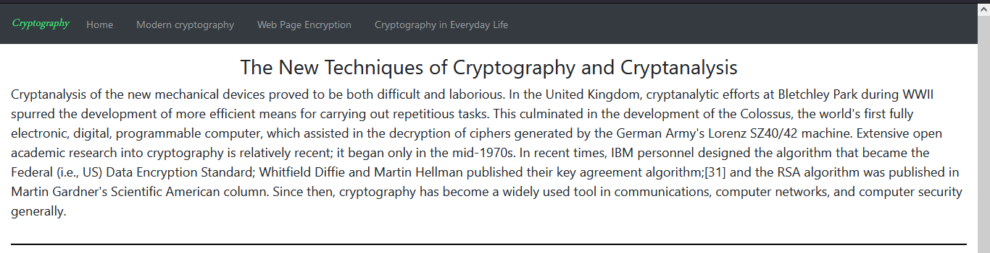This page shows the new ways and techniques in cryptography and cryptanalysis. In addition, what are the most popular techniques and algorithms used in general in our present time? As there are the Symmetric-Key, Public Key, Hash Functions [3].

**The Fourth Page (Web Page Encryption):**

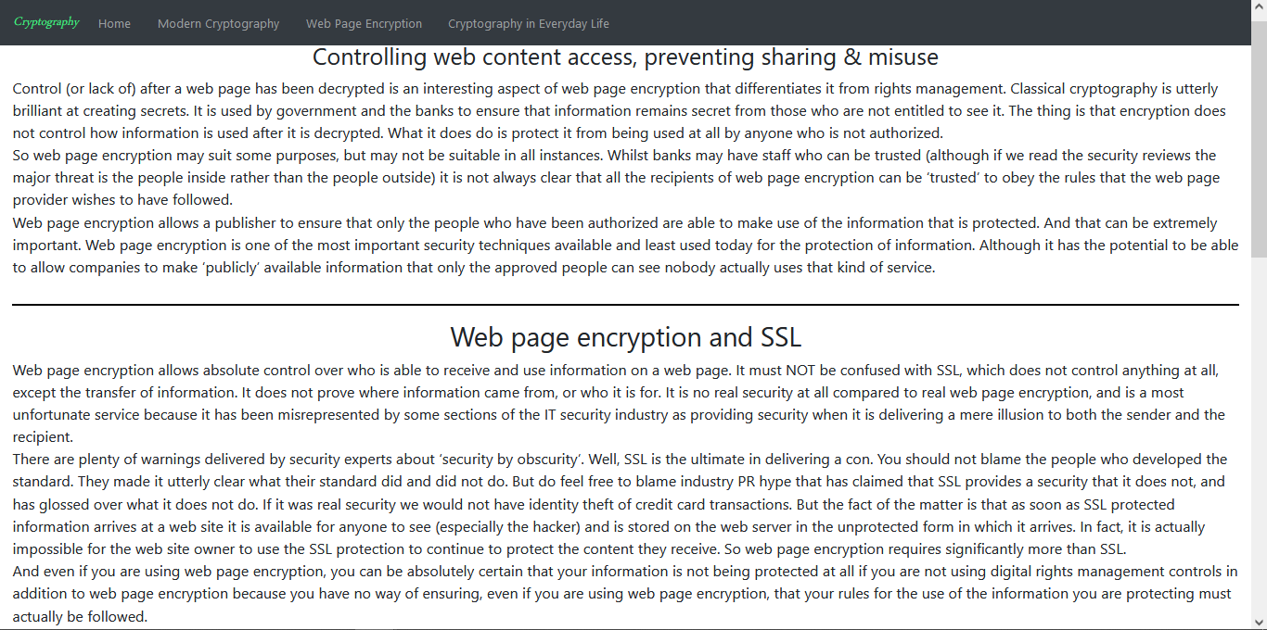The content of this web page is what the encryption methods used to encrypt pages is and how to control access to web pages. There is also some information about the web page encryption method SSL [4]. In addition, there are four applications used in cryptography and encryption and a lot of information about them [5].

**The Fifth Page (Cryptography in everyday life):**

This page shows the application of Cryptography In the present days. Cryptography is used in

* Authentication/Digital Signatures
* Electronic Money
* Secure Network Communications

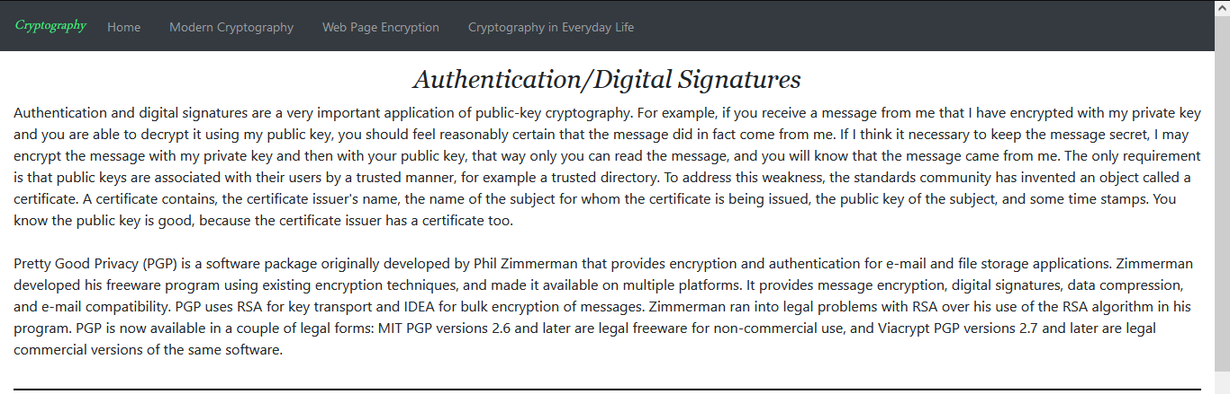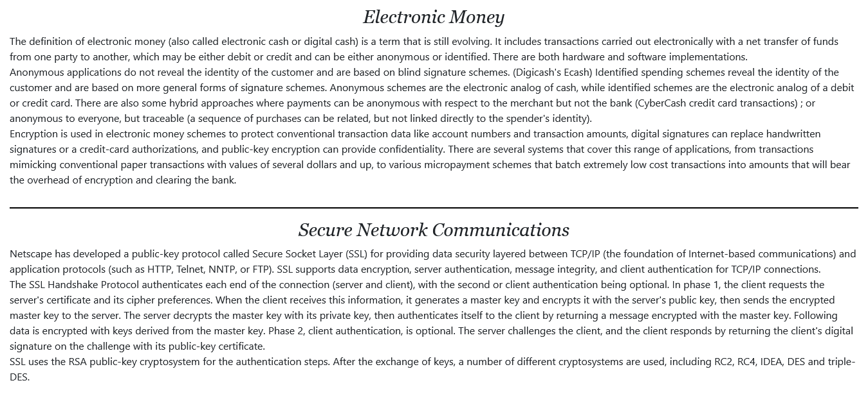and many other fields in our life.

This is part of the code in the main index file:

<doctybe html>

    <html>

    <head>

        <meta charset="UTF-8" />

<meta name="viewport" content="width=device-width, initial-scale=1, shrink-to-fit=no">

        <title>Cryptograph Home Page</title>

        <meta name="discription" content="Crypto" />

        <link rel="stylesheet" href="cssfiles/bootstrap.css">

        <link rel="stylesheet"href="https://cdnjs.cloudflare.com/ajax/libs/font-awesome/4.7.0/css/font-awesome.min.css">

        <link rel="stylesheet" type="text/css" href="cssfiles/pro.css">

        <script></script>

    </head>

<div class="container-fluid">

            <div class="row">

                <div class="wheres col-12">

                    <h1

                        style="text-align: center;font-style: oblique; font-family: Georgia, 'Times New Roman', Times, serif;">

                        Cryptography</h1>

                </div>

            </div>

            <div class="row">

                <div class="col" style="margin-bottom: 10px;">

                    <video controls autoplay loop style="margin: auto;

                    margin-bottom: 10px;

                    display: block;

                    width:  100%;">

                        <source src="imgs/What_is_cryptography.mp4" type="video/mp4">

                    </video>

                </div>

            </div>

        </div>

        <script src="js/jquery-3.3.1.min.js"></script>

        <script src="js/bootstrap.min.js"></script>

        <script src="js/my_script.js"></script>

    </body>

</html>

**References**

|  |  |
| --- | --- |
| [1] | Khan academy, *What Is Cryptography? | Journey into Cryptography | Computer Science | Khan Academy*. YouTube, 27 Mar. 2012, www.youtube.com/watch?v=Kf9KjCKmDcU. |
| [2] | “Cryptography.” Wikipedia, Wikimedia Foundation, 28 May 2021, en.wikipedia.org/wiki/Cryptography. |
| [3] | “What Is Cryptography? Definition of Cryptography, Cryptography Meaning.” The Economic Times, economictimes.indiatimes.com/definition/cryptography. |
| [4] | “Web Page Encryption: Encrypt Web Pages against Unauthorized Access &amp; Use with DRM Security Software.” Locklizard, 6 May 2021, www.locklizard.com/web-page-encryption/. |
| [5] | Rubenking, Neil J. “The Best Encryption Software for 2021.” PCMAG, PCMag, 13 May 2021, www.pcmag.com/picks/the-best-encryption-software. |
|  |  |
|  |  |