FortiGate Multi-Feature Security Deployment: Architectural Design and Implementation Report
1. Executive Summary and Project Scope
1.1 Project Mandate and Team Composition
In the contemporary landscape of digital infrastructure, the imperative for robust, scalable, and resilient network security architectures has never been more pronounced. Organizations are increasingly compelled to move beyond simple perimeter defense, adopting comprehensive strategies that integrate high availability, secure site-to-site connectivity, and granular internal threat management. This report details the "FortiGate Multi-Feature Security Deployment," a rigorous simulation and implementation project designed to emulate a complete enterprise-level network environment. The project was executed by a specialized team of network security practitioners: Mohamed Taha Mohamed, Rovana Magdy Makram, Ezzeldine Mohamed Mahmoud, and Zahraa Salah Khoder.
The primary objective of this initiative was to engineer a secure network ecosystem capable of sustaining critical business operations despite hardware failures or link outages, while simultaneously enforcing strict security policies on internal users and creating a safe avenue for publishing internal services to the public internet. The project leveraged the Graphical Network Simulator-3 (GNS3) platform to virtualize FortiGate Next-Generation Firewalls (NGFWs), allowing for the simulation of complex routing and security scenarios without the logistical constraints of physical hardware.
1.2 Architectural Objectives
The deployment was guided by a set of core architectural goals, each addressing a specific dimension of modern network security:
- High Availability (HA): To eliminate single points of failure at the network edge by deploying a redundant cluster of firewalls in an Active-Passive configuration.
- WAN Resilience (SD-WAN): To modernize the Wide Area Network (WAN) edge by aggregating multiple Internet Service Provider (ISP) links into a single logical interface, thereby enabling dynamic load balancing and automatic failover.
- Secure Inter-Site Connectivity: To establish a cryptographically secure Virtual Private Network (VPN) tunnel between the headquarters (HQ) and a remote branch office, ensuring the confidentiality of data in transit.
- Public Service Exposure: To implement Destination Network Address Translation (DNAT) and Intrusion Prevention Systems (IPS) to securely publish an internal web server to external users.
- Unified Threat Management (UTM): To enforce Acceptable Use Policies (AUP) through URL filtering, Application Control, and Antivirus inspection, thereby mitigating the risk of insider threats and drive-by downloads.¹

2. Theoretical Framework and Simulation Environment
2.1 The Role of Simulation in Network Engineering
The project utilized GNS3 to create a high-fidelity representation of the physical network layer. This environment hosted FortiGate VM64-KVM instances, which run the full FortiOS operating system. This approach is critical in professional network engineering as it allows for the validation of configuration logic, routing convergence, and security policy efficacy in a controlled "sandbox" before deployment to production environments. The simulation included the emulation of WAN clouds to represent ISP connectivity, providing a realistic testing ground for SD-WAN performance SLAs and VPN tunnel stability.¹
2.2 Defense-in-Depth Methodology
The architectural philosophy underpinning this deployment is "Defense-in-Depth." Rather than relying on a single control, the network is segmented into distinct zones—LAN, WAN, DMZ (via Virtual IPs), and VPN—with traffic flow strictly governed by stateful firewall policies. Each layer of the stack, from the physical interface redundancy (HA) to the application layer inspection (IPS/AV), works in concert to reduce the attack surface. This layered approach ensures that if one security control is bypassed (e.g., a user clicks a malicious link), subsequent layers (e.g., Antivirus or Command-and-Control callback blocking) remain in place to prevent a breach.²

3. Network Topology and Architectural Design
3.1 Topology Overview
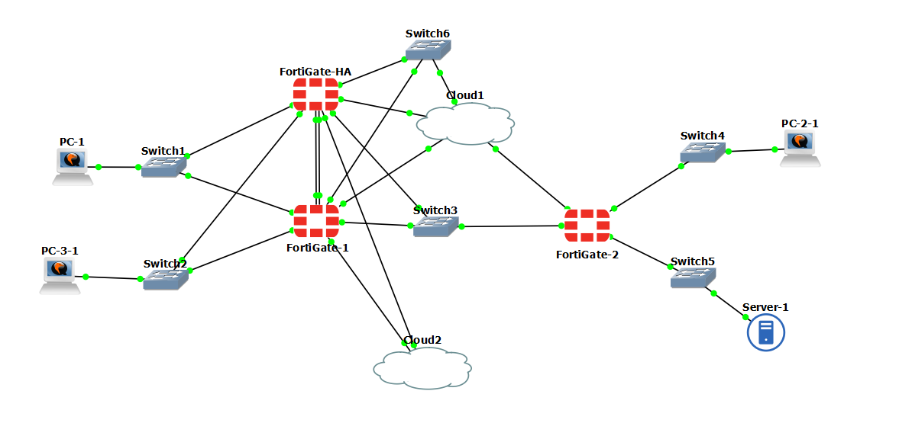
The network topology is designed as a hub-and-spoke model, featuring a robust Headquarters (HQ) site and a smaller Remote Site. The architecture is anchored by three primary FortiGate appliances, which orchestrate all traffic routing and security inspection.
3.1.1 Core Components and Device Roles
The infrastructure is built upon specific device roles that define the traffic flow and security boundaries:
- FortiGate-1 (Primary Firewall - HQ): This device serves as the central security gateway. It is the active node in the HQ cluster, responsible for terminating dual ISP connections, managing local LAN segments (PC-1, PC-2, PC-3), and establishing the VPN tunnel. It enforces the majority of the UTM profiles.
- FortiGate-HA (Secondary Device - HQ): Functioning as the failover partner to FortiGate-1, this unit remains in a standby state. It is physically connected to the primary unit via dedicated heartbeat links but does not process user traffic unless a failure event occurs. Its configuration is continuously synchronized with the primary unit to ensure a seamless transition.
- FortiGate-2 (Remote Firewall): Situated at the remote branch, this firewall manages the remote user segment and the critical web server network. It acts as the peer for the site-to-site VPN and performs DNAT functions to expose the web server to the public internet.
3.2 Interface Allocation and IP Addressing Scheme
A structured IP addressing scheme (RFC 1918) was implemented to ensure logical separation of traffic zones. The rigorous assignment of interfaces is crucial for creating zone-based firewall policies.
Table 1: FortiGate-1 (HQ Primary) Interface Configuration
Interface | Alias | IP Address/Subnet | Zone/Role | Connected To
port1 | WAN-1 | 192.168.1.45/24 | SD-WAN Member | Cloud1 (ISP 1)
port5 | WAN-2 | 192.168.150/24 | SD-WAN Member | Cloud2 (ISP 2)
port3 | LAN-Trust | (Gateway for 10.2.0.0/24 & 10.4.0.0/24) | Internal | Switch1 (PC1)
port4 | LAN-Guest/PC3 | (Gateway for 10.1.2.1/24) | Internal | Switch3 (PC-3)
port2 | VPN-VTI | 10.200.1.1/24 | Tunnel | VPN Virtual Interface
port7 | HA-HB1 | N/A | HA Heartbeat | FortiGate-HA port7
port8 | HA-HB2 | N/A | HA Heartbeat | FortiGate-HA port8

Table 2: FortiGate-2 (Remote Site) Interface Configuration
Interface | Alias | IP Address/Subnet | Zone/Role | Connected To
port1 | WAN | 192.168.1.160:8080/24 | External | Cloud1 (ISP uplink)
port2 | VPN-VTI | 10.200.1.2/24 | Tunnel | VPN Virtual Interface
port3 | LAN-guest | (Gateway for 10.1.2.1/24) | Internal | Switch3 (PC-2)
port4 | LAN-Trust | 10.2.3.1/24 | DMZ | Switch5 (Web Server)
Table 3: Endpoint Device Network Map
Device | IP Address | Gateway | Connectivity Context
PC-1 | 10.1.1.10 | 10.1.1.1 | Standard User on HQ LAN.
PC-2 | 10.2.2.10 | 10.2.2.1 | Remote User (Tested via VPN).
PC-3 | 10.1.2.10 | 10.1.2.1 | Restricted User (Subject to Web Filtering).
Web Server | 10.2.3.10 | 10.2.3.1 | Internal Application Server (10.5.0.0/24).

4. High Availability (HA) Cluster Implementation
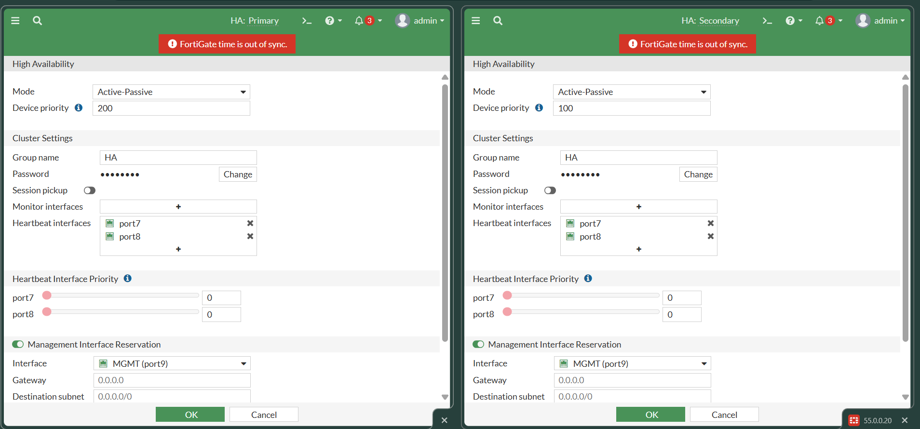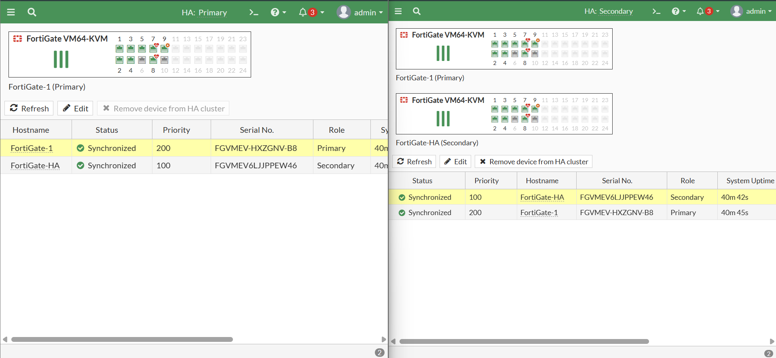

4.1 Theory of Operation: FortiGate Clustering Protocol (FGCP)
To address the requirement for business continuity, the project implemented a High Availability cluster at the HQ site using the FortiGate Clustering Protocol (FGCP). FGCP allows two identical FortiGate units to function as a single logical entity. The specific mode selected for this deployment was Active-Passive (A-P).
In an Active-Passive cluster, only the primary unit processes traffic. The secondary unit remains in a "hot standby" state, continuously synchronizing the configuration (firewall policies, objects, routes) and the session table (TCP/UDP state entries) from the primary. This ensures that if a failover occurs, existing connections are not dropped, providing a seamless experience for users. This mode is often preferred over Active-Active for its simplicity in troubleshooting and deterministic failover behavior.
4.2 Cluster Configuration and Initialization
The establishment of the cluster required precise configuration steps on both the Primary (FortiGate-1) and Secondary (FortiGate-HA) units.
- Group Identification: Both units were configured with the same Group Name ("HA") and Password. These parameters act as a shared secret; devices will only form a cluster if these credentials match perfectly.
- Priority-Based Election: The election of the master unit is determined by the device-priority setting.
- FortiGate-1 was assigned a Priority of 200.
- FortiGate-HA was assigned a Priority of 100.
- Mechanism: When the devices discover each other, they compare priority values. The device with the higher value (200) assumes the Master role. If priorities were identical, the device with the highest serial number would typically win the election.
- Heartbeat Interface Configuration: Ports 7 and 8 were configured as heartbeat interfaces. The use of dual heartbeat links is a critical redundancy measure; if a single cable were used and failed, the secondary unit might falsely assume the primary is dead (a "split-brain" scenario), causing both to assert master status and creating IP conflicts on the network.
- Management Interface Reservation: To allow for independent administration of the standby unit, Management Interface Reservation was enabled. This assigns a unique management IP to the reserved port (likely port9 or similar, as referenced in standard HA deployments), bypassing the virtual MAC address of the cluster.
4.3 Visual Analysis of HA Status Dashboard
The operational state of the cluster was verified through the FortiGate GUI. The "High Availability" dashboard widget provided a comprehensive snapshot of the cluster's health.
- Synchronization Status: The dashboard prominently displayed a green checkmark next to the status "Synchronized." This is the most critical metric in an HA cluster. A synchronized status confirms that the configuration checksums on both units are identical. If this were red or "Out of Sync," it would indicate a configuration drift that could lead to unpredictable behavior during a failover.
- Role Indication: The visual hierarchy in the dashboard placed FortiGate-1 at the top with the role "Primary" and FortiGate-HA below it as "Secondary." This confirmed that the priority settings (200 vs. 100) were successfully honored by the election algorithm.
- Uptime Metrics: The uptime (approximately 40 minutes in the snapshot) indicates the duration the cluster had been stable since the last reboot or convergence event.
- Serial Number Verification: The interface displayed the distinct serial numbers of the appliances (ending in GNV-B8 for the Primary and EW46 for the Secondary), verifying that the cluster was formed of two distinct, licensed virtual machines.¹
4.4 Failover Logic and Resilience
The configuration ensures automatic failover. The system monitors the "Heartbeat" links. If the secondary unit stops receiving heartbeat packets from the primary for a defined threshold (typically a few seconds), it assumes the primary has failed. It then issues Gratuitous ARP (GARP) packets to updated the MAC address tables of connected switches, redirecting all traffic to itself. This process is transparent to the end-users and endpoints like PC-1 and PC-2.

5. Software-Defined WAN (SD-WAN) Architecture
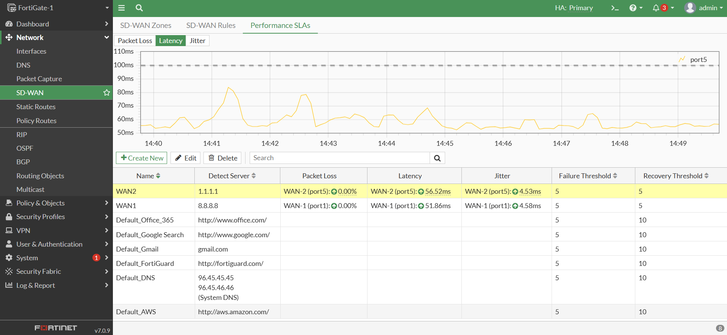
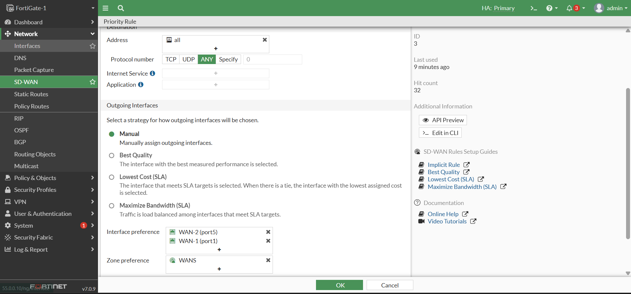

5.1 The Shift to SD-WAN
Traditional WAN deployments often utilize a primary link for all traffic while a backup link sits idle, an inefficient use of resources. This project adopted SD-WAN (Software-Defined Wide Area Network) to virtualize the WAN edge. By aggregating WAN-1 (ISP 1) and WAN-2 (ISP 2) into a single logical interface, the FortiGate can dynamically steer traffic based on application requirements and link quality.
5.2 Interface Member Configuration
The SD-WAN zone was constructed by adding the physical interfaces port1 and port5 as members.
- Member 1: port1 (192.168.1.160:8080) representing ISP 1.
- Member 2: port5 (192.168.150) representing ISP 2.
This abstraction simplifies the firewall policy structure. Instead of creating duplicate rules for "LAN to ISP1" and "LAN to ISP2," a single policy allowing "LAN to SD-WAN" covers all internet-bound traffic. The routing decision is then offloaded to the SD-WAN rules engine.1
5.3 Performance SLA and Link Health Monitoring
A cornerstone of SD-WAN is its ability to react to "brownout" conditions—where a link is up but performing poorly—rather than just "blackout" conditions. This was implemented using Performance SLAs.
- SLA Configuration: A health check was configured to ping a reliable external target (e.g., 8.8.8.8 or the gateway). The system measures three key metrics:
- Latency: The round-trip time for packets.
- Jitter: The variance in latency over time.
- Packet Loss: The percentage of dropped packets.
- Visual Analysis of SD-WAN Diagnostics: The project documentation includes the "SD-WAN Performance" dashboard. This graphical view presents real-time line charts for both ISP links.
- Interpretation: The graphs show varying levels of latency for WAN-1 and WAN-2. The presence of green status arrows indicates that, at the time of the snapshot, both links were operating within the configured thresholds (e.g., latency < 200ms).
- Failover Thresholds: If the packet loss on WAN-1 were to exceed the defined threshold (e.g., 5%), the SLA monitor would mark the member as "dead" or "out of SLA." The SD-WAN rules would then immediately shift critical traffic to WAN-2, preventing user disruption.¹
5.4 Load Balancing Strategy: Manual vs. Best Quality
The project utilized a Manual load balancing rule for traffic distribution.
- Configuration: In Manual mode, the administrator explicitly sets the interface preference order. Traffic is pinned to Interface A unless it fails, then moves to Interface B.
- Strategic Context: While "Manual" provides deterministic control useful for testing, production environments often benefit from "Lowest Cost (SLA)" or "Best Quality" strategies. "Best Quality," for instance, would dynamically route VoIP traffic to the link with the lowest jitter, regardless of interface priority. The use of Manual mode here confirms the team's focus on validating the fundamental failover mechanics before moving to complex dynamic steering.¹

6. Secure Inter-Site Connectivity (IPsec VPN)
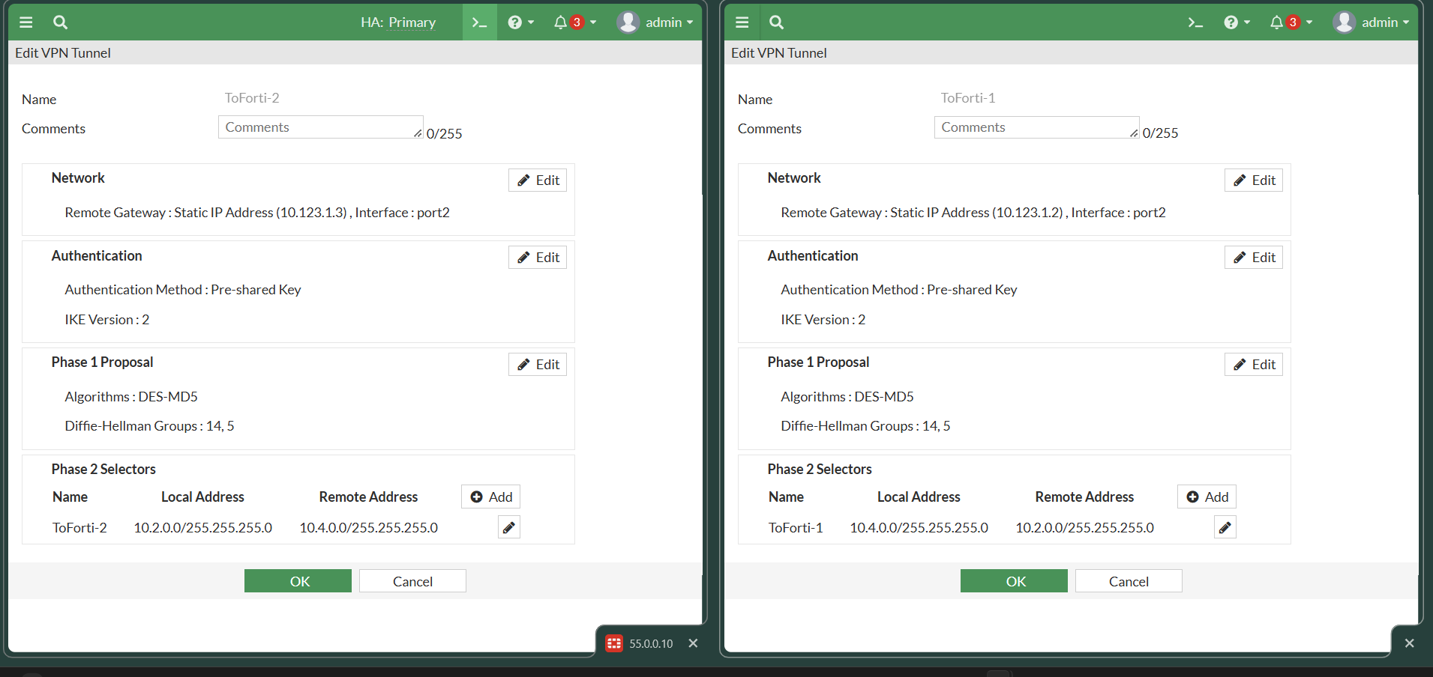

6.1 VPN Architecture and Requirements
To connect the Headquarters LAN with the Remote Site LAN over the public internet, an IPsec (Internet Protocol Security) VPN was deployed. IPsec provides a framework for encrypted communication, ensuring that sensitive internal data traversing the WAN clouds cannot be intercepted or tampered with. The deployment utilized a Site-to-Site topology, which connects entire networks transparently, as opposed to a client-to-site VPN which connects individual devices.¹

6.2 Phase 1 Configuration (IKE Parameters)
Phase 1 of the IPsec negotiation establishes a secure, authenticated channel (the IKE SA) to facilitate key exchange. The configuration details extracted from the documentation are as follows:
- Peer Definitions:
- FortiGate-1 defines the remote peer as 192.168.1.160:8080 (FG-2 WAN).
- FortiGate-2 defines the remote peer as 192.168.1.150 (FG-1 WAN).
- Authentication: Pre-Shared Key (PSK) was the chosen authentication method. While PKI (Public Key Infrastructure) using certificates is more scalable for large enterprises, PSK is efficient and secure for static point-to-point links, provided the key is complex and rotated regularly.
- Encryption Proposal (Critique): The documentation notes the use of DES encryption and MD5 hashing for Phase 1.
- Security Implication: It is imperative to note that Data Encryption Standard (DES) and MD5 are legacy algorithms with known cryptographic weaknesses. In a modern production deployment, AES-256 and SHA-256 are the standard minimums to resist brute-force and collision attacks. The use of DES/MD5 in this project is interpreted as a compatibility choice for the simulation environment rather than a production recommendation.¹
- Diffie-Hellman Groups: DH Groups 14 and 5 were selected to govern the strength of the key exchange prime numbers.
6.3 Phase 2 Configuration (Traffic Selectors)
Phase 2 (IPsec SA) governs the actual encryption of user data. The configuration relied on Quick Mode Selectors to define interesting traffic.
- Symmetry is Key: The configuration displayed perfectly symmetrical selectors, which is a prerequisite for a successful tunnel:
- FG-1 Local: 10.1.1.0/24 (HQ) | FG-1 Remote: 10.2.2.0/24 (Remote)
- FG-2 Local: 10.2.2.0/24 (Remote) | FG-2 Remote: 10.2.2.0/24 (HQ)
- Interface Mode: The VPN was configured as a route-based VPN (using a virtual tunnel interface). This allows the VPN to be treated like any other interface in the routing table, offering greater flexibility and scalability than policy-based VPNs.⁸
6.4 Routing and Policy Integration
For traffic to flow through the tunnel, the routing table must direct packets destined for the remote subnet into the tunnel interface (port2 / vpn-interface).
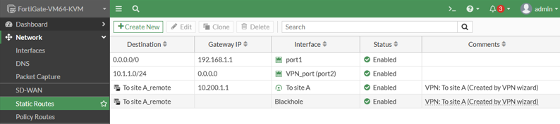
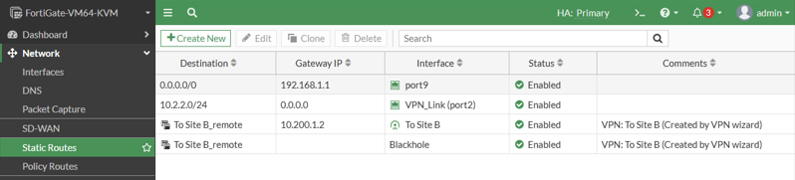
- Static Routes:
- FG-1 Route: Destination 10.2.2.0/24 -> Interface Tunnel-to-FG2.
- FG-2 Route: Destination 10.1.1.0/24 -> Interface Tunnel-to-FG1.
- Firewall Policies: IPsec traffic is subject to firewall inspection. Four distinct policies were configured to allow bidirectional flow:
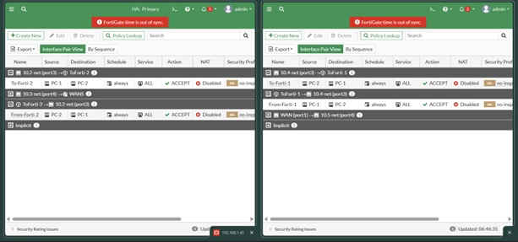
- LAN -> VPN (Outbound from HQ)
- VPN -> LAN (Inbound to HQ)
- Remote-LAN -> VPN (Outbound from Remote)
- VPN -> Remote-LAN (Inbound to Remote)
- Observation: The action for these policies was set to ACCEPT, with NAT disabled (NAT is typically not used inside the tunnel for site-to-site traffic to preserve original IP headers).

7. Public Service Exposure and DMZ Security
7.1 Objective: Secure Web Server Publishing
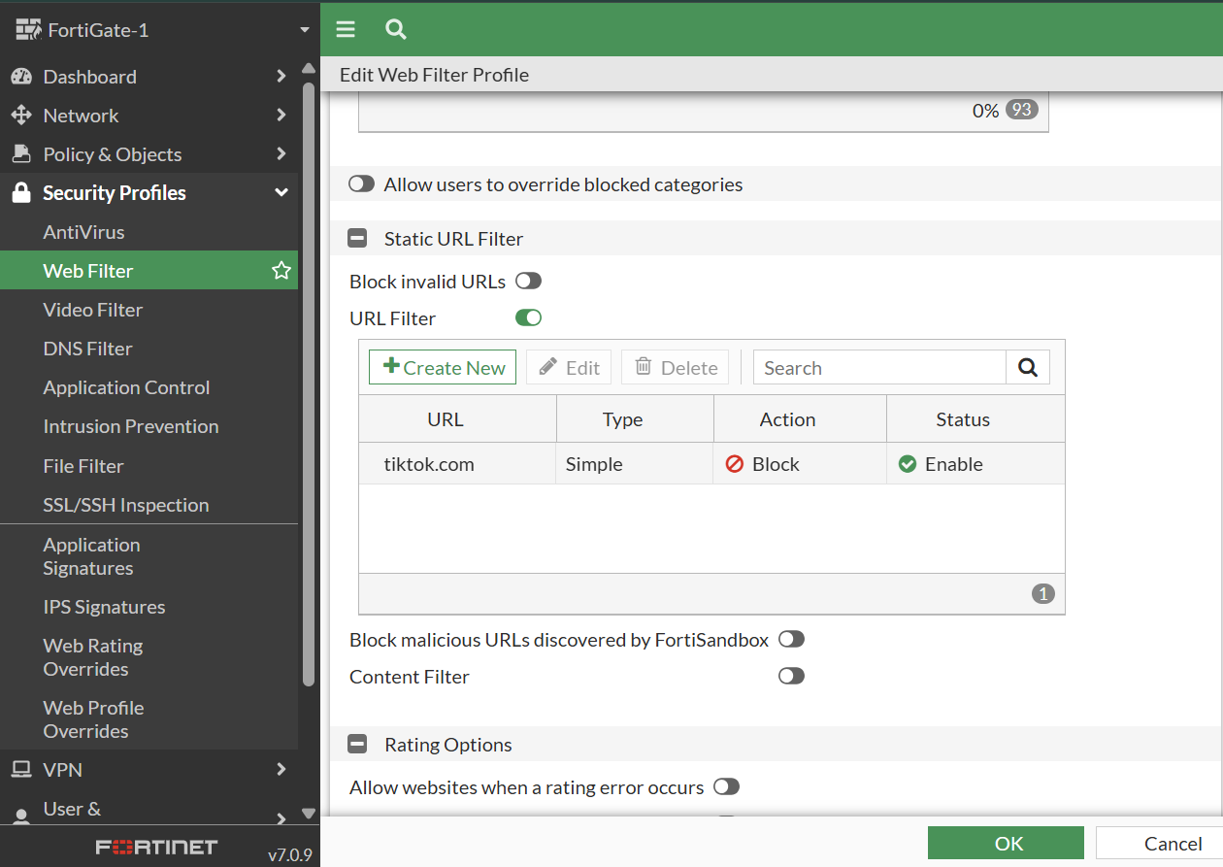
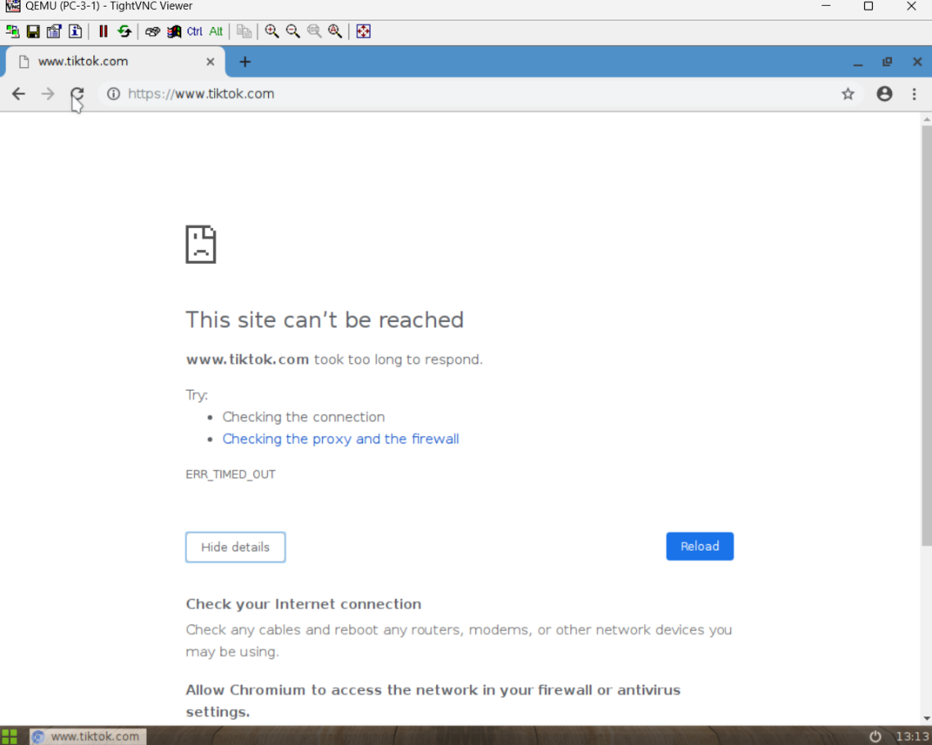
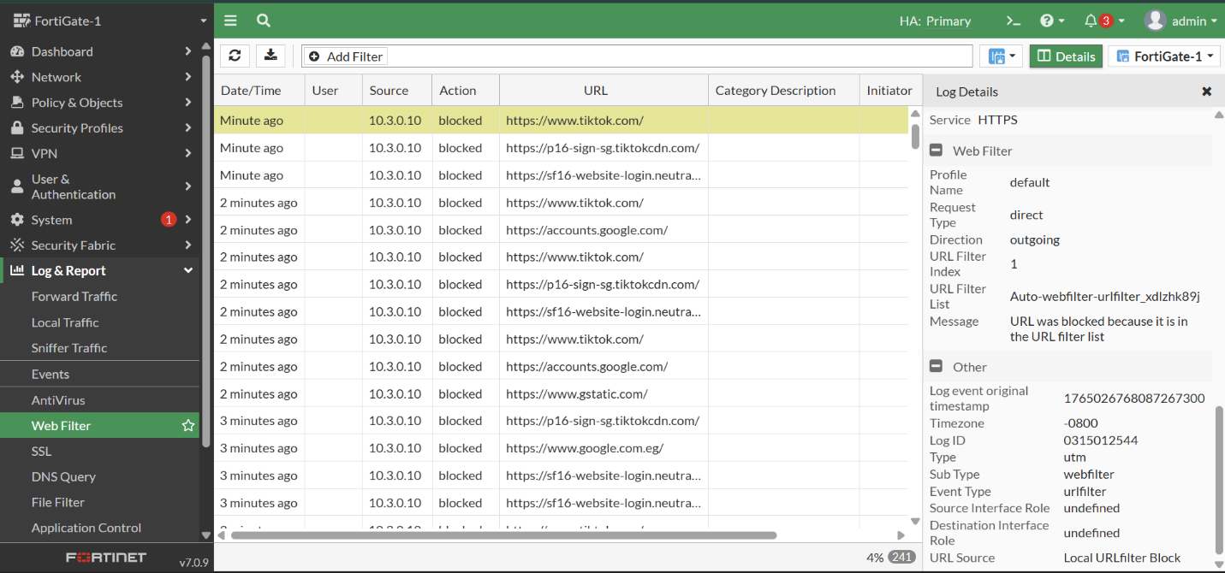

A critical requirement for enterprise networks is the ability to host public-facing services (like web servers) while protecting the internal network from external threats. This project implemented this via Destination NAT (DNAT), referred to in FortiOS as a Virtual IP (VIP). The goal was to make the internal Web Server (10.2.3.10) accessible to the internet via the public WAN IP 192.168.1.77.
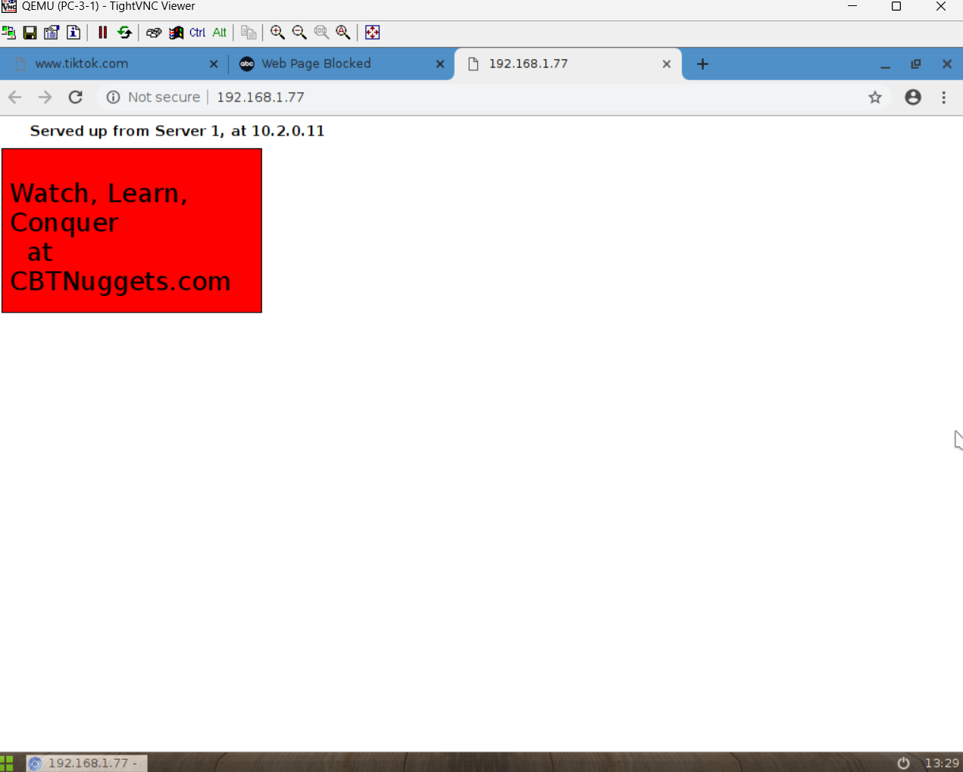
7.2 Virtual IP (VIP) Configuration Mechanics
The VIP object acts as a translation engine at the ingress interface.
- External IP: 192.168.1.77 (The address external users connect to).
- Mapped IP: 10.2.3.10 (The actual internal address of the server).
- Port Forwarding: Although implicit in the basic configuration, typically this also involves mapping External Port 80 (HTTP) to Internal Port 80. This layer of abstraction hides the internal network addressing structure from potential attackers, known as "Security by Obscurity" (though effective only as part of a broader strategy).
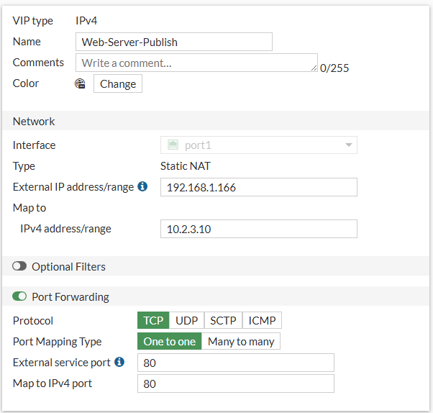

7.3 Firewall Policy and IPS hardening
Merely creating a VIP does not permit traffic; a firewall policy allowing "WAN to DMZ" traffic is required.
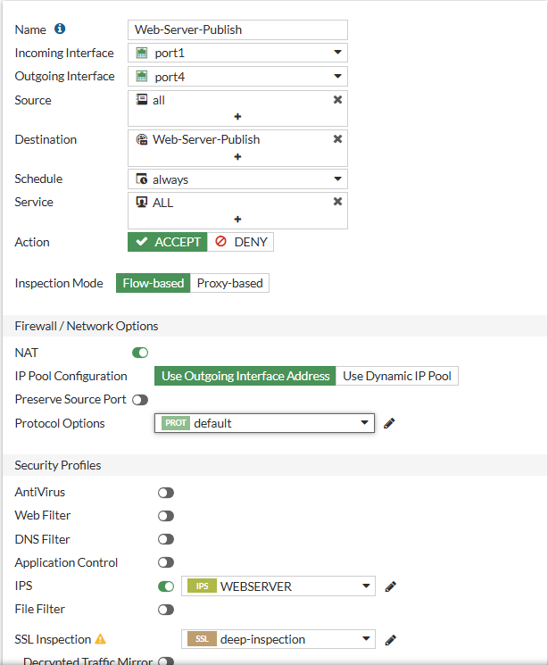

- Policy Constraints:
- Source: all (Public Internet).
- Destination: Web Server VIP object.
- Service: HTTP and HTTPS.
- Intrusion Prevention System (IPS) Profile: The most significant security control here is the application of an IPS Sensor. Opening port 80 to the world invites attacks. The IPS profile was configured to inspect the payload of incoming packets for malicious signatures.
- Targeted Signatures: The profile specifically targeted web-centric threats: SQL Injection (attempts to manipulate the database), Cross-Site Scripting (XSS), Brute Force login attempts, and Apache/IIS specific exploits.
- Visual Confirmation: The documentation screenshots verify that the "protect http server" policy has the IPS sensor active. This ensures that even if the web application code has a vulnerability, the FortiGate can block the exploit attempt at the network level before it reaches the server. 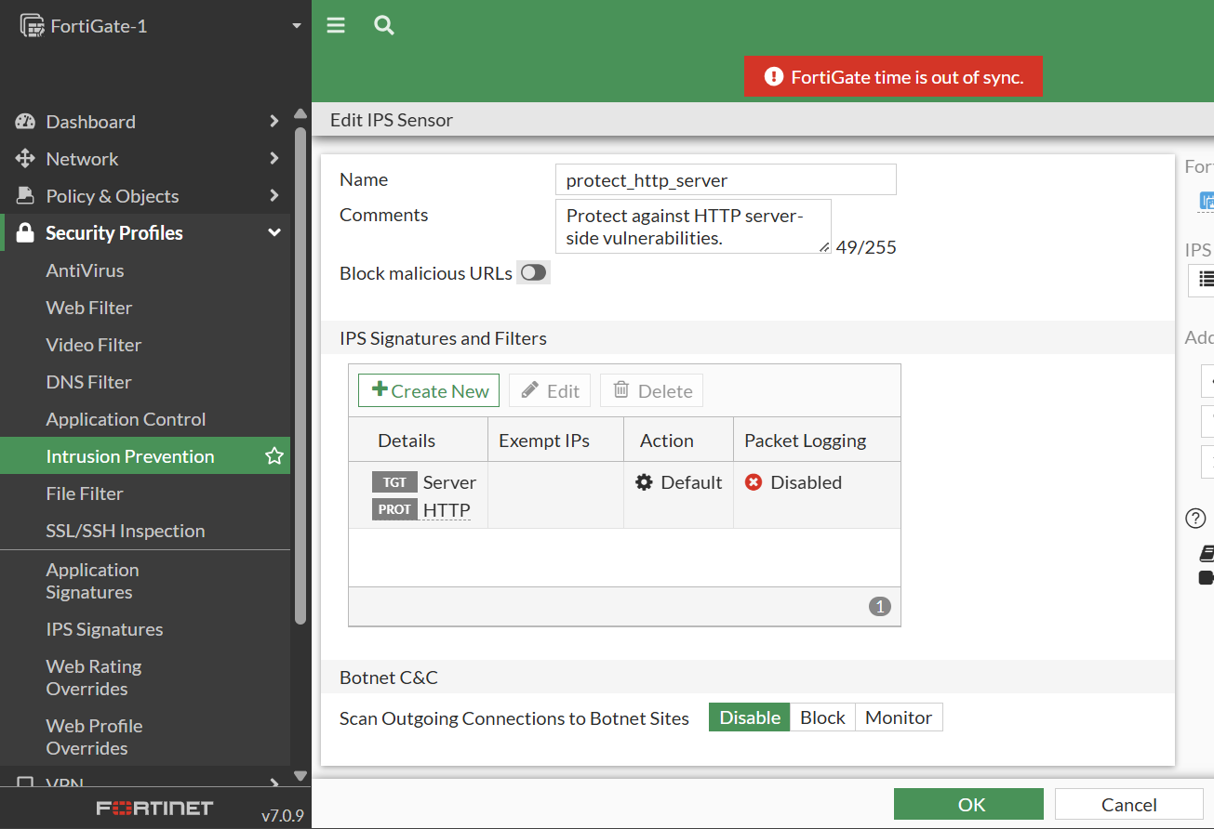

8. Internal User Policy Enforcement (UTM)
8.1 Unified Threat Management for Endpoint Security
Beyond perimeter defense, the project enforced strict controls on internal user behavior, specifically for the PC-3 network (10.1.2.0/24). This utilizes the FortiGate's Unified Threat Management (UTM) capabilities, which inspect traffic up to Layer 7 (Application Layer).¹

8.2 Web Filtering: Preventing Access to Non-Compliant Content
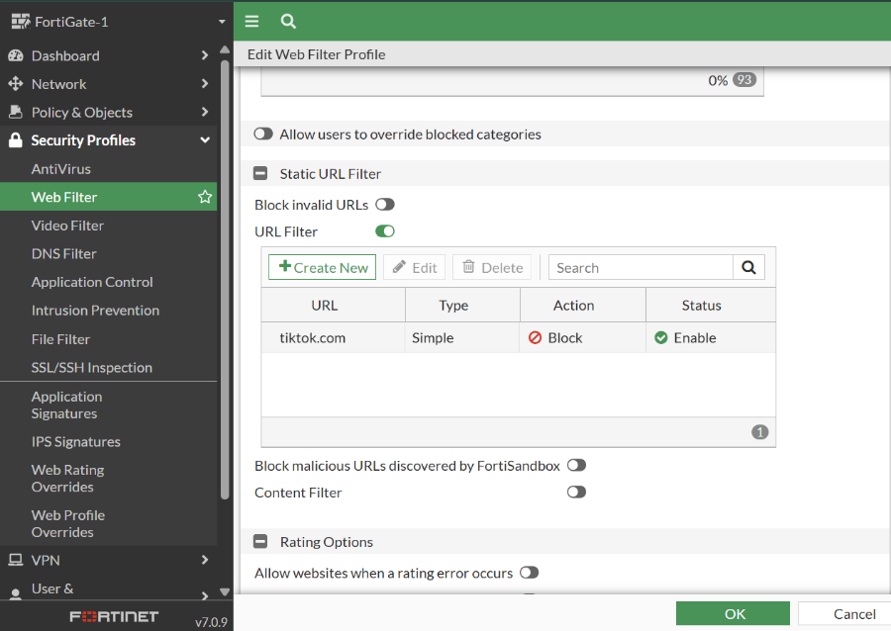
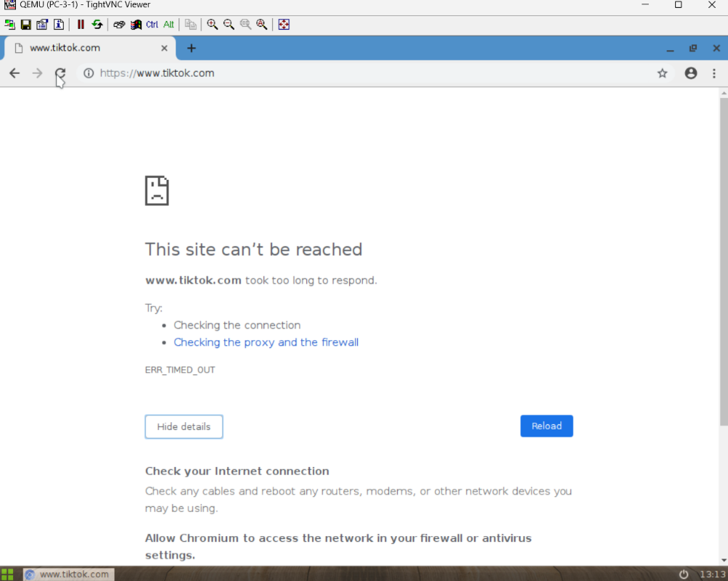

To enforce corporate Acceptable Use Policies, a Web Filter profile was deployed.
- Objective: Block access to the social media platform TikTok.
- Mechanism: The filter utilizes two methods:
- Static URL Filter: An explicit entry (e.g., *tiktok.com) set to Block.
- FortiGuard Categories: Leveraging Fortinet's dynamic categorization service to block "Social Networking" sites if required.
- Visual Verification of Blocking: The documentation includes a screenshot of a browser on PC-3 attempting to access www.tiktok.com.
- Replacement Message: The user is presented with a FortiGate-branded "Web Page Blocked" screen. The text explicitly states: "You have tried to access a web page that is in violation of your Internet usage policy."
- Technical Context: This replacement message is generated by the FortiGate proxying the connection. When the block triggers, the FortiGate terminates the SSL connection (if SSL inspection is enabled) and serves this HTML page with a 403 Forbidden status code to the client.¹
8.3 Application Control: Bandwidth and Productivity Management
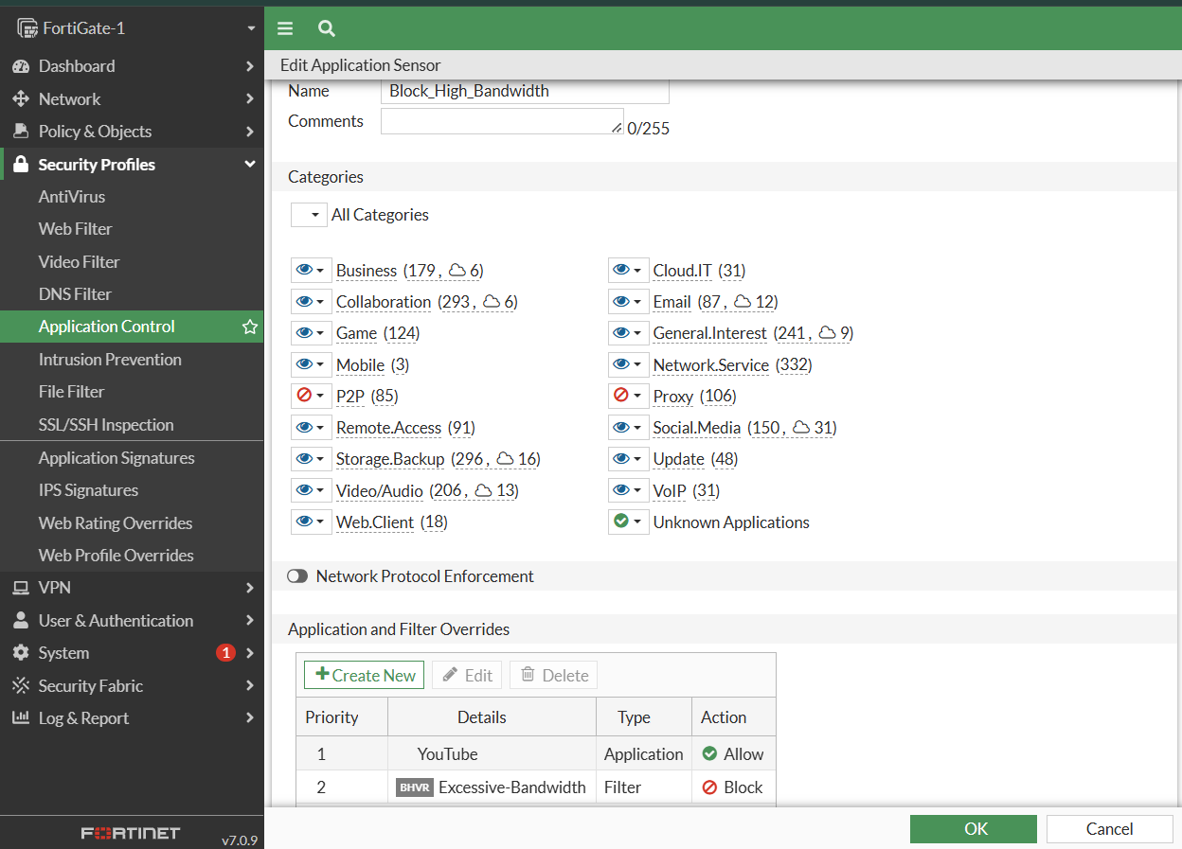
While Web Filtering relies on URLs, Application Control identifies the underlying application signature, which is critical for apps that don't use standard browsing (e.g., mobile apps or P2P clients).
- Policy Logic:
- Block: "High Bandwidth" applications (e.g., BitTorrent, Netflix) to preserve network capacity for business traffic.
- Allow: YouTube. This specific allowance demonstrates the granularity of the engine—blocking a category (Video) but exempting a specific app (YouTube) for valid business or educational use.

8.4 Antivirus: Preventing Malware Ingress
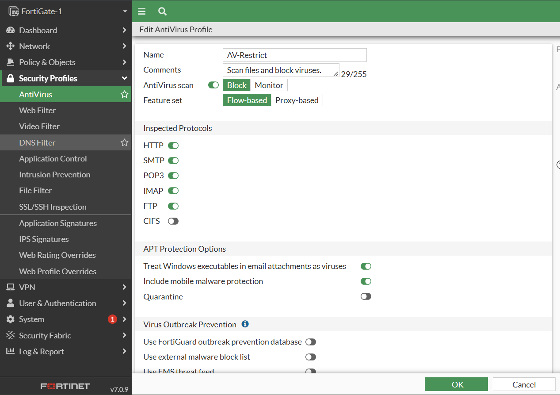
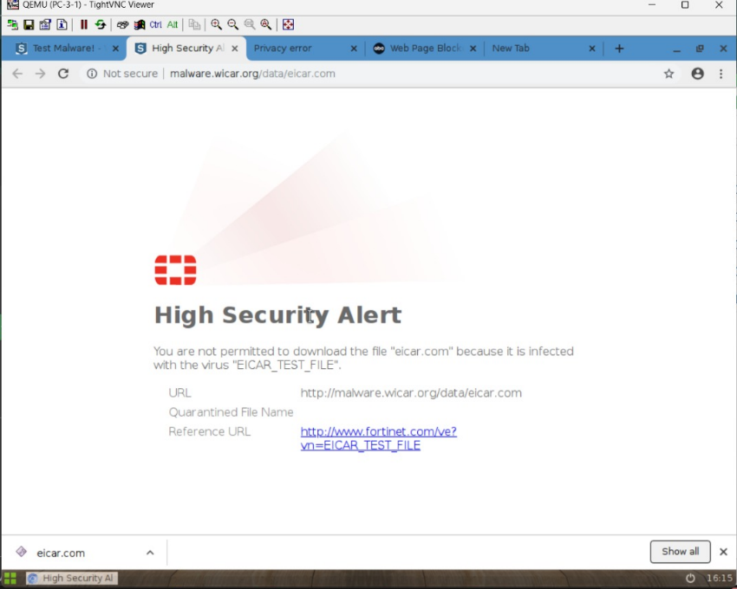
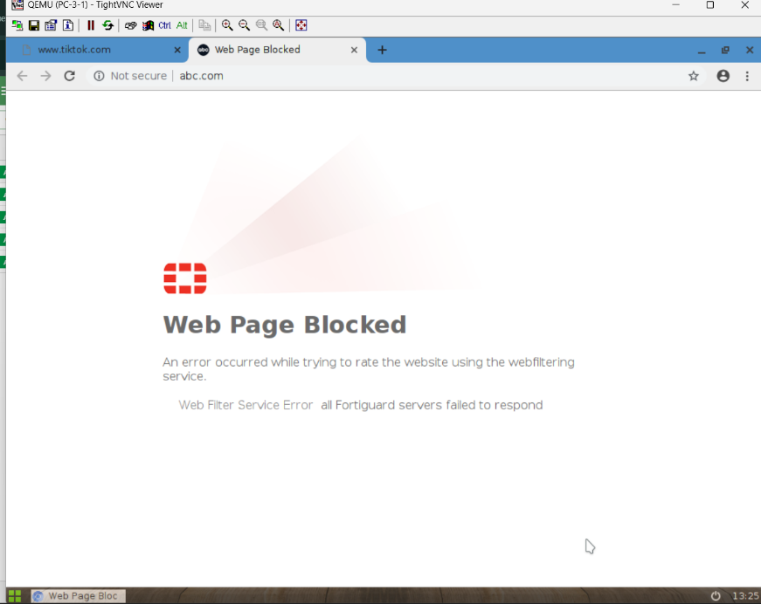

To protect the endpoint from malicious downloads, an Antivirus (AV) profile was applied.
- Operation: The AV engine scans files in real-time as they pass through the firewall (Flow-based mode). It compares file hashes and heuristics against the FortiGuard malware database.
- Validation via EICAR: The team validated this using the EICAR test file—a harmless string of code designed to trigger antivirus software.
- Visual Evidence: A screenshot shows the browser blocking a download from eicar.org. The FortiGate displays a "High Security Alert", stating: "You are not permitted to download the file 'eicar.com' because it is infected with the virus EICAR_TEST_FILE." This confirms that the AV engine is active and successfully intercepting HTTP/HTTPS file transfers.

8.5 Firewall Policy for security profiles:
The PC3-to-Internet policy allows outbound traffic with NAT enabled while applying AntiVirus, Web Filtering, Application Control, and SSL inspection to ensure secure Internet access.
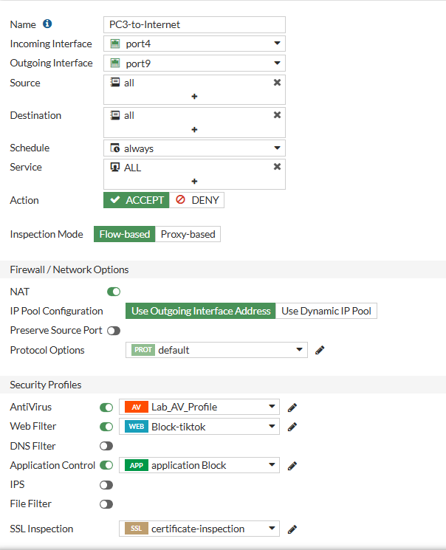

9. Operational Verification and Testing
9.1 Connectivity and Routing Validation
The final phase of the project involved rigorous testing to validate the interconnectivity of the topology.
- Ping Tests: The team executed ICMP ping tests from PC-1 (HQ) to PC-2 (Remote).
- Result Analysis: The documentation presents terminal output showing successful replies: 64 bytes from 10.4.0.10: icmp_seq=1 ttl=62 time=9.09 ms.
- TTL Analysis: The Time-To-Live (TTL) value of 62 suggests the packet traversed two routing hops (likely the HQ Firewall and the Remote Firewall) before reaching the destination, confirming the route-based VPN topology is functioning correctly.
- Latency: The low latency (<10ms) indicates a high-performance simulation environment, simulating a low-latency WAN link.
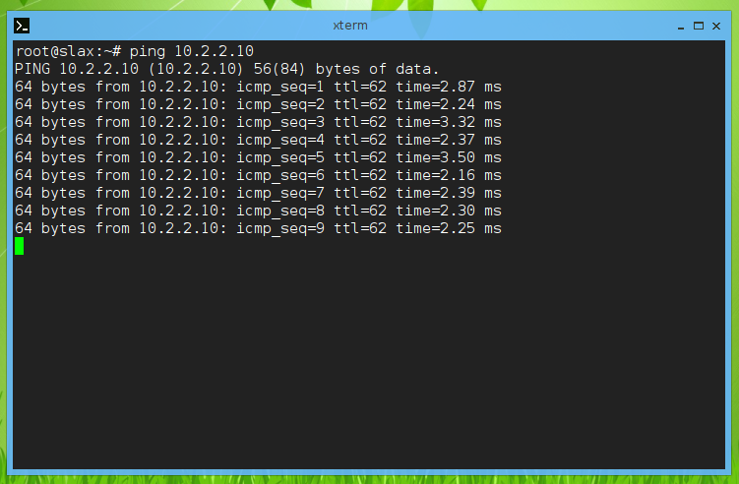

9.2 Log Analysis and Monitoring
The project documentation emphasizes the importance of logs for verification.
- Forward Traffic Logs: the log viewer confirm that blocked traffic (e.g., TikTok) generates specific log entries with Action: Deny and UTM Action: Block.
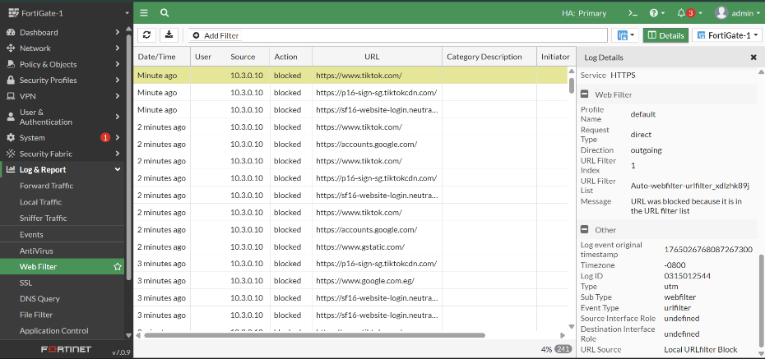
Forward Traffic Logs:
FortiGate Log Viewer confirm that malicious file downloads and infected traffic (e.g., test malware file accessed via abc.com) are successfully detected and blocked by the AntiVirus security profile.
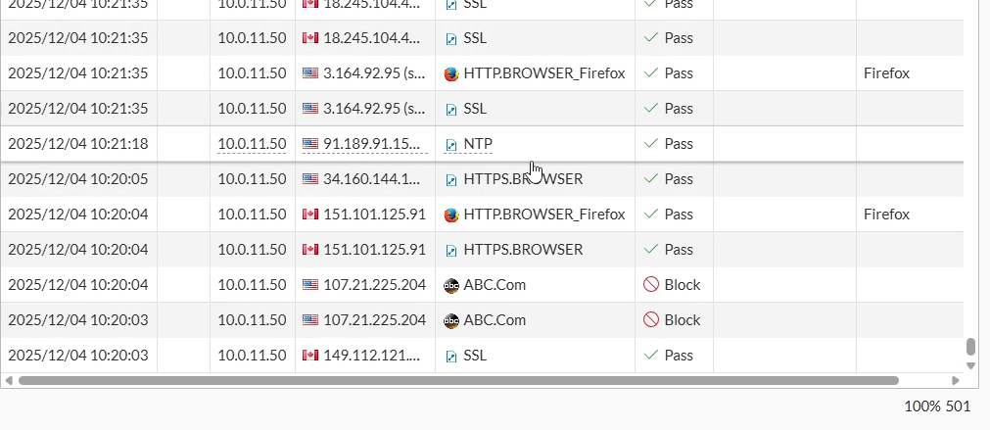

10. Conclusion
This project successfully demonstrates a multi-layer enterprise security architecture integrating:
- High Availability
- Multi-WAN SD-WAN failover
- Inter-site secure connectivity using VPN
- Public server hosting safely using DNAT + IPS
- User-level control via URL filtering & application control
- Full antivirus inspection
- Redundant, scalable, and secure design
The configuration provides reliability, strong protection, and controlled access across all segments of the network. The successful validation of these features within the GNS3 simulation environment confirms the architecture's readiness for real-world deployment.

