Gravity Book Store ETL Project (GBS)
Business Value
- Strategic Decision Making
- Identify profitable products and customers
- Customer Insights
- Understanding customer behavior
- Segment customers for targeted marketing
- Monitor customer service metrics
- Financial Analysis
- Revenue analysis by multiple dimensions
- Cost analysis (shipping costs)
- Optimize shipping methods
Gravity Book Store Database ERD
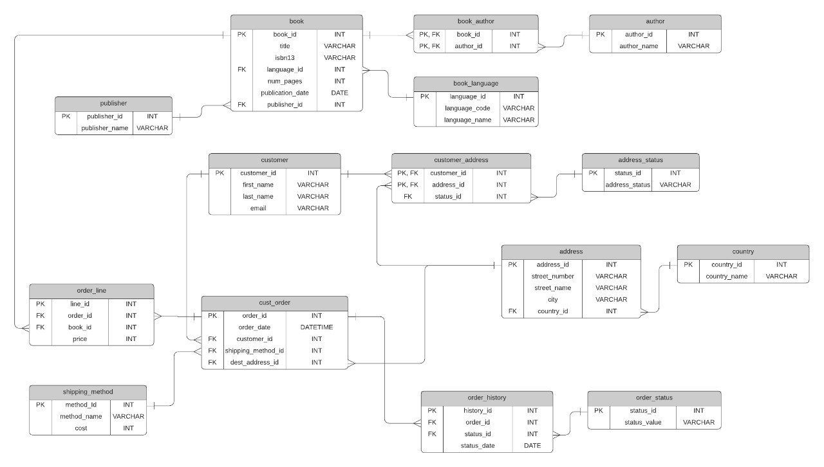
GBS Data Warehouse Diagram (Dimensional Modeling)
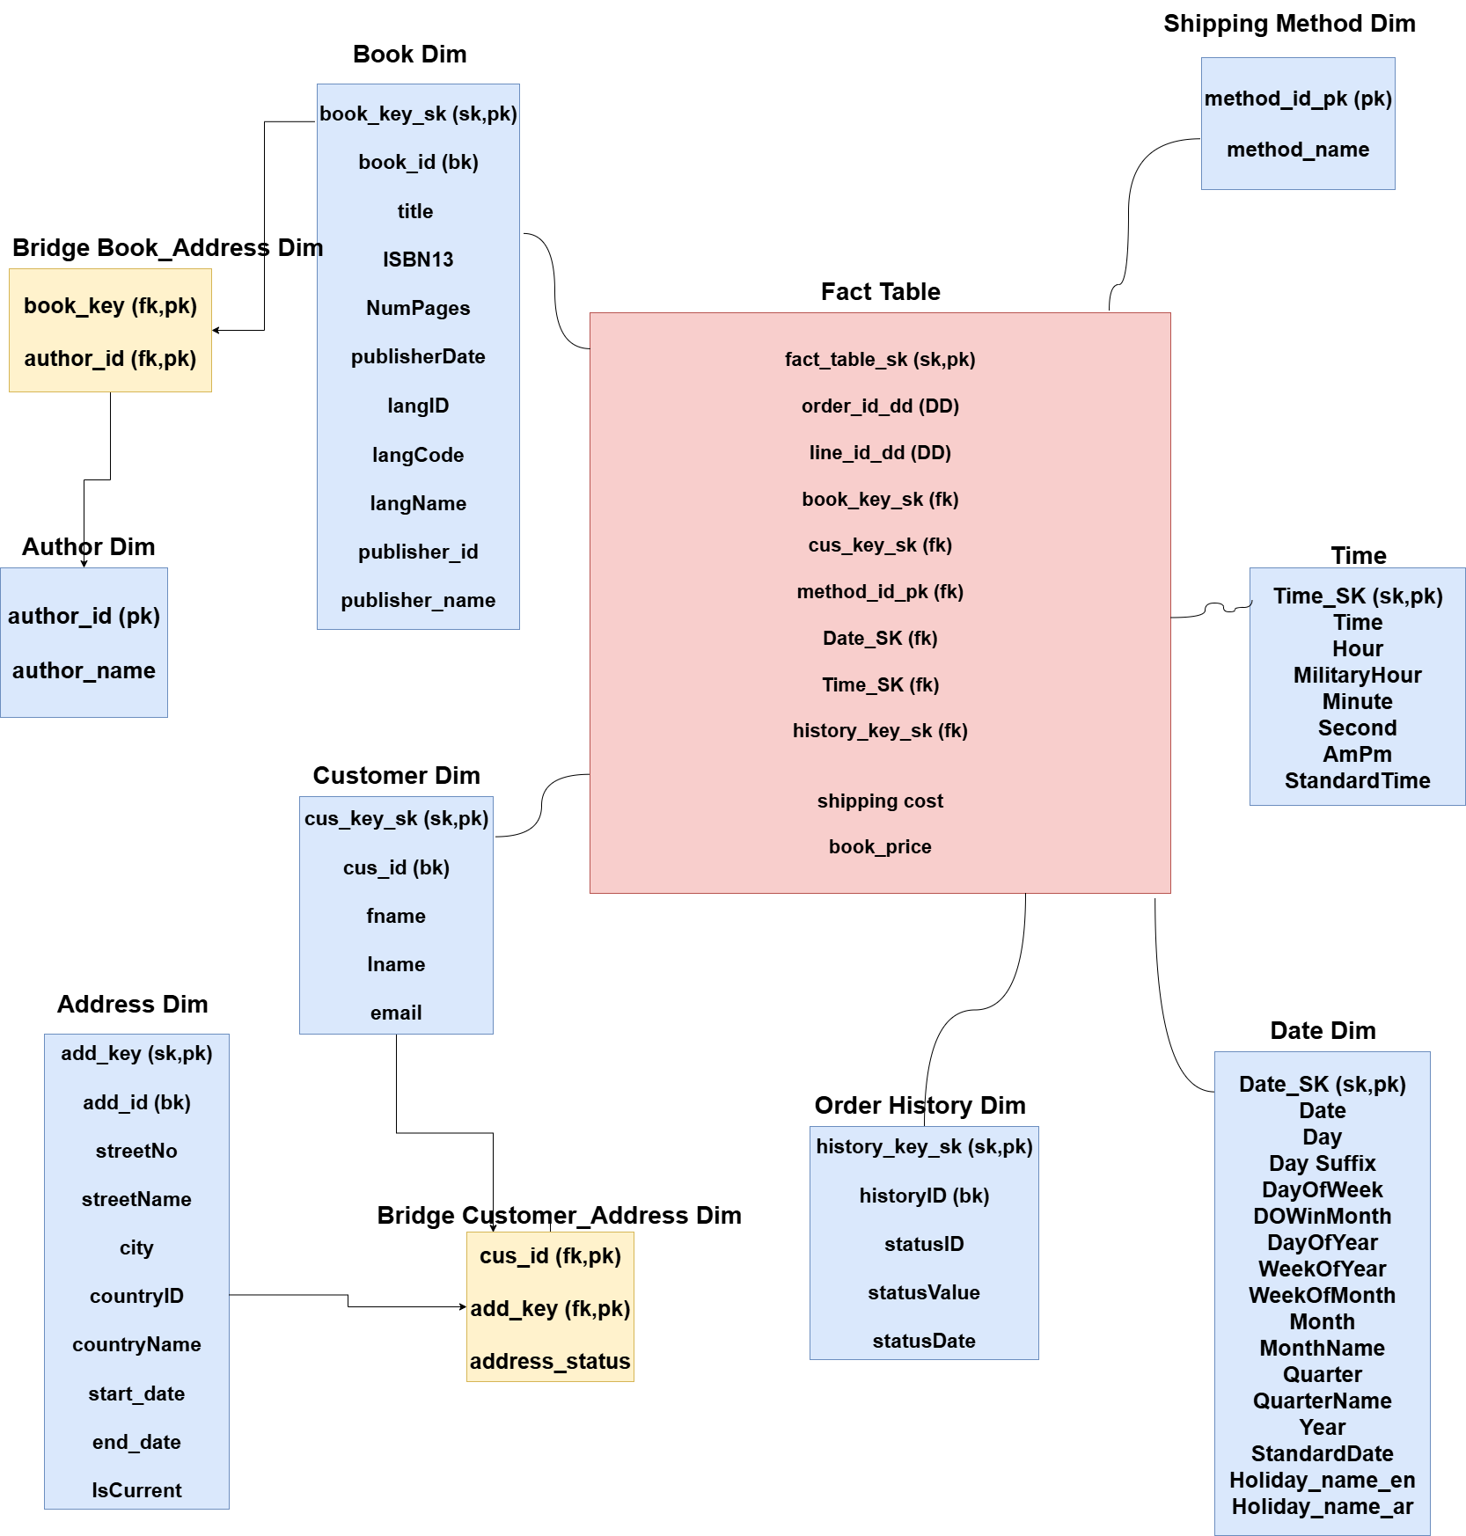

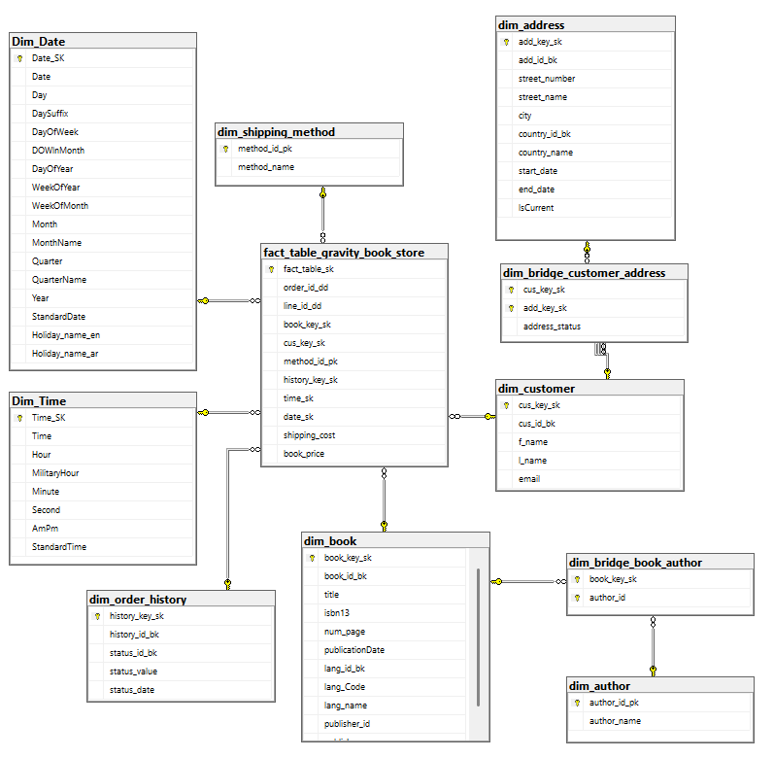

ETL
Dim Address (Slowly Changing Dimension):
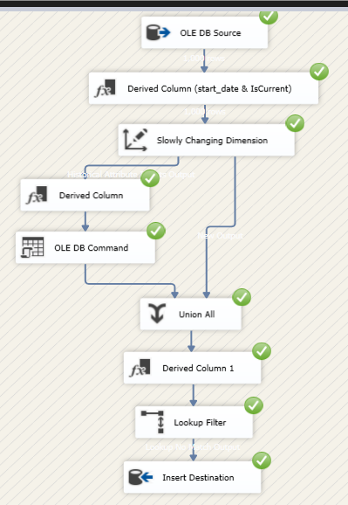
Dim Author:
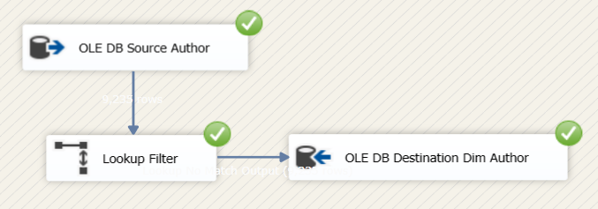
Dim Book:
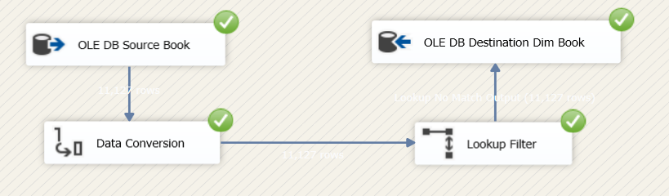

Dim Bridge Book Author:
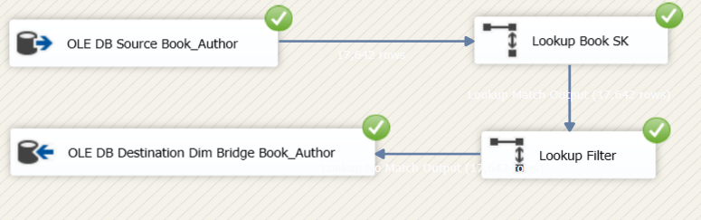

Dim Customer:
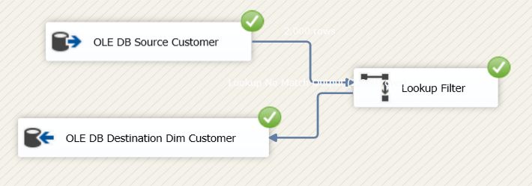

Dim Bridge Customer Address:
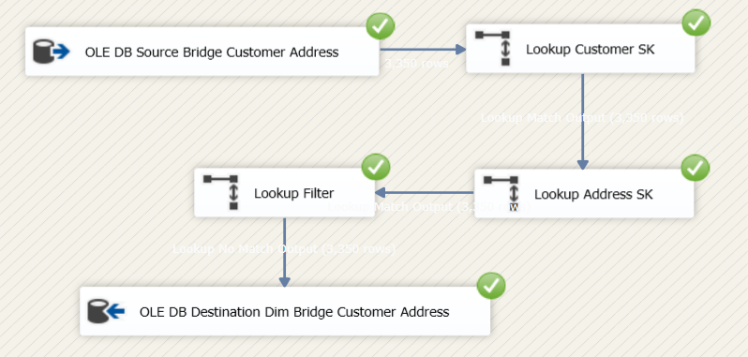
Dim Order History:
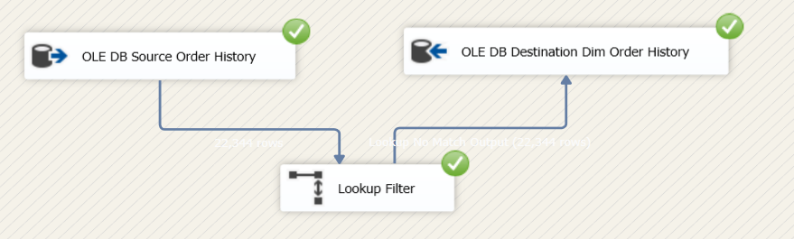
Dim Shipping Method:
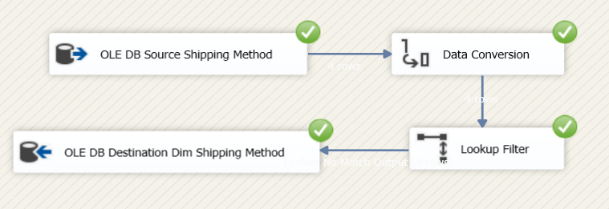
Fact Table:
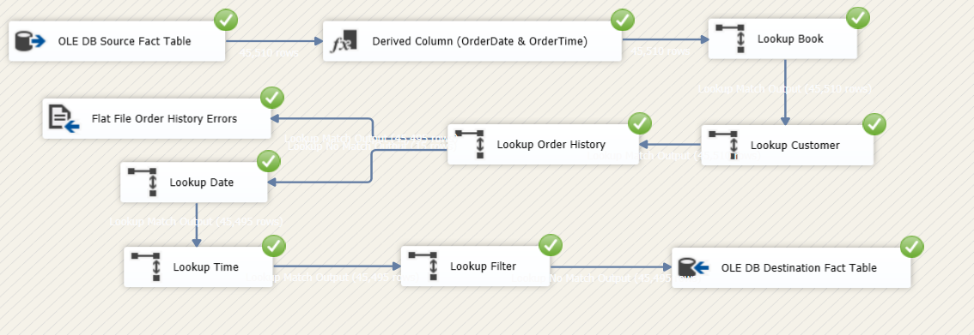

Dashboards
Customers Dashboard:
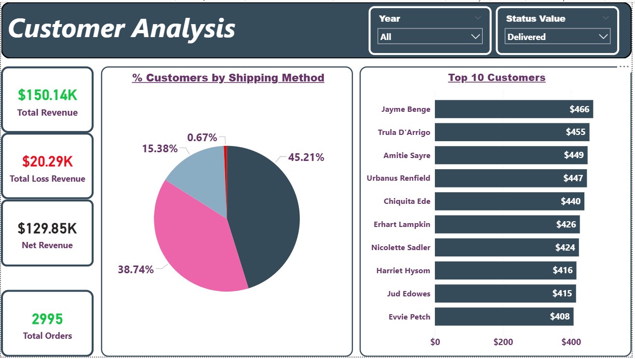

Book Dashboard:
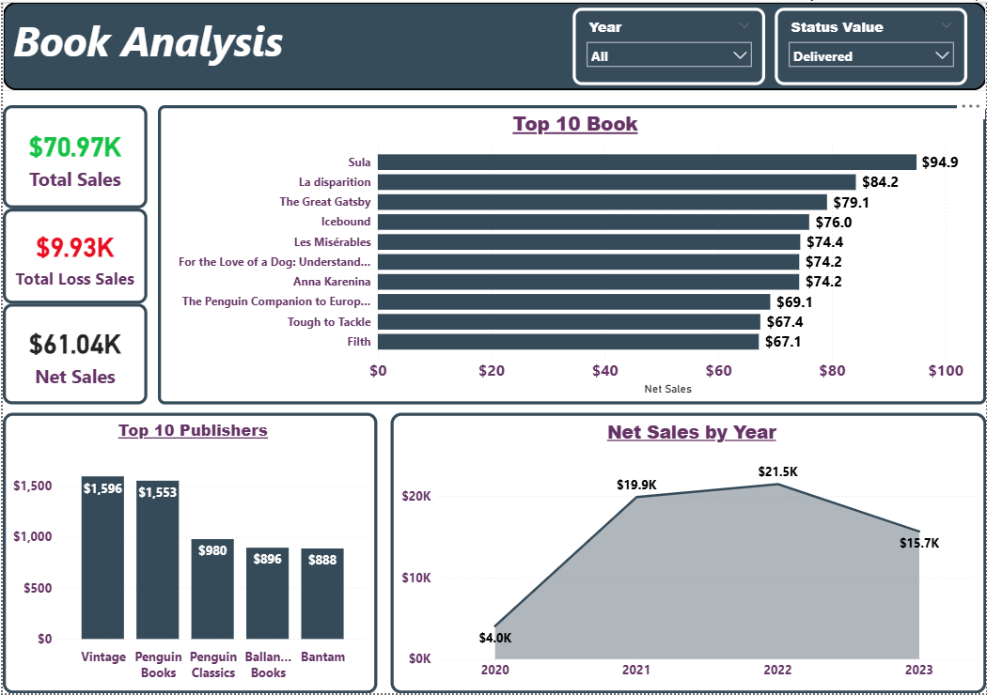

Types of Dimensions & Facts
- “Dim order history” = fast changing dimension (status changes)
- “Dim book” = heterogenous dimension (book + lang)
- “Dim bridge book author” = outrigger dimension
- “Dim address” = slowly changing dimension type 2 historical
- “Fact table” = transactional fact
- “Price” = semi-additive measure/fact
- “Cost” = semi-additive measure/fact
- “Total Cost” = derived measure/fact
- Others = fact less facts (e.g.: “book id sk “– “date sk”)
- “Order id” = dd
- “Order line” = dd
- “Date dim” = role playing dimension
- “Time dim” = role playing dimension

Technical Observations
- “Order address” = “customer address” (Can’t change the address to somewhere else unless the customer changed his/her address).
- If the customer has more than one address, the address status determines which one the order goes.
  - “Book price” = exist
  - “Shipping cost” = exist
  - “Order cost” = exist
  - “Total cost” = not exist (can be derived)
  - “Quantity” = not exist (can be derived)
- The book should have one publisher, and the publisher could have many books.
- In “dim book”, we have two options:
- Include publisher & language tables to the “dim book” redundancy
- Add publisher & language tables as a separate dimension complex schema – no redundancy
- In this case, option 1 will be the best (Snowflake Schema)
- “Publication date” is kept in the “dim book” because it is an attribute that describes the book. So, we can’t remove it while it has already existed in “dim date”
- Same concept applies to the “status date”
- Let’s assume the “address_status” describes if the customers’ address is (Valid/Invalid)
- “Line id “& “order id” is degenerated dimensions (dd) that will be added to the fact table
- “Order date” will be removed and be put into “dim date”

Recommended Next Steps
- Implement error handling in SSIS packages
- Add data quality checks in ETL
- Implement fact table partitioning
- Create aggregate tables for performance

