Business Solution Description
Transaction Management

Client | FNB
Reference | BSD-FNB-SMB-Trx_Mng_V2.1
Date | 31/03/2018
Version | 2.1
Status
Established by | HPS | Hssaini Bahaeddine
Checked by | HPS
Validated by | FNB

Document Versions
Version | Status | Author(s) | Date | Modifications
1.0 | Draft | Hssaini Bahaeddine | 16/03/2018
2.0 | Draft | Hssaini Bahaeddine | 31/03/2018
2.1 | Draft | Ahmed EL ORCHE | 05/12/2018

Reference Documents
Code | Document name | Version | Origin

Terminology & Abbreviations
Term | Definition

Distribution List
Company | Name | Position

Summary

1 Introduction 4
2 Context 5
3 General Flow 6
4 Integrity validations 8
4.1 Back office processing 8
4.2 View messages 10
5 Validation message processing 12
5.1 Valid processing 12
5.2 Financial impact 14
5.2.1 Customer short credited 14
5.2.2 Removal message not received 16
5.2.3 Verification message checks 17
5.3 No Financial impact 19
5.3.1 Removal less than Drops 19
5.3.2 Removal different Verification 19
5.4 Settlement validations 19
6 Accounting 20
7 Appendix 23

Introduction
This document describes the solution provided by HPS to manage SmartBox messages coming to PowerCARD as well as the transactional flow of a SmartBox message.

Context

The project has been initiated by FNB SmartBox to replace its current system with PowerCARD as part of MS CAMS acquiring replacement.

The goals aimed are focused on the cost efficiency, creating positive synergy and take advantage of the cross-sell opportunities between MS and SmartBox teams.

In this BSD the focus will be given to the transaction management based on SmartBox requirement expressed in the FRS using the User Stories.

This document will cover the following areas in the transactional flow:
- Loading the financial message.
- Successful processing of a financial message.
- Controls and exception handling.

General Flow
PowerCARD will receive the SmartBox messages via Webservices, there are 4 messages received by PowerCARD:

- Drop message: generated by the device, contains the information related to each drop on the cash device.
- Removal message: each time the CIT remove a bag, this signal is sent to PowerCARD.
- Verification message: when cash center counted the physical bag, a signal is sent to PowerCARD to inform the system about the counted value in the bag.
- Demand message: this message is sent by the device to trigger the settlement for SmartBox merchants that are in on demand settlement option.

Once those 4 messages are received, PowerCARD will do some integrity checks (described in detail further on in the document) and respond back with a status message, containing either a success status code or a failure status code.

The general flow from a transaction management point of view is described as follow:

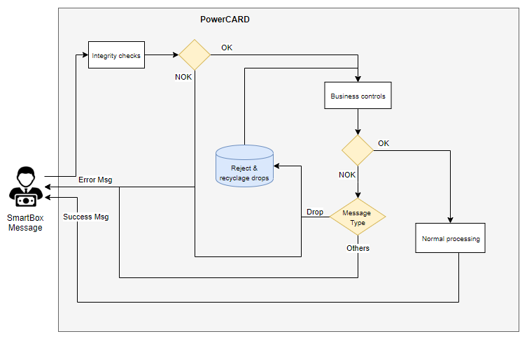

Once a SmartBox message gets to PowerCARD, the system will trigger sequentially 2 processes:
- The first process is message integrity checks, this is a real time process in a sense that once a message is received by PowerCARD, the system will respond immediately with a success or failure reason codes.

- Once the message passed all the integrity checks, the second process starts, it is referred to in this BSD as business validations. The business validations and processing of the message is a real time process in a sense that PowerCARD logs the message in a settlement queue for processing and the output will be available at the time.

PowerCARD will immediately acknowledge SmartBox message and respond back with a status message:
- In case of failure depending on the check integrity an error code will be sent back to SmartBox and the message is logged into a PowerCARD table for audit purposes.

- In case of failure depending on the business validation failed, an error code will back to SmartBox and the message is logged into PowerCARD table for audit/recycling purposes in the case of drop message, for others the message is logged in PowerCARD table for audit purposes.

- When validation success, the message will be processed according to merchant settlement option.

Integrity validations

Integrity checks
As per the SRS document several integrity validations need to be done, the validation diagram is shown hereafter:

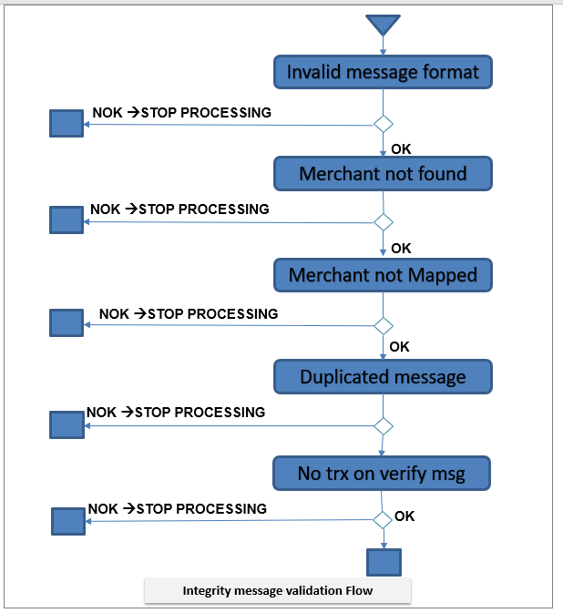

The integrity validations order is shown in the diagram above, the order is relevant since as soon as an integrity validation is triggered the validation process is stopped and the corresponding error message is sent back to SmartBox in the status message.

- Invalid message format: this validation will fail when
  - Message indicator is not recognized or not present.
  - Merchant number is not present. (N/A for Removal and verification message types).
  - Device number is not present.
  - Bag number is not present.
  - Container indicator in not recognized.
  - Sequence number is not present.
  - Transmission date is not present or not correctly formatted.
  - Transaction id is not present.
In case of failure:
  - Error reason code = INV
  - Error description = Message integrity failure

- Merchant not found: this validation fails when the merchant number meet any of the following conditions
  - Not found in PowerCARD outlet table.
  - Outlet status is closed.
  - Outlet status is suspended.
  - Outlet status is deactivated.
In case of failure:
  - Error reason code = MNF
  - Error description = Merchant not found or invalid merchant status

- Device not mapped: this validation fails in 2 different cases
  - Simple merchant: device do not belong to the merchant in the message.
  - Deposit merchant: deposit outlet and device not linked to the same sponsor outlet.
In case of failure:
  - Error reason code = MAP
  - Error description = Wrong merchant hierarchy

- Duplicated message: this message fails when an existing message is found with the following
  - Same merchant number
  - Same bag number
  - Same transaction id
  - Same date and time.
In case of failure:
  - Error reason code = DUP
  - Error description = Duplicated message

- Verification message without drops
  - If the bag number do not correspond to any drops in the system, means all device messages are nor received
In case of failure:
  - Error reason code = NDP
  - Error description = No messages received in the system

At the end of the loading process the result state is shown in the following diagram:

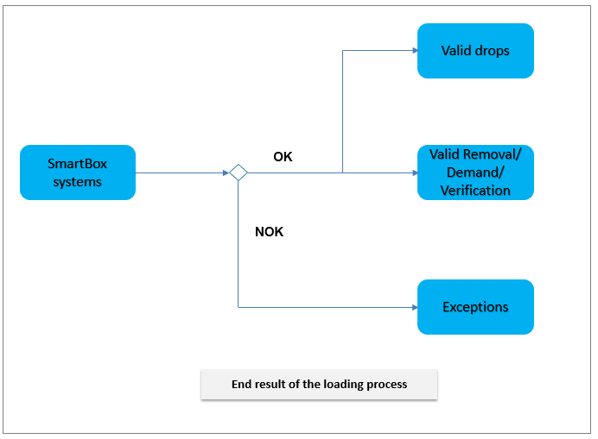

Business validation
Transaction bank control parameters define for each bank processed by the system, the specific control performed on the transactions remitted by its merchants and bank branches. These parameters also provide the possibility to associate decisions on the next processing steps depending on the performed control and verification, as well as the required actions in case of failure.
Each message after processing the integrity checks, it must be controlled by the list of controls defined in the trans_control_Param screen (Parameters > Bank parameters > Clearing > Bank control parameters (Trans_control_param)).
To achieve this objective the screen will be improved to specify the SmartBox controls by adding a new column with checkboxes to specify if the control is selected for Smartbox. the figure below shows the new version of the screen.

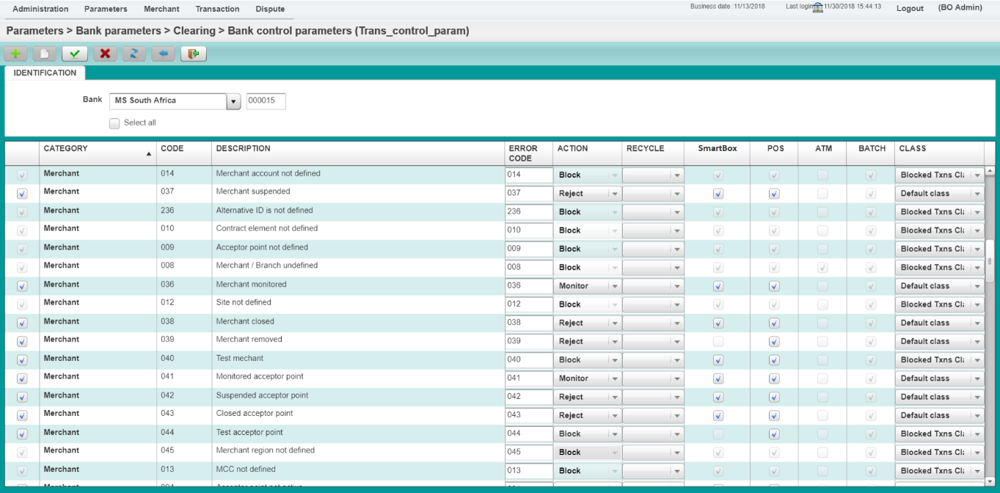

View messages

All messages received from SmartBox systems are logged in PowerCARD tables.

Aiming to achieve the servicing optimization and efficiency, HPS will use the existing screens for FinOps to be able to service MS as well as SmartBox in the very same screens.

Valid transactions are then viewable via processed transactions screen, however, for a user to be able to view the specificities of a SmartBox transaction, a button will be added to transaction screen, this button will be active only when the transaction is a SmartBox one. The specificities that the user can view by clicking SmartBox popup are mainly notes, coins, type of messages etc ….

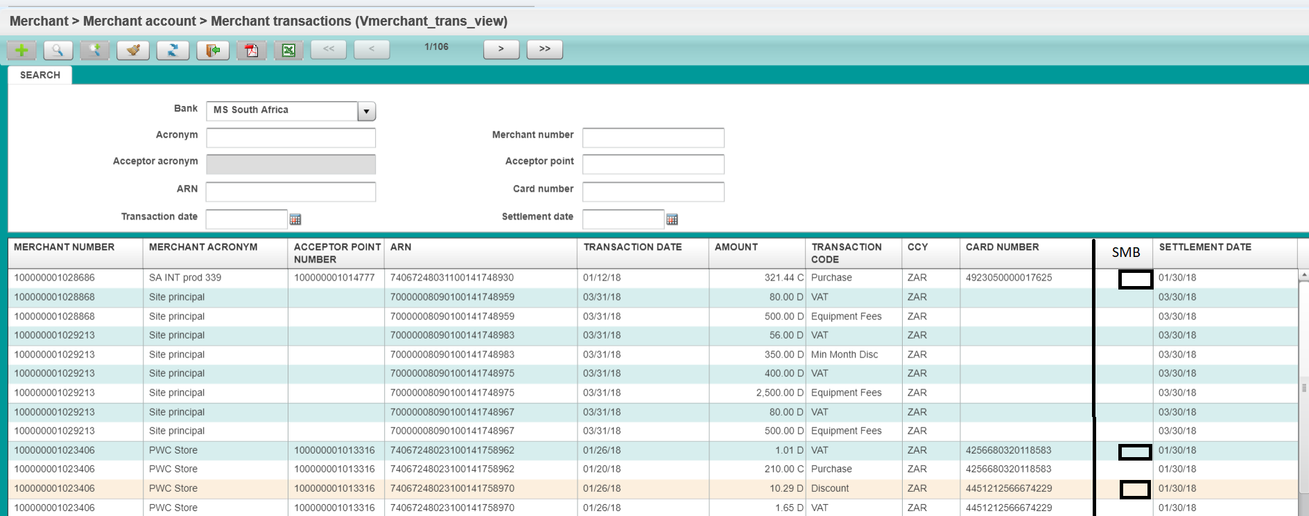

As per processed messages, the rejected messages will be logged in an audit table to keep track in PowerCARD of rejected messages.

Validation message processing

In this section, we will extract only the relevant requirements to the BSD transaction, all the requirements related to the settlement/billing will be considered in the corresponding settlement/billing BSD.

When a message is failing a validation, as per the requirement there are two type cases:
- Control resulting in a financial impact.
- Control resulting in a case generation for information purposes.

The diagram below shows the business validation flow.

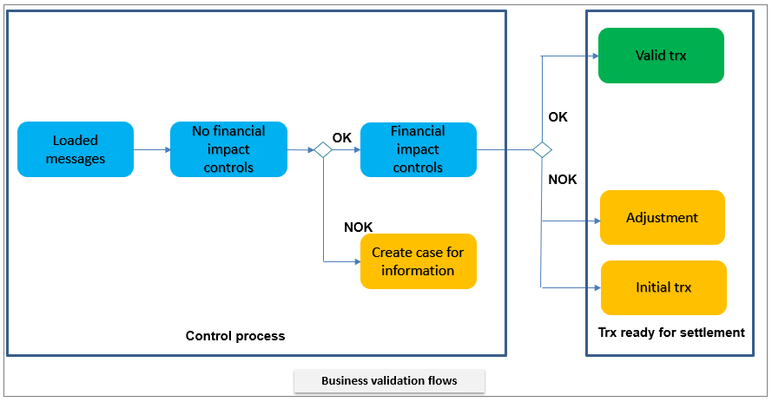

Valid processing

Once the integrity checks are done successfully the valid drops and other messages are ready to be processed, the starting point of the business validation is than the valid drops table as well as valid (Removal/verification/demand) table.

To provide some clarity we will start of green line process where no business validation failed.

- Value on drop:

Since the drop message is the message triggering the settlement, the drop message will be moved immediately to the settlement process.
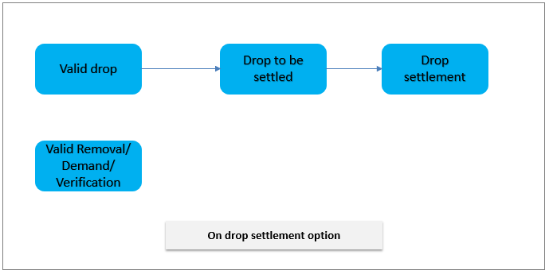

- Value on demand/Predetermined times

The drops between 2 valid demand messages will be moved for settlement processing.

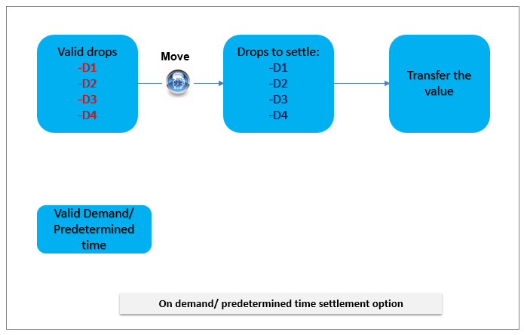

- Value on Removal

The drops related to a given removal message will only be moved for settlement processing when a valid removal message is received.

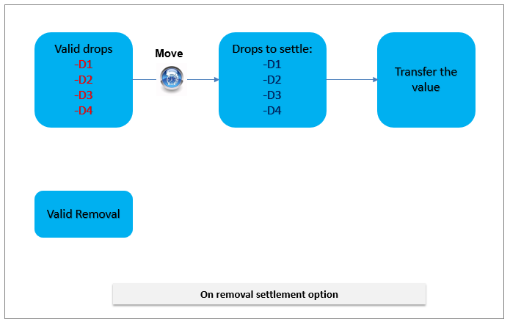

- Value on count

The drops related to a given verification message will only be moved for settlement processing when a valid verification message is received.

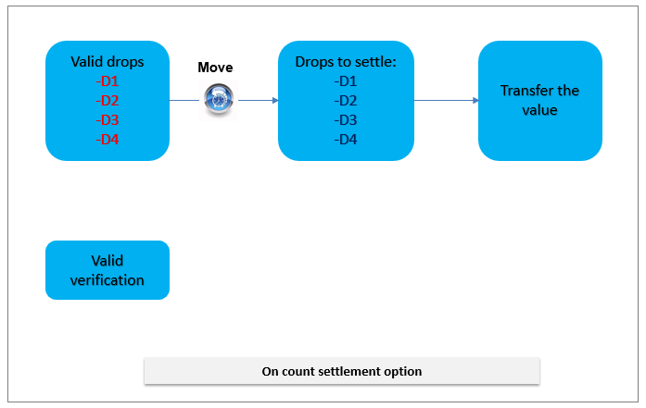

Financial impact

Customer short credited

This validation fails in case the sum of the drops is smaller than the removal value. Means the customer has been short credited. In this case, PowerCARD will do the following per settlement option:

- On drop:

Create an adjustment transaction with the difference between the removal message and the drops messages.
The adjustment transaction will have its own transaction code in credit sign and will be processed to the customer DDA account.

Since the adjustment transaction have a specific transaction code, it can be accounted from GL point of view to the corresponding accounts (parameter driven).

From an informational point of view a case will be triggered for consultation purposes.

- On removal:

In this case, since the removal message is the settlement trigger, the settlement value is based on the removal value, however, in order to balance the drops values with the removal value an adjustment transaction will be created as per explained above.

Since the adjustment transaction have a specific transaction code, it can be accounted from GL point of view to the corresponding accounts (parameter driven).

From an informational point of view a case will be triggered for consultation purposes.

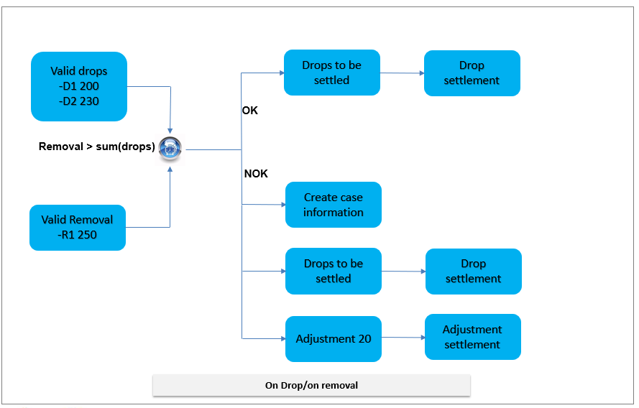

- On demand/Pre-determined times/On count

Since the removal has no impact on the settlement messages in those cases no financial processing is required, however, as per the previous cases a case will be created for consultation purposes.

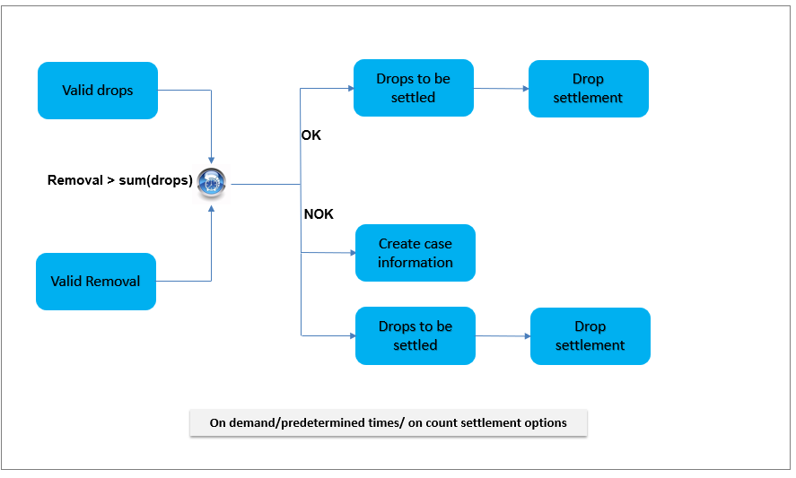

Removal message not received

This validation fails in case PowerCARD cannot match the removal message of the bag coming in the verification message.

In that case PowerCARD will create the removal message based on the verification message.

PowerCARD will then perform the validation on the amount of the removal message against the drops message and trigger the financial adjustment as per paragraph 5.1.1 if the removal value is greater than the sum of drops.

In the meantime, a case for information purposes is triggered for a user to view.

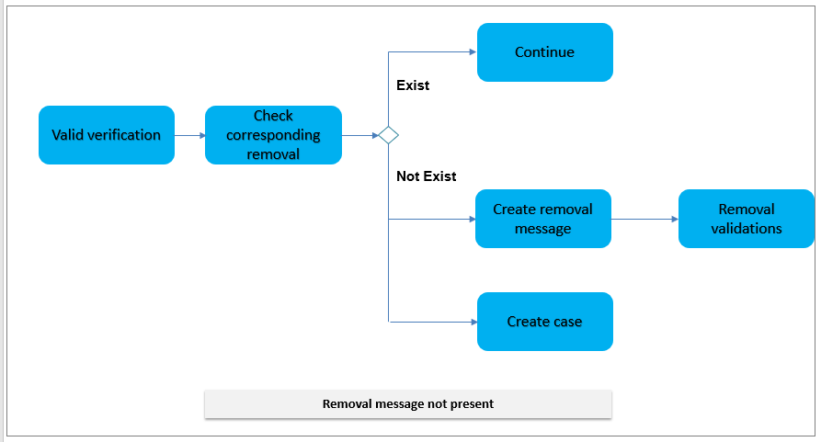

Verification message checks

This validation fails when the verification message value does not agree to the sum of drops received (including the adjustment if any).

When the verification message is greater than the sum of drop we are talking about a surplus in that case the merchant has been short credited.

PowerCARD will than do the following processing.

- Retrieve the control values from the equipment contract of the vendor
- If the difference is less than min control value of the vendor
  - Retrieve the account of the vendor.
  - Create a case with the credit transaction as follow.
  - Create a credit adjustment transaction to the vendor DDA account and process it automatically.
- If the difference is between the min and max control value of the vendor
  - Create a case with the credit transaction as follow.
  - Create a credit adjustment transaction to the customer DDA account and process it automatically.
- If the difference is higher than max control value
  - No automatic processing is done.
  - Case with the credit transaction as follow.
  - Create a credit adjustment transaction to the customer DDA account.
  - User must approve the case to trigger the processing of the adjustment to DDA account after investigation

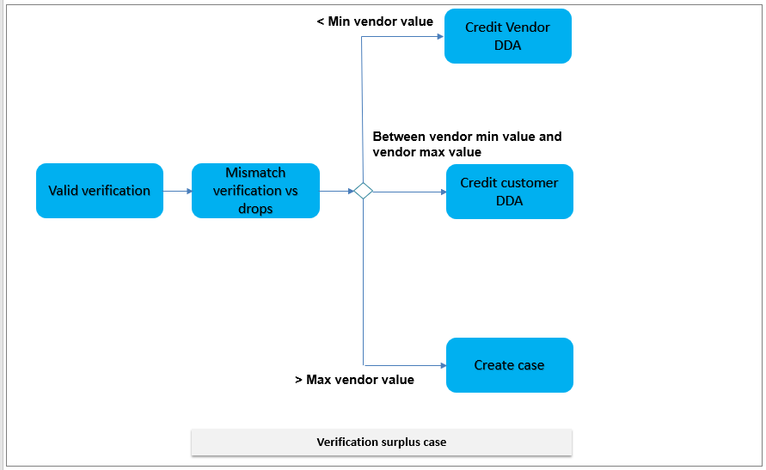

When the verification message is smaller than the sum of drop we are talking about a shortage, in that case the merchant has been over credited.

PowerCARD will than do the following processing.

- Retrieve the control values from the equipment contract of the vendor
- If the difference is less than min control value of the vendor
  - Retrieve the account of the vendor.
  - Create a case with the debit transaction as follow.
  - Create a debit adjustment transaction to the vendor DDA account and process it automatically.
- If the difference is between the min and max control value of the vendor
  - Create a case with the debit transaction as follow.
  - Create a debit adjustment transaction for GL purposes.
  - User must not process the transaction used.
- If the difference is higher than max control value
  - No automatic processing is done.
  - Create a debit adjustment for processing

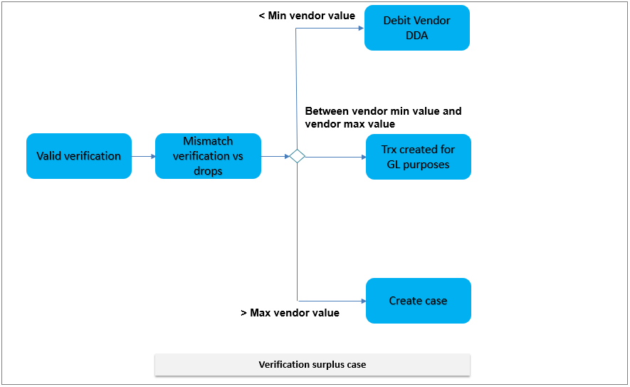

No Financial impact

Removal less than Drops

This validation fails when the removal value is less than the sum of the drops.

PowerCARD will create a case with no financial for a user consultation/investigation purposes.

Removal different Verification
This validation fails when the removal value is less than the sum of the drops.

PowerCARD will create a case with no financial for a user consultation/investigation purposes.

Settlement validations

The processes described in the requirement to receive the settlement message back is a collection process, as principle of this implementation, SmartBox must align to MS which has no collection process in place yet. This requirement is out of scope for the first implementation and needs to be done according to the build that needs to happen for MS.

Accounting

The accounting generation as per MS must follow the transactional flow, in PowerCARD the accounting is not generated online but in batch mode following the transactional value chain. To illustrate SmartBox team on the GL generation, we will follow the transactional flow as per the diagram below:

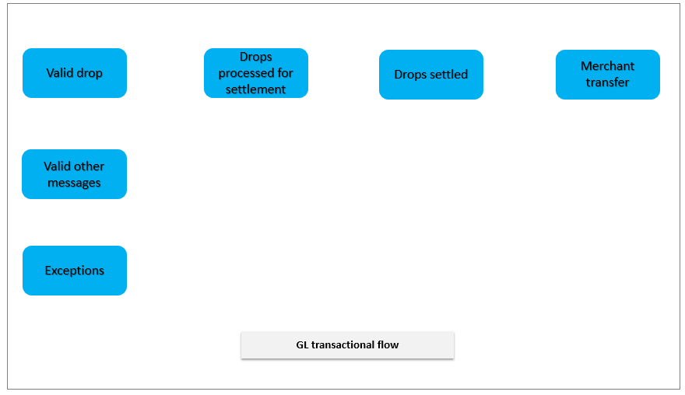

The above flow will be the data source of the accounting itself being:

- Valid drops: the GL representing the loaded transactions but not yet to be settled (settlement message not received yet)
- Valid other message: this GL data source will contain all the removal, demand, verification messages, all those messages will be logged in this table with a different transaction code in order for FNB to create the corresponding GL entries as needed to the different GL accounts.
- Drops processed for settlement: this GL data source contains the drops that are ready for settlement, in essence, the drops where the settlement message has been received in PowerCARD as per the settlement option of the merchant.
- Drop settled will represent the settlement tables where in addition to the drops all the fees “device rental, services etc …” and the adjustment transactions are hosted.
- Merchant transfer is the data source containing the actual transfers to the merchant.

For SmartBox team to have clarity on the system parametrization of the accounting, please find below a print screen of the 2 parametrization screens.

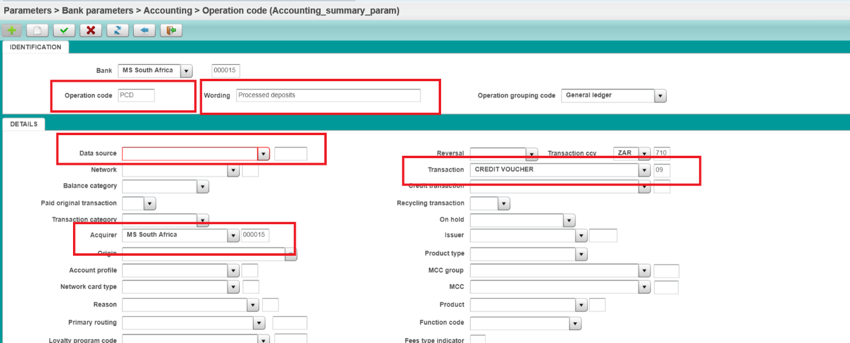

The operation code screen uses several transactional criteria in order to match the transaction to be accounted, we will describe briefly the most important ones:
- Operation code will identify the accounting operation
- Description of the accounting operation
- Data source which stage/table of the transactional flow to retrieve the data from
- Transaction in our case it can be drops, demands, verifications, removals, adjustment, fees ….
- Acquirer bank South Africa in a fist stage and subs further on.

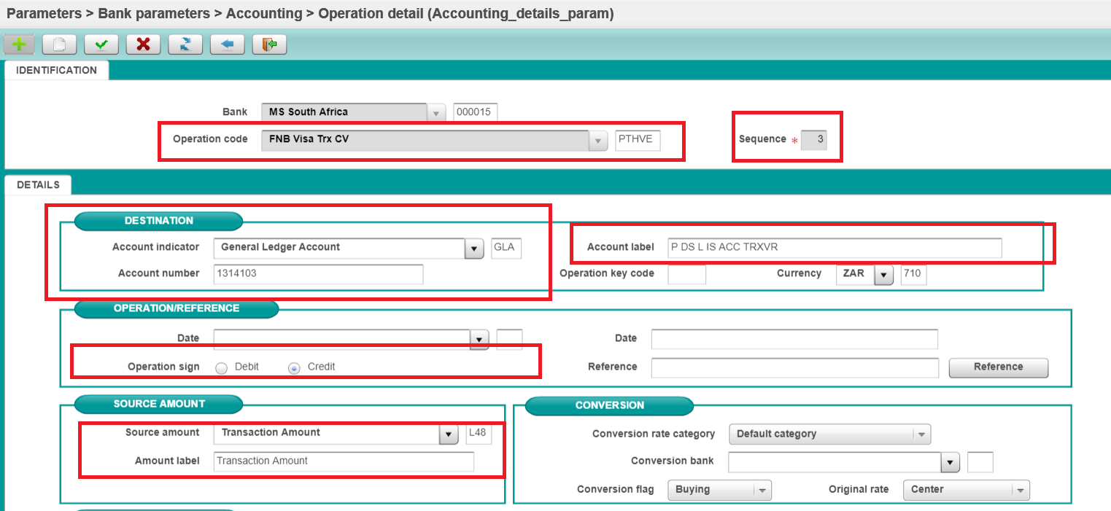

The detail operation will allow FNB to define the following:
- The operation code that details belongs to.
- Sequence (several GL accounts can be generation on the same operation) credit and debit, sequence is than needed in order to uniquely identify them.
- The GL account number and label
- The transaction amount and label of the accounted message.
- the debit/credit indicator.

Appendix

