

**UNIVERSITY OF GHANA**

**COLLEGE OF EDUCATION**

**A MOBILE APPLICATION FOR MANAGING THE TROTRO TRANSPORT SYSTEM IN GHANA**

**JOYCELYN EFE BARNES**

**DEPARTMENT OF DISTANCE EDUCATION**

**JULY 2019**



**UNIVERSITY OF GHANA**

**COLLEGE OF EDUCATION**

**A MOBILE APPLICATION FOR MANAGING THE TROTRO TRANSPORT SYSTEM IN GHANA**

**BY**

**JOYCELYN EFE BARNES**

**(10542987)**

**THIS PROJECT SUBMITTED TO THE DEPARTMENT OF DISTANCE EDUCATION, UNIVERSITY OF GHANA, IN PARTIAL FULFILLMENT OF THE REQUIREMENTS FOR THE AWARD OF A BACHELOR OF SCIENCE DEGREE IN INFORMATION TECHNOLOGY**

**DEPARTMENT OF DISTANCE EDUCATION**

**JULY 2019**

**DECLARATION**

**I, Joycelyn Efe Barnes hereby declare that, this work was carried out as a student of the Computer Science Department, University of Ghana, Legon. It was submitted in August 2019 under the supervision of Dr. Isaac Wiafe. This work has never been submitted wholly or in part for any degree of this noble University. Where other works of other authors have been quoted, they have been duly acknowledged.**

………………………………………….. DATE ………………………

DR. ISAAC WIAFE

(SUPERVISOR)

………………………………………………………………… DATE ……………………………………

JOYCELYN EFE BARNES

(STUDENT)

**ACKNOWLEDGEMENT**

I am first of all most grateful to the almighty God for seeing me through successfully in my project work.

They are God’s gift and an encouragement to my life. Thanks to my spiritual fathers; Rev. Reginald Mensah Noye and Rev. Joseph Boateng. You were my strength at difficult times.

Many thanks go to my supervisors Dr. Isaac Wiafe for his intense supervision, suggestions and critics, which helped in the project development.

I really want to thank my family so much for supporting and believing in me.I could not have done this without you. Special thanks to my late mother, Ernestina Arhin of blessed memories, my dad Mr. Edmund Maxwell Barnes and to his wife Mrs. Felicia Barnes. My appreciation would be so incomplete without mentioning my uncle and his wife Mr. and Mrs Ofori-Appiah and to Mr. Isaac Kwesi Hayford. I really appreciate everything and your immense support. God richly bless you all.

Friend are inevitable in our lives, I will therefore want to acknowledge all my friends for being there for me. A special thanks to Mr. Edem Adjei.

To all who have played a role in my life in diverse way, I really appreciate you and May God blesses you bountifully. AMEN

**DEDICATION**

This piece of work is dedicated to my protector, the one who have sustained my life from birth up to this very time, my LORD and SAVIOUR JESUS CHRIST. I couldn’t have done anything without him.

To my late mother of blessed memories, a strong and gentle soul who thought me to believe in God and believed in me, I dedicate this project to you.

**ABSTRACT**

Transportation is very key to the development of society and countries. Poor transportation would mean that, there will less productivity affecting the economy of a country. The most popular transportation system in Ghana is what is known locally as “Trotro”. With a greater percentage of urban dwellers using Trotro, it has come to stay with the Ghanaian populace but has come with its own problems. This project has looked at the challenges associated with the Trotro transportation system in Ghana and has proposed the use of a mobile application to deal with the numerous problems associated with the Trotro transportation system in Ghana.

# TABLE OF CONTENT

**DECLARATION** i

**DEDICATION** ii

**ACKNOWLEDGEMENT** iii

**ABSTRACT** iv

TABLE OF CONTENT v

CHAPTER ONE 1

INTRODUCTION 1

1.0 Background 1

1.1 Problem Statement 2

1.2 Research Question 3

1.4 Scope of the study 4

1.5 Limitations 4

CHAPTER TWO 6

LITERATURE REVIEW 6

2.0 Background about Trotro Transports System 6

2.1 Trotro Services 6

2.2 Existing Transport Systems 7

2.3 Mobile application 8

2.3.1 Historical background of Mobile applications 8

2.3.2 Advantages and Disadvantages of Mobile applications 10

2.4 Technology Integrated In the Transport Systems 10

2.5 Payment Models 12

2.4 Conclusion 13

CHAPTER THREE 14

METHODOLOGY 14

3.0 Introduction 14

3.1 System Development Methodology 14

3.2 Requirement Gathering Methodology 15

3.3 Documentation of the existing system 16

3.3.1 Issues with the existing system 16

3.3.2 Conflicts in the Existing System 17

3.4 Rich Picture of the proposed system 17

3.5 Use case Diagrams 18

3.5.1 Flow of event for the Usecase Diagrams 20

3.6 Functional Requirements 23

3.7 Data flow Diagram 23

3.8 Development of the System 25

3.9 Conclusion 25

CHAPTER FOUR 26

IMPLEMENTATION 26

4.0. Brief introduction to implementation and documentation 26

4.1 Description of the new system 27

4.2 Testing 31

4.3 Deploying the system 31

4.4 Evaluation of system 33

4.5 Conclusion 33

CHAPTER FIVE 34

CONCLUSION 34

5.1 Summary 34

5.2 Findings 35

5.3 Future Work and Directions 36

REFERENCES 37

# LIST OF FIGURES

Figure 1.0 Methodology block diagram 5

Figure 3.1 Waterfall model of system development Methodology. 15

Figure 3.2 Rich Picture of the proposed system 18

Figure 3.3 Use Case of the proposed system 19

Figure 4.1 Dashboard of the Mobile Application 27

Figure 4.2 Passenger ordering for a ride 28

Figure 4.3 Confirmation of Trotro Request 29

Figure 4.4 QR Code for Payment 30

# CHAPTER ONE

# INTRODUCTION

## 1.0 Background

Transportation is a very important of society. Throughout history, people have moved from one place to the other through various means of transportation. over time the means of transportation has evolve.it has evolved from walking from one end to another to other forms of transportation such as the use of animals (Horses, Donkeys, camels and elephants), bikes, cars, ships and boats and to airlines and trains. Covering distances are both long and short distances.

Due to the expansion of cities and towns, it is becoming more and more difficult to commute using by walking. Many people have adopted the use of various means of transportation which includes the use of motorbike, tricycles and cars both commercialised and private.

In some developed cities in the Africa and the world as a whole, means of transportation includes small boats, taxis, buses and trains to commute people in the city. In Ghana, the commonest means of transporting people in the urban space is the use of “TroTro". This is made up of minivan and buses which can accommodate between 9 and 21 passengers at a time. The TroTros ply on most of the main roads of the city, stopping at various bus stops to either pick up passengers or drop off passengers who have arrived at their location. The passenger is therefore required to pay an amount as the cost for being transported from his location to his destination.

TroTro has become the commonest means of transportation in Ghana due to its availability and the low cost. The use of TroTro has spread throughout the city especially in Accra and Kumasi. This has also being companied by its’ own associated problems.

## 1.1 Problem Statement

Even through the TroTro has become a common means of transportation in Ghana, it has its own associated problem. These challenges with the use of TroTros include the following:

Even though there is a standard to govern the use of vehicles for commercial purpose by the Drivers and Licensing Authority (DVLA), the cars been use as TroTros (commercial minibuses) do not adhere to these standards. This results in the use of car that are depleting and below standard most causing inconvenience to both passengers and other road users. these lack of standard causes other inconvenience like cuts from exposed metals, emission of fumes which are toxic and harmful to life, accidents on the road to mention a few.

Another problem that is identified with the use of TroTro is the lack of standards with the payments made by the passenger when they commute in the TroTro from one end to another. One of the major issues when it comes to payments is when the drivers mate charge more than it is expected. Some passenger practically fights with driver’s mates in other to arrive at the correct or compromised fair to be paid. In some situations, drivers mate do not have change if the passenger gives out an amount or denomination that is larger than the actual price. In such situations, either the passenger has to compromise or the mate has to let go, or the car has to stop for the drivers mate to find change. If the option is the latter, then the inconvenience of time wasting becomes a problem since the passenger s may not be able to arrive on time.

Drivers and the conductors can also decide to change their route at any given period because of the lack of regulations. This normally happens when the driver thinks it will not be financially prudent if the journey is continues. The passenger is left in the middle of the journey to identify another TroTro to be able to reach to his or her destination. This is also due to the lack of regulation of the TroTro space in the cities.

lastly, the passenger especially at peak hours has to physically struggle with other passenger to get access to TroTro due to the disorder that arises when the people are more than the number of TroTro that are available. Passengers gets hurt or injured in the process while some loose the valuables due to theft or during the struggle for the TroTro.

The drivers mate and the drivers are always in quarrels because the driver’s mate is mostly accused of stealing portions of the money that is paid by the passengers. This is because there is no way to account for the monies paid by the passengers.

## 1.2 Research Question

How can technology be used to improve the TroTro transportation system in Ghana to curb the current challenges with public transport in Ghana?

To be able to answer the above questions, the following questions will be posed?

1. How is the current transportation system run in Ghana?
2. What are the challenges with the current system?
3. How can technology used in solving the problems in the public transport space?
4. What type of technology can used to solve these public transport problems in Ghana?
5. How will passengers and drivers make and receive payments?

**1.3 Aims and objective**

The aim of this project is to develop a mobile application that will help manage the front end between the passengers and Drivers and TroTro conductors. The aims can be broken down as

1. identifying TroTro on route and board them
2. Book TroTros before it reaches its destinations.
3. use of a suitable payment mode for the TroTros
4. adhere to the TroTro standards set by the DVLA

## 1.4 Scope of the study

The scope of work will cover the following:

1. An application or systems that will manage TroTro public system in Ghana.
2. It will look at the current way the TroTro public transport is run and the challenge associated with it.
3. The study will identify and efficient and effective way of managing the TroTro space in Ghana.
4. The study will propose provide a mobile application that will be used driver and passengers only.

## 1.5 Limitations

1. The study will not extend to the administrator and its actives in the system that will be developed.
2. It will not include activities of regulatory authorities such as DVLA, GPRTU and others

**1.6 Methodology**

The methodology is described in figure 1.0 below

Literature Review

- Review of Key Words/Terms

- Review of similar systems

- Review of tools and software used

- Summary of literature Review

Introduction

* Problem Definition
* Objectives
* Limitations of the study

Requirement gathering (Observation)

Analysis of current trends and old system

Project Development and Design

* System analysis design blocks
* Database design
* User interface/ software design modules

Debugging and Corrections

* Results
* Findings
* Conclusions
* Recommendations

Figure 1.0 Methodology block diagram

# CHAPTER TWO

# LITERATURE REVIEW

## 2.0 Background about Trotro Transports System

The Trotro transport system has become part and parcel of the for routing through the various cities especially, Accra and Kumasi. The Trotro is typically imported second-hand mini buses which picks between 12 and 22 passenger on route to a particular destination or part of the city. (Zijlma, 2019) states that, Historically, the Trotro were Bedford which were converted into holding passengers on wooden benches and over time, has revolved into the current minibuses that are used today.

The name Trotro originates from the more of payment for the bus that is one “tro” per trip. Tro is a Ga word which means 3 pence (which is the coin used for transactions during the colonial days of Ghana. Passengers where changed three pence per trip which brought about the name Trotro. (Askia, 2018).

According to (Okoye, 2010) about 70 percent of the residents in Accra use Trotro to route between homes, work, shopping and other activities in and around the city. Trotro is mostly used because of its affordability and availability even at peak hours though passengers may have the queue of rush to aboard the Trotro. People use it as the most reliable and affordable means to get to all parts of the city.

## 2.1 Trotro Services

The Trotro have various route to almost all parts of the city. The way to find Trotro is to stand along the street or bus stop at the route to your destination and pick the available Trotro. The driver’s mate will always shout the route the Trotro is plying, so that the passenger to make a decision to join or not. The Trotro makes frequent stops to pick passengers till it gets full (Askia, 2018).

Trotro used modified or fabricated seats which does not assure the passenger comfortability though the seats are supposed to be one seat for a passenger. Payments are made to the Trotro made based on the destination of the passenger (Askia, 2018)

With the enormous problems that accompanies the usage of trotros in Ghana, there is the need to modify its mode of operation. Technology can be tool to improve the Trotro system in Ghana.

## 2.2 Existing Transport Systems

Chen & Alan Mislove (2018) explains that Uber is one the transport companies which uses the ridesharing concept which has implemented to pick up passengers from one location to another. It uses online maps and location finder to identify the location of the passenger who request for a taxi service (Murtaza, 2015). The payment model for Uber is mainly paid on arrival to the final destination or the use of a debit card on arrival to the destination of the passenger (Brishen, 2018). Uber has successfully being deployed in Ghana but the major challenge is the high cost of transporting people and the number people it can pick per ride (as it is with 4 passengers in a salon cars).

Another similar system which has being successful deployed in Ghana is Taxify. Taxify is no different from Uber using the same form of technology and payment method. The only arguable difference is the cost of the ride per distance and time which is relatively cheaper than Uber. The arguments still remains that, both Uber and Taxify is more expensive than the traditional Trotro transport system in Ghana (Andrew, 2019).

The third system which has being successfully deployed in Ghana and to a greater extent, relatively cheaper than the Trotro is the Metro Mass transport system. The Metro Mass Transport system uses buses to commute people from various location to another destination. Because of few number of buses that are available, it can only meet the demands of just some very few commuters in Accra. Another challenge it the Metro Mass Transport system is that, they have limited routes they ply daily. The implication is that, some localities in Accra cannot get access to these buses for their transport means. The Metro Mass transport system which is government owned has only one noticeable technology implement which is a card payment system. Passengers are required to by the card and load money onto it just like debit cards work. The commuter can therefore make payments without having physical cash. Even through this payment method is a way forward for a country considering cashless society, most of the commuter do not use the card system (Metro Mass Trasit, 2019).

## 2.3 Mobile application

Mobile app or mobile application is a software application which runs on a mobile phone. Gradually, the world has embraced mobile phone and the applications that run on it making working easy from various destinations.

## 2.3.1 Historical background of Mobile applications

The first mobile phone call was made on 3rd April 1973 by Motorola's Copper Martin. The development of mobiles phone technologies took up to about two decades for the first mobile application to be developed. This first mention of the word "Smartphone was in 2002 when the Blackberry smart phone was released. This was a major achievement and ground-breaking for the development as far as mobile applications evolution and development are concerned. Before that, mobile phones had made some strides as IBM in 1992 had introduced small and basic applications such as calculator, clock and calendar in 1993. After these development in the mobile phones industry, a lot of developments have happened as it created some interesting evolutions of mobile applications. For an instance, in the 90s, PDAs has an operating system called EPOC that was developed by Psion that was used to execute applications such as diaries, databases, spreadsheets and word processors. In 1996, Palm Inc. introduced a touch screen Graphical User interface which included a Wireless Application Protocol (WAP) browser. The Research in Motion Limited (RIM), now blackberry limited also integrated wireless emails into the mobile phone in 2002 which is dubbed as the Blackberry smart phone. This was a landmark developments lead to the developments like J2ME/JME across several PDA platforms. Psion improved their EPOC OS into the Symbian which became one of the breakthrough applications for mobiles phones such as Nokia, LG and Samsung.

Companies such as google and apple developed the Android OS and iOS (for iPhone) has now taken over mobile devices with the various forms of applications running on it. The execution power of mobile phones and tablets are nearing PC computing powers and ruining similar applications that are run on computer now running on mobile devices has become the order of the day due to its effectiveness. Now, almost every single application that can be run in the PC is also run in the mobile phone as a mobile application. The applications on mobile phone are limitless.

Over the years, android has becomes the most widely used operating system for mobile phones to run mobile applications. According to GlobalStats (2019), Android has 76.03% of the shares of all mobile phone usage. Android is far ahead of the second holder of shares as far as mobile phones operating systems are concerned. iPhones OS takes the second position with 22.04%. KaiOS is next with 0.79%, followed by 0.31%, 0.21% and 0.21% being unknown, Windows and Samsung respectively. This then suggest that, applications that are developed on android are more likely to have a larger audience of users than the other Operating systems. mobile application developers therefore prefer to develop application for android and iOs because of its wide usage. Statistics put together by newzoo.com points out that as at the end of 2017, about 2.3 billion people were hooked to the android platform which means that android has a huge market share that could be leveraged on for the development of any mobile application.

## 2.3.2 Advantages and Disadvantages of Mobile applications

The most obvious advantage of mobile application is the fact that it is portable. This means that, personal and business activities can be performed on the go with little or no limitations. Some of the advantages of mobile applications incudes GPS location which gives the opportunity to mobile device users mobile applications which are needs to access the location of the user.

Mobile application also improves the user experience due to the numerous applications for variety of purposes. The smartphone market is growing exponentially therefore, it is attractive areas to present solutions to the users and developers of mobile applications to generate income. Even though there are a loss of opportunities to maximise from the end, from the perspective of the client, it is very expensive t develop applications. It would be an incentive to let users accomplish a specific action via your app.

Mobile applications generally increases awareness as it help to open up the users to the world and also gives the users the opportunity the share. the major challenges with mobile applications includes the high cost of developing the application coupled with the complexities in the processes but generally, mobile applications has come to stay due to the enormous benefits to the use.

## 2.4 Technology Integrated In the Transport Systems

**Maps API**

One of the key things that has successfully being implemented in Uber and Taxify is the map APIs. The most popular of these maps are the Google Maps API and the Bing API. Maps are able to help point the user to a destination or his current location with the capabilities of giving directions to a requested destination.

Location is becoming a very popular topic day by day. Google is one of the main game changers in this area. The simplest usage of Google Maps is a simple integration of it API on a website which will show the direction of the location a company. Google Maps can also have advance features that shows different information on the maps which can also be implemented in mobile applications. Google Maps API has great support in base maps, satellite images, and the API itself. For example, the API can be used to show only one location or all the data of a government agency on a map. Google maps is virtually free with some extended feature being sold but generally, open source. The free limit Google Maps APIs present is enough for most developers to implement in the websites or mobile app (Alper & Uraz, 2013).

The developer would have to pay if there are will be more than the 25,000 limits for map loads. This raises the issues of **scalability**. Any developer has to consider the probability that the system will grow over time and as such, 25,000 loads of maps might be enough especially for a public transport system which conveys about 70 percent of city’s commuters.

Another popular API which is widely used is the Bing Maps designed by Microsoft. Though the Bing Maps Dev Center provide tools Most of the code samples and applications are for Windows, Windows Phone, Microsoft Azure, Office, SharePoint and other products (Microsoft Corp., 2018).

Bing maps API and Google Map APIs have similar features. Some of the are road view which give a vector imagery of houses and roads, Satellite imageries the gives an aerial view by identifying major roads and landmarks, a bird view which gives a view of the roofs of buildings and some other important features. Another major feature of Google and Bing maps is the ability to give detailed directions to a particular designation, estimating the duration it might take to reach the final destination and the traffic situation (Microsoft Corperation , 2019).

This major features makes it ideal for a developer of a system which requires movement from one place to another ideal.

A rarely used mapping technology is the IP Geolocation which uses the geographic internet connection including the IP address, ISP, country, longitude and latitude information to ascertain the location of a person. Users of IP Geolocation have claimed it is about 98% accurate but the major challenge that spans out is the fact that, the location will always depend on the access point of the service provider.

Due to the proximity issues relating to IP Geolocation, it will not be an ideal technology to be used in a transport system but with features and characteristics of Google maps API and its ease of use across platforms covering a larger share of the market, good maps API will be the preferred technology for a propose application for a Trotro transport system.

## 2.5 Payment Models

There are variety of payment models that are available but the commonest that can be used in Ghana is the Mobile Money operated by the Telecommunication companies in Ghana. Some of these companies have developed API to facilitate transactions if implemented in a website or mobile app. Some third parties companies in collaboration with the telecommunication industries have also developed APIs for same purpose. Such APIs can be used for payment in the Trotro system. With mobile money penetration up to about 48% of the population in Ghana, Mobile money will be ideal for payments (DPO Group, 2018). The traditional mode of payment can still be maintained for the purpose of those without Mobile money.

Though Mobile money penetration has made it the most ideal for transactional payment in Ghana, the records shows that, if Mobile money is used as the means of payment, some people will be disadvantaged (52% of the population) and cannot use some of the services that is paid through Mobile money. The Scratch Cards payment models can therefore be used since it can be purchased from any vendor and credited to the account of a customer or client for prepaid payments.

## 2.4 Conclusion

Mimicking the Uber and Taxify model using an appropriate Maps API and Payment model, a mobile application can be developed the give these large populace of city an easy way to commute through city without its accompanying discomfort.

# CHAPTER THREE

# METHODOLOGY

## 3.0 Introduction

The analysis stage of any software development project is one of the most important as this is the point at which all the main details of the system are worked out. By analyzing this system we will be able to answer who will be using the system, what each of the users will be using it for, and when and where these users will be using it. With all of these bits of information a very thorough view of what the system needs be able to do when you finally start building it can be obtained. The general steps to take when analysing a system, which will be followed for this project, are first information gathering, then modelling the new system that has been identified from this information, and finally creating documentation outlining the requirements of the system.

## 3.1 System Development Methodology

The methodology adapted for the modelling of the system is the waterfall model. The waterfall model identifies requirement for the development of a system before the programming or designing of the system being. It starts for the Planning Stage where there is the gathering of information and the project execution. Analysis stage looks at the feasibility of the project if it can be achieved or not. The next stage is the design stage which is involved in the construction of the system according to the information provided by at the planning. The implementation stage deals with the testing and training stage of the system and the finally the role out of the system being the final stage.

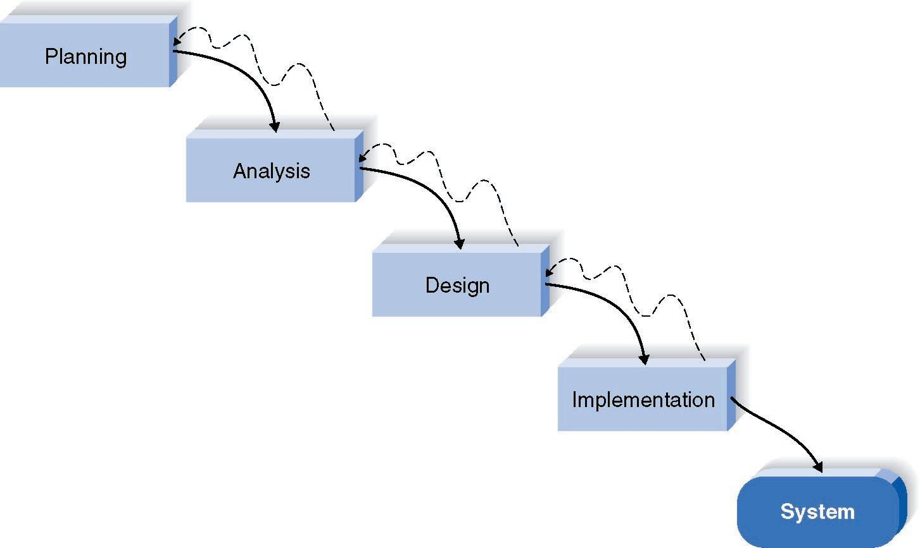

Figure 3.1 Waterfall model of system development Methodology.

## 3.2 Requirement Gathering Methodology

Requirement gathering is one of the most important stages of developing a system. This stage deals with trying to get the information from the stakeholder of a system to be developed or improved. During this stage of the development of the system, the requirement gathering analyst tries to ascertain the way the current or existing system operates and the challenges. This will inform what should go into the development of the system. The requirement taken by the researcher was the use of Observation.

Observation was chosen because the operations of Trotro in Ghana is very transparent with little or no cut out parts from the public. The researcher therefore decided to use observation. In this case, pay particular attention to details on the operations of Trotro. The observation was done on-board the Trotros plying roads to and from Spintex Road and Madina, Madina to Accra Centra, Achimota and Kwame Nkrumah Circle, Kwame Nkrumah Circle and Kasoa and Accra Central and Dansoman. Based on the findings from the observations, the operations of the Trotro transport system is discussed in the next section.

## 3.3 Documentation of the existing system

The Trotro systems has being in the used in Ghana for many years. In the currents system, it has three main stakeholders, namely, the passengers, the driver and the drivers mate or conductor. The passenger stands along road or major streets that the Trotro passes. This vantage pick-up for the passenger pick-up are not standardised as the passenger can stand anywhere and pick up a Trotro. The Trotro stops to pick people randomly at these passengers standing at the road side. In most cases these drivers do not adhere to the designated places for picking up passengers causing a nuisance on the road. The passenger will then have to inform the drivers mate his or her destination. On the basis of that, the drivers mate charges the passenger the cost of transporting him from the pick-up point to the destination. In the case where there is a change, the mate gives it to the passenger. When the passenger arrives, the drivers mate orders the driver to stop and the passenger alights.

### 3.3.1 Issues with the existing system

Some of the major issues that arises with the current system includes the following

1. Drivers do not stop at designated points to pick passenger
2. Drivers overloads passengers in Trotro
3. Payment has to be made to the driver’s mate or conductor
4. the Passenger is dropped at his destination

### 3.3.2 Conflicts in the Existing System

The conflict that arises in the current system include the following

1. Passenger and Divers mate or Conductors: this happens where the passenger is not given the correct change or the passenger pays less than it is required.
2. Drivers and Passenger: this happens when the driver of the Trotro drops the passenger at a place that the passenger objects to.
3. Drivers and Law enforcers: these conflict happens when the driver stops at an unlawful place of the road and are apprehended for road safety breaches.
4. Passengers and drivers mate: this occurs when the passenger complains about overloading in the car. The Drivers mates in most cases want to selfishly overload the cars to the resistance of passengers.
5. Passengers and Drivers: an auxiliary complain or conflict that arises comes from the nuisance of radio and music in that car which most passenger complain about.

## 3.4 Rich Picture of the proposed system

See below a rich picture that depicts the environment of the proposed Trotro systems in Ghana.

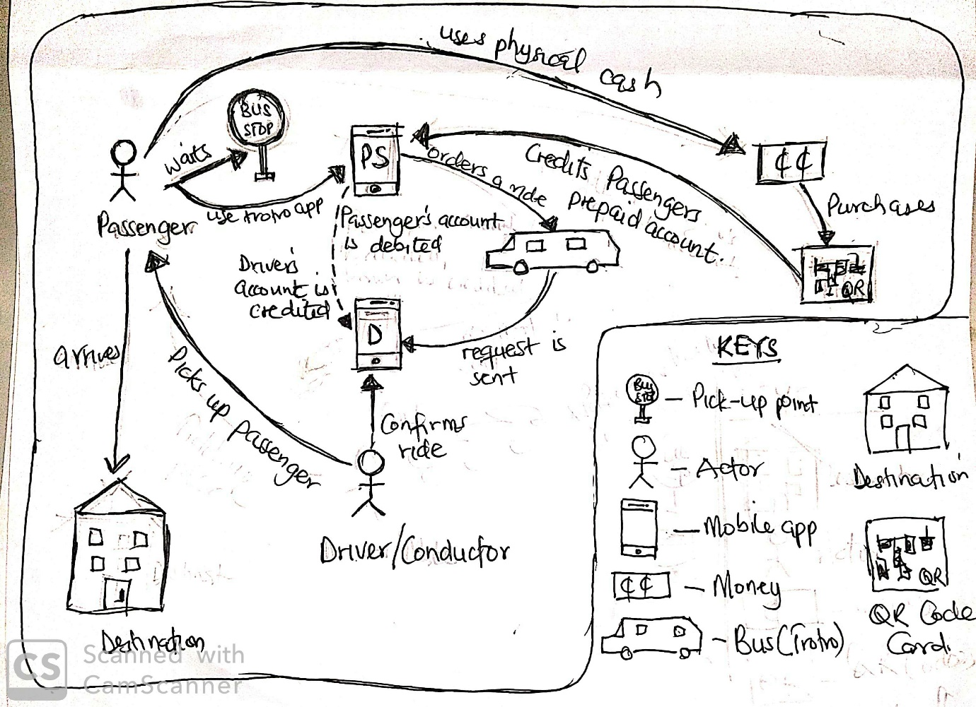

Figure 3.2 Rich Picture of the proposed system

## 3.5 Use case Diagrams

Based on the documentation of the existing system, Use case was used to identify each actor and role they play in the system. This is to help identify the functional requirements of the system.

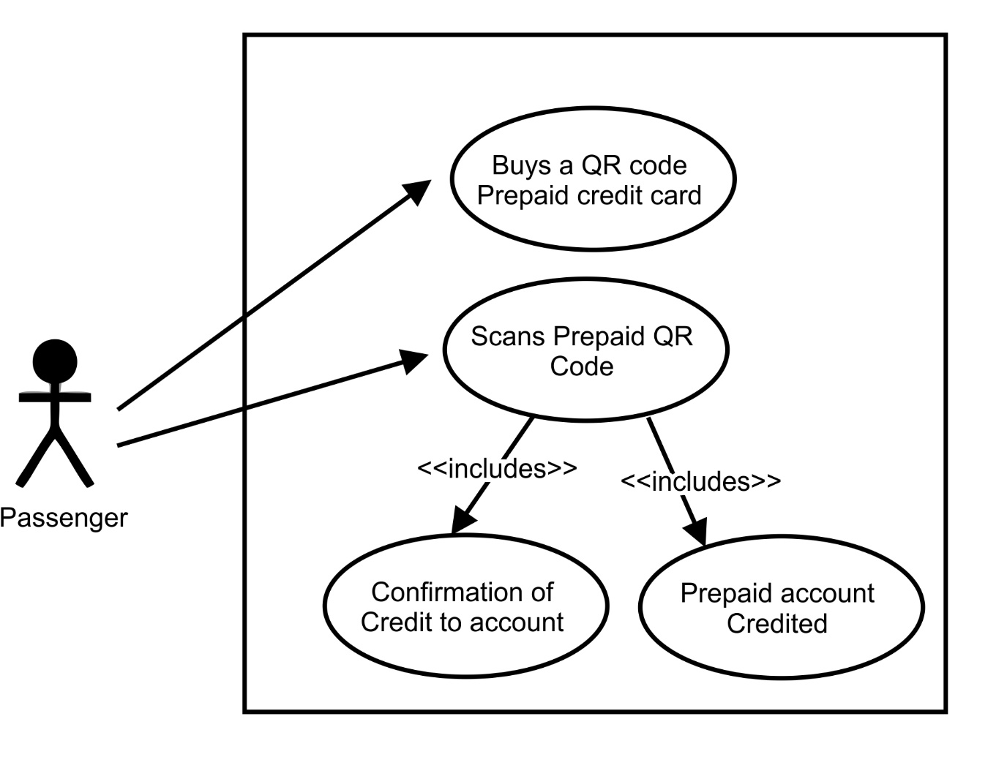

Figure 3.3 Use Case of the proposed system

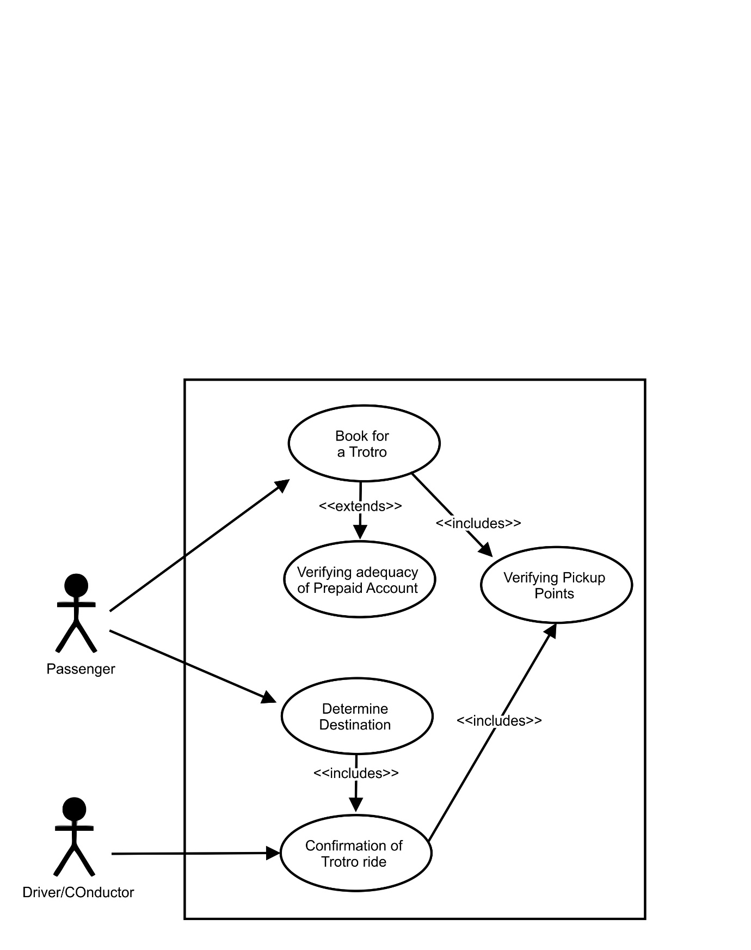

Figure 3.2 Use Case 2 of the proposed system

### 3.5.1 Flow of event for the Usecase Diagrams

***Passenger registering for the system***

Actor: Passenger

1. Process starts when passenger downloads the application from play store
2. Passenger register with his personal details (Biodata)
3. An SMS or email is sent to passenger for verification
   1. If the passenger is unable to confirm registration, the registration is aborted.
4. the Passenger confirms the registrations via the code sent
5. Use case ends what the passenger's registration is confirmed

***Driver registration***

Actor: Driver

1. Process starts when the Driver downloads the application
2. Driver provides Personal details
3. Driver provides car details
   1. If the details provided is incorrect, the system rejects the registrations
4. Driver waits for confirmation from DVLA
5. Driver confirms via SMS or email
   1. If the driver is unable to confirm, the registration is incomplete and terminated terminates.
6. Use case ends if driver and car confirmations are successful.

***Booking a Trotro***

Actor: Passenger

1. Use case starts when passenger orders a Trotro
   1. If the passenger do not enough credit in the prepaid account, the trotro cannot be booked.
   2. If the Trotro is full, the passenger’s book will be incomplete
2. Passenger stands at a bus stop on route of the Trotro
3. Trotro's details is displayed to the passenger
4. As soon as he enters, the driver's mate and conductor initiates the travel process
   1. If the passenger wants to change his destination, he can change it according to the route of the driver.
5. Passenger Confirms destination
6. Both passenger and Driver's mates confirms destination on arrival
7. Passenger gets off the Trotro.

***Payment***

Actor: Passenger and Drivers Mate

1. use case starts when passenger enters the Trotro
2. the Drivers mate initiate trip as soon as the car moves
3. the Drivers mate terminates trips as soon as the trotro reaches the destination of the passenger
4. the passengers fair is deducted from the passengers prepaid account
5. use case ends when the passenger gets off the trotro

***Loading Prepaid account for passengers***

Actor: Passenger

1. use case begins when passengers buys a QR Code card from a vender or drivers mate
2. Passenger uses the mobile app to scan the QR codes
   1. If the QR code has being used, the application rejects it.
3. Confirmation of the amount is loaded into the Passengers account

## 3.6 Functional Requirements

On the basis of the above, the following functional requirements for the propose mobile application to manage the TroTro are

1. Passenger is able to book a ride via the mobile application
2. Drivers and drivers mate is able to identify pickup points of the passenger via the mobile application
3. Drivers are able to identify and drop passengers at their destination via the mobile application
4. Passenger is able to load credits using QR codes onto the mobile application
5. Passenger is able to make payments from his or her prepaid account
6. Driver or drivers mate is able to receive payment on the mobile application.

## 3.7 Data flow Diagram

Figure 3.4 Context Diagram (Data Flow Diagram)

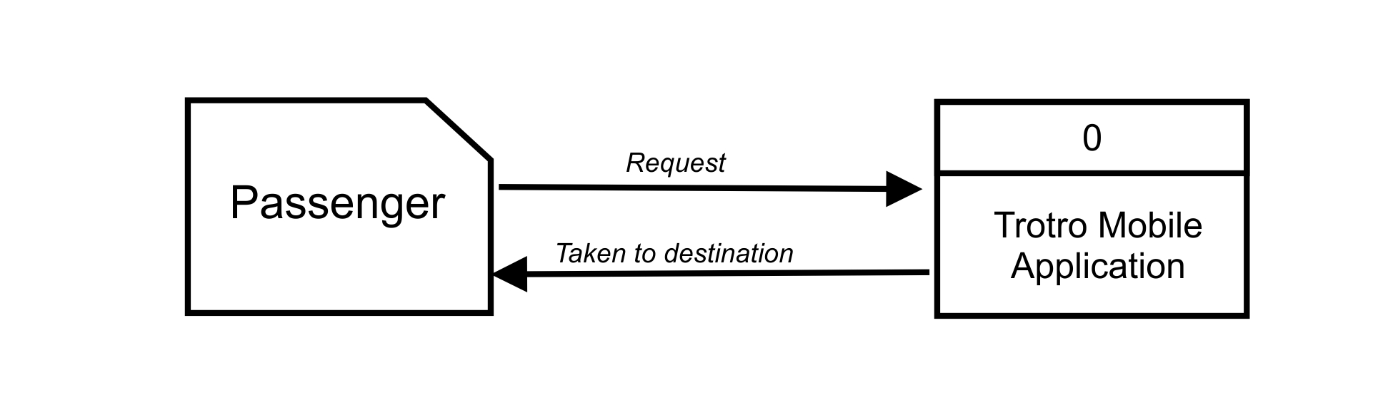

The level 0 diagram (context diagram) of the Data Flow Diagram shows the process indicative of the main purpose of the application being developed. The central view of the application will be the passenger and the way they interact with the systems. This is shown in the above diagram. Figure 3.5 shows the decomposition of the Level 0 diagram of the Data Flow Diagram.

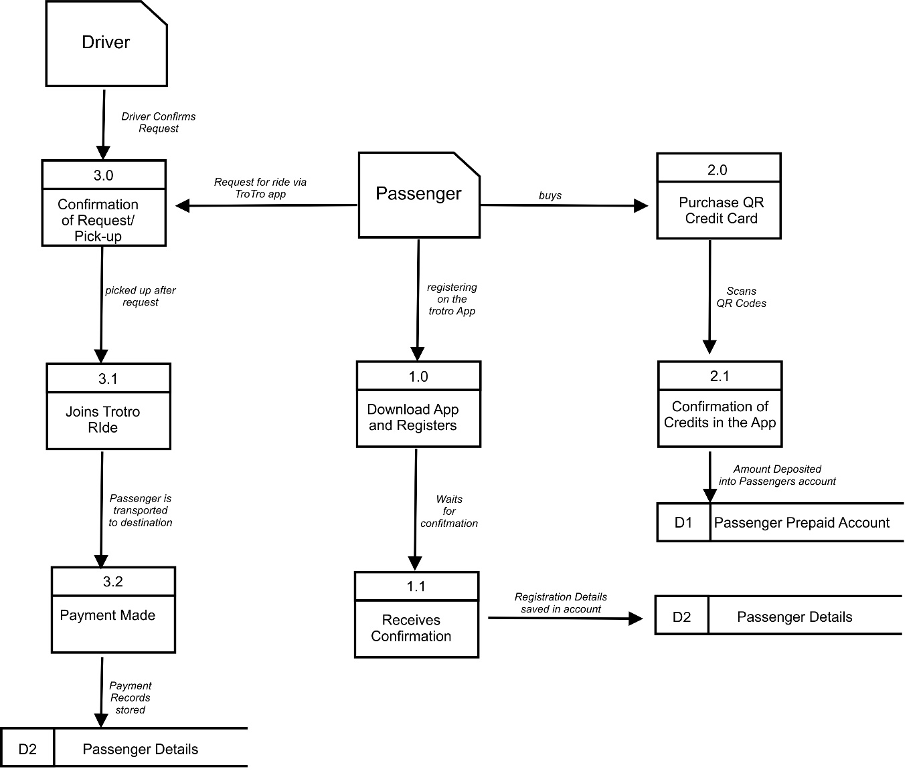Figure 3.5 Level 1 Diagram (Data Flow Diagram)

In Figure 4.5, the passenger has to first download the application on Google Play Store and go through Registration which is done through the confirmation with SMS. After the conformation is done the details of the passenger will be saved in a permanent data store called "Passenger details". The registered passenger will now have the opportunity to use the application but first need to upload his prepaid account. As shown in the dataflow diagram, the passenger has to purchase a credit card made of a QR code, and scan it with his or her phone. The confirmation of the credit is uploaded and debited into his account and this is also saved in the "Passenger Prepaid Account" data store D1. The passenger then can book a ride with the application. The Driver receives the application and confirms it. The passenger is picked up, when the passenger arrives at his destination, the account of the passenger is debited and that of the drivers is credited. This data is stored in D2 (Passenger Payment Rocords).

## 3.8 Development of the System

After the analysis stage, the application was developed using the Android Studio IDE and Java as the programming language for the development of the application. Java was choose because it is the most widely used and has support services from variety of sources. The Android Studio IDE was also adopted because it is an openware and developed by google to build mobile applications for their android platforms. The Trotro application developed is discussed further in Chapter 4

## 3.9 Conclusion

This chapter has looked at the analysis and design stage of the project by looking at the existing systems and how trotros are operated in Ghana. On the basis of that, a proposed system which uses a unique payment method through the use of scan codes was introduced and implement into the system to facilitate payments of passengers’ cost of transporting them from their pickup point to their destination. The evaluations of the system will be discussed in Chapter four.

# CHAPTER FOUR

# IMPLEMENTATION

## 4.0. Brief introduction to implementation and documentation

Implementation is the carrying out, execution, or practice of a plan, a method, or any design for doing something. As such, implementation is the action that must follow any preliminary thinking in order for something to actually happen. Implementation encompasses all the processes involved in getting new software or hardware operating properly in its environment, including installation, configuration, and running, testing, and making necessary changes.

Software documentation also known as software manual on the other hand is a Comprehensive information on the capabilities, design details, features, and limitations of a systems or application software. It may also include software licensing requirements, and comes usually as a printed document or as another piece of software.

## 4.1 Description of the new system

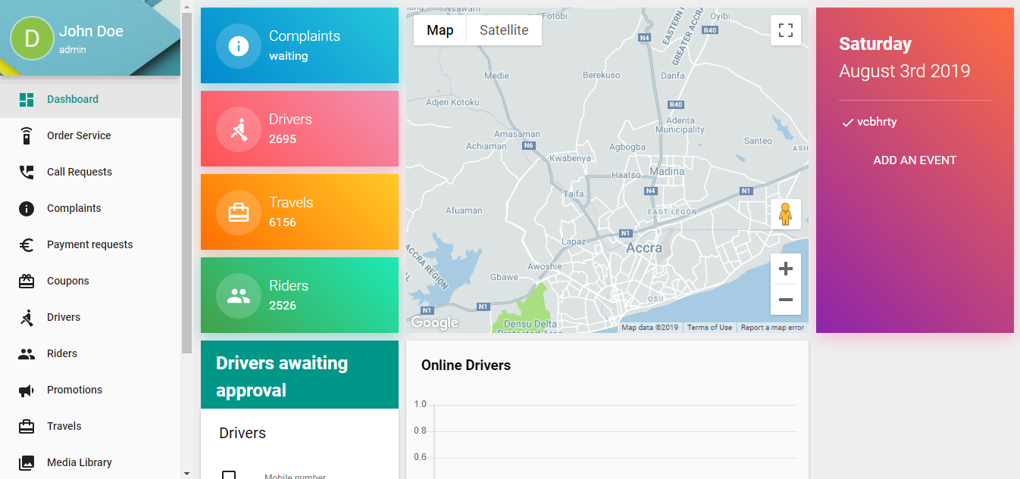

Figure 4.1 Dashboard of the Mobile Application

Figure 4.1 depicts a dashboard for the mobile application. The dashboard helps the systems administrators to get access to the back end of the system where they can administer and manage changes in the application. It also enables them to view various reports that are generated by the systems at any given moment. In Figure 4.1 the dashboard gives views and reports on the following

1. The complaints that has being received from clients
2. The number of drivers who are on the platform with their details
3. The number of travels that has being successfully completed on the platform
4. The number of riders who will patronize the application
5. The number drivers awaiting approval for the Trotro app
6. Records of payments that as being made over the period of time

Other menus on the dashboard includes coupons, promotions and call request. This is to help the administrator of the system view reports and manage the application, so that any form of recommendations and improvement can be added to the system.

Figure 4.2 Passenger ordering for a ride

Figure 4.2 shows how the customer can book for a ride. The customer has to stand at a pickup point or bus stop and makes a request for a trotor. The available trotros will then will then be displayed with their respective prices based on the pickup point and the destination of the passenger. The passenger will then confirm the pick as he or she waits for the trotro at the pickup point.

After the passenger has made a request, the Drivers request panel receives a notification that a request has being made. Base on the current occupancy of the bus. The driver reserved the right to pick passenger or not depending on his or her route and whether there is enough space to accommodate another passenger. The driver therefore can accept or reject a request as shown in Figure 4.3

Figure 4.3 Confirmation of Trotro Request

Figure 4.4 shows the payment model as implemented using the QR codes. The passenger has purchase the QR code and scan it to load and credit the customer’s account. The system is able to scan the QR code and deal with the problems associated with payment in mobile money, debit and credit cards as generally used in Ghana. The credit loaded into the customer’s account and he or she is pay from the credit in the passengers account.

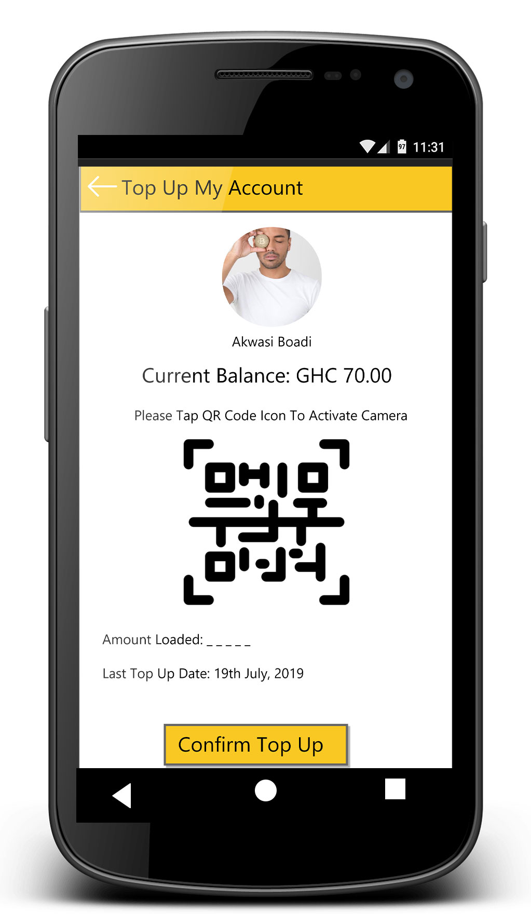

Figure 4.4 QR Code for Payment

## 4.2 Testing

Testing is conducting an investigation to provide stakeholders with information about the quality of the product or service under test. Software testing can also provide an objective, independent view of the software to allow the business to appreciate and understand the risks of software implementation.

Testing can be stated as the process of validating and verifying that a developed system or product. Verification has to do with ascertaining if the set of activities to ensure that the mobile application is developed based the set of functions that has being put in place such that it is built correctly. Validation is to ascertain that the set of activities ensures the mobile application is built to meet the requirement of the systems the customer desires.

The types of testing deployed for the mobile application is Unit Testing, integration testing and Validation Testing. The unit testing concentrated on the component and functions of a mobile application based on how the implementation of the source code was done. The integration testing also looks at the designs and architectural framework informed by requirements from the users. The validation testing done on the mobile application to ascertain if it meets the requirements of the user. After performing the testing, it was ensured that functional requirements are satisfied, behavioural characteristics are achieved, performance requirements are attained and usability and other requirements are met.

## 4.3 Deploying the system

There are various stages of deploying applications. This includes Pilot, Phased, Big Bang/abrupt and the parallel changeover. In the case of the Trotro mobile application, the abrupt changeover methodology of deploying a system cannot be used since it would be legislation by stakeholders to use the system. The abrupt changeover would mean that, the entire way of running the Trotro system has to at a particular point change from current to the new systems which would be sudden. The other change over methods can be therefore used. Each of these method has one advantage of the other.

The phased changeover can be used for the deployments but will not be the most ideal for deploying the system because the system will not be developed in phases. Deploying the system in phases will mean that, the system will be deployed in parts. The system is not built in phases and for that matter cannot be deployed in phases. Another reason for not using the phased changeover is that it has limited functionality. This will mean that, part of the full application may not be functional which is sometimes demoralizing to both the users and the developer.

Using the pilot methodology will also mean that, part of the system is used by part of the Trotro operators. In this case these Trotro operators are not well organised and for that matter, difficult to run a pilot as a deployment methodology for the Trotro application. The ideal changeover method for the Trotro operators will be the parallel changeover there Trotro operators who want to use the application with the current unautomated system of managing Trotro in the country. This also helps the Trotro operators to make comparism on the old systems to be able to identify the improvements with the existing or current systems.

## 4.4 Evaluation of system

This section deals with the developed systems evaluation based on the functional and non-functional requirements.

|  |  |  |
| --- | --- | --- |
| **Functional Requirements** | **Evaluation** | **Success Criteria** |
| Passenger Registration | Passenger is able to register into the system and confirm registration through an SMS | Successful |
| Passenger login | The passenger is allowed to login in to the systems as get access to a dashboard. | Successful |
| Passenger is able to load prepaid credit | The passenger is able to login to the system and scan a QR code load e-cash into his/her account. | Successful |
| Booking a ride | The passenger can stand at a pickup point and search for a ride through the mobile application | Successful |
| confirms ride | Both the driver and the passenger are able to confirm the ride via the mobile application | Successful |
| Identify the routes | Both passenger and driver are able to identify route to their destination and confirms rides on that route | Successful |
| Payments | Passenger are able to make payment via their prepaid account that was recharged using the QR codes | Successful |
| Driver receives Payment | Upon alighting of the passenger, the drivers account is credited with the payments from the passengers accounts | Successful |

## 4.5 Conclusion

The application developed will therefore deal with the Trotro transportation system in Ghana. Passengers can at the convenience and pickup point, order for a Trotro, make payments and get to their desitination without any major problems or issues.

# CHAPTER FIVE

# CONCLUSION

## 5.1 Summary

Trotro has being in the urban areas of Ghana for many years. It is the most used and commonest means of transportation in the urban space in Ghana due to its relevance of moving people to various parts of city. One of the main reasons for the high patronage of the Trotro is that, it is able to reach most part of the city which is quite difficult to reach by the two major government owned transport companies in Ghana. They are also cheap as compare to taxis that are used in the urban areas.

Based on observation the major problems associated with the Trotro system includes conflicts between the passengers and the Trotro conductor in how much is supposed to be paid by the passenger from the pick-up point to the destination and the issues of change if the passenger give an amount more than the actual cost of items. Another challenge identified during the investigation period is the fact that, people have to "fight" in other to get access to Trotro especially when it is rush hours.

Some of the drivers also abort the journey when there is too much traffic or the number of passengers in the car is deemed unprofitable. Passengers are mostly left stranded to get a Trotro to transport them to their various destinations.

The purpose of the project therefore was to provide a solution to the mentioned a solution to deal with the problems associated with Trotro transport system in Ghana which takes care of the majority of the passengers who moves through the major cities in Ghana with the use of a mobile application which will help passengers to

1. identifying Trotro on route and board them
2. Book Trotro before it reaches its destinations.
3. use of a suitable payment mode for the Trotro
4. adhere to the Trotro standards set by the DVLA

## 5.2 Findings

The project therefore developed and documented a mobile application that is able to book a Trotro on route to a particular destination through the developed android mobile application. with the application, the passenger is able to order a Trotro based on route and the driver or his attendant confirms the books and pick up point such that, they are able to pick up the passenger to his or her destination. Passengers will not have to queue or struggle for a car if the Trotro confirms a seat for him or her at the pick-up point. This will solve the problem of passengers physically struggling for Trotro at peck or rush hours.

The mobile application is also able to deal with the payment model of the Trotro by introducing a QR code system of payment where the passenger can purchase the QR code and can it onto his phone. The QR codes works just like the scratch cards, instead, in this particular situation, the mobile application will be able to scan and the amount credited to the account of the passenger. This will deal with the various conflicts that comes in Trotro because it will be a cashless system which will debit the passengers account and credit the drivers account as soon as the passenger arrives or reaches his or her destination. This also implies that, there is no form of cheating as most passengers accuses the drivers and their mates of cheating.

Due to the nature of the mobile application, before the driver is given the permission to be able the run the application, the car and the driver will have to adhere to the standards the DVLA. Standards will also mean that, Trotro will not be in a dilapidated states as seen with most Trotro in the city.

## 5.3 Future Work and Directions

The project for the future direction take a look at various payment models that can contribute to effective payments for the Trotro systems in Ghana. Further research can also look at how QR codes can be used as a cashless payment model for other transactions in Ghana. With the use of this mobile application, the future projects can also look at how to integrate the system into all the other means of transportation in Ghana and the sub region.

# REFERENCES

Alper, D., & Uraz, B. (2013). *Google Maps JavaScript API Cookbook.* BIRMINGHAM: Packt Publishing .

Andrew, M. (2019, February 2019). *Taxify vs Uber: Side by side comparison for drivers*. Retrieved from www.finder.com.au: https://www.finder.com.au/taxify-vs-uber

Askia, H. (2018, October 15). *Face2FaceAfrica.com*. Retrieved from https://face2faceafrica.com/article/the-trotro-a-force-to-be-reckoned-with-when-you-visit-ghana

Brishen, R. (2018). The Social Costs of Uber. *The University of Chicago Law Review Dialogue*, (pp. 85-102). Chicago.

Chen, L., & Alan Mislove, C. W. (2018). https://www.ftc.gov/system/files/documents/public_comments/2015/09/00011-97592.pdf. *https://www.ftc.gov/system/files/documents/public_comments/2015/09/00011-97592.pdf*.

DPO Group. (2018, March 19). *State of Cashless Payments in Ghana*. Retrieved from DPO Group : https://blog.directpay.online/state-of-cashless-payments-in-ghana/

Metro Mass Trasit. (2019, March 13). Retrieved from http://www.metromasstransit.com.gh/

Microsoft Corp. (2018, May 5). *Maps*. Retrieved from www.bing.com: www.bing.com

Microsoft Corperation . (2019). Retrieved from www.microsoft.com: https://www.microsoft.com/en-us/maps/documentation

Murtaza, H. (2015). *To Uber or Not to Uber: That is the Question.* Toronto.

Okoye, V. (2010, September 29). *http://earth.columbia.edu/*. Retrieved from Columbia University: https://blogs.ei.columbia.edu/2010/09/29/report-from-the-field-the-tro-tro-an-essential-mode-of-transport-in-accra-ghana/

Zijlma, A. (2019, January 11). *Getting Around Ghana by Tro-Tro: a Complete Guide*. Retrieved from /www.tripsavvy.com: https://www.tripsavvy.com/tro-tros-in-ghana-1454315