**Program Requirements:**

Design and create a program to read in a file of integers and process the list. The input file should be named “data.txt”. The first line of the file is how many integers are contained in the rest of the file. The remainder of the file will have one integer per line. You must use the new operator to dynamically allocate storage for the list of numbers. You must also use the delete operator to deallocate the storage when you are done with the list.

**Program Inputs:**

File "data.txt”:

Usage: loaded to ifstream object to input integer values onto the list

Acceptable inputs: Integer values with the first value corresponding to the size of the list(other values will throw error due to the integer typing)

Int searchNum:

Usage: sent to search() function to search for input value through the list

Acceptable inputs: Integer values (error thrown otherwise)

**Program Outputs:**

Float mean:

Description: mean value of list

Bool valuePresent:

Description: checks if the value input is present in the list

Int even:

Description: Number of even values present in the list

**Test Plan:**

The test plan include various data.txt inputs

**Alogrithm:**

Driver: main()

1. Load input file to filestream object
2. Skip all steps if list initialization fails
3. Get size of list from first value in file
4. Load values from file to integer list
5. Call each function (meanOfList, search and evenNumbers) to get output
6. Delete list memory allocation

meanOfList()

1. Get int list and const size and initialize mean to 0
2. Iterate through the list and add all values of the list to float mean
3. Divide mean by size of list to get mean value
4. Return mean value

search()

1. Get int list, const size and const item and initialize valuePresent to false
2. Iterate through the list and if any list value is same as item then set valuePresent to true
3. Return valuePresent

evenNumbers()

1. Get int list and const size and initialize even to 0
2. Iterate through the lsit and if any list value is divisible by 2 then increment even
3. Return value of even

**Flowchart:**

Main:

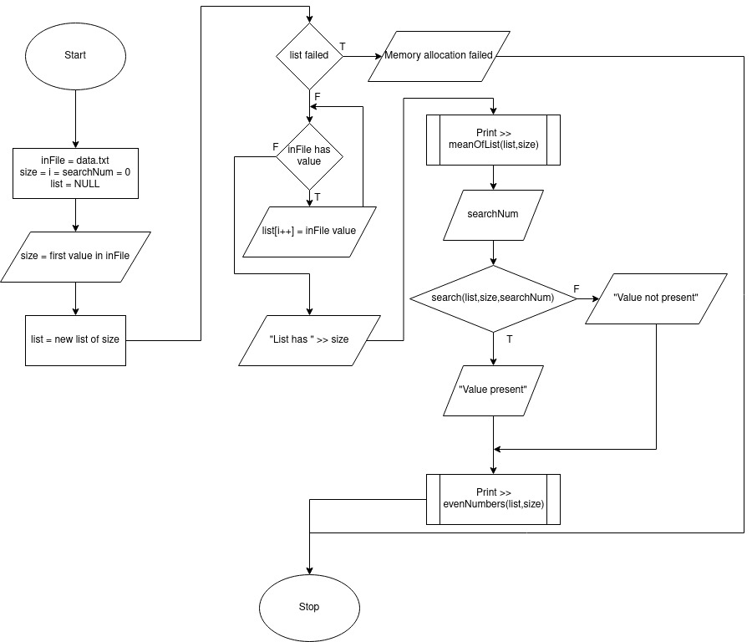

MeanOfList():

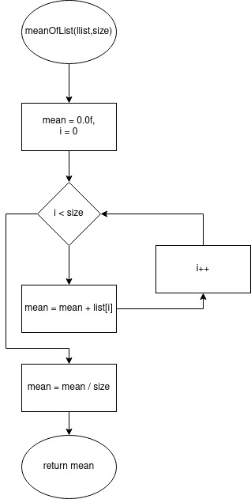

Search():

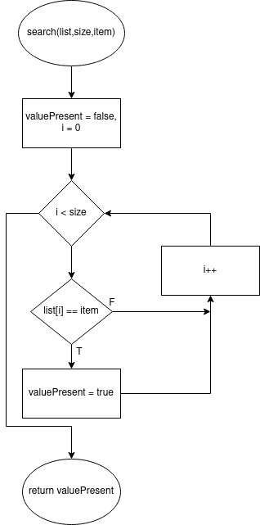

EvenNumbers():

