**Program Requirements:**

Design and create a C++ class to convert a string representing a positive integer or positive decimal value into the long int and double numeric types. If the string value represents a decimal value, the converted integer version will be truncated. If the string value represents an integer, the converted decimal value will have a decimal portion of zero.

**Program Inputs:**

String in:

Usage: passed to class converToNum to be converted to an integer and double value

Acceptable inputs: String inputs with digit characters only(letters will quit the program as int and double does not support letters)

**Program Outputs:**

Long intgerRes:

Description: Long integer value of input string

Double decimal:

Description: Double value of input string

**Test Plan:**

|  |  |  |
| --- | --- | --- |
| Input String | Integer Conversion | Decimal Conversion |
| “123” | 123 | 123.0 |
| “12.45” | 12 | 12.45 |
| "122.221” | 122 | 122.221 |
| “14401.12112” | 14401 | 14401.12112 |
| “9878877887.654” | 9878877887 | 9878877887.654 |

**Alogrithm:**

Driver: main()

1. Input value of string
2. Send value of string to convert()
3. If convert returns true Receive value and print return values of intgerRes and decimal from getIntValue() and getDoubleValue()
4. Else Output input failed and continue to exit

ConvertToNum: convert()

1. Get string in
2. Loop string in for characters till we cannot push any more values to stack integer and then jump to step 5
3. If character is not digit then return false
4. If character is ‘.’, then break loop and continue to step
5. Loop string for fractional part till we cannot push any more values to fractions stack and then jump to step 7
6. If character is not digit then return false
7. Loop to pop values from fractions stack and add values to returnDouble till stack is empty
8. Loop to pop values from integers stack and add values to returnInt and returnDouble till stack is empty
9. If stacks are empty return true, else return false for failure

ConvertToNum: getIntValue()

1. Return value of returnInt

ConvertToNum: getDoubleValue()

1. Return value of returnDouble

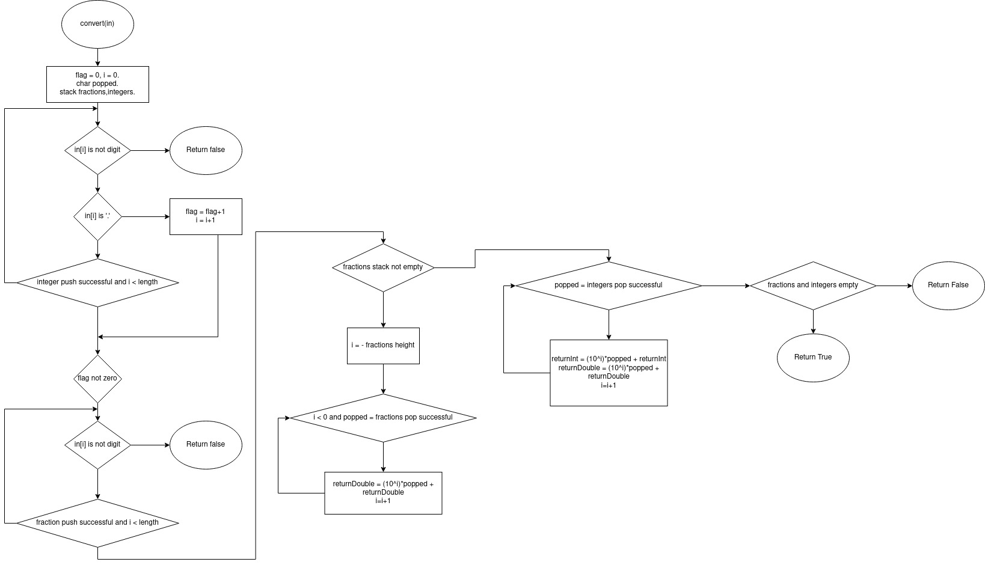**Flowchart:**