**Integrating AWS Services with Terraform and CloudWatch:**

Step 1: Set Up S3 Terraform Backend State:

1. **Sign in to your AWS Account:**
   * Access the AWS Management Console.
2. **Navigate to S3 Service:**
   * Go to the S3 service.
3. **Create S3 Bucket:**
   * Click on "Create bucket."
   * Name: **bucketforterraform**
   * AWS Region: **us-east-1**
   * Enable Bucket Versioning to keep old versions.
   * Uncheck "Block all public access."
4. **Create Folder Inside the Bucket:**
   * Within the newly created bucket, create a folder.
5. **Update Terraform Main.tf:**

In your Terraform main.tf, add the following lines:

* terraform { backend "s3" {
* bucket = "bucketforterraform"
* key = "StoreterraformState/terraform.tfstate"
* region = "us-east-1"

}

}

Step 2: Create CloudWatch Monitoring Module:

1. **Create Module for EC2 Monitoring:**
   * Develop a module in Terraform for CloudWatch monitoring of EC2 instance CPU utilization.
2. **Configure CPU Utilization Threshold and Alert:**
   * Set up a CloudWatch alarm to trigger when CPU utilization is greater than or equal to 80%.
   * Specify an evaluation period of two times before triggering the alert.
3. **Associate CloudWatch Module with SNS Module:**
   * Establish a relationship between the CloudWatch module and an SNS module.
   * The SNS module should create a topic for alerting purposes.
4. **Terraform Code Example:**

module "cloudwatch_ec2_monitoring" {

source = "path/to/cloudwatch_ec2_monitoring_module"

ec2_instance_id = aws_instance.example.id

threshold = 80

evaluation_periods = 2

}

module "sns_alert" {

source = "path/to/sns_alert_module"

topic_name = "EC2_CloudWatch_Alert"

}

Step 3: Testing:

1. **Include the Terraform Code:**
   * Include the updated Terraform code with the S3 backend configuration and CloudWatch module in your project.
2. **Run Terraform Commands:**
   * Run **terraform init**, **terraform plan**, and **terraform apply** to apply the changes.
3. **Verify CloudWatch Configuration:**
   * Confirm that CloudWatch metrics are being monitored and the alert is set up according to the specified conditions.
4. **Check SNS Topic:**
   * Validate that the SNS topic is created, and alerts are being sent to the specified topic.

By following these steps, you should have successfully integrated AWS services using Terraform, configured an S3 backend for Terraform state, and set up CloudWatch monitoring with alerting for an EC2 instance.

Screenshots:

After Terraform init then Terraform plan then terraform apply.

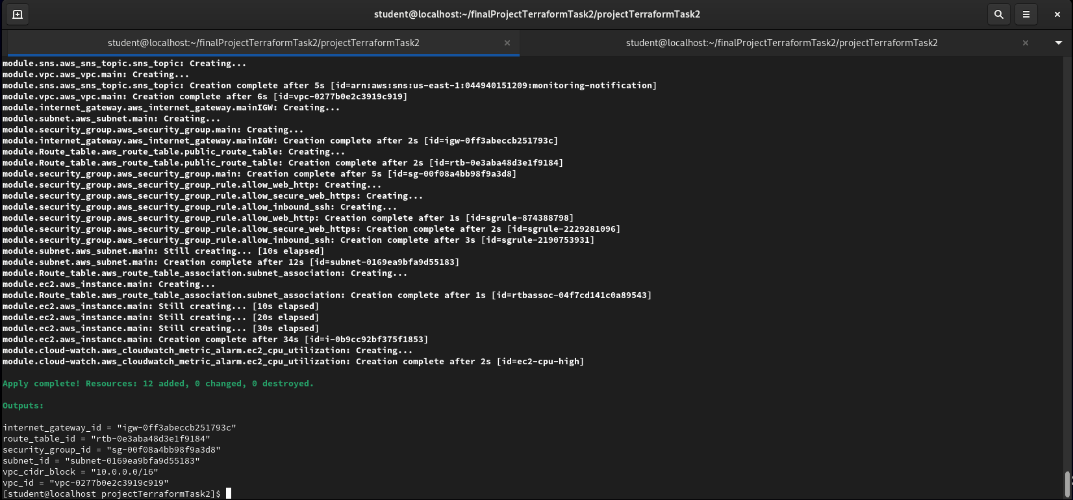

The terraform saved their tfstate file in the s3 bucket with the value I have provided.

