Felix Baker

Internship Report
April 12th – June 7th

Développeur Web en Java
Concepteur Développeur d’Applications

Baobab Ingéniere

In association with Greta de l’Essonne

Table of Contents
Project Summary 3
Competences covered by this project 4

Résumé de stage

Contexte :
J'ai effectué mon stage pour l’obtention d’un Titre professionnel Concepteur Développeur d'Application au sein de l'entreprise Baobab Ingénierie.
L’Entreprise a été crée en 2010 et géré par Maxime LODIN et elle a sept employés. Elle est une société spécialisée dans la consultation et formation informatique. J'ai travaillé en tant que développeur web sur Spring 5 et React 18. Je faisais partie d'une équipe de deux autres stagiaires et nous travaillions en parallèle.
Ma mission de dix semaines était de concevoir une partie d'une application web full-stack de type formation en ligne. J'ai eu la liberté de choisir de quelle partie j'étais responsable. J'ai choisi la case d'utilisation (UC) « enregistrer et confirmer un nouvel utilisateur ».
L'application doit permettre à des l'élèves de s'inscrire à un cours en ligne. Ensuite, elle permettra aux formateurs ou gérants d'approuver ou rejeter l'inscription d'un éleve. L'inscription doit porter un système de confirmation de compte par courriel.

Réalisation :
J'ai consacré la première phase de stage à l'analyse et la conception des fonctions nécessaires au projet. J'ai fait une étude du marché pour voir quelles sont les meilleures pratiques. Ensuite, j'ai créé des modèles conceptuels en forme UML et des maquettes d'interface. Pendant cette période, j'ai auditionné et choisi les outils de gestion de projet, notamment GitLab et Trello.
La deuxième phase était l'implémentation du projet. J'ai créé une base de données de développement en MySQL qui correspond à mon UC. puis j'ai créé le back-end en utilisant le Spring Framework (Java). L'Application était sécurisée par les API de Spring Security, J2EE et Java Web Tokens (JWT). Après, j'ai créé le front-end en utilisant React et le framework d'interface Material UI.
La dernière phase du projet était le test et le déploiement. J'ai analysé mon application pour identifier les bogues et le code à améliorer. Ensuite, j'ai implémenté des séries de test en utilisant JUnit 5 et Selenium IDE. Le déploiement a été effectué avec le système de conteneurisation Docker sur mon serveur Web personnel.

Apports du Stage :
Ce stage m'a été très important car il m'a permis de continuer mon apprentissage comme développeur web full-stack. Il m'a porté l'occasion de participer dans une équipe de développeurs et m'a rendu la responsabilité à compléter indépendamment le chaque étape de ma partie du projet. De plus, la revue de code hebdomadaire m'a bien aidé à m'en focaliser sur les techniques et les technologies pertinentes. Enfin, ce stage m'a permis de mettre en application les connaissances que j'ai acquises pendant cette formation.

Internship Summary

Context :
For my internship, I worked in a team of three developers for Baobab Engineering, a software consultancy and training business located in Paris 15eme. Our technical tutor was Mr Bouvanesvary in association with my training organization Greta de l’Essonne. The internship took place under the pretext of the continued COVID-19 pandemic and consequently we worked remotely with regular code reviews via Discord.
The purpose of this project was to create a fullstack web service modeled after an educational collaborative platform. We were given the opportunity to choose an objective from a number of use cases stipulated by the client. I wanted more experience with security features and chose the login and registration system.
The client requested that the application permit users to login and register to the site. Newly registers should receive a confirmation email containing a unique link to verify the email address. Following confirmation, an admin is then required to approve or deny the registration. If the request is approved, the new user can then login.

Implementation:
The project had several requirements in order to validate the final product. The project had to use N-Tier architecture and all communication between the frontend, backend, and database had to be secured.
The language could be one of our choosing but the requirements of my training program stipulated that I show proficiency in JavaScript, Java, and MySQL. I was also required to demonstrate functional knowledge of all technologies used by the end of the 10 week internship period. Based on this criteria I chose to use Spring Boot from the Spring framework and Create React App from React.js.
Security for the application was provided on all three levels. The frontend used components to sanitize and verify user input. The backend used a token and password encryption system to communicate with the frontend. The database was secured by various techniques in the backend and directly with restrictive triggers to assure data conformity.
The final phase of the project was testing and deployment. I wrote unit tests for the backend, UI tests for the frontend, and manual scripts to test the database triggers. My deployment target was an Linux server running on a Raspberry Pi. First, I loaded the server with MySQL and java. Then I created a jar file containing both the frontend and backend. I exported both the database and the jar to the server and ran the jar using a basic java script.

Insights :
This intership offered me a number of opportunities to experience development at a professional level. In spite of the remote working conditions, we still met regularly through Discord. The internship gave me experience in regular code reviews and required me to be responsible for a single use case. This allowed me to be more focused on my task and consequently I learned more and was more productive.

Internship Context

Company:
My internship took place with Baobab Ingénierie, a software and training consultancy agency in the 15th district of Paris. I was part of a team of two other developers working beneath lead developer and technical tutor, Supramanien Bouvanesvary.

Timeline
This stage took place over the course of 10 weeks from April 12th – June 7th . Due to the context of the continued Covid-19 pandemic, the internship was entirely remote. We used Discord to organize our daily team meetings and weekly code reviews.

Compétences couvert par le Stage

Concevoir et développer des composants d'interface utilisateur :
- Maquetter une application
- Développer la partie front-end d’une interface utilisateur web
- Développer la partie back-end d’une interface utilisateur web

Concevoir et développer la persistance des données :
- Concevoir une base de données
- Mettre en place une base de données
- Développer des composants dans le langage d’une base de données

Concevoir et développer une application multicouche :
- Collaborer à la gestion d’un projet informatique et à l’organisation de l’environnement de développement
- Concevoir une application
- Développer des composants métier
- Construire une application organisée en couches
- Préparer et exécuter les plans de tests d’une application
- Préparer et exécuter le déploiement d’une application

Project Description and Scope

Context:
The project is an online learning streaming platform variety of tools such course-specific chat rooms and exercise modules for students. Users must be able to connect with audio, visual, and screen sharing support. Professors must be able to give exercises and monitor student progress.
Students must be able to subscribe to a channel and a channel can cover one or more courses. Channels can also be created without a specific course as in the case of study groups.

Principle Roles:
- Professor
- Student
- Program Director
- Admin
- Member (of a channel)

Objective:
The client gave us a list of 18 objectives required to complete validation of the final product. We were instructed to work in parallel and choose at least one objective to complete A – Z. I chose use case 8 (UC8), the user login and registration system as I wanted more experience with web security and account validation mechanisms.

Technical Requirements:
For this project we used Spring Boot to create the backend in accompaniment with a variety of other Maven plugins. The frontend was created using React.js and the database used MySQL. Testing of the application was facilitated by JUnit, Postman and Selenium IDE. The deployment server was a Raspberry Pi running Ubuntu 20.04 with MySQL and Java installed. Project management was organized using Trello and the project repository was hosted on GitLab. Our team communications and code reviews were done via Discord.

Functional Requirements:
UC8 had two primary functional requirements:
- students must be able to sign up and receive a confirmation email after registration
- the program director or professor must be able to approve or deny new user registration

Implementation Requirements:
The implementation must be secured using a token system and encrypt user data during registration. These security measures must be fulfilled by the backend (Spring)

Nonfunctional Requirements:
We had the liberty of choosing our technology with the expressed requirement that any technology used be explainable. Due to my current capacity as a web developer, I was unable to use more advanced concepts such as mock testing of rest services in the backend or state management via Redux in the frontend. The other project requirements are as follows:
- the database must be secured
- user passwords must encrypted

Conceptualization

Use Case :
We were given the opportunity to choose a particular use case. I chose the login and registration system, also referred to as UC8. I used use case diagrams to get a better understanding of the relationship between each actor and identify the critical components. I created a global use case diagram and then extracted the specific actions related to my chosen task.
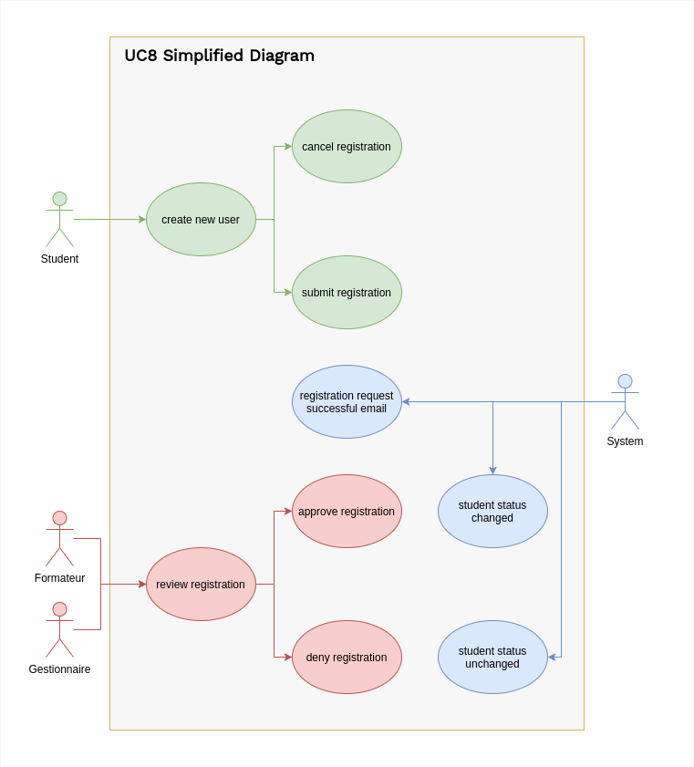Figure 1: Simplified use case showing only UC8
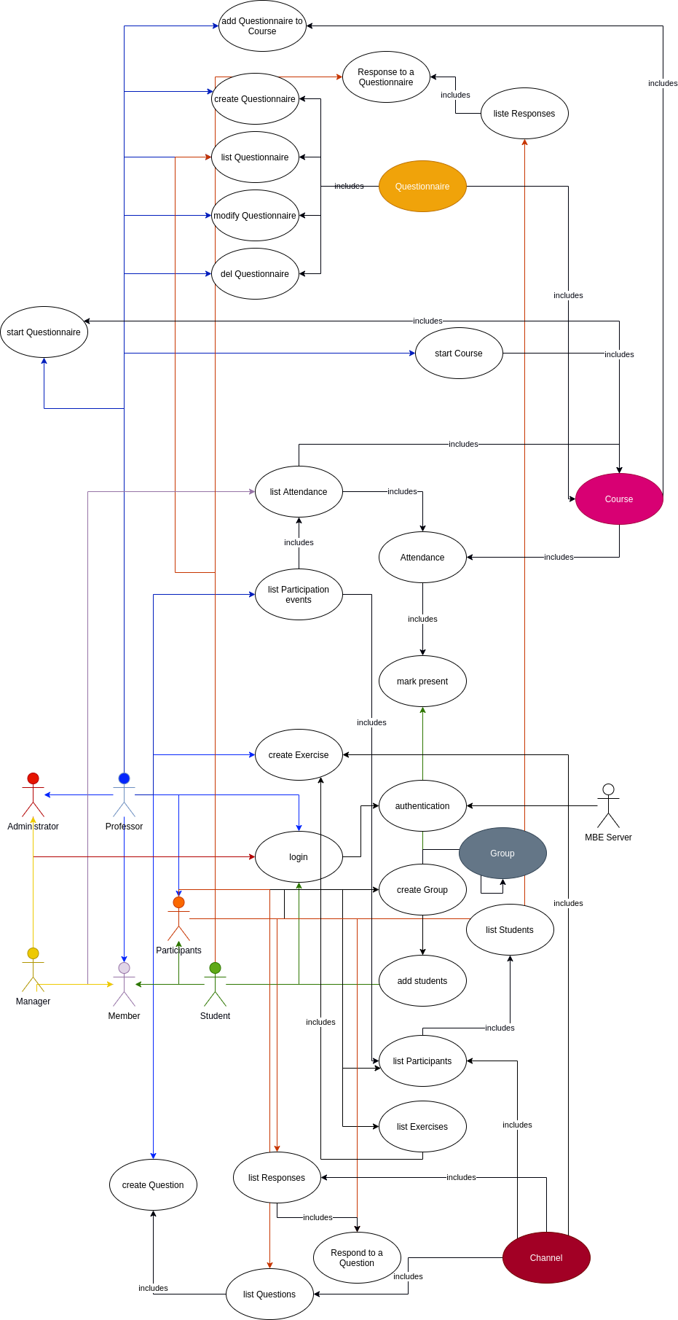
Figure 2: Global use case detailing all actor relations

UC8 Detailed Description:
8a: New User Registration
Actors:
- Student

Preconditions:
- User must be a new student

Triggers:
- Guest user accesses registration page

Optional
  - Form timer is started

Normal Flow:
- Description:
  - A guest user fills out the registration form and submits it
  - An email is sent to the address confirming registration request

- Post conditions:
  - A subscription request is now available in the Admin/Teacher dashboard

Alternate Flow:
- Description:
  - A guest user decides to stop registration by clicking away, closing, or hitting “Cancel Registration” button
  - All form data is dropped
- Post conditions:
  - if the guest user clicks the “Cancel” button, they are redirected to the homepage

Exceptions Flow:
- EX1 Description:
  - Guest user takes too long to fill out the form
- Post conditions:
  - The registration page drops all form data and displays a prompt to refresh the page

- EX2 Description:
  - Guest user does not confirm email address
- Post conditions:
  - Guest user remains a guest and cannot login
  - Duplicate requests to register replace the previous request should the token not yet be expired

8b: New User Approval
Actors:
- Director
- Teacher

Preconditions:
- The subscription requester must confirm their email

Triggers:
- The Director/Teacher must access the registration request page

Optional
  - request confirmation form timer started

Normal Flow:
- Description:
  - Manager/Teacher reviews the form and approves the request
  - Approval request is removed from the pending tab to approved tab
  - Request has the approving Faculty member’s ID appended

Optional:
  - Student receives an registration complete confirmation
  - Student receives an “welcome” onboarding email

- Post conditions:
  - The guest user (now “student”) can now log in and access profile features

Alternate Flow:
- A1 description:
  - Manager/Teacher reviews the form and denies the request

Optional
  - Manager/Teacher writes a short description about the request denial
  - The guest user receives a request denial confirmation

- Post conditions:
  - Registration request is moved to the denied tab
  - Guest users can apply for registration again

Exceptions Flow:
- No significant exceptions to be handled during this phase

UC8 Validation Requirements:
As a student, I can
- submit a request for registration
As a director or teacher, I can
- approve or deny the request

System Sequence Diagram:
The following is a simplified Diagramme de Sequence Système showing the global behavior of the application under normal circumstances.
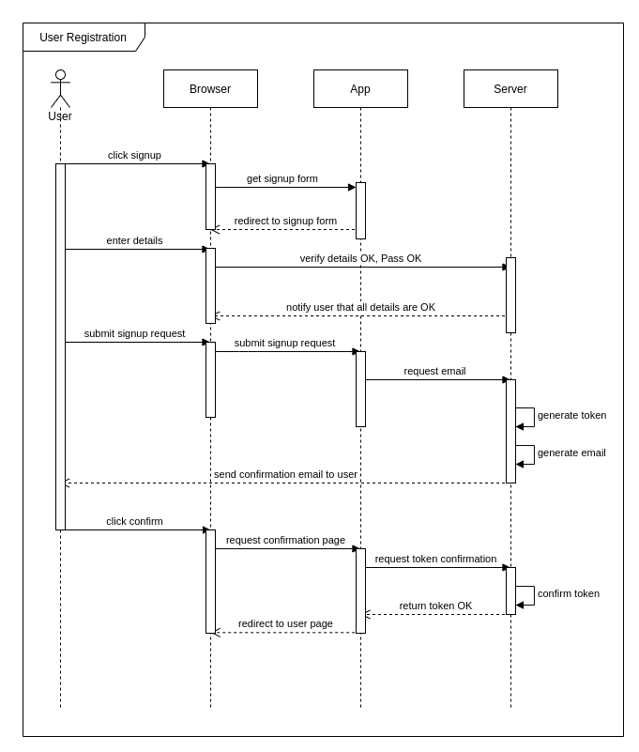Figure 3: Diagramme de Sequence Système, demande d’inscription
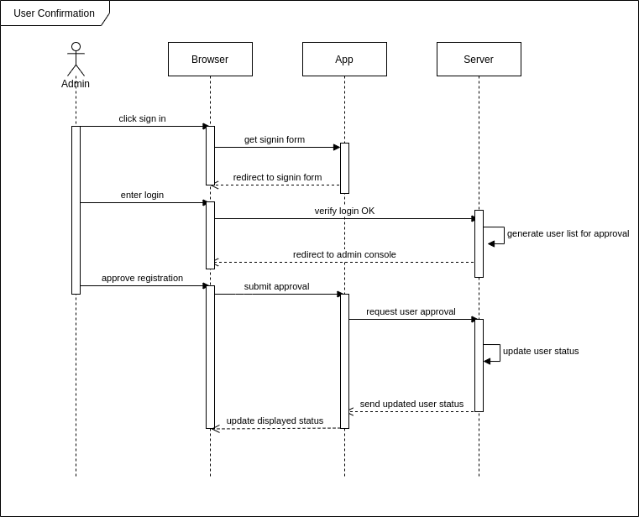Figure 4: Confirmation d'utilisateur par un Admin

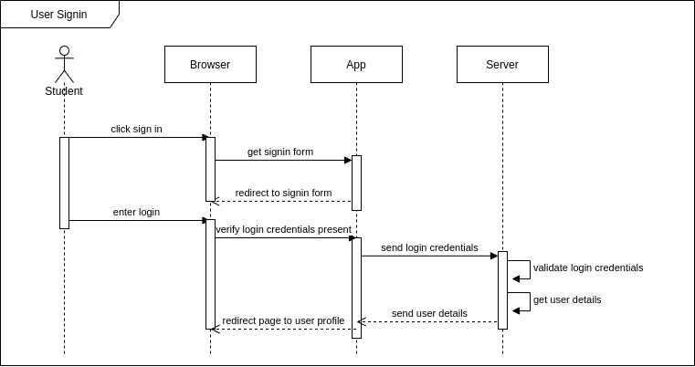Figure 5: Connexion d'utilisateur après confirmation

Sequence Diagrams for Exceptions:
This section is where the diagrams for all other cases will be. As of 21/06, I am not currently finished with this portion but assure that it will be presentable by 25/06. Thank you for your understanding

