1.ping另外一台计算机

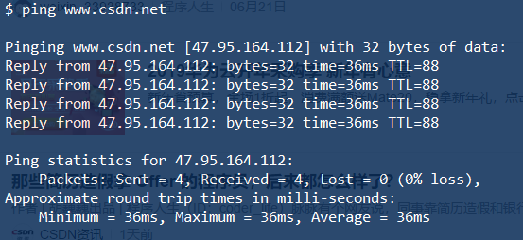

2.tracert一个服务器

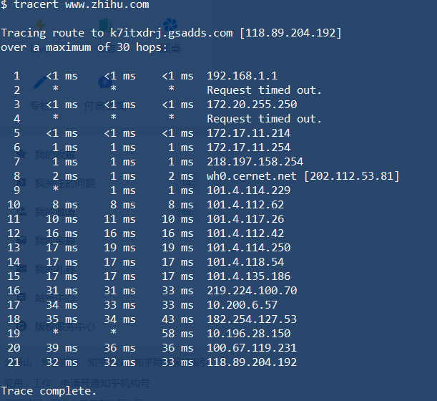

**P2. Solution:**

The delay is the time interval between when the first packet has just started to be transmitted and when the last (P) packet arrives at the destination.

**d1**

**d2**

d1

d1

d1

d1

**……**





……

Therefore, dend-to-end = d1+d2 = (P - 1) $\frac{L}{R}$* + N $\frac{L}{R}$

*

= (N+P-1) $\frac{L}{R}$

*

**P8.Solution:**

a. N = 3Mbps/150kbps = 20

b. p=0.1

c. P(n users are transmitting) = $C_{120}^{n}*{0.1}^{n}*{0.9}^{120-n}$

d .P(X>=21) = $\sum_{21}^{120}{C_{120}^{n}*{0.1}^{n}*{0.9}^{120-n}}$

= 0.079

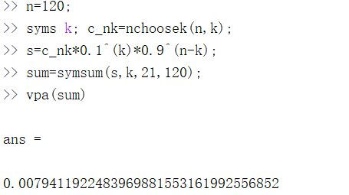

**P13.Solution:**

a. $d_{n}=\left(n-1\right)*\frac{L}{R}$

Thus, $d_{avg}=\sum_{n=1}^{N}{d_{n}}$

= $\frac{N-1}{2}*\frac{L}{R}$

b. Since N packets can be transmitted in N*L/R seconds, there is no need for the next batch to queue after the prior one.

Thus, $d_{avg}$ = $\frac{N-1}{2}*\frac{L}{R}$.

**The reference answer of P8 is incorrect.**

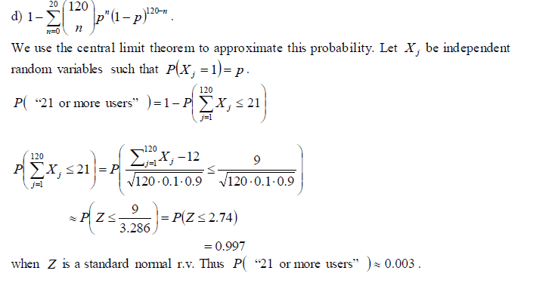

P(“21 or more users”) = 1-P($\sum_{j=1}^{120}{X_{j}≤20}$)

Then, P($\sum_{j=1}^{120}{X_{j}≤20}$) $≈P\left(Z≤\frac{8}{3.286}\right)=P\left(Z≤2.43\right)=0.9925$

P(“21 or more users”) =0.0075 , which is approximately equal to the answer calculated by series.