ETHICAL HACKING ESSENTIALS
Task 3: Beginner CTF Write-Up
Platform: CyLab Security Academy – “Irish Name Repo Series” Learning Path

Field | Detail
Prepared By | Chisom (@Chisom)
Engagement Type | Beginner-friendly CTF-style learning path (authorized practice platform)
Platform | CyLab Security Academy (learn.cylabacademy.org)
Learning Path | Irish Name Repo Series – 3 challenges, 9,902 total community completions
Challenges Completed | Irish-Name-Repo 1, Irish-Name-Repo 2, Irish-Name-Repo 3 (3/3 – Learning Path Completed)
Challenge Category | Web Exploitation – SQL Injection / Authentication Bypass
Difficulty Breakdown | 0 Easy, 3 Medium, 0 Hard (per platform challenge-completion stats)
Date Completed | Week of 5–11 October 2026 (platform activity log)
Tools Used | Web browser; Browser Developer Tools (Inspector); manual SQL injection; manual ROT13 / encoding analysis

1. Executive Summary
This report documents the completion of Task 3 of the Ethical Hacking Essentials internship program: a beginner-friendly Capture The Flag (CTF) exercise. The “Irish Name Repo Series” learning path on CyLab Security Academy was selected, consisting of three progressively more difficult web-exploitation challenges (Irish-Name-Repo 1, 2, and 3). All three challenges were completed, exceeding the task's requirement of a single beginner-friendly CTF challenge.
Each challenge presented a login form protected by a backend SQL query, and the objective in every case was to bypass authentication without valid credentials by manipulating the query through SQL injection. The series was designed to escalate in difficulty: the first challenge was a straightforward, unfiltered SQL injection; the second introduced basic input filtering on the password field, requiring the injection to be moved to the username field using an SQL comment; and the third introduced a ROT13 encoding layer on the password, requiring the encoding to be reverse-engineered via the browser's developer tools before a working payload could be constructed.
All three flags were captured and the learning path was marked “Completed” on the platform (screenshot evidence in Section 3). This write-up covers the tools used, the reasoning applied to each challenge, the technique behind each bypass, the real-world impact of the underlying flaw, and the concept each challenge was designed to teach.

2. Objectives
- Complete at least one beginner-friendly Capture The Flag challenge on a recognized training platform.
- Document the tools used and the thought process followed from first encountering each challenge to capturing its flag.
- Reflect on the underlying security concept each challenge was designed to test.
- Where relevant, relate the technique used to its real-world impact and appropriate remediation.

3. Platform, Scope & Evidence of Completion
The CTF challenges were completed on CyLab Security Academy (learn.cylabacademy.org), a legitimate, purpose-built security training platform. The “Irish Name Repo Series” learning path comprises three self-contained web-exploitation challenges, all centered on authentication-bypass via SQL injection, with increasing difficulty at each stage.
- Learning path: Irish Name Repo Series – 3 challenges, 9,902 total completions platform-wide.
- Challenges completed: Irish-Name-Repo 1, Irish-Name-Repo 2, Irish-Name-Repo 3 — all marked complete (3/3).
- Difficulty, per the platform's own challenge-completion statistics: 0 Easy, 3 Medium, 0 Hard.
- All activity was performed against the platform's own sandboxed challenge instances; no external or unauthorized systems were accessed.
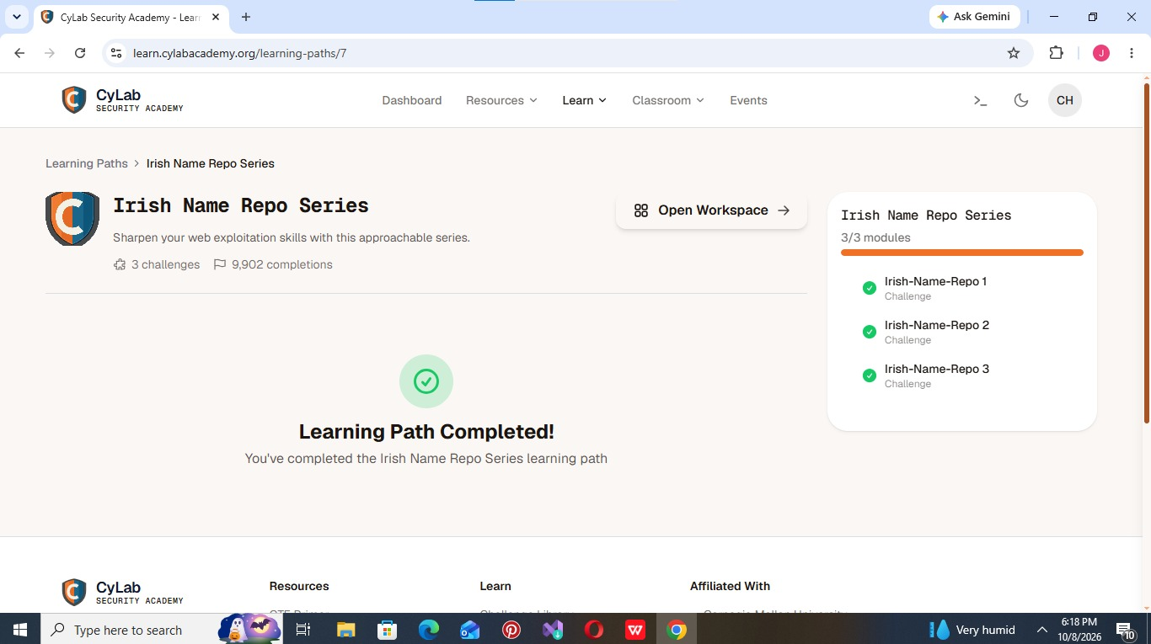
Exhibit A: CyLab Security Academy – “Irish Name Repo Series” learning path showing all 3/3 modules complete (“Learning Path Completed!”).
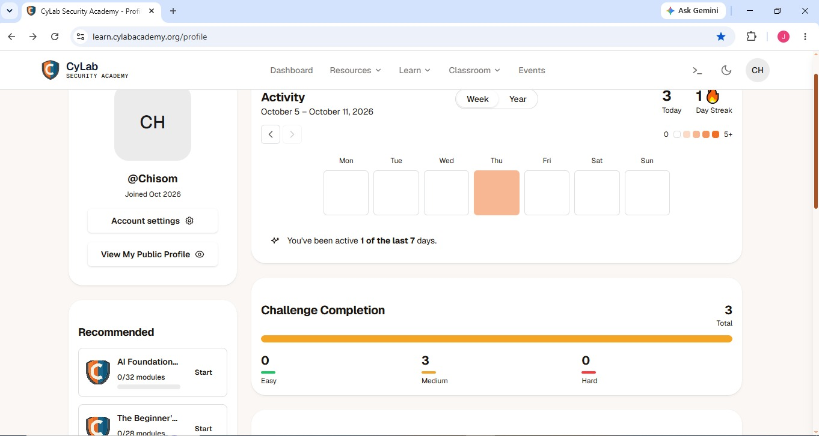
Exhibit B: Platform profile showing 3 total challenges completed, all at Medium difficulty, with recorded activity for the week of 5–11 October 2026.

4. Methodology & Walkthrough
The same general approach was applied across all three challenges: interact with the login form to understand its behavior, test how the backend query responds to special characters, and iteratively refine an injection until authentication was bypassed and the flag was revealed. Browser Developer Tools were used throughout to inspect hidden form fields and, where available, debug output. No automated tooling (e.g., Burp Suite, SQLMap) was used — every payload was constructed and tested manually, consistent with the exercise's beginner, fundamentals-first intent.

4.1 Irish-Name-Repo 1 – Classic SQL Injection Auth Bypass
Challenge: A standard administrator login form backed by a SQL query with no input sanitization.
Approach: An initial SQL injection attempt was submitted into the login fields to test how the application handled special characters such as a single quote ('). This produced a database error, confirming the input was being concatenated directly into the backend SQL query rather than being parameterized or escaped.
Technique Used: A classic SQL-injection auth-bypass pattern was then placed in the password field — a condition such as ' OR '1'='1 designed to make the query's authentication check always evaluate as true, regardless of the actual password stored in the database.
Key Realization: The login query was vulnerable to SQL injection: by manipulating the password input, the WHERE clause's logical condition could be forced to always evaluate true, causing the database to treat the login as valid.
Result: The authentication check was bypassed and the application granted administrator access, revealing the challenge flag (captured and verified; redacted in this report per standard CTF write-up practice).

4.2 Irish-Name-Repo 2 – SQL Injection with Password-Field Filtering
Challenge: The same style of login form, but the password field now applies basic filtering intended to block the simple payload that worked in Repo 1.
Approach: Re-using the Repo 1 payload in the password field failed, confirming that some form of input filtering or sanitization had been added there. Attention was shifted to the username field instead, reasoning that if only the password field was filtered, the username field might still be unsanitized.
Technique Used: An SQL comment sequence (e.g., -- or #) was appended after a valid-looking username in the username field, of the general form admin'-- . Because SQL treats everything after a comment marker as ignored, this had the effect of truncating the query before the password check was ever evaluated.
Key Realization: SQL comment syntax can be used to surgically remove an entire clause from a vulnerable query — here, the password check — so that filtering applied to one field (password) becomes irrelevant if a different field (username) is still unsanitized.
Result: The password check was effectively bypassed entirely, granting access and revealing the flag for this stage.

4.3 Irish-Name-Repo 3 – SQL Injection Through ROT13 Encoding
Challenge: A login form where the password value is passed through a ROT13 transformation before being used in the backend SQL query — meaning a plain SQL injection payload would also be “scrambled” by ROT13 and would no longer be valid SQL by the time it reached the database.
Approach: The page contained a hidden debug field set to 0. Using Browser Developer Tools (Inspector), this value was changed to 1, which caused the application to reveal the raw SQL query it was constructing — a deliberate debug feature that became the key to solving the challenge.
Technique Used: With the real query visible, the alphabet was submitted as a test password to observe how each character was being transformed. Comparing the input against the revealed output showed a consistent letter-shift pattern, which was identified as ROT13 (each letter replaced by the letter 13 positions after it in the alphabet).
Key Realization: Because the application applies ROT13 to the password before using it in the query, a normal SQL injection payload would be scrambled into meaningless text. The injection therefore had to be pre-encoded in ROT13 itself, so that after the application's own ROT13 transformation was applied, it would decode back into valid, working SQL syntax (e.g., supplying the ROT13 equivalent of a string like OR '1'='1 rather than the plain-text version, with spacing adjusted to survive the round-trip correctly).
Result: After adjusting the payload's encoding and spacing to survive the ROT13 round-trip, the authentication check was bypassed and the final flag in the series was revealed, completing the learning path.

5. Concepts Tested & Reflection
Challenge | Main Concept | What It Demonstrated
Irish-Name-Repo 1 | SQL Injection | Manipulating SQL input to bypass authentication via an always-true condition.
Irish-Name-Repo 2 | SQL Injection + Auth Bypass via Comments | Using SQL comment syntax to bypass a password check even when that field is filtered.
Irish-Name-Repo 3 | SQL Injection + Weak Encoding/Obfuscation | Identifying a ROT13 transformation via debug output and crafting an injection that survives it.

Taken together, the series illustrates a single root cause — unsanitized, directly concatenated SQL queries — expressed in three increasingly disguised forms. Repo 1 showed the vulnerability in its plainest form. Repo 2 showed that partial, field-specific filtering is not a fix if any other input path into the same query remains unsanitized. Repo 3 showed that custom encoding schemes (like ROT13) are not a substitute for real input validation or parameterized queries — they only obscure the vulnerability rather than remove it, and can usually be reverse-engineered once an attacker can observe the application's own debug or error output.

6. Real-World Impact
Although these were sandboxed training challenges, the underlying flaw — SQL injection in a login form — is one of the most consistently damaging vulnerability classes found in real-world web applications. If a production authentication system were vulnerable in the same way:
- An attacker could log in as any user, including an administrator, without ever knowing a valid password — a complete authentication bypass.
- The same injection point could often be extended (e.g., via UNION-based injection) to read arbitrary data from other database tables, such as other users' personal information, payment details, or password hashes.
- Debug features left enabled in production — as deliberately illustrated in Repo 3 — can hand an attacker the exact query structure needed to craft a working exploit, turning a theoretical weakness into a trivial one.
- Relying on obfuscation (such as ROT13 or other “security by obscurity” techniques) instead of genuine input validation gives a false sense of protection, since such schemes are typically reversible with modest effort.

7. Recommendations (Remediation)
- Use parameterized queries or prepared statements for all authentication and database-access code, so user input is never concatenated directly into SQL syntax.
- Apply consistent server-side input validation across every field that feeds into a query — filtering one field (e.g., password) while leaving another (e.g., username) unsanitized provides no real protection, as Repo 2 demonstrated.
- Never rely on custom encoding (ROT13 or similar) as a security control; use proper password hashing (e.g., bcrypt/Argon2) and parameterized queries instead.
- Disable debug flags, verbose error messages, and raw query output in any publicly reachable environment — this information materially shortens the path to a working exploit, as seen in Repo 3.
- Apply the principle of least privilege to database accounts used by web applications, to limit the damage a successful injection can still cause.

8. Conclusion
Task 3 was completed by solving all three challenges in the CyLab Security Academy “Irish Name Repo Series” learning path, exceeding the single-challenge minimum. Each challenge built on the last: a plain SQL injection, a filtered field bypassed via SQL comments, and an encoded field bypassed by reverse-engineering a ROT13 transformation from the application's own debug output. Together, they reinforced that authentication logic is only as strong as its weakest unsanitized input, and that obfuscation is never an adequate substitute for genuine input validation and parameterized queries. This closes out the hands-on component of the Ethical Hacking Essentials program, complementing the reconnaissance work in Task 1 and the exploitation work in Task 2.

9. Flag Disclosure Note
In line with standard CTF write-up practice, the literal flag strings captured for each challenge have been omitted/redacted from this report. All three flags were successfully captured and verified on the platform, as evidenced by the “Learning Path Completed” status and 3/3 challenge completion shown in Exhibit A and Exhibit B above.

