ETHICAL HACKING ESSENTIALS
Task 1: Reconnaissance & Footprinting Report
Target: OWASP Juice Shop (Dockerized Lab Environment)

Field | Detail
Prepared By | Chisom (chisom@kali)
Engagement Type | Authorized internal lab reconnaissance (training exercise)
Target Application | OWASP Juice Shop (bkimminich/juice-shop) – Docker image
Target Host | 127.0.0.1 (localhost) – Docker container "juice-shop"
Target Port / Service | TCP 3000 – HTTP (Node.js / Express application)
Attacking Platform | Kali Linux 2026.3.2 (rolling)
Date of Assessment | 07 October 2026
Tools Used | Docker, Nmap 7.99, Mozilla Firefox, Bash/Shell

1. Executive Summary
This report documents the passive and active reconnaissance and footprinting activities performed against a designated lab target, OWASP Juice Shop, deployed locally via Docker on a Kali Linux attacking machine. The exercise forms Task 1 of the Ethical Hacking Essentials internship program and was conducted strictly within an isolated, self-hosted lab environment with explicit authorization, in line with OWASP Juice Shop's intended purpose as a legal practice application.
The objective was to identify the attack surface of the target — open ports, running services, underlying technologies, and any information inadvertently disclosed by the application — using the same methodology a security analyst would apply during the information-gathering phase of a penetration test. Reconnaissance was carried out in two stages: environment/service setup and verification (treated as passive groundwork), followed by active scanning with Nmap and direct application review in a browser.
Key findings include one exposed TCP service (port 3000) hosting a Node.js/Express web application with verbose HTTP response headers, a publicly accessible copyright/version banner, and a non-standard HTTP header (X-Recruiting) that discloses an internal application route. These findings, while expected for a deliberately vulnerable training application, mirror the type of information-disclosure weaknesses that a real-world attacker would use to fingerprint and profile a production target.

2. Objectives
- Stand up a legally sanctioned, intentionally vulnerable web application (OWASP Juice Shop) inside an isolated lab environment.
- Perform active reconnaissance to enumerate open ports, running services, and service versions on the target host.
- Identify the technologies, frameworks, and configuration details exposed by the target application.
- Document all findings in a structured format consistent with professional security-assessment reporting standards.
- Lay the groundwork for subsequent exploitation and remediation tasks (Tasks 2 and 3 of the program).

3. Scope
The assessment was limited to the following in-scope asset, with no external or third-party systems touched at any point:
- Host: 127.0.0.1 (localhost) on the assessor's own Kali Linux virtual machine.
- Application/Container: “juice-shop” Docker container built from the official bkimminich/juice-shop image, exposed on TCP port 3000.
- Testing window: single session on 07 October 2026, approximately 06:58 – 07:29 (local system clock).
All activity was performed against a self-deployed instance; no production or third-party infrastructure was scanned or accessed.

4. Methodology
The engagement followed a standard reconnaissance workflow: environment preparation, service deployment/verification, active port and service scanning, and manual application review. Each phase and its corresponding commands are detailed below.

4.1 Environment Preparation
The Kali Linux system package index was refreshed and Docker was installed to host the vulnerable target application:
$ sudo apt update
$ docker --version # confirmed Docker was not yet installed
$ sudo apt install docker.io -y
Docker Engine, containerd, runc and supporting dependencies (docker.io 28.5.2, containerd 2.1.9, runc 1.3.6, criu 4.2.1-1) were installed successfully. The Docker service was then enabled and verified as active and running:
$ sudo systemctl enable --now docker
$ sudo systemctl status docker
Output confirmed: “Active: active (running)”, with the Docker API listening on /run/docker.sock and the daemon reporting successful initialization — establishing a stable container runtime for the lab target.

4.2 Target Deployment (Passive Setup)
The official OWASP Juice Shop image was pulled from Docker Hub and instantiated as a detached container, mapping container port 3000 to host port 3000:
$ sudo docker pull bkimminich/juice-shop
$ sudo docker run -d --name juice-shop -p 3000:3000 bkimminich/juice-shop
$ sudo docker ps
The docker ps output confirmed the container (ID 20e7a9e950d3) was “Up” and healthy, with port mapping 0.0.0.0:3000→3000/tcp and [::]:3000→3000/tcp, under the name juice-shop.

4.3 Active Reconnaissance – Port & Service Scanning
Nmap was used to perform active service and version detection against the loopback target:
$ nmap -sV -p- 127.0.0.1
Initial scan results showed all 65,533 scanned TCP ports closed with one host up, except for two unrecognized services returned without a confident version match, prompting a focused, script-assisted re-scan:
$ nmap -sC -sV -p 3000 127.0.0.1
The follow-up scan returned a complete HTTP fingerprint for port 3000, summarized in the table below.
Port / Proto | State | Service | Details
3000/tcp | open | http | Golang net/http server (initial automated guess) – confirmed on manual review to be a Node.js/Express application (OWASP Juice Shop)

Nmap's NSE HTTP scripts (-sC) captured the full response headers returned by the web server, which were reviewed for information disclosure:
HTTP Header | Value
HTTP/1.1 | 200 OK
Access-Control-Allow-Origin | *
X-Content-Type-Options | nosniff
X-Frame-Options | SAMEORIGIN
Feature-Policy | payment 'self'
X-Recruiting | /#/jobs
Accept-Ranges | bytes
Cache-Control | public, max-age=0
Last-Modified | Wed, 07 Oct 2026 11:06:08 GMT
ETag | W/"24b1-1a1160acbe3"
Content-Type | text/html; charset=UTF-8
Content-Length | 9393

4.4 Application-Layer Footprinting (Manual Review)
The raw HTML response body returned alongside the Nmap fingerprint, and a direct Firefox browser session to http://localhost:3000/, were reviewed to extract technology and versioning clues:
- Page <title>: “OWASP Juice Shop”
- Meta description: “Probably the most modern and sophisticated insecure web application” (a self-disclosed hint that the target is intentionally vulnerable)
- Embedded copyright banner: “Copyright (c) 2014-2026 Bjoern Kimminich & the OWASP Juice Shop contributors”
- SPDX-License-Identifier: MIT (disclosed directly in the HTML source)
- Viewport meta tag and markup style indicative of a modern single-page application (SPA) front end, consistent with Juice Shop's known Angular-based client
- Storefront confirmed functional in-browser: product catalog (e.g., Apple Juice, Apple Pomace, Banana Juice), account/login menu, shopping basket, and language selector all rendered correctly, confirming the application was fully operational for subsequent exploitation tasks.

5. Findings Summary
# | Finding | Risk Rating | Description
1 | Single exposed service on non-standard port | Informational | Only TCP/3000 (HTTP) is reachable; no other listening ports were discovered on the host during the full-range scan.
2 | Verbose HTTP response headers | Low | Headers such as ETag, Last-Modified, and Content-Length reveal internal application state and could assist an attacker in cache-based or timing-based profiling.
3 | Custom header discloses hidden route (X-Recruiting) | Low | The X-Recruiting: /#/jobs header exposes an application path not otherwise linked from the main navigation, expanding the discoverable attack surface.
4 | Permissive CORS policy | Medium | Access-Control-Allow-Origin: * permits cross-origin requests from any domain, which can increase exposure to client-side attacks if sensitive endpoints are later identified.
5 | Technology stack identifiable from markup/banners | Low | Copyright banner, SPDX license tag, and SPA-style markup allow quick identification of the application (Juice Shop) and its open-source codebase, enabling an attacker to pull public vulnerability data for it.

6. Recommendations
- Restrict Access-Control-Allow-Origin to a defined allow-list of trusted origins instead of a wildcard (*).
- Remove or rename non-standard, informational headers (e.g., X-Recruiting) in production builds so internal routes are not advertised to unauthenticated scanners.
- Suppress or genericize server banners, ETags, and Last-Modified values where they are not operationally required, to reduce fingerprinting surface.
- Apply the principle of least exposure: only the ports and services strictly required for the application to function should be bound to externally reachable interfaces.
- Keep the underlying framework and dependencies patched, since the identifiable technology stack allows attackers to quickly cross-reference known CVEs.

7. Conclusion
The reconnaissance and footprinting phase successfully identified the target's single exposed attack surface (TCP/3000, an HTTP/Node.js application), enumerated its HTTP-layer configuration, and extracted technology and versioning artifacts through both automated (Nmap NSE) and manual (browser-based) review. No intrusive or exploitative actions were taken at this stage; all activity was limited to information gathering, consistent with the passive/active reconnaissance phase of the penetration-testing lifecycle. These findings establish the baseline attack surface that will be carried forward into Task 2 (Exploit a Vulnerable Web App).

8. Appendix – Evidence Screenshots
The following terminal and browser screenshots, captured live during the session, provide direct evidence for the methodology and findings documented in this report.

Exhibit A – Kali Update & Docker Installation
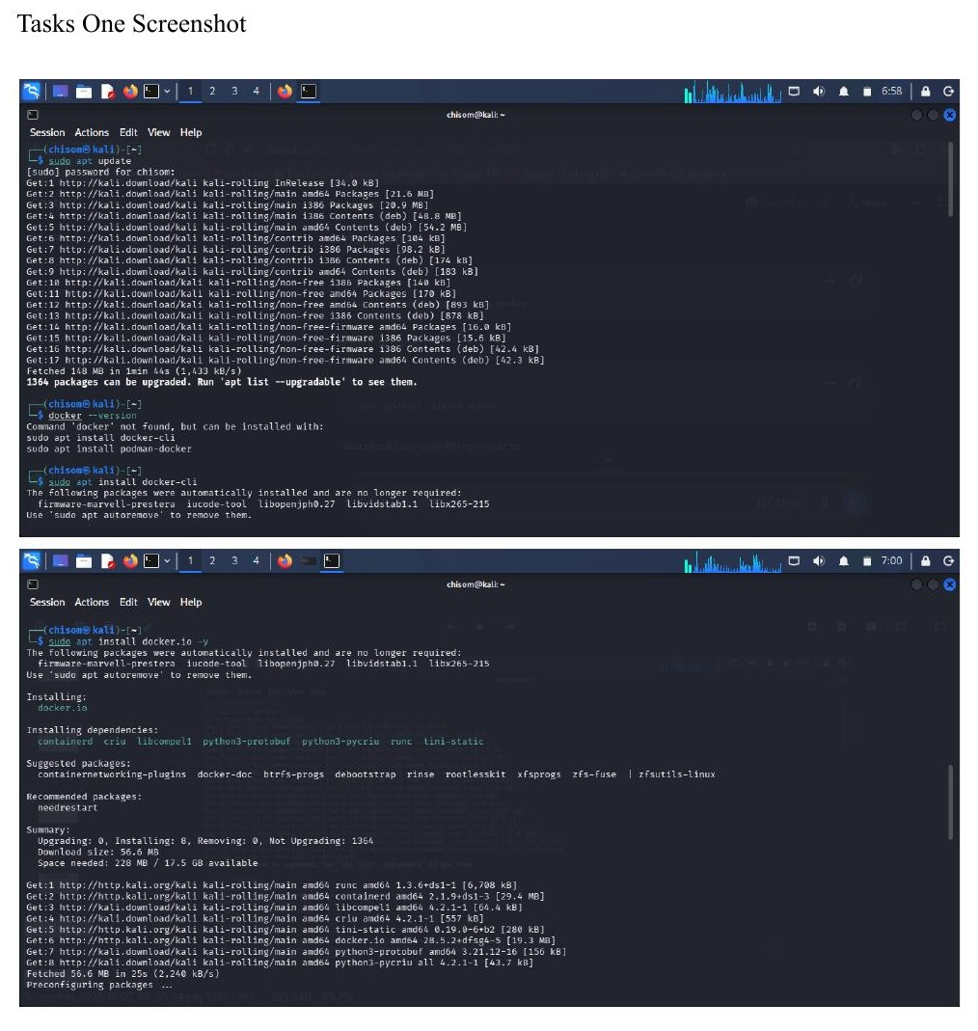
Exhibit A: ‘sudo apt update’ and ‘sudo apt install docker.io -y’ – system refreshed and Docker Engine installed.

Exhibit B – Docker Service Enabled & Verified Active
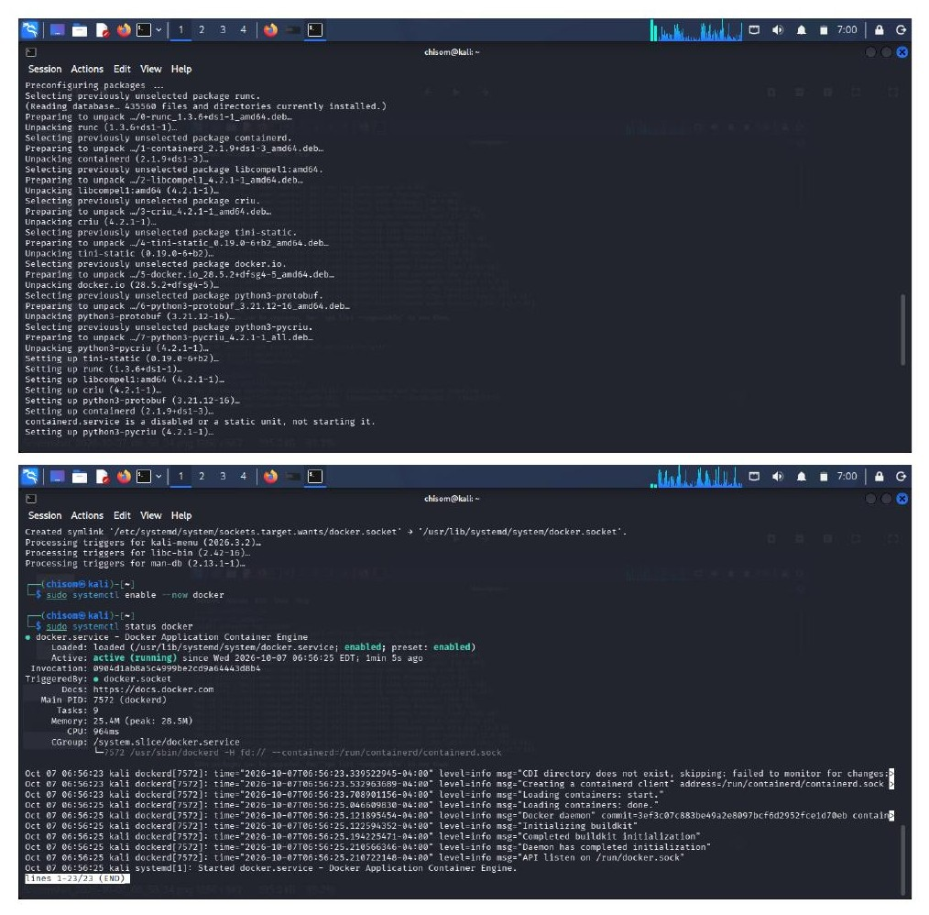
Exhibit B: Docker package unpacking/configuration completes; ‘systemctl enable --now docker’ and ‘systemctl status docker’ confirm the engine is active (running).

Exhibit C – Juice Shop Deployment & Initial Nmap Scan
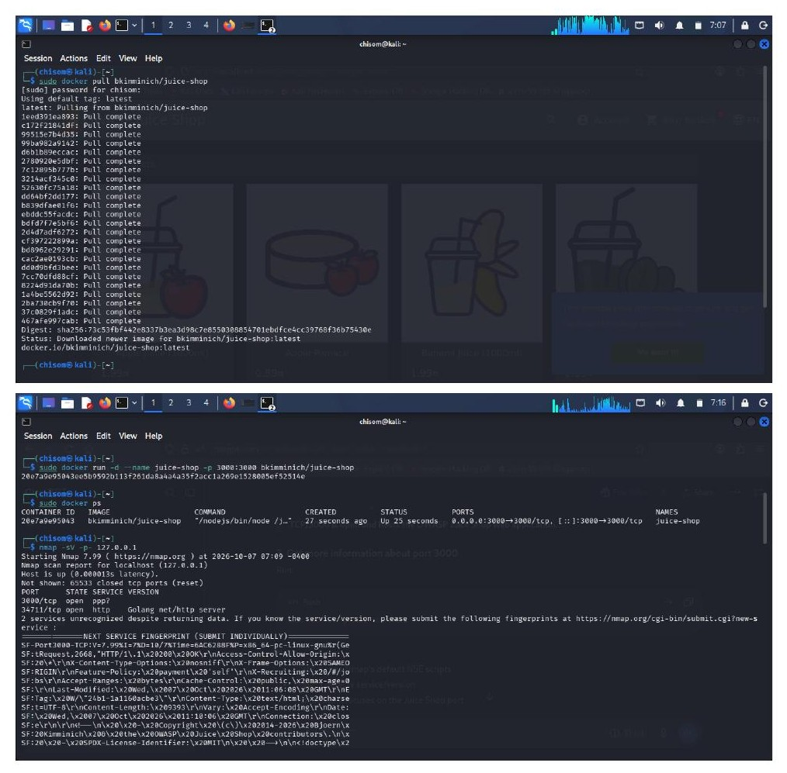
Exhibit C: ‘docker pull bkimminich/juice-shop’, container start (‘docker run’/‘docker ps’), and the initial ‘nmap -sV’ scan identifying port 3000 open.

Exhibit D – Targeted Nmap Service-Script Scan (Part 1)
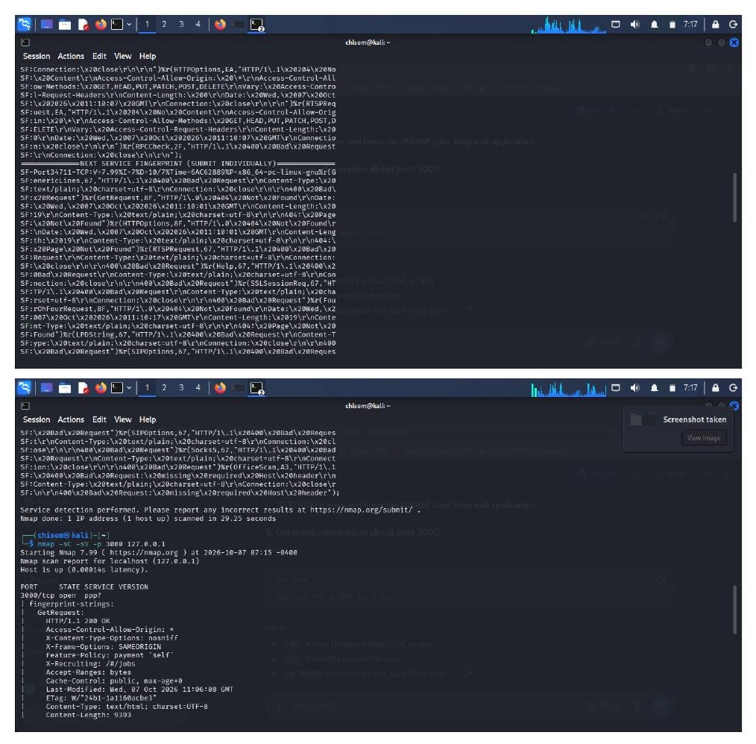
Exhibit D: ‘nmap -sC -sV -p 3000’ output capturing the beginning of the HTTP service fingerprint and response headers.

Exhibit E – Targeted Nmap Service-Script Scan (Part 2 – Full HTTP Fingerprint)
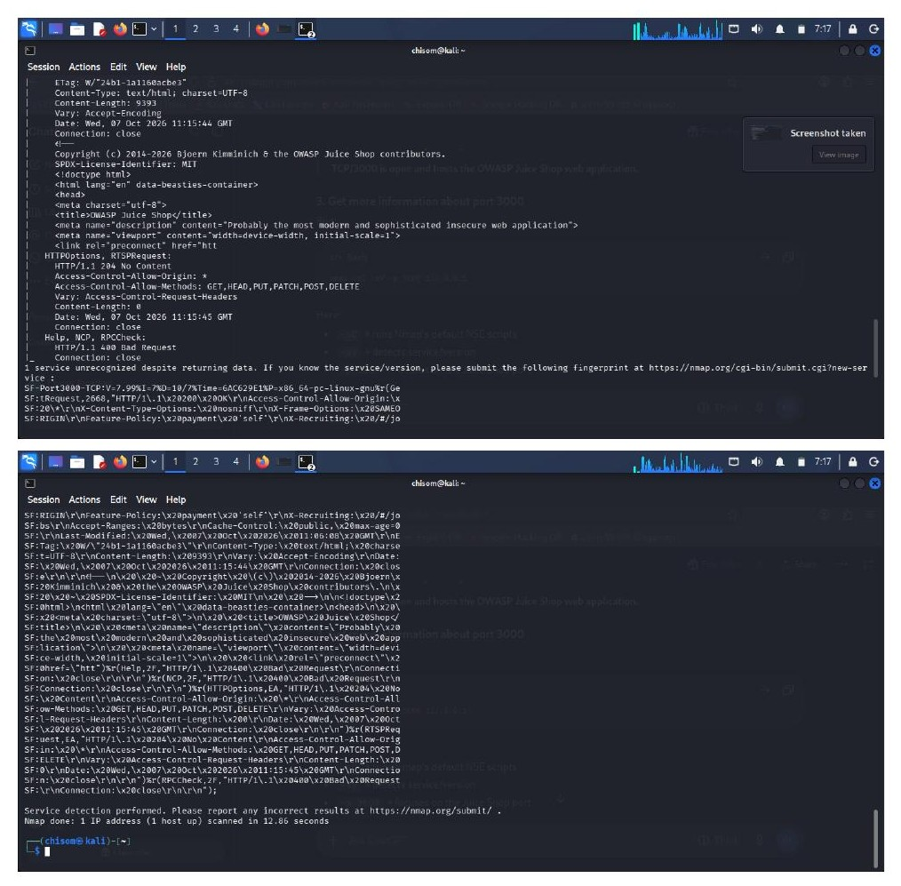
Exhibit E: Completed HTTP fingerprint, including HTML banner, license identifier, and full response header set; scan completed in 12.86 seconds.

Exhibit F – Live Application Verification (Browser)
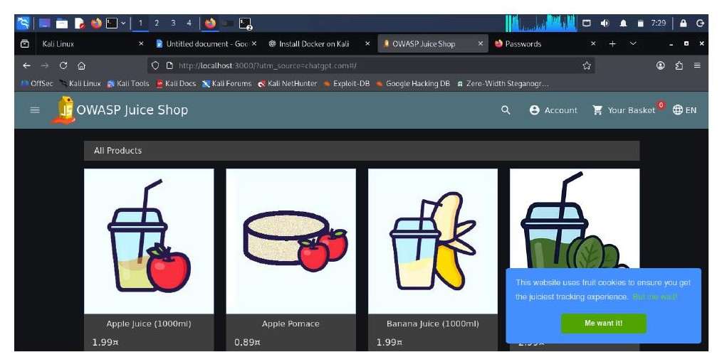
Exhibit F: OWASP Juice Shop storefront rendering correctly at http://localhost:3000, confirming the target application is fully operational.

