Accordion меню

<https://habrahabr.ru/post/174029/>

<https://www.w3schools.com/howto/howto_js_accordion.asp>

<https://designmodo.com/css3-accordion-menu/>

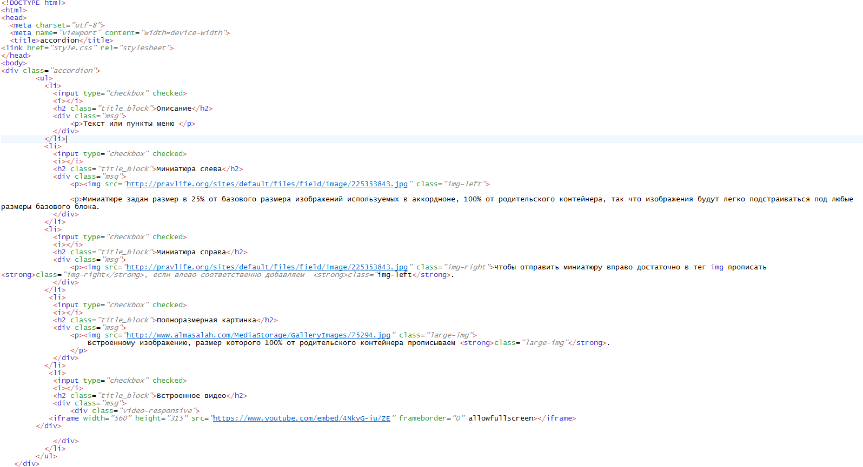



CSS

