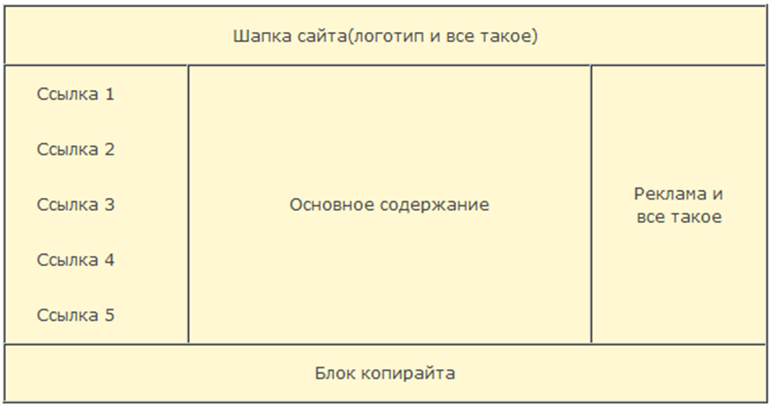

http://ru.html.net/tutorials/html/lesson8.php