Homework

1. <http://d99796fq.beget.tech/2018/03/13/blini/>

https://search.google.com/structured-data/testing-tool#url=http%3A%2F%2Fd99796fq.beget.tech%2F2018%2F03%2F13%2Fblini%2F

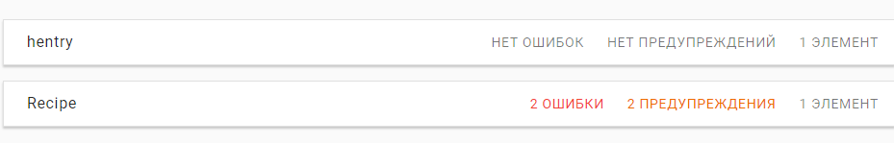

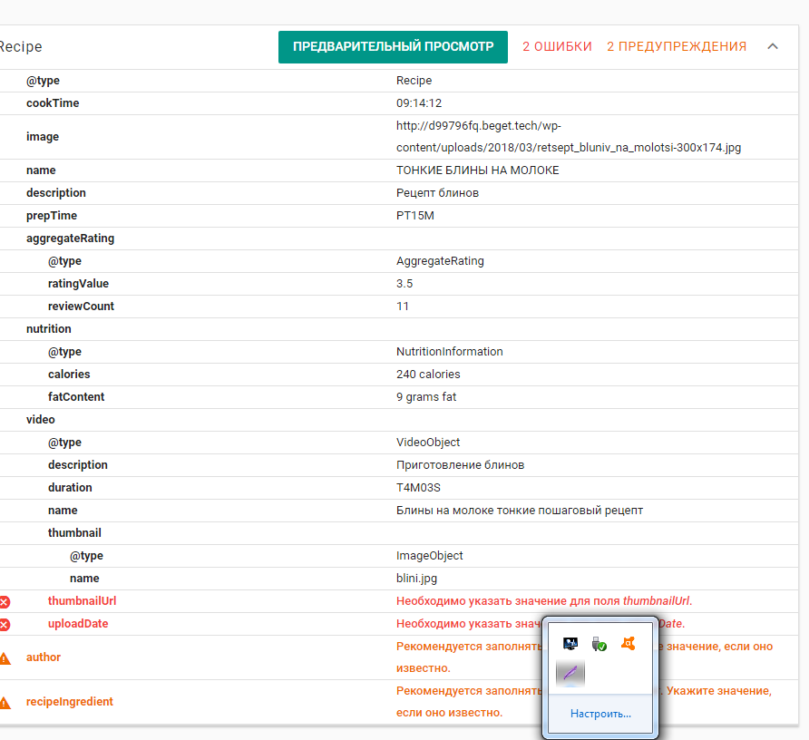

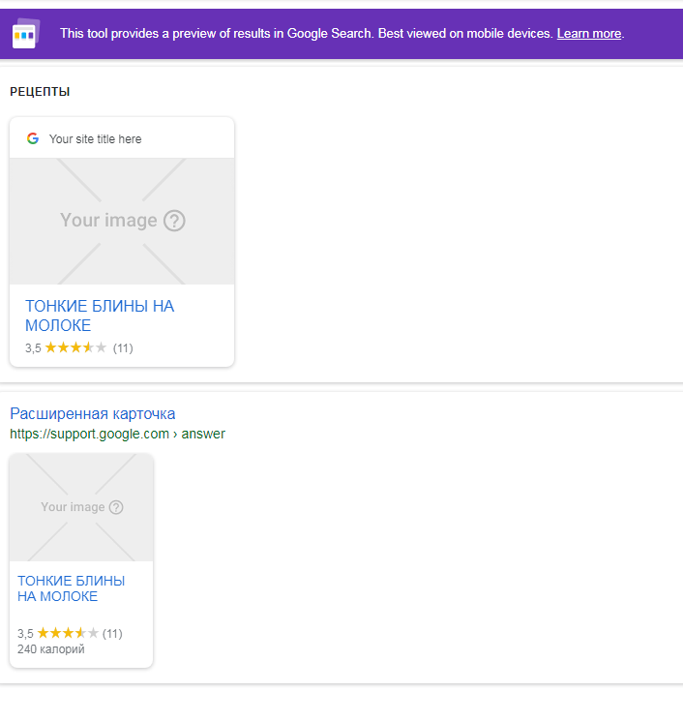

1. <http://d99796fq.beget.tech/2018/03/13/forum/>

https://search.google.com/structured-data/testing-tool#url=http%3A%2F%2Fd99796fq.beget.tech%2F2018%2F03%2F13%2Fforum%2F

