**Paper Adventure**

**Create by**

**6131009621 Chayanan Kludkhamthong**

**2110215 Programming Methodology**

**Semester 1 year 2019**

**Chulalongkorn University**

**Introduction**

Paper adventure is a rpg game.You will become an adventurer . At the beginning you will be a novice clear stage to gain exp and level up to become stronger . once you clear one stage it will unlock next stage which have a stronger enemy and more exp you will receive. Once your level reach level 5 you can change the job .Swordman the tanker come with high Hp and defense ,Mage high intelligent and have the most powerful skill , Archer with high Attack and it is the only job that can draw Critical damage by using skill is one of the interesting job .you can change to these three jobs and clear the game. But be careful if you died you will lose Exp .

**Main menu**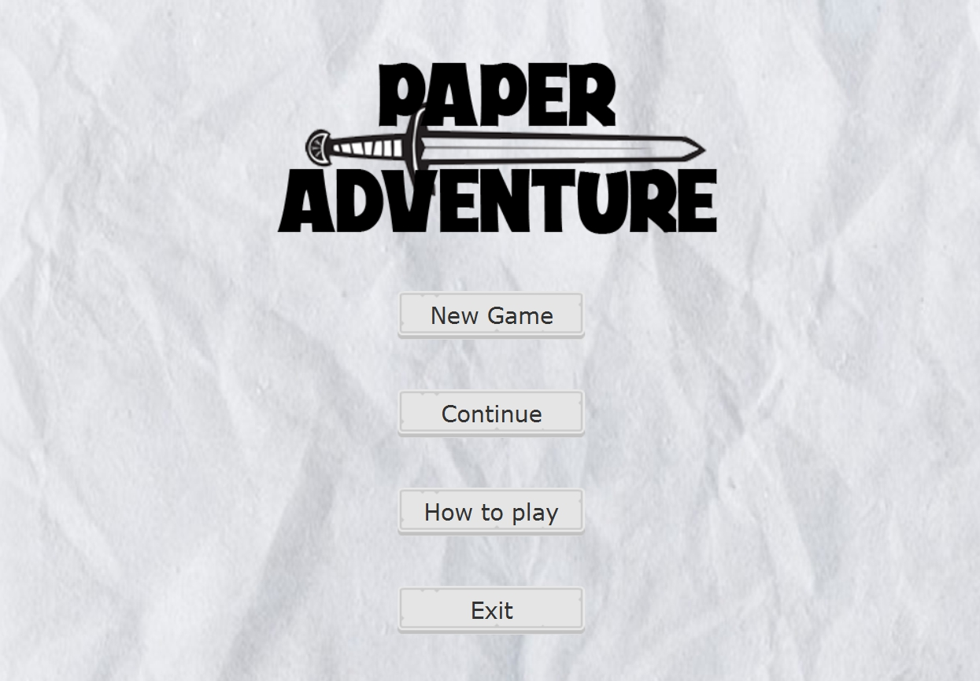

**How to play sub scene** (appear when click how to play button)

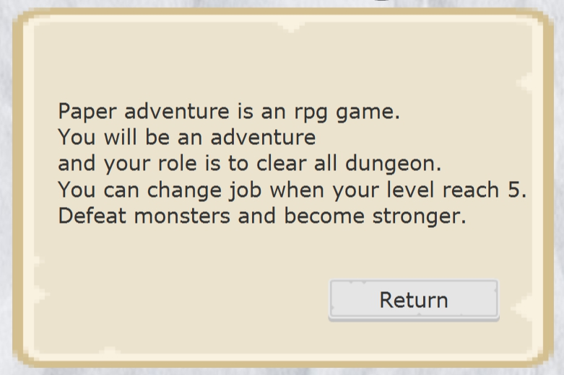

**Name Input sub scene** (appear when click New Game Button)

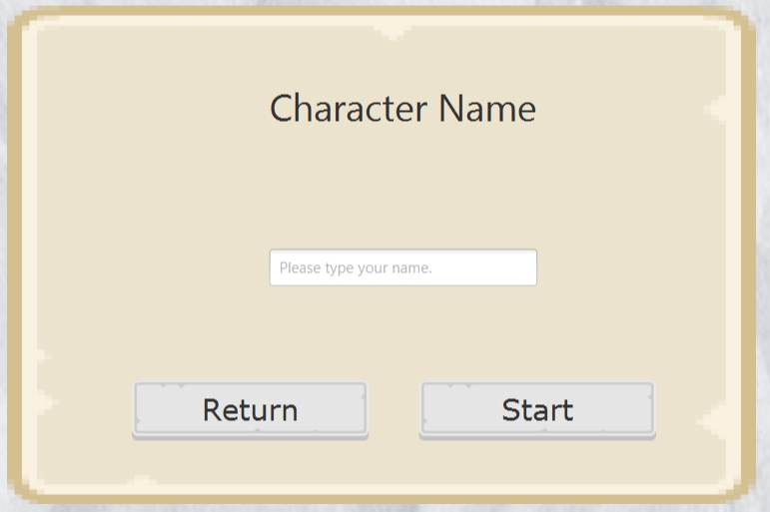

**Alert when name is empty**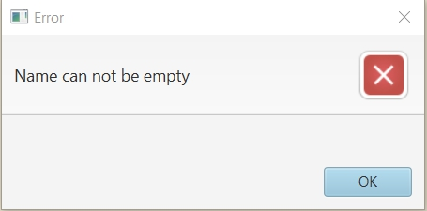

**Alert when name length is more than 8**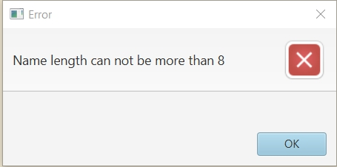

**Game scene**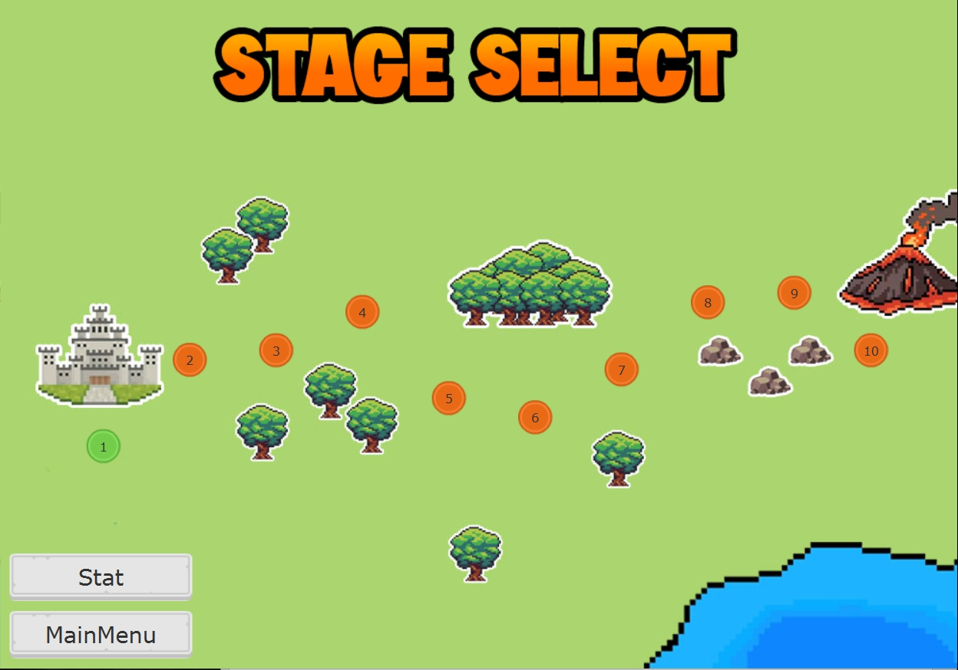

**Stat scene**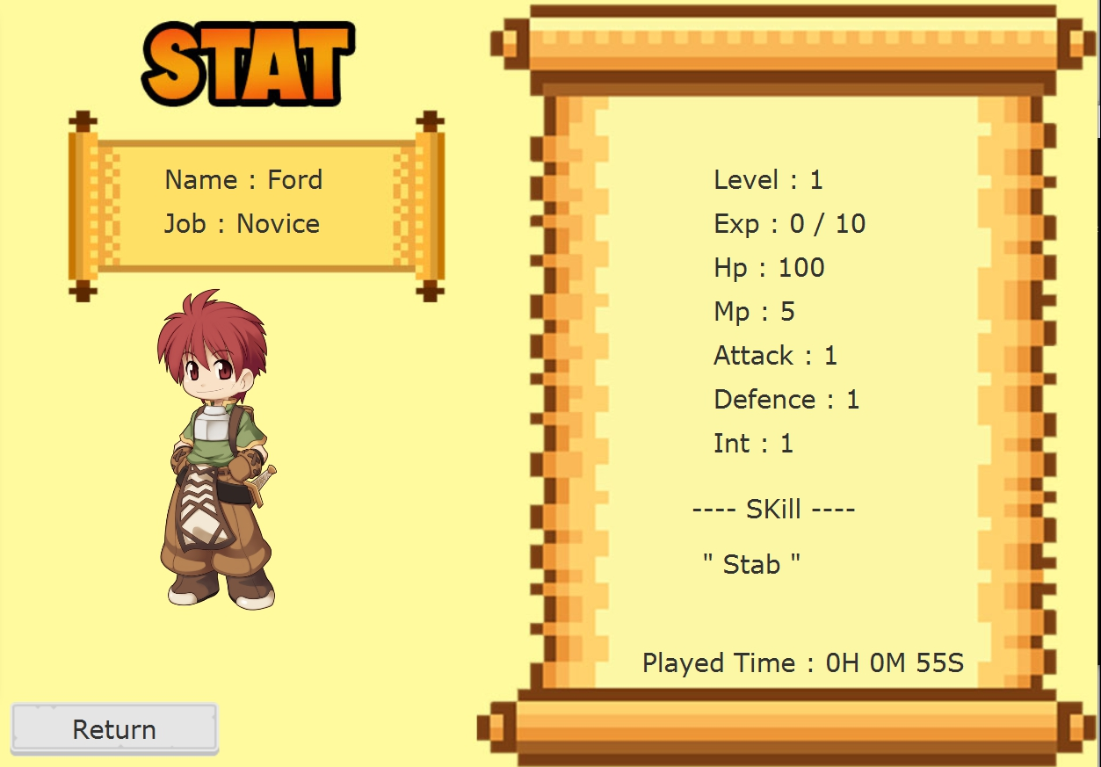

**Stage scene**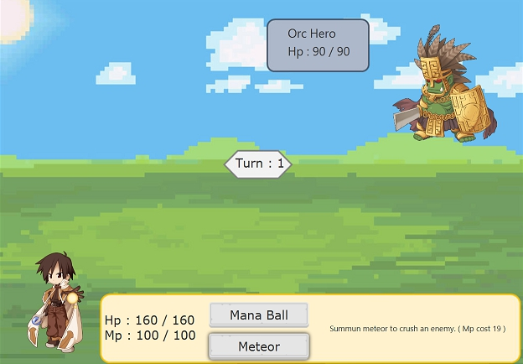

**Alert when not have enough Mp to use second skill**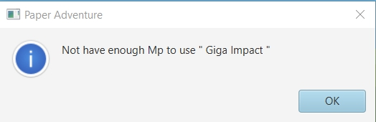

**Alert when win the stage**

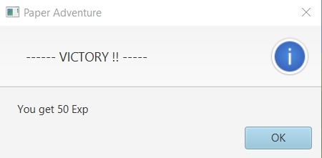

**Alert when lose the stage**

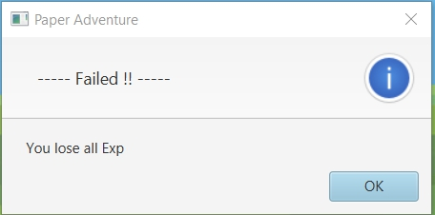

**Job selection sub scene**

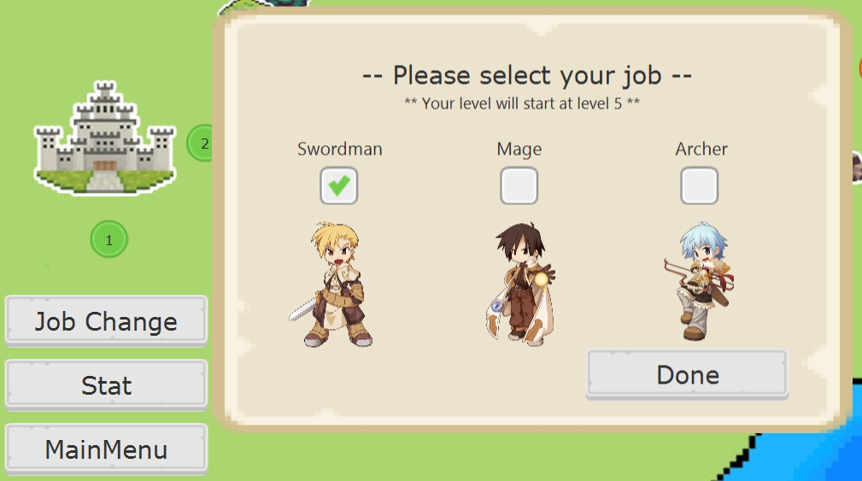

**Confirm alert** (after press “done” )



**UML (1)**

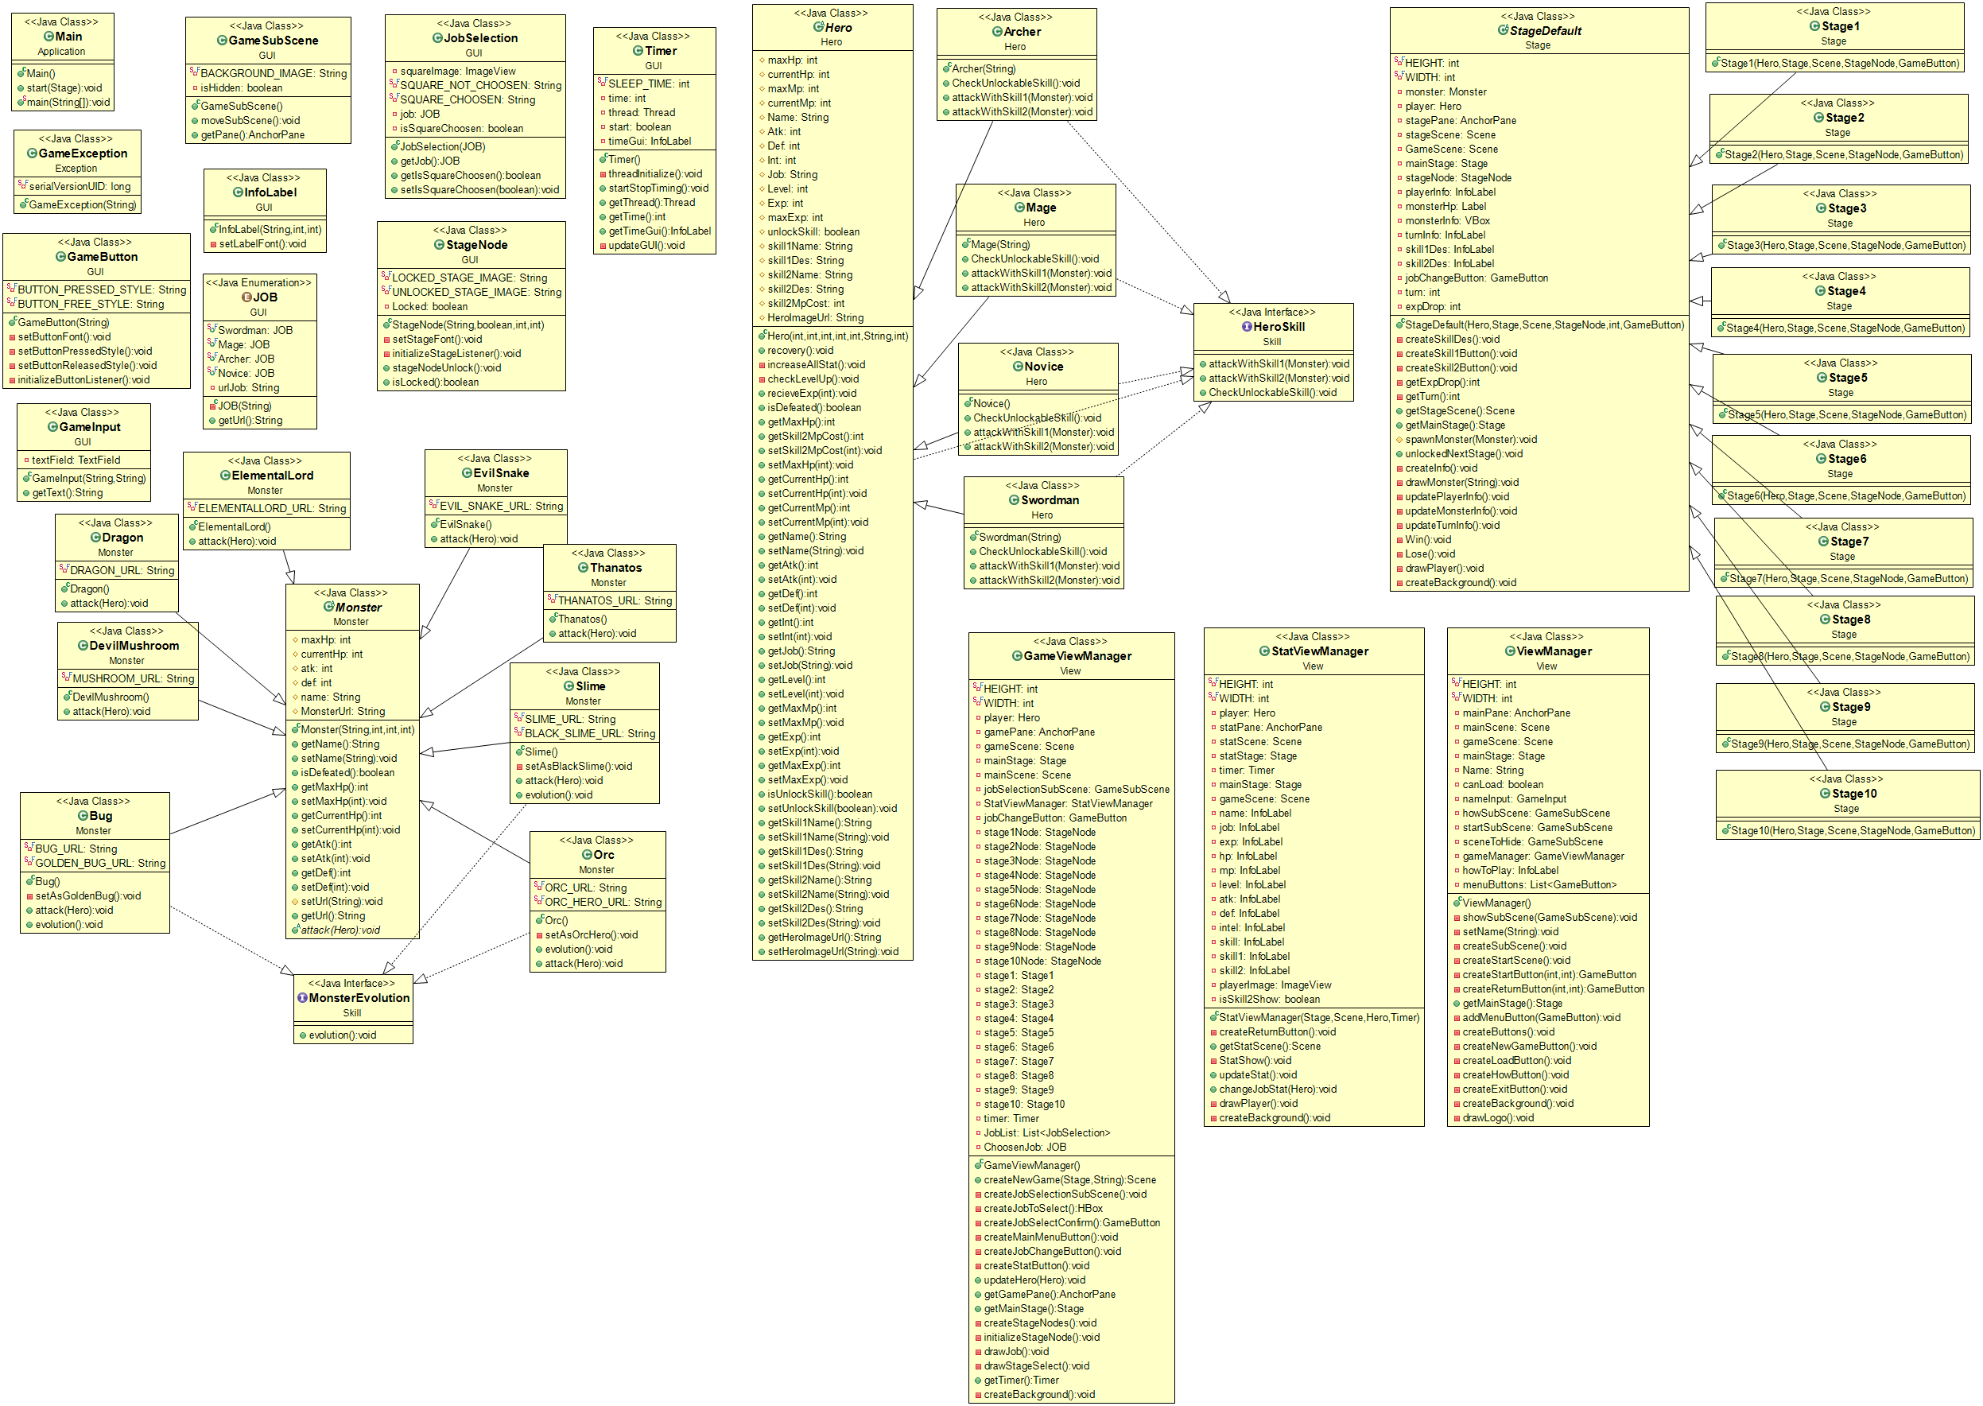

**UML (2)**

1. **Package Application**
   1. **Class :** Main extends Application

1.1.1 Method

|  |  |
| --- | --- |
| + void start (Stage primaryStage) | - Initialize ViewManager and set it as primaryStage  - set primaryStage title to “Paper Adventure”. |
| + void main(String[] args) | An entry point of application. |

1. **Package Exception**

**2.1 Class :** GameException extends Exception

2.1.1 Field

|  |  |
| --- | --- |
| - long serialVersionUID | serialVersionUID = 1L |

2.1.2 constructor

|  |  |
| --- | --- |
| + GameException(String message) | Initialize message |

**3. Package GUI**

**3.1 Class :** GameButton extends Button

3.1.1 Field

|  |  |
| --- | --- |
| - String BUTTON_PRESSED_STYLE | String path for pressed button image  and background effect to transparent |
| - String BUTTON_FREE_STYLE | String path for unpressed button  image and background effect to  transparent |

3.1.2 Constructor

|  |  |
| --- | --- |
| + GameButton(String text) | - Set button text as text.  - Set font style by setButtonFont().  - Set width to 190 and height to 49.  - Set style as BUTTON_FREE_STYLE.  - Initialize button listenner by  initializeButoonListeners() |

3.1.3 Method

|  |  |
| --- | --- |
| - void setButtonFont() | Set font as “Verdana” font and set font size to 23 |
| - void setButtonPressedStyle() | - Set style of button to  BUTTON_PRESSED_STYLE.  - Set button height to 45.  - Change the position in Y coordinate  downward by 4 |
| - void setButtonReleasedStyle | - Set style of button to  BUTTON_PRESSED_STYLE.  - Set button height to 49.  - Change the position in Y coordinate  upward by 4 |
| - void initializeButtonListeners() | - Set primary mouse pressed event to  set button pressed style.  - Set primary mouse released event to  set button released style.  - Set enter mouse event to set drop  shadow effect to button.  - Set mouse exited event to remove  button drop shadow effect |

**3.2 Class :** GameInput extends VBox

3.2.1 Field

|  |  |
| --- | --- |
| - TextField textField | TextField for receiving the input |

3.2.2 Constructor

|  |  |
| --- | --- |
| + GameInput  ( String title, String promptText ) | Initializes the InputField (not to be confused with TextField).  - Sets the inset padding of 10  - Sets the spacing of the InputField to 90  - Instantiates a Label and a TextField:  Instantiated Label have an appropriate text with font size 30  - Set PromptTex  - Set textField height to 30  - Set Layout x to 200  - Set Layout Y to 50  - Adds a label and an inputTextField to the InputField as a children. |

3.2.3 Method

|  |  |
| --- | --- |
| + String getText() | Getter for current text in inputTextField text should be trimmed using trim() method |

**3.3 Class :** GameSubScene extends SubScene

3.3.1 Field

|  |  |
| --- | --- |
| - String BACKGROUND_IMAGE | String path for Background image |
| - Boolean isHidden | Status of subscene |

3.3.2 Constructor

|  |  |
| --- | --- |
| + GameSubScene() | - Create AnchorPane() with width = 600 and height = 400 as root  - Load and set background image for anchorPane.  - Set isHidden is true.  - Set layout of subscene |

3.3.3 Method

|  |  |
| --- | --- |
| + void moveSubScene() | -Create and set duration of  TranslateTransition to 0.3 second. If  isHidden is true move subscene out.  Else move subsecne in to the main  scene. |
| + AnchorPane getPane() | getter of Anchor pane root |

**3.4 Class :** InfoLabel extends Label

3.4.1 Constructor

|  |  |
| --- | --- |
| + InfoLabel(String text, int X , int Y) | - Set label text as text  - Set label font using setLabelFont() method  - Set label layout x to X  - Set label layout y to Y  - Set wrapText true |

3.4.2 Method

|  |  |
| --- | --- |
| - void setLabelFont() | Set font as “Verdana” font and set font size to 23 |

**3.5 Class :** enum JOB

3.5.1 Field

|  |  |
| --- | --- |
| - String urlJob | String path for job image |

3.5.2 Constructor

|  |  |
| --- | --- |
| - JOB(String urlJob) | Initialize urlJob for each job |

3.5.3 Method

|  |  |
| --- | --- |
| + String getUrl() | Getter for String urlJob |

**3.6 Class :** JobSelection extends VBox

3.6.1 Field

|  |  |
| --- | --- |
| - ImageView squareImage | Image for select square |
| - String SQUARE_NOT_CHOOSEN | String path of select square that is not chosen |
| -String SQUARE_CHOOSEN | String path of select square that is chosen |
| - JOB job | Choosen job |
| - Boolean isSquareChoosen | Boolean of square is choosen or not |

3.6.2 Constructor

|  |  |
| --- | --- |
| + JobSelection(JOB job) | - Initialize squareImage as  SQUARE_NOT_CHOOSEN  - Initialize job  - Set isSquareChoosen to false  - Set an alignment to center  - Add squareImage to jobSelection as children |

3.6.3 Method

|  |  |
| --- | --- |
| + void setIsSquareChoosen(Boolean isSquareChoosen) | - Set boolean for isSquareChoosen.  - Set squareImage to SQUARE_CHOOSEN if  isSquareChoosen is true, if false set to  SQUARE_NOT_CHOOSEN |
| Getter | Getter for job and isSquareChoosen |

**3.7 Class :** StageNode extends Button

3.7.1 Field

|  |  |
| --- | --- |
| - String LOCKED_STAGE_IMAGE | String path for locked stage image  and background effect to transparent |
| - String UNLOCKED_STAGE_IMAGE | String path for unlocked stage image  and background effect to transparent |
| - Boolean Locked | Is current stage is locked or not |

3.7.2 Constructor

|  |  |
| --- | --- |
| + StageNode(String text,Boolean locked , int X,int Y ) | - Initialize locked  - Set button text to text  - Set height and width to 36  - Set layout x to X and layout y to Y  - Set stage font using setStageFont()  - Set style to LOCKED_STAGE_IMAGE if Locked is true and UNLOCKED_STAGE_IMAGE if Locked is false  - initialize stage listener() using initializeStageListener() |

3.7.3Method

|  |  |
| --- | --- |
| - void setStageFont() | Set font as “Verdana” font and set font size to 23 |
| - void initializeStageListener() | - if Locked = false set Glow effect when mouse entered and set effect null when mouse exited |
| + void stageNodeUnlock | - set Locked to false  -set button style to UNLOCKED_STAGE_IMAGE |
| + boolean isLocked() | Getter for Locked |

**3.8 Class :** Timer

3.8.1 Field

|  |  |
| --- | --- |
| - int SLEEP_TIME | Set to 1000 |
| - int time | Amount of time |
| - Thread thread | The thread use to run timer |
| - boolean start | Boolean control a counting |
| - InfoLabel timeGui | Label to show current time |

3.8.2 Constructor

|  |  |
| --- | --- |
| + Timer() | - set time to 0  - initialize timeGui and set layout(x,y) to (585,590)  - initialize thread using threadInitialize() |

3.8.3 Method

|  |  |
| --- | --- |
| - void threadInitialize | - initialize thread  -the thread will run if start is true  -update GUI using updateGUI()  -set thread sleep to SLEEP_TIME |
| + void startStopTiming() | -if start is false set to true  Initialize thread and start thread  - if start is true set to false |
| - void updateGUI() | Set text timeGui to current time |
| Getter | Getter for thread time and timeGui |

**4.Package Hero**

**4.1 Abstract Class :** Hero implements HeroSkill

4.1.1 Field

|  |  |
| --- | --- |
| # int maxHp | Max amount of Hp must not be negative |
| # int currentHp | Amount of current Hp must not be negative |
| # int maxMp | Max amount of Mp , maxMp = Int * 5 |
| # int currentMp | Amount of Mp must not be negative |
| # String Name | String of Player name |
| # int Atk | Amount of attack must not be less than 1 |
| # int Def | Amount of defense must not be negative |
| # int Int | Amount of intelligent must not be less than 1 |
| # String Job | String of player job |
| # int Level | Amount of level must not be less than 1 |
| # int Exp | Amount of experience must not be negative |
| # int maxExp | Max amount of experience maxExp = Level * 10 |
| # Boolean unlockSkill | Is skill 2 unlocked set as false |
| # String skill1Name | String of first skill name |
| # String skill1Des | String of description for first skill |
| # String skill2Name | String of second skill name |
| # String skill2Des | String of description for second skill |
| # int skill2MpCost | Amount of Mp that second skill cost must not be negative |
| # String HeroImageUrl | String path of Hero image |

4.1.2 Constructor

|  |  |
| --- | --- |
| + Hero(int maxHp , int atk , int def, int Int , int level , String job , int skill2MpCost) | - initialize all field  - Set MaxMp using setMaxMP()  - Set MaxExp using MaxExp()  - Set CurrentHp and CurrentMp using recovery() |

4.1.3 Method

|  |  |
| --- | --- |
| + void recovery() | - Set CurrentHp to maxHp  - Set CurrentMp to maxMp |
| - void increaseAllStat() | - increase maxHp by 5  - increase Atk by 3  - increase Def by 2  - increase Int by 1  - calculate new maxMp using setMaxMp()  - recovery() |
| - void checkLevelUp | - if Exp >= maxExp increase 1 level increaseAllStat()  checkUnlockableSkill() , set exp to leftOverExp /*leftoverExp = maxExp – Exp*/  initialize information Alert  checkLevelUp() |
| + public void recieveExp(int exp) | - increase Exp by exp  - checkLevelUp() |
| + Boolean isDefeated() | Return true if currentHp is 0 |
| Getter & Setter | Generate getter and setter for all field |

**4.2 Class :** Archer extends Hero implements HeroSkill

4.2.1 constructor

|  |  |
| --- | --- |
| + Archer (String name) | - super(150,20,8,6,5, “Archer” , 15)  - initialize name  - initialize skill 1,2 name and description  - setHeroImageUrl use enum class to get Archer url |

4.2.2 Method

|  |  |
| --- | --- |
| + void CheckUnloackableSkill() | If level is 7 setUnlockSkill to true |
| + void attackWithSkill1(Monster monster) | - damage= Atk – monster’s Def /*damage must not be negative */  - decrease monster current hp by damage |
| + void attackWithSkill2(Monster monster) | - if currentMp >= skill2MpCost  Decrease currentMp by skill2MpCost  Random number 0-9 if number > 6 int Crit = 3 else Crit = 2  damage = Atk * Crit – monster’s Def /*damage must not be negative*/  Decrease Monster currentHp by damage |

**4.3 Class :** Mage extends Hero implements HeroSkill

4.3.1 constructor

|  |  |
| --- | --- |
| + Mage (String name) | - super(150,10,8,18,5, “Mage” , 19)  - initialize name  - initialize skill 1,2 name and description  - setHeroImageUrl use enum class to get Mage url |

4.3.2 Method

|  |  |
| --- | --- |
| + void CheckUnloackableSkill() | If level is 7 setUnlockSkill to true |
| + void attackWithSkill1(Monster monster) | - damage= Int – monster’s Def /*damage must not be negative */  - decrease monster current hp by damage |
| + void attackWithSkill2(Monster monster) | - if currentMp >= skill2MpCost  Decrease currentMp by skill2MpCost  damage =((Int + 5) * 2)– monster’s Def /*damage must not be negative*/  Decrease Monster currentHp by damage |

**4.4 Class :** Novice extends Hero implements HeroSkill

4.4.1 constructor

|  |  |
| --- | --- |
| + Novice() | - super(100,1,1,1,1, “Novice” , 6)  - initialize skill 1,2 name and description  - setHeroImageUrl use enum class to get Novice url |

4.4.2 Method

|  |  |
| --- | --- |
| + void CheckUnloackableSkill() | If level is 3 setUnlockSkill to true |
| + void attackWithSkill1(Monster monster) | - damage= Atk – monster’s Def /*damage must not be negative */  - decrease monster current hp by damage |
| + void attackWithSkill2(Monster monster) | - if currentMp >= skill2MpCost  Decrease currentMp by skill2MpCost  damage = (Atk/2)*3– monster’s Def /*damage must not be negative*/  Decrease Monster currentHp by damage |

**4.5 Class :** Swordman extends Hero implements HeroSkill

4.5.1 constructor

|  |  |
| --- | --- |
| + Swordman (String name) | - super(200,15,10,6,5, “Swordman” , 12)  - initialize name  - initialize skill 1,2 name and description  - setHeroImageUrl use enum class to get Swordman url |

4.5.2 Method

|  |  |
| --- | --- |
| + void CheckUnloackableSkill() | If level is 7 setUnlockSkill to true |
| + void attackWithSkill1(Monster monster) | - damage= Atk – monster’s Def /*damage must not be negative */  - decrease monster current hp by damage |
| + void attackWithSkill2(Monster monster) | - if currentMp >= skill2MpCost  damage = Atk * 2 – monster’s Def /*damage must not be negative*/  Decrease Monster currentHp by damage |

**5. Package Monster**

**5.1 Abstract Class :** Monster

5.1.1 Field

|  |  |
| --- | --- |
| # int maxHp | Max amount of Hp Must not be negative |
| # int currentHp | Amount of current Hp Must not be negative |
| # int atk | Amount of attack Must not be less than 1 |
| # int def | Amount of defense Must not be negative |
| # String name | String of monster name |
| # String MonsterUrl | String path of monster image |

5.1.2 Constructor

|  |  |
| --- | --- |
| + Monster(String name , int maxHp , int atk , int def) | - Initialize name , maxHp , atk , def  - set currentHp to maxHp by using setMaxHp() |

5.1.3 Method

|  |  |
| --- | --- |
| + boolean isDefeated | Return true if current Hp is 0 |
| + abstract void attack(Hero hero) | Implement later |
| Getter & Setter | Generate getter and setter for all field |

**5.2 Class :** Bug extends Monster implements MonsterEvolution

5.2.1 Field

|  |  |
| --- | --- |
| - String BUG_URL | String path of bug image |
| - String GOLDEN_BUG_URL | String path of golden bug image |

5.2.2 Constructor

|  |  |
| --- | --- |
| + Bug() | - Super(“Thief Bug”,20,25,3)  - setUrl to BUG_URL |

5.2.3 Method

|  |  |
| --- | --- |
| + void attack(Hero hero) | damage = atk – hero’s defense /*damage must not be negative*/  hero’s Hp decrease by damage |
| - void setAsGoldenBug() | - Set name to “Golden Bug”  - Set atk to 40  - Set def to 6  - Set MaxHp to 50  - Set url to GOLDEN_BUG_URL |
| + void evolution() | setAsGoldenBug() |

**5.3 Class :** DevilMushroom extends Monster

5.3.1 Field

|  |  |
| --- | --- |
| - String MUSHROOM_URL | String path of devil mushroom image |

5.3.2 Constructor

|  |  |
| --- | --- |
| + DevilMushroom() | - Super(“Devel Mushroom ,30 ,35 ,4”)  - setUrl to MUSHROOM_URL |

5.3.3 Method

|  |  |
| --- | --- |
| + void attack(Hero hero) | damage = atk – hero’s defense /*damage must not be negative*/  hero’s Hp decrease by damage |

**5.2 Class :** Dragon extends Monster

5.4.1 Field

|  |  |
| --- | --- |
| - String DRAGON_URL | String path of dragon image |

5.4.2 Constructor

|  |  |
| --- | --- |
| + Dragon() | - Super(“Dragon” , 150 , 40 , 10)  - setUrl to DRAGON_URL |

5.4.3 Method

|  |  |
| --- | --- |
| + void attack(Hero hero) | damage = atk – hero’s defense /*damage must not be negative*/  hero’s Hp decrease by damage |

**5.5 Class :** ElementalLord extends Monster

5.5.1 Field

|  |  |
| --- | --- |
| - String ELEMENTALLORD_URL | String path of elemental lord image |

5.5.2 Constructor

|  |  |
| --- | --- |
| + ElementalLord() | - Super(“Elemental Lord”, 130 , 70 , 8)  - setUrl to ELEMENTALLORD_URL |

5.5.3 Method

|  |  |
| --- | --- |
| + void attack(Hero hero) | Random number 0-9 if number > 7 damage = atk+40 – hero’s defense  else damage = atk – hero’s defense /*damage must not be negative*/  hero’s Hp decrease by damage |

**5.6 Class :** EvilSnake extends Monster

5.6.1 Field

|  |  |
| --- | --- |
| - String EVIL_SNAKE_URL | String path of evil snake image |

5.6.2 Constructor

|  |  |
| --- | --- |
| + EvilSnake() | - Super(“EvilSnake”,120 ,35 , 8)  - setUrl to EVIL_SNAKE_URL |

5.6.3 Method

|  |  |
| --- | --- |
| + void attack(Hero hero) | damage = atk – hero’s defense /*damage must not be negative*/  hero’s Hp decrease by damage |

**5.7 Class :** Orc extends Monster implements MonsterEvolution

5.7.1 Field

|  |  |
| --- | --- |
| - String ORC_URL | String path of orc image |
| - String ORC_HERO_URL | String path of orc hero image |

5.7.2 Constructor

|  |  |
| --- | --- |
| + Orc() | - Super(“Orc”,70,30,3)  - setUrl to ORC_URL |

5.7.3 Method

|  |  |
| --- | --- |
| + void attack(Hero hero) | damage = atk – hero’s defense /*damage must not be negative*/  hero’s Hp decrease by damage |
| - void setAsOrcHero () | - Set name to “Orc Hero”  - Set atk to 35  - Set MaxHp to 90  - Set url to ORC_HERO_URL |
| + void evolution() | setAsOrcHero () |

**5.8 Class :** Slime extends Monster implements MonsterEvolution

5.8.1 Field

|  |  |
| --- | --- |
| - String SLIME_URL | String path of slime image |
| - String BLACK_SLIME_URL | String path of black slime image |

5.8.2 Constructor

|  |  |
| --- | --- |
| + Slime() | - Super(“Slime”,5,5,0)  - setUrl to SLIME_URL |

5.8.3 Method

|  |  |
| --- | --- |
| + void attack(Hero hero) | damage = atk – hero’s defense /*damage must not be negative*/  hero’s Hp decrease by damage |
| - void setAsBlackSlime () | - Set name to “Black Slime”  - Set atk to 11  - Set def to 2  - Set MaxHp to 15  - Set url to BLACK_SLIME_URL |
| + void evolution() | setAsBlackSlime () |

**5.9 Class :** Thanatos extends Monster

5.9.1 Field

|  |  |
| --- | --- |
| - String THANATOS_URL | String path of thanatos image |

5.9.2 Constructor

|  |  |
| --- | --- |
| + Thanatos() | - Super(“Thanatos”,200,70,12)  - setUrl to THANATOS_URL |

5.9.3 Method

|  |  |
| --- | --- |
| + void attack(Hero hero) | damage = atk – hero’s defense /*damage must not be negative*/  hero’s Hp decrease by damage |

**6. Package Skill**

**6.1 interface :** HeroSkill

6.1.1 Method

|  |  |
| --- | --- |
| + void attackWithSkill1(Monster monster) | Attack monster with first skill |
| + void attackWithSkill2(Monster monster) | Attack monster with second skill |
| + void CheckUnlockableSkill() | If level reach requirement unlock second skill |

**6.2 interface** MonsterEvolution

6.2.1 Method

|  |  |
| --- | --- |
| + void evolution() | Evolution monster |

**7.package Stage**

**7.1 Abstract Class :** StageDefault

7.1.1 Field

|  |  |
| --- | --- |
| - int HEIGHT | Make height = 700 |
| - int WIDTH | Make width = 1000 |
| - Monster monster | Make monster |
| - AnchorPane stagePane | Make stage pane |
| - Scene stageScene | Make stage scene |
| - Scene GameScene | Make game scene |
| - Stage mainStage | Make main stage |
| - StageNode stageNode | Make Stage node |
| - InfoLabel playerInfo | Label that show player information |
| - Label monsterHp | Label that show monster Hp |
| - VBox monsterInfo | VBox that show monster information |
| - InfoLabel turnInfo | Label that show current turn |
| - InfoLabel skill1Des | Label that show player’s first skill description |
| - infoLabel skill2Des | Label that show player’s second skill description |
| - GameButton jobChangeButton | Button to show job slectiion sub scene |
| - int turn | Amount of turn set to 1 |
| - int expDrop | Amount of exp play will get once clear |

7.1.2 Constructor

|  |  |
| --- | --- |
| + StageDefault(Hero player, Stage mainStage, Scene gameScene, StageNode stageNode, int expDrop, GameButton jobChangeButton) | - Initialize game scene , player , exe drop , main stage , stage node , job change button  - initialize stage pane  - createSkillDes()  - createSkill1Button()  - drawPlayer()  - if player is unlock skill 2 : createSkill2Button()  -createBackground() |

7.1.3 Method

|  |  |
| --- | --- |
| - void createSkillDes() | - initialize InfoLabel of skill1des and skill2des  - set visible to false  - set font size to 15  - add to stage pane as children |
| - void createSkill1Button() | - initialize skill1 button  - Set layout (x,y) to (400,580)  - set action :  If mouse entered set drop shadow effect and set skill1des visible to true  If mouse exited set effect null and set skill1des visible to false  If mouse pressed player attack monster with first skill update monster info and turn info if monster is defeated do win() else monster attack player if player is defeated do lose()  Update player info  - add to stage pane as children |
| - void createSkill2Button() | - initialize skill2 button  - Set layout (x,y) to (400,640)  - set action :  If mouse entered set drop shadow effect and set skill1des visible to true  If mouse exited set effect null and set skill1des visible to false  If mouse pressed player :  If player have enough mp to use second skill attack monster with second skill update monster info and turn info if monster is defeated do win() else monster attack player if player is defeated do lose()  Update player info  Else initialize information alert to notice user that not have enough mp  - add to stage pane as children |
| # void spawnMonster(Monster monster) | - Initialize monster  - createInfo()  - draw monster |
| + void unlockedNextStage() | Unlock stage node |
| - void createInfo() | - Initialize playerInfo monsterInfo turnInfo  - set layout for playerInfo monsterInfo turnInfo  - add playerInfo monsterInfo turnInfo to stage pane as children |
| - void drawMonster(String monsterUrl) | - initialize monster image  - set PreserveRatio to true  - set width to 200  - set layout (x,y) to (750,50)  - add to stage pane as children |
| - void updatePlayerInfo() | Update player current hp |
| - void updateMonsterInfo() | Update monster current Hp |
| - void updateTurnInfo() | - increase turn by 1  - update turnInfo |
| - void win() | - initialize information alert to notice user about exp drop  - recovery player  - unlockNextStage()  - set scene to game scene  - give player exp  - check if player level > 5 and player job is novice : set job change button to visible |
| - void lose() | - initialize information alert to notice user that they lose exp due to lose  - recovery player  - set player exp to 0  - set scene to game scene |
| - void drawPlayer() | - initialize player image  - set PreserveRatio to true  - set layout (x,y) to (50,480)  - set height to 200  - add to stage pane as children |
| - createBackground() | - initialize background image  - set stage pane background |
| Getter | Generate getter for expDrop ,turn ,stageScene ,mainStage |

**7.2 Class :** Stage1 extends StageDefault

7.2.1 constructor

|  |  |
| --- | --- |
| + Stage1(Hero player, Stage mainStage, Scene gameScene, StageNode stageNode, GameButton JobChangeButton) | - initialize player mainstage gameScene stageNode JobChangeButton  - set exp drop to 10 by super()  - initialize slime  - spawnMonster slime |

**7.3 Class :** Stage2 extends StageDefault

7.3.1 constructor

|  |  |
| --- | --- |
| + Stage2(Hero player, Stage mainStage, Scene gameScene, StageNode stageNode, GameButton JobChangeButton) | - initialize player mainstage gameScene stageNode JobChangeButton  - set exp drop to 20 by super()  - initialize black slime  - spawnMonster black slime |

**7.4 Class :** Stage3 extends StageDefault

7.4.1 constructor

|  |  |
| --- | --- |
| + Stage3(Hero player, Stage mainStage, Scene gameScene, StageNode stageNode, GameButton JobChangeButton) | - initialize player mainstage gameScene stageNode JobChangeButton  - set exp drop to 30 by super()  - initialize bug  - spawnMonster bug |

**7.5 Class :** Stage4 extends StageDefault

7.5.1 constructor

|  |  |
| --- | --- |
| + Stage4(Hero player, Stage mainStage, Scene gameScene, StageNode stageNode, GameButton JobChangeButton) | - initialize player mainstage gameScene stageNode JobChangeButton  - set exp drop to 40 by super()  - initialize devil mushroom  - spawnMonster devil mushrooom |

**7.6 Class :** Stage5 extends StageDefault

7.6.1 constructor

|  |  |
| --- | --- |
| + Stage5(Hero player, Stage mainStage, Scene gameScene, StageNode stageNode, GameButton JobChangeButton) | - initialize player mainstage gameScene stageNode JobChangeButton  - set exp drop to 50 by super()  - initialize golden bug  - spawnMonster golden bug |

**7.7 Class :** Stage6 extends StageDefault

7.7.1 constructor

|  |  |
| --- | --- |
| + Stage6(Hero player, Stage mainStage, Scene gameScene, StageNode stageNode, GameButton JobChangeButton) | - initialize player mainstage gameScene stageNode JobChangeButton  - set exp drop to 60 by super()  - initialize orc  - spawnMonster orc |

**7.8 Class :** Stage7 extends StageDefault

7.8.1 constructor

|  |  |
| --- | --- |
| + Stage7(Hero player, Stage mainStage, Scene gameScene, StageNode stageNode, GameButton JobChangeButton) | - initialize player mainstage gameScene stageNode JobChangeButton  - set exp drop to 70 by super()  - initialize orc hero  - spawnMonster orc hero |

**7.9 Class :** Stage8 extends StageDefault

7.9.1 constructor

|  |  |
| --- | --- |
| + Stage8(Hero player, Stage mainStage, Scene gameScene, StageNode stageNode, GameButton JobChangeButton) | - initialize player mainstage gameScene stageNode JobChangeButton  - set exp drop to 80 by super()  - initialize evil snake  - spawnMonster evil snake |

**7.10 Class :** Stage9 extends StageDefault

7.10.1 constructor

|  |  |
| --- | --- |
| + Stage9(Hero player, Stage mainStage, Scene gameScene, StageNode stageNode, GameButton JobChangeButton) | - initialize player mainstage gameScene stageNode JobChangeButton  - set exp drop to 90 by super()  - initialize elemental lord  - spawnMonster elemental lord |

**7.11 Class :** Stage10 extends StageDefault

7.11.1 constructor

|  |  |
| --- | --- |
| + Stage10(Hero player, Stage mainStage, Scene gameScene, StageNode stageNode, GameButton JobChangeButton) | - initialize player mainstage gameScene stageNode JobChangeButton  - set exp drop to 100 by super()  - initialize thanatos  - spawnMonster Thanatos |

**8.package View**

**8.1 Class :** ViewManager

8.1.1 Field

|  |  |  |
| --- | --- | --- |
| - int HEIGHT | | Make height = 700 |
| - int WIDTH | | Make width = 1000 |
| - AnchorPane mainPane | | Make main pane |
| - Scene mainScene | | Make main scene |
| - Scene GameScene | | Make game scene |
| - Stage mainStage | | Make main stage |
| - String Name | String of input name | |
| - boonlean canLoad | Set to false it will set to true once game has start | |
| - GameInput nameInput | Make name input | |
| - GameSubScene howSubScene | Make how sub scene | |
| - GameSubScene startSubScene | Make start sub scene | |
| - GameSubscene sceneToHide | Set sub scene that is showing | |
| - GameViewManager | Make game view manager | |
| - InfoLabel howToPlay | Information about how to play | |
| - List<GameButton> menuButtons | List of all Buttons in this main scene | |

8.1.2 Constructor

|  |  |
| --- | --- |
| + ViewManager() | - initialize menuButtons mainPane mainScene mainstage  - set scene to main scene  - createButtons()  - createBackground()  - createSubScene()  - createStartScene()  - drawLogo() |

8.1.3 Method

|  |  |
| --- | --- |
| - void showSubScene(GameSubScene subScene) | - if sceneToHide is not null move scene to hide else move subScene  - set sceneToHide to subScene |
| - void setName(String name) throws GameException | - intitialize name  - if name is empty throw new GameException  - if name length is more than 8 throw new GameException |
| - void createSubScene() | - initialize howSubScene , howToPlay , returnButton  - set returnButton layout(x,y) to (350,300)  - add howToPlay and ReturnButton to howSubScene as children  - add howSubScene to mainPane as children |
| - void createStartScene() | - initialize startSubScene ,startButton ,returnButton,nameInput  - set returnButton layout(x,y) to (100,300)  - set startButton layout(x,y) to (330,300)  - add namInput , startButton, returnButton to startSubScene as children  - add startSubScene to mainPane as children |
| - GameButton CreateStartButton (int X,int Y) | Set action if pressed : -> try setName if catch GameException set Error Alert to notice user GameException message  -> initialize gameManager  -> createNewgame  -> move sceneToHide  -> set sceneToHide to null  -> set canLoad to true  - set layout to (X,Y)  - return startButton |
| - GameButton createReturnButton(int X, int Y) | - initialize returnButton  - set layout to (X,Y)  - set action if pressed :  -> move sceneToHide  -> set sceneToHide to null  - return returnButton |
| - void add MenuButton(GameButton button) | - set layout x to 405  - set layout y to 300+menuButton size*100  - add button to menuButtons  - add button to mainpane as children |
| - void createButtons() | - createStartButton()  - createLoadButton()  - createHowButton()  - createExitButton() |
| -void createNewGameButton() | - initialize NewgameButton  - addMenubutton  - set on action if pressed : show startSubScene |
| - void createLoadButton() | - initialize LoadButton  - addMenuButton  -set action if mouse entered : if canLoad set effect drop shadow else set effect null  - set action if mouse exited : set effect null  - set action if mouse pressed : if canLoad set like GameButton and set scene gamescene and make timer to continue count |
| - void createHowButton() | - initialize howButton  - addMenuButton  - set action If mouse pressed : show howSubscene |
| - void createExitButton() | - initialize exitButton  - addMenuButton  - set action if mouse pressed : close main stage |
| - void createBackground() | - initialize background image  - set mainPane background |
| - void drawLogo() | - initialize logo image  - set layout(x,y) to (35,50)  - add to mainPane as children |
| Getter | Generate getter for mainStage |

**8.2 Class :** GameViewManager

8.2.1 Field

|  |  |
| --- | --- |
| - int HEIGHT | Make height = 700 |
| - int WIDTH | Make WIDTH = 1000 |
| - Hero player | Main character |
| - AnchorPane gamePane | Make gamePane |
| - Scene gameScene | Make gameScene |
| - Stage mainStage | Make mainStage |
| - Scene mainScene | Make mainScene |
| - GameSubScene jobSelectionSubScene | Sub scene for job selection |
| - StatViewManager StatViewManager | Make StatViewManager |
| - GameButton jobChangeButton | Button for changing job |
| - StageNode stage1Node | Make stage 1 Node |
| - StageNode stage2Node | Make stage 2 Node |
| - StageNode stage3Node | Make stage 3 Node |
| - StageNode stage4Node | Make stage 4 Node |
| - StageNode stage5Node | Make stage 5 Node |
| - StageNode stage6Node | Make stage 6 Node |
| - StageNode stage7Node | Make stage 7 Node |
| - StageNode stage8Node | Make stage 8 Node |
| - StageNode stage9Node | Make stage 9 Node |
| - StageNode stage10Node | Make stage 10 Node |
| - Stage1 stage1 | Make stage 1 |
| - Stage2 stage2 | Make stage 2 |
| - Stage3 stage3 | Make stage 3 |
| - Stage4 stage4 | Make stage 4 |
| - Stage5 stage5 | Make stage 5 |
| - Stage6 stage6 | Make stage 6 |
| - Stage7 stage7 | Make stage 7 |
| - Stage8 stage8 | Make stage 8 |
| - Stage9 stage9 | Make stage 9 |
| - Stage10 stage10 | Make stage 10 |
| - Timer timer | Make timer to count played time |
| - List<JobSelection> JobList | List of all available job |
| - JOB ChoosenJob | The job the user choosen |

8.2.2 Constructor

|  |  |
| --- | --- |
| + GameViewManager() | - initialize gamePane , gameScene , timer  - start timer  - createMainMenuButton()  - createStatButton()  - createStageNodes()  - createJobChangeButton()  - createJobSelectionSubScene()  - drawStageSelect()  - createBackground() |

8.2.3 Method

|  |  |
| --- | --- |
| + Scene createNewGame(Stage menuStage , String name) | - initialize menuStage and name  - initialize novice  - set player as novice  - set player name  - initialize StatViewManager  - return gameScene |
| - void createJobSelectionSubScene() | - initialize JobSelectionSubScene  - initialize information label about changing job  - createJobToSelect()  - createJobSectionComfirm()  - add all to jobSelectionSubScene as children |
| - Hbox createJobtoSelect() | - initialize HBox  - set spacing to 130  - initialize jobSelection  - add jobSelection to Joblist and add to HBox as children  - set jobSelection action if mouse pressed: set all job in jobList isSquareChoosen to false and set jobSelection isSquareChoosen to true  - set ChoosenJob to jobSelection.getjob()  - set HBox layout(x,y) to (100,150)  - return HBox |
| - GameButton createJobSelectConfirm() | - initialize JobSelectionConfirmButton  - setLayout(x,y) to (350,320)  - drawJob()  - set action if mouse pressed :  -> if ChoosenJob = null move JobSeletionSubScene  Else initialize confirmation alert with two button (yes , no) if press no close alert  If press yes set player as choosen Job ,move jobSelectionSubScene , set jobChangeButton visible to false ,chang Job stat in StatViewManager  -return jobSelectConfirm |
| - void createMainMenuButton() | - initialize mainMenuButton  - set layout(x,y) to (10,640)  - set action if mouse pressed : set scene to mainScene and stop timer from counting  - add to gamePane as children |
| - void createJobChangeButton() | - initialize jobChangeButton  - set layout(x,y) to (10,520)  - set visible to false  - set action if mouse pressed : move jobSelectionSubScene  - add to gamePane as children |
| - void createStatButton() | - initialize statButton  - set layout(x,y) to (10,580)  -set action if mouse pressed : set scene to StatViewManager scene and updateStat in StatViewManager |
| - void updateHero(Hero player) | - set this player to player |
| - void createStageNodes | - initialize all stageNodes (1- 10)  - set all stageNodes locked to true only stage1Node set locked to false  - initializeStageNode()  - add all stageNodes to gamePane as children |
| - void initializeStageNode | - initialize stage(1-10)  - set all stageNodes action if mouse pressed:  -> if stageNode is not locked set scene to stage scene  ** stage[i]Node set scene to stage[i] scene Ex. stage8Node set scene to stage8 scene |
| - drawJob() | - initialize all jobs image  - set layout for all jobs image  - set PreserveRatio to true for all jobs image  - setheight to 120 for all jobs imgae  - add all jobs image to jobSelectionSubScene as children |
| - void drawStageSelect() | - initialize stage select image  - set layout(x,y) to (0,20)  - add to gamePane as children |
| - void createBackground() | - initialize background image  - set gamePane background |
| Getter | Generate getter for timer , gamePane , mainstage |

**8.3 Class :** StatViewManager

8.3.1 Field

|  |  |
| --- | --- |
| - int HEIGHT | Make height = 700 |
| - int WIDTH | Make WIDTH = 1000 |
| - Hero player | Main character |
| - AnchorPane statPane | Make statPane |
| - Scene statScene | Make statScene |
| - Stage statStage | Make statStage |
| - Stage mainStage | Make mainStage |
| - Scene gameScene | Make gameScene |
| - Timer timer | Use to counting played time |
| - InfoLabel name | Label that show player’s name |
| - InfoLabel job | Label that show player’s |
| - InfoLabel exp | Label that show player’s exp |
| - InfoLabel hp | Label that show player’s Hp |
| - InfoLabel mp | Label that show player’s Mp |
| - InfoLabel level | Label that show player’sLevel |
| - InfoLabel atk | Label that show player’s attack |
| - InfoLabel def | Label that show player’s defense |
| - InfoLabel intel | Label that show player’s intelligent |
| - InfoLabel skill | Label that print “Skill” |
| - InfoLabel skill1 | Label that show player’s first skill name |
| - InfoLabel skill2 | Label that show player’s second skill name |
| - ImageView playerImage | Payer image |
| - Boolean isSkill2Show | Will show second skill if available Set as false |

8.3.2 Constructor

|  |  |
| --- | --- |
| + StatViewManager(Stage mainStage, Scene gameScene, Hero player, Timer timer) | - initialize statPane , statScene , statStage,gameScene , mainstage , player , timer  - set scene stat stage to statScene  - createReturnButton()  - drawPlayer()  - StatShow()  - createBackground() |

8.3.3 Method

|  |  |
| --- | --- |
| - void createReturnButton() | - initialize ReturnButton  - set layout (x,y) to (10,640)  - set action if mouse pressed : set scene to gameScene  - add to statPane as chiildren |
| - void StatShow() | - initialize all InfoLabel in field  - set skill2 visible to false  - add all InfoLabel to statPane as children  - add timer.getTimeGui() to statPane as children |
| - void updateStat() | - update all player stat  By can text in InfoLabel  - if player second skill is available set skill2 visible to true and set isSkill2Show to true |
| + void changeJobStat(Hero player) | - set this player = player  - updateStat()  - Change Skill1 and Skill2 name  - set isSkill2Show to false  - remove playerImage from statPane  - drawPlayer() |
| - void drawPlayer() | - initialize player image  - set PreserveRatio to true  - set height to 300  - set layout(x,y) to(140,260)  -add to statPane as children |
| - void createBackground() | - initialize background image  - set statPane background |
| Getter | Generate getter for statScene |