1. Define a loss function for SVM

損失值越小，分類器的效果越好，越能反映輸入數據與輸出類別標籤的關係;相反，損失值越大，我們需要花更多的精力來提升模型的準確率。

1. Derivation of optimal ω's for a 3 - layer MLP

隱藏層

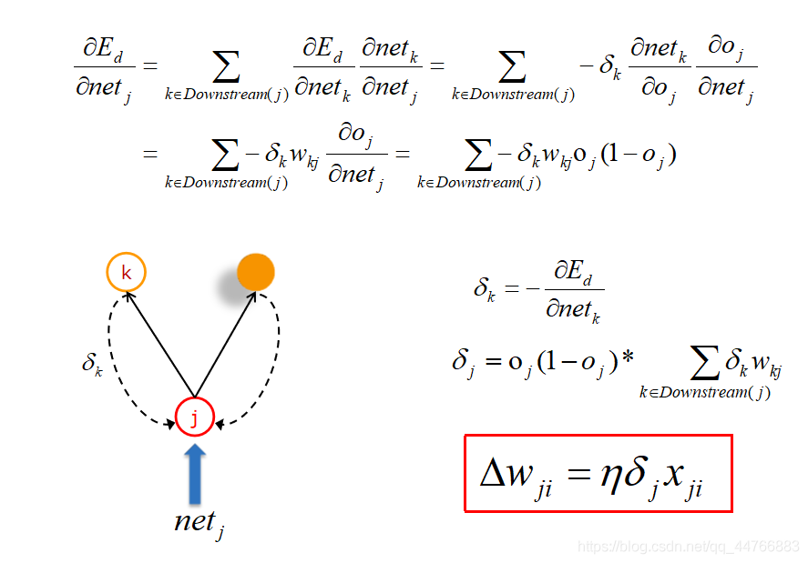

輸出層

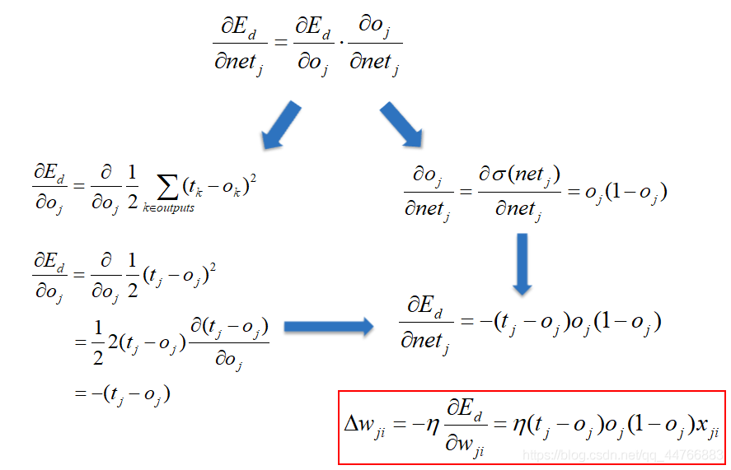

1. Derivation of optimal ω for a binary SVM

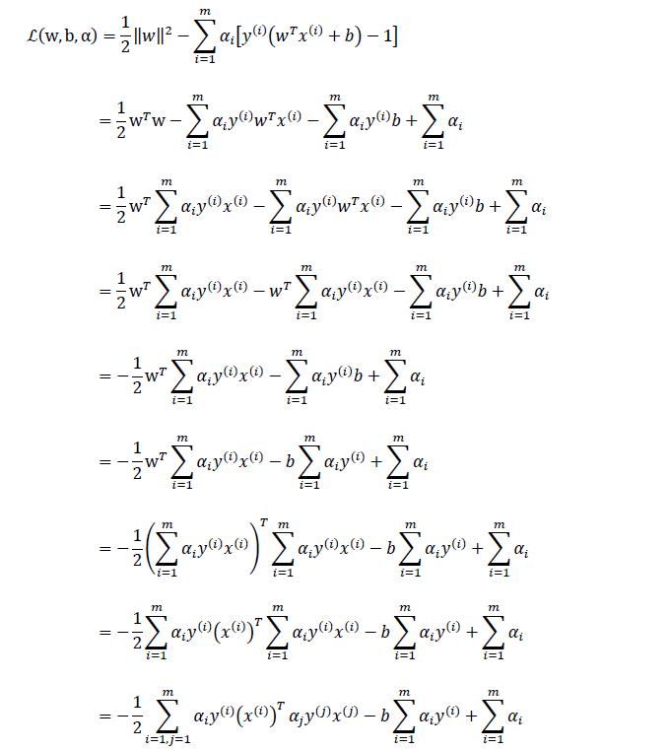

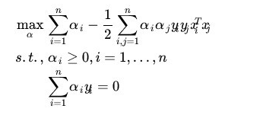 https://img-blog.csdnimg.cn/20181227102803911

參考文獻

<https://blog.csdn.net/weixin_45834080/article/details/103020958>

<https://blog.csdn.net/qq_44766883/article/details/110000709>

<https://www.itread01.com/content/1545878162.html>

<https://www.youtube.com/watch?v=_PwhiWxHK8o&t=1s>