201 Dual Attenuverters User Manual
05-2026 Rev. 1

1 Introduction
The 201 Dual Attenuverters are 2 utility attenuverters in an Intellijel 1U format. Each attenuverter is capable of attenuating, inverting, and attenuverting the input signal with a single knob.

2 Installation & Power
This module requires 14hp of free space in a rack. When installing, always turn off the power supply before plugging anything in. When plugging in the 10-16 pin ribbon power cable, ensure that the red stripe lines up with the RED LINE mark (refer to fig. 2.1) on the module and the marking that indicates -12v on the bus board.
This module is not reverse polarity protected. This means that the module will get heavily damaged if the power cable is plugged in backwards. Additionally, a reversed power cable may also cause damage to the components in the module, as well as other modules connected to the same power supply.
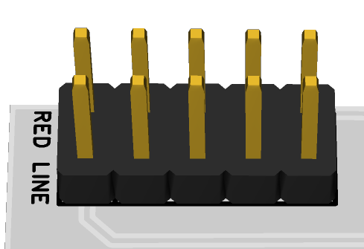
fig. 2.1 Power Connector

3 Front Panel Overview

4 Technical Specifications
4.1 Dimensions & Power
Width | Height | Depth | +12v Current | -12v Current
14hp | 1U Intellijel | ~25mm max.

4.2 Inputs & Outputs
Inputs |  | Outputs
IN 1, 2 | Any modular levels | OUT 1, 2 | Any modular levels

