302 Dual Analogue Saw Core VCO User Manual
05-2026 Rev. 1

1 Introduction
The 302 Dual Analogue Saw Core VCO is a simple dual VCO pair based on Moritz Klein’s Shapes VCO. It features two identical saw core oscillators that produces sawtooth and square/PWM outputs. As a basic building block of the modular synthesizer, it has good $1 V/oct$ tracking over several octaves, and is easy to use.

2 Installation & Power
This module requires 14hp of free space in a rack. When installing, always turn off the power supply before plugging anything in. When plugging in the 10-16 pin ribbon power cable, ensure that the red stripe lines up with the RED LINE mark (refer to fig. 2.1) on the module and the marking that indicates -12v on the bus board.
This module is not reverse polarity protected. This means that the module will get heavily damaged if the power cable is plugged in backwards. However, a reversed power cable may still cause damage to the components in the module, as well as other modules connected to the same power supply.
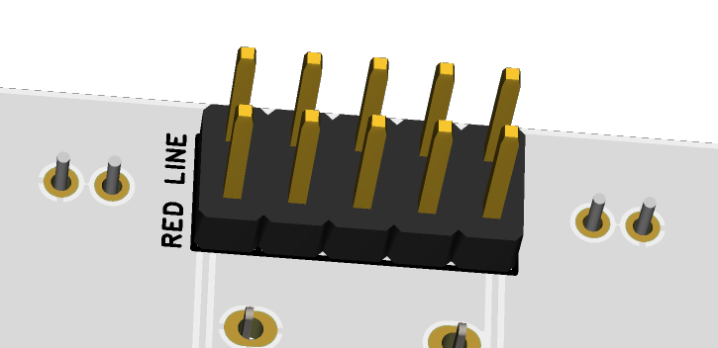
fig 2.1 Power Connector

3 Front Panel Overview

4 Additional Information
4.1 $1 V/oct$ Calibration

4.2 Waveform Outputs

5 Technical Specifications
5.1 Dimensions & Power
Width | Depth | +12v Current | -12v Current

5.2 Inputs & Outputs
Inputs |  | Outputs
Input name | Additional info | output name | Additional info

6.3 Other Specifications

